Level 2 Certificate in Fitness Instructing (Gym-Based Exercise) (QCF)
Learner Assessment Record
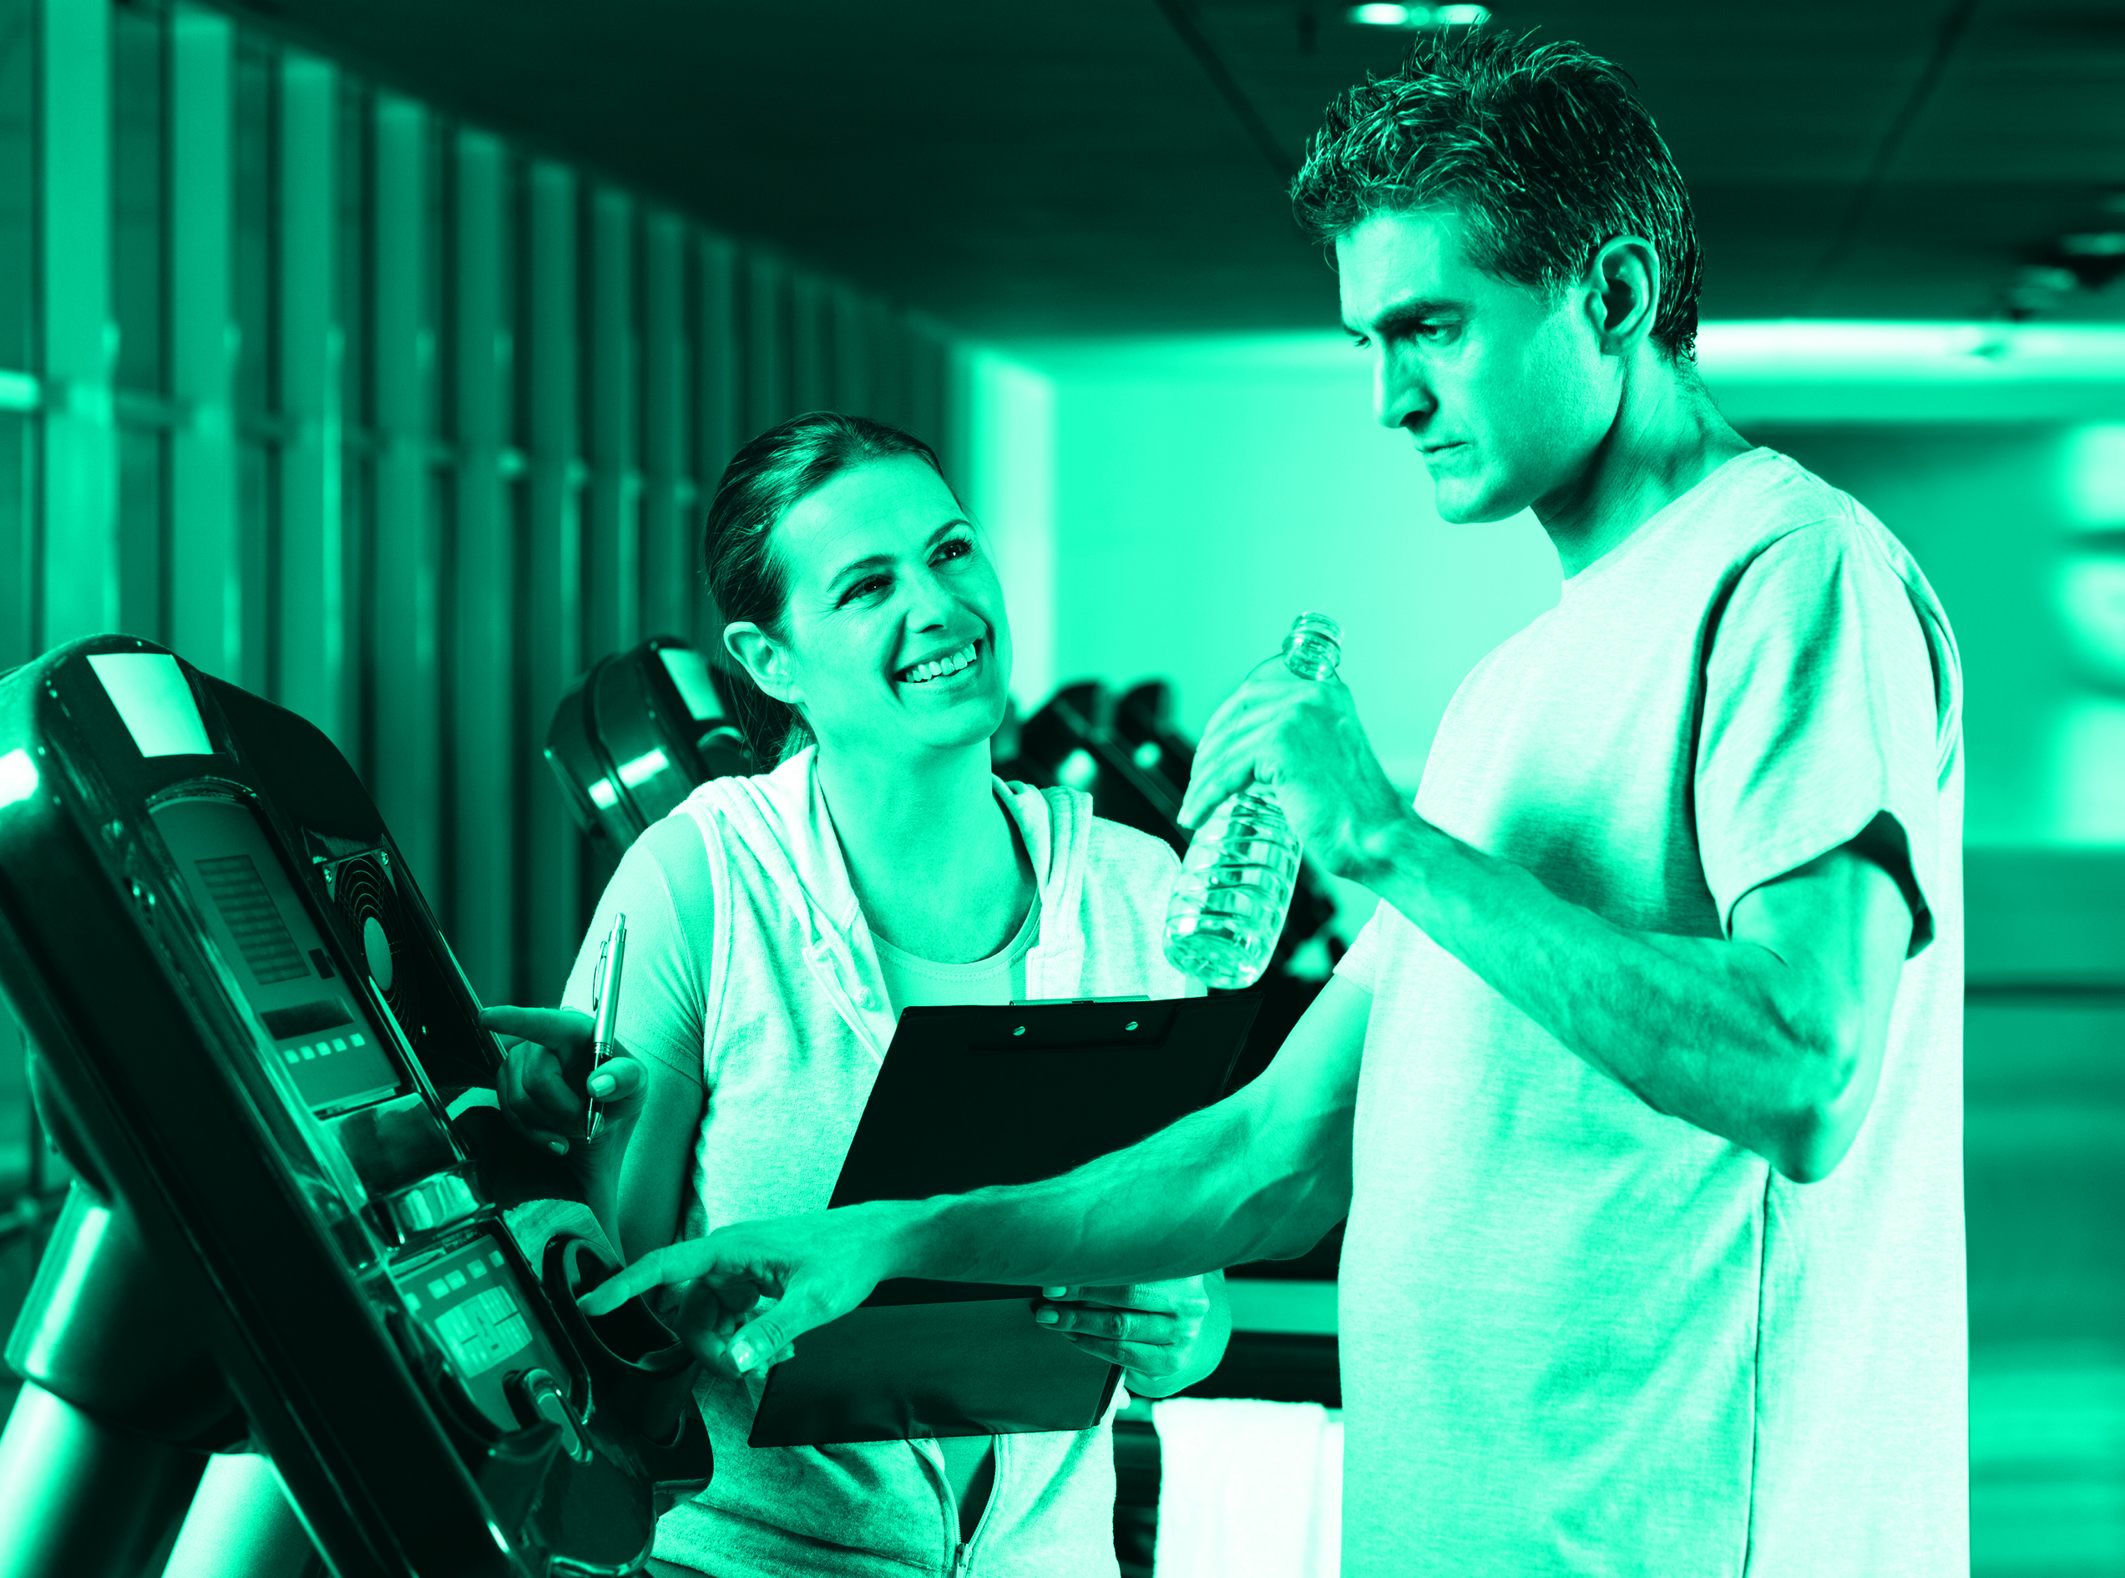

YMCA Awards
112 Great Russell Street
London
WC1B 3NQ
020 7343 1800
www.ymcaawards.co.uk
Level 2 Certificate in Fitness Instructing (Gym-Based Exercise) (QCF)
Learner Assessment Record
Copyright © YMCA Awards 2015
All rights reserved. No other part of this publication may be reproduced, stored or introduced into a retrieval system, or transmitted in any form or by any means (electronic, photocopying, recording or otherwise), without the prior written permission of the copyright owners of this pack.

Contents
Introduction 6
About YMCA Awards 6
Learner assessment record (LAR) 6
Qualification structure 6
Assessment specification 7
Assessment plan 11
Planning gym-based exercise (F/600/9018) 12
Worksheet 12
Gym programme overview 14
Gym programme card 15
Planning checklist 18
Instructing gym-based exercise (A/600/9020) 20
Worksheet 20
Summative observation checklist 23
Session evaluation 28
Appendices 29
Table of designated exercises 30
Assessor feedback sheet 32
Supplementary questions record 33
Physical activity readiness questionnaire (PAR-Q) 34
Informed consent 36
Summary of achievement 37

Introduction

About YMCA Awards
YMCA Awards is one of the UK's leading health and fitness specific awarding bodies and is a trusted name that enjoys widespread respect within the fitness industry. YMCA Awards qualifications are designed for people taking their first steps in the health and fitness industry or for those already working in the industry wishing to progress their careers. YMCA Awards has been responsible for over 200,000 people launching or progressing their careers.
As an internationally recognised organisation, YMCA Awards has a number of study options available including full time or part time, distance learning and progressive study routes. This variety ensures that there will be a study option that is right for you and which will enable you to increase your knowledge, gain new skills and develop your career. All of YMCA Awards’ proven and established resources and assessment materials have been developed by leading industry experts in consultation with employers and training providers.
For more information, visit www.ymcaawards.co.uk

Learner Assessment Record (LAR)
Your Learner Assessment Record is designed to support the assessment of your YMCA Awards Level 2 Certificate in Fitness Instructing – Gym-Based Exercise. It contains all the paperwork that you, your tutor and your assessor need in order to complete the 2 gym-based exercise units. It does not contain the paperwork for the 4 mandatory units, as this paperwork can be found in the Level 2 Mandatory Units LAR.
You will share the Learner Assessment Record with your tutor and assessor, who will use the paperwork contained within to assess you throughout the duration of your training. This document is an essential part of your assessment and should be kept safe. Your tutor and assessor will guide you as to which forms you need at particular times, as well as how they should be used and completed.

Qualification structure
To achieve your YMCA Awards Level 2 Certificate in Fitness Instructing (Gym-Based Exercise), you must pass all 6 units; 4 of which are not covered in this syllabus and 2 gym-based exercise units.
Unit reference number | Unit title | Level | GLH | Credits
H/600/9013 | Anatomy and physiology for exercise | 2 | 41 | 6
T/600/9016 | Health, safety and welfare in a fitness environment | 2 | 16 | 2
A/600/9017 | Principles of exercise, fitness and health | 2 | 28 | 4
M/600/9015 | Know how to support clients who take part in exercise and physical activity | 2 | 13 | 2
F/600/9018 | Planning gym-based exercise | 2 | 23 | 4
A/600/9020 | Instructing gym-based exercise | 2 | 37 | 6
For the first 4 units please refer to the Level 2 Mandatory units LAR
You will gain 24 credits within the Qualifications and Credit Framework (QCF).

Assessment specification
Your assessment has 9 elements across 6 units. This LAR covers the 5 assessment elements relating to the 2 gym-based exercise units.
- Elements 5 and 6 relate to Planning gym-based exercise (F/600/9018)
- Elements 7, 8 and 9 relate to Instructing gym-based exercise (A/600/9020)
For assessment elements 1 to 4 see the Level 2 Mandatory Units LAR
Assessment element 5: Planning worksheet
You are required to complete the planning worksheet, externally set by YMCA Awards.
Paperwork that relates to this assessment element:
Planning gym-based exercise worksheet
Assessment element 6: Plan a gym-based exercise session
You will be required to complete the planning paperwork listed below.
Gym programme overview – This document covers details about the client and the health and safety of the session and environment. The client will also need to complete a PAR-Q and an informed consent form.
Gym programme card – This is a complete outline of the gym-based exercise session, detailing; the exercises, timing, intensity and alternatives/adaptations, it must include:
- Appropriate warm up and cool down
- 3 of the following types of cardiovascular equipment (one must be for a CV workout):
  - Upright cycle
  - Recumbent cycle
  - Treadmill
  - Stepper
  - Rowing machine
  - Elliptical trainer
  - Cross trainer
- Exercises from each of the following (see the list of designated lifts to choose from at the back of this LAR):
  - 4 resistance machine lifts
  - 4 free weight lifts (ensure at least 1 exercise is a bench lift to show spotting/lifting and passing technique)
  - 3 body weight exercises
You will be assessed against the planning ‘summative checklist’. You need to familiarise yourself with this checklist to ensure you cover all the areas required for the assessment.
Paperwork that relates to this assessment element:
Gym programme overview
Gym programme card
Planning checklist
PARQ (see the appendices section of this LAR)
Informed consent (see the appendices section of this LAR)
Assessment element 7: Instructing worksheet
You are required to complete the instructing worksheet, externally set by YMCA Awards.
Paperwork that relates to this assessment element:
Instructing gym-based exercise worksheet
Assessment element 8: Practical delivery of specific gym-based exercises

You will be required to deliver a number of gym-based exercises, which will be observed by an assessor.
These exercises can be taught using a peer from the course.
Instructing gym-based exercise (the dark-shaded area of this checklist)
You will be assessed against the instructing section of the ‘summative observation checklist’ (dark-shaded areas only).
You need to familiarise yourself with this checklist to ensure you cover all of the areas required for the assessment. This assessment will be carried out on the course and is a formal summative assessment. You will only be put forward for assessment when your tutor deems that you are ready. You will need to pass this assessment element before you can move on to assessment element 9.
You will be observed delivering specific gym-based exercises (selected by your assessor) with a client (peer), covering the following:
- 1 type of cardiovascular equipment:
  - Upright cycle
  - Recumbent cycle
  - Treadmill
  - Stepper
  - Rowing machine
  - Elliptical trainer
*this must be different to the equipment selected in assessment element 9
- 4 exercises, 2 from each of the following:
  - Resistance machine lifts
  - Free weight lifts
- 3 body weight exercises
*see the list of designated lifts to choose from at the back of this LAR – the exercises selected must be different from those chosen for assessment element 9.
The above areas can be covered across a number of planned assessments, all dates need to be planned and your assessor should record these on your assessment plan.
Paperwork that relates to this assessment element:
Summative observation checklist (dark-shaded areas – instructing checklist only)
Assessment element 9: Practical delivery of a gym-based exercise session
You will be required to deliver a gym-based exercise session which will be observed by an assessor. This assessment must be conducted in 1 complete session.
You are required to bring a client with you who is an apparently healthy adult age 16 or over (this can be a peer from the course).
You will be assessed against the ‘summative observation checklist’ (light-shaded areas only). You need to familiarise yourself with this checklist to ensure you cover all the areas required for the assessment.
The sections on the checklist are:
Preparing to instruct gym-based exercise - You will be observed preparing a client for a session which contains the range of exercises detailed in the instructing section below.
Instructing gym-based exercise (the dark shaded area of this checklist) - You will be observed delivering the elements of the planned session (assessment element 6) listed below:
- Appropriate warm up and cool down
- 2 of the following types of cardiovascular equipment (one of these can be used in the warm up, the other must be for a CV workout):
  - Upright cycle
  - Recumbent cycle
  - Treadmill
  - Stepper
  - Rowing machine
  - Elliptical trainer
  - Cross trainer
*the 2 types of equipment (must be different from the 1 you chose for assessment element 8)
- 4 exercises, 2 from each of the following:
  - Resistance machine lifts (1 will be the assessor’s choice from the list of designated lifts)
  - Free weight lifts (1 will be the assessor’s choice from the list of designated lifts)
*see the list of designated lifts to choose from at the back of this LAR – the exercises selected must be different from those chosen for assessment element 8.
Ending a session – You will be observed ending the session
Evaluation – You will be required to fully complete the session evaluation form
Supporting the client – You will be observed supporting your client, this section relates to the support you give the client throughout the whole session.
Paperwork that relates to this assessment element:
- Summative observation checklist
- Session evaluation form

The remainder of the forms contained within this record are
explained below:
Assessment plan
This document is designed to allow you and your assessor to plan your progress through the assessment components. You can use this to plan with your assessor and tutor when assessment activities will take place.
Assessor feedback sheet
This form will be used by your assessor to record any feedback that you may be given. This form may be used at any stage in your learning to record feedback.
Supplementary questions record
This form will be used by your assessor to record any questions that you may be asked and any responses you may give.
Summary of achievement
This document is designed to record the outcomes of the assessment elements and any further action that may be required. For example, you may need to be re-assessed in a particular area. This form will also be signed by you to declare authenticity of work and by your assessor to indicate which of the units have been satisfactorily completed. This document should be kept in a safe place as it acts as evidence of your achievements.

Assessment plan
YMCA Awards Level Certificate in Fitness Instructing (gym-based exercise)
Unit title | Element  number | Evidence/assessment method | Date, time and place of assessment | Any reasonable adjustments negotiated agreed
Planning gym-based exercise  (F/600/9018) | 5 | - written worksheet
Planning gym-based exercise  (F/600/9018) | 6 | - written gym programme card  - written session overview
Instructing gym-based exercise  (A/600/9020) | 7 | - written worksheet
Instructing gym-based exercise  (A/600/9020) | 8 | - practical delivery of specific gym-based exercises
Instructing gym-based exercise  (A/600/9020) | 9 | - practical delivery of a  gym-based exercise session  - written evaluation
For the Level 2 Mandatory Units please refer to the Mandatory Units LAR
Learner’s name: | Click here to enter text. | Learner’s signature: | Click here to enter text.
Assessor’s name: | Click here to enter text. | Assessor’s signature: | Click here to enter text.
IQA’s name: | Click here to enter text. | IQA’s signature: | Click here to enter text.

Planning gym-based exercise (F/600/9018)

Worksheet
Learner’s name: |  | Click here to enter text.
Assessor’s name: | Click here to enter text.
You are required to fully complete this worksheet, externally set by YMCA Awards. This worksheet should be completed prior to planning your gym-based exercise session, as the knowledge required in this section will assist you with your session design.
1. Explain the process of informed consent
2.Describe the type of information that can be obtained from the client when using the following methods and when they are appropriate to be used:
PAR-Q
Interview
Observation
Physical measurements
3. Describe 1 factor based on client screening, which may affect safe exercise participation
4. Give 1 example of how information obtained from a client might affect the planning of gym-based exercise

5. List 1 reason for temporary deferral of exercise
6. Explain when you might refer a client to another professional
7. Use the following table to describe how to plan gym-based exercise to meet the needs of clients with the following different objectives:
Client objective | Frequency |  | Intensity | Time | Type
Weight loss

Increased cardiovascular fitness
8. Give 1 reason why it is important to agree goals and objectives for gym-based exercise with a client
9. Describe how you would plan gym-based exercise using a circuit format
10. List 1 adaptation you would make to your plan to cater for each of the following:
Young people aged 14-16
Ante and postnatal women
Older people (50+)

Final result: Choose an item.

Learner’s signature: | Click here to enter text. | Date: | Click here to enter a date.
Assessor’s signature: | Click here to enter text. | Date: | Click here to enter a date.
IQA’s signature: | Click here to enter text. | Date: | Click here to enter a date.

Gym programme overview
Learner’s name: | Click here to enter text.
Client’s name: | Click here to enter text.

Session and venue details
Venue: |  |  | Location of first aid kit:
Duty first aider: |  |  | Location of telephone:
Discipline: Gym-based exercise |  |  | Duration of session:
Client information
Informed consent form completed: YES / NO |  |  | PAR-Q completed: YES / NO
Height: | Weight: |  |  | BMI:
Session objectives (as agreed by client):

Any specific consideration relating to the client (eg, injuries, exercise likes/dislikes, clothing)

Environment checks – list the health and safety checks made to the following:
Gym/studio: |  |  | Fire exits:
Temperature/ventilation: |  |  | Obstacles:
Organisation of equipment/resources
Equipment requirements |  | List of health and safety checks made to equipment
I (the client) agree with the session objectives outlined above

Client’s signature: | Click here to enter text. | Date: | Click here to enter a date.

Gym programme card

Learner’s name: Click here to enter text.
Client’s name: Click here to enter text. Date Click here to enter a date.
Training goals: Click here to enter text.
Warm up
Overview of content (including mobility, pulse raising (CV machine) | Equipment and duration | Level/speed | RPE/HR | Adaptation(s) or alternatives
Preparatory stretches – circle static stretches and list the muscles groups stretched dynamically
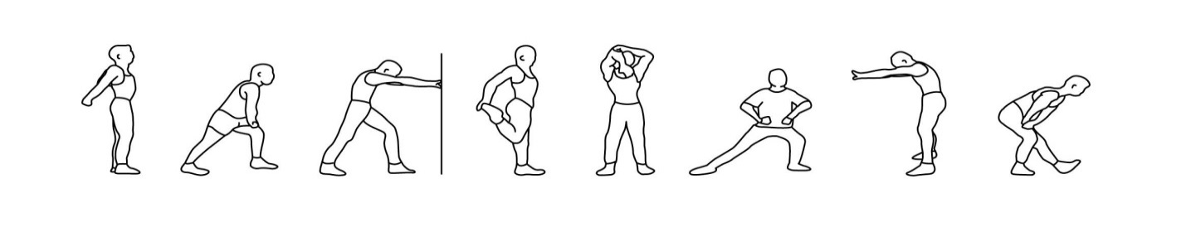
Cardiovascular training
Equipment and approach | Programme timings | Level/speed | RPE/HR | Adaptation(s) or alternatives
Resistance training
Exercise/machine | Resistance | Reps | Sets | Rest | Adaptation(s) or alternatives
Body weight exercise |  |  | Sets/reps/rest
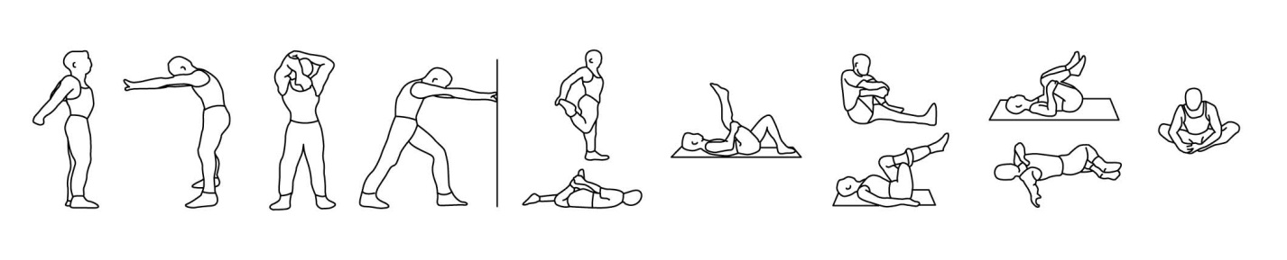
Cool down/flexibility
Cool down (if a re-warm or pulse lowering phase is required please detail in the space below)
CV machine | Time and intensity range
Post-workout stretches (circle as applicable) - indicate which stretches are maintenance (M) and which are developmental (D)

Planning checklist
Planning gym-based exercise (F/600/9018)
Learner’s name: | Click here to enter text.
Assessor’s name: | Click here to enter text.
IQA’s name: | Click here to enter text.
Key: = Pass, C = Pass with comment, Q = Question and R= Refer. The learner requires a or a C in every box in order to pass.
The second ‘outcome’ column is for reassessment (when applicable).
Gym programme overview, PAR-Q, informed consent and gym programme card
The learner: | Outcome | Outcome
The learner: | Initial assessment | Re-assessment
P1. Used appropriate methods to collect information to plan a gym-based exercise programme
P2. Checked accuracy and currency of client information whilst maintaining client confidentiality
P3. Identified client’s needs and any possible risks from participation in a gym-based exercise programme
P4. Agreed programme objectives with the client
P5. Selected gym-based exercises that helped the client to develop the components of physical fitness
P6. Planned how to minimise any risks relevant to the programme
P7. Planned realistic timings and sequences for exercise
P8. Recorded programme plans in an appropriate format
P9. Planned a safe and effective warm up
P10. Planned a safe and effective cool down
P11. Planned for the use of 3 different types of cardiovascular equipment
P12.Planned 4 resistance machine lifts
P13. Planned 4 free weight lifts
P14. Planned 3 body weight exercises
Result for planning | Pass / Refer | Pass / Refer
Final result: Choose an item.

Learner’s signature: | Click here to enter text. | Date: | Click here to enter a date.
Assessor’s signature: | Click here to enter text. | Date: | Click here to enter a date.
IQA’s signature: | Click here to enter text. | Date: | Click here to enter a date.

Instructing gym-based exercise (A/600/9020)

Worksheet

Learner’s name: | Click here to enter text.
Assessor’s name: | Click here to enter text.
You are required to fully complete the task, externally set by YMCA Awards. This task should be completed prior to delivering your gym-based exercise session, as the knowledge required in this section will assist you with your session delivery.
1. List 2 key teaching points relating to safe and effective joint alignment for each of the following:
Gym-based exercise | Teaching point 1 | Teaching point 2
Running on a treadmill

Cycling on an upright cycle

Rowing on a rowing machine

Seated knee extension on a fixed machine

Seated shoulder press on a fixed machine

Lateral pull down (in front of chest) on a fixed machine

Lying hamstring (thigh) curl on a fixed machine

Upright row – using a free weight (barbell)

Seated triceps press (dumbbell)

Dumbbell lunge

Bench press

2. Using one of the exercises listed on the previous page, give an example of how this exercise could be developed to improve your client’s coordination during their gym-based exercise session
Exercise:

Development:

3. Using one of the exercises listed on the previous page, explain how you would introduce it if you were giving a group induction (focusing on the differences between group and individual inductions)
Exercise:

Procedure for group induction:

4. Briefly explain below how your instructing skills would be improved by evaluation and reflective practice
Final result: Choose an item.

Learner’s signature: | Click here to enter text. | Date: | Click here to enter a date.
Assessor’s signature: | Click here to enter text. | Date: | Click here to enter a date.
IQA’s signature: | Click here to enter text. | Date: | Click here to enter a date.

Summative observation checklist
Instructing gym-based exercise (A/600/9020)
Learner’s name: | Click here to enter text. | Venue | Click here to enter text.
Assessor’s name: | Click here to enter text. | IQA’s name: | Click here to enter text.

Key: = Pass, C = Pass with comment, Q = Question and R = Refer. The learner requires a or a C in every box in order to pass this section. Questioning is not permitted in order to confirm competence of practical skills.
The second ‘outcome’ column is for reassessment should the learner not achieve a pass against all criteria.
This section should be assessed along with the instructing section of assessment element 9 (the light-shaded components on the next page)
Preparing to instruct gym-based exercise, the learner: | Outcome | Outcome
Preparing to instruct gym-based exercise, the learner: | Initial assessment | Re-assessment
P1. Prepared self to supervise gym-based exercise
P2. Selected equipment for gym-based exercise programmes appropriate to the client’s needs
P3. Prepared the environment and equipment appropriate to the client’s needs
P4. Helped the client feel welcome and at ease
P5. Explained the purpose and value of the exercises in the session
P6. Described the physical and technical demands of the exercises
P7. Confirmed or revised the plans with the client as appropriate
P8. Advised the client of the facility’s emergency procedures
P9. Used warm up activities that were safe and effective for the client
Result for preparing | Pass / Refer | Pass / Refer

Key: = Pass, C = Pass with comment and R = Refer, o after a component eg FW 4 o = assessor’s choice. Questioning is not permitted in order to confirm competence of practical skills
Dark-shaded components (CV, RM1 and 2, FW 1 and 2 and BW 1, 2 and 3) are designed to be formally assessed during the course/programme of study when the learner is deemed ready. The learner requires a ✓✓ or a C in every dark-shaded box in order to pass. Reassessment is permitted and can relate to the individual criteria/component referred (you may need to have a second copy of this checklist for reassessment).
Light-shaded components (WU, including a CV machine, CV workout, RM3 and 4o, FW 3 and 4o and CD, including flexibility) are designed to be formally assessed at the end of the course in one complete assessment session. The learner requires a or a C in every light- shaded box in order to pass. Reassessment: up to 2Rs requires reassessment against only those criteria and for the component(s) to which the R(s) relate(s); 3 or more Rs, requires reassessment against all criteria for all session components (you may need to a second copy of this checklist for reassessment).
Code for exercise/machine  (eg, TM= Treadmill, BP= Bench press) |  |  |  |  |  |  |  |  |  |  |  |  |  |  |  | Outcome (instructing assessment element 8) | Outcome  (instructing assessment element 9)
Instructing gym-based exercise, the learner: | WU | CV | CV | RM 1o | RM 2o | RM 3 | RM 4O | FW 1o | FW 2o | FW 3 | FW 4o | BW 1 | BW 2 | BW 3 | CD | Outcome (instructing assessment element 8) | Outcome  (instructing assessment element 9)
IN1.Gave explanations and demonstrations that were technically correct (including spotting/lifting and passing technique)
IN2. Communicated as appropriate to the client’s needs and the environment
IN3. Adopted appropriate positions to observe the client and respond to their needs
IN4. Monitored the safety and intensity of the exercise
IN5. Provided feedback and instructing points which were timely, clear and motivational
IN6. Adapted exercises with suitable progressions and regressions according to the client’s needs
Result for instructing |  |  |  |  |  |  |  |  |  |  |  |  |  |  |  | Pass/Refer | Pass/Refer

Summative observation checklist continued
Instructing gym-based exercise (A/600/9020)
Learner’s name: | Click here to enter text.
Key: = Pass, C = Pass with comment and R = Refer. Questioning is not permitted in order to confirm competence of practical skills. The learner requires a or a C in every box in order to pass this section.
The second ‘outcome’ column is for reassessment should the learner not achieve a pass against all criteria
The next 3 sections should be assessed along with the instructing section of assessment element 9 (the light-shaded components on the previous page)
Ending a session, the learner: | Outcome | Outcome
Ending a session, the learner: | Initial assessment | Re-assessment
ES1. Allowed sufficient time to end the session according to the client’s level of experience
ES2. Used cool down activities that were safe and effective for the client
ES3. Gave the client an accurate summary of feedback on the session
ES4. Gave the client the opportunity to:
- reflect on the session
- ask questions
- provide feedback
- identify further needs
ES5. Ensured the client knew how to continue with their programme without direct supervision
ES6. Left the environment in a condition acceptable for future use
Result for ending a session | Pass/Refer | Pass/Refer

Evaluation, the learner: | Outcome | Outcome
Evaluation, the learner: | Initial assessment | Re-assessment
E1. Reviewed the outcomes of working with client’s and client feedback
E2. Identified:
How well the exercises met client needs
How effective and motivational the relationship with the client was
How well the instructing style matched the clients’ needs
E3. Identified how to improve personal practice
Result for evaluation | Pass/Refer | Pass/Refer

Supporting the client (this section relates to the whole gym-based exercise practical assessment), the learner: | Outcome | Outcome
 | Initial assessment | Re-assessment
SC1. Presented a positive image of self and organisation to the client
SC2. Established an effective working relationship with the client
SC3. Communicated with the client in a way that made them feel valued
SC4. Used motivational styles appropriate to the client and the exercise format
Result for supporting the client | Pass/Refer | Pass/Refer
(All sections of the summative observation checklist need a pass to achieve a final result of a pass)
Final result: Choose an item.
Learner’s signature: | Click here to enter text. | Date: | Click here to enter a date.
Assessor’s signature: | Click here to enter text. | Date: | Click here to enter a date.
IQA’s signature: | Click here to enter text. | Date: | Click here to enter a date.

Session evaluation
Instructing gym-based exercise (A/600/9020)

Learner’s name: | Click here to enter text. | Date: | Click here to enter a date.

After my session, I received the following feedback from the client:
My exercises met the needs of the client in the following ways:
Instructing style

Individual needs
My relationship with the client, including motivation, was effective in the following ways:
I will improve my personal practice in the following ways:

Appendices

Table of designated exercises
Joint/movement | Resistance machines | Free weight | Body weight
Shoulder flexion | Seated chest press (neutral grip) | Front raise
Shoulder extension | Seated row (low pulley)  Seated row (neutral grip) | Single arm row  Bent arm pullover (DB)
Shoulder abduction | Shoulder press | Shoulder press (DB)  Lateral raise (DB)  Upright row (BB)
Shoulder adduction | Lateral pull down (in front of the chest)  Assisted pull up |  | Chins
Shoulder horizontal flexion | Bench press  Seated chest press (BB grip)  Pec dec | Bench press  Chest flyes(DB) | Press up
Shoulder horizontal extension | Seated row (BB grip) | Prone flye (DB)
Elbow extension | Triceps pushdown (high pulley)  Triceps press | Supine triceps press (BB)  Single arm triceps press (DB) | Press up
Elbow flexion | Biceps curl (low pulley)  Seated biceps curl | Biceps curl (BB) (DB)
Hip extension | Leg press  Total hip | Lunge (BB, DB optional)  Deadlift (BB) (DB) | Lunge
Hip adduction | Seated adductor  Total hip
Hip abduction | Seated abductor  Total hip
Knee extension | Seated knee extension  Leg press | Lunge  Deadlift (BB) (DB)  Squat (BB) (DB) | Lunge  Squat
Knee flexion | Lying thigh curl  Seated thigh curl
Trunk flexion | Abdominal machine |  | Abdominal curl
Spinal extension | Lower back machine | Deadlift (BB) (DB) | Back raise
Key: BB = Barbell; DB = Dumbbell
Source: Skills Active assessment strategy – Level 2 certificate in fitness instructing (gym-based exercise, exercise to music, water-based exercise and physical activity for children)

Assessor feedback sheet
Learner’s name: | Click here to enter text.
Assessor’s name: | Click here to enter text.
Assessment element: | Click here to enter text.

Ref | Feedback

Learner’s signature: | Click here to enter text. | Date: | Click here to enter a date.
Assessor’s signature: | Click here to enter text. | Date: | Click here to enter a date.
IQA’s signature: | Click here to enter text. | Date: | Click here to enter a date.

Supplementary questions record
Learner’s name: | Click here to enter text.
Assessor’s name: | Click here to enter text.
Assessment element: | Click here to enter text.

Ref | Assessor’s question | Learner’s response

Learner’s signature: | Click here to enter text. | Date: | Click here to enter a date.
Assessor’s signature: | Click here to enter text. | Date: | Click here to enter a date.
IQA’s signature: | Click here to enter text. | Date: | Click here to enter a date.

Physical activity readiness questionnaire (PAR-Q)

Name: | Click here to enter text. |  |  | Age: | Click here to enter text. |  |  | Gender: |  | Click here to enter text.
Contact number: |  |  | Click here to enter text. |  |  | Email: | Click here to enter text.
Next of kin: |  | Click here to enter text. |  |  |  | Contact number: |  |  | Click here to enter text.
This PAR-Q is designed to help you to help yourself. Many benefits are associated with regular exercise, and completion of the PAR-Q form is a sensible first step to take if you are planning to increase the amount of physical activity in your life.

For most people, physical activity should not pose a problem or hazard.

The PAR-Q has been designed to identify the small number of people for whom physical activity might be inappropriate or for those who should seek medical advice concerning the type of activity most suitable for them. Common sense is your best guide for answering these questions.
1. Has your doctor ever said that you have a heart condition and that you should only do physical activity recommended by a doctor? | YES/NO
2. Do you feel pain in your chest when you do physical activity? | YES/NO
3. In the past month, have you had chest pain when you were not doing physical activity? | YES/NO
4. Do you lose your balance because of dizziness or do you ever lose consciousness? | YES/NO
5. Do you have a bone or joint problem (for example, back, knee or hip) that could be made worse by a change in physical activity? | YES/NO
6. Is your doctor currently prescribing drugs (for example, water pills) for your blood pressure or heart condition? | YES/NO
7. Do you know of any other reason why you should not do physical activity? | YES/NO

If you have answered YES to any of the above questions, then you are required to gain consent from your doctor before participating in the gym-based exercise programme.

If you have answered NO to all of the above questions and you have reasonable assurance of your suitability for:

A gym-based exercise programme – which will include; a warm up, cardiovascular training using equipment, fixed weights, using resistance machines, free weights, using dumbbells and barbells, body weight exercises and cool down stretches.

You are advised to postpone entry into the programme if you feel unwell or have a temporary illness. You must inform your gym instructor of any changes to your health status, whilst engaged in your training programme.

Client signature: | Click here to enter text. | Date: | Click here to enter a date.
Witness signature: | Click here to enter text. | Date: | Click here to enter a date.

This PAR-Q has been designed for use on the Level 2 Fitness Instructing (Gym-Based Exercise) course for a copy of a generic PAR-Q please go to: Canadian Society for Exercise Physiology’s website (www.csep.ca/publications).

Informed consent
Informed consent form for exercise prescription
Programme objectives and procedures
I understand that the purpose of the exercise programme is to provide safe and individualised exercise to improve health and fitness. Exercises may include:
- Cardiovascular machine activities – treadmill walking or jogging, rowing, upright or recumbent cycling, stair climbing and other such activities
- Resistance training activities using resistance machines, free weights or body weight to improve muscular strength or endurance
- Cool down and flexibility exercises to improve movement around the joints and range of motion

Potential risks
The exercise programme is designed to place a gradually increasing workload on the cardiovascular and muscular systems and thereby improve their function. The reaction of the cardiovascular and muscular system to such exercise cannot always be predicted with complete accuracy. There is a risk of certain changes that might occur during or following the exercise. These changes could relate to blood pressure or heart rate.
Potential benefits
I understand that a programme of regular exercise has been shown to be beneficial. Some of these benefits include:
- A decrease in risk of heart disease
- A decrease in body fat
- Improved blood pressure
- Improvement in psychological function
- Improvement in aerobic fitness
The gym-based exercise programme has been explained to me and my questions regarding the programme have been answered to my satisfaction. I understand that I am free to withdraw at any time. The information obtained will be treated as private and confidential.

Signature of client: Click here to enter text. Date: Click here to enter a date.
Witness signature: Click here to enter text. Date: Click here to enter a date.

Summary of achievement
YMCA Awards Level 2 Certificate in Fitness Instructing – Gym-based exercise
For the Level 2 Mandatory Units please refer to the Mandatory units LAR
Learner’s name: | Click here to enter text. | Centre name | Click here to enter text.
Assessor’s name: | Click here to enter text. | IQA’s name: | Click here to enter text.

Unit title | Assessment element | Assessment outcome | Action plan for achievement and evidence produced for exemption | Reassessment outcome (if applicable) |  | Assessor’s and learner’s signature and date of  sign-off | IQA’s signature and date (if sampled) | EQA’s signature and date (if sampled)
Planning  gym-based exercise  (F/600/9018 | 5. planning - worksheet | Pass  Refer  Exemption |  | Pass  Refer
Planning  gym-based exercise  (F/600/9018 | 6. plan a gym based exercise session | Pass  Refer  Exemption |  | Pass  Refer

Unit title | Assessment element | Assessment outcome | Action plan for achievement and evidence produced for exemption | Reassessment outcome (if applicable) |  | Assessor’s and learner’s signature and date of  sign-off | IQA’s signature and date (if sampled) | EQA’s signature and date (if sampled)
Instructing  gym-based exercise  (A/600/9020) | 7. instructing worksheet | Pass  Refer  Exemption |  | Pass  Refer
Instructing  gym-based exercise  (A/600/9020) | 8. practical delivery of specific  gym-based exercises | Pass  Refer  Exemption |  | Pass  Refer
Instructing  gym-based exercise  (A/600/9020) | 9. practical delivery of a gym-based exercise session  (including evaluation) | Pass  Refer  Exemption |  | Pass  Refer
Learner authenticity statement:
I confirm that the evidence provided for this qualification is entirely my own work.
Learner’s signature: | Click here to enter text. | Date: | Click here to enter a date.

Assessor sign-off statement
I confirm that I am satisfied that the learner named above has provided evidence that is valid, authentic, reliable, current and sufficient to demonstrate the required knowledge, understanding and/or skills for the units signed off here.
Assessor’s signature: | Click here to enter text. | Date: | Click here to enter a date.

www.ymcaawards.co.uk
awarding excellence
112 Great Russell Street, London, WC1B 3NQ | T +44 (0)20 7343 1800 | F +44 (0)84 3221 1549
| E awards.info@ymca.co.uk| W ymcaawards.co.uk
Registered charity no. 213121 | Registered in England & Wales no. 119249

YMCA Awards is one of the UK’s leading health, fitness and wellbeing specific awarding organisations. It offers training centres and learners across the world a diverse suite of qualifications, from introductory (Level 1) to advanced levels (Level 4).

YMCA Awards issues over 30,500 qualification certificates a year, helping learners in the UK and overseas to launch and progress their careers in the active leisure sector.

To view YMCA Awards’ full range of qualifications please visit www.ymcaawards.co.uk.

