Data Handling and Business Intelligence A2
Programme: BA (Hons) Business Management
Module: Data Handling & Business Intelligence
Module code: LCBB5000
Lecturer: Gasso Wilson Mwaluseke

Student Name: Momchil Kostadinov
Student Number: 2028013

Table of Contents
Part 1 3
Using Excel for pre – processing of data 3
Data Analysis 10
Descriptive statistics 12
Data visualization 13
Part 2 15
Numbers students liking vanilla flavor of ice cream 15
Number of Students being Male & female 16
Mean & median of participants liking chocolate and strawberry flavor 17
Example of clustering – K means 18
Methods of data mining & text mining used by the businesses 24
Advantages & disadvantages of using Excel & SPSS 26
REFERENCES 28
Books and Journals 28
APPENDIX 29

Part 1

Using Excel for pre – processing of data
Microsoft excel is used commonly as a great tool for performing pre – processing on data alongside handling structured data. There are number of techniques built within excel through which data cleaning is done over structured data (Salkind and Frey, 2021). Data pre-processing is also regarded as the component of the process of data preparation which involves raw data processing to make it suitable for the performance of another procedure. It also involves manipulation of data prior to making use of it for the tasks related to data analysis.
With respect to the superstore data set, we have applied the filter function of excel through which the data related to sales and profit has been grouped together based on year in which they have been generated. In present case, the application of filter on the column “order date” has resulted in selection criteria as 2009, 2010, 2011 and 2012 and therefore, the results show the data associated with the selected year. By summing up the sales and profit figures on year-to-year basis, the following table has been obtained.
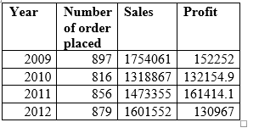
Filter function: With the help of filter, data analysts can filter the data set based on criteria defined (Mayes, 2020). In case of superstore data set, the steps that have been performed while applying the filter function to obtain the sales & profit associated with past four years are as follows:
1. At first step, the column is selected of data which is required to be filtered. From the data set of superstores, the “order data column” has been selected.
2. In Home tab within editing group, the option of Sort and filter is clicked which gives the drop-down list from which the filter option is selected resulting in application of filter of sheet’s column head.
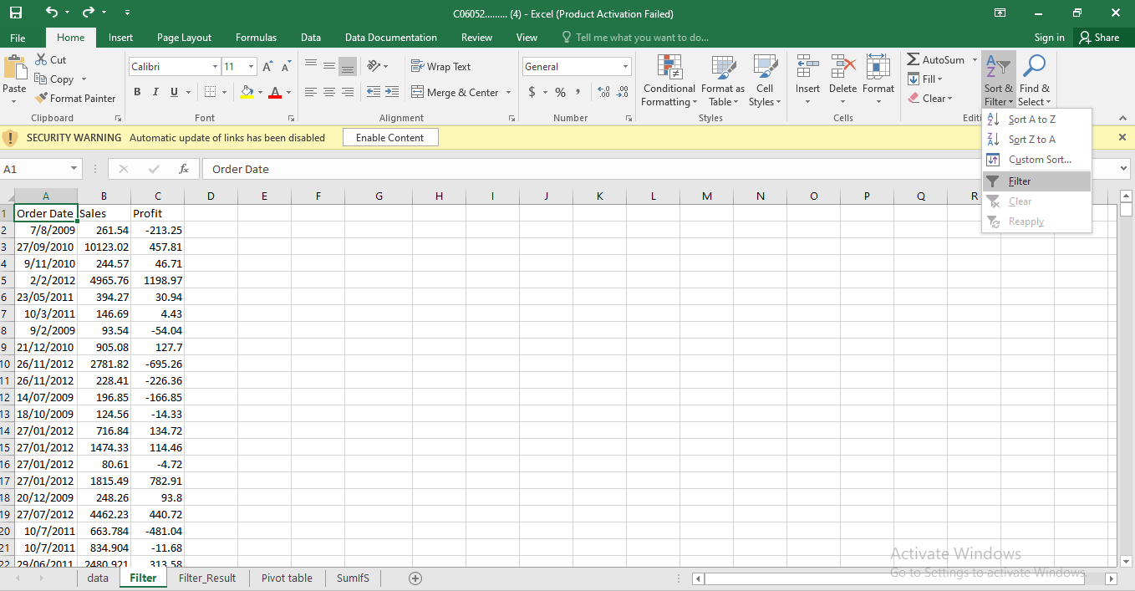

3. By clicking on the down arrow of any of the column head, the criteria can be selected for filtering the data. In the data set of superstores, the down arrow on the “order date” column has been clicked which gives the criteria for selection and the year 2011 has been selected while unselecting all other options. This gives the sales and profit figures relevant to 2011 and by adding up all the sales and profit, we have got the total sales & profits of different years as shown in the table above.
Therefore, data preprocessing is helpful in presenting data that fulfils the analyst’s criteria. Also, one could develop precise knowledge about the data set before conducting detailed analysis of data & drawing conclusions out of it.
Further, another powerful tool meant for data preprocessing has been used with respect to superstore data that is, pivot table which is useful in gaining understanding of how sales & profits are moving through 2009 to 2012.
Pivot table: It is used for summarizing, exploring, analyzing, and presenting the summary of large data sets. It facilitates quick & interactive summarization of data set alongside performing detailed analysis of numerical data to answer questions such as how the business has performed during the past years on different aspects (Anderson and et.al., 2020).
1. First, table array is selected consisting of all the rows & columns for which the pivot table will be created. Like for superstore data set, rows and columns are selected as follows:
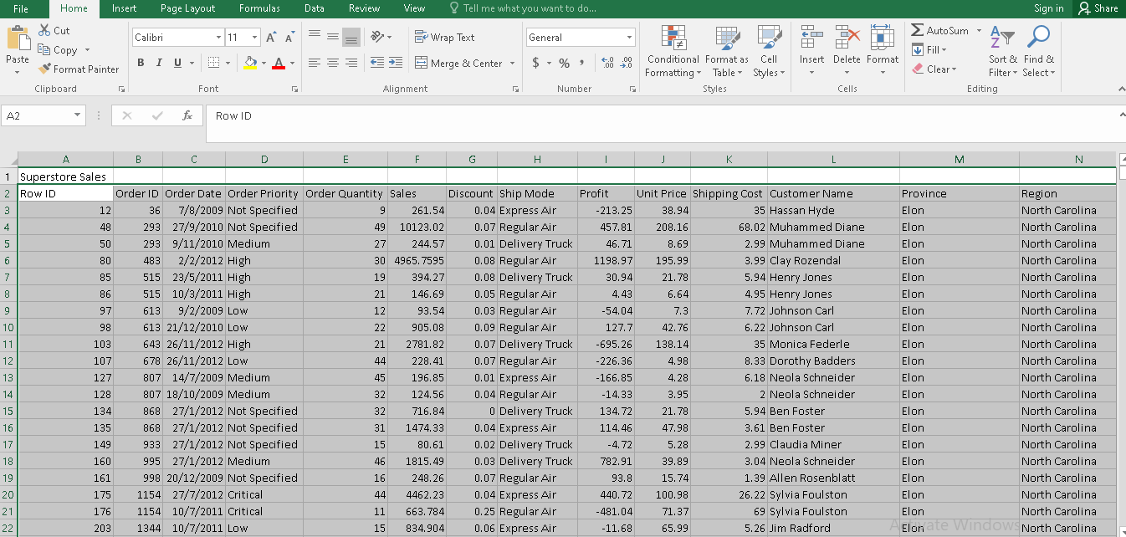
2. Click on insert table where the “tables” group represent the pivot table option.

3. When this option is clicked, the dialog box gets displayed which shows the cell reference for the table based on the rows and columns selected in the first step.
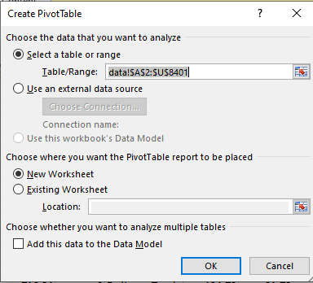
4. Check “new worksheet” option which gives the result for pivot table on new sheet. Click OK. Accordingly, template for creating pivot table will be generated on the new sheet.
5. On new worksheet, the pivot table fields can be seen at the right side, the order date has been dragging and dropped to the filter’s quadrant, product category in the quadrant of row and the last profit and sales in the quadrant of column.
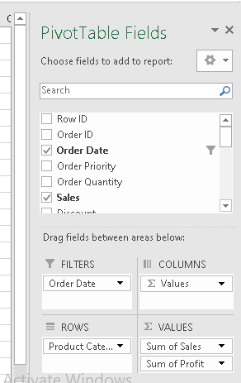
6. The resultant pivot table can be used for looking at the sales and profit associated with a particular category of product in 2011 by clicking on the order date and setting 2011 as the criteria.
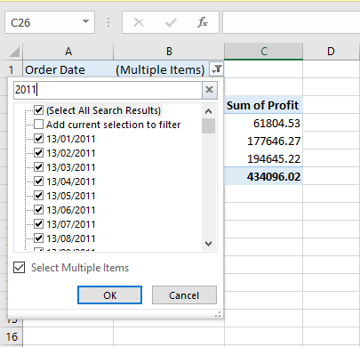
The following results have been generated based on the above selection.
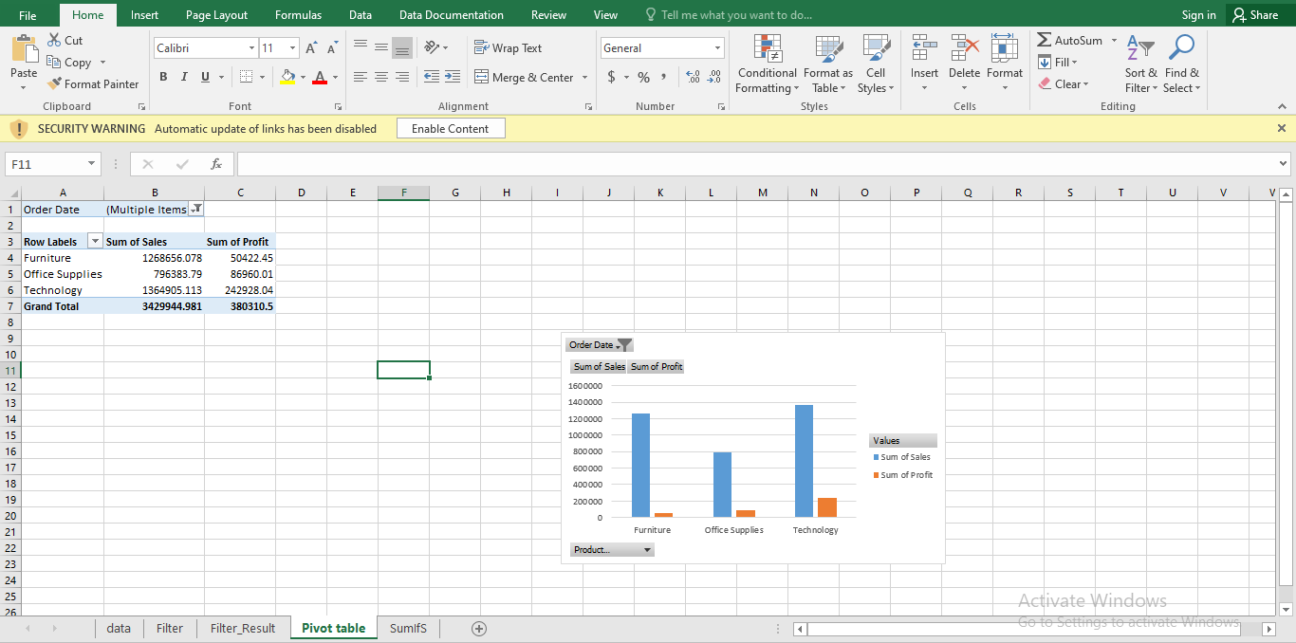
Further, if the analyst will select “All” as a criterion in order date column, the figures for sales and profit would be generated for all the three categories of product over the past four years as follows:
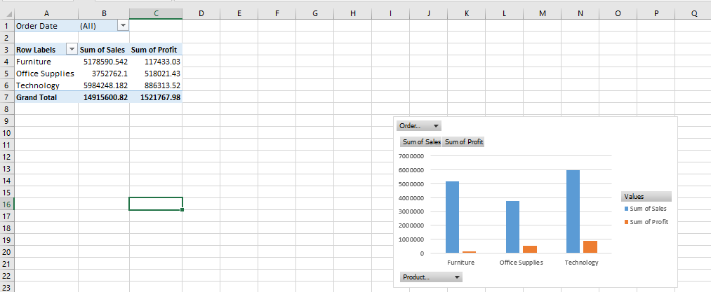
SUMIFS: It is regarded as the best function provided by excel which assists in adding only those values that meet the criteria specified by the user. Accordingly, analysts can get the sum of values if its corresponding cells meet the specified criteria in terms of dates, numbers & text. For doing so, the following syntax is entered:
=SUMIFS (sum_range, range1, criteria1, [range2], [criteria2], ...)
With respect to the data set of Superstore, this excel function has been applied to obtain the sales & profits relevant to different years that is, 2009, 2010, 2011 and 2012.
The SUMIFS formula used for the superstore data set is as follows:
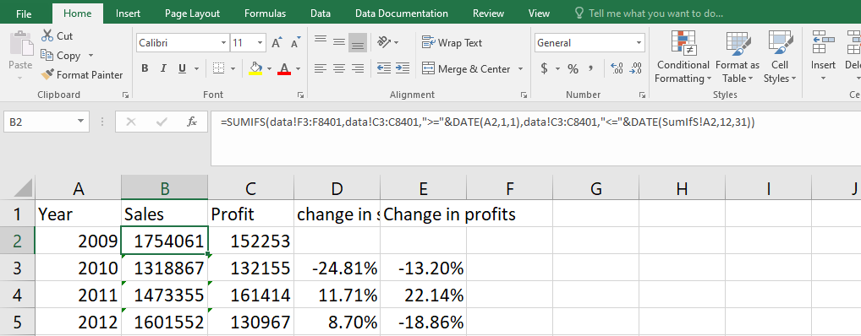
= SUMIFS (Sales data, order date range, “>=” &DATE (year, month, date), order date range, “<=” &DATE (year, month, date)
Accordingly, the percentage change in Sales and profits during the past four years has been computed as follows:
= (Profit for the current year – Profit of the previous year) / Profit for the current year * 100
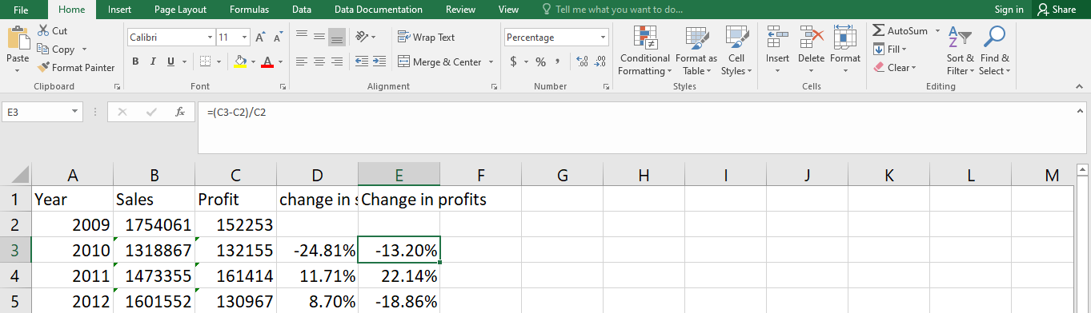
The results obtained through the application of this function is as follows:
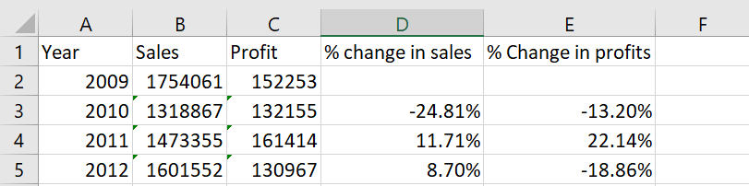

Data Analysis
With respect to the superstore data, filter function has been used to filter the data based on criteria specified. This in turn has led to the generation of data related to sales, profits as well as the number of orders placed during the last four years as with regards to the superstore data set as follows:
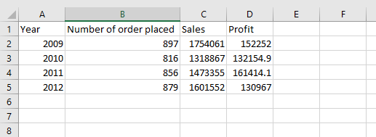
The above table generated with the help of filter option can be used for the purpose of data analysis from which it can be analyzed that the performance of superstore has been reduced from 2009 to 2010 in terms of sales, number of orders and profits. From 2010 to 2011, the performance has improved which can be analyzed through rise in sales, profitability as well as orders placed. At last, from 2011 to 2012, the number of orders and sales have increased while the profit have reduced which may be due to reduction in price or increase in cost of acquisition of goods.
SUMIFS: The results obtained through the applications of this function over the superstore data are as follows:
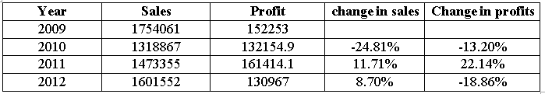
The table shows that the sales and profits have reduced by 24.81% and 13.2% from 2009 to 2010. However, the same has increased by 11.71% and 22.14% respectively between 2010 and 2011. Further, in 2012, the sales have increased by 8.7% while the profits have reduced by 18.86% as compared to 2011.
Pivot table: The following pivot table depicts the sales and profits performance of superstore in terms of different product category.
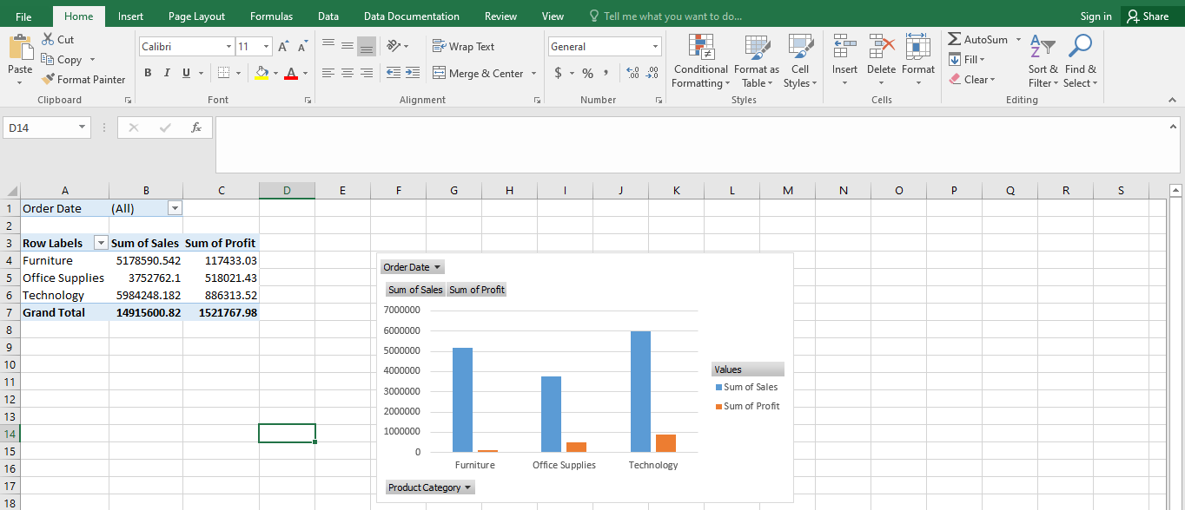
The above pivot table results depict that the superstore has realized highest sales and profit from technology. The sales of furniture come at second position among the three-product category but have generated lower profits as compared to the office supplies whose sales is lowest among the three products during the period of four years.

Descriptive statistics
The excel has yielded the following results for descriptive statistics for the sales and profit of superstore:
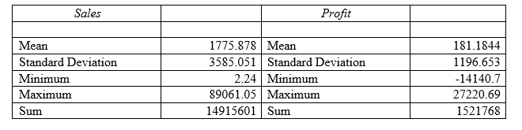
In the table above, mean depicts the average sales and profit of superstore for four years which has been identified as 1776 and 181 respectively and the sales amount during this period is deviation by 3585 and 1196 from the average sales and profits of the superstore. The minimum sales order is 2.24 while the minimum profit being negative shows that the superstore has made sales on loss as well. Maximum sales order size and profits made during the last four years has been identified as 89061 and 27221 respectively.
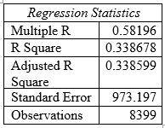
The regression analysis done over the sales and profit data of superstore gives the moderate degree of correlation between sales and profits and accordingly, rise in sales would lead to the rise in profits to a moderate level. The r square value depict that 33.86% changes can be explained in profits through the changes taking place in sales.

Data visualization
The following graphs and charts have been produced with respect to the superstore:
Superstore’s sales & profit based on product category

Superstore’s sales and profits during 2009 – 2012

Part 2

Numbers students liking vanilla flavor of ice cream
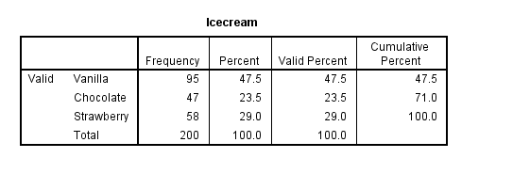
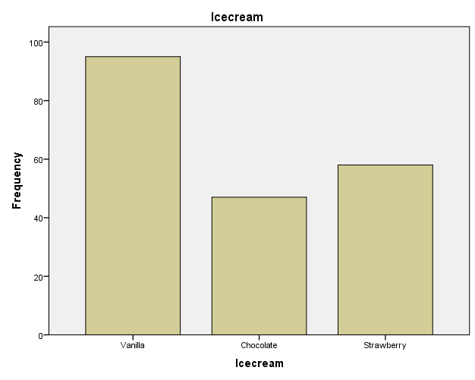

Therefore, 95 out of 200 students like vanilla flavor of ice cream.

Number of Students being Male and female
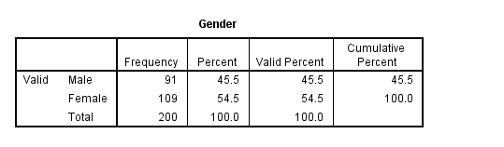
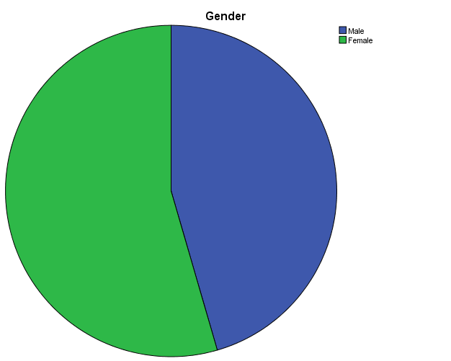

Out of 200 students, 91 are male and 109 are female.

Mean and median of participants liking chocolate and strawberry flavor
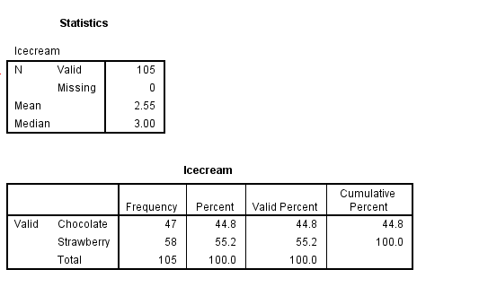
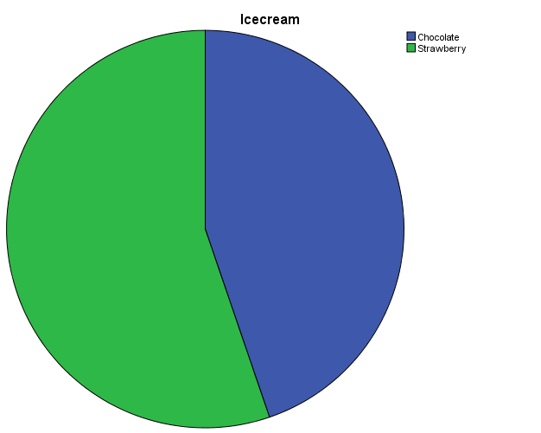
The mean of participants liking chocolate and strawberry flavor of ice cream is identified as 2.55 while the median being 3 which indicates average participants having preference for strawberry flavor.

Example of clustering – K means
The following steps are useful in applying K-means cluster to the given data set.
1. In Analyze tab, select classify and then K-means cluster.
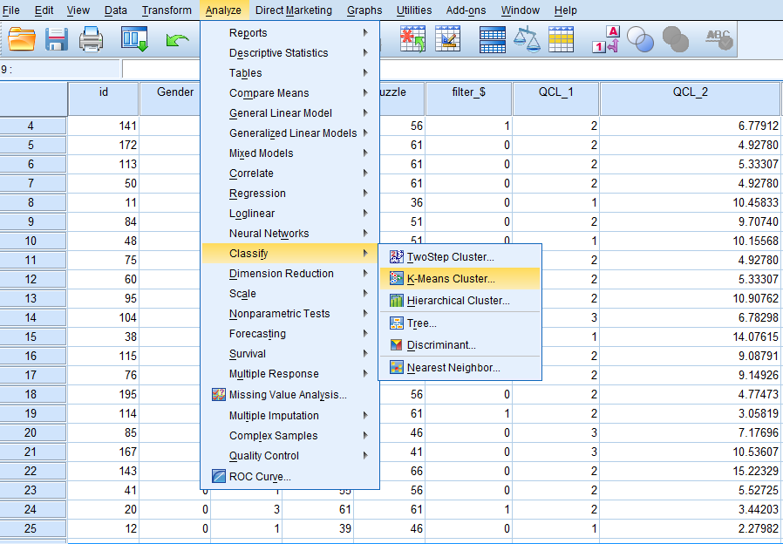
2. In the K-means cluster dialogue box, the variables are move into the variables box.

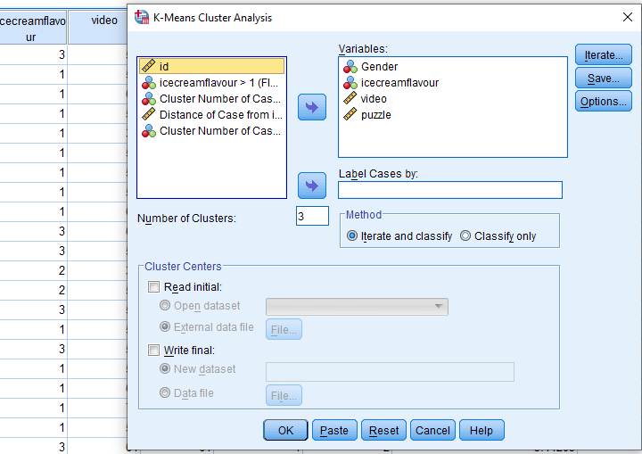
3. Click on “Iterate” button. Check that the maximum iterations are 10 or not and then click continue.
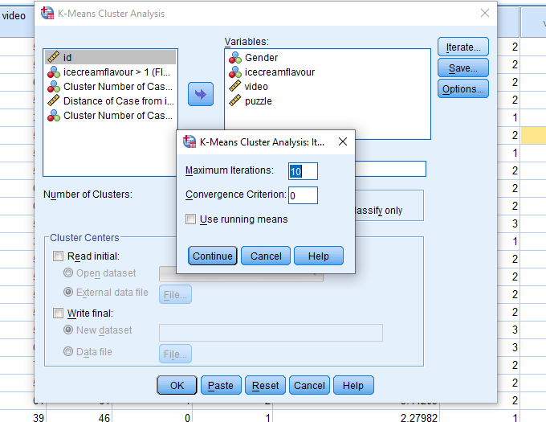
4. Click on “Save” button and check “cluster membership” and click the “continue” button (Shanthi, 2019).
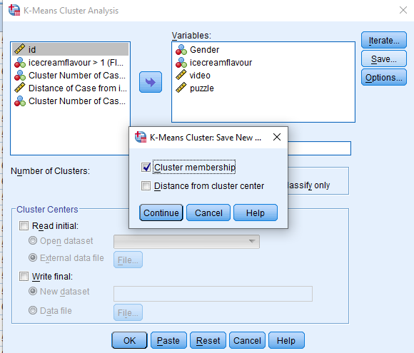
5. Click “Options” button and check all the three options under statistics, click continue (George and Mallery, 2019).
6. Click OK button.
The following results would be generated.

Initial Cluster Centres
 | Cluster
 | 1 | 2 | 3
Gender | 1 | 1 | 0
Icecream | 2 | 1 | 1
video | 29 | 55 | 72
puzzle | 26 | 71 | 31

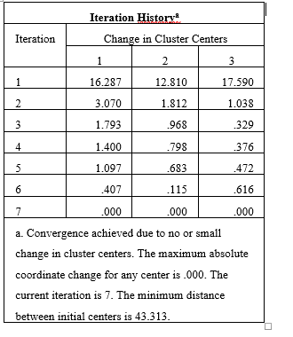
The above table shows the progress of the process of clustering where at early stage, there is a lot of changes took place in cluster centers. But moving ahead that is, from the fifth iteration, the changes within the cluster centers have found to be settled down and accordingly, in the last two iterations in the above iteration history, there are minor changes in cluster centers found (Denis, 2018).

Final Cluster Centres
 | Cluster
 | 1 | 2 | 3
Gender | 1 | 1 | 0
Icecream | 2 | 2 | 2
video | 41 | 58 | 56
puzzle | 46 | 61 | 39
The table headed as “final cluster centers” demonstrates the feature of each cluster as follows:
- Students forming part of cluster 1 have preference for chocolate flavor of ice cream alongside have more interest in playing puzzles.
- Students forming part of cluster 2 have preference for chocolate flavor of ice cream itself and found to be interested in puzzles only.
- Students who form part of cluster 3 likes chocolate flavor of ice cream while interested in playing video games.

Distances between Final Cluster Centres
Cluster | 1 | 2 | 3
1 |  | 22.077 | 16.063
2 | 22.077 |  | 21.380
3 | 16.063 | 21.380

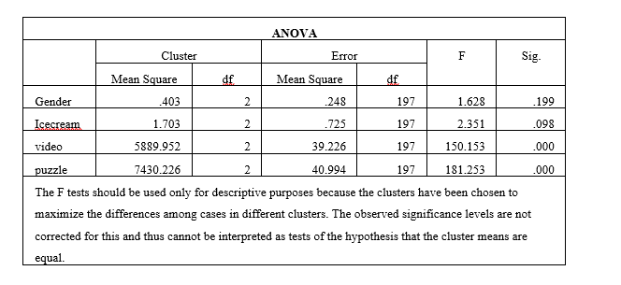
Through the ANOVA table, it has been identified that the variable “puzzle” has the greatest influence during the formation of clusters while the variable “Gender” having the least influence during the cluster formation (Roni and Djajadikerta, 2021).
Number of Cases in each Cluster
Cluster | 1 | 67.000
Cluster | 2 | 101.000
Cluster | 3 | 32.000
Valid |  | 200.000
Missing |  | .000

Methods of data mining & text mining used by the businesses
Data mining refers to the sorting of large data sets to determine relationships and patterns to assist in solving the business problems (Pallant, 2020). The following are the common data mining methods:
Associations: This method is used for analyzing relationships within the data set. In other words, correlation between items within the large data sets is possible through the identification of hidden pattern by way of association method. Usually, to analyze the market basket, association is used to predict the customer’s behavior (Babbie, Wagner III and Zaino, 2022). For instance, association can be used by the marketing manager of supermarket to identify the products bought by the customers together on frequent basis.
Classification: With the help of this method, the items within the data sets can be distinguished in groups and classes. Accordingly, the behavior of items within the group can be predicted accurately. For instance, credit manager at banks could use classification for the identification of loan applications with high, medium, or low credit risks.
Prediction: This data mining method is useful in predicting the prospects of the business based on the present and past set of data. For instance, sales manager of the company can use this method to make predictions for the number of sales that is expected to be generate of each item based on past data sets (Qaiser and Ali, 2018).
Data cleaning: This is the most common method used for data mining where data are organized, duplicates are eliminated, and values are filled in null values. Accordingly, highly useful information is harvested for the purpose of analysis.
Text mining refers to the process involved in the transformation of unstructured text in structured format to determine new and meaning patterns as well as insights. The following are the most common methods used by the businesses for text mining:
Information extraction: It is regarded as the most famous technique for text mining where the extraction of meaning information is possible from large sized textual data. This method is useful in the identification of attributes and their relationships within the unstructured texts (Romero and Ventura, 2020).
Clustering: It is another crucial method of text mining which facilitates identification of intrinsic structures within the textual information which then organized into relevant subgroups also known as clusters for performing detailed analysis.
Categorization: It can also be referred to as the Natural Language Processing or NLP which involves the process of gathering of text documents. Then, the gathered text documents are analyzed to uncover the indexes and topics for each of the document gathered. Businesses are widely using this for the purpose of spam filtering as well as web page categorization.
Clustering: Being the most crucial method of text mining, it helps in identifying intrinsic structures within the textual information followed by the organization of these identified structures into relevant clusters or subgroups (Amado and et.al., 2018).

Advantages & disadvantages of using Excel & SPSS
The following table depicts the advantages & disadvantages of SPSS & Excel:
 | SPSS | Excel
Advantages | It provides quick and easier access to functions such as descriptive statistics and many other statistical tools and techniques. Also, there are number of charts and graphs available to be used for data presentation. Thus, it is preferred for conducting statistical analysis in easy manner. | It facilitates storage of large amount of data sets in a most appropriate format with the help of excel. Also, it is regarded as the best tool for the performance of numerous types of calculations over the complex data set. For instance, filter is useful in obtaining the concise data with respect to the requirements of the data analysis.
Disadvantages | It is regarded as an expensive tool alongside having limited functionality for handling or performing complex analysis. | Excel spreadsheet is considered to being prone to human error. Further, there is lack of security and control provided by this software package.

REFERENCES

Books and Journals
Amado, A., and et.al., 2018. Research trends on Big Data in Marketing: A text mining and topic modeling-based literature analysis. European Research on Management and Business Economics, 24(1), pp.1-7.
Anderson, D. R., and et.al., 2020. Modern business statistics with Microsoft Excel. Cengage Learning.
Babbie, E., Wagner III, W. E. and Zaino, J., 2022. Adventures in social research: Data analysis using IBM SPSS statistics. Sage Publications.
Denis, D. J., 2018. SPSS data analysis for univariate, bivariate, and multivariate statistics. John Wiley & Sons.
George, D. and Mallery, P., 2019. IBM SPSS statistics 26 step by step: A simple guide and reference. Routledge.
Mayes, T. R., 2020. Financial analysis with Microsoft excels. Cengage Learning.
Pallant, J., 2020. SPSS survival manual: A step by step guide to data analysis using IBM SPSS. Routledge.
Qaiser, S. and Ali, R., 2018. Text mining: use of TF-IDF to examine the relevance of words to documents. International Journal of Computer Applications, 181(1), pp.25-29.
Romero, C. and Ventura, S., 2020. Educational data mining and learning analytics: An updated survey. Wiley Interdisciplinary Reviews: Data Mining and Knowledge Discovery, 10(3), p.e1355.
Roni, S. M. and Djajadikerta, H. G., 2021. Data analysis with SPSS for survey-based research. Singapore: Springer.
Salkind, N. J. and Frey, B. B., 2021. Statistics for people who (think they) hate statistics: Using Microsoft Excel. Sage publications.
Shanthi, R., 2019. Multivariate data analysis: using SPSS and AMOS. MJP Publisher.

APPENDIX


