Assignment 1 PESTLE Analysis on Cisco in Attracting Talents

Case Study
Cisco System Inc. was founded by Len Bosack and Sandy Lerner, both working for Stanford University, in San Jose of California from 1984. Through decades of development, it has become the telecoms technology giant and multinational corporation ranked 64th on the Future 500 List in 2019 (Fortune Media IP Ltd., 2019), with over 74,200 employees worldwide and business across networking, security, collaboration and the cloud. Cisco entered China in 1994, and it has built six R&D centres in China that retains more than 2,000 employees in Shanghai (Cisco, 2019).

The Introduction of PESTLE
Attracting talents is the most important and challenging part of people resourcing, that covers so many employee issues such as job design, workforce planning, strategical adjustment, advertisement of employer brand, candidate relationship management, then attracting people (Armstrong and Taylor, 2014; Delottie, 2019). Besides providing better opportunities, rewards and working conditions of employment than other companies to the talents, there are many external factors affecting talents acquisition for the organisation. Therefore, we analyse the different influences with the important PESTLE tool (CIPD, 2017) from these six aspects: political, economic, social, technological, legal and environmental, as figure 1, to identify the macroeconomic conditions for the multinational corporation Cisco.
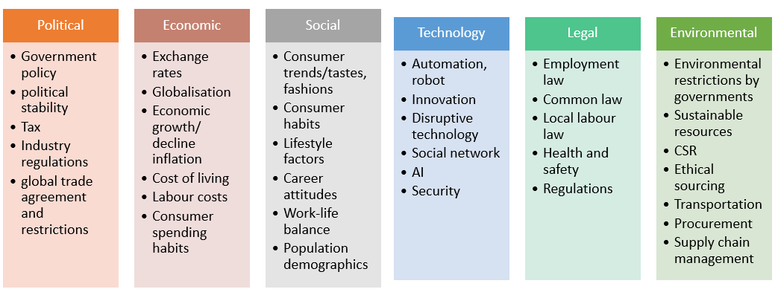
Figure 1 descriptions of PESTLE analysis

Political Analysis
The political factors, such as stability of government policy, potential changes to legislation, global trade influences, tax will affect the talent attraction in Cisco China significantly, especially the US-China trade war (CIPD, 2017). And the negative impacts on HR issues, or ‘host-country’ effects (Edwards and Rees, 2011) on various workers are listed in the following table 1.
Table 1. political factors and its impact on Cisco

Economic Analysis
The economic trends including those indicators such as employment rates, labour cost, inflation, economic growth of China, consumer confidence, competitors will affect the Cisco in talents acquisition significantly as well (CIPD, 2017; Pelkey, 2010). And the negative impacts on recruitment are listed in the following table 2.
Table 2. economic factors and its impact on Cisco

Social Analysis
Chinese society has changed much including lifestyle factors, demographic influences, income distribution, population, culture diversity and preference over the past decades. And some positive influences on talent attraction are listed in the following table 3, largely relying on its employment brand and reputation building.

Table 3. social factors and its impact on Cisco

Technological Analysis
New digitized technology plays an increasing role in recruiting activity, some influences of that are of benefit to Cisco, such as standardized recruitment platform, effective tools and social network management. Even in the open talent economy, Cisco (2011) emphasizes more on building developing programs for employees and linking technique skills, social intelligence to organisational objectives together (Seward and Patel, 2019). They are listed in table 4 below.

Table 4. technological factors and its impact on Cisco

Legal Analysis
Cisco China enjoyed the policy priorities such as low social insurance costs, low value-added tax (VAT) rates (Koty, 2019) by Chinese local government while created more urban job opportunities. And the firm also has a responsibility to obey the local employment laws and industry regulations to protect the health and safety of employees (Central Committee of the Communist Party of China, 2016; Xinhua, 2019; Cisco, 2019).

Environmental Analysis
The R&D centres of Cisco China all have good locations for instance Beijing, Hangzhou, in that the first and second tier cities always attract young people with urban advantages such as convenient transportation, more opportunities and good infrastructure construction. Last but lease, Cisco always put much effort on energy efficiency, environment friendly materials and renewable energy projects (Cisco, 2017, 2018, 2019), help solving the environmental issues for earth. That long-term and sustainable value also attract talents in new generations.

Assignment 2 The Labour Market Trends for Cisco in the United States and China
In order to operate the multinational corporation well in different countries, human resource professionals should specifically understand the context of peculiar business environment and prepare to the changes in local labour market (CIPD, 2019; Taylor, 2018). This study will take Cisco as an example to analyze the different conditions in the United States and China with economic comparisons and demographic comparisons, which can help HR make suitable workforce planning.

Part 1. Economic condition comparisons of the U.S. and China
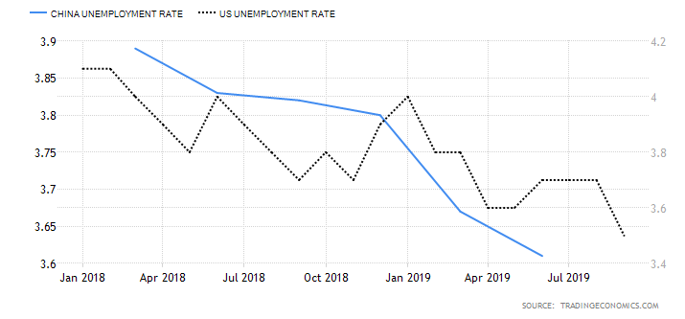
Figure 1 comparisons of unemployment rate
Chinese population were 1,395.4 million until Dec 2018; the United States’ population reached 328.2 million people in Dec 2018 (CEIC, 2019).
- Unemployment rate.
U.S.: 3.5 percent in September 2019 (U.S. Bureau of Labor Statistics);
China: 3.61 percent in Jun 2019 (CEIC, 2019).
- GDP annual growth rate. (The World Bank, 2019)
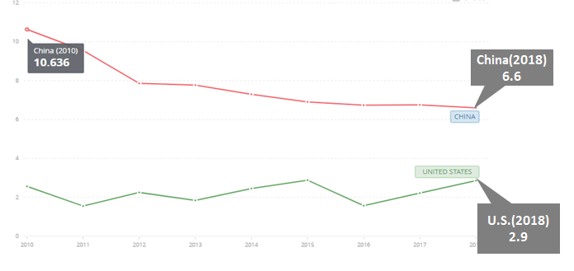
Figure 2 comparisons of GDP annual growth rate
- Labour force indicators.
The labour cost index points in Jul. 2019 (Trading Economics, 2019).
Labour force participation rate, annual mean wage (The World Bank, 2019)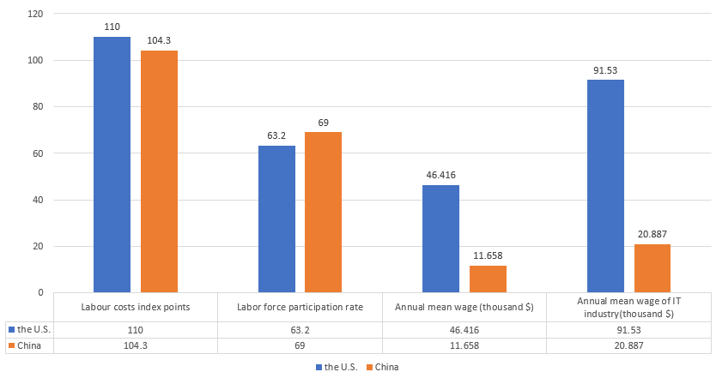
Figure 3 comparisons of labour forces
Chinese population and the United States’ population are as same above (CEIC, 2019).
Figure.1 illustrates that because of larger population in China, the unemployment in China is the more severe challenges than that in the U.S although unemployment rates are very close.
Figure.2 depicts that, the speed of economic growth in China has gradually slowed down since 2010, while the U.S is also projected to keep stable or declined for the next ten years (The World Bank, 2019; Achuthan, L. & Banerji, A. 2019; Mutikani, 2019).
In figure.3, there are huge gaps of annual income between developed and developing country. But the annual salary of those whose occupations are in Information Transmission, Software and Information Technology, are almost averagely twice than the mean wage of regular employees in their own countries. It demonstrates that, two labour markets both have high demand for workers of high skills, professional knowledge and higher education, especially in high-tech industries such as data scientist, R&D managers (the Hays Global skills index, 2018; Minter, 2019).
From the economic analysis above, along with the boosting employment rate and rising wages of employees in IT industry (CIPD, 2019), all demonstrate that no matter China or the U.S., the labour market currently is a state of tight market (Albouy, 2019; CEIC, 2019; Reuters, 2019).

Part 2. Demographic factors comparisons of the U.S. and China
The latest two factors are illustrated in figure.4 below.
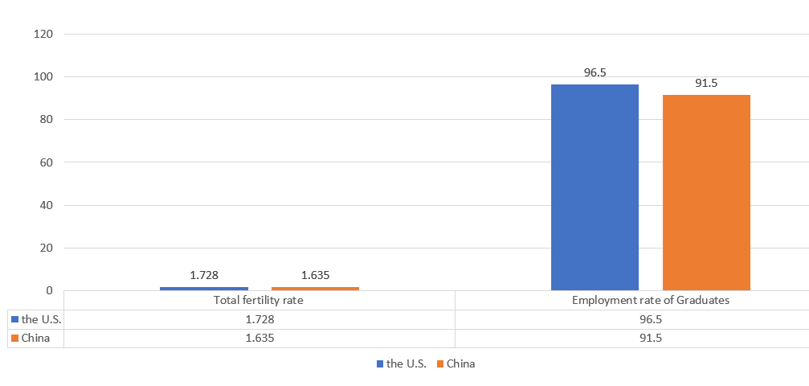
Figure 4 comparisons of two demographic factors
Chinese population and the United States’ population are as same above (CEIC, 2019). We analyzed three important demographic factors on the furure labour market in the below table. 1, with figure.4.
Table 1. analysis of the demographic factors
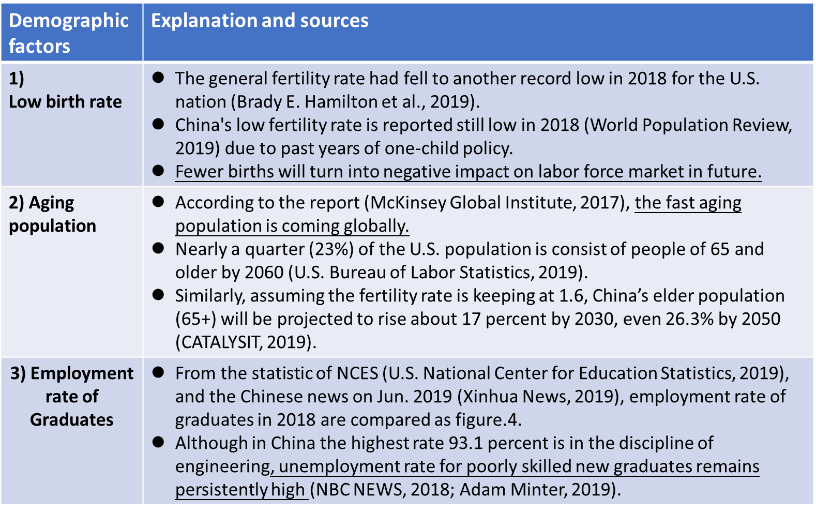
For Cisco U.S., a large portion of the workforce is Asian. Due to the U.S. tightening immigration policy and the trade tensions (U.S. National Centre for Health Statistic, 2019), immigration will be an important but uncertain factor affecting the size of the future labour force. Therefore, Cisco should consider the strategic recruitment and retention including the internal development and extended talent pool outside (Yoo, 2017). While building the organisational culture of diversity and inclusion for immigrants and cultivating excellent graduates from colleges as intern, and reducing labour cost with outsourcing plan is the issue for Cisco.
For Cisco China, internal labour immigration will be a challenge (The World Bank, 2019). In R&D centers of Cisco such as Beijing, Shanghai, where are restricted by population caps with ‘Hokou’ system (Cyrill, 2019; Zhang, 2019), the local talents will be very limited for Cisco in the future, as well as the rising labour costs. Consequently, Cisco should make its workforce planning and strategic adjustment to some second or third-tier cities, and invest more on the college graduates by program competitions and scholarships to broaden its talent pool earlier. Also, in order to keep diverse, Cisco might be more open to foreign talents, not only the growing Chinese returnees or foreign students in China, but real migrant talents overseas.

Assignment 4 The Comparisons of Liberal and Coordinated Economies on HRM Policy of Cisco

Introduction of HRM policy
HRM policies define the written guidance for implementing HR strategies in business, that play an important role in dealing with all employment issues to create the positive organisational culture and value of fairness, transparency and consistency (CIPD, 2019; Armstrong and Taylor, 2014) towards employees and managers.
For those multinational corporations, under the same mindset of globalization and organisational culture, but the international human resource policies still confront challenges from different economic situation, culture, labour market conditions and legal systems in different countries. Since the generalized guidelines by headquarter are usually not “one-size-fit-all” (Edwards and Rees, 2011), some changes need to be made into applicable specific practices (Parry et al., 2008).

Two types of market economy
Liberal market economy (LME) is defined as a free market economy and relatively decentralized system of industrial relations in which trade behaviours of firms are usually determined by demand and supply conditions (Hall and Soskice, 2001; Griffiths, 2014). By contrast, coordinated market economy (CME), rely heavily on non-market relationships and characterized by a centralized system in which firms coordinate their behaviours with others, being easily affected by governmental regulations, tax and instructions (Soskice, 1990; Katharina, 2005).
Taking Cisco as an example, it has more than 200 offices around the world, three headquarters respectively in America, Asia Pacific and Europe. There are differences between two types of market economy: liberal economy (e.g. the U.S.) and coordinated economy (e.g. China), and their applications such as selection, equal opportunity, diversity, employee development, relationships and reward etc. (Parry et al., 2008; Armstrong and Taylor, 2014) when implementation of specific HR policies into reality. From the Hofstede six-dimension cultures (2011), the differences between two countries of HRM programs are displayed by six reference rankings in figure. 1 and 2 (Hofstede Insights, 2019).
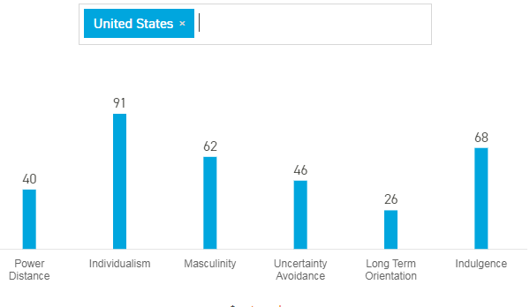
Figure. 1 six-dimension values of the U.S.

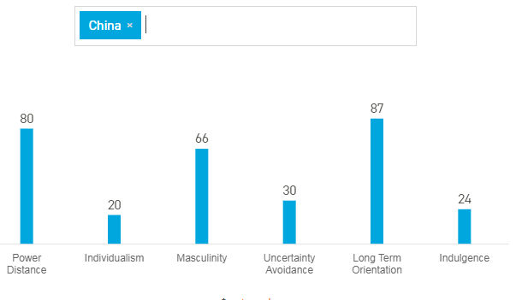
Figure. 2 six-dimension values of China

HRM policy of Cisco in LME
- HRM policy always takes the interest of shareholders first (Cisco, 2018) in LME. In an organisational structure of low Power Distance, equal opportunities to all employees will guaranteed by policy (Parry et al.,2008). Emphasis on short-term planning such as quarterly reports are required to pursue and maximize the profit of company.
- Market economy of higher uncertainty avoidance makes the Cisco tend to remain competitive, protect innovation and prepare for in the VUCA environment with risk management (ERM) program (Cisco, 2018, 2019).
- For talent attraction and retention: besides the wage setting by the U.S. headquarter, Cisco HRM put more effort on Individualism (for instance, sound compensation, reward, opportunities, career development, stock ownership and autonomy) (Parry et al., 2008), according to pay-for-performance philosophy of Cisco.
- For employee development, Cisco prefers to develop their academy and programs to develop employees such as educational achievement, creativity, communication skills, decision-making, social intelligence and leadership ability (Cisco, 2011), especially masculine culture with radical innovation in LME (Akkermans et al.,2009).
- Since relationships between employers and employees are low-trust, competitive and contract-based, HRM policy more relies on functional flexibility of internal workforce and numerical flexibility of external workers (Taylor, 2018).

HRM policy of Cisco in CME
- In a collectivist society, line manager has the priority of supporting an internal candidate than recruiting talent externally, for higher loyalty and social network to the firm (Meshksar, 2012). Although Cisco China has the same organisational structure as in the U.S., employees still feel relatively higher in the Power Distance cultures with different positions in firm. Lower uncertainty avoidance in CME makes greater job stability in China.
- Local leaders need to take a long-term view of corporate the program with government planning or local investment (DI, 2005).
- HRM policy still obeys the pay-for-performance value of host country, while it varies the wages according to the labour costs in local region and sectoral level, with less Individualisation but more team performance than that in the U.S (Meshksar, 2012).
- For employee development, besides the uniform online training, by contrast, Cisco China might add feminine cultures, the diversity and inclusion to reinforce the long-term, higher trust relationships in CME (Parry et al.,2008; Bosch and Charest, 2008). For example, some hosting events by female leaders’ network can help develop more customers (Armstrong and Taylor, 2014).
- Besides that, external factors such as legislations and procedural ground rules (Pistor, 2005) should be considered and choose between the local law and Cisco COBC (Cisco, 2019) when there is conflict.
Variety of economies in LM and CM will lead to quite heterogeneous HRM decisions within specific context at national, sectoral, and local level (CIPD, 2015). However, multinationals like Cisco should balance a means between the influence of country-of-origin effect and integration of host-and-home culture (Edwards and Rees, 2011; IUBH Fernstudium, 2014).

Assignment 6 Implication of Atkinson Model on Cisco in the Open Talent Economy

The open talent economy and Atkinson model
Nowadays a wide range of changes such as globalization, demographic shifts, disruptive technology, mobility and people’s new behaviours are happening in the workplace and influencing the socio-economic (Deloitte, 2013). The emerging trend is called open talent economy (Deloitte, 2013). According to the characteristics of the economy, “collaborative”, “transparent”, “technology-enabled”, “rapid-cycle way” demonstrate that the transactions between provider and customer are no more restricted by geographical area or certain organisation and only based on short-term task or demand through the equal digital platforms with internet (CIPD, 2019). From a survey of employee expectations for jobs in 2020 (Cisco, 2011), the flexibility even became the top one, followed by prosperity and opportunity, instead of traditional answers such as security, salary and benefit. Besides, in the coming decades, majority talents of generation Y and Z would intend to maximize their flexible work arrangement and possess more options across organisations (Ahmad, 2015). Therefore, many traditional working practices have been redefined, for instance, permanent worker, talent pool, boundary of firms, HR policy, working time and industry regulations, etc (Procter, 1994). This leads to a new way of rethinking about the Atkinson flexible firm model as the figure below (Atkinson, 1984).
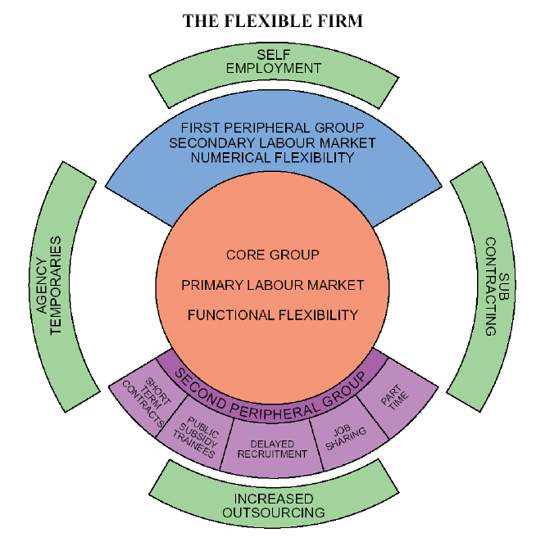
Figure 1 Atkinson Model
There are three basic groups (core group, peripheral group and third group outside) and three types of flexibility (functional flexibility, numerical flexibility and financial flexibility) to benefit organisation in this model (Atkinson,1984; Pollert,1988; Taylor, 2018). In the past, the core employees, also called full-time workers, were the majority in the organisation. Along with the trend of open talent economy, those top talents in the centre are increasingly expecting greater autonomy and opportunities or work-life balance, so the size of permanent workers in the talent ecosystem might shrink (Deloitte, 2013; Cisco, 2011). Apart from this, since the talent pool is more open to the global scope, the different atypical workers outside of core group will be extended in a bigger and ambiguous boundary (Deloitte, 2013; CIPD,2019) as figure 2. In order to cope with the changes of workforce in the VUCA world, organisations must adjust its HR strategies and attract global talents to profit from the flexibility (Deloitte, 2013).
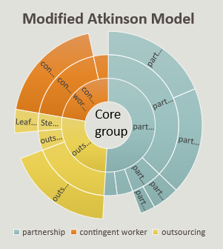
Figure 2 modified Atkinson model

Implication on Cisco
As early as in 2011, Cisco had built its agile business model to prepare for the revolutions of workforce functions, and the gaps between employee expectations and skills (Cisco, 2011, 2018). However, only the decentralized, or “multi-centralized” corporation can provide opportunities for global talents and realize multifunctional working arrangements through contracts and relationships. Thus, the organisation needs to be a flatter, less hierarchy structure with culture of diversity, collaboration and innovation. Therefore, a Dynamic Networked Organisation Model (DNO), enabled by the Cisco Collaborative Management Model (CMM), was designed to operate among different business units and distribute diverse human capital through the talent networks from then on.
Secondly, Cisco integrated the third group into its projects such as engaging vendors and partners to implement their own tasks in multiple functions, from data collection, marketing, to administrative support (Kling, 2012). Subsequently, new social network consisted of crowdsourced talents will emerge after a specific project, and a new relationship will be built through digital platforms, beyond the boundaries of companies and markets. In the open talent economy, it is a more efficient and effective way of accessing to those specialist and experts outside and benefit from their professional contributions with no cost of recruiting and training them (Seward and Patel, 2019).
However, not only the top talents in the centre of Atkinson model, but also the peripheral groups and outsourcing group, a lower degree of commitment and loyalty is present from employees (Taylor, 2018). Therefore, long-term retention of talents in the new economy with right policies is the last but most significant issue (Sitaraman, 2019) for Cisco. Besides interdepartmental employee rotations, certifications by Networking Academy, formal training programs, investment in reskilling, other initiative such as “people-first culture”, are critical for organisation development sustainably (Yoo, 2017; Levy et al., 2019).

