

LEVEL 4

SEMESTER 1

MODULE CODE: sshs4076
THE GREAT OUTDOORS

aSSESSMENT TYPE: e-Poster
Assessment/Component: 2

COMPONENT WEIGHTING: 50 %

WORD COUNT: 2000 WORDS equivalent

MODULE TUTOR: D. LEONARD

SUBMISSION DETAILS: Poster Presentation

Submit and then present an ‘E-poster’ outlining your personal philosophy on ‘Outdoor Adventure Education’ including its purpose and current educational relevance.

Make sure you include reference to academic theory to support your personal perspective.

Poster Submission Details:
Date: Fri 6th December 2019
Time: 3pm
Portal: Turnitin (Presentations TBC)

School of Sport, Health & Outdoor Education

Assessment Feedback Sheet

Student No./Name: 1901487 / Isaac Ayres
Module: The Great Outdoors
Module Code: SHSS4076

Module assessment: Present an ‘E-poster’ outlining your personal philosophy on the concept of ‘Outdoor Adventure Education’ including its purpose and current educational relevance.

Personal Evaluation – to support your academic progress please complete the section below BEFORE submitting your work.
What do you consider to be the best aspects of this work? | My choice of photos for my poster so the poster feels more personal to me
Which aspects do you consider could have been improved in this piece of work? | I think I could’ve spent more time thinking out what layout I wanted
What have you found most satisfying whilst undertaking this submission? | I found that the end result of how the poster looked was satisfying.

ASSESSMENT CRITERIA | Learning  Outcomes |  | GRADE
ASSESSMENT CRITERIA |  |  | Poor  < 19% | Weak  20 – 29% | Unsatisfactory  30 – 39% |  | Satisfactory  40 – 49% | Good  50 – 59% | Very Good  60 – 69% | Excellent  70 – 84% |  | Exceptional  85 – 100% | %
Clarity of personal philosophy (coherence of ideas and concepts and how they fit together) |  |  |  |  |  |  |  |  |  |  |  |  | 40%
Theoretical underpinnings |  |  |  |  |  |  |  |  |  |  |  |  | 20%
Relevance to current social / educational issues |  |  |  |  |  |  |  |  |  |  |  |  | 20%
Visual presentation and Response to questions |  |  |  |  |  |  |  |  |  |  |  |  | 20%
It is expected that students will present work that is proof read and follows the School Reference Guide and Assessment Checklist. Therefore a range of 0 – 10 marks will be deducted for poor referencing, spelling, grammar, punctuation, and presentation.
TUTOR COMMENTS:

Submission date: |  | Return date:  (at least within 4 weeks) |  |  |  | Tutor: |  |  |  |  | Mark:

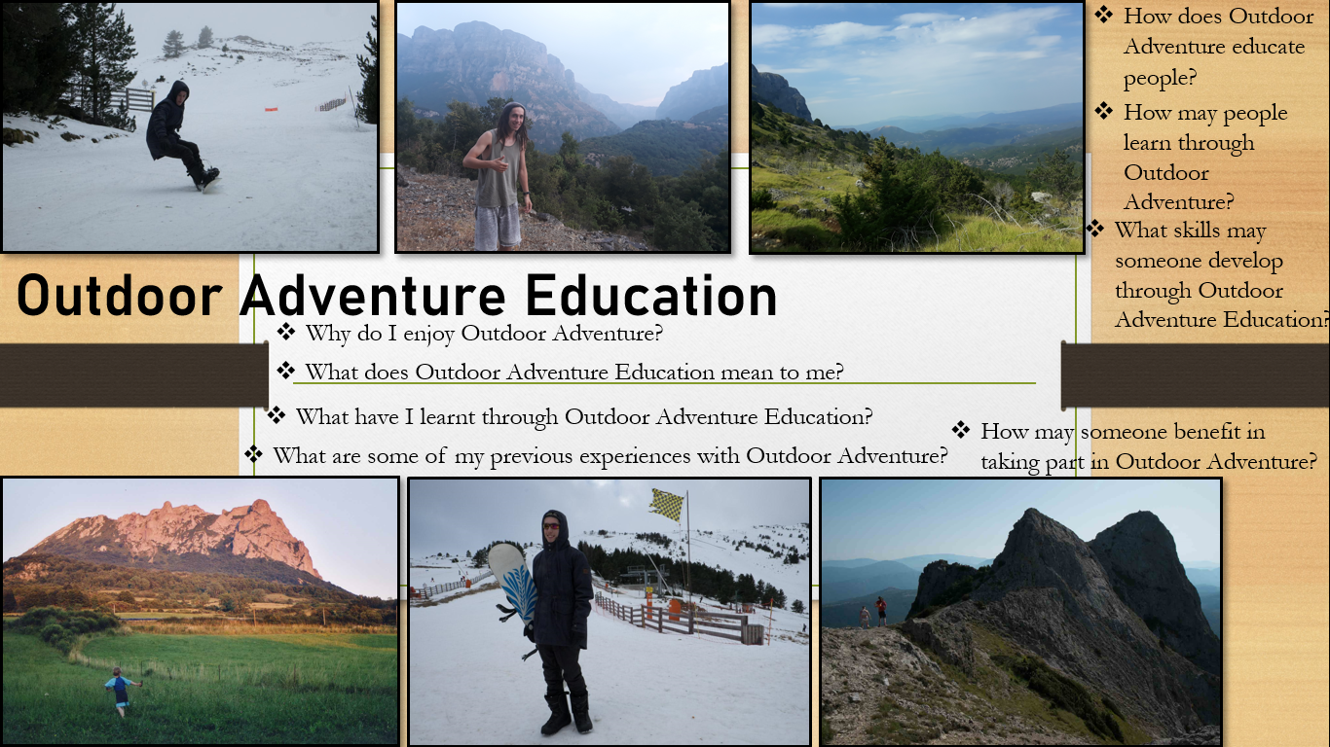

Notes for presentation:

I enjoy Outdoor Adventure because of the thrill it gives me. Whether I am out in the mountains or hitting the trails on my bike, I enjoy the connection I get with the outdoors.

To me outdoor adventure education is the learning of the outdoors whilst outdoors. This can be during a trek with a group and sharing your knowledge on the environment such as what species of trees grow in the area.

Through Outdoor Adventure Education I have learnt that the more you have fun outdoors, the more you will learn. For example, if you go out in the mountains and all you can think about is being at home in the comfort of your own bed, it will be hard to take in and learn about anything that you are not interested in.

Previously, a couple of expeditions I have done include camping in the Pyrenees and in Zagori in Greece. From these experiences I learnt a lot about the nature of different climates and what effect weather can have on you. For example, in the Pyrenees a few summers ago a huge lightning storm with wild winds blowing trees around circled us for hours during the night before we summitted the mountain. The morning of the summit was clear until we got to the top and saw what was coming the other side. Another huge storm was about to hit us as we descended the mountain. Greece was more chill on the weather side however I learnt that even in the summer it can start to get very chilly over 5 or 6000ft high.

Outdoor adventure can educate people through experiential learning. Kolb’s (1984) 4 stage learning cycle on experiential learning consists of plan, do, review and conclude. In an outdoor environment this can be as simple as planning an expedition, going on the expedition, reflecting on how it went, was it fun? Did you achieve what you had planned? And concluding your expedition, what did you learn from it?

People lean from experiences. However, Mortlock’s (1984) model for adventure is split into 4 categories, Play, Adventure, Frontier adventure and misadventure. As you go up from play towards misadventure, there is higher risk involved in the activity. Less control and feeling less comfortable in an activity allows someone to further develop their skills. An example of play can be walking around in the countryside along fields and forests, in terms of skill development, you won’t be able to learn much. When you change the environment to being along a ridge such as cryb goch this sense of play may change to a sense of adventure or frontier adventure.

An average person can benefit in taking part outdoors as there are so many new experiences to be had. Staying active can lead to a healthier lifestyle, and people can expand their knowledge on the environment that surrounds them.

Reference list:

Mortlock, C. (1984) The Adventure Alternative. Cumbria: Cicerone.

Kolb, D. A. (1984). Experiential learning: Experience as the source of learning and development. Englewood Cliffs, NJ: Prentice-Hall.

