


UNIVERSITY OF WALES
Trinity St. David

BA (Hons) Leadership and Management Skills for the Workplace

Developing relationships and workplace achievements

Report on "PDP, development needs, and expectations."

LOUIS VUITTON

Lecturer: Charles Nwaogwugwu
Student: Oksana Mrsic (2131895)

Table of Contents
Introduction 3
Performance Management Cycle 3
Planning 4
Monitoring 4
Reviewing 5
Rewarding 5
Performance development vehicles in Louis Vuitton UK and their effectiveness 6
360-degree feedback 6
Management by Objectives (MBO) 6
Individual Pay-Related Performance (IPRP) 7
Professional Development Plan (PDP) 7
Conclusion 9
Recommendations 9
References 9
Appendix 10

Introduction
Louis Vuitton (LV) is a global organisation known for its luxurious products. It mainly specialises in luxury clothing, bags, jewellery, watches, perfumes, and shoes. It was founded in Paris, France, but has branched into various parts of the world, including the UK. This report will focus on the performance management of Louis Vuitton UK. The company was founded on 5 May 1982 and has 657 employees as of 2020. It specialises in the retail sale of leather goods. It is the UK's most famous fashion brand behind its competitors, such as Dior, Gucci, Calvin Klein, and Lacoste (Amatulli et al., 2016). This report will discuss the concept of the employee performance management cycle in the organisation. It will also evaluate different performance vehicles available in the organisation, which include 360-degree feedback, individual pay-related performance, and management by objectives. In addition, it will propose a professional development plan following the SMART framework. This report aims to meet the needs of employees, thus improving their performance and improving the success of LV UK.

Performance Management Cycle
Performance management sets specific standards that help manage, guide, and gauge employee performance. It involves practices that continuously motivate the employees to develop and improve their jobs. When performance management is effective, employees are likely to be retained, and they will go above and beyond to ensure the company's objectives are met (Mone et al., 2018). This process involves four main phases: planning, monitoring, developing, and rewarding employees, usually done in a one-year timeframe. The process is done continuously, thus creating a cyclical process known as the performance management cycle.
However, four components of this process determine its effectiveness. They include the organisation's culture, communication, leadership, employee's abilities and skills. Organisational culture is the employees' surroundings, which could motivate or demotivate them (Akbar & Khanfar, 2020). In addition, effective communication, such as transparency, helps boost the company's performance. Also, the company's leadership approach is crucial in motivating the employees. Lastly, the employees' abilities, interests and skills are essential to improving the employee's performance. If an employee loves what they do and is in line with their values, they are highly likely to give their best and boost the company's performance (Bhuvanaiah & Raya, 2014).
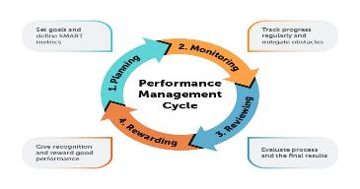

Planning
Planning is the most crucial phase in this process since it determines the success of the whole cycle. Therefore, adequate planning needs more time to ensure that every step is calculated beforehand. This phase consists of four crucial steps that must be considered for an effective process. Organisational goal setting is the first step, where the leader formulates the company's objectives for the whole cycle period. This step is crucial since it sets the pace of the process, and all the other steps must align with it ( Mullins and McLean, 2019). The next step is the employees' goal setting, where the employees, with the support of the managers, set their individual performance goals. This step enables employees to improve their skills and also develop new ones along the way. However, they have to be in line with the company's objectives.
The SMART goal-setting framework (specific, measurable, achievable, realistic, timely) is mainly adopted in this step. The third step is forming a development plan. The plan includes the skills, behaviours and knowledge needed to acquire to achieve both company and individual goals set. This plan includes plans for the business's future expansion and the employee's future career goals (Guest, 2017). The final step is the review of the job description. The manager reviews the job description of the employees to ensure they are up to date and aligned with the employees' goals. This step is crucial to ensure each employee do their role and is clear on their duties and responsibilities.

Monitoring
This phase is the acting phase, where the employees work on the goals set in phase one. If there is training the employee should do, they do in this phase. The manager has to provide support and resources that could be needed for the employee to work according to the plan. Also, they should regularly check the employee's progress, preferably monthly or quarterly (Shields et al., 2015). However, problems might arise along the way, and they should be solved as early as possible to ensure they do not interrupt the process outcomes. According to Taylor's scientific management theory, yearly goals might look too big, but when broken into monthly subgoals, they are achievable. Therefore, holding meetings after a specific time, such as monthly, is very effective in checking the employee's progress. It will keep the employee on their toes and be accountable for their actions. Some subjects to consider monitoring are the accomplishments made so far, roadblocks encountered, what could be changed, support needed, and recapping of the performance.

Reviewing
This phase also checks in on the progress but from a bigger-picture point of view. The meetings are usually held once a year and measure the progress of the overall development plan. It focuses on the overall performance, lessons learned, and the employee's career development during that year. It encourages more collaboration between managers and employees and motivates them to continue working diligently. The review phase is an excellent chance to evaluate the process and the outcome generated during that time. This phase also gives feedback, and techniques such as a 360-degree feedback process are used (Locke & Latham, 2013). The feedback makes the review constructive since it is a two-way discussion. The employees evaluate themselves and then give and receive feedback on the team. Questions include: Were the goals realistic and aligned with the organisation's objective? Did the employee gain any significant skills? Was there enough support from management? Additionally, the possible solutions are discussed and implemented if any challenges are encountered.

Rewarding
This is the final phase of the cycle, and it is crucial for employee motivation. Motivation is significant in boosting the employees' morale, and they feel recognised in the workplace. It also improves engagement with them and encourages them to go above and beyond to meet the organisation's goals (Armstrong and Taylor, 2014a). However, the rewards should be fair to ensure an employee is rewarded for their effort. Rewards also encourage those not cited to put in more effort to be awarded in the future. The common ways to reward an employee include increasing salary, recognising awards, giving bonuses, booking vacations at the company's expense, and promoting (Mehmood et al., 2013). After this stage, another meeting could be held to review the whole cycle and plan for the following year's goals. The cycle renews again.

Performance development vehicles in Louis Vuitton UK and their effectiveness

360-degree feedback
This is a method used in organisations to review employees where the feedback comes from the manager and about six peers, co-workers, and staff members. It is helpful for the employee to understand their strengths and weaknesses from different sources. LV UK uses this strategy to review its employees' Fields (Mohapatra, 2015). The employee also gives feedback on their performance during self-assessment. However, this type of feedback is based on the behaviours that other employees can depict. Therefore, there are more chances that the feedback is based on the weaknesses more than the strengths of the employee. In LV UK, the feedback providers are the people who primarily interact with the employees being reviewed (Karkoulian et al., 2016). This feedback promotes teamwork and accountability of the employees, depicts areas that need improvement, and improves employees' outputs. It is used in most Fortune 500 companies and has effectively improved employees' performance; thus, the company objectives are likely to be met.

Management by objectives (MBO)
Management by objectives (MBO) is an approach managers use to enhance employee performance. The managers at LV UK outline the company's objectives to the employees, intending to achieve them after a particular time. However, monitoring and giving feedback on employee performance enables this approach to work effectively. The MBO process is similar to the performance management cycle (Eisele et al., 2013). MBO is essential since it enables the employee to realise their potential by working on a particular goal to achieve it. It also improves teamwork and communication within the organisation. A limitation of the MBO approach is that the manager emphasises the employees' and organisation's goals, forgetting the need to be involved and improve on their side. However, MBO is a practical approach used in LV UK and enables the employees to set achievable milestones and focus on reaching them.
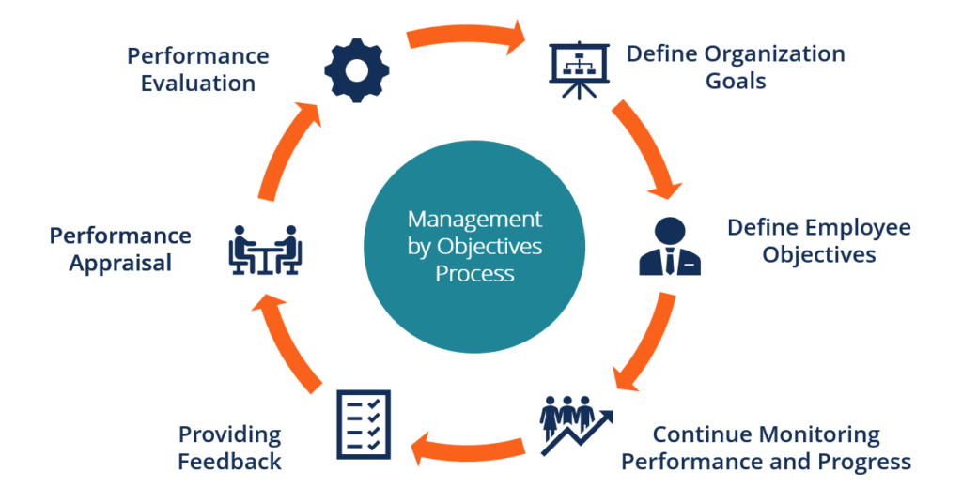

Individual Pay Related performance (IPRP)
This is the approach of increasing salary according to employee performance. It is a practical approach that increases the performance of employees. The additional incentives motivate the recognised employee to keep improving and encourage the other employees to give their best ( Mullins and McLean, 2019). LV UK uses this approach to reward their employees according to their performance. However, the employees' interest has to align with the business objectives for this approach to work.
Moreover, increased individual performance improves organisational performance, and the employees are more likely to be retained. In addition, IPRP creates high-performance individuals who contribute to the efficiency of the business. However, LV UK could consider differentiating different types of rewards, that is, extrinsic and intrinsic rewards. According to expectancy theory, some employees want money as a reward, which is the extrinsic type (Bjerke and Renger, 2017). Conversely, some would prefer intrinsic rewards that promote personal development. The limitation of this approach is that it might be too competitive, thus killing the employees' morale. Also, the employees might expect more rewards and end up overworking themselves, which is unhealthy. IPRP helps recognise outstanding performance, which improves business efficiency.

Professional Development Plan (PDP)
The manager creates this plan to identify skills and resources to support the employees and the organisation's needs (Schools, 2014). LV UK has the potential to expand to different parts of the UK, opening stores in Manchester and Liverpool; new employees will be needed. Therefore, an evaluation of development vehicles and a professional development plan will be required to develop the performance of new and existing employees. It is essential to look at the development tools and professional development plans that are being used to help employees and meet the organisation's goals.
1. Alignment with Organisational Goals: The review should check if the PDP fits LV UK's growth goals. Making sure that the skills and tools listed in the plan help the organisation grow is precisely what it should do.
2. Usefulness of Development Vehicles: To see if the chosen development vehicles, like training programmes, workshops, or mentoring chances, are valid for filling skill gaps or improving employee performance. Consider how helpful they are at teaching important information and valuable skills.
3. Employee Engagement: Applying this plan to determine how involved your workers are in their professional development. Are they taking part? Do they want to get better at what they do? Employee feedback can help the PDP figure out what needs to be changed.
4. Measuring Progress: Check to see if there are straightforward ways to track progress towards the personal goals set out in the PDP. Regular reviews can help you see how much an employee has grown and determine if they need any changes or extra help.
5. Adaptability and flexibility: Check to see if the PDP can be changed to meet the needs of the company or an individual employee as they change over time. For a plan to work, it needs to be flexible enough to deal with unplanned events while still keeping long-term goals in mind.
6. Always Getting Better: Ask managers and workers for feedback regularly about how they felt about the PDP implementation process. This will help things keep getting better by showing where changes can be made to get better results.
The human resource manager at LV UK can make sure that they have a good system in place that helps employees grow, improves performance management, and eventually leads to the success of the company by looking at these aspects of development vehicles and PDP implementation. It will use the SMART goal-setting framework; this table is attached to the appendix B.

Conclusion
Performance development is crucial in determining the employee's performance in meeting their personal and organisational needs. The report exhaustively analyses the performance development cycle and discusses its four phases. It has also critically analysed three development vehicles used in Louis Vuitton UK, namely, 360-degree feedback, management by objectives (MBO), and Individual pay-related performance (IPRP). Finally, a professional development plan for LV UK has been developed to improve employee engagement and performance. However, LV UK has the potential to expand its markets in different countries of the UK and thus increase its sales. Also, if the above PDP could be adopted, it could improve employees' productivity and engagement. Therefore, they would increase the performance of LV UK and improve their competitive advantage.

Recommendations
Louis Vuitton is a well-known company worldwide with a good reputation in the retail shopping of luxurious leather products. However, there are still areas for improvement for the employee's well-being. One of the recommendations they could adopt is using intrinsic and extrinsic rewards to ensure all the employee's preferences are met. Moreover, they could adopt the 540-degree feedback approach to upgrade to the current 360-degree one. This new approach will include the customers' feedback to the specific employees. As a result, the employees will understand their strengths and weaknesses from a broader perspective and strive to improve (Mullins and McLean, 2019)

References
Armstrong, M. And Taylor, S. (2014a). Armstrong's handbook of human resource management practice. 13th ed. Philadelphia, Pa: Kogan Page Ltd.
Armstrong, M. And Taylor, S. (2014b). Armstrong's Handbook of Human Resource Management Practice, 13th Edition. Kogan Page.
ADEBISI, S. A. & OLADIPO, A. O. 2015. The reward system is a strategy for improving employee productivity in Nigeria. Revista Eletrônica de Estratégia & Negócios, 8, 56-84.
AKBAR, M. S. & KHANFAR, F. 2020. Benefits and Compensations in Employees' Motivation. Asian Journal of Economics and Business, 1, 19-33.
AMATULLI, C., MILETI, A., SPECIALE, V. & GUIDO, G. 2016. The relationship between fast fashion and luxury brands: An exploratory study in the UK market. Global marketing strategies for the promotion of luxury goods. IGI Global.
BJERKE, M. B. & RENGER, R. 2017. Being smart about writing SMART objectives. Evaluation and program planning, 61, 125-127.
Beilcke, A. (2017). Interprofessionelle Zusammenarbeit in Pflegeheimen Eine fragebogengestützte Analyse des Ist- Zustandes. Saarbrücken: AV Akademikerverlag.
Hargreaves, D.H. (2004). Learning for life The foundations for lifelong learning. Bristol Policy Press.
Mullins, L.J. and mclean, J. (2019). Organisational Behaviour in the Workplace. 12th ed. Harlow: Pearson.
Rees, W.D. (2017). Skills of management and leadership: managing people in organisations. London: Palgrave.
KARKOULIAN, S., ASSAKER, G. & HALLAK, R. 2016. An empirical study of 360-degree feedback, organisational justice, and firm sustainability. Business Research, 69, 1862-1867.
LE, D., AQUINO, P., TRUC, N., SI, L. & MY, L. 2021. Factors affecting employees' motivation. Management Science Letters, 11, 1063-1070.
LOCKE, E. A. & LATHAM, G. P. 2013. Work motivation: The high performance cycle. Work motivation. Psychology Press.
MONE, E., LONDON, M. & MONE, E. M. 2018. Employee engagement through effective performance management: A practical guide for managers, Routledge.
SCHOOLS, P. P. 2014. Professional development plan.
SHIELDS, J., BROWN, M., KAINE, S., DOLLE-SAMUEL, C., NORTH-SAMARDZIC, A., MCLEAN, P., JOHNS, R., O'LEARY, P., PLIMMER, G. & ROBINSON, J. 2015. Managing employee performance & reward: Concepts, practices, strategies, Cambridge University Press.
(

Appendix

- Personal swot analysis on the role of an HR in Louis Vuitton.
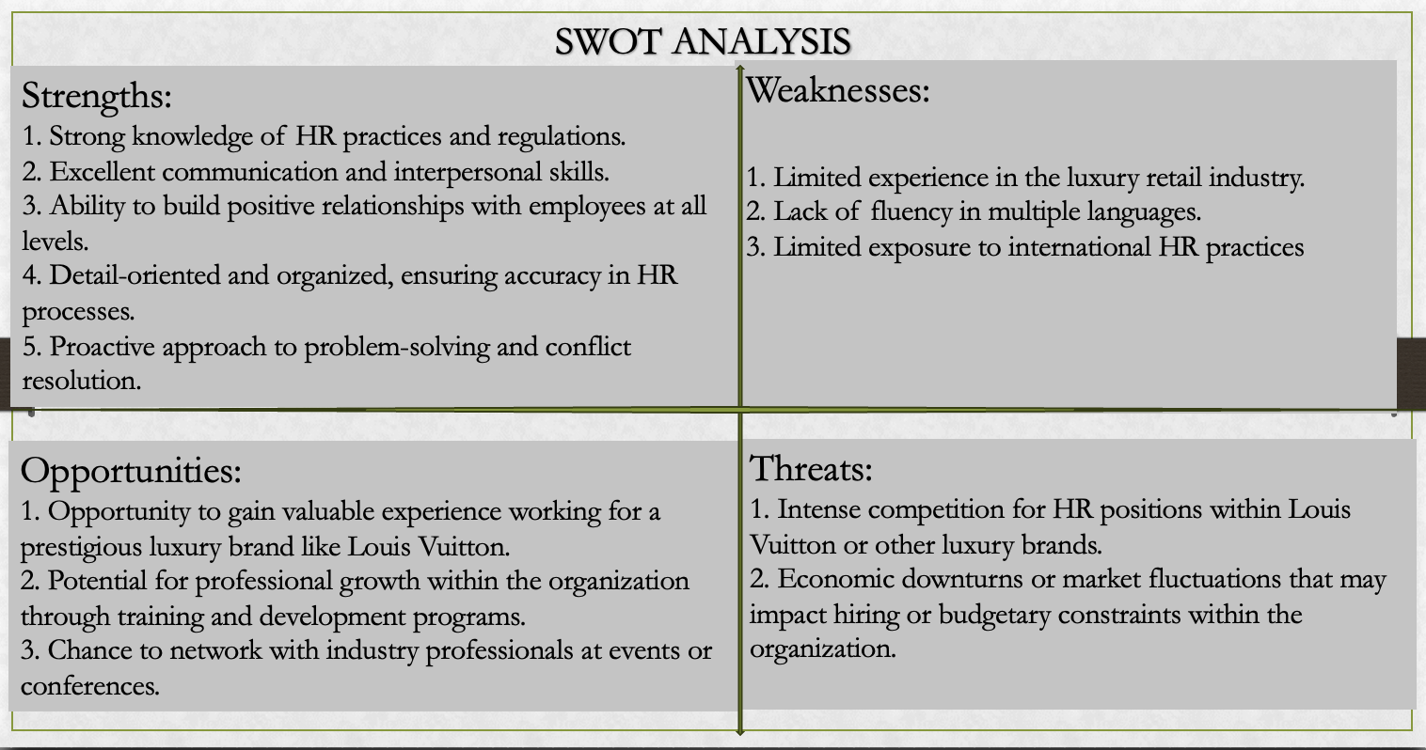

- Professional Development Plan


