Employee Engagement

Student Name: Mihai Diaconu
Student ID: 2131599
Module Title: Personnel Resourcing and Development(BMIH5005)
Lecturer’s name: Helen Evans

Table of Content
Introduction 3
Main body 3
Conclusion 9
Reference 10

Table of figures
Figure 1: Employees in Whitbread including Premiere inn brand 5
Figure 2: Employee lifecycle 7
Figure 3: Net income of Marriot 9

Introduction
Employee engagement is the process of interaction with a workforce to motivate them to retain them to maintain sustainability in the long run (Riyanto, Endri and Herlisha, 2021). Premiere Inn is selected in the report for conducting further research about employee retention. It was founded in 1987 and is based in London, United Kingdom, and serves in a hotel chain (Premiere Inn, 2023). The role of the human resource department in large hotels and developing talent will be described in the essay. The importance of managing and developing talent will be discussed in the essay. Employee lifecycle will be discussed in the assignment considering its six stages. These are attraction, recruitment, Onboarding, development, retention and separation. Several examples will be discussed in the project that would be beneficial for the organisational performance. Industry examples will be discussed effectively in the project based on best practices. Managing and developing talent to benefit organisational performance is essential for companies. The essay will discuss the importance of talent management in large hotels effectively. The organisational performance will be enhanced through effective management of the employees focussing on the life cycle. Critical evaluation for the human resource department will be discussed in the assignment to increase credibility and supporting discussion.

Main body
In the modern business world, companies have been enhancing the role of the human resource department as they build effective customer relationships. It is beneficial for increasing the revenue and turnover of the organisation. Employee retention is essential for achieving sustainability and increasing productivity in operations. Managing and developing talent through human resources is measured as an essential criterion for an organisation. Premiere Inn supports the discussion and organises activities and programs that are beneficial for its employees. The organisation has 800 hotels worldwide with a number of employees (Premiere Inn, 2023).
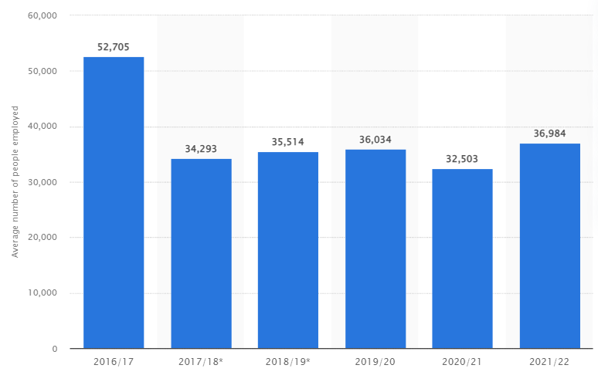
Figure 1: Employees in Whitbread including Premiere inn brand
(Source: Statista, 2023)
In 2022, the organisation had 36,984 employees worldwide, as per the above chart. It has been determined that the organisation had 32,503 employees in the previous year. The company had the highest count of employees in 2017, which was 52,705 that year (Statista, 2023). It has been analysed that the employee count is decreased over the years, which increases concern for the organisation to manage and develop employee retention. It has been measured that human resources play an essential role in the company generating high revenue and turnover. In 2022, the organisation generated £1.7 billion in revenue from its 800 hotels worldwide (Statista, 2023). It has been reported to this revenue through playing and managing human resources with effectiveness. Human resource plays an important role in managing and developing talent as it is incurred with different features. These functions are recruitment, staffing, organising, training, development and others. There are various considerations which are required for the company to develop employee engagement in business operations. It helps in achieving business objectives effectively, which is useful for maintaining sustainability and growth purpose.
According to Munir and Djaelani (2022), it is analysed that human resource plays an essential role in managing and developing talent in an organisation. There are different areas which are covered by the human resource department that is useful for achieving business objectives. Successful execution of procedures like recruitment and staffing increases the chances of achieving business objectives effectively. The human resource department is concerned with the development of talent and skills in an individual that is useful for increasing productivity. In the hotel industry, customer relationship is required to be maintained for sustainability in performance. Thus, employee retention is a helpful aspect managed by the human resource department in a hotel company. However argued by AlShehhi et al. (2022), human resource concerns about the workforce only increase confusion and avoid other essentials such as technology, infrastructure and others. It is analysed that an organisation incurred high costs for optimising operations related to human resources. It decreases the revenue of a company in the hotel chain and also decreases the importance of other essentials to achieve objectives. Inappropriate management and development lead to decreased efficiency in a hotel company. It has been determined that an organisation requires high knowledge and skilful employees to manage operations. It is difficult to identify the talent and increases the cost of operations related to human resource management.
Therefore, it is measured important for managing and developing talent to increase the productivity of the business operations optimised by the Premiere Inn. Enhancing skills and knowledge to perform operations increased through managing and developing talent. Allocating the right person to the right place develops the innovation and creativity to deal with the customers. It is also beneficial for the company to establish effective customer relationships to increase revenue. Managing and developing talent improvises the company's performance, enhancing sustainability in the business environment. It has been analysed that managing talent increases the opportunity to grab a competitive advantage as it is helpful for enhancing productivity. Developing talent in the business environment increases the concern for adopting new technologies which are suitable for the organisation. There are a number of new technologies which are required to be adopted adequately to increase productivity. Thus, managing talent and developing it is essential for the company to enhance its organisational performance. Customer relationships can effectively maintain through managing talent; therefore, it is helpful for increasing consumer loyalty.
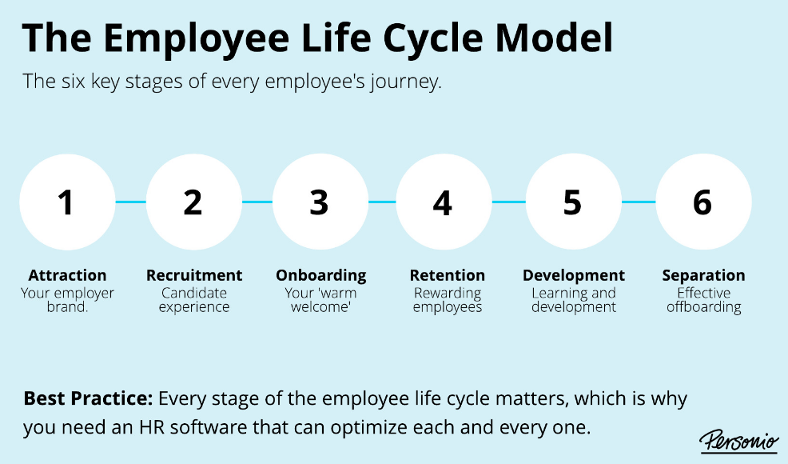
Figure 2: Employee lifecycle
(Source: Personio, 2023)
Employee lifecycle consists of six stages, as mentioned in the above image; attraction, recruitment, Onboarding, retention, development and separation.
Attraction: - Organisational rules, structure, systems, stories and other aspects influence individuals and attract them towards the organisation. Employees choose an organisation of various factors such as job title, salary, remuneration, leaves, etc. Therefore, it has been analysed that employees can be attracted through various aspects based on their needs and demand from the organisation. Premiere adopts several strategies to attract individuals to be employed. It has been determined that various benefits are provided to employees under the employment act to the individuals. It involves an employer brand in the market that attracts individuals to initiate the employee lifecycle.
Recruitment: - It is the second stage of the employee lifecycle based on the organisation's needs and requirements for a specific purpose. Recruitment is done to enhance the counts of employees in the company to manage the operations and increase options for the company. Managing and developing talent is included in the recruitment procedures (People management, 2023). It also involves the hiring procedure to improvise using new tools and techniques within the business environment. The recruitment procedure is essential for the development and mitigation of the requirements related to demand generated in the market. It is resolute that recruitment helps improve the company's organisational performance.
Onboarding: - After the recruitment process, the organisation's responsible for making employees feel safe and welcome during their Onboarding. It is measured that premiere inn has adopted techniques to make people safe in the company. This is about helping new employees blend with the organisation's existing corporate culture. Staff appraisal is one of the techniques adopted by the organisation to maximise its employee retention and engagement. A successful performance management cycle of employees increases the employee retention rate in the company. It is measured that Onboarding is a stage where employees build relationships with each other.
Retention: - The fourth stage of the employee lifecycle ensures that the organisation sticks with the top talent and makes them retain. Premiere Inn has adopted a strategy for increasing employee retention, which is reward and recognition. It helps organisations with employee retention, which maximises sustainability. There are various programs which are organised to increase employee retention within the organisation. Boosting retention rates is one of the objectives of organisations for maintaining sustainability in their operations. Premiere Inn has adopted a technique that boosts employee motivation which is helpful for employee retention. It is increased by developing individual skills and knowledge as per their personal development.
Development: - Career development is concerned with the development stage in the employee lifecycle stage. Organisations adopt learning and development to enhance the interest of the employees. It is a phase where the organisation is required to incur some part of its budget to develop skills and knowledge. Development is helpful for enhancing the knowledge of the employee. It keeps the environment sound and suitable, which is helpful for improving productivity. Development of an individual incurred with a cost that has to be managed by the company effectively. Encouraging people for their development of skills and knowledge within the business environment.
Separation: - It is the last stage of the employee life cycle that measures the loyalty and retention of the workforce. Employee experience is considered during their improvement in the organisational environment. It is determined as the process of offboarding employees from the organisation that is helpful for involving new employees. An employment contract is one of the measures through which the separation process can be initiated. The organisation organises corporate functions to develop the essence of this process and stage (Singh, 2019). An influential role is played by the separation stage for managing talent. There are various concerns that the company focuses on processing within the organisation.
For example, organisational performance will be enhanced by motivating employees and encouraging them. The revenue of the organisation will be increased by allocating the right people to the right place. Brand awareness of premier inn is measured at 93% in the United Kingdom, out of which 53% chose the company for stay (Statista, 2023). Organisational and team performance will be enhanced through engaging with employee engagement activities. Various concerns impact the performance of the company, which can be measured through employee retention and sustainability in the operations. Therefore, it has been analysed that the company can grow its sustainability in the business operations through maintenance of the employee life cycle.
For example, Marriot Hotel has come back after covid-19 by focusing on its employee lifecycle. It benefited the organisational performance and increased annual revenue after the pandemic.
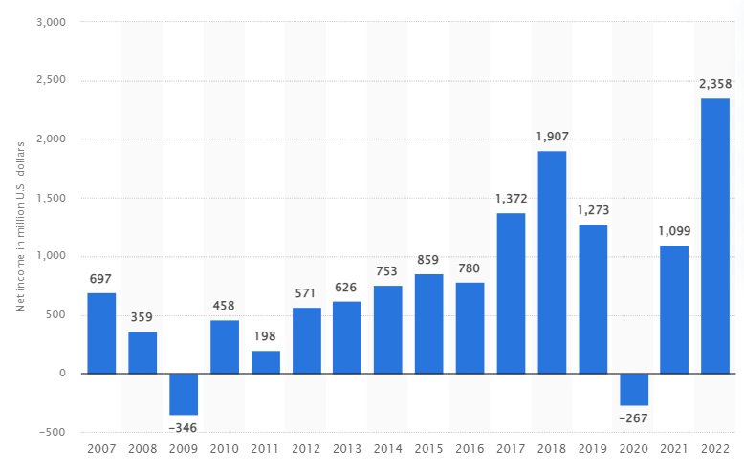
Figure 3: Net income of Marriot
(Source: Statista, 2023)
From the above chart, it is measured that Marriot Hotel will have a net income of £2.35 billion in 2022. It has been measured that the company had a net loss of £267 million in 2020 (Statista, 2023). Various operations are required to be oriented effectively related to employee engagement. It is measured that the Marriot Hotel company has appropriately engaged in an employee motivation program that influences its organisational performance. It has been analysed that the organisation generates high revenue and comes back into the market after facing loss. Therefore, talent management plays an important role in delivering organisational success in the market. It performs accurately in the operations by managing employees effectively. Hence, it is analysed that employee engagement is essential for companies to increase effectiveness in organisational performance. Therefore, the premier inn can also enhance productivity by maintaining the retention rate of employees. It will be helpful for the organisation in the long run.

Conclusion
The essay has summarised the concept of employee engagement in the premiere inn company that is based in the United Kingdom. It has been analysed that developing employee engagement activity influences a company’s performance. It is measured that organisational performance is influenced by the practical orientation of operations related to employees. Retaining the workforce increases sustainability in business activities. It is resolute that the employee lifecycle is required to be concern by the organisation. There are various concerns which influence the employee’s mindset. It is observed that organisational performance is enhanced through managing and developing the talent within the company. The role of managing and developing talent increases the productivity of the organisation, which is helpful for maintaining sustainability. The role of human resources in managing and developing talent is discussed in the report. Employee lifecycle has been determined by the essay considering its six stages. These are attraction, recruitment, Onboarding, retention, development and separation. Each of them has been distinguished effectively in the essay for measuring their importance in employee engagement. An example of Marriot Hotel is concerned in the essay for developing an understanding of the importance of employee engagement. Critical evaluation has been discussed in the essay to increase employee retention has influenced organisational performance led by employee retention.

Reference
AlShehhi, A.M.A.A., Nasir, B.B.M., Kilani, A., Abuhassna, H. and Awae, F., (2022). The Role of Human Resource Management in the Face of Crises: Performance Measurement Analysis. International Journal of Academic Research in Business and Social Sciences, 12(11), pp.206-223.
Munir, M. and Djaelani, M., (2022). Information Technology and Repositioning of Human Resource Management Functions. Journal of Social Science Studies (JOS3), 2(2), pp.50-55.
People management, (2023). People management journal [Online] Available Through <http://surl.li/hoogr> [Accessed on 2 June 2023]
Personio, (2023). Employee lifecycle [Online] Available Through <http://surl.li/hoogh> [Accessed on 2 June 2023]
Premiere Inn, (2023). About us [Online] Available Through <http://surl.li/hhgfi> [Accessed on 2 June 2023]
Riyanto, S., Endri, E. and Herlisha, N., (2021). Effect of work motivation and job satisfaction on employee performance: Mediating role of employee engagement. Problems and Perspectives in Management, 19(3), p.162.
Singh, D., (2019). A literature review on employee retention with focus on recent trends. International Journal of Scientific Research in Science and Technology, 6(1), pp.425-431.
Statista, (2023). Employees in Premiere Inn [Online] Available Through <http://surl.li/hoogd> [Accessed on 2 June 2023]
Statista, (2023). Net income of Marriot [Online] Available Through <http://surl.li/hoogm> [Accessed on 2 June 2023]
Statista, (2023). Premiere inn brand profile [Online] Available Through <http://surl.li/hoogj> [Accessed on 2 June 2023]
Statista, (2023). Revenue of Whitbread worldwide [Online] Available Through <http://surl.li/hoogg> [Accessed on 2 June 2023]

