Individual Academic Report

Bachelor of Arts in Business Management
Academic Year: 2022/2023
Student Name: Ileana Lupu
Student Number: 2231908
Lecturer Name: Dr Umar Sadaat
LCBB4004_BIRM
Marketing Fundamentals
-

Table of Contents

Introduction 3
Main analysis 3
Conclusion 13
References 13

Selected Organisation - H&M

Introduction

As stated by Kannan (2017, p. 24), digitalisation can be considered as the usage of digital technology for changing a business model to have a better return on investment as well as value-producing opportunities for a longer period of time. After the Covid pandemic, different brands within the fashion industry along with H&M had to adjust to different changes because of the emergence of digitalisation.
The above-concluded essay would highlight different factors associated with marketing and their importance in a detailed discussion. Along with this, the challenges faced by H&M while marketing during that post-Covid era would also be discussed in this essay as well. Additionally, the key trends the H&M had to implement in their work to cope with the external world would also be included in this section as well for better understanding. Due to digitalisation, many brands within the UK including H&M had to shift their focus towards digital media for marketing their products across various social media platforms. Moreover, several recommendations to overcome identified challenges that H&M faced would also be illustrated in this section of the essay as well. Further, a stakeholder analysis would also be included through analysing a stakeholder matrix for identifying the impact that they possess toward taking the correct decisions for the overall betterment of the organisation.

Main analysis
I. Explain and assess different challenges a Global organisation faces and various megatrends that influence the overall marketing post the Covid-19 Pandemic

Challenges Faced by H&M post Covid-19 Pandemic

The continual growth of digitalisation
As per the views of Chaffey and Ellis-Chadwick (2019), continual growth in digitalisation has seen many changes over the last few years since the pandemic which has forced many big brands to change their way of marketing in a different manner altogether. H&M has faced many issues post covid-19 that have made them shift their focus towards digitalisation as people have started to prefer online rather than going into shops for selecting their accessories, also is one of the biggest fashion retail brands in the whole UK.
H&M had to choose different digital marketing techniques to make people aware of certain changes that the company brings. For this, dependency on digital media got enhanced a lot which was one of the effects of digitalisation post-Covid era. Digitalisation post-Covid made them change their way of marketing for which initially they faced a lot of challenges to cope with others as far as digital media is concerned.

Rising energy costs and shortage of staff
According to Saura (2021, p. 104), post Covid Russia Ukraine war was one of such major geo-political events that impacted all the countries and their economic growth. Due to the ongoing war, crude oil prices have increased rapid growth. Similarly, the process of natural gas that is generally used as a substitute for crude oil has enhanced as well because of the European boycott of importing Russian resources. Russia is one of the biggest exporters of energy and for this, not only H&M but also many companies have faced a lot of trouble managing their marketing as well as business operations during that time. Similarly, after Covid as well H&M had to face a lot of challenges regarding staff shortages that affected their overall marketing as well as business operations. Hence, it can be considered as one of such challenges that H&M had to face post Covid in managing their business operations.

Cyber issues and their implications for marketing
As proposed by Olson et al., (2021, p. 290), digitalisation was one thing post-Covid, that impacted the overall business of H&M during that time. To cope with the external changes, H&M had to switch to digital media for managing their marketing as well as business development. With the emergence of digital media, cyber issues were one thing that impacted the business of not only H&M but also other big brands as well. As all the relevant data started to flow into the public domain, cyber issues emerged as a major problem for different brands in spite of having encryption. For this, the cyber issues made a lot of constraints on H&M to market their products through the digital media itself.

Green marketing and emerging technologies
As per Herhausen et al., (2020, p. 284), green marketing is considered to be a practice for promoting products of different services that are suitable as well as eco-friendly. Post- Covid many brands had to switch to green marketing to a suitable brand value of their own within the competitive market. H&M had to choose that option as well, which presented significant issues because it was something completely new for every other brand, including H&M. Apart from that, the emergence of different technologies also created some challenges against H&M as they had no other option but to use different social media platforms to promote their brand just like others. Hence, these are a few challenges that H&M faced post- Covid to manage their marketing as well as overall business operations to have a sustainable output throughout.

Impacts of megatrends on marketing functions of H&M in the post-pandemic situation
Overdependence on Digital Media
Over-dependency on digital media was the most trending aspect that H&M along with different other brands had to encounter post-Covid. After Covid people started to shift their focus from offline to online mode and choose to opt for online marketing more than anything else. As per the consumers, online marketing is very much convenient for them that saves a lot of time and helps to explore different new segments of designs as well. For this, H&M had to opt for digital marketing as well, like others to have a competitive advantage that can eventually lead to enhancement in customer traffic to their websites and different other marketplaces. Similarly, they had to market their products on different social media platforms, as well to gain a suitable amount of customer base that shows the over-dependency on digital media that H&M had to encounter post-Covid era.
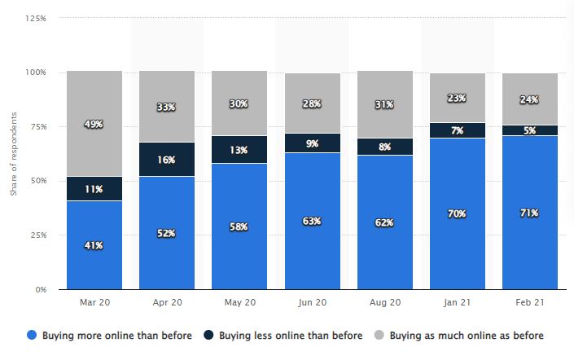
Figure 1: Percentage change in online purchases due to the covid-19
(Source: statista.com, 2023)

Usage of artificial intelligence
As stated by Alshaketheep et al., (2020, p. 840), the emergence of artificial intelligence has seen rapid growth since the covid-19 pandemic as people had to switch to remote working mode for some time, which required technical advancement through different software. Hence, the usage of artificial intelligence was very much trending during that time, as brands started to use it in their marketing as well. Using AI to market different products, helps in analysing market data, customer buying patterns and consumer needs in a much more prominent way altogether. According to the above-concluded graph, people have started to buy online more than ever during the Covid pandemic. The change in growth as people started to shop online is very much significant in this graph that shows the emergence of different technical advancements for which digital media has become accessible to everyone no matter what. For this H&M saw a huge rise in the usage of AI in different marketing channels, to figure out what can be the possible way that can eventually enhance the customer traffic in online websites as well as different e-commerce marketplaces.
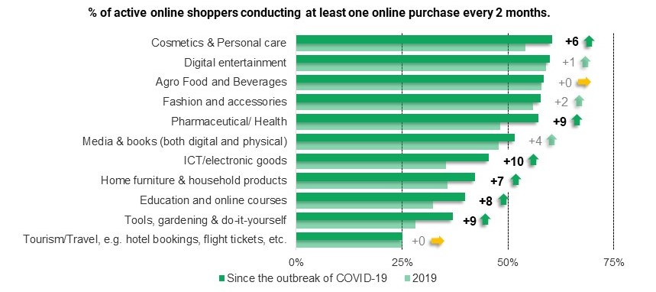
Figure 2: Emergence of online shopping post covid era
(Source: unctad.org, 2020)

Millennials and their social influence on Marketing
Enhancement in globalisation saw many changes in digital media marketing for many companies including H&M. As per Apasrawirote et al., (2022, p. 482), different brands started to switch towards digital media for promoting their products. For this, dependency on millennials was one such thing that H&M had to experience during that time. Similar to others, H&M was required to look for certain millennials for branding their products, so that a certain level of customer traffic over social media platforms can be generated. This eventually can help in getting a sustainable amount of revenue margin through promoting online shopping as well. As per the above graph, it can be seen that the growth of online shopping after Covid-19 is very prominent within the UK. Not only for shopping but for daily essentials as well people started to go for online marketplaces post Covid era. Hence, post Covid this is one trend that H&M had to encounter that influenced their way of doing marketing up to a certain extent.

II. Analyse the way the selected organisation constantly develops its marketing strategies to have a competitive advantage over others
Marketing Mix (4Ps)
Product
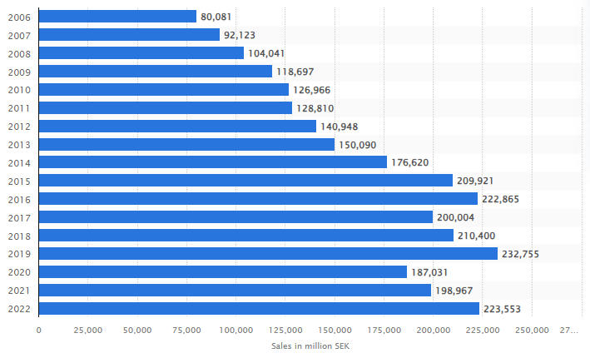Figure 3: Revenue of H&M in the global market
(Source: statista.com, 2022)
The variety of products offered by H&M has followed the latest trends in the market to meet the demand of the customers. The design of the product is focused on delivering at an affordable price without compromising the quality. For developing products, the company uses a collaboration strategy to meet up with top designers to create an exclusive collection which would benefit the organisation in enhancing the brand image further becoming appealing to customers, who are concerned with fashion and trends. It has been reported that H&M has gained over 223.55 billion dollars worldwide with its offering of trendy fashionable clothes (statista.com, 2022). The product development of the organisation gives a competitive advantage globally with its improvement in product quality and ensures the customer's satisfaction level.

Price
The competitive pricing strategy of H&M focuses on offering fashionable trendy clothes at an affordable price. The strategy is employed for getting the customer value for a money product while maintaining profitability. This helps the organisation in enhancing its customer base and gain a competitive advantage in the market over high-end brands. In addition, the cost leadership strategy is associated with stocking the products and supplying chains at a reasonable price from cost-effective suppliers and employing production techniques to be efficient (Javed et al., 2020, p.18). This approach helps the organisation in staying competitive while maintaining a low price. The pricing strategy of H&M also focuses on various market segments offering the product at various prices which allows the company to cater to each customer with a different budget and their preference, increasing the customer base in the bigger market. The dynamic nature of the pricing adapts to changing market conditions and the preference of the customers. This includes promotional sales to entice more customers in trying their products.
Place
H&M has increased its presence in various countries worldwide with its presence in high traffic, to draw more customers and increase its visibility and accessibility to potential customers. In addition, the online presence of H&M has a strong presence through the e-commerce website and the website to reach more customers through the online platform. As per Moreira, (2020), the website offers a seamless online shopping experience using navigation, detailed information about the product, and payment options. The collaboration of the company with other brands generates buzz and attention among customers, driving traffic to the store and increasing the sale online. There is scope for the organisation to explore opportunities to expand its business globally reaching customer base to a broader range.
Promotion
Implementing various promotional channels help H&M in targeting a broader audience including digital and social media platforms. The creation of trendy and appealing ads depicts the latest collection to the customers making it appealing for them to increase their purchasing power. Marketing through social media using Facebook, Instagram, Pinterest, and Twitter helps in engaging more audiences who are socially active and share fashion inspiration. The promotion strategy through social media helps the brand to make a connection with customers maintaining a strong online presence.

III. Evaluate key stakeholders of the organisation along with their impact on different marketing approaches
Key stakeholders of the organisation
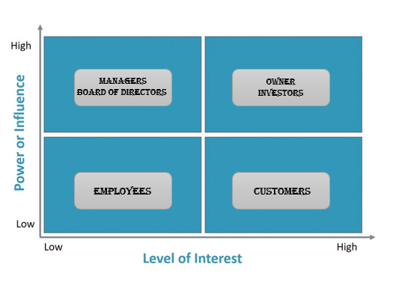
Figure 4: Stakeholder Matrix of H&M
(Source: Developed by the learner)
High Power & High Interest: The owner and the investors of H&M are certain stakeholders who hold the maximum power regarding taking any decision for the overall betterment of the organisation. Apart from that, the Owner of H&M as well as different key investors who have invested their money for a better return in the future also holds the maximum interest possible regarding the betterment of the company by taking different key measures altogether. Hence, these are the individuals who will manage the working of H&M closely as they hold maximum power as well as maximum interest towards the development of the company.
High Power & Low Interest: Managers, the Board of Directors and supervisors are those stakeholders who hold much higher power than others in taking any decisions to grow the company. Individuals who primarily have a higher position within the organisation are the type of stakeholders who, while having more authority, have the least interest in the outcome of decisions. Thus, managers, supervisors, and board members will fall into the category of keeping satisfied customers because they have the most influence yet have little interest in making any kind of decision.

Low Power & High Interest: Customers of H&M, industry peers, non-governmental organisations (NGOs) and policymakers are those stakeholders who have a greater interest in the company's performance but hold the least power in taking any decisions for the betterment of the organisation. Consumers and governing bodies must be kept informed all the time regarding companies' growth and performance as they hold the maxim interest for the sake of the company and yet cannot take effective decisions.
Low Power & Low Interest: Employees of H&M who hold a much lower position within the hierarchy belong to this category. Employees hold the least power in making any decision as well they have the least interest regarding any outcome. They are kept for monitoring all the work as in spite of possessing low power and interest they are an integral part of the company no matter what. Hence, these are all the stakeholders of H&M who look after the betterment of the company by taking correct decisions and effective measures.

Impacts of the Stakeholders on the Marketing Function of H&M
Influence the decision-making process regarding marketing approaches

As proposed by Barbosa et al., (2022, p.24), stakeholders are mainly those individuals who have a consigned interest in the decision-making process for the sake of betterment towards the company’s growth. Stakeholders of H&M help in taking effective decisions regarding marketing approaches so that the company can brand their products in a better way altogether. Similarly, stakeholders also provide different insights regarding which challenges must be used to have a better return on investment that eventually leads to enhancement in revenue margin as well for the organisation. Apart from that, taking correct measures to maintain all the business activities including sales and marketing is the primary responsibility of stakeholders that they do for the betterment of the company in the long run.
Provide feedbacks that influence the ability to operate

According to Peter et al., (2021, p. 254), assessing all the business growth and workplace operations stakeholders generally provides necessary inputs and feedback for the overall quality enhancements. For marketing only, closely monitoring the growth in consumer retention and consumer traffic, stakeholders of H&M give their insight regarding what can be done better to have a significant impact on the marketing campaign. Hence, providing essential feedback regarding which marketing advertisement must be used, which social media channel has the highest engagement, which influencer must be hired and many more, stakeholders influence the ability of the marketing department to operate in a certain direction which can eventually give them the fruitful result that they are looking for.
Improves relations among business functions for enhancing performance

As stated by Daud et al., (2022, p. 42), intervening and establishing effective communication between departments and stakeholders improves the relationship between different business functions. This improves the coordination as well as communication between each other which eventually resulted in enhancement in productivity for H&M. When all business functions collaborate, marketing improves significantly, resulting in an increase in revenue creation as well. Hence, these are some of the impacts that the stakeholders of H&M hold as far as decision-making to develop better marketing strategies.

IV. Deliver suitable recommendations on marketing approaches to mitigate the specific identified challenges
Using social-media-based influencer marketing

It is highly recommended that the higher management of H&M must focus on social-media-based influencer marketing to have a significant impact in terms of enhancing customer traffic. After Covid-19 due to enhanced social media outrage, globalisation posed a huge challenge in front of H&M as far as competing with the outside world. To cope with digitalisation, H&M should consider focusing on influencer marketing more than anything else so that they can target the youth of the UK in a prominent manner. As technical advancement is taking place all across the world, people started to shift towards digital media more. H&M must utilise this thing to have a competitive advantage over others in the fashion sector. Having said that, using social media H&M will be able to expand its brand value as well across different societies which will eventually help them generate a sustainable amount of customer base for the betterment in the long run.

Introducing technical advancements for marketing purposes
As stated by El Junusi (2020, p. 24), incorporating technical advancement has become a necessity for every business across the globe, if they want to have a competitive advantage over others. It is highly advisable that H&M must focus on incorporating different technical advancements to their business operations so that they are able to implement different approaches to their marketing for their overall betterment in the long run. H&M should focus on incorporating technical advancements such as AI, automation, IoT, machine learning, blockchain, DBMS and many more into their existing business operations so that they are able to market their product in a better way altogether. By introducing all of these technological advancements and opting for influencer marketing, H&M will be able to overcome those challenges that they faced regarding digitalisation post-Covid era.
For this, it is strongly recommended that the higher management of H&M should focus on implementing different technical advancements so that they can market their product in a better way over different online challenges to have a better competitive edge over others within the fashion industry of the UK.

Focusing on content development
Focusing on key marketing metrics the higher management of H&M must focus on developing engaging content to appeal to a large number of customers across different societies. Similarly, using different technical advancements H&M look to develop engaging content so that targeting as well as position can get better eventually in terms of making people aware of new products that they are about to bring. For this, it is highly advisable that H&M should look to focus on developing engaging content by analysing customer demand and buying operations as well as marketing metrics. This will eventually help them to have a better competitive edge over others and to overcome the challenges that they faced initially during the Covid-19 pandemic. Hence, using different technical advancements various issues related to cyber security that H&M faced during the Covid period would also be minimised as well up to a certain extent which will eventually give them a certain competitive edge over others as well.
Analyse competitor's growth
According to Krishen et al., (2021, p. 190), analysing competitors' growth and marketing strategies can also be an approach to developing an understanding of the market. H&M should focus on analysing the current market data more importantly competitors' performance so that they can position themselves better in a competitive market like the fashion industry to overcome certain challenges that they faced during the Covid period. ASOS, Zara and PVH are some of the major competitors that H&M has within the fashion industry. Assessing their performance as well as marketing approaches H&M will be able to analyse their growth as well so that developing engaging and appealing content from their end as per the market need becomes possible. This will eventually help them in managing sustainable growth in a competitive market like fashion for a much longer period of time. Hence, these are some of the recommendations to H&M that they should consider for having a better marketing edge over others so that they can eventually overcome the challenges they faced post Covid era.

Conclusion
The above-concluded essay has analysed different aspects related to marketing along with its importance in having a sustainable amount of revenue margin for an organisation. For this, H&M has been taken here to discuss this topic further. Marketing can be considered as an approach to let people know about certain changes that a company brings for their customers. Since digitalisation took over, different brands all across the world had to switch their focus towards online mode for coping with the change abruptly. Apart from that, different challenges that H&M faces in maintaining their marketing approaches post-Covid era has been identified in this section of the essay as well for better understanding. Additionally, key market trends that H&M encountered after the Covid period have also been identified in this section of the essay as well. Stakeholders are one of the major pillars of an organisation that helps in taking major decisions for the betterment in the long run. Moreover, the impact of different stakeholders has also been illustrated in this section of the essay as well through illustrating a stakeholder matrix. Further, some recommendations have also been provided in this essay as well for H&M to overcome certain challenges that they faced in the post-Covid era.

References
Alshaketheep, K.M.K.I., Salah, A.A., Alomari, K.M., Khaled, A.S. and Jray, A.A.A. (2020) ‘Digital marketing during COVID-19: Consumer's perspective’, WSEAS Transactions on Business and Economics, 17(1), pp.831-841.
Apasrawirote, D., Yawised, K. and Muneesawang, P. (2022) ’Digital marketing capability: the mystery of business capabilities’, Marketing Intelligence & Planning, 40(4), pp.477-496.
Barbosa, B., Saura, J.R. and Bennett, D. (2022) ‘How do entrepreneurs perform digital marketing across the customer journey? A review and discussion of the main uses’, The Journal of Technology Transfer, pp.1-35.
Chaffey, D. and Ellis-Chadwick, F. (2019) Digital marketing.7th edn. Pearson UK.
Daud, I., Nurjannahe, D., Mohyi, A., Ambarwati, T., Cahyono, Y., Haryoko, A.E., Handoko, A.L., Putra, R.S., Wijoyo, H., Ariyanto, A. and Jihadi, M. (2022) ‘The effect of digital marketing, digital finance and digital payment on finance performance of Indonesian SMEs’, International Journal of Data and Network Science, 6, pp.37-44.

El Junusi, R. (2020) ‘Digital marketing during the pandemic period; A study of Islamic perspective ‘, Journal of Digital Marketing and Halal Industry, 2(1), pp.15-28.
Herhausen, D., Miočević, D., Morgan, R.E. and Kleijnen, M.H. (2020) ‘The digital marketing capabilities gap’, Industrial Marketing Management, 90, pp.276-290.
Javed, T., Yang, J., Gilal, W.G. and Gilal, N.G. (2020) ‘The sustainability claims' impact on the consumer's green perception and behavioural intention: A case study of H&M’, Advances in Management and Applied Economics, 10(2), pp.1-22.
Kannan, P.K. (2017) ‘Digital marketing: A framework, review and research agenda’, International journal of research in marketing, 34(1), pp.22-45.

Krishen, A.S., Dwivedi, Y.K., Bindu, N. and K.S. (2021) ‘A broad overview of interactive digital marketing: A bibliometric network analysis’, Journal of Business Research, 131, pp.183-195.
Moreira, R.D.M. (2020) Fast fashion retailer’s marketing strategies: brand awareness and customer brand engagement. Available at: https://bibliotecadigital.fgv.br/dspace/handle/10438/30178 (Accessed: 06 July 2023).
Olson, E.M., Olson, K.M., Czaplewski, A.J. and Key, T.M. (2021) ‘Business strategy and the management of digital marketing’, Business Horizons, 64(2), pp.285-293.

Peter, M.K. and Dalla Vecchia, M.(2021)’ The digital marketing toolkit: a literature review for the identification of digital marketing channels and platforms’, New trends in business information systems and technology: Digital innovation and digital business transformation, pp.251-265.
Saura, J.R. (2021)’ Using data sciences in digital marketing: Framework, methods, and performance metrics, Journal of Innovation & Knowledge, 6(2), pp.92-102.

statista.com (2023) UK: Change in online shopping since COVID-19 2020-2021, Statista. Available at: https://www.statista.com/statistics/1230225/changes-in-online-buying-among-uk-consumers-since-covid-19/ (Accessed: 06 July 2023).
Statista.com. (2022) Smith, P. (2023) Sales of the H&M Group Worldwide 2022, Statista. Available at: https://www.statista.com/statistics/252190/gross-sales-of-the-h-und-m-group-worldwide/ (Accessed: 06 July 2023).
unctad.org (2020) Covid-19 has changed online shopping forever, survey shows, UNCTAD. Available at: https://unctad.org/news/covid-19-has-changed-online-shopping-forever-survey-shows (Accessed: 06 July 2023).

