Food and Beverages Operations

BMIH4002

Student ID : Florin Ispas

Tutor’s Name : 2212651

VALENTINE’S DAY SPECIAL

Hotel Trinity



VALENTINE’S DAY SPECIAL

At Hotel Trinity, we are proud to present an exquisite Valentine’s Day selection, crafted with the finest seasonal ingredients, to be enjoyed in the heart of our vibrant city. Celebrate your special day with us and explore the romance of our luxurious three-course menu.

Four Course Meal
£90 Per Person.
Starters
- Smoked Salmon, Beetroot and Horseradish Mousse, served with Rye Bread and Crème Fraiche
- Wild Mushroom Soup with Truffle Oil, served with Toasted Sourdough
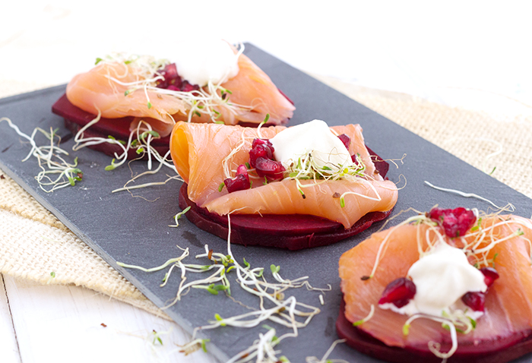

Main Courses
• Fillet of Beef Wellington with a Red Wine Jus, served with a Parsnip Puree and Roasted Vegetables
• Pan Seared Halibut with a Crushed Potato and Spinach Cake, served with a Creamed Leek and Lemon Butter Sauce
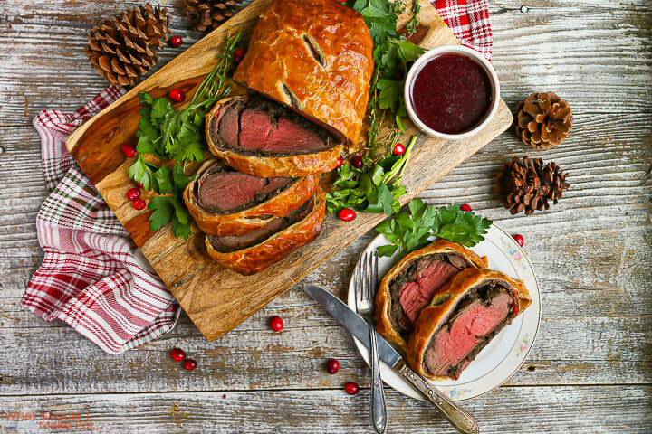

Desserts
- Chocolate Fondant with Salted Caramel Sauce and Vanilla Ice Cream
- Strawberry Cheesecake with Fresh Raspberries


Drinks Packages
- The Love Package - A bottle of Prosecco and two glasses of house red or white wine
- The Champagne Package - A bottle of Champagne and two glasses of house red or white wine

Booking
Available on Valentine’s Day, 14th February 2021. A non-refundable deposit of £30 per person is required to secure your booking.

Allergens
Please be aware that all dishes may contain traces of allergens. If you have a food allergy, please let us know before ordering. We look forward to welcoming you and your loved one to celebrate this special day at Hotel Trinity.

References
Dobbin, S. (2020). ‘If you can make it there, you can make it anywhere…’. The Routledge Handbook of Placemaking, [online] pp.283–293. doi:https://doi.org/10.4324/9780429270482-33
Lopers Win 2 Ground game, improved defense leads football team to 2-0 start for first time in seven years Lopers Win 2 Ground game, improved defense leads football team to 2-0 start for first time in seven years Lopers Win 2 Ground game, improved defense leads football team to 2-0 start for first time in seven years Phi Delt Fish Fry Annual philanthropy event raises money for the ALS foundation Special Coverage. (n.d.). Available at: https://openspaces.unk.edu/cgi/viewcontent.cgi?article=1077&context=unkantelope [Accessed 16 Feb. 2023].
‌ Google Books. (2023). Little Ohio. [online] Available at: https://books.google.co.ke/books?hl=en&lr=&id=2IekEAAAQBAJ&oi=fnd&pg=PP1&dq=Smoked+Salmon,+Beetroot+and+Horseradish+Mousse,+served+with+Rye+Bread+and+Cr%C3%A8me+Fraiche+&ots=zeqEXuRKxb&sig=z-cVmxgqVMEmgMpvo0B6e31igvA&redir_esc=y#v=onepage&q&f=false [Accessed 16 Feb. 2023].
‌ Jstor.org. (2023). Hong Kong Valentine on JSTOR. [online] Available at: https://www.jstor.org/stable/40636598 [Accessed 16 Feb. 2023].
Food, Culture & Society. (2020). New Nordic upmarket bistros and the practical configurations of artful dining. [online] Available at: https://www.tandfonline.com/doi/abs/10.1080/15528014.2019.1668203 [Accessed 16 Feb. 2023].
Acculturation: the symbolism of ethnic eating among contemporary British consumers | Emerald Insight. (2023). British Food Journal, [online] 98(10), pp.12–26. doi:https://doi.org/10.1108//bfj.
Google Books. (2014). Women, Food, and Families. [online] Available at: https://books.google.co.ke/books?hl=en&lr=&id=Unq8AAAAIAAJ&oi=fnd&pg=PP10&dq=Celebrate+your+special+day+with+us+and+explore+the+romance+of+our+luxurious+three-course+menu.++&ots=wP5A9x0RGP&sig=j1gyHP5JFQ_BMf35kuqLro4gFqI&redir_esc=y#v=onepage&q&f=false [Accessed 16 Feb. 2023].
‌

‌

‌

‌

