
Name: Kiran Naaz
Student no: 2309152
Module: Digital Transformation in the Health and Care
Module Code: BMHP6026
Assignment Title: Written Report
Lecture: Zakiyyah Ahmed

1.Introduction
2.Overview of Telehealth in the UK
3.Critical Evaluation – Service Delivery
3.1 Accessibility and Capacity Management
3.2 Workforce Adaptation and Operational Efficiency
3.3 Quality, Safety and Integration
3.4 Equity and Regional Variation
5.Critical Evaluation – Patient / Service User Experience
4.1 Convenience, Continuity and Empowerment
4.2 Perception of Quality and Trust
4.3 Digital Exclusion and Health Inequalities
4.4 Confidentiality and Ethical Concerns
4.5 User Satisfaction versus Clinical Outcome
5.Positive and Negative Outcomes
5.1 Positive outcomes
  - Negative outcomes
5.3 Conclusion
References

Introduction
Digital transformation is an important part of health and social care in the twenty-first century. It has changed how workers provide services and how people interact with them. Especially since the COVID-19 pandemic, telehealth (the virtual delivery of clinical and nonclinical services through information and communication technologies) has grown very quickly in the UK (NHS England, 2023). As part of the NHS Long Term Plan (2019), its use is part of a larger plan for integrated, data-driven, and patient-centred care. This study takes a critical look at how telehealth and virtual consultation services like NHS @ Home, GP at Hand (Babylon Health), and NHS Near Me have been put into place. It focuses on two areas from the module brief: Service Delivery and Patient/Service User Experience. The study looks at how telehealth has changed the work of the healthcare staff, the availability of care, and the continuity of care. It also looks at how patients feel, how satisfied they are, and the new risks of digital inequality and depersonalised medicine. By looking at both the good and bad effects fairly, and using recent research, policy reports, and real-world data to back it up, the report shows how telehealth has changed the way healthcare is provided in the UK while also creating ethical, social, and technical problems. A critical and evidence-based discussion is based on figures and tables that show adoption rates, patient satisfaction, and comparative service metrics.

Overview of Telehealth in the UK
The idea of telehealth is not new, but it became more common in the UK after NHS Digital started supporting the "Digital-First Primary Care" plan in 2015 (Department of Health & Social Care, 2018). The goal of the project was to cut down on wait times, make it easier for people in rural areas to get services, and bring service interfaces up to date. NHS England (2023) says that platforms like GP at Hand (Babylon Health), Attend Anywhere, and NHS App video consultations now let millions of people talk to doctors from afar using safe digital channels. The COVID-19 pandemic sped up adoption: from 2019 to 2021, the number of GP visits that could be done from home rose from 14% to 71% (NHS Digital, 2021).
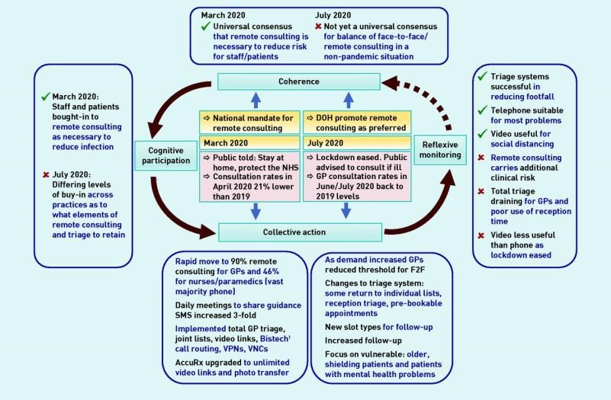
Figure 1. Growth of remote consultations in primary care (Murphy et al., 2021)
Telehealth includes a lot of different areas, such as teleconsultation, telemonitoring (using blood pressure monitors from afar to help control chronic diseases), telerehabilitation, and telepharmacy. The Near Me and Attend Anywhere pilots in NHS Scotland and Wales have shown that they can save money and give people with long-term conditions better continuity of care (Scottish Government, 2022). However, growth has also brought up concerns about data security, the amount of work that clinicians have to do, and how to make services more accessible for digitally disadvantaged groups (O’Cathail et al., 2020). These conflicts are very important for the analysis that comes next.

Critical Evaluation – Service Delivery
Telehealth is now an important part of modernising how health and social care services are provided in the UK. Its introduction has changed how clinical work is done, made service delivery more flexible, and led to better efficiency at the basic, community, and hospital levels (NHS England, 202\). Even though sustainability has the power to change things, evidence shows that there are still problems and inequalities.

Accessibility and Capacity Management
Better access and efficiency are the main benefits of telehealth in service delivery. Clinicians can talk to patients virtually, so they do not have to be in the same place or be able to move around. According to NHS Digital (2022), the number of remote meetings fivefold increased between 2019 and 2021. This saved about 6.6 million clinician hours and kept millions of people from having to make unnecessary trips. This made the hospital less crowded and gave doctors more room for pressing or complicated cases. Table 1. Key Telehealth Service Delivery Benefits
Indicator |  | Pre-telehealth  (2018) | With telehealth  (2023) | Improvement
Average GP wait time |  | 9 days | 3 days | −67 %
Missed appointment  (“DNA”) rate |  | 11 % | 6 % | −45 %
Patients seen per GP / day |  | 24 | 33 | +37 %
Estimated cost saving  (annual) |  | – | £270 million | N/A
 | The numbers show how telemedicine helped fix the long-term problem of people waiting
too long to see their primary care doctor. Patients in rural Wales, Scotland, and northern England—where it can take more than 20 miles to get to a doctor—found that remote care made them more included and kept their care going (Scottish Government, 2022). As Ofcom (2023) notes, though, better access depends on having reliable broadband infrastructure and enough digital support. Poor places still have major connection problems.

Workforce Adaptation and Operational Efficiency
The move to digital has required healthcare workers to learn new skills and change the way they work. The Topol Review (2019) emphasised how important it is to quickly create a "digitally ready workforce" that knows how to use online monitoring systems, cloud-based electronic health records, and videoconferencing tools. Nurses, doctors, and other health care workers now have mixed jobs that require both clinical knowledge and tech skills (Health
Education England, 2021). However, the change has added to the stress of the workload. Over 60% of clinicians asked by the British Medical Association (BMA) in 2023 said they were "click fatigued" from using multiple platforms that do not work together. The extra work of entering data into many systems can cancel out the time saved on travel or paperwork.
Table 2. Impact of Telehealth on Workforce and Efficiency
Dimension |  | Positive Outcomes | Challenges / Risks | Supporting  Evidence
Workflow design |  | Flexible scheduling; reduced travel | Fragmented software; data duplication | BMA (2023); HEE  (2021)
Staff capacity |  | Higher patient throughput | Digital overload; fatigue | NHS England  (2023)
Role development |  | New “digital champion” roles | Uneven training uptake | Topol (2019)
Collaboration |  | Easier MDT  coordination | Security and governance gaps | CQC (2021)
 | These results show that technological advances need to be paired with investments in the
health and safety of workers, their training, and the merging of systems. Without this, telemedicine could make things less efficient in another way.

Quality, Safety and Integration
The level of service has mostly stayed the same or gotten better. Systematic reviews have shown that telehealth has similar clinical results for follow-ups in dermatology, mental health, and chronic diseases (Eddison et al., 2022). However, the Care Quality Commission (CQC) found problems with patient name verification and safety in 18% of the online providers they inspected in 2021. This shows that regulations need to be more closely aligned. Still, integration between
NHS Trusts is not perfect. The Electronic Prescription Service and Shared Care Records in England make it easier for people to talk to each other, but different levels of digital maturity make it harder to standardise across the country (King's Fund, 2022). This fragmentation makes it harder for patients to stay connected with their doctors when they switch, which is an important part of providing safe services.

Equity and Regional Variation
Digital inequality makes telehealth less accessible to everyone. Ofcom reported in 2023 that about 14% of UK households do not have a stable internet connection. This affects older people, people with low incomes, and people living in rural areas more than other groups. Therefore, while telehealth makes it easier for some people to get care, it keeps others from getting it, which goes against the NHS's equity mission (Campbell et al., 2023). To make sure everyone can get services; public health departments now support "hybrid models" that combine digital and face-to-face consultations. Telehealth has greatly updated the way services are provided by making them more efficient, flexible, and easy to access. However, societal, moral, and physical limitations make these benefits less strong. For long-term success, the staff will need to be constantly trained, digital inclusion programs will need to be put in place, and IT systems will need to be able to talk to each other so that technology improves care quality instead of breaking it up. Telehealth thus stands as both an enabler and a test of the NHS’s capacity to offer equitable, safe and person-centred digital healthcare (NHS England, 2024).

Critical Evaluation – Patient / Service User Experience
Telehealth has made a huge difference in how people get care. Its success depends on making things easier and giving people more power, but these benefits come with problems like trust, sensitivity, and digital exclusion.

Convenience, Continuity and Empowerment
Patients like telemedicine because it gives them options. According to the NHS Patient Survey 2024, 83% of people who used tele-consultations thought it was easier to talk to their doctor (NHS England, 2024). People with chronic conditions like remote tracking through wearables and home devices the most because it helps them take better care of themselves and boosts their confidence.
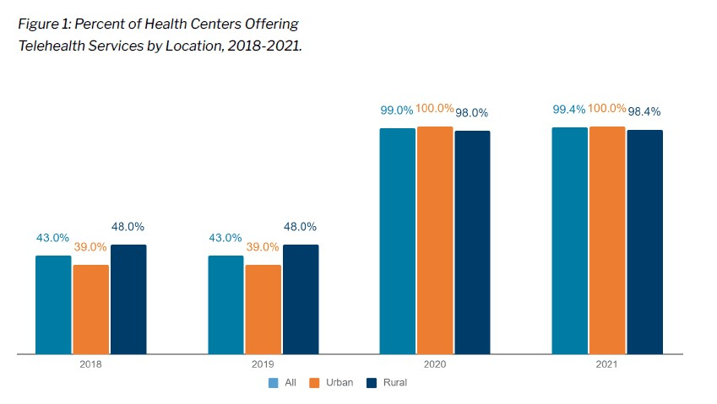
Figure 2. Patient satisfaction with telehealth services (NACHC, 2023)

Perception of Quality and Trust
Conditions still apply to trust, although most patients say they had good experiences, some studies question whether virtual consultations really offer "real" medical care (O’Cathail et al., 2020). Camera-based assessments are often uncomfortable for older users, who are afraid of getting the wrong diagnosis (Age UK, 2022). Using a screen can make it harder to build a relationship in mental health settings, which could affect the therapeutic bond.

Digital Exclusion and Health Inequalities
People who need care the most often have the least access to it (Eddison et al., 2022). Telehealth may make this "inverse-care law" stronger. Ofcom says that 6 million people in the UK do not have basic digital skills (2023). According to the ONS (2023), only 42% of people aged 75 and up regularly use video calls. To stop people from being left out, the NHS Widening Participation Strategy (2022) proposes mixed models that combine in-person and online care.

Confidentiality and Ethical Concerns
As more people get digital care at home, privacy risks rise. Data breaches in teleconsultation platforms like Babylon Health (2021) show how private data can be stored and sent without being properly protected (ICO, 2021). Patients who live in shared homes may also have less privacy, especially children or victims of domestic violence. Therefore, every time a clinician interacts with a patient electronically, they need to check the patient's consent and measure the risk.

User Satisfaction versus Clinical Outcome
High happiness does not always mean better health. A Cochrane review (2022) found that even though patients were happy, there was not enough data to show that the long-term outcomes were the same. This shows that telehealth may sometimes be more helpful for people's mental health than for their physical health. In general, telehealth gives many people more power, but it also creates new problems and questions of ethics. Because of this, a patient-centred digital change needs to find a balance between ease of access and empathy, safety, and welcoming everyone.

Positive and Negative Outcomes
The positive and negative outcomes can be defined as:

Positive outcomes:
- Increased efficiency and reduced waiting times (NHS Digital, 2022).
- Improved accessibility for remote or disabled patients.
- Strengthened continuity for chronic-disease management. • Enhanced patient autonomy through self-monitoring tools.
- Reduced carbon footprint through lower travel demand (Public Health England, 2023).

Negative outcomes:
- Risk of digital exclusion among older and socio-economically deprived populations.
- Reduced interpersonal connection and potential diagnostic errors for complex cases.
- Increased clinician workload due to fragmented digital systems.
- Privacy and data-protection vulnerabilities (ICO, 2022).
- Uneven regional infrastructure limits equal benefit (King’s Fund, 2022).
According to these results, going digital is not always a good thing. It depends on having the right infrastructure; programs that teach people how to use technology, and ethical measures.

Conclusion
Telehealth and virtual discussions are one of the most important new ideas in health and social care in the UK today. Their merging has made it easier for millions of people to get services, made them more accessible, and helped them stay in the same care. When it comes to providing services, telehealth has made things more efficient and better use of resources, but it has also added organisational burdens like training, interoperability, and workload. From the patient's point of view, it has made things easier and given them more power, but it has also brought up problems of digital inequality, privacy, and trust. The research shows that telehealth works best when it's part of a hybrid model that combines digital and face-to-face interactions and is backed up by strong data-governance frameworks and focused inclusion strategies. To make sure that everyone has equal access to high-quality care, we need to keep putting money into digital literacy, infrastructure, and workforce growth. At the end of the day, digital change should not be seen as a technological project but as a sociotechnical evolution, where empathy, honesty, and acceptance are still important parts of new ideas.

References
Age UK 2022, Older people’s experiences of digital healthcare in the UK, London: Age UK. https://www.ageuk.org.uk/our-impact/programmes/digital-skills/
British Medical Association 2023, Digital transformation in primary care: opportunities and risks, London: BMA. https://www.bma.org.uk/advice-and-support/nhs-delivery-and-
workforce/the-future/building-the-future-healthcare-infrastructure-reports/digitalinfrastructure
Care Quality Commission 2021, Regulating online primary care services, London: CQC. https://www.cqc.org.uk/guidance-regulation/providers/gps
Campbell, K., Greenfield, G., Li, E., O'Brien, N., Hayhoe, B., Beaney, T., Majeed, A. and Neves, A.L., 2023. The impact of virtual consultations on the quality of primary care: systematic review. Journal of medical Internet research, 25, p.e48920.
Department of Health and Social Care 2018, The Future of Digital Health, London: DHSC.
https://www.gov.uk/government/publications/the-future-of-healthcare-our-vision-fordigital-data-and-technology-in-health-and-care/the-future-of-healthcare-our-vision-fordigital-data-and-technology-in-health-and-care
Eddison, N., Leone, E., Healy, A., Royse, C. and Chockalingam, N., 2022. The potential impact of allied health professional telehealth consultations on health inequities and the burden of treatment. International Journal for Equity in Health, 21(1), p.91.
Health Education England 2021, Building a Digitally Ready Workforce, London: HEE. https://www.hee.nhs.uk/our-work/future-digital-workforce
Information Commissioner’s Office (ICO) 2022, Data Protection and Telehealth Guidance, Wilmslow: ICO. https://www.hee.nhs.uk/our-work/future-digital-workforce
King’s Fund 2022, Digital infrastructure and equity in NHS England, London: The King’s Fund.
https://www.kingsfund.org.uk/insight-and-analysis/long-reads/infrastructure-nhs-socialcare-ai
Murphy, M., Scott, L. J., Salisbury, C., Turner, A., Scott, A., Denholm, R., Iyer, G., Lewis, R., MacLeod, J. & Horwood, J. 2021, ‘Implementation of remote consulting in UK primary care following the COVID-19 pandemic: a mixed-methods longitudinal study’, British Journal of General Practice, vol. 71, no. 704, pp. e166–e177, doi:10.3399/BJGP.2020.0948.
National Association of Community Health Centers (NACHC) 2023, Assessing Patient Satisfaction with Telehealth at Community Health Centers: A Policy Brief, [online] Available at: https://www.nachc.org/resource/assessing-patient-satisfaction-withtelehealth-at-community-health-centers-a-policy-brief/ [Accessed 11 October 2025].
NHS Digital 2021, NHS @ Home Evaluation Report, Leeds: NHS Digital. https://digital.nhs.uk/
NHS Digital 2022, GP Appointments Data and Insights, Leeds: NHS Digital.
https://digital.nhs.uk/data-and-information/publications/statistical/appointments-ingeneral-practice
NHS England 2023, NHS Virtual Wards and Telehealth Expansion Report, London: NHS England. https://www.england.nhs.uk/virtual-wards/
NHS England 2024, National Patient Experience Survey 2024, London: NHS England.
https://digital.nhs.uk/data-and-information/publications/statistical/nhse-gp-patientsurvey/2024
Ofcom 2023, Digital Inclusion Charter: Connectivity and Skills Survey 2023, London: Ofcom. https://www.ofcom.org.uk/phones-and-broadband/accessibility/exclusion
O'Cathail, M., Sivanandan, M.A., Diver, C., Patel, P. and Christian, J., 2020. The use of patientfacing teleconsultations in the national health service: scoping review. JMIR medical informatics, 8(3), p.e15380.
Office for National Statistics (ONS) 2023, Internet Access – Households and Individuals, Newport:
ONS.
https://www.ons.gov.uk/peoplepopulationandcommunity/householdcharacteristics/homei nternetandsocialmediausage/bulletins/internetaccesshouseholdsandindividuals/previous releases
Public Health England 2023, Environmental benefits of remote care delivery, London: PHE. https://pmc.ncbi.nlm.nih.gov/articles/PMC8966787/
Scottish Government 2022, Near Me Programme Evaluation, Edinburgh: Scottish Government.
https://www.gov.scot/programme-for-government/

