

Module: Management Accounting for Managers
Module code: LCBB 5010
Lecturer: Babar Syed
Assignment Title – Individual report
Task: Netflix, accounting tools and techniques
Student name – Florin Ene
Student ID – 2310120

Contents
Introduction 1
Cost Analysis and Business Model 2-4
Budgeting and Financial Planning 4-5
Performance Measurement and Decision-Making 5-6
Sustainability and Ethical Considerations 6-8
Conclusion 8
Referencing 9-12
Appendix 13-16

Introduction
Netflix Inc. is a Los Gatos, California-based streaming entertainment service established in 1997. A major player in the Subscription Video on Demand (SVOD) market, it offers a comprehensive collection of TV series, movies, games, and real-time content, stylishly divided into specific genres and languages and shared with customers in more than 190 countries (Business Model Navigator, 2026). Its total streaming revenue in 2025 amounted to $45.18 billion, representing 16% growth from the previous year, while operating income was $13.33 billion and the operating margin was 29.5% as of December 31, 2025 (Simonetti, 2026). About 16,000 people work full-time for the company, and there are flexible subscription options, such as the ad-supported edition (DPA, 2024).
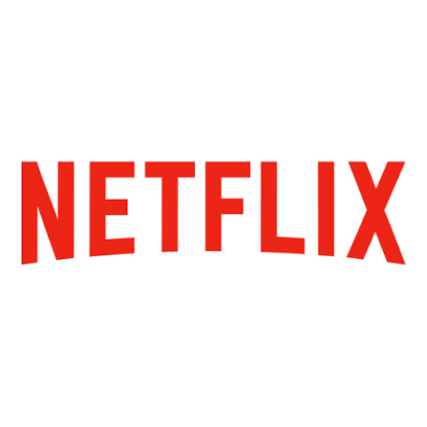
Figure: Netflix (Netflix, 2023)
In the current day world of business, Management accounting is important in giving the latest and relevant financial and non-financial data that helps in strategic and operational decision-making for businesses (Muhammad, Sophia and Shetty, 2025). These features, including cost analysis, budgeting, variance analysis, and performance measurement, also help managers in industries with significant variable content, like streaming entertainment, to maximise high fixed content expenses, review pricing options, optimise resource use, and adapt to changing macroeconomic conditions and competitive factors (Hussain, 2025). In the context of Netflix's high investment in content and expansion into new international markets, managing accounting is key to ensuring profitable growth.

Cost Analysis and Business Model
Business Model
Netflix's strong business model is based on the subscription-based revenue model. Most of its revenue comes from monthly membership fees on its streaming offering, which has a variety of pricing tiers designed for various tiers of consumers and geography (Li and Duan, 2024). By 2025, offers are available as far back as the U.S. dollar equivalent of some $1 to $37 per month, with options for additional sub-accounts for members and an ad-supported tier for extra value. This flexible pricing model helps Netflix increase the market penetration whilst also enabling it to benefit from various willingness-to-pay segments (Rizzo, 2025). In 2025, streaming revenues reached $45.18 billion, a 16% increase from $39.00 billion in 2024. Strategically developed, but somewhat insignificant, supplemental revenues include ad tier ads, consumer products and live experiences (Netflix, 2026).
Cost Analysis
The company's cost analysis is described by high fixed costs, typical of the streaming entertainment industry. Cost of revenues is the largest expense, representing an outlay of about $23.28 billion in 2025 (Netflix, 2026). Netflix costs a significant amount in the short term, but is mostly fixed, owing to multi-year licensing arrangements and production engagements (Castillo, 2018). Important content investment is crucial for retaining members and being competitive, but it also affects the operating leverage of Netflix; that is, producing or licensing content once will replicate each marginal dollar of that content delivered to a new user, which is quite low.
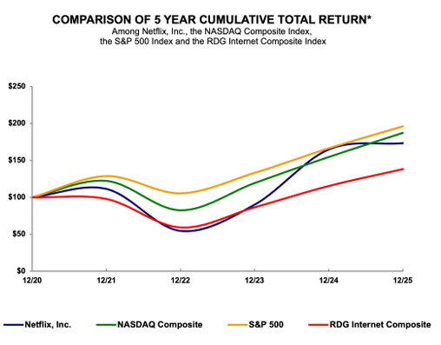
Figure: Return Growth of Netflix (Netflix, 2026)
Technology and development ($3.39 billion), sales and marketing ($3.30 billion), and general and administration ($1.89 billion) are other operating expenditures (Netflix, 2026). Some of these are more predictable in nature, such as payment processing fees, streaming delivery bandwidth, and performance-based marketing, which vary according to growth and utilisation of the membership, but most of them are fixed commitments. This is because both new subscriber acquisition and retention are crucial to enhancing profitability.
Netflix clearly has a positive economy of scale. Margin expansion as the size of the membership base increases will normalise the fixed content and technology costs in a larger revenue base (Szalkowski and Johansen, 2025). This led to an operating margin of 29.5%, compared to 26.7% in 2025. But it has its drawbacks. The difficulty of complying with costly content commitments when growth tone lags, and the requirement for ongoing investment to secure against strident competition from other streamers.
Management accounting tools are, accordingly, crucial to Netflix to apply optimised pricing, manage content spend and facilitate data-driven decisions on content renewal and new investments, such as cost-volume-profit analysis and contribution margin evaluation tools, which will be useful here (Liu, 2024).

Budgeting and Financial Planning
Netflix is a subscription-based film streaming company, so they have budget projections for content, marketing, technology infrastructure and operating margin expectations on an annual and quarterly basis (Yuan, 2023). Budgeting enables strategic goals to be met, including global content expansion, advertising enhancements and operational efficiencies. Management carries out flexible budgeting and rolling forecasts to meet fast shifts in market responses from subscribers, the dynamics of competition, and the foreign exchange market (Prakash et al., 2024). Netflix continues to be financially disciplined by forecasting a robust operating margin for 2026 and, at the same time, is making massive investments in content (Netflix, 2026).
Netflix earned $45.18 billion in revenue, its operating margin increased from 26.7% to 29.5%, and it proved to be a good budget manager in 2025. The latest figures from Google Finance and the companies show that Netflix's total operating costs for 2025 will be around $31.86 billion, which is an increase of 11.45% over 2024 (Farooque, 2026). For the trailing 12 months ending March 31, 2026, operating expenses totalling $32.95 billion increased 13.47% YoY, and Q1 2026 operating expenses were $8.29 billion, which is a 15.24% increase from Q1 2025 (Netflix, 2026).
Netflix continued to invest heavily in original content and technology development. They are doing so to ensure that member satisfaction and competitiveness are maintained. In addition, the company spent on strategic activities, such as making improvements to its ads platform and other potential LBO transactions (The Strategy Institute, 2025). Overall, efficiency measures, including optimised content amortisation and cost discipline in sales and marketing, held growth in check against revenue.
External macro-economic factors also had a part to play. Reported expenditures were impacted by movements in the foreign exchange rates, but the impact was moderated by constant currency conversions. Upward pressure was driven by wider economic factors, such as production increased by inflation, talent costs, and regulatory demands. Competition among industry players also drove the need for continued marketing investments and content offerings for subscriber acquisition and retention (Tokhy, 2024).
Netflix's application of management accounting is strong overall when it comes to budgeting, meaning it has used variance analysis and improved the margins. This approach helped the company weather the streaming industry's growth and continue to be profitable, even though subscriber figures are not necessarily indicative of long-term strategy. This has helped the company to successfully move through the evolving streaming landscape and keep profitability high, even though subscriber numbers do not always reflect the long-term strategy.

Performance Measurement and Decision-Making
Netflix has a balanced mix of financial and non-financial Key Performance Indicators (KPIs) to measure performance and make decisions. From the 2025 Annual Report and financial platforms, five key KPIs include:
- Revenue Growth: 16% year-on-year in 2025, reaching $45.18 billion (Netflix, 2026).
- Operating Margin: Showed good cost discipline and delivered an improvement to 29.5% in 2025 from 26.7% in 2024.
- Free Cash Flow: $9.5 billion for the full year 2025, fueling liquidity and shareholder returns.
- Paid Membership: A steady increase in paid memberships to 325 million by the end of 2025, with good market penetration.
- Engagement Metrics: Monitor view hours and completion with respect to content to increase retention and guide content investments.
Based on this information, Netflix has made a few strategic decisions. To counteract a soon-to-reach maturity in their developed markets' subscriber base, management implemented pricing adjustments and introduced the ad-supported tier in 2022–2023 (Hsiao, 2024).
This has helped to mitigate some of the negative price effects, but has also established alternative income streams, significant for the ad tier, since advertising revenue has more than doubled in 2025
The company also stepped up enforcement of its password-sharing policy with millions of new paid memberships in 2024–2025. Financial calculations of the retention rate and acquisition costs made this decision. This was based on the financial analysis of retention ratios and new subscriber costs and turning “free riders” into revenue-paying readers at little extra cost to them in the delivery of the content (Delouya, 2024).
On the content side, Netflix invests heavily in originals and licenses, with growth in its operating income and robust free cash flows. The choice comes from engagement metrics indicating that captivating and exclusive content widens the bottom line (Allahham, 2021). Also, substantial buybacks, especially in the fourth quarter of 2025, indicate strong expectations for future cash flow and demonstrate their commitment to returning capital to shareholders.
The decisions highlight the use of financial and non-financial information in management accounting systems at Netflix, such as performance dashboards and strategic variance analysis. The company's emphasis on profitability and sustainable growth has elevated its competitive standing in the market amidst the changes and challenges facing the sector.

Sustainability and Ethical Considerations
Netflix embeds sustainability in its financial decision-making in several ways, particularly through its action-oriented approach that uses a framework of core Environmental, Social & Governance (ESG) principles to inform decisions across its content production, operations and long-term investment activities (Netflix, 2023). To reach these targets, the company has type-2 attested short-term emission reduction targets that aim for a decrease of about 50% by 2030 and for being net zero every year by reducing its emissions and, where necessary, offsetting those remaining by excellent quality natural climate solutions. Netflix's focus was on Scope 1, 2 and 3 emissions, with key areas of progress on greening production, such as carbon-neutral shoots, and on powering their data centres and CDN infrastructure with renewables, in 2024–2025 (Deepak, 2024). The cost-benefit analysis of these initiatives is incorporated into the budgeting of these similar initiatives, and the benefits compared to content costs and operational efficiency to support long-term profitability and stakeholder expectations are NetFlixk2025 ESG Report.
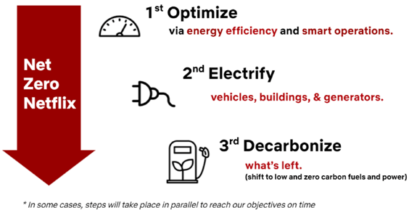
Figure: Netflix’s ESG program (Netflix, 2023)

In the context of management accounting, Netflix is taking actions such as using ESG data for performance measurement and allocating capital towards suppliers and productions that demonstrate sustainability. This will ease regulatory risks and build corporate brand reputation.
Issues of ethics in cost management, pricing policies, and approaches are significant (Ioanid and Iliescu, 2024). Netflix's exceptionally cost-plus-focused original programming business undermines the margins of its producers but has been criticised for failing to give creators a share of the profits and creating labour issues in the industry, such as the guild negotiations it was facing in 2026. The effect of pricing policies, such as tiered plans and password-sharing enforcement, raises issues of accessibility and equity. Although better economic benefits are assured, it can exclude lower-end users in some markets. Further, issues relating to the privacy of data and the quality and cost of algorithmic content recommendations exist, requiring ethical considerations regarding standards for labour practices to consider global management of the costs of production.
It can be concluded that Netflix has taken steps towards sustainability with concrete goals, but needs to further develop an ethical review of the costs and pricing strategy so as not to lose trust with the stakeholders and run into a reputation risk.

Conclusion
Finally, Netflix has managed to effectively utilise management accounting concepts to make its operations viable in its subscription business model and secure financial performance and results of scale in 2025 with $45.18 billion of revenue from streaming services, and an operating margin of 29.5%. They are well on their way to the integration of sustainability, take effective action on high-latex content costs, implement budgeting for margin expansion and make strategic decisions based on important financial and non-financial KPIs. But there is still room for pricing considerations in terms of accessibility, as well as cost management of content.
Recomandation
To bolster its position, Netflix needs to implement Activity-Based Costing (ABC) to improve the content profitability analysis, create a more comprehensive balanced scorecard that includes both standard financial and environmental, social and governance (ESG) measures, and deepen rolling forecasts and scenario planning to control macroeconomic fluctuations and long-term content commitments. These recommendations present a clearer cost transparency, strategic alignment and overall resilience in decision making.

Referencing
Allahham, M. (2021) Netflix: Business Report.
Available at: https://www.academia.edu/45305324/Netflix_Business_Report
Accessed: 10 June 2026
Bhaskar, H.L. and Reeta, E. (2025) Human-centric integration of 6G-enabled technologies for modern society fundamentals, applications, analysis and challenges. Available:https://www.researchgate.net/publication/391572735_Human-Centric_Integration_of_6G-Enabled_Technologies_for_Modern_Society_Fundamentals_Applications_Analysis_and_Challenges
Accessed: 10 June 2026
Business Model Navigator (2026) Netflix business model.
Available at: https://businessmodelnavigator.com/case-firm?id=70
Accessed: 11 June 2026
Castillo, M. (2018) Netflix tries a different model for TV shows, paying more up front but keeping more later, big hits, insiders say.
Available: https://www.cnbc.com/2018/08/15/netflix-cost-plus-model-tv-shows-revenue-upside.html
Accessed: 11 June 2026
Deepak (2024) Netflix’s sustainability.
Available at: https://thesustainableinnovation.com/netflix-sustainability/
Accessed: 12 June 2026
Delouya, S. (2024) Netflix cracked down on password sharing. The result? Millions of new subscribers.
Available at: https://www.cnn.com/2024/04/18/business/netflix-earnings-first-quarter
Accessed: 12 June 2026
DPA (2024) Netflix says its ad-supported plan now has 70 million users.
Available:https://finance.yahoo.com/news/netflix-says-ad-supported-plan-154214781.html
Accessed: 15 June 2026
Farooque, M. (2026) Netflix’s growth plan now comes at a cost.
Available at: https://finance.yahoo.com/markets/stocks/articles/netflixs-growth-plan-now-comes-155920481.html
Accessed: 15 June 2026
Hsiao, Y.-H. (2024) 'The business strategy analysis of Netflix', Transactions on Social Science Education and Humanities Research, 11, pp. 760-767.
Available:https://pdfs.semanticscholar.org/0418/cdfee079cdbf834abd369556b64f1fc6fb43.pdf
Accessed: 15 June 2026
Hussain, S.A. (2025) Mastering financial strategy: a guide to management accounting. Available:https://www.researchgate.net/publication/393495406_Mastering_Financial_Strategy_A_Guide_to_Management_Accounting
Accessed: 15 June 2026
Ioanid, A. and Iliescu, D. (2024) 'Sustainability and profitability in the streaming industry', IEEE Access, 12, pp. 1-1.
Available at: https://doi.org/10.1109/access.2024.3470511.
Accessed: 15 June 2026
Li, R. and Duan, S. (2024) 'Business model analysis of Netflix', Advances in Economics, Management and Political Sciences, 92(1), pp. 285-292.
Available at: https://doi.org/10.54254/2754-1169/92/20231106.
Accessed: 15 June 2026
Liu, J. (2024) 'Financial analysis of Netflix with a strategic approach', Advances in Economics Management and Political Sciences, 68(1), pp. 92-96.
Available at: https://doi.org/10.54254/2754-1169/68/20241360.
Accessed: 16 June 2026
Muhammad, Sophia, J. and Shetty, P. (2025) 'The evolving role of management accounting in strategic decision-making: a study of contemporary practices in data-driven enterprises', International Journal of Research and Scientific Innovation, XII(VI), pp. 1578-1590.
Available at: https://doi.org/10.51244/ijrsi.2025.120600133.
Accessed: 16 June 2026
Netflix (2023) Netflix - environmental, social & governance - ESG information.
Available at: https://ir.netflix.net/governance/ESG/default.aspx
Accessed: 16 June 2026
Netflix (2026) Netflix - financials - annual reports & proxies.
Available at: https://ir.netflix.net/financials/annual-reports-and-proxies/default.aspx
Accessed: 16 June 2026
Prakash, K.O., Abdullah, K.A., Daoud, R., Moulana, Y. and Matriano, M.T. (2024) The budgeting and forecasting analysis and the impact on company financial performance and strategic decision-making: a case of National Finance, Oman.
Available:https://www.researchgate.net/publication/384537685_THE_BUDGETING_AND_FORECASTING_ANALYSIS_AND_THE_IMPACT_ON_COMPANY_FINANCIAL_PERFORMANCE_AND_STRATEGIC_DECISION-MAKING_A_CASE_OF_NATIONAL_FINANCE_OMAN
Accessed: 16 June 2026
Rizzo, L. (2025) Netflix to hike prices on standard and ad-supported streaming plans. Available at: https://www.cnbc.com/2025/01/21/netflix-raises-prices.html
Accessed: 17 June 2026
Simonetti, I. (2026) Netflix earnings: revenue and profit rise as subscriptions top 325 million.
Available at: https://www.wsj.com/business/media/netflix-nflx-q4-earnings-report-2025-6986e192
Accessed: 17 June 2026
Szalkowski, G.A. and Johansen, C. (2025) 'Evidence of diseconomies of scale in subscription-based video on demand services: the case of Netflix',
Available at: https://doi.org/10.1109/access.2025.3561718
Accessed: 17 June 2026
The Strategy Institute (2025) From local to global: Netflix’s strategic approach to worldwide expansion.
Available at: https://www.thestrategyinstitute.org/insights/from-local-to-global-netflixs-strategic-approach-to-worldwide-expansion
Accessed: 17 June 2026
Tokhy, A.S. (2024) The impact of foreign currency exchange rate changes on firm value. Available at: https://doi.org/10.21608/MASF.2024.374399.
Accessed: 17 June 2026
Yuan, C. (2023) A case study of Netflix’s marketing strategy.
Available:https://www.researchgate.net/publication/369398933_A_Case_Study_of_Netflix
Accessed: 17 June 2026

Appendix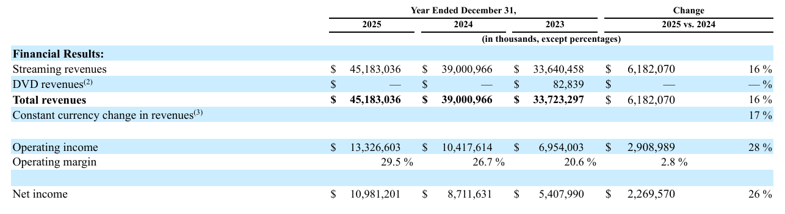

Revenue Figure
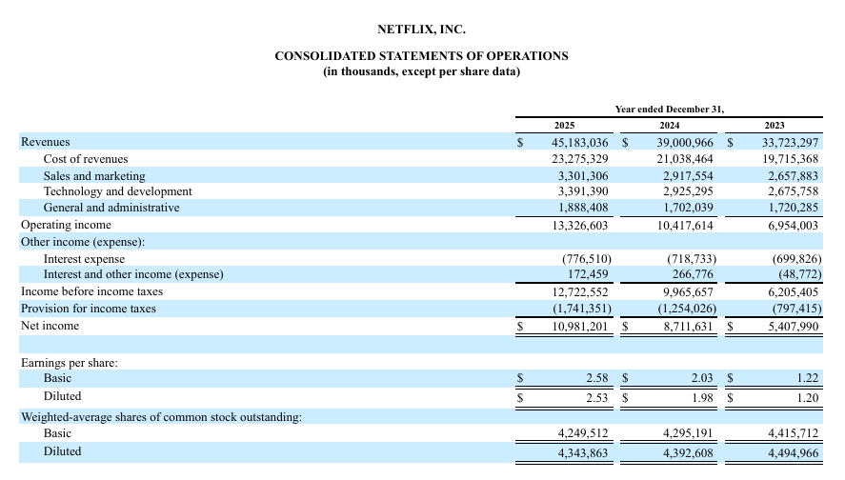
CONSOLIDATED STATEMENTS OF OPERATIONS
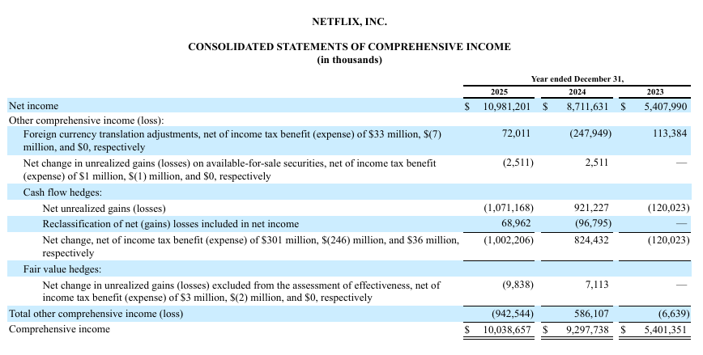
CONSOLIDATED STATEMENTS OF COMPREHENSIVE INCOME
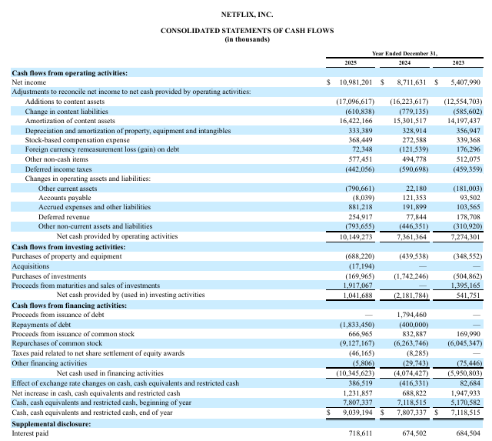
CONSOLIDATED STATEMENTS OF CASH FLOWS
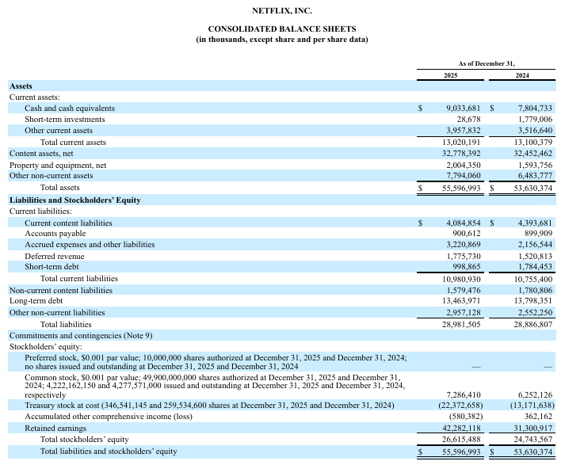
CONSOLIDATED BALANCE SHEETS

