Jessica cox
Student number: 1901525
Visual enquiry 1

For my topic visual enquiries 1 I decided to look at the keeper of the collieries which stands on the top of what was once known as Coegnant Colliery and the Maesteg Washery but is now the spirit of Llynfi woodlands. The keeper is a nine-foot tall and one and a half tonne life like oak sculpture that has been placed in the middle of a new community woodland overlooking the valley. The miner was built in 2005. The public health wales did research into the local population and found that if you live in the Maesteg area and you’re over the age of 50 years old your life expectancy is 20 years less than if you lived further down into Bridgend. Another reason this placed the Keeper where it is now is because there would be less water going into rivers because of planting. When the Keeper was first placed schools from around the community would go up there and plant trees, there may be around 60,000 trees planted around the keeper since he has been placed. School children also planted hundreds of bulbs around the Keeper so come spring he will be stood on a carpet of wildflowers. Everything about the site is designed to be sustainable, even the sculpture was carved from welsh tress that had fallen naturally.

The Keeper was placed in reminder of those who lost their lives when mining in the Colliery’s.
Garth – sunk in 1864 and closed in 1930
Coegnant – sunk in 1882 and closed in 1981
Caerau – sunk in 1889 and closed in 1979
Oakwood – sunk in 1868 and closed in 1928/9
St.John’s – sunk in 1908 and closed in 1985 (the last deep mine in the Llynfi Valley)
The Keeper is built on what was once the mines the Keeper is Neil Thomas who was one of the people who died in the mines. He was put there to look over the community night and day which is what I was trying to show in my photos.
The Llynfi Coal and Iron Co. Ltd. Opened the drift mine in the late 1860s. which is where most of maesteg’s population came where the work brought in more people.
For this project what I wanted to do was to take images of a location that I felt had the strongest meaning in my community. I decided that the Keeper also known as the miner is something that has the strongest meaning in my community because it is a statue that was built to watch over the valley and a reminder of the lives lost down in the mines.to represent this I took photos of the miner in the day and the night to show how the keeper is looking over the valley throughout the daytime and the night. In order to do this, I had to walk up there during the day to take photos I found this difficult because the weather was unpredictable. I found it harder to take the photos in the night because it was cloudy out which prevented you from seeing the stars like I wanted to I took 3 separate trips up there in the night to try and show this but I felt that it didn’t work because each night would be cloudy. However, I am happy with the outcome because you can tell that the images was taken at different times in the day and it shows how the keeper is watching over the valley throughout the day. I also like how airy the night photos look because it shows there is a history.
One person that I looked at for inspiration is the artis Alejandro Duran. What this artist photographs is pollution she is trying to make a change in order to do this she needed to take photos of the problem. For Alejandro Duran to take photos of the problems he sees he went around and collected up all the plastic and placed them in one area that is the most affected and takes photos of all the rubbish there. Although this is not the exact same thing that. Am doing I took inspiration from his work by taking photos of something that has a meaning in my area and that was the keeper and the thing that had the biggest effect on my community
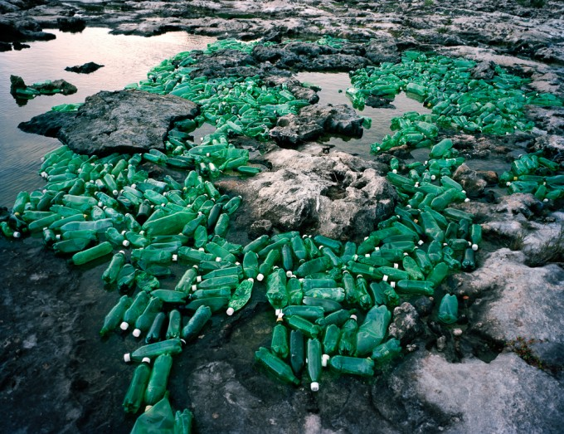

This photo was taken by Alejandro Duran where you can see how he placed the plastic bottles around the ocean rocks. He did this to show the impact of not recycling and to try and change the way that people act. He collected these bottles and used them for his project because these was one of the main sources of rubbish that he found when he collected his rubbish. Overall, I feel that Alejandro Duran links to my work because he looks at taking pictures of things that has a meaning and that is what inspired me to take photos of something that has a meaning around me. I feel that if the water bottles had been placed somewhere different the meaning of it would change dramatically, this is because in the news you hear so much about pollution in the sea and when you see a photo of all the rubbish you can see how the photographer is trying to make you aware of the problem that is happening right now. If the bottles was to be placed on a mountain I don’t think as many people would of taken as much notice of the images compared to how much attention people pay to it now.

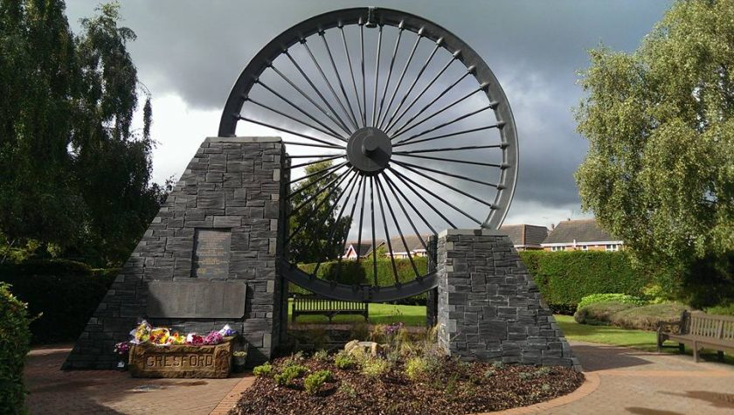

The photo above is a remembrance of those who lost their lives in the Gresford Mining Disaster. The Gresford Colliery disaster was one of Wrexham’s greatest tragedies – with almost every village in the county borough losing someone. On September the 22nd 1934 an explosion took place in the Dennis section of the colliery leading to the death of 266 men. The pit wheel was placed in order to remember those who lost their lives which is why I chose to look the Gresfor Colliery disaster because I feel that this has a huge link to my work. This photo links to my work because when I took my photos, I took photos of the Keeper of the valley which is a statue of a former miner who also lost their life down in the mines. The statue was built to help remember those in my area who lost their lives while mining.

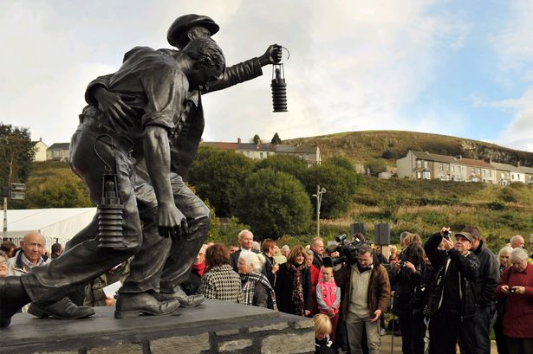
the image above is of a statue that was placed in memories of one of the biggest mining disasters in the UK history, which saw 440 workers lose their lives after a huge explosion. This explosion took place in Senghenydd. The disaster at the universal colliery sent shockwaves throughout the world and is still recognised as one of the worst underground explosions to have happened in history. This happened in 1913 where not just the miners lost their lives but some of the search rescue also. The statue is to shows the danger and sacrifice by those who went underground in search of coal but never returned.

Overall, I am happy with my work because after doing some research I found that there were many statues that has been put into place for a memorial to those who lost their lives while mining. This is one of the reasons why the Keeper in Maesteg was placed to remember those in the valley who sadly lost their lives. I felt that not all my photos turned out the way that I wanted because I wanted them to show stars and because the sky was cloudy it stopped the stars from showing however I like the way the skies look because it shows how the keeper is watching over the valley all day long. I also found that there has been a lot of deaths throughout the mining history due to explosions and feel that the miners need to be remembered for what they did which is why I decided to look at the keeper because it shows a remembrance. I used long exposure to take some of my photos because I wanted you to be able to see the starts at night-time however because of the clouds you couldn’t. I felt that this worked in my favour because while using long exposure it allowed you to see the movement in the clouds which to me told me how the keeper is standing and watching over the valley as time passes and allows you to see the time passing.

