Research Proposal

Student Name: Daniel Davies
Student Number: 1701603
Project Title: Steganography
Supervisor Name: Gordan Dickers

Contents
Introduction / Background to the proposed research 3
Introduction 3
Give your research a working title 3
Describe clearly the background to the subject area of study. 3
Provide the reader with an understanding of the field in which you’re study lies and an idea of where and how your study fits into this field. 4
Define one overarching aim of the study (the research purpose). Construct a series of objectives that specify what you will do to achieve the aim (typically 3 or 4 objectives) 4
Expected outcomes and/or deliverables 5
Conclusion 5
Research and Development Methods 6
Introduction 6
Research philosophy and approach 6
Research strategy 6
Reliability and validity 7
Identify your data collection methods for each objective 7
If relevant, identify and justify any development methods and techniques that you will use as part of systems development. 8
Identify risks/limitations/ethical/legal issues and ways that you might deal with those risks. 8
How will you analyse the data/evaluate your results? 9
Conclusion 10
Resources and Planning 11
Introduction 11
Identify any resources required 11
Construct a Gantt chart that demonstrates evidence of project planning and management. Identify the timescales for each component of the study. 11
Conclusion 13
Bibliography 14
References 14

Introduction / Background to the proposed research

Introduction
Within the first section of the proposal, the type of project which is going to be undertaken will be looked at. Also, the aims and the objectives for the project and the outcome which the completed project will bring.

Give your research a working title
The title for the project is “Steganography – the art and science of hiding messages within messages”

Describe clearly the background to the subject area of study.
Steganography have been around for hundreds of years and was even used by the Greeks, however it has come a long way now and steganography has found its way into the digital world. Steganography is “the practice of concealing a file, message, image, or video within another file, message, image, or video” [1]. Furthermore “Steganography is an encryption technique that can be used along with cryptography as an extra-secure method in which to protect data” [2]. The main point is secrecy as nobody will know that the steganography file contains a hidden message accept the person who is receiving it. This means that thousands of people can look at the file but they will have no idea that there is a secret file. A popular use for a steganography technique is to hide a text file within an image file, this means that the text data will be hidden within the image file.
When this file is then received it can then be extracted so that the person who is meant to receive the file is able to read the secret message with anyone else looking at the file will have no idea that there is a secret message at all.
As Steganography is “hard to crack” [3] and “not widely used” [3] then it makes it the ideal method for transmitting sensitive information through email, over the web and even social media. This is because nobody will be looking for steganography files meaning that it will be extremely secure and even if someone is looking for the files then it will be very difficult to actually “crack” the file.
When it comes to actually hiding the actual file within another file then there are two main methods, these are:
- Adding bits to a file
- Using the “Least Significant Bit” (LSB)
The first method being adding bits to a file, what is meant by this is actually adding the steganography content to another file, this will then intern make the file size bigger. The content can be added to the file header which contains information such as the file type and in the cause of a JPG file then it will also contain information about the resolution and the colour depth. However, it can also be added at the end of the file, as every file contains a defined end point of the file, then the steganography content can simply be added at this point.
The downside to this method that the file which has been modified will have a noticeable difference from the original. This is because the file size will increase in size when the hidden content is added to the original file. If somebody were to gain access to both the steganography file and also the original file then they will be able to tell that there is some hidden content.
The second method being the Least Significant Bit (LSB), with this method instead of adding to the original file the bits of the file are adjusted, what is meant by this is that every byte is made up of 8 bits. However not all of these bits are required, for example to define the colour of a pixel in an image a certain colour does not require all 8 bits. This means that the last bit can be adjusted and will have little to no effect on the file. The hidden content can then be hidden by changing these bits. The reason why this is more secure than the first method is that it is almost impossible to tell the difference from the original file to the steganography file.

Provide the reader with an understanding of the field in which you’re study lies and an idea of where and how your study fits into this field.
The aim of the project is going to be to design and create a program which can hide messages within an image. After the message has been hidden within the image the program should also be able to extract the message. For the creation of the program C++ is going to be used, this is where the study comes in. This is because C++ is a major part of the course meaning that the project is going to fit perfectly with the course.

Define one overarching aim of the study (the research purpose). Construct a series of objectives that specify what you will do to achieve the aim (typically 3 or 4 objectives)
The aim of the study is to provide a program that can be used by anyone to successfully create a steganography file, this file will store some text within an image which it can then be extracted at a later date. To achieve this aim a few objectives will first need to be met:
- Investigate existing programs and investigate how they work
- To design the program and create a prototype
- To design the program and create the program
- To test, analyse and evaluate the final program

Expected outcomes and/or deliverables
After the project has been completed the expected outcome will be a program which can successfully hide a message within a JPEG image will be both designed and built. The program will contain a user interface which will allow the user to:
- Choose what image they would like to hide the image in
- What text they would like to hide within the image
- A way to extract a steganography file which has previously been completed
Accompanying this program itself a report will be created contains a user manual showing how the program functions.

Conclusion
Within this section of the report, the title for the project has been decided with some background for the subject of study has been completed. Furthermore, the aim for the overall project has been set with some objectives which needs to be followed to accomplish this aim. Lastly, all the expected outcomes for the project was looked at.

Research and Development Methods

Introduction
Within the next section of the report first the research methodology that is going to be undertaken will be looked at. Secondly, the development method which is going to be used will also be looked at. Furthermore, any ethical and legal issues which could arise over the course of the project will be looked with any risks that could happen with the project with steps that can be taken to prevent these risks. Lastly, a look at how to know if the aims and objectives have been achieved at the end of the project.

Research philosophy and approach
Before any research and take place firstly an appropriate philosophy will be required. The decided research philosophy is “Positivism”. This has been selected as testing will take place on other similar software and will be used to find out key features with other software, and with an evaluation of other software’s it can then be implemented within the final program and also the prototype. As the positivism approach is all based on a “factual knowledge gained through observation” this makes finding out important details about other software very important. This is because the final program will contain all the best features from all the different software’s which was tested and evaluated.
Moreover, over the course of the project various prototypes are going to be created to test certain features of the final project and to also expand the knowledge of the creator so that the final project will be more polished. This also makes positivism a good choice as positivistic is based on a testing theory.
Now that the philosophy has been chosen it is now important to think about which approach is going to be used for the research. The most appropriate approach is going to be a deductive approach. This is because it is going to be a very structured approach which is key when create new software. It is also because of all data which is going to be produced is going to be valid and is going to be quantitatively measured.

Research strategy
One appropriate strategy which has been decided on is the software development method. This strategy involves developing novel software and testing that it works effectively. This has been decided on as this will not only increase coding skills but it will also make the final program a more professional feel, this is due to having developed a few of the key parts of the final program beforehand. The novel software which will be completed will include features which the final program will have in it, for example this could be writing and testing the code for extracting a steganography image.
Along this this strategy a second strategy will also be used this one is a document review. This strategy involves identifying the main theories in the field. This is because

Reliability and validity
When it comes to researching it is very important for the research to be both reliable and valid. Reliability “refers to consistency” [4], whilst validity “refers to accuracy” [4]. To achieve both of these goals the research which in undertaken must all be accurate (the research is correct) whilst being consistent (the research should be similar through the different sources). For this to be achieved all sources are required to be up to date and trust worthy, whilst being similar with any other research which has been performed.
If the research is not both reliable and valid then it could have massive then it could cause massive problems for the project at a later date. This means that it is going to be very important that all research done is reliable and valid.

Identify your data collection methods for each objective
For the completion of the project various objectives set a few different data collection methods are going to be used these include both primary and second collection methods, with a focus on quantitative and qualitative data collection.
The secondary collection method is going to be used to get information about the product from sources like books and websites etc. This data is going to be used to do all the fundamental research for the project such as:
- To find other similar products
- To find important details about creating software
- To find important information on the project
After the program has been built then a few testers will be asked to test the program. After they have done this they will be asked to fill out an anonymous questionnaire which will then be used to find out key details on their experience using the software and as well as anything which they did not like very much about the program. This will then be used to improve the program and to finalise it. The questionnaire is going be considered as both quantitative and qualitative data collection methods as the questionnaire will involve both open-ended questions and closed-ended questions.

If relevant, identify and justify any development methods and techniques that you will use as part of systems development.
It is going to be very important to decide on an effective development method which will help with the development of the project. For this waterfall development has been decided on as this is because it is going to be very easy to manage this is because at every stage of the it has a specified deliverables and a review process whilst all every stage getting completed one at a time. This makes it very easy to manage what tasks need start and when. It is also very effective when the project requirements are very well understood in which this case they are.
Along with the waterfall model prototyping is also going to be used, this will be used to develop and test various functionality which is going to be used in the final program. The reason why prototyping has been decided on is because it is going to help make the final program more polished as all the features have already been created beforehand. It will also make the final program easier and faster to complete as all the functions have already been created and tested and it will just be case of bringing everything together.

Identify risks/limitations/ethical/legal issues and ways that you might deal with those risks.
There have been a number of issues which have be identified which will require a solution throughout the course of the project. There are going to be a number of different risks which could arise of the course of the project, these risks include:
- Not having the skills to be able to build the prototype and the final program
- The program or prototype itself could be hindered (Hardware failure, natural disaster, file corruption).
- Not enough time to actually build both the prototype and the final program
- Not being able to meet the requirements and objectives due to setting unachievable targets
- Poor time management
These are the major risks which could affect the project, however a few counter measures can be taken to minimise these risks from happening. The first one being that a Gantt chart is going to be created which is going to help with both time management and not leaving enough time to build both the prototype and the final program. This is because everything is going to be planned out what needs doing with deadlines to meet and a reasonable order with the task completion.
The next problem is if the program or prototype itself is hindered in a bad way, this is a very simple fix and involves backing up both the prototype and the final program in different locations regularly. This with lower the chance of anything happening to the files and if something does there are going to be a number of backups.
The next risk is that the skills might not be advanced enough to actually build the prototype or the final program. However, anything which may pose a challenge or out of the creators capability will be able to self-teach the lack of skills. This will then intern increase the amount of time which it is going to take to complete the project. However, this is going to be the main point of the prototype is to learn how to do the different functions which are going to be required for the final program.
The final risk which can arise is going to be that the program does not meet the requirements. To counter this realistic goals are going to be set at the start, and over the course of the prototype one of the requirements may seem to be unachievable then it will be evaluated again before going into the final program.
More onto the legal and ethical issues there are going to be a number of issues which could arise. Currently, the final program and its features are unknown however if there is going to be some sort of account management feature which allows the user to create an account and sign in, this means that privacy is going to be a major ethical and legal issues. This is because a few questions will need to be asked these include:
- Do people know how their accounts are monitored?
- How far does the monitoring go?
The user of the program must know the answers to these questions or it could become a major ethical and legal issue.
If any information is getting stored about the user of the program then it is the software handler who need to make sure that their information is secure and follows the Date Protection Act. If this act is not followed then it can be an ethical and legal issue.

How will you analyse the data/evaluate your results?
Firstly, before the final program can begin development and design stages a proto type will first be created. This proto type will contain most of the key features that the final prototype will contain but it will more than likely not be fully functional and only be used as a learning curve. The prototype will then be evaluated by getting compared to the requirements for the program as well as the aims and objectives which were created at the start of the project. After this it will be tested to see what is working and what need to be improved.
After this, the evaluation which was taken place to the prototype will then be taken in the final project and will help through the development stage. After the program has been completed the same steps will be taken to compare the requirements for the program as well as the aims and objectives. It will then be tested by both the creator of the program, and then later by testers. Their feedback well then be taken in and any changes which a necessary will be done to the program to finalise the program.

Conclusion
Within this section of the report all research techniques as well as any development methods which is going to be used through the course of the project has been looked at. Along with this any limitations, risks, ethical and legal issues which could occur of the course of the project have been looked at. Lastly, a look at how the final program is going to be evaluated.

Resources and Planning

Introduction
Within this section of the report the resources which are required for the completion of the project to be a success will be look at. Accompanying this the project management planning skills which are required will also be looked at.

Identify any resources required
For the completion of the project various resources are going to be required, these resources include:
- PC – This is going to be used for building the program itself as well as any documentation to go with it, all research will also be undertaken on the this device.
- Visual Studio – This is going to be the software that the final program will be developed and completed on.
- C++ - This is the programming language which is going to be used to develop the program.
- Microsoft Word – This is the software which is going to be used to document any important information and to also create the user manual.
- Book on the subject area – The books are going to be used to undertake important research on the subject area.
- Internet – The internet is going to be used to undertake important research on the subject area.
- Testers – Some testers will be required to use the software so feedback can be obtained about the program itself.

Construct a Gantt chart that demonstrates evidence of project planning and management. Identify the timescales for each component of the study.
Planning and time management is a very important part of a project and to help with this a Gantt chart has been created. This plan goes through all the keys steps which are required for the completion of the project. Each of the tasks has been ordered so that they are in order of completion and that all resources which are required are free to use when each step starts. Lastly, dates have been decided and assigned to each of the tasks, with all the dates being assigned a realistic time frame.
All the resources which are required for the completion of the project have all been put within a resource sheet and have been assigned to the tasks which they are going to be required on.

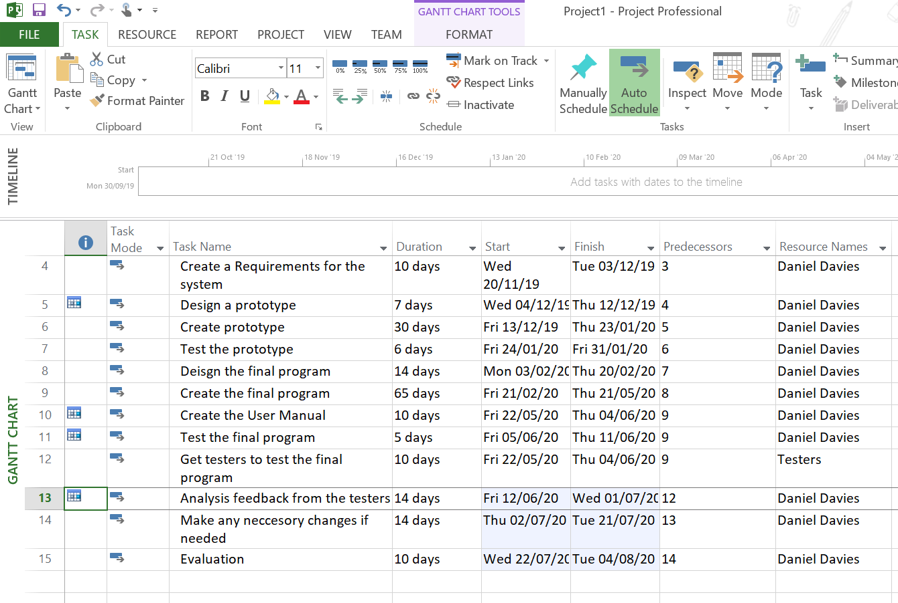

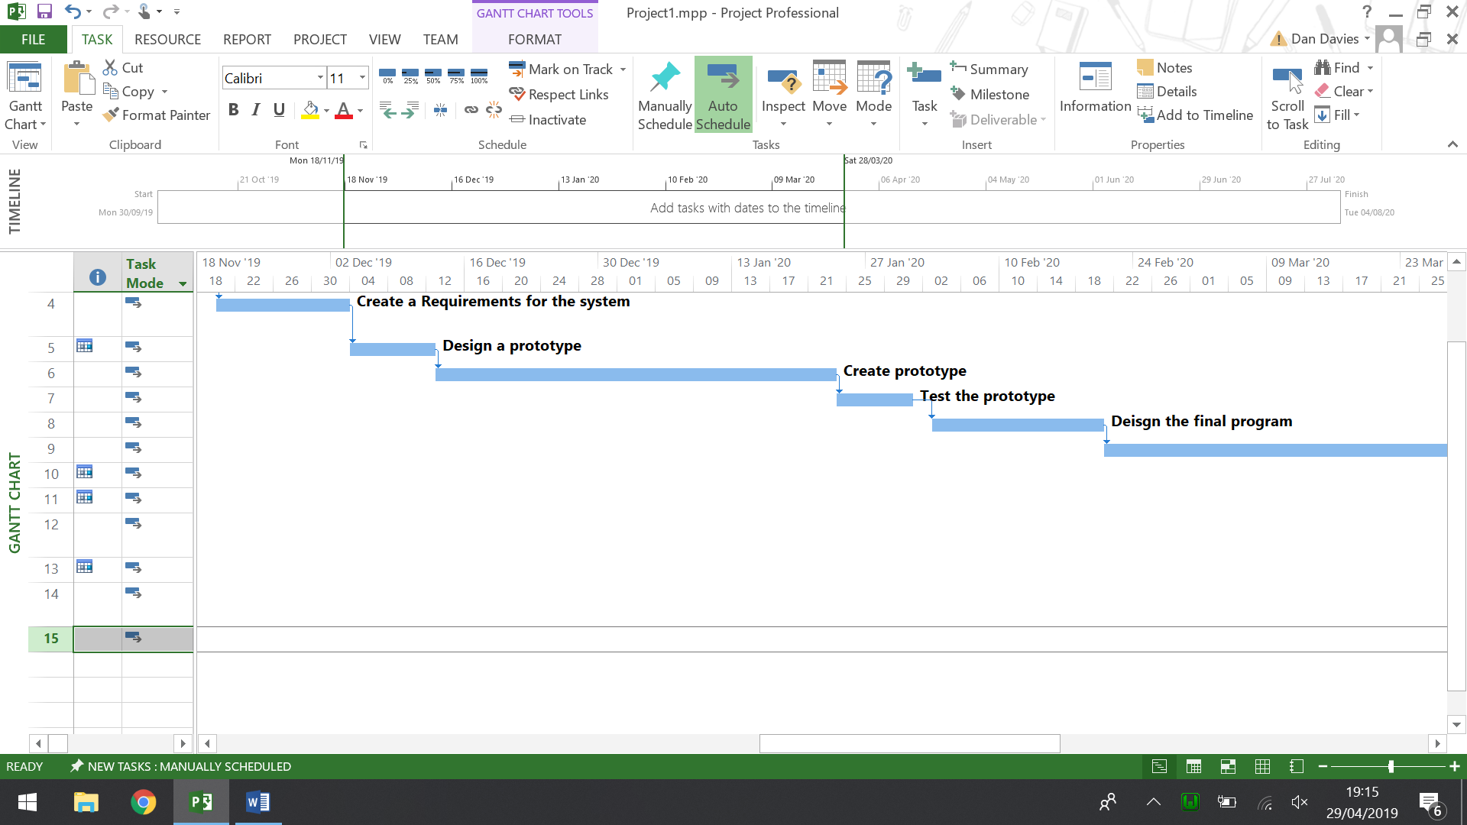

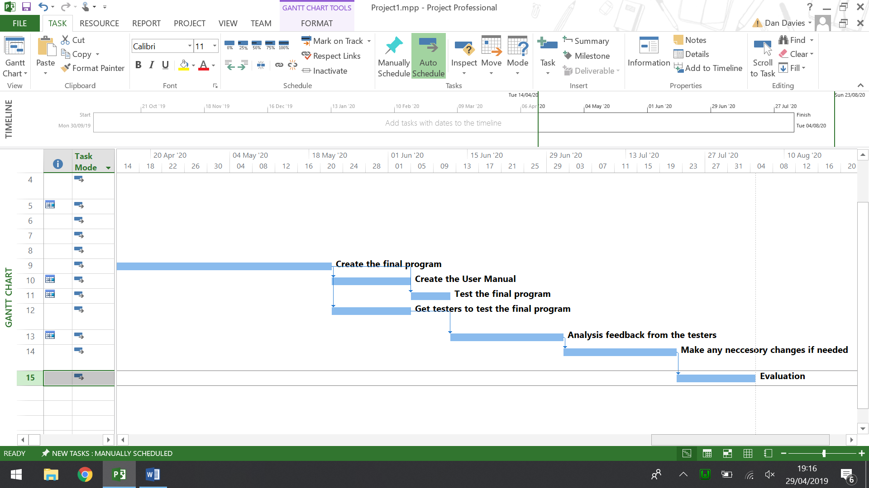

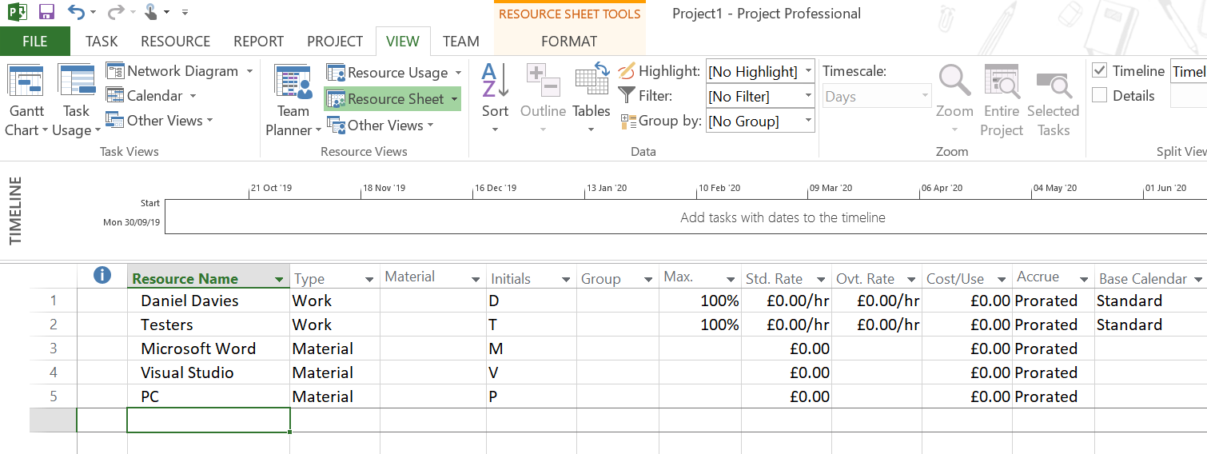

Conclusion
To conclude the resources which are going to be required for the project have all been looked at, it may be possible that a resource may be required which was not thought of. However if any required resources do arise which was not though of then it should not cause too big of a problem and will be easily fixed. Furthermore, the timescale which have been made within the project planning stage are not the final timescale and they will be subject to change once the project starts progressing.

Bibliography

[1] | M. Rouse, "steganography," 12 2018. [Online]. Available: https://searchsecurity.techtarget.com/definition/steganography. [Accessed 28 04 27].
[2] | "Steganography," [Online]. Available: https://www.techopedia.com/definition/4131/steganography. [Accessed 26 04 2019].
[3] | S. Villinger, "Crash course: Digital steganography," 09 05 2011. [Online]. Available: https://www.itworld.com/article/2826840/crash-course-digital-steganography.html. [Accessed 28 04 27].
[4] | "How to Know if a Research Study is Reliable," 03 04 2017. [Online]. Available: https://sites.psu.edu/kmh6360/2017/04/03/how-to-know-if-a-research-study-is-reliable/. [Accessed 30 04 2119].
[5] | "Research strategy," [Online]. Available: https://www.open.edu/openlearn/money-management/understanding-different-research-perspectives/content-section-6. [Accessed 30 04 2019].
[6] | 5. L. a. E. I. i. IT. [Online]. Available: https://www.bestcomputersciencedegrees.com/lists/5-legal-and-ethical-issues-in-it/. [Accessed 30 04 2019].
[7] | "Positivism Research Philosophy," [Online]. Available: http://research-methodology.net/research-philosophy/positivism/. [Accessed 01 05 2019].

References

[1] | M. Rouse, "steganography," 12 2018. [Online]. Available: https://searchsecurity.techtarget.com/definition/steganography. [Accessed 28 04 27].
[2] | "Steganography," [Online]. Available: https://www.techopedia.com/definition/4131/steganography. [Accessed 26 04 2019].
[3] | S. Villinger, "Crash course: Digital steganography," 09 05 2011. [Online]. Available: https://www.itworld.com/article/2826840/crash-course-digital-steganography.html. [Accessed 28 04 27].
[4] | "How to Know if a Research Study is Reliable," 03 04 2017. [Online]. Available: https://sites.psu.edu/kmh6360/2017/04/03/how-to-know-if-a-research-study-is-reliable/. [Accessed 30 04 2119].
[5] | "Research strategy," [Online]. Available: https://www.open.edu/openlearn/money-management/understanding-different-research-perspectives/content-section-6. [Accessed 30 04 2019].
[6] | 5. L. a. E. I. i. IT. [Online]. Available: https://www.bestcomputersciencedegrees.com/lists/5-legal-and-ethical-issues-in-it/. [Accessed 30 04 2019].
[7] | "Positivism Research Philosophy," [Online]. Available: http://research-methodology.net/research-philosophy/positivism/. [Accessed 01 05 2019].

