
Applied Leadership and Management Outreach
Module Assignment Submission
Student Name: | Nicky-J Paton-Lewis
Student Number: | 2315603
Module No: | BMSK4014
Module Title: | Problem Solving and Decision Making

Statement of Confirmation of Authenticity
By the act of making this submission, the student declares that this is the work of the student named above. The work has not, in whole or in part, been knowingly presented elsewhere for assessment, or where assessment has been built on a previous assessment, this has been identified. Where materials have been used from other sources it has been properly acknowledged. If this statement is untrue, the student acknowledges that an assessment offence has been committed.
Attention is drawn to the plagiarism and unfair practice policies of UWTSD.

Table of Contents
Define a complex problem in the workplace, including its scope and impact 4
Analyse information on the identified problem, to help inform the decision making process 4
Propose a range of alternative solutions to the problem 7
Using a decision making technique, evaluate a range of solutions to identify the most appropriate option 7
Develop a detailed plan for implementing the solution. 9
Communicate the plan to relevant stakeholders 10
Assess appropriate monitoring and review techniques to ensure successful 11
implementation of solution 11
References 13

Define a complex problem in the workplace, including its scope and impact

I am currently running a waste removal and scrap collection business. I opened the company back in 2018. At the start it was difficult to get customers but with some persistence I soon picked up regular customers both domestic and commercial. At the beginning it was just myself operating the business but soon after I found myself burnt out and physically exhausted at that point I knew it was time to get a helping hand with me on a day to day basis. In 2019 my good friend Dean joined the team and since then we have gone from strength to strength slowly building the business day by day together as a team. Recently, we have run into a complex problem, the workload has increased dramatically, which is resulting in us doing double the amount of the jobs.
Often, we find ourselves pushing jobs forward a day or two because there are not enough hours in the day. This is dramatically decreasing client satisfaction. This will eventually lead to customers going to other companies for their services and us being seen as unreliable. Sometimes we find ourselves out working until 9 pm at night. This is really affecting both mine and Dean’s work/life balance, we are feeling burnt out on a daily basis trying to keep our customers happy.
.

Analyse information on the identified problem, to help inform the decision making process

To analyse the problem and find solutions, one tool we used was brainstorming. Myself and my employee sat informally and encouraged each other to think of diverse ideas, without criticising each other, however we did find ourselves laughing at each other and had fun whilst doing our brainstorming session. We used mind mapping to record our ideas, this is visually effective as we could see straight away what ideas would work and some that were just ridiculous. However each idea generated another.
Being creative with ideas is made possible through mind mapping which enables individuals to dive deep into their minds to discover unique solutions instead of using the generic ones.
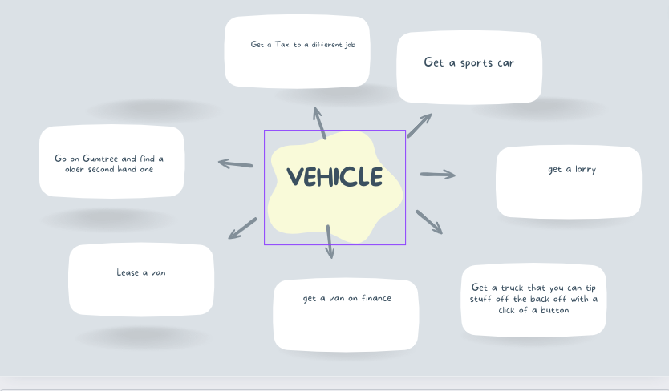

I have also used Benjamin Franklin's 5-Why Analysis (1772) to get deeper into the problem in our business and analyse what may be the cause of the problem. One of Franklin’s lesser-known secrets to his success was his decision-making method. According to his biography, Franklin developed the method when he was in his early 20s. He would continue to use it throughout the rest of his life, guiding him ever forward to success with each decision. Today, it is known as The Ben Franklin Method.

The problem at hand = only having one vehicle leading to not completing jobs on time and client disatisfation.
WHY? Looking for a suitable vehicle that's cost effective
WHY? Commercial vehicles are expensive to maintain and run.
WHY? Because they work hard on a daily basis carrying heavy loads and a lot of mileage.
WHY? Due to the work I undertake in my business it requires me to carry heavy items and to travel to and from jobs.
WHY? Without a vehicle that is built strong enough to carry these heavy loads the job would not be possible.

A fishbone diagram is great for digging into problems. It helps break down complex issues, shows relationships between causes and guides teams to find effective solutions. It's a roadmap for problem solving, making it easier to tackle root causes and improve processes efficiently.

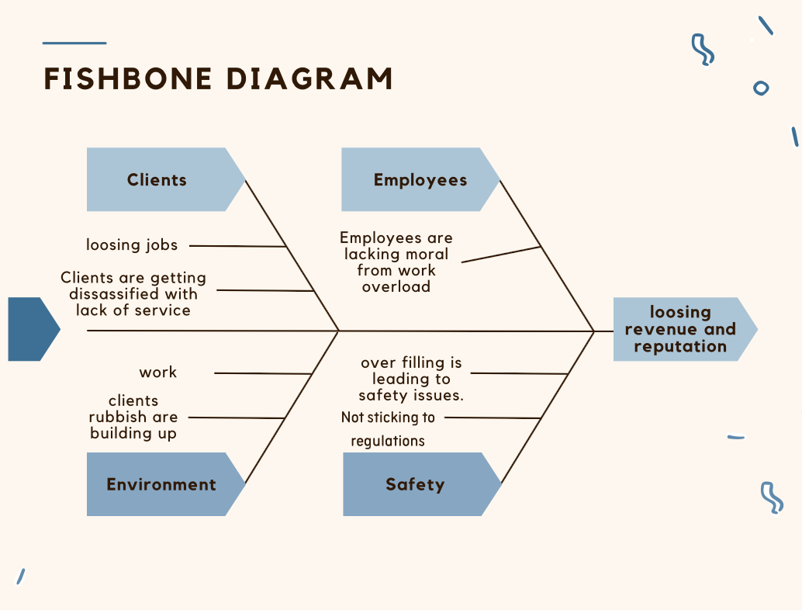

The Ishikawa diagram was invented by Kaoru Ishikawa, who pioneered quality management techniques in Japan in the 1960 s. The diagram is considered one of the seven basic tools of quality control. It is also known as a fishbone diagram because of its shape. The 'fish head' represents the main problem. Wong (2011).

By analysing all the sub-causes of the problem it is possible to increase our knowledge of the problem and identify areas that must be improved. By visually seeing them all contributing to the main problem it is possible to get a clearer picture of the bigger problem. It is also easy to see that a problem of the vehicle not being big enough, and clients dissatisfaction could ultimately lead to all sorts of safety issues as we are overloading the vehicle on a daily basis and putting pedestrians and my employee at risk. The more we dig into the problem the more complex it becomes.

Propose a range of alternative solutions to the problem
As a business run by myself with only one employee we have implemented the brainstorming technique to find alternative solutions as well as some new ideas for the business. Baruah et al (2008) said “Brainstorming means using the brain to storm a creative solution for a problem”. This allowed my employee and I to come up with some strong ideas that could help the business in the long run.
The biggest issue within the business is needing to purchase another motor vehicle. With the purchase of another vehicle there are a few different avenues you can go down such as, buying a vehicle outright, financing a vehicle or buying a second hand one from Gumtree (2000). Gumtree is a free site where individuals can advertise and buy items such as clothes, cars, furniture and much more.

Needing a second vehicle is crucial to my business. I often find myself turning down additional jobs due to lack of transport. The vehicle I currently use is often overloaded and causes spillages. This could cause serious danger. When overloading the vehicle It is going against all the health and safety guidelines that I agreed to when gaining correct licences to start my business.
When looking for ways to expand a waste removal business without immediately investing in another vehicle, several alternative solutions can be considered. One option is to optimise the current vehicle's schedule and routes to increase efficiency. By carefully planning routes and pickups, you can maximise the vehicle's capacity and reduce unnecessary trips. Additionally, outsourcing overflow jobs to other waste removal companies during peak times can help manage demand without the need for a new vehicle. But that would cause us to lose money.
Another approach is to explore partnerships or collaborations with local businesses or individuals who already own suitable vehicles. By forming healthy partnerships that I can potentially share resources and costs, enabling both of us to benefit from the arrangement.
Implementing these alternative solutions can help address the need for additional vehicles in my waste removal business, enabling growth without investing a great sum of money into another vehicle.

Using a decision making technique, evaluate a range of solutions to identify the most appropriate option

To solve the business problem we narrowed down to three possible solutions. We used
Grid analysis, Pugh (1981) to evaluate and analyse each option by giving them weights of what is important to the business such as cost and the impact the vehicle would have on business helped us come to a final desicion.

Grid analysis for the purchase of a vehicle for the waste business.
Factors | Cost | Potential Impact | How does it look | Total
Weights | 4 | 5 | 4
A financed Vehicle | 3 12 | 5 25 | 4 16 | 53
A second hand Vehicle | 1 4 | 4 20 | 1 4 | 28
Purchase of a brand new Vehicle | 2 8 | 4 20 | 3 12 | 40

Although there are some great options to choose from by looking at the grid analysis above, the one that I will purchase will be the financed vehicle. I am choosing to purchase this even though the cost yearly is larger, it will have the greater impact. It will allow me to pay in monthly instalments rather than one lump sum. With undertaking a financed vehicle it comes with a 3 year warranty. This means that if there are any mechanical faults the finance company is required to fix it and get it back on the road. It also looks like a professional vehicle and can show business growth to customers.

Cost is directly related to outcome (or you get what you pay for) Brian, T, Yates (1985)
Cost analysis to show benefits of the financed vehicle.
Items | Year 1 | Year 2 | Year 3 | Total
Financed vehicle | £2,400 | £2,400 | £2,400 | £7,200
Insurance | £1000 | £1000 | £1000 | £3000
cleaning of the vehicle | £240 | £240 | £240 | £720
 |  |  |  | £10,920

I have looked at many different vehicle shops where they offer finance and the most cost effective place I have found is Motorpoint, Swansea. Motorpoint offered a 2024 registration van for £200 per month which included warranty. The insurance for the financed vehicle is £1,000 per year and the monthly upkeep of valeting is £20 per month.
Looking through different sale websites and market places I have found a vehicle which is 14 years old. It is priced at £3,000 to purchase this second hand vehicle and yearly MOT’s of £60. With the purchase of a second hand motor of that age there does come with a lot of cons such as; if it breaks down I would have to pay to get it back road worthy or it may be a high mileage vehicle which could come with engine problems.
To buy a van outright of the year 2024 there would be a one off purchase of £20,000. As it will be a brand new vehicle, vehicles do not need to undertake yearly MOT tests until their 3 year anniversary of its registration according to GOV-UK. However from evaluating this solution it is not one we could approach at this time as we do not have enough revenue.

Develop a detailed plan for implementing the solution.

To execute my final plan of purchasing a vehicle I have used the Gantt Chart as a detailed timeframe to determine the process I will need to go through in order to get the correct vehicle I need for my business. Gantt charts started with a man named Henry Gantt who was born in 1861 and died in 1919. But it was only a few years before he died that he actually created these unique (and extremely useful) charts.
Gantt charts provide a visual representation of the project's timeline, making it easier to understand the next steps in the timeline. Project managers and staff can also see their roles and managers can see potential problems that may arise. charts can be updated to show completed tasks and also to show any new tasks that may be needed for the project to run sucessfully.
Below is a gantt chart to show the relevant steps of the purchasing of the business vehicle.
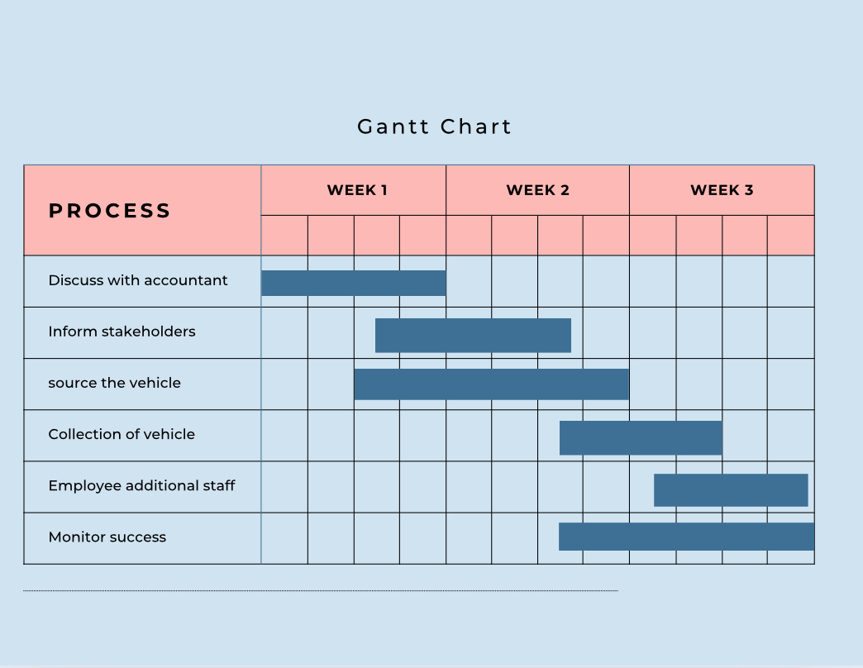

Communicate the plan to relevant stakeholders

I will not need to engage with all my stakeholders but will when necessary with different forms of formailty. By using the Influence - Interest Matrix Mitchel et al (1997) we can assess what stakeholders based on their level of influence over a project or decision needs more interaction.
In my waste removal business, stakeholders play a crucial role in its success and sustainability. Stakeholders are individuals or groups that have an interest or concern in the operations and outcomes of your business. My customers are primary stakeholders as they directly use my business for waste removal services. Their satisfaction and feedback are vital to maintaining and growing my business.
My only employee is an essential stakeholder as he is directly involved in the day-to-day operations of waste collection, sorting, and disposal. Keeping them motivated and well-trained is crucial for the efficiency of your business.
Suppliers of equipment, vehicles, or recycling facilities are key stakeholders. Building strong relationships with them ensures a smooth supply chain and quality service delivery. I always leave a business card with my suppliers as it’s great for others to see that I also use that business to support my own.
Compliance with waste management regulations is essential. Swansea City Council are also considered my stakeholders as they set the rules and standards for my business must adhere to.
My local community where my day to day business operation takes place is a stakeholder. Maintaining a positive relationship with the community by being environmentally friendly and considerate of their needs is crucial.
My accountant plays a big role within my business as he advises me on the most cost effective strategy going forward. We will discuss the project on a monthly basis in a formal setting. We can also use emails to discuss any potential problems and successes.
When discussing the need for additional work vehicles with my stakeholders, it was crucial that I communicated clearly as they are dyslexic. My employee expressed how ideal it would be to have a new vehicle so he could then travel to jobs, price jobs and even finish the work by. I can then stay on the current job or take control of the admin side of the business.

Assess appropriate monitoring and review techniques to ensure successful

implementation of solution

We will know everything is going to plan with the solution to our problem by checking in on the gantt chart on a daily and weekly basis. Myself and my employee will measure success on a daily basis by getting our jobs done on time and gaining our work-life balance back. We will have formal and informal meetings to monitor our sucess. By purchasing the second vehicle on finance we will have to meet the payment deadlines that will be measured monthly. The next milestone will also be employing additional staff members in the allocated time frame. We will update the gantt chart as we go and reach our targets and deadlines.

We can also use a communication plan shown below to plan relevant communication chains, by organising ourselves it gives us a better chance of succeeding in the business.

Communication Plan
What? | when? | how? | Who's responsible? | Who will measure my success?
We can undertake more jobs with additional vehicles. | On-going | I will have informal chats with customers. | Myself and my employee. | Myself
Formal meeting with my accountant on a monthly basis or when relevant. | Monthly | Formal meeting | Myself. | The accountant will measure my success and he will also measure his own success.
Employ additional staff | 2-3 months | I will conduct informal interviews to find the best employee for the job. | Myself. | I will measure this success as well as customers.

References

Baruah, J., & Paulus, P. B. (2008). Effects of training on idea-generation in groups. Small Group Research, 39, 523-541.
Gumtree, (2000) https://www.gumtree.com/?gad_source=1&gclid=CjwKCAjwoJa2BhBPEiwA0l0ImKGZzBgToxwwrvn97seMldtx-xpIUicAok2P-IoV0o6ueNaGzzHSKRoC9V0QAvD_BwE
GOV UK https://www.gov.uk/getting-an-mot#:~:text=The%20MOT%20test%20checks%20that,it's%20over%203%20years%20old
Henry Gantt (1915) https://www.instagantt.com/gantt-chart-experts/what-is-gantt-chart-schedule-uses-and-history#:~:text=Gantt%20charts%20started%20with%20a,to%20show%20a%20project%20schedule.
Mighty Unknown, (2021) To Make Better Decisions, Practice “The Ben Franklin Method” published By Better Advice. https://medium.com/better-advice/to-make-better-decisions-practice-the-ben-franklin-method-fe2d54c85d3d#:~:text=One%20of%20Franklin's%20lesser%2Dknown,was%20in%20his%20early%2020s.
Mitchell, R.K.,Agle, B. R,. and Wood, D.J., (1997). “Toward a Theory of Stakeholder Identification and Salience: Defining the Principle of Who and What really Counts” , Academy of Management Review 22(4).
Pugh, S. (1981). Concept Selection: A Method That Works. In: Hubka, V. (ed.), 'Review of Design Methodology.Proceedings International Conference on Engineering Design, March 1981, Rome,' Zürich: Heurista. p.497-506.
Wong, K.C. Using an Ishikawa diagram as a tool to assist memory and retrieval of relevant medical cases from the medical literature. J Med Case Reports 5, 120 (2011).
Yates, B. T., Haven, W. G., & Thoresen, C. E. (1979). Cost-effectiveness analysis at Learning House: How much change for how much money? In J. S. Stumphauzer (Ed.), Progress in behaviour therapy with delinquents (pp. 186-222). Springfield, IL: Charles C Thomas.

