

BMSW4005

PROFESSIONAL CAREER DEVELOPMENT
MS. MARY MARCH

Student: Dariusz Rzepecki
1916895

Table of Contents
Introduction 3
Important factors of a better career and personal plans 3
Decision-making abilities 3
Leadership 4
Self-motivation 6
Personal SWOT analysis 6
Career plan 7
Personal development plan 8
Conclusion 9
Reference list 11
Annex……………………………………………………………………………………………………..13

Introduction
This report is based on personal development plans and implementation of such plans in order to obtain a proper and stable career. In addition to this, this report is highlighting the exploration of career options, self-motivation, professional development plans, required skills for the workplace, and many more. Moreover, personal SWOT analysis is being done for the purpose of a better understanding of professional as well as personal development plans. This selected report is concentrating on a discussion of reflective study for achieving a better career plan and the ways of execution of such plans are elaborated.

Important factors of a better career and personal plans
In this section, crucial factors are under discussion, a number of skills are known so that personal, as well as the professional development goals, can be achieved. The attributes are discussed in the following part.

Decision-making abilities
This particular skill is very crucial for adopting a better and progressive professional life. Decision-making skills are required to be adopted by each and individual leaders as well as managers as appropriate decisions are effective for the growth of the organisation. As per my job role, I have realised that I need to make quick and efficient decisions as there is no scope of mistakes and any wrong decision will result in a loss of the company.
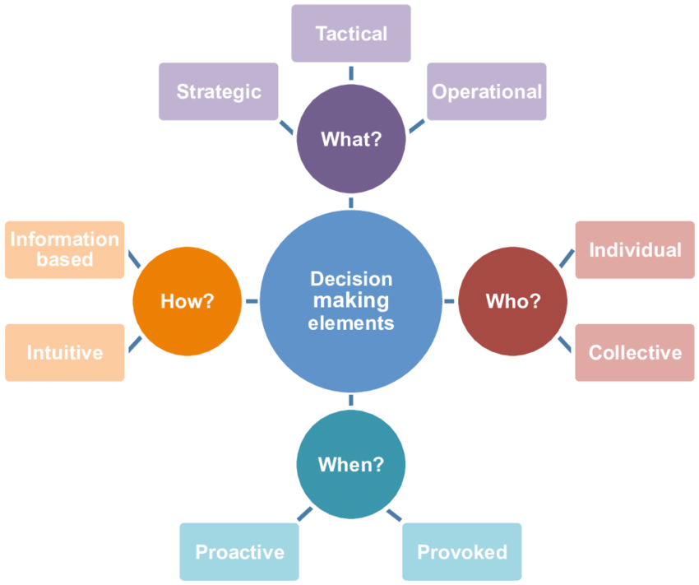
Figure 1: Decision making
(Source: Lent et al. 2017)
This skill is an important aspect in personal life too as there are so many situations that demand quick and proper decisions. Being a transport manager, I need to make some urgent and effective decisions in order to face the crucial situations. As per the requirement of correct decision making, there are some steps to be followed such as identification of the decisions, collection of information, making alternative plans, and many more.

Leadership
As per the opinion made by Rubens et al. (2018), proper leadership is required for managing the organisation in a systematic way. In addition to this, it can be said that there are several responsibilities to be taken in order to assist in the growth of the company. In my personal opinion, it can be said that leadership qualities such as good communication skills, innovative approaches, and many more are important for my professional development.
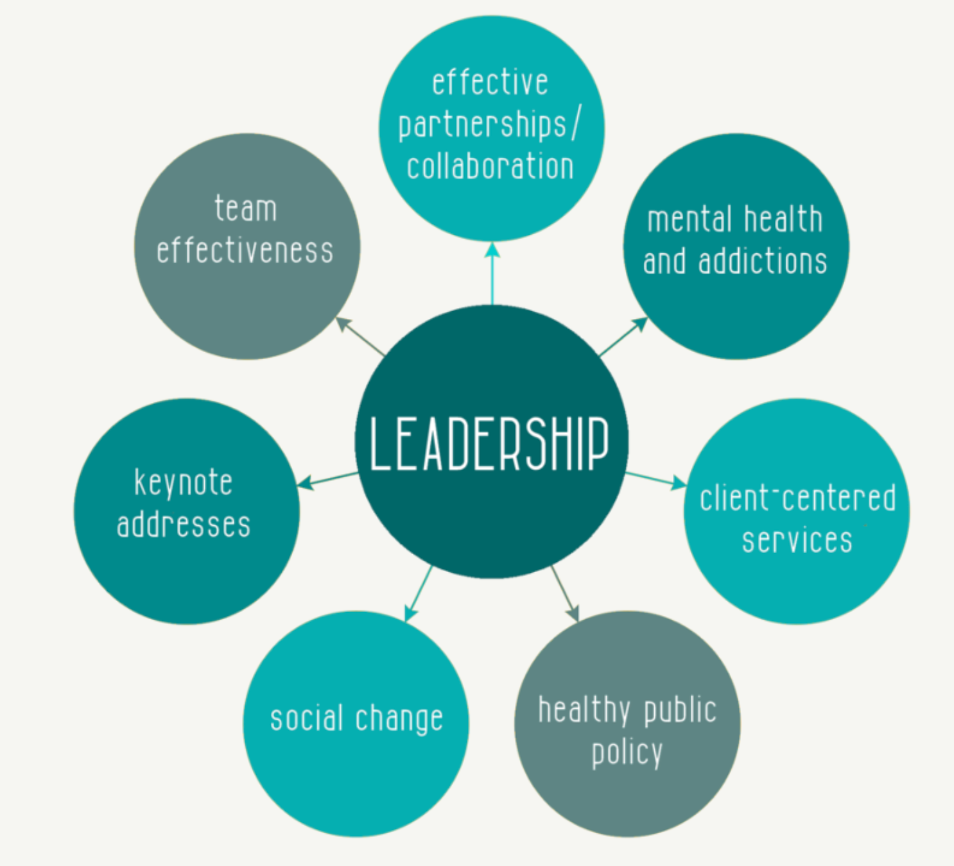
Figure 2: Leadership skills
(Source: Coenders and Verhoef, 2019)
Effective leadership is assisting in motivating other employees so that their ultimate productivity can be enhanced. Furthermore, strategy building is another crucial responsibility of an efficient leader. As per my opinion, leadership can be adopted for becoming an effective transport manager. In addition to this, there are several skills such as good communication, honesty, relationship with other members, and innovation.

Self-motivation
Being a manager, I have acknowledged that self-motivation is an effective attribute that should be present in a leader. At the time of handling tough situations, I need to be self-motivated and it helps to tackle difficult scenarios. From the research of Ismadiyarov (2019), it has been gained that self-motivation is an essential attribute that will drive someone to overcome several drawbacks. The job responsibilities of a transport manager are so tough that there are many difficult situations to decline the confidence level. Self-motivated managers are always positive and the communication skills are helping to influence others so that the employees are more engaged with the job.

Personal SWOT analysis
This section is focusing on the discussion of personal skills with the help of SWOT analysis. Furthermore, as per this analysis, it can be decided that I am efficient as a transport manager or not.

Strength | Weaknesses | Opportunities | Threats
In the list of my strengths, I can include that my communication skills are strong. It helps to support all the employees and I can reach their problems and resolve their respective problems. In addition to this, the motivation level is effectively helping to influence other members so that they are more involved with the specific organisation.  I am confident with my innovative ideas; I can implement such plans for the betterment of the company.  Strong and efficient leadership quality is one of my strongest attributes and I prefer transformational leadership which supports effective changes and creative ideas.  Moreover, it can be said that the collaborative and supportive nature of mine is an important aspect for better growth in the career. | Stress management is a tough task for me as I cannot manage any stressful situation. Due to this reason, it adversely affects my decision-making skills. Added to this, it has been realised that a lack of work experience is leading to face some tough situations. I have to admit that there is a requirement of more technical knowledge so that I can improvise myself. Team handling is another aspect that I need to be more efficient. For example, I can concentrate on one matter so other factors may be ignored. | The weaknesses of the competitors are greater opportunities. I can assure that I have a vast knowledge of the current market scenario so I can adopt the opportunities in quick succession. Added to this, knowledge regarding different organisations is effectively helping to grab the chances of progression. Flexibility to any work culture provides me with greater opportunities. A sense of the global market is another important attribute of mine. In addition to this, I have the idea of perfect timing to enter the market when the company can make maximum profit. | The highly competitive market is a crucial threat. In addition to this, the lack of efficient employees makes the situation tough. The global competition is increased so there is less chance of developing the expansion of the company. The cost of transportation is another threat for me as the transport manager. In the COVID-19 outbreak, the market has been down, the profit level has been declined. In addition to this, effective employees have lost their job and this affects the business performance of the company.
Table 1: Personal SWOT analysis
(Source: created by learner)

Career plan
As per the requirement of the growth of my career as the manager, I have decided to possess some effective plans. This section comprises such plans and the ways are discussed to have a stable and progressive career. According to the study of Hartung et al. (2018), it can be easily understood that an appropriate career plan is effective for the ultimate growth of professional life. Added to this, pursuing the career as the transport manager will be positively influencing and it will help to develop knowledge and skills regarding the position.
From the SWOT analysis, it can be seen that the above-mentioned strengths are clearly essential for the job role. Additionally, it has been stated that my career plan includes practices of proper work culture in this specific industry. One of the major objectives of the career plan is to gather more experiences. Gaining experiences in this particular field will be effective for me to develop my professional goals and the plan includes some strategies such as involving myself in group activities so that I can enhance my sense of professionalism. I require proper guidance of experienced and supportive senior managers; thus, I will acquire the knowledge of this particular field. For the purpose of enhancing the technical knowledge, I will enrol my name in technical courses related to my occupation. In addition to this, my career plan includes utilisation of proper opportunities such as every chance will be grabbed for the growth of my professional life. For the purpose of leading a better career, I have the plan of joining some training and evaluation programs organised by several reputed companies. Thus, an immense knowledge about the current market situations and the effective strategies demanding for this highly progressive market can be adopted.
Professional development training programs are playing a key role in the evaluation of professional maturity as per the requirements of the industry. According to the study of Coenders and Verhoef (2019), it has been clearly mentioned that focusing on the key attributes will help to boost the engagement towards the job. My career plan also includes pursuing professional courses in order to widen my knowledge and this will be assisting in the promotion of my position, the enhancing experiences will be an effective move for the betterment of my career. Thus, the above discussion is elaborating my career plan in brief.

Personal development plan
Apart from professional development in order to achieve a great career, personal evolution is a crucial aspect, it can be said that personal and professional development is somehow interconnected. This section of the report is focusing on personal evaluation plans and strategies. According to the opinions made by Lent et al. (2019), it has been gained that personality development is extremely important for grooming and evaluation of essential skills. The skills that are required to be adopted are good communication skills, critical thinking ability, problem-solving skill, flexibility, adaptability, and many more. In this study, an overall discussion of the requirements of these self-development skills is done. As per my view, it can be highlighted that my communication skill is playing the key role, it helps in grooming and having involved in conversations with others. This actually depicts that I am confident about the statements that I have made. In addition to this, I will practice making my communication skill stronger so that it will create an impact on listeners' minds.
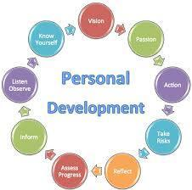
Figure 3: Personal development plans
(Source: Sachs et al. 2019)
Integrity is an effective element of an appropriate personality, and it is not only important for personal life but also in professional aspects, this attribute is a crucial element. I have to make myself a person of integrity so that I can focus on the unidirectional objectives of my life. This can be improved by mental stability, more specifically, fluctuations in choices cannot be entertained. Added to these skills, critical thinking and analysing abilities are included to the list self-development plans. There are several crucial situations where critical analysis is necessary so that the correct decision can be made after judging the scenario. For the purpose of improvement of this particular skill, I need to face more critical situations so that I can improve my analysing capabilities.
As per the study of Sachs et al. (2019), this has been clearly highlighted that self-confidence can help in order to face several issues and it will be an effective element for problem-solving. From my personal analysis, I have realised that I need to work on boosting my confidence level up so that I have decided that I have to take more responsibilities and face more challenges. The more challenges I will tackle, I can enhance my confidence level at the peak. In addition to this, it can be emphasised that self-confidence is another critical aspect for increasing the motivation so that interest and engagement can be enhanced.
In a personal development plan, it must be included that there is a requirement of emotional intelligence (Jackson and Wilton, 2017). Emotional intelligence known as emotional quotient (EQ) is a necessary component for developing personal characteristics and it comprises self-awareness, self-regulation, social skills, and many more. It will be creating an impact on my personal growth and I will be more effectively participating in social activities in order to gain personal goals. From the above personal analysis, I have acknowledged that I have to maintain a proper mission containing several objectives such as communication, productivity, time management, etc. Thus, I can gain the ultimate knowledge of personal development plans in order to achieve my personal goals.

Conclusion
From the above discussion, it can be concluded that this reflective study is based on professional as well as personal development plans. This study is providing an ultimate sense of professional objectives with the help of the above-discussed career plan of mine. As per the SWOT analysis, personal key skills are elaborated. In addition to this, self-development plans are being discussed in this report, and an idea of the requirement of these plans has been gained.

Reference list
Rubens, A., Schoenfeld, G.A., Schaffer, B.S. and Leah, J.S., 2018. Self-awareness and leadership: Developing an individual strategic professional development plan in an MBA leadership course. The International Journal of Management Education, 16(1), pp.1-13. Available at https://www.researchgate.net/profile/Bryan_Schaffer/publication/322193806_Self-awareness_and_leadership_Developing_an_individual_strategic_professional_development_plan_in_an_MBA_leadership_course/links/5b4e4144a6fdcc8dae27a1ef/Self-awareness-and-leadership-Developing-an-individual-strategic-professional-development-plan-in-an-MBA-leadership-course.pdf
Ismadiyarov, Y., 2019. THE SPECIFICS OF THE PROFESSIONAL ACTIVITY OF THE MANAGER-INNOVATOR IN EDUCATION. International Journal of Academic Research and Reflection, 7 (6), pp.20-23. Available at http://www.idpublications.org/wp-content/uploads/2019/10/Full-Paper-THE-SPECIFICS-OF-THE-PROFESSIONAL-ACTIVITY-OF-THE-MANAGER-INNOVATOR-IN-EDUCATION.pdf
Leontev, M., 2018. Influence of construction organization project managers’ personal qualities on their professional efficiency. In MATEC Web of Conferences (Vol. 193, p. 05015). EDP Sciences. Available at https://www.matec-conferences.org/articles/matecconf/pdf/2018/52/matecconf_esci2018_05015.pdf
Coenders, F. and Verhoef, N., 2019. Lesson study: professional development (PD) for beginning and experienced teachers. Professional development in education, 45(2), pp.217-230. Available at https://www.tandfonline.com/doi/pdf/10.1080/19415257.2018.1430050
Hartung, P.J. and Santilli, S., 2018. My career story: Description and initial validity evidence. Journal of Career Assessment, 26(2), pp.308-321. Available at https://journals.sagepub.com/doi/pdf/10.1177/1069072717692980
Lent, R.W., Ireland, G.W., Penn, L.T., Morris, T.R. and Sappington, R., 2017. Sources of self-efficacy and outcome expectations for career exploration and decision-making: A test of the social cognitive model of career self-management. Journal of Vocational Behavior, 99, pp.107-117. Available at https://isidl.com/wp-content/uploads/2017/10/E4975-ISIDL.pdf
Jackson, D. and Wilton, N., 2017. Career choice status among undergraduates and the influence of career management competencies and perceived employability. Journal of Education and Work, 30(5), pp.552-569. https://uwe-repository.worktribe.com/preview/902292/Undergraduate%20career%20choice%20status%20revised%20final%20%281%29.pdf
Meoli, A., Fini, R., Sobrero, M. and Wiklund, J., 2020. How entrepreneurial intentions influence entrepreneurial career choices: The moderating influence of social context. Journal of Business Venturing, 35(3), p.105982. https://www.researchgate.net/profile/Azzurra_Meoli/publication/336717732_How_entrepreneurial_intentions_influence_entrepreneurial_career_choices_The_moderating_influence_of_social_context/links/5daeca07a6fdccc99d92adf5/How-entrepreneurial-intentions-influence-entrepreneurial-career-choices-The-moderating-influence-of-social-context.pdf
Rubens, A., Schoenfeld, G.A., Schaffer, B.S. and Leah, J.S., 2018. Self-awareness and leadership: Developing an individual strategic professional development plan in an MBA leadership course. The International Journal of Management Education, 16(1), pp.1-13. https://www.researchgate.net/profile/Bryan_Schaffer/publication/322193806_Self-awareness_and_leadership_Developing_an_individual_strategic_professional_development_plan_in_an_MBA_leadership_course/links/5b4e4144a6fdcc8dae27a1ef/Self-awareness-and-leadership-Developing-an-individual-strategic-professional-development-plan-in-an-MBA-leadership-course.pdf
Sachs, J.D., Schmidt-Traub, G., Mazzucato, M., Messner, D., Nakicenovic, N. and Rockström, J., 2019. Six transformations to achieve the sustainable development goals. Nature Sustainability, 2(9), pp.805-814. https://static1.squarespace.com/static/5d59c0bdfff8290001f869d1/t/5ef259c6c02ec610aaa78c70/1592941001445/Sachs+et+al+%282019%29_Six+Transformations+to+Achieve+the+SDGs.pdf

Private & Confidential
Application for Employment

To ensure that you are able to complete the application form in full, please refer to the short-listing criteria on the job description.
Position Applied For | Transport Manager
How did you learn about this vacancy? | workplace

1. Personal Details
Title | Mr
Surname | Rzepecki
Previous Name
Forenames | Dariusz
Address | flat 8 Princess Logde, 39-45 Princess street, Luton
Post Code | lu15at
Telephone number |  |  | Mobile No |  |  | 07871262694
E-mail address | rzepeckidariusz1@gmail.com
National Insurance  Number | SR*****
1a. Additional Information
Do you hold a full, clean driving license valid in the UK? |  |  |  |  | Yes |  | yes |  | No
Do you have the right to work in the UK without restriction?  (Proof of right to work in the UK ID will be required) |  |  |  |  | Yes |  | yes |  | No

2. Employment History
The last 5 years employment should be detailed, including any gaps in employment.
Please continue on a separate sheet if required.
Current or Most Recent Employment
Employers Name | Poundland
Address | Fourth Ave, Harlow
Postcode | CM195AA
Job Title | Lorry driver
Dates of Employment | From |  | 01.09.2017 | To |  | Date
Reason for leaving | promotion |  |  | Salary |  | x
Brief outline of main responsibilities and key duties | Vechicle check, driving lorry, unloading, store deliveries, paperwork

2. Employment History
The last 5 years employment should be detailed, including any gaps in employment.
Please continue on a separate sheet if required.
Current or Most Recent Employment
Employers Name | Brakes
Address | West, Flex Meadow, Pinnacles, Harlow
Postcode | CM19 5TJ
Job Title | Lorry driver
Dates of Employment | From |  | 01.02.2016 | To |  | 01.09.2017
Reason for leaving | better work conditions |  |  | Salary |  | x
Brief outline of main responsibilities and key achievements | Pub deliveries, unloading, paperwork

Previous Employment
Employers Name | SEVA
Job Title | Lorry Driver
Dates of Employment | From | 01.2015 | To | 01.2017
Reason for leaving | better wage |  | Salary
Brief outline of main responsibilities and key achievements | collection from customers and deliveries, paperwork, unloading, securing load and vechicle checks

Previous Employment
Employers Name
Job Title
Dates of Employment | From |  | To
Reason for leaving |  |  | Salary
Brief outline of main responsibilities and key achievements

Please continue on a separate sheet if required.
3. Formal Qualifications and Training & Development
Continue on a separate piece of paper if required. You will be required to provide original qualification certificates if successful.
Secondary Education Qualifications
Name of Qualification | Date Gained |  |  |  | Level | Grade |  | Awarding Body
High scool in Poland | 24.06.1995 |  |  |  |  |  |  | Jan 3 Sobieski

Further/Higher Education Qualifications
Name of Qualification | Date Gained |  |  | Level |  | Grade |  | Awarding Body

Professional Qualifications
Name of Qualification | Date Gained |  |  | Level | Grade |  | Awarding Body
Class 1 and 2 lorry driver  Body Building Trainer  Forklitf course-licence | 24.06.2019  10.09.2015  05.03.2014

CPD / Training and Development
Brief description / course title |  | Date Taken

4. Interests and hobbies
Please provide details of your hobbies / leisure activities / voluntary work
Sport:
Cycling
Gym
Table tenis
Boks
Thai boksing
Kick boksing
Hiking
Voleyball
Basketball
Fishing
ice skating
skiing
snowboarding
Automotive:
restoring vintage and youngtimmer cars

5. Referencing
Referencing required for 2 full years (with a minimum of 2 references). At least 1 reference should be your current of most recent employer. Please confirm any existing personal / family relationship with existing PRC employees
References (Current or most recent employer)
Name of Referee | Anna
Job Title | Transport menager
Employers Name | Poundland
Address | Fourth Ave, Harlow
Postcode | CM195AA
Telephone Number | 07787158974 |  | Ext. Number
E-Mail Address
Are you willing for this referee to be approached prior to interview? | Yes x No

References
Name of Referee | James
Job Title | Flow menager
Employers Name | Brakes
Address | West, Flex Meadow, Pinnacles, Harlow
Postcode | CM195TJ
Telephone Number | 7944236293 | Ext. Number
E-Mail Address
Are you willing for this referee to be approached prior to interview? | Yes x No

6. Reason for applying
Please detail below reasons for applying for the position including your skills, experience and attributes.
I see the transprt manager position as a great opportunity in order to step forward in my career path.
I think i have enough experience to understand and manage supply chain also good knowledge about road traffick and how to effectively plan delivery routes.

Please specify how you meet the criteria for this role.

7. Declaration
Please complete the following declaration and sign it in the appropriate place below.
I certify that:
- All the information given to me on this form is correct to the best of my knowledge
- All questions relating to me have been accurately and fully answered
- I possess all the qualifications which I claim to hold
Signed: Date:28.11.2020

Print Name:Dariusz Rzepecki

