Change Makers: Building your Personal Brand for Sustainable Employment

BMHP5015 BSc Health and Social Care
Online Portfolio of Set Exercises

Student Name: Karin Tokarova
Student ID: 2414165

Table of Contents
Introduction 3
Task 1: Employability Skills Audit 3
Task 2: Professional Identity 4
Task 3: Personal Branding In Healthcare 4
Task 4: Communication in Clinical Settings 6
Task 5: Resilience & Wellbeing in NHS Work 7
Task 6: Career Development Plan 8
Task 7: Theory Application 9
Task 8: Reflective Practice 10
Conclusion 11
References 13

Table of Figures
Figure 1: NHS Core Skills Framework diagram 4
Figure 2: 6Cs model 5
Figure 3: Digital professional identity in healthcare 6
Figure 4: SBAR communication model diagram 7
Figure 5: Occupational burnout cycle in healthcare 8
Figure 6: Integrative employability model infographic 10

Introduction
The UK health and social care system is also offered on a long-term basis of workload pressure, and the NHS England study demonstrates that the shortage of the frequency of providing frontline care persists both within the hospitals and in the community setting (The Health Foundation, 2025). In that sense, the NHS Healthcare Support Worker employment opportunity is at the centre of producing patient-centred care, assisting clinical teams, and ensuring continuity in high-pressure scenarios. This is a critical reflection portfolio on employability skills and development of a personal brand and professional identity in accordance with the values and expectations of the NHS. Latest employment data indicate the structural imbalances between the demand and capacity of the service and put forth a solid case in support of qualified and dynamic health care professionals (NHS, 2024). The portfolio will pursue reflective thought about communication, resilience, and career preparedness that will generate interpersonal growth and career fit. An emphasis is placed on the creation of a respectable professional archetype that adheres to NHS competencies and ethical standards and demonstrates critical awareness of employability criteria in contemporary healthcare systems.

Task 1: Employability Skills Audit
The NHS Healthcare Support Worker role will be required to be able to fit within the NHS competency frameworks, such as the NHS Core Skills Framework, and particularly, communication, teamwork, and duty of care (Lewis et al., 2024). Comparative analysis implies that, although NHS services report a workforce of more than 820,000 employees, ongoing shortages and 125,000+ positions in health and social care indicate that, rather than an increase in the workforce, there is a long-term imbalance in skills.
The self-assessment demonstrates that there are strengths in interpersonal communication and empathy that fulfil the expectations of patient-centred care. However, time management under pressure and limited exposure to the clinical setting may restrict operational performance in over-demand settings. This indicates a partial mismatch between current and expected NHS adaptability, resilience, and responsiveness to unforeseen care situations.
More importantly, the preparation of the NHS position is thus average instead of complete. Workforce analysis evidence indicates that growing demand and complexity of care need not only technical competence but also long-term resilience and reflective practice to help avoid burnout and service delivery inefficiency (Geary, McKee, and Petty-Saphon, 2024).
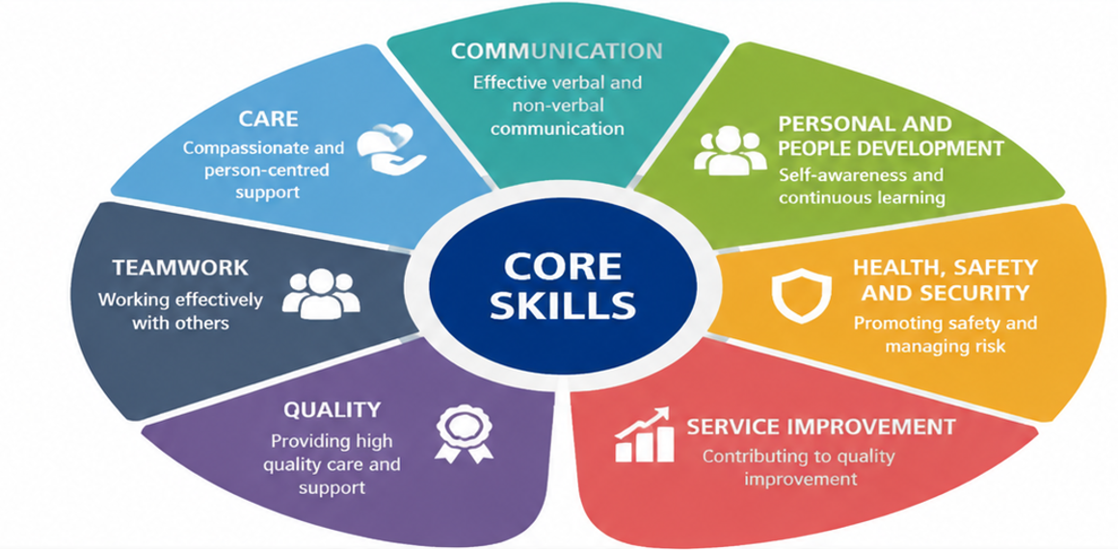
Figure 1: NHS Core Skills Framework diagram

Task 2: Professional Identity
Professional identity in health and social care can be said to be the combination of values, behaviour, and competencies that determine how an individual operates in a care setup, especially in regard to the NHS standards. It is not simply a reference to role description but also a sign of ethical practice, accountability, and consistency in providing patient-centred care. The principles of the NHS, particularly dignity, compassion, and safeguarding, determine my future identity as a Healthcare Support Worker since this set of values is the key to preserving trust and quality within the care delivery process.
More importantly, professional identity is not studied but constructed through training and experience. This is reinforced by the patient-centred care theory that emphasizes more respect towards individual needs and shared decision-making. However, keeping the identity requires a price of unceasing reflection, since in practice in the clinical context, demands and the workplace pressures of emotional labour can challenge the consistency of ethical behaviour and the decision-making based on higher professional values.

Task 3: Personal Branding In Healthcare
It can define personal branding in the context of the NHS as a self-promotional sense of professionalism that can be sub-classified into three areas of competence, ethical values, and anticipations of patient-centred care. In health care practice, it extends the self-presentation and self-effort into continuity of behaviour, communicating and aligning with NHS values, particularly its 6Cs model (NHS England, 2015). This implies that a quality personal brand is not a style, but rather realistic and affects a certain degree of trust and credibility in clinical practices.

Figure 2: 6Cs model
Source: (NHS England, 2015)
Digital resources such as CVs and LinkedIn profiles are becoming more and more diverse in terms of distributing employability, providing candidates with a chance to demonstrate their skills, credentials, and reflective practice. However, when it comes to NHS recruitment, prioritization has been given to the evidence-based competence and behavioural congruence as opposed to self-promotional narrations. The professional behavior, both online and offline, should thus be the same to prevent reputational dissonance.
One of the fundamental requirements of healthcare delivery is relationship-building since patient outcomes largely depend on how professional they are and the quality of communication. The reliability between the patients and multidisciplinary teams will be enhanced by means of digital identity and consistency in workplace behaviour (Wener et al., 2022). However, there are also serious dangers of bad management of digital identity, be it through oversharing, unofficial communication, or masquerading as competent, which can be a disaster to professional trust and employability.
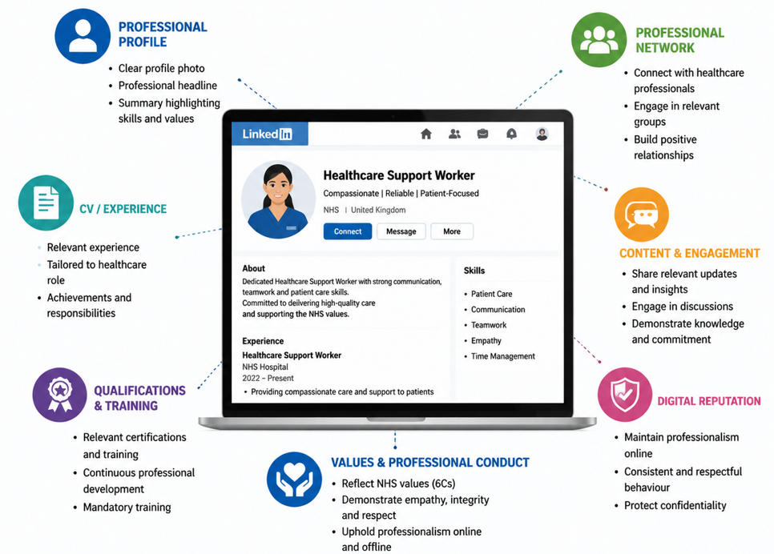
Figure 3: Digital professional identity in healthcare

Task 4: Communication in Clinical Settings
The quality of communication in NHS clinical practice is a determinant of patients' safety, care, and integration of disciplines (MD et al., 2025). The NHS Healthcare Support Worker is supposed to utilize clarity, empathy, and active listening in patient communication so that the care instructions can be taken and anxiety minimized, especially when the patients are vulnerable or experiencing a stressful situation. However, efficiency of communication is not only the personal level of competence but also a systemic demand, such as workload and time constraints.
Timely information sharing between the nurses, doctors, and allied health professionals is also a multidisciplinary teamwork. Inadequate communication during the stage has been determined to be the reason behind clinical errors and reduced continuity of care. Such NHS models as the SBAR (Situation, Background, Assessment, and Recommendation) are designed to normalize the communication; however, they are influenced by the various applications across hierarchical levels.
Obstacles have a serious influence on the quality of communication. Open communication can be hindered, especially by the support workers who are most likely to be anxious with growing issues due to language barriers, emotional pressures of work in acute care units, and hierarchical relations. These organizational barriers emphasize that the nature of the breakdowns in the communication is more interpersonal than organizational (Forat and Salih, 2024).
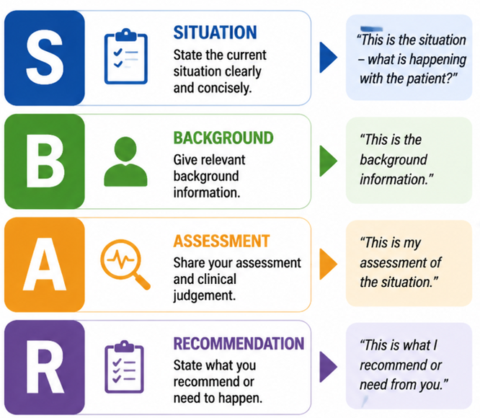
Figure 4: SBAR communication model diagram

Task 5: Resilience & Wellbeing in NHS Work
The areas of resilience and well-being are core to maintaining workforce performance in the NHS Healthcare Support Worker job, especially in the current demand on the UK health services (Qureshi et al., 2023). In NHS England workforce statistics, the number of vacancies in the sphere of health and social care exceeds 120,000, which encourages stress and additional mental torture among the existing workers (NHS Digital, 2025). Such structural deficiency heightens emotional labour as employees are expected to control emotions even as they provide empathetic, patient-based care, typically in high-acuity settings.
The risk of burnout is therefore a recognised problem, which is characterised by emotional burnout, lack of personal achievement, and depersonalisation. Recent Health Foundation actions show that insufficient staffing and growing pressures have resulted in direct pressure and growth in sickness absence and labour loss in the NHS setting (Health Foundation, 2024). That is to demonstrate that burnout is not purely an individual problem, but it is a problem of the system.
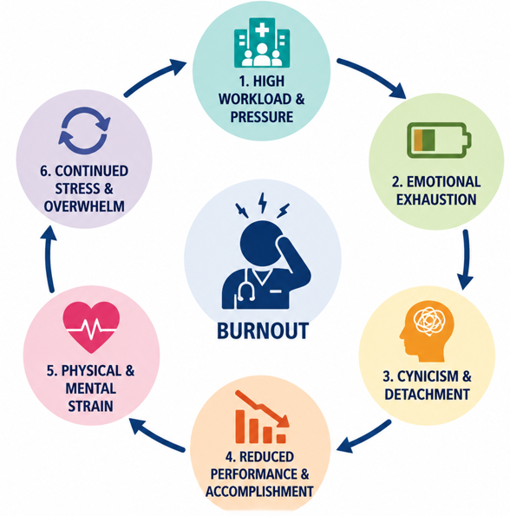
Figure 5: Occupational burnout cycle in healthcare
Various coping mechanisms, including reflective practice, clinical supervision, and peer support mechanisms, are some of the methods used by the NHS that help to build psychological resiliency and professional flexibility. However, their usefulness is based on organisational culture and accessibility, and not availability itself. Notably, my resilience is average at the moment; I am sensitive emotionally, but I am aware of my weaknesses concerning coping with a high-pressure environment, over a significant period of time.

Task 6: Career Development Plan
The NHS Healthcare Support Worker (HCSW) career progression is employed on the principle of competency growth, constant training, and formal career models, such as the NHS Career Framework and Agenda for Change (Griffin, 2022). HCSWs' general practice Band 2-3, and potentially develop into a Band 4 Assistant Practitioner or registered nursing aspirations via further education and clinical practice (Lewis, 2022). Internal advancement of the system is aided by a report of persistent shortage of registered nurses and More than 40,000 nursing vacancies in England alone, which hints at consistent demand to encourage internal progress in the future (NHS Digital, 2025).
HCSWs' training needs include a mandatory induction, the content of the Care Certificate, and training on safeguarding and ongoing enhancements of the clinical skills. These are essential to the safety and adherence to the standards of care delivery suggested by the NHS. Continuous Professional Development (CPD) can, therefore, be non-elective yet written in workforce sustainability strategies (Foster‐Collins, Mattick, and Baumfield, 2023).
My SMART career plan is: (1) in the next six months, gain the Care Certificate to develop my basic clinical competence; (2) 12-month NHS or community care experience to develop applied clinical judgement; (3) in the following three years, complete the nursing associate training to develop clinical responsibility. These are specific, measurable, achievable, realistic, and time-bound targets, which ensure systematic enhancement of employability.

Task 7: Theory Application
To improve employability, the NHS Healthcare Support Worker occupation can be addressed critically using the human capital theory, transferable skills framework, and reflective practice models to meet the requirements of the human capital theory. According to human capital theory, investment in the skilled labour force and training increases worker productivity and labour market value, but in the health care sector, mediated by structural constraints, such as staffing and training (Bykova, Khasanova, and Polonkoeva, 2024). The report of NHS workforce figures observes that skills shortage is an ongoing threat, the number of employment opportunities in health and caring services is above 120,000, and the construct of employability depends on the systemic demand as opposed to personal ability (NHS Digital, 2025).
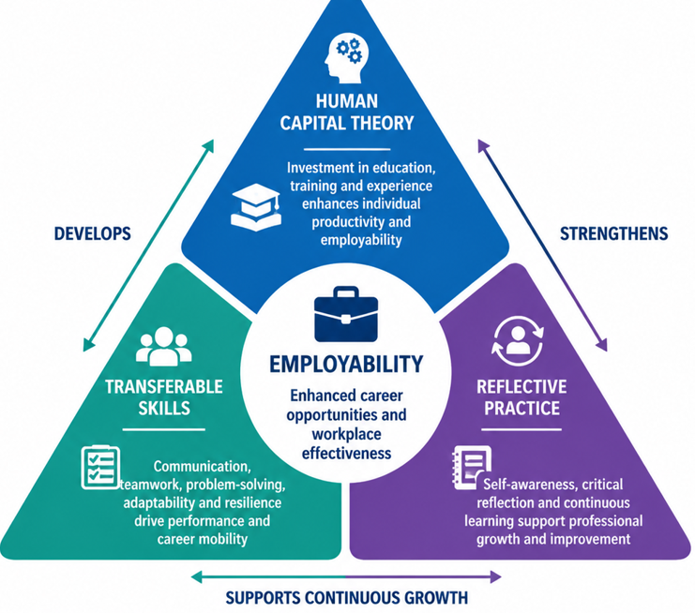
Figure 6: Integrative employability model infographic
The skills learned and transferable are communication, teamwork, and empathy, as they play a crucial role in HCSW practice and directly impact patient outcomes. They are, however, useful in contextual application in high-pressure clinical environments where they may be hampered in their regular use due to time constraints. Reflective practice is also beneficial to employability because, through reflective practice, you have the opportunity to practice self-assessment, and you change all the time, and this corresponds with what Schoen has postulated about experiential learning.
Importantly, though, the theory of human capital is full of linearity in the development of skills; NHS career pathways exhibit non-linearity in which the structures of promotion opportunities are at work. The more approachable model of continuous development is reflective practice, albeit limited by workload and not having protected learning time (Ohikhuare, Oyewole, and Adedeji, 2022).

Task 8: Reflective Practice
Reflective practice is crucial to professional development as an NHS Healthcare Support Worker since, through it, the practitioner can continue to learn and stay abreast of the emerging clinical demands (Sadare, 2024). I have gained skills and knowledge of employability; in the course of this module, my definition of employability has changed to a more critical understanding of the role of competencies like communication, resilience, and teamwork in the functioning of intricate healthcare systems. This satisfies the reflective practitioner model of Schoen that places emphasis on learning through experience and critical reflection of practice.
On the skill front, my level of confidence in knowing what can be transferred across has increased, particularly that of interpersonal communication and empathy, without which nothing will happen in the delivery of patient-centred care. However, self-assessment shows that time management, clinical capacity, and chronic abilities to perform under pressure have been lacking. These vacancies are significant to discuss the NHS workforce pressures, as an ever-growing number of 120,000 health and social care vacancies create additional workload pressures and operational demands (NHS Digital, 2025).
By attempting to address these shortcomings, I will have organized improvement techniques; these will include, but not be limited to, my doing simulated clinical practice, finding mentors, and participating in reflective supervision courses. These are very crucial in bridging the communication between the theoretical understanding and practical expertise.
My readiness to work in the NHS is consolidated, as of urgent importance. Even though the foundation of the employability skills exists, it requires extended exposure to clinical and continuous professional development to reach full role preparedness. My future preparedness to work with the NHS will, therefore, depend on my ability to reconcile reflective learning with positive work experience in order to harness flexibility within high-stress settings of healthcare and professional sustainability in the long term.

Conclusion
This portfolio shows a gradual acquisition of employability skills that fit the expectations of an NHS Healthcare Support Worker. Through a critical approach to communication, resiliency, and professional identity, it is clear that transferable competencies, which include teamwork, empathy, and reflective practice, have been acquired. Building an individual brand has enhanced knowledge of professional expectations needed in healthcare environments, and specifically, NHS values and patient-centred care. Nevertheless, the weaknesses in confidence and operational readiness reveal that further building is needed based on experiential learning and CPD. Overall, the preparedness of the NHS workforce entry is still in progress, and more practice will be required to become fully competent and able to lead a long and fruitful working life.

References
Bykova, V., Khasanova, M., and Polonkoeva, F. (2024). THE ROLE OF HUMAN CAPITAL IN ECONOMIC DEVELOPMENT: AN ANALYSIS OF FACTORS CONTRIBUTING TO ECONOMIC GROWTH. Reliability: Theory & Applications, [online] 19(SI 6 (81)). Available at: https://cyberleninka.ru/article/n/the-role-of-human-capital-in-economic-development-an-analysis-of-factors-contributing-to-eco nomic-growth.
Forat, A.-M. and Salih, Z. (2024). Language Barriers And Their Impact On Effective Communication In Different Fields. International Journal of Advancement in Social Science and Humanity) 2024, [online] 18(18), pp.22–32. Available at: https://ijassh.org/admin1/upload/02%20Dr.%20Al-Mutairi%20Forat%20Zaki%20Salih%2001282.pdf.
Foster‐Collins, H., Mattick, K. and Baumfield, V. (2023). Workplace support for newly qualified doctors and secondary school teachers: A comparative analysis. British Educational Research Journal, 49(5). doi: https://doi.org/10.1002/berj.3879.
Geary, U., McKee, M., and Petty-Saphon, K. (2024). Mind the implementation gap: a systems analysis of the NHS Long Term Workforce Plan to increase the number of doctors trained in the UK raises many questions. British Medical Bulletin, 150(1). doi: https://doi.org/10.1093/bmb/ldae002.
Griffin, R. (2022). Healthcare Support Workers. doi: https://doi.org/10.4324/9781003251620.
Lewis, R. (2022). General practice nurse trainees’ perspectives on general practice nursing as a career choice in the UK: findings from a Vocational Training Scheme in the United Kingdom. [online] www.researchsquare.com. Available at: https://www.researchsquare.com/article/rs-2275862/latest.
Lewis, R., Duckworth, J., Willis, D., and Yarker, J. (2024). Developing a competency framework for integrated care working across healthcare, social care, and allied professions. British Journal of Healthcare Management, 30(1), pp.25–36. doi: https://doi.org/10.12968/bjhc.2023.0106.
MD, F.A., ALDOSARI, H.M.S., Hussein, M., ALANAZI, F.S.F., and ALDOSARI, N.M. (2025). Multidisciplinary Healthcare: Towards an Integrated Model for Improving the Quality of Healthcare Services and Improving Patient Outcomes. Vascular and Endovascular Review, [online] 8(3s), pp.60–70. Available at: http://verjournal.com/index.php/ver/article/view/287.
NHS (2024). NHS Workforce Statistics - NHS Digital. [online] NHS Digital. Available at: https://digital.nhs.uk/data-and-information/publications/statistical/nhs-workforce-statistics.
NHS England (2015). Introducing the 6 C’s. [online] NHS England. Available at: https://www.england.nhs.uk/6cs/wp-content/uploads/sites/25/2015/03/introducing-the-6cs.pdf.
Ohikhuare, O., Oyewole, O., and Adedeji, A. (2022). Public Health Investment, Human Capital Accumulation, and Labour Productivity: Evidence from West Africa. Zagreb international review of economics and business/Zagreb international review of economics & business, 25(2), pp.139–163. doi: https://doi.org/10.2478/zireb-2022-0019.
Qureshi, I., Chaloner, J., Gogoi, M., Al-Oraibi, A., Wobi, F., Reilly, H., Medisauskaite, A., Martin, C.A., Irizar, P., Papineni, P., Lagrata, S., Agbonmwandolor, J., Pareek, M., and Nellums, L. (2023). Caring for Those Who Take Care of Others: Developing Systemic and Sustainable Mental Health Support for the Diverse Healthcare Workforce in the United Kingdom. International Journal of Environmental Research and Public Health, [online] 20(4), p.3242. doi: https://doi.org/10.3390/ijerph20043242.
Sadare, I. (2024). Clinical Research Practitioner: Transformation to a Competent Professional Through Reflective Practice. Nursing and Health Sciences, [online] 26(4). doi: https://doi.org/10.1111/nhs.70009.
The Health Foundation (2025). NHS and social care workforce. [online] The Health Foundation. Available at: https://www.health.org.uk/topics/nhs-and-social-care-workforce [Accessed 2026].
Werner, P., Leclair, L., Fricke, M., and Brown, C. (2022). Interprofessional Collaborative Relationship-Building Model in Action in Primary Care: A Secondary Analysis. Frontiers in Rehabilitation Sciences, 3. doi: https://doi.org/10.3389/fresc.2022.890001.

