Introduction
This report presents the findings of the data collected during my research into Firearms licencing in England and Wales following the tragic events in Plymouth where a firearms licence holder went on a killing spree, the events have triggered a review into current legislation and the application process conducted by police forces throughout England and Wales.
The report will analyse and summarize my findings and present the results based on a questionnaire completed by 74 people made up from my local community and 20 people who were interviewed around the subject, I was conscious not to target people with similar views so I chose candidates who would give a true and honest reflection to my questions.
Twenty people were chosen and interviewed, out of the people interviewed there were members from the British Association for Shooting and Conservation (BASC), local farmers, parish members, NHS workers and neighbours, I have documented my findings and converted the data into chart form for easier dissemination.

Do you think civilians should be allowed to own Firearms in the United Kingdom?

74 people were asked if they think gun ownership should be allowed in the UK, out of these 74 people 26 selected Yes, 46 selected No and 2 people were unsure, the general consciences was that people don’t think civilians should own such weapons, when asked during the interviews there was an array of answers where most reporting they had been influenced by media reports of incidents from other countries such as the United States and New Zealand, only three of the ten people asked mentioned incidents in the UK such as Dunblane and Plymouth.
What would you class as a good reason to own a firearm in the UK?

74 people were then asked to select from four categories what they believed was a good reason to own a firearm in the United Kingdom, 34 people felt that Museums and Antique firearms was classed as a valid reason, while surprisingly only 3 people said they thought private collectors had a justified reason, out of the twenty people who were interviewed 14 said that Vermin control was needed for legal quarry such as Fox, Pigeons and rabbits.
12 people selected sports Shooting / Targets in the survey however there was a strong feeling during interviews that this category should be banned as this was “not” a good reason to own a firearm with three of the interviewees relating to the Dunblane Massacre, their views were that the active shooter Thomas Hamilton was a target shooter and following the review of the incident all handguns were banned and competitions stopped, they feel that rifle shooting should go the same way.
Several farmers were interviewed and all said that Vermin shooting was a valid reason as they have lost hundreds if not thousands of pounds to vermin attacking crops and livestock, one farmer showed me a photograph of a decapitated lamb that was killed by a fox and was very passionate on the subject.

Do you feel gun control in the UK could be stricter?

Out of the 74 people who completed the survey 68 of them all selected that they feel Gun control in the United Kingdom should be stricter with only 4 selecting No, I found this intriguing so this same question was asked to the twenty people who were interviewed, out of the twenty all came back and said they feel that the current gun laws should get stricter, I was surprised as some people who answered yes were also licence holders themselves, they all gave very similar answerers that the very minority of licence holders who don’t abide by the strict conditions make the whole shooting community look bad, licence holders welcome stricter sanctions in an attempt to wean out the bad apples and bring less attention to the sport.

Do you think there should be a law that would ban possession of firearms for recreational shooting?

This was another surprising result where 57 people would welcome a ban of firearms for recreational shooting and only 17 selecting No,
During the interviews it was again surprising to see licence holders expressing their views in favour of a ban, most of the answers felt that vermin control was needed and viewed firearms as a tool to getting this done effectively and humanly, most of the interviewees felt that ownership of firearms just as a hobby should not be granted as there is nothing positive to come from target shooting with noise pollution and the potential of accidents being the most issues raised.
Several people who were interviewed had the opinion that less firearms being owned and less licence holders would lower the chance of further massacres, out of the twenty interviewed only a handful said that they would be against a potential ban on target shooters and said it was their right to choose a hobby that they wanted and should not be dictated or discriminated against if this was their preferred sport, there were several references to the Olympic sport of shooting where there are currently three shooting disciplines.

Do you think civilians have access to larger rifles that currently being used by NATO troops?



Out of 74 people who were asked during the survey if they thought that civilians had access to larger calibre rifles than the military, I was astounded to find that all selected No!
In fact, the two common NATO rounds are 5.56 mm and the 7.62 mm, this size calibre is designed by NATO forces to be a universal round that can be fired from various rifles used by Army’s around the world. There is currently no limit of size firearm that can be owned by civilians in the UK with the same application process for a .22 long rifle, (commonly used for rabbits), to a 50-calibre rifle (used to take out armoured vehicles).
below is the comparison of the two rounds.
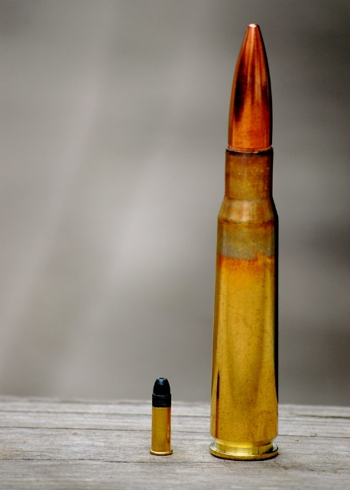
Out of the twenty people who were interviewed all were shocked when hearing that civilians can legally own weapons larger than the military and anyone could apply for those size weapons for recreational shooting.

Do you think that civilians have access to expanding ammunition?

As part of this question firstly I explained what expanding ammunition was, I found a good definition on a Deer stalking forum that defines it as
“A missile designed or adapted to expand on impact causing significant transfer of energy into the target, this ammunition is known as ballistic tip, hollow point, or Dum Dum bullets” (Jones, P 2022).
Expanding ammunition has been banned in armed conflicts throughout the world by the Hague convention of 1899 as it is deemed to be inhumane as it causes significant damage on impact.
Out of the 74 people who answered this question 65 people stated that civilians should not have access to such ammunition with 6 believing they should.
During the 20 people who were interviewed there was a common consensus of shock when told that this type of ammunition was available to civilians however could see the logic when given the reasons for the use, they were told that this is a cleaner kill for the animals that were shot as part of vermin control and would cause the animal less suffering.

What do you feel the main route cause was behind deaths caused by a licence firearms holder?

This question was asked to the 74 people in the survey where the breakdown is shown in the graph above, the same question was used in interview with most answering that Mental health will have a contributing factor towards incident involving licence holders, one of the persons who was interviewed was my local Doctor from my practice and they explained that as part of the application stage the police write to them asking about the applicants medical health and if there is anything documented stopping them from having a firearms licence, All Doctors throughout the country are not happy filling this part of the form as they could be personally liable if that applicant would later use his weapon in a massacre.
All interviewed welcomed a larger input from Health service during the application stages.

Other valid points raised during interviews
There were several persons of the opinion that firearms should be kept in the local police armoury where there would be a signing in / out process with a random breathalyser procedure conducted on sign out, I feel this could benefit the shooting community and give the public peace of mind knowing that gun control would be tightened.
Many Shooters who use their weapons solely for target / recreational uses would welcome new laws to keep their weapons in their respective gun clubs.

Conclusion
On conclusion I found that the bulk of people who undertook the survey and interviews were against gun ownership in the United Kingdom and their views were influenced by media reports of massacrers throughout the world, almost all were shocked to hear that civilians are legally allowed to own larger firearms than used by military soldiers and the use of ballistic tip ammunition is also accessible.
I was shocked to hear the views that all current licence holders welcomed tougher laws and sanctions even though it put their sport at risk, many people felt that there is no place in society for recreational shooting but could see that use of such weapons was justified for vermin control.
Many people who conducted the survey made a direct link with mass shootings to mental health and supported a greater involvement from Health professionals during the application stages.
Word count 1594

