

RESULT

ASSIGNMENT DETAILS AND FEEDBACK
SOUTH WEST WALES CENTRE FOR TEACHER EDUCATION
Student name: | Lauren Arthur | Student P number: | 1301029
Programme: * | PGCE Primary
Module: * | The Enquiring Teacher | Module Level (6 or 7):* | 7
Module code: * | ECPP7001 | Contribution to Overall  Module Assessment (%): * | 100%
Module Lead:* | Catherine Morgan
Assignment Title:* | Write a critical and analytical essay that discusses your practitioner research ‘lesson study’ in relation to a chosen field. | Assignment No (x of x):* | 1/1
Start date:* | 09/01/18 | Submission deadline:* | 16/04/18
Return date of provisional marks & written feedback:*
Sections marked with * should be completed by module lead

Referencing: | In the main body of your submission you must give credit to authors on whose research your work is based. Append to your submission a reference list that indicates the books, articles, etc. that you have read or quoted in order to complete this assignment (e.g. for books: surname of author and initials, year of publication, title of book, edition, publisher: place of publication).
Submission: | All assignments must be submitted to Turnitin unless otherwise instructed by the Lecturer.  Note: the Turnitin version is the primary submission and acts as a receipt for the student. Late submission of the electronic version of the assignment will result in a late penalty. Penalties for late submission: Up to one week late, maximum grade D. Over one week late, Refer. Only the Extenuating Circumstances Panel may grant an extension. | Date: | 16/04/18

Module lead to tick to indicate if a hard copy version of the assignment must be submitted.* | YES
 | NO

Student Self Evaluation Form

This section repeats in brief the common assessment criteria detailed on previous pages. The extent to which these are demonstrated by you determines your mark. Using these criteria, tick the box that best indicates the level of achievement you feel you have achieved with regard to each of them.

Common Assessment Criteria Applied
Common Assessment Criteria Applied | REFER |  | D |  | C |  | B | A
 | OUTRIGHT FAIL | UNSATISFACTORY | SATISFACTORY | GOOD |  | VERY GOOD |  | EXCELLENT
1. Subject Knowledge and Understanding (which includes using research-informed literature and knowledge and understanding of the subject)
2. Intellectual Skills (Analysis)
3. Pedagogic and Professional Applications (Practical Application and Deployment)
4. Key Transferable Skills

PLEASE COMMENT ON AREAS IN WHICH YOU FEEL THAT YOU HAVE PERFORMED WELL | PLEASE COMMENT ON AREAS you feel that you need TO DEVELOP
- Wide range of reading.  - Focusing the discussion on specific elements.  - Clearly structured. | - To be able to synthesis.  - To be able to make my points more concise.

Student’s Name | Lauren Arthur | Date | 15/4/18
Student’s Signature | L.Arthur

How can we improve Self-Assessment through the use of peer interaction in the Foundation Phase?
Name: Lauren Arthur
Number: 1301029
Module: The enquiring Teacher
Submission date: 16th April 2018
Word Count: 6,523

Table of Contents
Aim, focus and purpose of research……………………………………………………7-8
Research Context…………………………………………………………………….….9
Literature Review………………………………………………………………..…...10-14
Explanation of lesson study design……………………………………………..……15-20
Ethical Considerations…………………………………………………………………..21
Lesson Study and Analysis………………………………………………………….22-27
Discussion of research findings…………………………………………………….28-30
Conclusion and recommendations………………………………………………….31-34
Appendices………………………………………………………………………….35-54
References……………………………………………………………………………55-59

Aim, focus and purpose of research
The aim of this research is to conduct a small scale research project to improve a personal area of practice. The purpose of this research is to assess self-assessment (SA), and see how it can be improved with the integration of peer interaction (PI). Abdoe (2017), witnessed within his international study, that often when children self-assessed, their choices were unreliable. At first, I disagreed with the theory of Abdoe (2017) as in my Professional Teaching Experience (PTE) I was amazed to see the amount of SA strategies which were used by children in the Foundation Phase (FP) including colours, characters and similar child friendly stimuli. During the PTE, the focus of children’s SA was of significance and an element of improvement within my practice. Therefore, I felt as if the amount of SA used was of good standard and something which I incorporated into many lessons. Therefore I felt that I had fulfilled the needs of the Assessment for Learning (AfL) which was required for children across the country by implementing this where and when I could (Spendlove, 2015 and Briggs, 2008).
However, when considering Abdoe’s (2017) theory collaboratively with the ideas of Dearnley (2008), I questioned if the children really understood the purpose and importance of their SA to become more visual in their learning (Donaldson, 2015 and Hattie, 2012). Or, are the children implementing the SA strategy because they are told to do so?

It was suggested within Dearnley’s (2008) study that children’s understanding of SA is limited, which could be evidenced by assessing the children’s justification for choosing a certain stimuli. This shared similarities with an example on my PTE where a child rated their work as spider man because they liked spider man as well as similar patterns, instead of the intended justification which presupposes that changes need to be made in order for SA to be improved within the FP.
My partner and I discussed our reflection during our PTE, specifically relating it with SA in our schools and we both drew similar conclusions regarding this focus. Collaboratively, we discussed flaws in SA and the essentiality to improve it due to its significance. From this discussion, and with reference to wider reading, such as those raised by Bellchambers, Erricker and Lowndes (2010), we found that children learn best with interaction and collaboration from others. Thus, giving a sufficient rationale to create the question, how can we improve children’s Self-Assessment through Peer Interaction in the Foundation Phase?

Research Context
The research will take place in FP settings within two large primary schools in West Wales. The first school has 598 pupils on roll and is a pioneer school for the new curriculum. The school is based in an area of deprivation where over 33% of the children are eligible for free school meals (FSM). Within the school 25% of pupils are diagnosed with ALN. The school is very applicant with visible learning and growth mind set (Estyn, 2017a).
The second school has 468 pupils on roll. In the school, 9% of pupils are eligible for FSM. Within the school 19% have been identified with a need for additional support (Estyn, 2017b).

Literature Review
After finding a focus to base the research on, it was important to look into further research to deepen my understanding and consider different perspectives for this particular view point. In order to gain further knowledge, I looked at several journal articles, websites, government documents and a wide range of books from different locations and different time periods. For the purpose of this study, and to gain a critical study, it is essential to gain a wider perspective and differing opinions, as well as how authors worldwide have considered this focus. Within the literature, some reoccurring themes became prominent which relating to the title. These will be explored sequentially, AfL, particularly self-assessment and peer interaction. Due to the limitations of the word count the summary of literature will be a brief summary of key points that have been found.
AfL is an initiative developed by William and Black (1998) which is arguably, one of the most effective strategies to raise attainment within schools, through the use of minor assessment. Specifically, SA is a reflective process requiring children to assess their work to see how their learning has improved and what actions needs to take place to improve work (Boud, 2013). SA has been suggested to allow pupils to be independent, assessment capable learners who are competent in their work whilst also providing resilience (McVarney and Milne, 2014). These skills associate with theories made by John Hattie (2012), where children can be visible in their learning whilst being able to understand and justify their stage in learning. Additionally, Carol Dweck’s (2017) influence with a growth mind set, where children reflect on their work, set their own goals and believe they can achieve. The theory of SA is arguably the most effective tool to accompany Dweck’s (2017) and Hattie’s (2012) theories and to progress children’s learning (Channing and Aubery, 2009).
Looking at this technique in context, it does seem as though the children can be reflective in their work. Yet, Ross (2006) found children, especially in younger years, struggle to identify their next steps. A study by Sackstein (2015) and Burton (2008) found that, particularly in foundation phase, children didn’t fully understand their SA. In particular, it was found that a lack of maturity in young children decreases the chances for understanding the process and purpose of their SA. Additionally, although children do partake in SA, it has been noted that children don’t reflect and act upon feedback and next steps (Peacock, 2014). This draws the question, could a low understanding of SA be a result of a lack of awareness? Or a choice not to engage with SA.
To rectify this, and sharing ideas with Thomas and Lewis (2016), as well as personal experience, a conclusion has been drawn. It is essential to ensure that teachers are explaining the significance of SA, and the benefits it entails on children’s learning in order to expand children’s understanding. Thus, resulting in seeing a positive impact on the use of SA which will be reflected in children’s work. Subsequently, a more child friendly approach could be used to allow children to gain an understanding in a simplistic manner, again, providing possibility for an improvement in children’s understanding of SA (Buck and Trauth-Nare, 2011). Although, during visiting many settings where all of these ideas have been put in place, it doesn’t seem to have been working as effective as what Buck and Trauth-Nare (2011) had hoped. Instead, children wanted to be a certain character, colour or symbol to represent their stage of leaning due to their desire to want to be that character or a likeness to the symbol representation.
In brief, the use of SA in FP may be restricted due to a lack of understanding and awareness for children. It has been found that this could be due to a lack of explanation from teachers, as well as a confusion of the application of child friendly stimuli to engage pupils learning. The subsequent section which will be explored is PI, an element which may play host to increasing the understanding of SA within FP. It is understood that this theme provides similar theory than that of peer assessment, yet it must be addressed that this section focuses on how children work socially with others.
It is a well-known fact that the majority of children are fond to interact socially with others (Argyle 2017 and Welsh Government 2017). The use of social interaction in class can enable young children to discuss the work, and potentially learn something new about a topic (Clarke, 2014). An example of this being effective is talk partners (Clarke, 2009). Social interaction has been suggested as a way of improving student outcomes, confidents and described as a key way to promote active learning (Clarke, 2009). In fact, there are many strategies used in class now that involve enhancing conversation with others as a means to extend our thinking. From this, Runcharoen (2014) suggested that there was a 20% increase in concentration when PI was used.
The use of PI in work may allow children to get ideas from other’s thoughts, providing a model for those who need scaffolding (William, 2011). Yet, Forrester (2014) suggested that using this technique may stimulate children to become lethargic as they become reliant on peer help. From seeing this in practice, a suggestion would be use different AfL as a follow up which may require children to work with different partners and different children to share their thoughts, therefore ensuring that all children are focused and engaged in work. Additionally, the use of an agreed criteria will allow the children to discuss focus points to emphasis discussion on the work with the hope of narrowing distraction (Butler, 2016).
This approach can be related to Vygotsky’s idea of Social Constructivism (SC), where a learner actively progresses understanding about a certain focus with the assistance of the environment in which surrounds them (Mihaela and Mihaela, 2016 and McBlain, 2014). The use of PI allows children to develop essential holistic skills (Dobao, 2017), thus allowing children to learn within their everyday, school life. Correlating to the thesis of Vygotsky’s Social Constructivist Theory.
Examples of the benefits of SC are shown within research conducted by Cole (2018) and Freeman, Eddy and Donough (2014). From this, it may be suggested that using this Vygotskian approach is an effective way to improve the way children learn. Contradicting this, a behaviourist view metaphorically labels a child as a blank slate, where children learn by being passively taught content. Theoretically, this deems relevant as children need pure concentration to understand a new concept. However the theory of SC contradicts the behaviour approach suggesting it is boring. Evidence from PTE and Blatchford, Pellgrini and Bains 2015) agree with SC and the idea correlates with PI.

Explanation of lesson study design
Many, including Glaser (2017) and Arthur et al (2012) argue that research methods is essential when undertaking a research project. There is an array of methods to consider when collecting qualitative methods, yet there are only a few which will support this research. Ideally, this study would critique and explore all methods considered however due to the word count only chosen methods will be explored.
The main form of methodology that will be used is Peter Dudley’s (2014a) lesson study: a form of action research developed in Japan which has rapidly become a crucial reflective tool (Dudley, 2014b). The Teacher Development Trust (2017) identified lesson study as a Japanese model of teacher-led research in which a triad of teachers work together to target an identified area for development in their students’ learning”.
This method has been chosen to allow myself and other teachers to be reflective in practice whilst focusing on a specific element (Dudley, 2014b). This data collection process allows one or more practitioner to collaboratively plan, observe, reflect and act upon a specific focus. Norwich and Jones (2014), argued that lesson study is a way of improving outcomes for pupils, developed on reflection in the classroom. Similarly, an international article from Hamilton and Ploughman (2016) highlighted the benefits of this methodology stating that the reflective process and observations from a new practitioner deems to identify good improvements in practice.
Yet, this methodology does have limitations. Firstly, a small scale South African study used this methodology and found that its ethos can be a very teacher led approach thus going against everything Donaldson (Ono and Ferrier, 2010) suggests. Although the purpose of this methodology is to improve practice, this study found it was too teacher led and there was limited evidence from the child’s involvement to ensure improvement considering the pupils voice (ibid, 2010). This research is a fairly dated study and throughout wider reading it has been seen that they have involved pupil voice more in their research, like from the research Wilson (2017).
From this, two questions have been drawn, that pupil voice should be considered more, or that this study is dated and the results may be different if conducted recently. With all the evidence discussed lesson study has been proven to be an effective tool to improve specifically, teachers practice in order to improve education for children. Yet considering the evidence lesson study is a clear effective way to improve practice, which is the intention, however I will consider the limitations displayed by Hart (2009) and will use the pupil voice to move my practice forward.
The subsequent section will be non-observation participation. This observation requires an observer to witness a specific aspect within research without taking an active part in the activity taking place. It has been suggested that this method has many benefits including getting truthful results without any assistance for the desired outcome. A study from Taylor, Bogdan and DeVault (2015) displayed the researcher being able to draw out data of the specific focus of the research without taking the participants from their everyday routine. This makes it extremely suitable and chid friendly during the research.
Yet, another small scale study drew the limitation that it was difficult to observe their participant as you are observing subtly and from a distance (Punch and Oancea, 2014). From this, it is important to ensure that the observer is in a suitable position and perhaps a few intervals could be included to compensate for any observations missed.
Furthermore, reflection will now be discussed. As the new curriculum draws closer it becomes more apparent that teachers are becoming more reflective with their practice. Ajayi (2014) highlighted the importance of reflective teaching as it shows versatility and willingness for feedback, and improvements for teaching. As well as being good for improving practice this is also a good quality to have as a teacher and is fundamental to be used throughout the daily classroom routine. The thesis of Gibbs (1988), Kolb (1984) and Shӧn (1978) all share similarities with their reflective process, primarily revisiting what was observed, critiquing and acting on the content to improve the desired outcome.
Yet, it must be considered that some of these processes has floors, and due to the limitations of the word count study only one model will be touched upon. Therefore, the study of Gibbs (1988) is seen as an effective model of reflection which is used frequently within research yet this system focuses on feeling and that is not what the essay is aiming to do. Yet the Assisted Reflective Conclusions (ARC) model has been selected because it incorporates good practice and theories from all the mentioned professionals and more. Although I am familiar with using this model throughout PTE, a limitation to this method experienced during practice is that the questions assisting are fairly broad. To rectify this I have tailored the questions on the side to be more specific to suit the reflection process.
The subsequent section to be discussed will be the use of Focus Group Interviews (FGI). Barbour, (2012.p.2) provides a definition of the use of FGI as “generating and analysing interaction between participants, rather than asking them the same question (or list of questions) to each group participant in turn”. This technique has been referred to similarly to interviews, yet it is a much more child friendly approach allowing the researcher to gain perspectives from children whilst they are in company with others (Connelly, 2015). Additionally gaining qualitative data (Cresswell 2007) Fettermann et al (2015) suggests that the use of FGI may provide an opportunity for new ideas to be introduced to research that may not have been apparent prior and as there are more than one in the data collection process it permits opportunity for discussion and debate, thus collecting rich, qualitative data and perspectives. Yet, FGI has been critiqued and described as a problematic approach in research. Albon and Mukherji (2014) found in their study that it was time consuming to annotate and transcribe as well as the complexity in writing down data from a number of participants. Overall, using a FGI seems a reliable source of data collection specifically when working with children, yet you can only question the validity of answers, particularly when answers come from younger children as they may tend to stick to what’s being said. In reference to the limitations, perhaps voice recordings could have been used, if this was the case however perhaps it would be difficult to account for the identity of those who are speaking due to the number of participants (Barbour, 2012). Although there is many positives to voice recordings, it was portrayed by Helen (2015) that this method is time consuming when looking at the data and there is no guarantee that the recorder will record. Yet, due to the relaxed approach a recording device can provide, I feel this would be a good method of data collection with children.
As an element of FGI in this research we will be looking at how the children engage with this work. For this, the Leuven Scale of Involvement has been considered (Laevers et al, 2005).This method will be used as a basis to track engagement whilst the children discuss their work. It is a well-used method with simple criteria to assess their level of engagement. Leuven’s scale has commonly been used to track wellbeing and involvement amongst children and has had many positives for children’s development (Allen and Gordon, 2017). Yet it has been found that it is not always a true representation. There is a gap in research to find a limitation to this method however there are other methods that are just as effective as his scale.
Thomas and McInnes (2017) argues that a sample is essential when conducting research. To collect a sample for the study I will request consent from the whole class so that if the chosen children are absent or withdraw that there will be others who may partake in the research (Appendix 1). Once consent is gained I will select two pairs of two, from different differentiated groups to partake in the research and they will be informed that they can withdraw with no consequence at any time. These children will be selected randomly through consultation with the class teacher to gain a true reflection of the outcome we will retrieve.

Ethical consideration
I have read the ethical code of conduct provided by University Wales Trinity St David’s as well as the British Educational Research Guidelines (BERA) and these guidelines will be followed for the entirety of the research (BERA, 2011). It is essential to note that no child will be treated differently to their normal classroom day and will not be put into any physical or emotional stress. I will obtain assent for all children involved (Appendix 2) and request assent for all in the class as well as getting confirmation from the classroom teacher that the children have given their assent. The children will be informed that they can, at any point, remove themselves from this research with no consequence. I will follow the code of conduct treated with respect so the safety and feeling of participants is paramount. However, with every research projects there are possible risks, for this research there is a possibility that children may feel under pressure. But as the researcher, it is my responsibility to reassure child has right to withdraw and are able to contribute if needed. The FGI will be in a corridor outside the main classroom and the classroom door will be left open and another adult will be present. I will probe open ended questions to ensure I get truthful responses from the children where they can respond as they wish. I will comply with legal requests for confidentiality making sure names are not mentioned and all data is kept on a password protected memory stick. Finally, if a parent or member of the school would like a copy of the final research findings they are entitled to do so after the assignment is completed.

Lesson Study and analysis
The next section will identify what the children achieved throughout the lesson study. Particularly the next section will specifically look at the children’s engagement within the lessons, their reference to their work whilst self-assessing, and analysing their justification of their understanding.
To set a brief context, the first lesson was based on instructional writing where the children were grouped in pairs and each had individual success criteria’s which they would mark at the specified time, to see the lesson plan, success criteria checklist and PowerPoint please see appendix 3, 4 and 5 . The lesson incorporated intervals which the children would self-assess their work and be able to identify what the next steps would be within their learning
To begin the analysis of lesson a focus will be of the engagement of discussion with their peer. As a whole, the children seemed engaged in the pit stops of the lesson. Using the Leauven Scale, as well as with accompanying observations (for the observation schedule see appendix 6) it became clear that through the use of peer interactions, children did become engaged in their discussion which always referred to their work. Particularly, when asking children their FGI questions, three out of the four children who were observed stated that they enjoyed working as group, sharing their stage of work with a friend and being able to together figure out next steps for each other (For transcriptions please see appendix 7). This suggests that the children think that using PI can help them identify areas of improvement within their learning that they may not necessarily have identified when self-assessing alone, it gives the children a chance to be more critical about their SA as when they do it on their own they may glance over the criteria and not thoroughly self-assess.
Yet, Nick’s (Child D) opinion differed from the other focus pupils, whose engagement started to deteriorate towards the end of the lesson. Nick stated that he was happier working alone because it was easier to do so. It may be considered that this is because of the number of pit stops, because at the beginning he seemed very engaged in the discussion for work. Yet it must be considered that all children are different and perhaps this way of working is not suiting every child. Perhaps, the researcher didn’t explain the purpose clearly enough with the benefits of the learning.
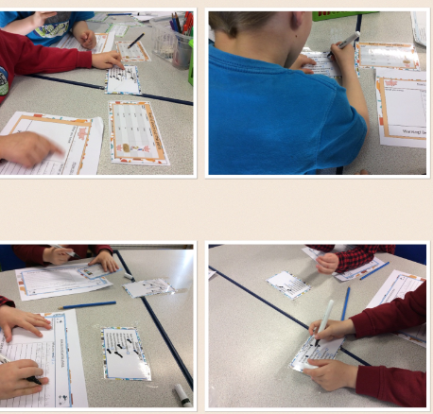
The next section to be analysed within the first stage of the lesson study is how the children referred to their work. Again, throughout the observation schedule it is clear that the children often referred to the work against the success criteria and this correlated to the children being able to identify the steps which they need to take to reach their learning intention. They used the success criteria as a checklist to monitor their own learning and progress which they are proudly showing others whilst doing their work.
Yet, within the first pit stop of learning Lucy and Harry (Child A and B) did need prompting to refer to their work when looking at their success criteria, however when this was reminded, they were eagerly working and referring to their work with the success criteria. Although the children did become on task, it must be considered that the children could benefit from an example of what their intention is so they fully understand what they’re doing.
Subsequently to be discussed, will be an overview of the children’s justified understanding of SA. The children could name different ways they can self-assess stating that one of the ways they could self-assess was talk partners where they can engage in PI. Throughout the pit stops the children were able to identify next steps in their learning by identifying elements of their success criteria which hadn’t been hit. Additionally, following the talk partners approach, the children had opportunity to discuss their work at the end and decide what they found easy, difficult and what they want to improve in their lesson, with their peers by explaining their thoughts to a small group.
On analysis of the lesson study there are certain changes that need to be implemented in order for the next stage of lesson study to be more effective in seeing if PI can improve SA. These will be provided subsequently:
- A change in FGI questions to become more concise and easier for the children to understand.
- Explain clearly and model an example of self-assessing with a peer against the success criteria.
- Creating a more child friendly approach for their SC.
- Decrease in pit stops to cancel out the option of a child becoming disengaged with the criteria.
Moreover, these changes were made and incorporated into the next lesson in order to reflect and establish if SA can be made more effective through the use of PI.
To briefly set the context of the next lesson, the intention was to create an Easter card by following a simple, picture success criteria. Instead of four pit stops there are now two to try and keep it more exciting for the children as well as providing more emphasis on a model example to allow the children to understand.
Following the same process as the previous lesson, firstly this assignment will look at how the children were engaged in the lesson followed by how children were engagement in the lesson followed by how children justified their understanding. Throughout the pit stops, the children were thoroughly engaged in their discussions with the other children. It was clear that the children modelled the example given to them at the start of the lesson which was transferred to how they self-assessed with their peer. The Leuven scale, as well as the observation schedule (appendix 8) consistently showed maximum signs of engagement of discussion with peers always relating to the work. It was clear that the children had found the example useful at the start of the lesson in order to replicate what they had seen and apply it to their work. The children were thoroughly engaged in appropriate discussion throughout the lesson which was the predominant finding about this key area. Subsequently, by reducing the amount of pit stops which were intended for this study the children’s engagement levels stayed high because of the novelty of the pit stops, additionally the pit stops were identified by a sound which motivated the children to begin their discussions. From the FGI, all children did suggest that they enjoyed discussing their stage of their work with a peer as it,
“…helped me find bits that I needed to do to finish my work” (Damian).
As well as,
“I was helping Alice find bits in her work she had completed within her success criteria and we could see what else she needed to do before our next pit stop” (Ben).
Subsequently, this also allowed the children to refer to their success criteria in front of them to figure out what the children had completed in their work. The children were more inclined to refer to their success criteria due to the more child friendly approach it offered. It was interesting to see the children become more engaged in their success criteria through the use of pictures. This was evident within the FGI where the children noted that the use of pictures helped them understand the step they were being asked to make. The children referred to their work against the success criteria when they heard the pit stop sound allowing the children to understand their stage in their learning as well as identifying next steps in their learning. Within the children’s discussion about what they found easy, difficult and areas of improvement also deemed useful when the pictures were included in the success criteria.
Moreover, this approach also seemed useful when the children were justifying their understanding as they could make simple links to the parts they were discussing as well as their overall feelings. Within the FGI, the children stated ways in which they could self-assess and when asked if they knew anyways they could improve self-assessment, interestingly, the children again identified them liked self-assessing when there was PI. This was evident when children were able to identify and justify what they needed in order to improve their learning.
Considering the findings from both lesson studies it is clear that both lessons acquired the completion of the lesson goals and did indeed see a benefit from PI when self-assessing from when both trainees had been in the classes previously. From this experience, it has become apparent that the changes that have been highlighted were consistent with our thoughts on how we could improve the lesson from the initial observation. From these changes it has become clear that the use of PI can really stimulate the children to become visual in their learning and become more understanding of why we do SA within our learning. It seems that as practitioners, sometimes it is not understood the complex approach they are being asked to complete. From this it seems that making a plenary as exciting, competitive and child friendly as possible will correlate to engagement, understanding and effectiveness of SA.

Findings with literature
Throughout this opportunity, there are many things that has been discovered to determine if SA can be improved through the use of PI. Due to the limitations of the word count this section will only focus on the primary findings, although I am aware of the numerous benefits that have become clear in this research. The finding will be discussed sequentially, PI influence on SA and children’s understanding of SA. It must be noted that it is understood that the findings within this study is small scale and may not be a true reflection on a wider scale.
A significant element within this research was the use of PI. Throughout the literature, it is evident that many theorists believe that a social constructivist approach can benefit children’s engagement and attainment (Argyle, 2017. Mihaela and Mihaela, 2016., McBlain, 2014 and Welsh Government, 2017). The research findings share correlations with literature, as the children stated they enjoyed self-assessing when involved in peer discussion, additionally this was witnessed within the observation notes where the children were often engaged, particularly when the pit stops were reduced to two to heighten engagement and not to diminish purpose. From this, it is evident that children’s social interaction can indeed heighten a child’s engagement, particularly when focusing on children’s SA. Yet, it was noticed within lesson study 1 that child D, Nick, did not see the benefits of working with a peer to improve SA, contradicting the literature gathered and the majority findings collected. It must be considered that this may be down to the small sample scale selected and may be because of the personal opinion of the child. On the other hand, this could be a reflection of children on a large scale and the sample collected may have only seen benefits from PI due to their personal preference. However, due to a plethora of literature for the benefits of PI and from evidence witnessed in placements, this study concludes that PI can be a useful tool to improve SA within school but it must be noted that all children learn differently so this technique may be extremely useful but not used constantly to encourage different ways of self-assessing which tailors for every child’s needs.
Subsequently, within the literature it was suggested that children’s knowledge of SA may be limited due to their understanding of the technique. Sackstein (2015) and Burton (2008) suggested that children may struggle to understand the self-assessment process as a result of the stage of maturity that the child is in at that time. Similarities with this thesis were seen within the first lesson study where children needed slight prompting to know what to do within their pit stops. Yet, this was adapted within lesson two where the children had a modelled form of what they were expected to achieve within the pit stops. This allowed the children to have a scaffold and understand their intentions as well as beginning to understand why we self-assess (William, 2011). Therefore, it may be assumed that there are ways in which children can understand their SA, and one way of doing this may be through the use of modelling. Therefore, the findings make contradictions to current literature suggesting that it is not a sense of maturity that restricts a child from understanding their SA, but that it may be how we as practitioners’ explain, implement and introduce SA.
Yet, it was noticed that literature suggested that children’s awareness of SA may be limited in early years (Ross, 2006), however in both focus group interviews, children were able to identify ways in which we self-assess. The findings found a range of ways children identified to self-assess. Thus, suggesting that children are aware of the way in which we self-assess but struggled to actually understand why we use and how we implement it to relate with the learning. Therefore there are correlations with what is stated in the literature, yet it may be suggested that children are more aware of SA than is believed and it is the way which we implement SA into lessons which will be the way forward to children’s understanding of SA, for example using PI.
In regards to my own practice, I will incorporate PI into SA often into the classroom routine but will do so as a uniqueness for SA where we will check our work throughout the lesson in order for children to understand their SC and have the benefit of PI to find elements of learning which can be improved and have opportunity to discuss their feeling about the lesson.

Conclusions and recommendations.
This section will critically examine my own research lesson. On completion of the lesson and in order to be reflective I completed adapted ARCs to analyse elements within the lesson. ARCs were created to reflect upon the methodologies used (Appendix 9) as well as a general reflection of how PI assisted SA (Appendix 10). Firstly, the methodologies used will be briefly reflected upon from my lesson study. Yet due to the limitations of the word count only the lesson study and focus group interview will be focused on.
When reflecting on the lesson study, it was clear that it is a beneficial tool which provides a significant opportunity to improve an element of a lesson with observations from another practitioner (Dudley, 2014b). It was found that this technique provides scope to attempt an element in learning to evaluate its effectiveness and impact on areas of education. This technique allowed me to identify elements within the lesson which were not as effective as once thought. For example, having four opportunities for children to self-assess seemed a good way for children to become familiar with the use of SA in lessons, yet it was observed that some children, towards the end of the lesson, were not as engaged as hoped towards the lesson intention. From this, it was evident that changes needed to be made and lesson study provided a chance to make changes to this element of the lesson and try it again in the next lesson which showed remarkable improvements in engagement.
Yet, due to the business of the lesson and the observations of four focus children, it was difficult for the researcher to gain lots of information for each individual child and instead of getting specific in depth analysis of each child the observations became more general observations due to the time restraint and the amount of data which was intended to be collected. However, due to the nature of the lesson study this then allowed me to change the observation schedule and allow more time for the researcher to be able to gain an ample amount of information.
Subsequently the use of FGI allowed children to be more relaxed because of the happy, collective ethos it contains. The FGI allowed children to reveal honest thoughts about the lesson and also allowed children to feel more confident about answering. Although an array of information was collected from the FGI, it seemed apparent that some children did not contribute as much as other, making some of the data collected a reflection of perhaps that specific child and not from the whole group. However, this is an area which cannot have much intervention as we want honest opinions and asking the child to contribute more may result in the child feeling uncomfortable and not wanting to take part thus providing invalid answers for the research.
In order to collect a dense amount of data many questions were included. This proved problematic as some children became uninterested towards the end and some questions were very similar and the children did not know how to answer them. Therefore it was essential to decrease the questions asked to stimulate the children whilst also collecting as much information as possible.
If I did this lesson again, I would ensure that the observer had extended opportunity to collect data within the lesson to ensure a dense collection of information to ensure we have not missed a chance to improve an element of the lesson. Additionally, I would run a pilot study of interview questions to assess if they would probe a suitable amount of data, to see if the amount of questions were amicable and to assess if the timing of the interview is too long for the children.
Within my next school experience I will reflect upon what I have already learnt and adapted throughout this lesson study and apply it within the classroom. The use of SA and PI will often be used within my lessons yet, from this study I have found that it will be used now and again so that the children will not become bored of this technique. Addressing Lesson Study as a whole, I will definitely strive to use this technique to reflect and improve many elements within learning. With Donaldson’s (2015) curriculum rapidly approaching it is essential that practitioners’ become reflective and become familiar with practitioner observations to find ways to improve practice. Therefore, using the lesson study approach will heighten the reflective ethos within my classroom and will enable me to tailor my approaches to the suitability and interest of the children. This will develop my practice by being able to pin point elements of lessons and improve features to ensure my lessons are as good as they can be and as effective as they can be.
In relation to improving SA with PI, I feel there has been sufficient evidence within this study to suggest that PI can improve SA and especially within the younger years. It is essential to consider that this approach may not be suitable for all children all the time. Yet, I believe that if this was brought in from time to time within practice that all children would benefit from this approach due to the novelty it includes.

Appendix 1: Copy of Parent consent
Dear Parent/Guardian,

Your child’s school is a partner with Yr Athrofa at University of Wales Trinity Saint David in Carmarthen and Swansea. This school offers placements to students who are learning to be teachers.

The student-teacher in your child’s class has been given the task of planning, teaching and evaluating one lesson so that he/she can develop specific strategies to improve their own teaching. As part of this, student-teachers will be observing the children’s responses and asking some pupils their views on parts of the lesson. This is designed to inform students’ own practice and support children’s learning.

Any information collected would remain confidential, and both the school and the children would remain anonymous in work produced. The work undertaken would be in line with the University’s ethical guidelines. If, at any time, your child does not want to share ideas, they would not be required to do so.

If you are happy for your child to contribute to the project, please complete the parental consent form below and return directly to the school as soon as possible. If you are interested in the outcome of this project or if you have any questions, please contact the University Partnership Office - partnership@uwtsd.ac.uk.

Yours faithfully,


Catherine Morgan
Module lead – The Enquiring Teacher

_____________________________________________________________________________________________

As Parent/Guardian of…………………………………………………………………….. (pupil name), I do / do not give consent (please delete) for my child to take part in this project.

Signed…………………………………………………………………………….(Parent/Guardian).

Date………………………………………………………

Appendix 2: Copy of child assent form

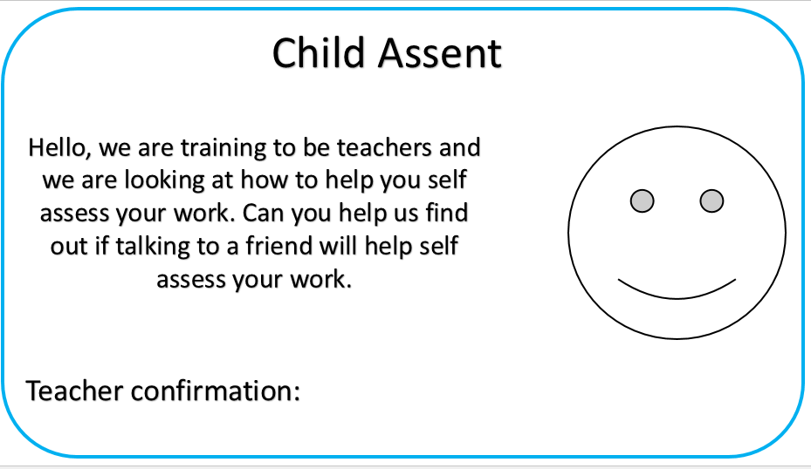


Appendix 3: Lesson Plan lesson study 1

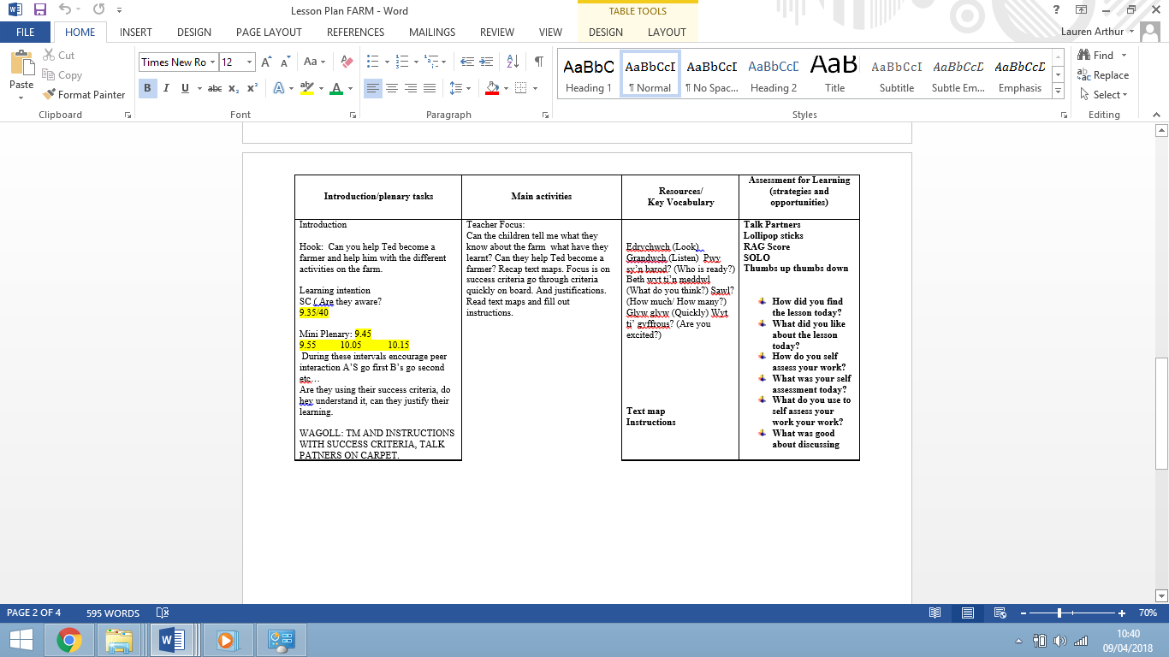

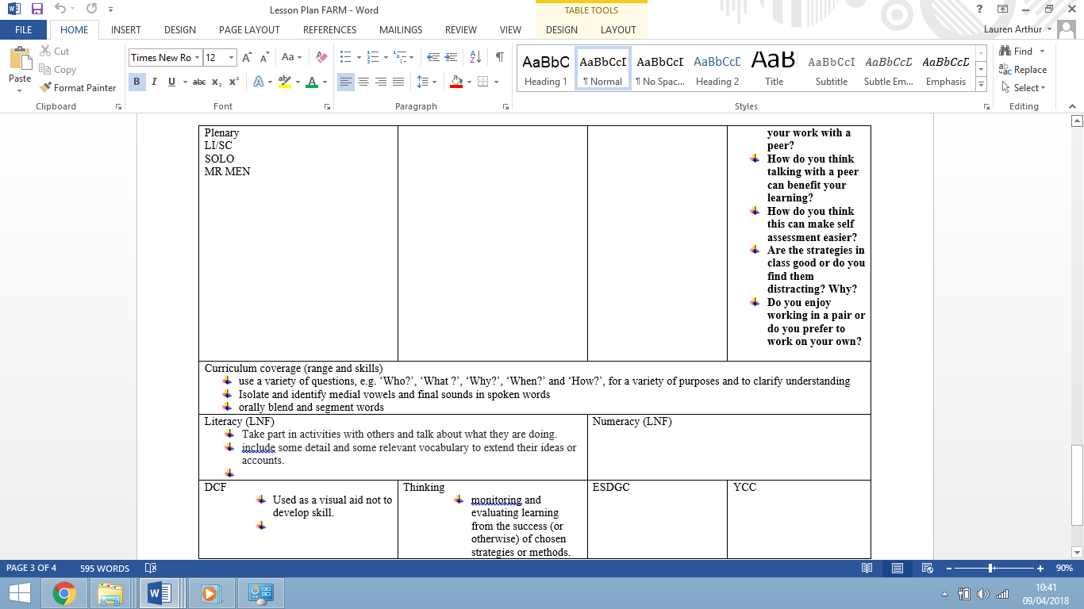

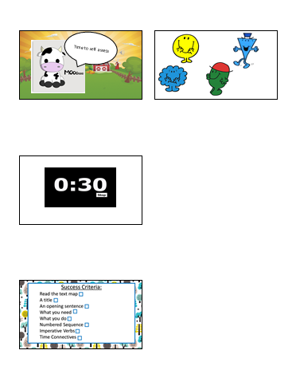
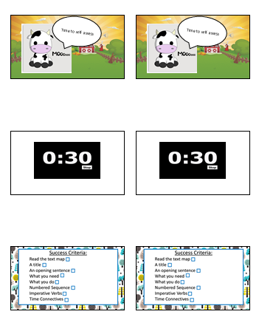
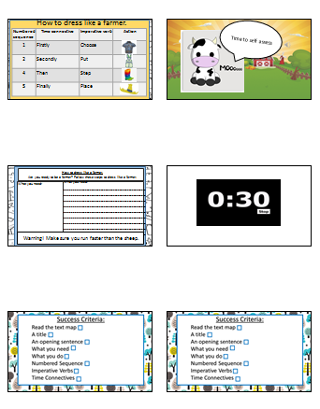
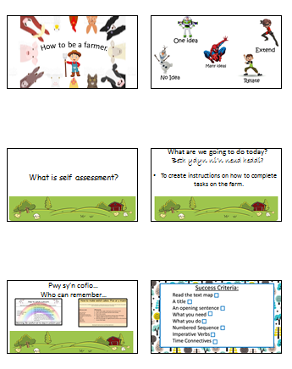
Appendix 4: Lesson 1 PowerPoint

Appendix 5: Success criteria check list.

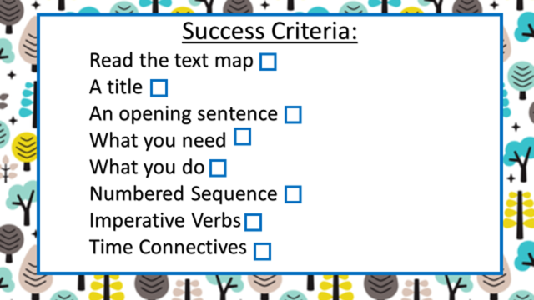

Appendix 6: Lesson Study 1 observation schedules.
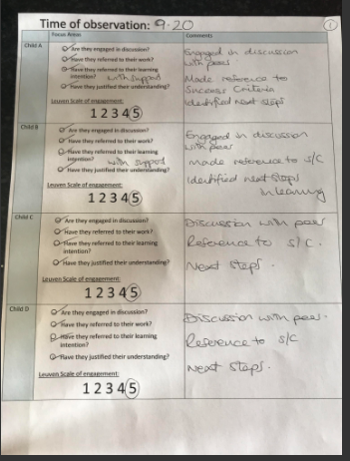

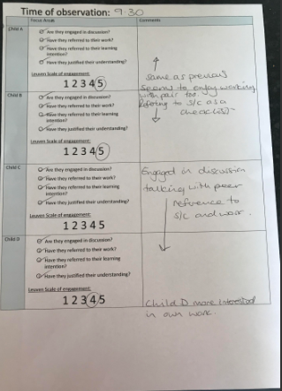

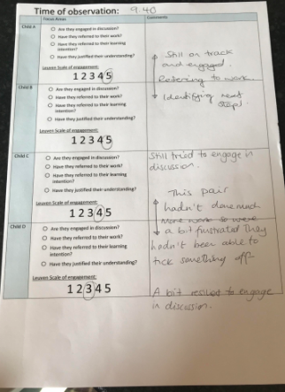

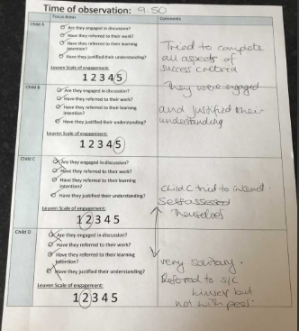

Appendix 7: Lesson 1 Transcription
Child | Pseudonym
A | Lucy
B | Harry
C | Molly
D | Nick

Question |  | Response
1 | How did you find the lesson today? | Good.  Good.  Fun.  I was happy.
2 | What did you like about the lesson today? | I liked it because I nearly finished the task.  It was fun to do some work. It was different.  I liked working with my friend, and I could show her my work.
3 | How do you self-assess your work? Do we understand why its important? | We use our mr men stickers. If we don’t self-assess we don’t know what we need to do next and you don’t know if we were happy with our work.  We use our thumbs (Shows me what they do)  Rag score and talk partners!  Solo Taxonomy
4 | What was your self-assessment today and why? | All- Mr Happy  I followed my success criteria and I created instruction for you to do things on the farm.  I found my work easy  I was happy with my work today, the steps helped me know where I was in my work and what I needed to do next.  Because I finished my work and I put in everything I needed to.
5 | What do you use to self-assess your work? | Our success criteria was on our table and we ticked them.
6 | What was good about discussing your work with a peer? | Yes, it was nice to work with someone else. It was nice to tell them what I’d done with my work.  I could see if I was beating my friend in their work.
7 | Do you think it was better to self-assess when talking about your work with a peer and why? | I liked doing it on my own because it is easier and I can get on with my work on my own.  I thought it was nice to talk with my friend to help each other with our work. It helped me figure out what I needed to do next and I helped my friend to know what she had to do next.  We could show each other what we needed to do to move on in our work and make it better.
8 | What way can you think of that will make it easier to assess your work? | I think we should clap our hands if we are happy and nod our heads if were not happy. (Interviewer) Do you think children would just clap their hands because it’s fun to clap your hands? Yes, children would clap their hands really fast because it’s fun.  I liked this way, can we use it all the time.
9 | Are the strategies you use for self-assessment good? Or do you think it’s distracting? Why? | I think it was distracting because I wanted to talk to my friend.  No it wasn’t! It was good to do self-assessment a different way.  I think it was good because we all did our work.
10 | Do you enjoy working in a pair for your self assessment? | I do!  I like it with my friend.  I like it on my own.  And me it’s easier.

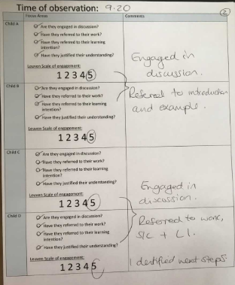
Appendix 8: Observation Schedule Lesson 2

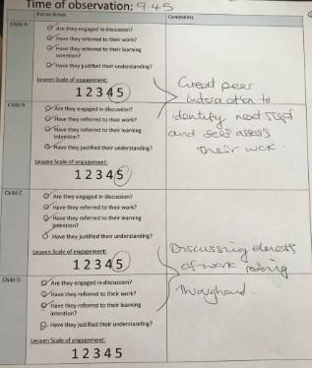

Appendix 9: Transcriptions lesson 2
Child | Pseudonym
A | Alice
B | Ben
C | Carla
D | Domonic

Question |  | Response
1 | How did you find the lesson today? | It was fun  I liked the lesson  Good  Exciting
2 | What did you like about the lesson today? | I liked it because I nearly finished the task.  It was fun to do some work. It was different.  I liked working with my friend, and I could show her my work.
3 | How do you self-assess your work? Do we understand why it’s important? | The different colours, my work was easy peasy!  Easy peasy!  We use talk partners.  Thumbs up or down if we found the work easy peasy or hard.
7 | Do you think it was better to self-assess when talking about your work with a peer and why? | I liked it. My friend helped me.  I thought it was good to work with a friend.
8 | Are the strategies you use for self-assessment good? Or do you think it’s distracting? Why? | I think its good to work with a friend.  Yes it is good and fun we can get work done helping eachother.  It is good!
9 | Do you enjoy working in a pair for your self-assessment? | I like talking about my work with my friend.  I thought it helped my work.  And me it was better.  Yes!

Appendix 9: ARC reflection methods
Appendix 10 Arc reflection
Appendix 11: Transcriptions Lesson study 2
Child | Pseudonym
A | Alice
B | Ben
C | Carla
D | Domonic

Question |  | Response
1 | How did you find the lesson today? | The lesson was fun  It was different  I liked it.
2 | What did you like about the lesson today? | I liked it because I finished my work.  I worked with my friend.  I showed my friend my work
3 | How do you self-assess your work? Do we understand why its important? | Talk Partners  Easy Peasy lemon squeezy!
7 | Do you think it was better to self-assess when talking about your work with a peer and why? | Yes, I was talking to my friend about my work and it helped me know what to do next.  It helped me with my work.  I think it is better to talk about the work.
8 | Are the strategies you use for self-assessment good? Or do you think it’s distracting? Why? | Yes!  They are fun and my teacher knows how I found my learning.  I might talk to my friend about something else but I spoke to my friend about the work.
9 | Do you enjoy working in a pair for your self assessment? | I do!  Yes!  Yes.  Yes.

References
Abdou, N. (2017) ‘Peer/Self assessment and student learning’, International Journal of Teaching & Learning in Higher Education. 29 (2) pp.255-270
Argyle, M.(2017) Social interaction: Process and products. Social interaction in social and language culture.London: SAGE.
Blatchford, P., Pellegrini, A and Baines, E. (2015) The child at school: Interactions with peers and teachers. London: Routledge.
Boud, D. (2013) Enhancing learning through self- assessment. London: Taylor and Francis.
Briggs, M.(2008) Assessment for Learning and teaching in the primary school. 2nd Edn. Exeter: Learning Matters.
Buck, A and Trauth-Nare, G.(2011) ‘Assessment FOR Learning’, The science teacher, 78(1) pp.34-39.
Burton, Y (2008). Early Childhood Education. Issues and Development. London: SAGE.
Butler, C (2016) Social Interaction in the playground. London : Routledge.
Dweck, C. (2017) Mindset: Changing the way you think to fulfil your potential. New York: The random house publishing group.
Channing, V and Aubery, K. (2009) Self-assessment. Oxford: Oxford university press.
Clarke, S.(2009) Talk Partner. Available: http://www.shirleyclarke-education.org/research/talk-partners-2009-year-5-4th-grade-us/ . Last accessed 17th March 2018.
Clarke, S. (2014) Outstanding formative assessment: culture and practice. New York: SAGE.
Cole, M. (2018) Lev Vygotsky: Learning and social constructivism. Learning theories for early years practice. London:Routledge.
Dearnley, C. (2008) ‘Student self-assessment and its impact on learning (Pilot Study)’, Elsevier, 27(3), pp.333-340.
Dobao, A. (2017) Peer Interaction and learning. Oxforf: University Press.
Dudley, P. (2014a) Lesson Study: A handbook. Available at: http://repositorio.minedu.gob.pe/handle/123456789/5017. Last accessed 20th March 2018.
Dudley, P. (2014b) Lesson study: Professional learning for our time. London: Routledge.
Estyn (2017a) Pembroke Dock Community School Inspection Report 2017. Available at: https://www.estyn.gov.wales/sites/default/files/documents/Pembroke%20Dock%20CP%20School.pdf. Last accessed 15th March 2018.
Estyn (2017b) Prendergast School Inspection Report 2017. Available at: https://www.estyn.gov.wales/sites/default/files/documents/Prendergast%20Community%20School.pdf. Last accessed 15th March 2018.
Forrester, M. (2014) Early Social Interaction. London: SAGE.
Freeman, S., Eddy, S and Donough, L. (2014) ‘Active learning increases student performances in maths’, Proceeding of the sciences, 111(23), pp. 8410-8415.
Hamilton, M and Ploughman, J. (2016) International Handbook of Teacher Education. 2nd edn. Oxford: Springsfield.
Hattie, J.(2012) Visible learning for teachers: Maximising impact on learning. London: Routledge.
McVarney, J and Milne, C, (2014) Teacher educators rethink self assessment in higher education. NewYork: Sage.
Norwich, B and Jones, J. (2014) Lesson Study: Making a difference to teaching pupils with learning difficulties. London: Bloomsbury.
Ono, Y and Ferrier, J. (2010) ‘A case study of continuing teacher professional development through lesson study in South Africa’. South African Journal of Eduaction. 14(2), pp.6-12.
Peacock, A. (2014) Beyond levels: Alternative assessment approaches developed by teaching schools. Available at: https://assets.publishing.service.gov.uk/government/uploads/system/uploads/attachment_data/file/349266/beyond-levels-alternative-assessment-approaches-developed-by-teaching-schools.pdf. Last accessed 9th April 2018.
Ross, J. (2006) ‘The reliability, validity and utility of self-assessment’, Practical assessment and evaluation. 11(10), pp. 1-13.
Runcharoen, S. (2014) ‘The development of social interaction of children with autism in an inclusive classroom’, Social and behavioural sciences. 116(4), Pp.4108-4113.
Sackstein, S.(2015) Teaching students to Self Assess: how do I help students reflect and grow as learners. New York: ASCD.
Spendlove, D. (2015) Assessment for Learning. London Bloomsbury.
Taylor, S Bogdan, R and Devault, M. (2015) Introduction to qualitative research methods. A guidebook and resource. London: Jessica Kinglsey Publishing.
Thomas, A and Lewis, A.(2016) An introduction to the Foundation Phase: Early years curriculum wales. London: SAGE.
Welsh Government.(2017) Children’s young play. Available at: http://gov.wales/topics/people-and-communities/people/children-and-young-people/play-and-leisure/?lang=en. Last accessed 17th March 2018.
William, D.(2011) Embedded formative assessment. New York. Solution Tree Press.
William, D and Black, P. (1998) Inside the Black box: Raising standards through classroom attainment. Available at: http://electronicportfolios.org/afl/InsideBlackBox.pdf . Last accessed 15th March 2018.
Wilson, E.(2017) School based research. A guide for education students. London: Bloomsbury.
Creswell, J. (2009) Research design. Qualitative and Quantitave approaches. London: SAGE.
Albon, P and Mukherji, D. (2015) Research methods in early childhood: an introductory guide. SAGE Publication: London.
Allen, S and Gordon, P. (2017) How Children Learn. London Routledge.
Helen, K. (2015) Creative research methods in social sciences: A practical guide. London: Routlegde.
Barbour, R.(2012) Doing Focus Groups. London: SAGE. P2.
British Educational Research Association (BERA). (2011) Ethical Guidelines for Educational Research. London: British Educational Research Association.
Connelly, L. (2015) ‘Focus Groups’, Medsurg Nursing, (5)24, pp. 19-24.
Arthur, J. (2012) Research Methods and methodologies in education. London: SAGE.
Punch, K and Oancea, N. (2014) Introduction to research methods in education. London: SAGE.
Bellchambers, E., Erricker, C and Lowndes, J.(2010) Primary Education: A new Approach. London: SAGE.
McBlain, L.(2012) Children’s Self Assessment. London: Bloomsbury.
Thomas, A and McInnes, K. (2017) Teaching Early Years: Theory and Practice. London: SAGE.
Hattie, J.(2012) Visible Learning for Teachers: Maximising Impact on Learning. London: Routledge.
Teacher Development Trust. (2012) Available at: http://tdtrust.org/http://tdtrust.org/. Last accessed 10th April 2018.
Donaldson, G. (2015) Successful Futures: Independent Review of Curriculum and Assessment Arrangements in Wales Crown Copyright available at: http://gov.wales/topics/educationandskills/schoolshome/curriculum-for-walescurriculum-for-life/why-we-are-changing/successful-futures/?lang=en. Last accessed 28th December 2017.
Laevers, F., Daems, M., De Bruyckere, G., Declerca, B., Moons, J., Silkens, R., Snoeck, G and Van Kessel, M. (2005) Siks-Ziko. Leuven Univeristy, Belgium: Research Centre for Experiential Learning Leuven University.

