Work Based Project

ACDA5016

Aaron Bowditch
2012801

Work Based Project Report

Acceptance Test Plan & Suite Test Rig

08/07/2022

Project title and background

The project title is based of the two main components of the project, these components being the acceptance test procedure (ATP) and also the suite test rig, this rig included a supplier bought power supply module (PSM) and test harnesses used to connect the suite to the rig.
For the brief it was stated that HSF would be tested, but due to complexity and immaturity of the system testing is not possible as there is no software for the system.
The aim of the project is to design a suitable plan and test rig which has the capabilities to test and approve the operational functions of a specified passenger suite for the JAL business class program.

For this project the task was to design a suitable test bench and the peripheral equipment required to test the functional operation of a double passenger suite configuration for the Japan Airlines Business class program. The main aim of the test bench is to act as a seat and allow the suite to operate, from this operation tests are then done to approve the suite as airworthy. The suite comprises of two main systems and two safety systems;

IFE – the in-flight entertainment system, also referred to as IFE, is a supplier purchased system which provides the passenger with all the required needs for a long haul flight. In the case of JAL business class the supplier is Panasonic and the system is known as the ‘next’ system, and like most suppliers they give a wide range of peripherals which can be added and removed from the system, for this business class program the suite contains –
    - Wireless charges
    - USB charging port
    - 3 pin 115V socket
    - Audio jack module
    - Monitor
    - SIP (seat information panel)
    - Handset – used to control the IFE system and alert cabin crew
Due to the complexity of the IFE system, Panasonic provide their own test plan and equipment which is used on production by the quality assurance team before signing off the suite as approved for flight.

Emergency lighting – the emergency lighting system is one of the most important systems on the aircraft, also known as the SMEL system (Seat Marking Emergency Lighting), the SMEL system is a simple two wire lighting loop connecting up a series of lights on the side of the suite used to illuminate the floor in case of emergencies. The lights sand harnesses undergo continuity and functional tests before installation into the suite, and once installed on the suite to ensure no damage during installation.

AMSAFE (Air Bag) – the airbag system is purchased from a supplier, all components are tested before delivery to Safran, once installed on the suite, there is a battery within the airbag main box, this allows the system to be tested using a test button on the box.

Actuation – the actuation system is a Crane designed and supplied system. Crane supply the actuators for the seat and main power box, it is then the responsibility of Safran to design and manufacture the system, this includes all harnesses and switches. Other peripheral components are then outsourced, such as the lights and, depending on the complexity the main PCU. On JALBC there are 13 different variants of electrical installations over 6 variants of suite, these variations come due to the double suite configuration, this causes rear rows to be single suites, there are also 3 cases where FDB’s (floor disconnect boxes) have restricted access, these require special case harnesses to route beneath the floor and connect to the aircraft. Due to the large number of variants and time constraints of this project the task was given to produce a single ATP and single test bench for one double suite configuration, in this case the most mature suites were selected, being 4D and 4G.

Project planning

Due to the nature of the project, usual planning conventions were not used, usual work practices for releasing drawings was not applied to this work package, therefore a work tracker was not needed as the work was only done by me. Instead three key milestone dates were set;
- 17th June – this was the date I set myself to complete the drafting of the test procedure document, this was task completed on time.
- 24th June – this date was set for the completion of the block diagram, this was a relatively easy task and was completed on time.
- 1st July – this was the final date to have all the harness drawings produced for the test bench, unfortunately this deadline was not met and was carried over into the week 4th July.
Due to the lead times on manufacturing harnesses being a minimum of 12 weeks, and these being SK harnesses not for flight this work package will not be manufactured.

Background research

Due to the nature of the project, the only valuable research was done by studying specifications, technical reports, and previous programs ATPs which have been accepted and approved by air framers. An ATP is a technical document which is submitted for approval to the air framer and EASA/FAA. This means that the document is required to be formal and produced in a safran approved template, these are readily available throughout the business on the shared drive. Studying the previously released ATPs allowed the document to be completed formally and to the standard laid out, and presented the required document numbers which needed to be revised, these documents are stated in the completed ATP.
After completing research on previous ATP’s, it was found that the following documents are relevant to the testing procedure, although due to the test bench being classed as ‘not for flight’ specifications do not need to be strictly adhered to;
- Seat Installation (Frame Specification) Document - 2521M1F1000 00 Iss 5
- Specification for the Electrical Integration of In-Seat Systems - X2521PTSI09010 Iss 4
- Electrical & Installation Requirements - ABD0100 1.8 Rev C
- Aerospace Recommended Practice - ARP 5526 Rev D
- Qualification Summary Document - 39114-A-2130 Rev 3
- System Safety Analysis - 39114-B-2160 Rev 0
- Design Verification Test Results - 39114-B-2144 Rev 0
- Production Acceptance Test Results - 39114-C-2144 Rev 0
- IFE Test Configuration - 39114-D-2144 Rev 0
- Seat Assembly Acceptance Test Results - 39114-E-2144 Rev 0
- Panasonic ATP - 127705 Latest revision
- Work Instruction - Change to Electrical Equipment - NPIE01/W42 Iss 2
- Must comply with company standards

Test boxes were studied on the shop floor to give a better understanding of the construction requirements, as instructed all mechanical devices for the bench, such as housing and trolley, are supplied and selected by the industrialization team, electrical design only has input on the workings of the test bench. From studying the largest bench available for the optima platform program, it was found that each extension cable would need to be a minimum of 1300mm long to allow connection, this specification comes from the restricted space within the suite to allow the trolley to be moved into where the seat is, this is most likely not going to be possible so long extension cables are required.
Harness extension leads were relatively easy to design as most of the harnesses they were connecting to I had designed. The required connector branch was taken and extended with the mating connector added to the other end of the branch, this allows them to function as extension leads. Whilst drafting the drawings the department has encountered an error with the drawing software, the macros used to complete the bill of materials is no longer accessible, this means the PN data base and bill of materials on drawings are currently on standby and are not able to be completed in time for submittal of this report. Due to the project being part of a future task for the JAL business class program, the produced drawings will not be approved, they will be preliminary drafts used only for the purpose of this project, when production begins in October the release process for these drawings will begin.

Document construction and design process

The first step of the project was to produce the ATP, this document would then outline all the requirements for the rest of the test procedure. This document was constructed using a Safran template which has all the required sections already set as headings, it is then a process of completing all the required fields. Once the base of the document was complete, the test procedure was determined and constructed, as this is only an initial draft with some immature systems removed from the procedure, updates are expected at a later date once production begins. The main stages of the test are described in detail in the test plan, and are down as subheadings in the plan as follows;
- Insulation Resistance
- Isolation Switch Operation / Hook-up Instructions
- Maintenance Port Testing
- Calibration Checks
- Manual Override Control – to include testing of;
  - Tracking Actuator
  - Recline Actuator
  - Split Backrest Actuator
  - Privacy Actuator
- Actuation System Testing – this test involves general function testing of the actuation system using the PCU to control the seat movement and also the lighting system. This test is alos used to test safety features, i.e. wardrobe sensor being used as a switch to allow operation of the seat when closed, and to block it when opened, these other tests include;
  - TTL to Lounge
  - Lounge to Bed Function
  - Bed to TTL Function
  - Backrest Function
  - Headrest Function
  - Tracking Function
  - Wardrobe Door Sensor
  - Lumbar Function
  - Privacy Function

Once the plan was completed and the test procedures had been laid out, the test bench was then able to go through the first stages of design, this was done by producing a simple block diagram, which can be seen in figure.1. From producing this block diagram the total number of extension harnesses required, and also any other re-purposed harnesses were decided and selected at this stage. Due to the nature of the test bench, all new harnesses designed were to be booked as ‘SK’ numbers. ‘SK’s’ are a drawing nomenclature used in Safran to state that a drawing is only a sketch and is not to be used for production or flight. Typically these drawings will have a not for production watermark to ensure this is kept to. As this project is not used for production as of yet, and the drawings are not going through the approval process, not for flight is not added as this would be added by the approver at that stage of the workflow.
As can be seen on the block diagram in Figure.1, a ‘dummy seat’ is readily available in the industrialization work area, this has the PN of SK42173 and is made up of all the required harnesses and three actuators, for tracking, recline and backrest functions of the seat, a lumbar unit is also there for testing.

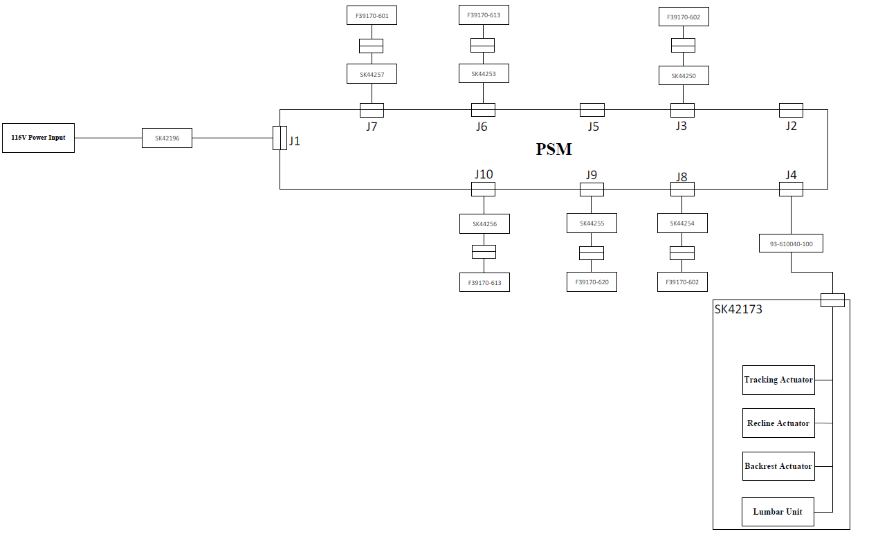
Figure.1

Now that the block diagram was complete, and all required PNs booked through the SK booking process, the next stage was to design the required SK harness extension leads.
This process was simple as the connectors used had all been made on the -018 level system drawing (system architecture block diagram).
In total eight extension harnesses were required, these were drafted using Visio following the businesses harness drawing procedure. A harness drawing example can be seen in figure.2. The drawing part numbers are bellow;

Drawings

The first two SK cables are used to power the IFE system, this is because the IFE system powers the 12V lines for the sensors;
- SK43304 – mates with - H0001R02, H0004R02, H0003R02 (power IFE system, not tested due to system immaturity)
- SK44202 – mates with - H0001R02, H0002R02, H0004R02 (power IFE system, not tested due to system immaturity) – shown in Figure.2
There was then 6 extension cables required to be drafted;
- SK44257 - J7 – P7 - mates with F39170-601
- SK44256 - J10 – P10 – mates with F39170-613
- SK44255 - J9 – P9 – mates with F39170-620 (switch is connected to this harness within the suites crew step accessible via quick release lid)
- SK44254 - J8 – P8 - mates with F39170-602
- SK44253 - J6 – P6 – mates with F39170-613
- SK44250 - J3 – P3 - mates with F39170-602
The final two SK numbers and part number cover the block diagram, dummy seat and purchased extension cable;
- SK44258 – seat test unit
- SK42173 - is a seat setup with actuators and lumbar unit – no drawing
- 93-610040 – crane J4 mates with seat box
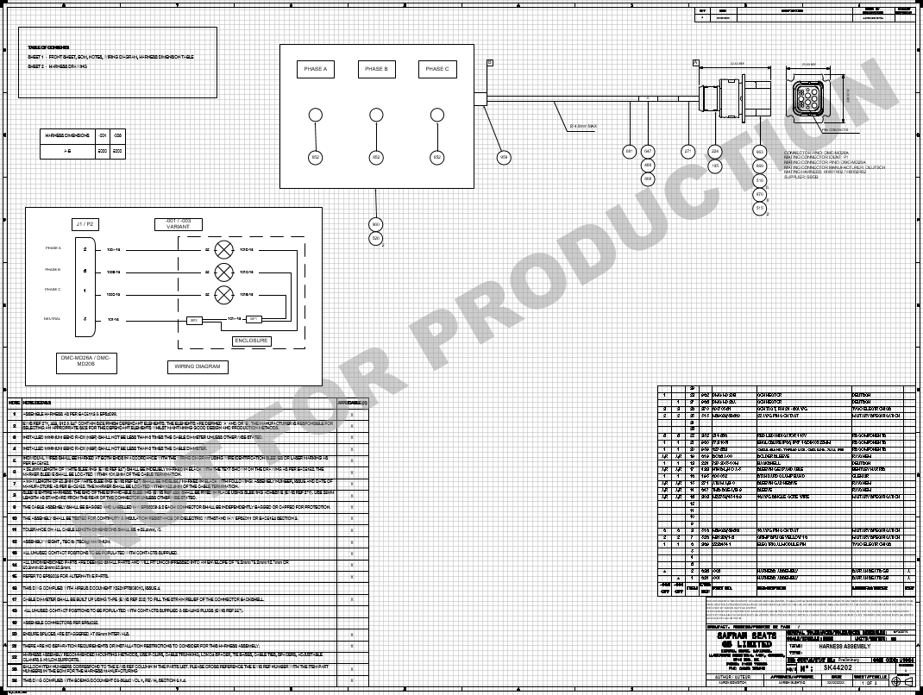

Figure.2

Testing

Due to the time restrictions of the project, and also the lead times and costs within the business, the test bench will not be manufactured. But an inspection was done on all the harness drawings and system drawings drafted to ensure everything was correct, following on from this and analysis of previously built test benches there is confidence that the test bench will operate as required when manufactured alongside production, and is also suitable for expansion and further development.
When in use, the test bench will be more a complex system, a laptop will be required to allow the bench the capability of changing the software on the PSM, as depending on the variant of the suite the system architecture used will be different. In total there are 3 different PSM configurations.

Reflection
Overall the project did not go as originally planned, the original plan was to design and produce a test bench for an outlier suite, but due to immaturity of the product, supplier manufacturing lead times and no product being available to use for testing this idea had to be remade. Instead the most mature thing possible for a work based project was a technical document and the corresponding engineering drawings outlining for the initial stage of an acceptance testing process which had a high workload and complexity of management which was completed on time. The final outcome of the project will be revisited and expanded on in the coming months when more data is readily available for the engineering team.

References
Due to the nature of this project no outside research was done to use for reference. Although the following documents were referenced when writing the ATP;
- Seat Installation (Frame Specification) Document - 2521M1F1000 00 Iss 5
- Specification for the Electrical Integration of In-Seat Systems - X2521PTSI09010 Iss 4
- Electrical & Installation Requirements - ABD0100 1.8 Rev C
- Aerospace Recommended Practice - ARP 5526 Rev D
- Qualification Summary Document - 39114-A-2130 Rev 3
- System Safety Analysis - 39114-B-2160 Rev 0
- Design Verification Test Results - 39114-B-2144 Rev 0
- Production Acceptance Test Results - 39114-C-2144 Rev 0
- IFE Test Configuration - 39114-D-2144 Rev 0
- Seat Assembly Acceptance Test Results - 39114-E-2144 Rev 0
- Panasonic ATP - 127705 Latest revision
- Work Instruction - Change to Electrical Equipment - NPIE01/W42 Iss 2

