Part One
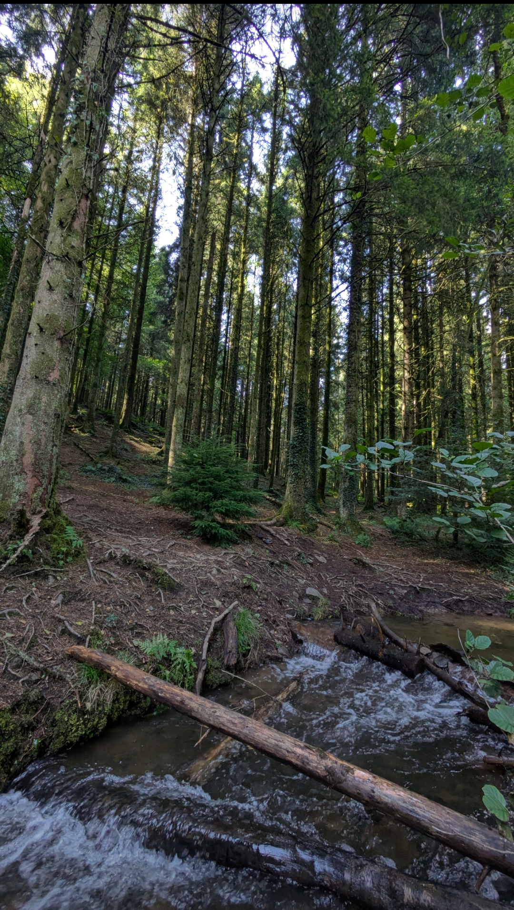

(Source: Davies, 2024a)
This photograph was taken in the Craig Yr Aber woods, just a short distance from my educational setting. I plan to take a group of fifteen children, aged six to seven, along with three practitioners, to this location. Below are several enriching ways I intend to introduce math and science in this natural setting
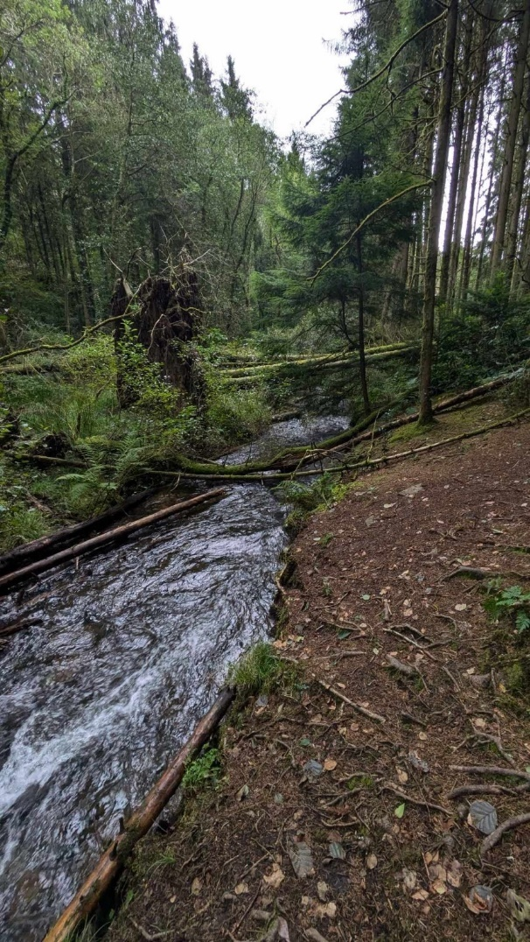
.

Part Two

Feature: River
Allowing children to explore the river fosters holistic learning, nurturing their intellectual, emotional, social, and physical development. Unstructured play encourages natural curiosity, risk-taking, and self-discovery. Through activities such as building dams and testing objects for sinking or floating, children can observe cause and effect, test hypotheses, and enhance cognitive and social skills. This hands-on, experienced based learning nurtures independence and critical thinking while fostering a deep connection with nature.

Math and Science Opportunities:
- Dam Building:
- Children can apply estimation and measurement while constructing small dams with natural materials like rocks and branches. They can estimate the number of stones or sticks needed and measure the river's width. Collecting materials naturally integrates foundational math concepts, reinforcing number recognition, categorisation, and classification skills.
- Children can observe hydrodynamics, water pressure, and flow rate by blocking and releasing water, introducing them to the concepts of cause and effect. Experimenting with different dam designs encourages creativity and problem-solving.

(Source: Davies, 2024b)

- Sinking and Floating Objects:
Sorting and classifying objects by size, weight, and material enhances counting and comparison skills. Children can predict whether gathered items (sticks, leaves, stones) will sink or float, introducing them to density and buoyancy. Through trial and error, they will observe how changes in object size or shape affect whether it sinks or floats.

- Mixing Mud and Water:
Children can mix varying amounts of water and mud to find the right consistency for tasks, introducing concepts of ratios and volume. Exploring mixtures helps them understand viscosity and material changes while encouraging sensory exploration and creativity.

- Erosion and Sediment Transport:
Observing how water carries dirt and rocks downstream helps children learn about erosion and sediment transport as they watch the river shape the environment. Experimenting with redirected water will aid in their understanding of gradual versus rapid changes in nature.
Curriculum Links
These activities build early math and science competencies while supporting holistic child development through hands-on, inquiry-based learning.
- Building Dams: Measurement, estimation, and spatial awareness.
- Collecting Materials: Number recognition, counting, and simple arithmetic.
- Mixing Mud and Water: Basic concepts of ratios and volume.
- Water Activities: Water pressure, buoyancy, and material properties.
- Erosion: Links to earth systems and environmental science.
These hands-on activities promote motor skills, teamwork, communication, and resilience, fostering independent thinking and problem-solving.

Areas for Learning
- Estimation and measurement
- Counting
- Ratios and volume
- Forces and motion
- Cause and effect
- Properties of materials
- Environmental science
- Children will learn about ecosystems and the impact of human actions, such as dam building, on nature and sustainability.

Cross-Curricular Skills
Designing and testing the dam enhances critical thinking and problem-solving skills. Collaborative construction fosters teamwork and communication across subjects, reinforcing practical, real-world learning while enhancing motor skills. This holistic approach integrates cognitive, physical, social, and emotional development while addressing sustainability and human interaction with nature.

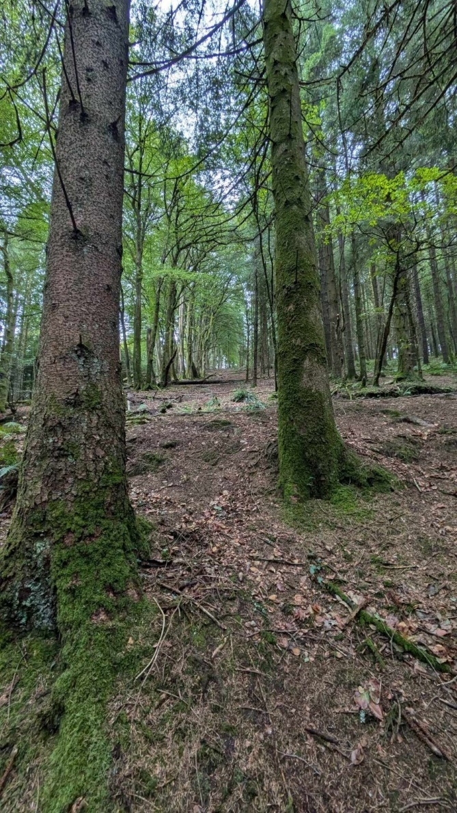
Feature: Hill
Exploring a hill in the forest offers rich opportunities for teaching math and science concepts through hands-on activities.
Math and Science Opportunities:

- Rolling Objects Down the Hill:
Children can roll objects of different sizes and weights down the hill, comparing how size and weight affect movement. This introduces measurement, comparison, and basic arithmetic. Timing the objects as they reach the bottom helps them grasp speed and time, allowing for average speed calculations. Observing how gravity accelerates objects explains this fundamental force. Questions like “Which object will roll fastest?” and examining differences in rolling (e.g., smooth rock vs. rough log) introduce concepts of friction and its effects on speed and distance. Heavier, faster objects demonstrate greater momentum and kinetic energy, prompting children to explore how different variables influence their rolling speed. These activities foster curiosity and imaginative problem-solving through hypothesis testing and inventing new challenges.

Welsh Curriculum Links
These activities align with the Welsh Curriculum by integrating mathematics and science through hands-on learning (Welsh Government, 2020).
- Rolling objects of different sizes and weights involves measuring time, comparing distances, and observing speed. This reinforces skills like measurement and data handling.
- Timing objects and calculating speed enhances numeracy.
- Exploring gravity and friction introduces concepts of physical forces, momentum, and energy, key components of the science curriculum.
This inquiry-based, hands-on approach fosters problem-solving and scientific inquiry, encouraging exploration and a love for learning. Group experiments can foster teamwork and enhance communication skills.

(Source: Davies, 2024c)
Cross-Curricular Skills
Recording and analysing results from experiments supports skills in data collection and analysis, reinforcing numeracy and scientific understanding.

Areas for Learning Timing objects and comparing distances.
- Analyzing the effects of size and weight on rolling speed.
- Understanding gravity, friction, momentum, and kinetic energy.
- Conducting experiments and testing hypotheses.
- Encouraging exploration and creative thinking.
- Developing teamwork and communication through collaboration and group activities.
Cross-Curricular Skills
Recording results via data collection, problem-solving and testing experiments, supports a well-rounded approach to learning, integrating math, science, personal growth, and skill development.

Feature: The Forest Floor

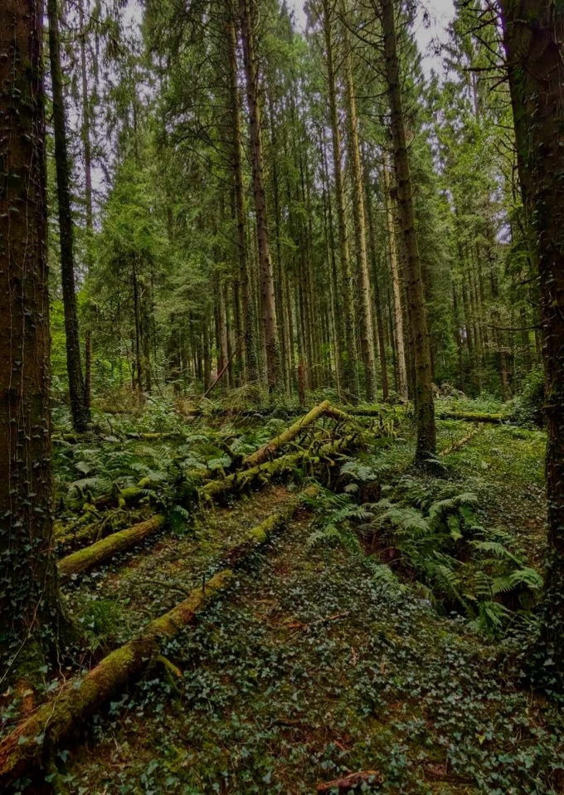
Exploring the forest floor provides diverse math and science learning opportunities through interaction with fallen trees, rocks, wildlife, and plant life.

Math and Science Opportunities:
- Measuring the Length, Width, and Height of Fallen Trees and Rocks:
This introduces basic concepts of size and comparison. Counting and sorting leaves by size and color reinforces arithmetic and categorisation. Observing patterns in leaves and rock shapes introduces geometry and pattern recognition.

- Exploring Biodiversity:
Looking under rocks and logs allows children to explore biodiversity and life cycles firsthand. They can discover various organisms, such as insects and worms, and observe their roles in the ecosystem. Identifying how wildlife uses these elements connects to animal behavior and environmental interactions.

- Understanding Nutrient Cycles:
Observing decomposition and plant growth explains nutrient cycles. While tracking plant development illustrates life cycles. Identifying plant species and their functions teaches plant biology. Whereas, exploring how trees and rocks impact soil, water, and growth demonstrates ecosystem interconnectedness. As such, investigating the forest floor fosters curiosity in children.

(Source: Davies, 2024d)

Curriculum Links
Both the Welsh Curriculum and Te Whāriki (New Zealand Early Childhood Curriculum) emphasize learning through hands-on, real-world experiences, integrating mathematical and scientific concepts with holistic development. These curricula relate to the activities and opportunities provided on the forest floor in various ways:

- Welsh Curriculum:
Measuring and comparing the size of fallen trees and rocks aligns with the Welsh curriculum's emphasis on practical applications of measurement and spatial awareness. Counting and sorting leaves or plant parts supports numeracy skills, reinforcing the curriculum’s focus on basic arithmetic and classification. Observing how fallen trees and rocks create habitats connects to lessons on ecosystems and biodiversity, while studying decomposition and plant growth links to understanding biological processes and environmental science. Additionally, identifying plants and their roles in the ecosystem reinforces key concepts in plant biology. Encouraging exploration of the forest floor nurtures independent inquiry, supporting the curriculum’s goal of fostering curiosity and critical thinking

- Te Whāriki:

Measuring fallen trees and rocks aligns with Te Whāriki's emphasis on practical experiences involving size and measurement. Counting and sorting leaves helps develop numeracy skills in a real-world context, while exploring how trees and rocks provide habitats enhances understanding of the natural world. Observing decomposition and plant growth links to learning about life cycles and ecological processes, while identifying plant functions deepens knowledge of plant biology.
These activities foster a sense of wonder, encourage active learning, and support holistic development through exploring the natural environment.

Areas of Learning
- Counting and categorising leaves and plant parts.
- Observing patterns in nature, such as leaf arrangements and rock formations.
- Exploring habitats formed by fallen trees and rocks.
- Studying decomposition and plant growth to understand life cycles.
- Identifying plants and their functions.

Cross-Curricular Skills
Designing and testing hypotheses about natural phenomena enhances critical thinking and problem-solving skills. An example could be investigating how moisture levels affect the decomposition of leaves. Students would first hypothesize that leaves in shaded, damp areas will decompose faster than those in sunnier, drier spots. They could collect leaves from different parts of the forest, noting the conditions like sunlight, soil moisture, and temperature. Over the course of the day, they could compare the texture, color, and rate of decomposition between the leaves in each area, testing their hypothesis. This activity encourages students to observe natural processes, analyze their findings, and refine their critical thinking and problem-solving skills based on real-world data.

Part Three
Risk – Benefit Assessment
Activity | Hazards and Risks | Likelihood | Benefit | Action to remove or reduce risk | Who? | Risk Level  (when actions observed)
Walking/running over uneven terrain in the forest. | Tripping, falling or sliding on branches, rocks or uneven terrain | High  It’s very likely that adults and children could trip or fall over uneven ground and debris. This could result in cuts, sprains, breaks or head injury. | - Enhances balance, coordination, and agility, as children must constantly adjust their movements to navigate uneven surfaces.  - Promotes fine and gross motor skills as children navigate obstacles like rocks, roots, and slopes, improving their overall body control.  - Navigating uneven ground stimulates the vestibular sense, helping children develop spatial awareness as they learn to assess and adapt to their environment in real-time. | - Adults should check the area thoroughly and advise children of areas that may be out of bounds.  - Children are to walk until they become more familiar with the area.  - Encourage children to look out for uneven ground, hidden roots, or other obstacles that might cause trips or falls. Clear high-traffic areas of debris as much as possible. | Adults & children | Medium
Using natural forest materials like sticks, branches and stones to construct dens, dams, and other structures | - Sharp edges on stones or broken branches can cause cuts, scrapes, or splinters if children handle them carelessly.  - Attempting to lift heavy branches or stones may result in muscle strain or back injuries if not done properly.  - Forest environments may harbor insects like ants, wasps, or spiders, which could bite or sting children while they gather materials. Some children may be allergic to natural materials like certain types of plants, they may also come into contact with stingy nettles.  - Children may come across off-lead dogs or horses that could be unpredictable, leading to potential bites or aggressive behavior. | High  - Sharp edges can lead to lacerations, which may require medical attention depending on their severity.  Medium  - Carrying heavy or awkwardly shaped objects can affect balance, leading to falls or collisions with other children or objects.  Medium  - Bites can become infected if not properly treated, leading to complications that may require medical attention.  - Ticks can transmit diseases like Lyme disease, which can have serious health implications if not diagnosed and treated promptly.  - Contact with poisonous plants like poison ivy or poison oak can cause rashes, blisters, and severe itching.  High  - Potential bites that can cause serious injuries and infections.  Medium  - Horses can become startled easily, and if approached improperly, they may kick or rear, posing a serious risk of injury.  - Encounters with aggressive animals can lead to lasting fears or anxieties about dogs or horses, impacting children's willingness to engage with animals in the future. In rare cases encounters with unknow animals can have serious long-term implications such as hospitalization or even death. | - Engaging in open-ended construction tasks sparks creativity, as children use natural materials to design and build their own unique structures.  - Building with uneven, unstructured materials encourages children to think critically, plan, and experiment with different approaches to make their structures stable and functional.  - Handling different textures, weights, and shapes of materials enhances sensory awareness, providing a rich variety of tactile experiences.  - By interacting directly with natural materials children develop a deeper connection to the environment and gain an appreciation for the natural world. | - Ensure close supervision, guiding children on how to safely gather and use materials, such as avoiding large, heavy branches and selecting stable items for construction.  - Educate children on handling sharp or jagged objects carefully to reduce the risk of cuts, scrapes, or splinters. Provide gloves if necessary.  - Set clear rules about the size and weight of materials children can lift and encourage teamwork to lift larger objects safely. Demonstrate proper lifting techniques to avoid strain or injury.  - Teach children to recognize plants that may cause allergic reactions or harm, such as stingy nettles. Check with parents for allergies beforehand and monitor for signs of allergic reactions.  - Teach children how to safely interact with dogs and horses they may encounter in shared spaces. Provide clear instructions on staying calm, avoiding sudden movements, and not approaching unknown animals.  - Always carry a first aid kit with you. And ensure that at least one adult in the party is first aid trained. | Adults and children | Medium  Low  Low  Medium  Low
Rolling objects down a hill | - If the objects are heavy or sharp, they can cause injuries if they hit a child or someone nearby.  - Uneven ground can pose risks. Such as ankle sprains or falls, especially if children are running to retrieve objects.  - Something falling from the canopy, such as branches, pinecones, or other debris.  - The act of rolling objects may distract children, increasing the risk of tripping or falling down the hill.  - Children may lose control of objects, leading to collisions with themselves or others. | Medium  - Cuts and scrapes  High  Sprains, breaks and cuts  High  Concussion or head injury  High  Sprains, breaks and cuts  High Sprains, breaks and cuts, head injury. | - Exploring various gradients and textures, such as crunchy, soft, and muddy surfaces.  - Moving over varied surfaces engages different muscle groups, promoting strength and stability in the legs and core.  - Managing uneven ground increases spatial awareness, helping children understand their body’s position in relation to their environment.  - Group experiments foster teamwork where children can learn from each other’s ideas and perspectives, enriching their understanding. | - Provide a safety briefing before exploration, highlighting potential hazards, such as sharp objects and poisonous plants.  - Establish clear boundaries for exploration areas, keeping children away from dangerous terrain or areas with known hazards.  - Encourage children to wear suitable clothing and sturdy footwear to protect against cuts, scrapes, and insect bites.  - Teach children to be mindful of their surroundings, including where they step and what they touch.  - Organise group experiments (which rock rolls faster heavy/light, big/small etc) to foster teamwork and ensure children are not wandering off alone. | Adults and children | Low  Medium  Medium  Medium  Medium
Making damns and playing in the river | - The most serious risk is drowning, especially if children are playing in deep or fast-moving water where they may struggle to stay afloat.  - Even shallow areas can have strong currents that can knock children over or sweep them away, posing a significant danger.  - Slippery banks or uneven ground can lead to falls, resulting in sprains, fractures, or other injuries.  - Children risk getting sick if they drink river water, as it may contain harmful bacteria, parasites, or pollutants. | Medium  - Drowning  High  - Drowning  - Concussion from hitting head when falling over  High  - Breaks, sprains and cuts  High  - Nausea, vomiting and diarrhea due to ingesting unsafe water | - Working together on a project fosters teamwork, communication, and social skills as children share ideas and responsibilities.  - Playing in natural water environments helps children learn about ecosystems, biodiversity, and the importance of water in nature.  - Navigating a river environment teaches children how to assess risks, make safe choices, and develop a sense of caution and awareness.  - Time in natural settings fosters environmental stewardship and appreciation. Enhancing holistic learning and nurturing children's emotional well-being and responsibility toward their surroundings.  - Outdoor play, particularly near water, can reduce stress, improve mood, and enhance overall well-being. | - Ensure close adult supervision during river activities to monitor children's safety and intervene when necessary.  - Set clear boundaries for safe play areas, avoiding deep or fast-moving water. Encourage the use of appropriate footwear to prevent slips and cuts from sharp rocks or debris.  - Have first aid kits available and ensure adults know basic first aid procedures for injuries or allergic reactions.  - Remind children to avoid drinking river water and to wash their hands after playing, especially if they have cuts or scrapes. | Children and Adults | Low  Low  Medium  Medium

Part Four

Outdoor learning offers a dynamic environment where children’s natural curiosity, critical thinking, and problem-solving skills can flourish. Effective practitioners play a key role in shaping these experiences by guiding exploration while ensuring safety (Avosa, Benson and Benard, 2020). In forest settings, where opportunities for discovery are plentiful, educators can enhance learning by recognising and supporting children's schemas. Practitioners can also bring additional resources, like ropes, rulers, or measuring tapes, to extend learning opportunities, encouraging children to test hypotheses, measure distances, and explore scientific and mathematical concepts like distance and volume. This balance of risk-taking, guided exploration, and hands-on activities helps align academic goals with a child’s natural sense of wonder and curiosity. Effective practitioners extend beyond simple supervision; they actively support, scaffold, and enrich the learning experience, enhancing children's natural curiosity and engagement with their surroundings (Bilton, 2010, pp. 164–199). While facilitating exploration, it is crucial for adults to balance their role with ensuring children's safety. In environments like forests with hills and rivers, inherent risks exist, but these should not hinder deep engagement. Instead, adults can set safe boundaries while allowing for risk-taking, guiding children in navigating riverbanks or identifying stable ground for climbing. This empowers children to evaluate their actions, make safe choices, and build confidence in their abilities (Gill, 2007). Recognizing and celebrating children's achievements as they navigate these challenges boosts their confidence, creating an outdoor learning environment that supports safety and independence while igniting curiosity and fostering a lifelong passion for learning (Abdullah et al., 2016).
Affordance Theory, developed by James Gibson, offers insight into how children perceive and interact with their environment (Greeno, 1994). The natural landscape provides numerous affordances. Adults play a vital role in recognizing and highlighting these, guiding children to interact in ways that foster inquiry and learning. By facilitating this, adults enrich the child's experiences, ensuring learning remains child-centered and responsive to environmental possibilities. However, critics argue that excessive focus on environmental affordances may overlook the value of structured learning experiences that provide essential knowledge and skills. They argue that this overemphasis on exploration can lead to gaps in foundational learning, particularly in academic subjects. Therefore, it is crucial for educators to create a balanced learning environment by integrating structured activities, such as building dams and measuring distances, alongside exploration, ensuring children engage with both the environment’s affordances and essential academic concepts.
Albert Einstein once stated that, "Imagination is more important than knowledge. For knowledge is limited, whereas imagination encircles the world" (Wikiversity, 2011). This insight captures the essence of Loose Parts Theory and the value of outdoor learning. Loose Parts Theory, popularized by architect Simon Nicholson, emphasizes providing children with a diverse array of open-ended materials for manipulation and transformation (Nicholson, 1971). In forest settings, the environment offers countless loose parts—such as sticks, stones, leaves, and pinecones—that children can use to explore scientific and mathematical concepts. To enrich this learning experience, adults can introduce additional materials like rulers, measuring tapes, and ropes to help children engage in mathematical thinking through measuring and comparing distances (Linda Thornton and Pat Brunton, 2010). Both Affordance Theory and Loose Parts Theory support child-led exploration from different perspectives. Affordance Theory frames the potential actions presented by the environment, while Loose Parts Theory provides practical tools for meaningful interaction (E. Houser et al., 2016). Critics of Loose Parts Theory warn that without adequate guidance, play may lack depth and educational value, resulting in chaotic environments that don't benefit all children equally. Piaget's cognitive development theories indicate that children progress through structured learning and play, suggesting that some developmental stages need more guided interactions than loose parts play typically provides. (Malik & Marwaha, 2023). Similarly, David Elkind warns that younger children may become overwhelmed by the unstructured nature of loose parts, as they still benefit from developmentally appropriate materials and structured guidance (Elkind, 2001). As such, in the outdoor environment, an adult's role must extend to scaffolding learning in line with Vygotsky’s Zone of Proximal Development, helping children achieve more than they could independently (Shabani, Khatib, and Ebadi, 2010). For instance, when a child builds a bridge with sticks and stones, the practitioner might ask, "What happens if we put the heavier stones on the bottom?" or suggest, "Let’s try placing this stick here for extra support." Such guidance encourages critical thinking, problem-solving, and knowledge-building through experimentation. Play can be enhanced by offering subtle guidance that integrates learning objectives while maintaining creativity. For example, when children build with sticks, the practitioner might inquire, "How can we make the base stronger?" or suggest comparing stick lengths to introduce mathematical concepts like balance and measurement. By observing children’s cues and asking open-ended questions like, "How could we measure how deep the water is in different places?" adults can foster reflection, inquiry, and shared problem-solving (Sylva et al., 2007; Rinaldi, 2006). Additionally, adults' behavior in the environment is vital for modeling curiosity and a positive attitude toward exploration (Kashdan et al., 2009). By enthusiastically sharing observations—saying, “Look at how these leaves float on the water—why do some sink and others float?”—adults demonstrate that asking questions and making discoveries is a natural part of learning. Openness to divergent thinking encourages children to generate multiple solutions and consider various observations. For example, if a child asks why the riverbank is eroding, the adult might invite them to brainstorm several possible reasons, prompting exploration of scientific explanations. Incorporating metacognitive talk further enhances the experience by helping children reflect on their thought processes (Education Endowment Foundation, 2021). As they explore and problem-solve, adults can encourage children to think about their approach to challenges. For instance, while a child experiments with stones in the river, the adult might ask, “Why did you choose this stone? How do you think the water will affect it?” This self-reflection supports critical reasoning and self-awareness, foundational for scientific and mathematical understanding.
Aligned with the Scandinavian approach to outdoor education, adults should promote child-led, open-ended play, fostering connections across various subjects (Størksen et al., 2023). By creating environments for free exploration, children naturally engage in activities that intertwine science, math, art, and language. For instance, when children collect materials from the forest floor to create patterns or structures, they practice mathematical concepts like symmetry and measurement while exploring scientific principles like balance and stability. Similarly, incorporating Froebel's theory of interconnectedness among all living things emphasizes that children learn best through direct experience with their environment (Froebel Trust, 2022). This perspective highlights the relationships between nature, children, and their learning processes. Outdoors, children can observe ecosystem interactions, such as how plants and animals rely on one another for survival. By fostering this awareness, adults can guide children to understand their role within the larger web of life, encouraging empathy and environmental responsibility. This holistic approach aligns seamlessly with the principles of Affordance Theory and Loose Parts Theory, promoting exploration and creativity while deepening children’s appreciation for nature.
Children’s right to be heard and have their views taken seriously, as established in Article 12 of the United Nations Convention on the Rights of the Child (UNCRC 1989) (Unicef, 2023), is also essential for creating a rich outdoor learning environment. Ensuring children’s voices are heard allows adults to seek input about their exploration interests. For example, asking, “What do you want to find out about the river today?” or “Where should we go next in the forest?” respects their agency and encourages active participation in their learning journey.
Despite the benefits of outdoor learning, some educators remain rooted in traditional methods, favoring worksheets and structured indoor activities. They may hesitate to take children outside during adverse weather, believing that indoor learning is more effective or manageable. This mindset disconnects the rich potential of outdoor learning from actual practices in many educational settings (Welsh Government, 2023b). To foster a culture valuing outdoor learning, educators should promote outdoor exploration as an essential learning component. Professional development can highlight its benefits, shifting perspectives of educators and parents. Parental concerns about safety, dirt, and hygiene can limit outdoor opportunities (Knight, 2009). However, educators can alleviate these worries by communicating outdoor learning's educational value and explaining safety and hygiene protocols (Education Scotland, 2009). Frameworks like Affordance Theory and Loose Parts Theory align well with the Welsh curriculum’s four purposes, aiming to develop ambitious learners, creative contributors, informed citizens, and confident individuals. However, implementing these theories is often hindered by pressure for extensive documentation, which can undermine the spontaneity and exploration central to outdoor education (Welsh Government, 2023). Flexible documentation methods, such as digital portfolios, photo journals, and reflective discussions, can capture child-led exploration without overwhelming educators. Educators can help children document outdoor discoveries through drawings, photographs, or digital journals. This approach aligns with the Welsh curriculum's principles, fostering curiosity and growth. Moving away from rigid methods like repetitive learning is essential, as these often stifle creativity and critical thinking (Robinson, 2006; Waite, 2017). Prioritizing exploration through outdoor learning nurtures deeper understanding and originality in students. Educators play a crucial role in adopting a holistic approach that values experiential learning, aligning with frameworks like Te Whariki. This involves fostering a mindset that values outdoor exploration, pursuing professional development, and improving communication with parents (Welsh Government, 2023). By addressing 'nature-deficit disorder'—a term coined by Richard Louv to describe the negative impacts of decreased outdoor time on children's mental and physical well-being—and reconnecting children with nature, educators support their health, creativity, and cognitive development (Louv and Roberts, 2013).
In Conclusion, practitioners can enhance outdoor learning in science and math by actively engaging with children's natural curiosity and using the environment as a rich, dynamic resource. Key to this is balancing child-led exploration with intentional, guided activities. Practitioners should focus on scaffolding learning by providing tools, asking open-ended questions, and encouraging metacognitive reflection. Integrating structured tasks, like measuring distances or experimenting with natural materials alongside spontaneous play, ensures essential academic concepts are covered while fostering creativity and problem-solving skills. Clear communication with parents, flexible documentation, and thoughtful risk management further supports the successful integration of outdoor learning into the curriculum. By adopting this balanced, responsive approach, educators create meaningful experiences that nurture children’s scientific and mathematical understanding while connecting them to the natural world.

Reference List

Abdullah, N., A. Shonubi, O., Hashim, R. and Hamid, N. (2016). Recognition and Appreciation and its Psychological Effect on Job Satisfaction and Performance in a Malaysia IT Company: Systematic Review. IOSR Journal of Humanities and Social Science, 21(09), pp.47–55. doi: https://doi.org/10.9790/0837-2109064755 [Accessed 12/09/24]

Avosa, A.A., Benson, O.C. and Benard, M. (2020). School Factors That Create a Dilemma in the Implementation of Learners’ Psychomotor Curriculum Activities in the Early Childhood Development Education. International Journal of Innovative Research and Development, 9(10). doi: https://doi.org/10.24940/ijird/2020/v9/i10/oct20034 [Accessed 19/09/24]

Bilton, H. (2010). Outdoor Learning in the Early Years. Routledge, pp.164–199.

Davies, G (2024) [Digital Photography]

E. Houser, N., Roach, L., R. Stone, M., Turner, J. and F.L. Kirk, S. (2016). Let the Children Play: Scoping Review on the Implementation and Use of Loose Parts for Promoting Physical Activity Participation. AIMS Public Health, [online] 3(4), pp.781–799. doi: https://doi.org/10.3934/publichealth.2016.4.781. [Accessed 10/09/24]

Education Endowment Foundation (2021). Metacognition and self-regulation. [online] Education Endowment Foundation. Available at: https://educationendowmentfoundation.org.uk/education-evidence/teaching-learning-toolkit/metacognition-and-self-regulation [Accessed 12/09/24]

Education Scotland (2009). Practical guidance, ideas and support for teachers and practitioners in Scotland Outdoor Learning OutdOOr Learning: PraCtiCaL guidanCe, ideaS and SuPPOrt 2 Contents. [online] Available at: https://education.gov.scot/media/0fklf35p/hwb24-ol-support.pdf [Accessed 04/09/24]

Elkind, D. (2001). The hurried child : growing up too fast too soon. Cambridge, Mass.: Perseus Pub.

Froebel Trust (2022). Children and Nature. [online] Froebel Trust. Available at: https://www.froebel.org.uk/training-and-resources/children-and-nature [Accessed 11/09/24]

Gill, T. (2007). No Fear : Growing up in a Risk Averse Society. London: Calouste Gulbenkian Foundation.

Greeno, J.G. (1994). Gibson’s affordances. Psychological Review, 101(2), pp.336–342. doi: https://doi.org/10.1037//0033-295x.101.2.336 [Accessed 19/09/24]

Kashdan, T.B., Gallagher, M.W., Silvia, P.J., Winterstein, B.P., Breen, W.E., Terhar, D. and Steger, M.F. (2009). The curiosity and exploration inventory-II: Development, factor structure, and psychometrics. Journal of Research in Personality, 43(6), pp.987–998. doi: https://doi.org/10.1016/j.jrp.2009.04.011 [Accessed 12/09/24]

Knight, S. (2009). Forest Schools & Outdoor Learning in the Early Years. SAGE, pp.48–59.

Linda Thornton and Pat Brunton (2010). Bringing the Reggio Approach to your Early Years Practice.

Louv, R. and Roberts, L. (2013). Museums & Social Issues A Journal of Reflective Discourse. >Last Child in the Woods: Saving Our Children from Nature-Deficit Disorder. doi: https://doi.org/10.1179/msi.2009.4.2.213 [Accessed 19/09/24]
Malik, F. and Marwaha, R. (2023). Cognitive development. [online] National Library of Medicine. Available at: https://www.ncbi.nlm.nih.gov/books/NBK537095/ [Accessed 10/09/24]

Ministry of Education (2017). Te Whāriki He whāriki mātauranga mō ngā mokopuna o Aotearoa Early childhood curriculum.

Nicholson, S. (1971). Imagination Playground Theory of Loose Parts Simon Nicholson. [online] Available at: https://media.kaboom.org/docs/documents/pdf/ip/Imagination-Playground-Theory-of-Loose-Parts-Simon-Nicholson.pdf [Accessed 17/09/24]

Rinaldi, C. (2006). In dialogue with Reggio Emilia : listening, researching and learning. London ; New York: Routledge.

Robertson, J. (2017). Simon Nicholson and The Theory of Loose Parts – 1 Million Thanks. [online] Creative STAR Learning | I’m a teacher, get me OUTSIDE here! Available at: https://creativestarlearning.co.uk/early-years-outdoors/simon-nicholson-and-the-theory-of-loose-parts-1-million-thanks/ [Accessed 22/09/24]

Shabani, K., Khatib, M. and Ebadi, S. (2010). Vygotsky’s Zone of Proximal Development: Instructional Implications and Teachers’ Professional Development. English Language Teaching, 3(4). doi: https://doi.org/10.5539/elt.v3n4p237 [Accessed 22/09/24]

Størksen, I., Rege, M., Solli, I.F., ten Braak, D., Lenes, R. and Geldhof, G.J. (2023). The playful learning curriculum: A randomized controlled trial. Early Childhood Research Quarterly, 64, pp.36–46. doi: https://doi.org/10.1016/j.ecresq.2023.01.015 [Accessed 15/09/24]

Sylva, K., Taggart, B., Siraj‐Blatchford, I., Totsika, V., Ereky‐Stevens, K., Gilden, R. and Bell, D. (2007). Curricular quality and day‐to‐day learning activities in pre‐school. International Journal of Early Years Education, 15(1), pp.49–65. doi: https://doi.org/10.1080/09669760601106968 [Accessed 18/09/24]

Unicef (2023). The Right to Participation for Rights Respecting Schools - UNICEF UK. [online] Rights Respecting Schools Award. Available at: https://www.unicef.org.uk/rights-respecting-schools/the-right-to-participation/#:~:text=Article%2012%20says%20that%20every [Accessed 19/09/24]

Waite, S. (2017). Children Learning Outside the Classroom. SAGE.

Welsh Government (2023). Enabling learning - Hwb. [online] hwb.gov.wales. Available at: https://hwb.gov.wales/curriculum-for-wales/designing-your-curriculum/enabling-learning [Accessed 21/09/24]

Welsh Government (2020a). Developing a vision for curriculum design - Hwb. [online] hwb.gov.wales. Available at: https://hwb.gov.wales/curriculum-for-wales/designing-your-curriculum/developing-a-vision-for-curriculum-design [Accessed 12/09/24]

Welsh Government (2020b). Developing a vision for curriculum design - Hwb. [online] hwb.gov.wales. Available at: https://hwb.gov.wales/curriculum-for-wales/designing-your-curriculum/developing-a-vision-for-curriculum-design [Accessed 14/09/24]

Welsh Government (2023a). Teaching and learning in the outdoors: the current state of outdoor learning in schools in Wales Research.

Welsh Government (2023b). Teaching and learning in the outdoors: the current state of outdoor learning in schools in Wales Research.

Wikiversity (2011). Talk:Albert Einstein quote - Wikiversity. [online] Wikiversity.org. Available at: https://en.wikiversity.org/wiki/Talk:Albert_Einstein_quote [Accessed 17/09/24]

I confirm that I have not used any AI tools in the research and creation of this assignment. I confirm that I have not presented any AI generated material as my own work. I confirm that I have copies of my drafts, notes and other resources used, which I may be asked to provide in evidence.

