

Structure and Culture of Tesco

Student name: Anastasiya Petrova
Student number: 1816952
Module title: Introducing the Modern Workplace (LCBB4003)
Assignment Title: Assignment 1
Module Lecture’s Name: Husam Helmi

Table of Contents:
- Introduction p. 3
- History, company profile, management and leadership p.4
- Culture p.5
- Structure p.7
- People p.10
- Performance p.12
- Recommendations and Conclusion p.13
- References p.14

Introduction:
The purpose of this writing is to present the link between structure, culture, people and organizational performance. Also explain managerial work and leadership, as well as the factors that determine their effectiveness. In addition, the factors that influence differences in individual behaviour that evaluate the behavioural approach to management are examined.
Religion, language, beliefs and behaviour, institutions, are part of the cultural differences that are shared by members of the public. Culture is a set of shared attitudes, beliefs, customs, written and unwritten rules that are established and validated over time and are considered valid. Organizational culture encompasses the experience, expectations, philosophy of the Organization, and the values that determine the behaviour of members. It is expressed in its membership image, internal work, future expectations and interaction with the outside world. Culture includes the vision, values, norms, systems, symbols, language, assumptions, beliefs and habits of the organization (The Business Dictionary, 2019). The main task of management is to organize and motivate people so that, through common efforts, values, structure and training, common goals, development and ability to meet new challenges can be achieved. Management is based on several basic principles (Drucker, 2001, p.1-13):
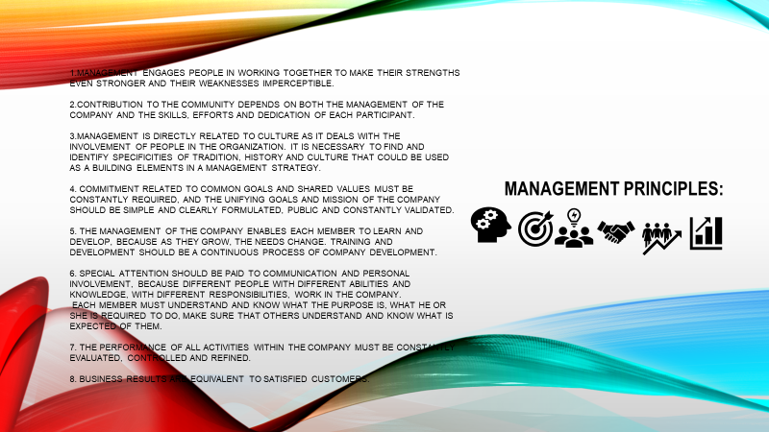
(Author developed)
History, company profile, management and leadership:
The experience of Tesco, a company that is one of the largest retailers in the world, is being analysed for the purpose of this writing. Some of the core elements of business process management will be analysed. Some recommendations will also be given regarding culture, people, structure and performance. The retailer's story began 100 years ago in 1919, when Jack Cohen returned from World War I and decided to improve his financial situation. Not the large sum he had in himself was enough to start fulfilling his dream. He believed in providing affordable food that could be within reach of anyone. Jack Cohen founded Tesco in 1920. Tesco's first store opened in Burnt Oak, Edgware, Middlesex in 1929. In 1956, the first self-service store opened in St. Albans, and the first supermarket in Maldon opened in 1956. In 1994, the company took over the William Low supermarket chain, successfully managing the competition of Sainsburys to control the company, which is based in Dundee and operates 57 stores. In 1995, Tesco introduced a loyalty card branded Clubcard, and later the company also provided an online shopping service. Tesco joined the US grocery business in July 2001 when it acquired a 35% stake in Grocery Works. In June 2003, Tesco acquired C Two-Network in Japan. And in October 2003, the company opened a UK telecommunications division including mobile and home telephony services to complement its existing Internet service provider business. Tesco participates in a joint venture with O2 to form the Tesco Mobile virtual network operator in 2007. In 2018, Booker Group merges with Tesco and the two companies combine their expertise to create the UK's leading UK's food business (Tesco Plc, 2019).
(Author developed based on: Tesco Pls,2019)
The company is focused on achieving its goal of providing quality goods and services to its customers, as well as for developing the workforce of the company, identifying the performances of the employees, as training them to be leaders. The mission of Tesco "Every little helps " is to continue to provide its customers, doing the little things that matter, which is also their statement. On the other hand, managers of each store are responsible for directing and motivating their team to deliver the promise of Tesco to their customers. Tesco's management style is adapted to the democratic style of leadership and their way of working is decentralised. The information is transmitted by senior management to the lower employees and everyone is free to express their views, to initiate effective ideas for the growth of the organization. Tesco's management encourages employees and makes them feel an important part of the organization.
Culture:
An organizational culture is a set of substantiated shared assumptions that define what happens in organizations by defining appropriate behaviours for different situations. Culture has an impact on employees, as people's behaviour is influenced by their values, and organizational culture is a set of shared values. That is why the culture of the Organization must create behavioural expectations to steer its employees towards such behaviour that is consistent with its culture (Stefano, 2017). According Schein, the key to the success of organisation is its organisational culture, and the function of leadership is to create and manage the culture. The concept of management depends on what the approaches to cultural management will be. Organisations can achieve their aims and objectives only through the coordinated efforts of members of the organisation. How it gets work done and how employee interact each other is reflection of organisational culture. To interact employees more effectively, a positive culture needs to be strong enough, and when a strong culture supports the business strategy, then the company becomes more effective (Kuppler, 2014).
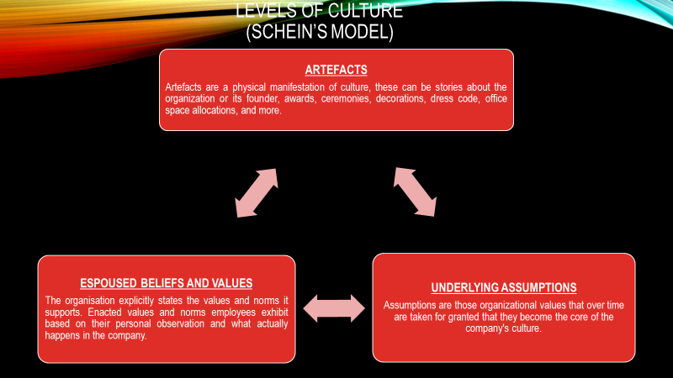
(Autor developed)
Managers work with different people who are from different countries and have different cultural values. The mechanism compares countries of cultural similarities and differences, assesses how the culture of society influences the values of its members and how those values influence their behaviour.
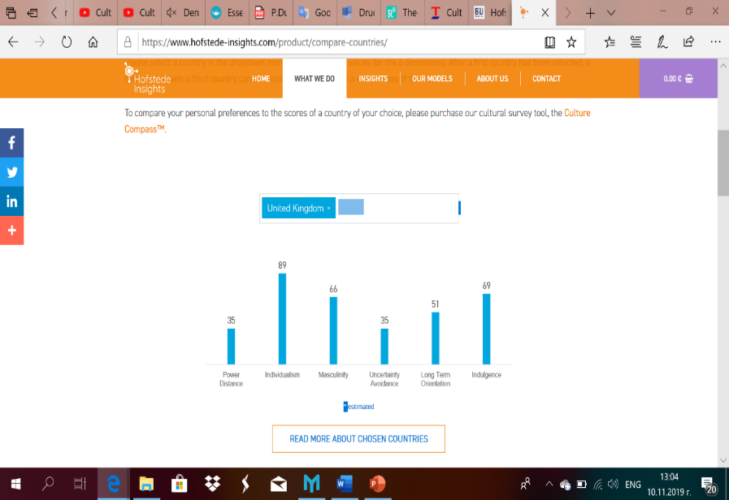
British Culture by Hofstede Cultural Dimension
(Hofstede Insights, 2019)
(Author developed)
Tesco's mission has remained unchanged over the years. It offers high quality and good value products that can be purchased and delivered easily and in a convenient way. Tesco helps its customers feel satisfied with the better quality and way of life – ‘Serving Britain’s shopper a little better every day’. Tesco's values ensure that every member of the company understands what is important, both as a teamwork and that the customer is at the centre of what is being done. 'Little Help Plan' is a core value for the company, and it is at the heart of 'Little Help'. This plan defines how Tesco sees the opportunity for change in social and environmental challenges because they are important for both clients and participants, as well as communities. Some of the challenges that he is tightly committed to are reducing carbon emissions, health and safety, cybersecurity, combating bribery. The plan includes helping the customer to make healthier choices about quality and affordable products; ensuring that no food is wasted; reducing the environmental impact of packaging. Independent research on the role they play in supporting different communities in the UK it takes in to account the contribution of the company and also analyses what more can be done in the future (Tesco Pls 2019).
Structure:
The hierarchical structure of the organization to be "flat " or "High " is determined by the combination of control scope and chain of command. Flat structures have minimal layers of control, have a low control range, because they need to be controlled on wider stretches. The communication model facilitates the relationship between the leader and the performer. This structure enables well-trained workers to make quicker decisions and thus be more productive in the process. Flat structures are more suitable for small companies because work and effort are smaller. The tall hierarchical structure, as well as the structure of Tesco, has a wide scope of control. Employees are grouped as each employee has a clear supervisor. Combining different groups is based on some different factors such as function, geography, product and service, customer type, etc (Mullins, 2010, p. 543-613)
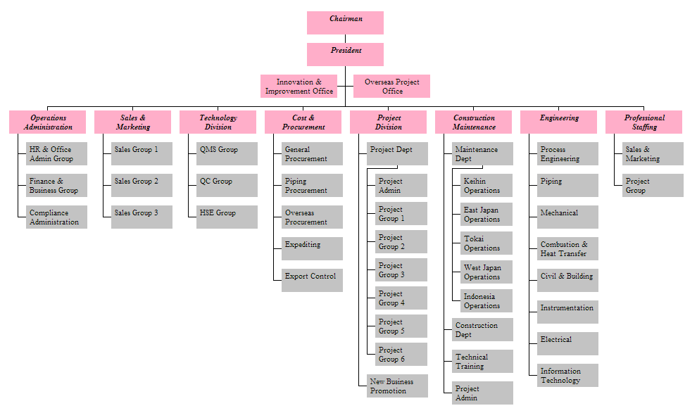
Company Employee Structure Chart Tesco Company
Organisational Structure Chart Example
(Chart Images Online)
The environment is one of the factors influencing the structure of the company. Tesco uses an organisational structure that allows to adapt and change rapidly. Branches and departments work as autonomous units. Each one works as if it were an independent company. This gives them the opportunity to make quicker decisions.
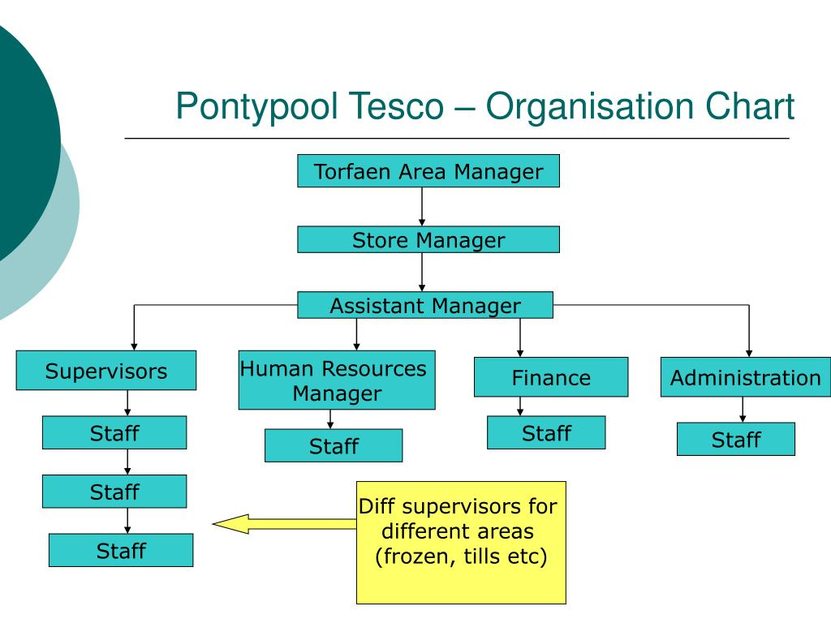
FUNCTIONAL AREAS (Clayton, J. 2019)
The functional structure organizes the employees by function/activity. The functional units fall into categories human resources, marketing, finance, research and development, sales. These employees tend to achieve a great degree of specialisation and development, and with this they contribute to the achievement of functional goals. With a regard to the geographic factor, the company has a presence in clusters of fourteen countries on different continents. In this way, changes in the needs of local customers and regional pressures on the environment can be easily reacted. Tesco has different store type. They have large stores called Tesco Extra, large supermarkets called Tesco Superstores and Tesco Metro, and small neighbourhood stores called Tesco Express and One Stop, that they can meet the needs of the customers in that area. All these stores are suited to sell different products with different amounts available. Tesco sort the products into categories that suit the customer's needs rather than just "food". Managers of different groups have assistants who lead the workers to ensure the well-being of the work. The managers haves to report to the store manager and then he/she reported to the store director.

People:
According to McGregor, theory X and theory Y represent the perceptions that managers have about their employees regarding their work within the organization (Hattangadi, V, 2015).
McGregor’s Theory X and Y
(Autor developed)
To maintain its high level of development, Tesco needs motivated, flexible and well-trained staff to meet customer needs. For its part, Tesco supports the company's employees in their various roles and levels. The motivated employee works harder and achieves greater results in less time, which reduces labour costs, requires less supervision and demonstrates pride in his work, which has a greater impact on the client. Well-motivated employees are more concentrated, less likely to make mistakes, less likely to cause accidents or engage in conflict. The motivated staff are more loyal to the company and have fewer absences. Non-motivated staff are dissatisfied with their role in the work environment, and this has a negative impact on the quality and efficiency of the work. According to Tesco management, the business depends on two groups of people - customers and staff. In assessing the important role of staff, the diverse lifestyle outside of work is also taken into account. In this regard, Tesco strives to maintain a work-life balance and offers remuneration by:

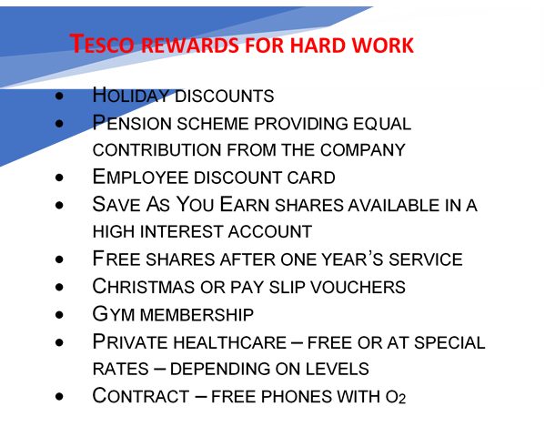
(Autor developed)
In addition to money, there are other factors that motivate people in their personal and working lives. Non-financial factors can also motivate employees to improve their production. This may be the desire to serve people, improve one's personal skills or achieve promotion. Once a year, Tesco conducts a survey among its employees called Viewpoint, which gives them the opportunity to express their views on various aspects of the job. This research helps Tesco suggest the right things to motivate his employees. Particularly important for organizing the activity in the company is good communication between the people working in the group and between the different units. This ensures a good understanding of the tasks to be performed and the proper allocation of resources. Controlling the activity and the results enables adequate decisions and actions to be taken (Lia, C. 2016). Intellectually people are engaged, and the correctness of thinking is determined by the various factors that may arise. Some of these factors that directly influence the social work environment are related to individual and collective processes of thinking, physical health, human values, human attitudes and norms of behaviour. These factors affect human behaviour, loyalty and trust (Lendzion,2015, p.674-680). According to Abraham Maslow, people are motivated by five basic needs. He demonstrated these needs through a pyramid, which he called the "hierarchy of need" (Mullins, 2010, p.260-267). At the bottom of the pyramid are placed basic needs that motivate people to work, such as shelter and food. When these needs are met, it comes to satisfying needs such as safety and security – good working conditions. Once these needs are fulfilled, there comes a turn of social needs, such as the need to belong to a certain group and self-esteem. The upper part is set for self - fulfilment. This is the place of challenges, creativity and interest (Hanna and Lee 2015).
(Autor developed)
Performance:
Organizational performance is a picture that reflects the actual results measured against the planned results (Albrecht et al, 2015, p.1-21). Performance is measured by:
(Autor developed)

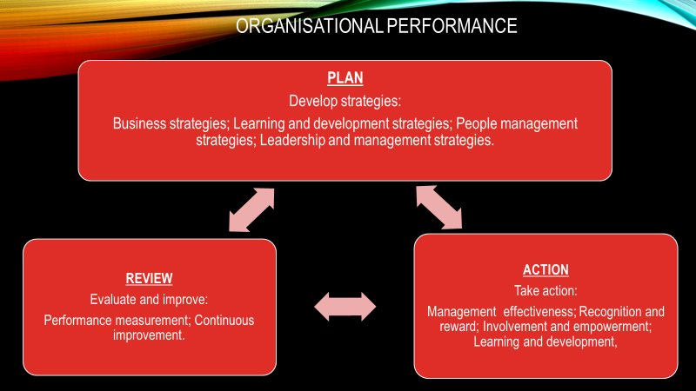
(Autor developed)

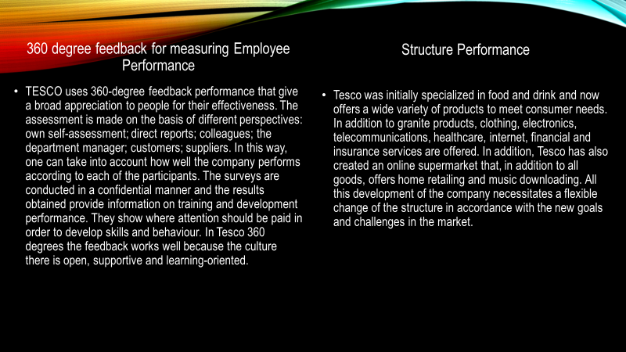
(Autor develop)
Recommendations and Conclusion:
From all of the above, it can be concluded that Tesco works as a ‘well-oiled machine’ with a well-built structure, satisfied workers and even more satisfied customers. Management is democratically oriented, respecting the rights and freedoms of workers, customers and suppliers. In Tesco, there is an organizational culture where everyone can come up with ideas, everyone's opinions are heard, everyone can accept the challenges, learn and develop to do their best to achieve better results in interest of the company. As a recommendation on the structure, it can be noted that the communication time is a little slow and this can lead to an accumulation of solutions. 360degree feedback has advantages, but if not properly handled, it can lead to anxiety, stress and discomfort in the workplace. The survey must be anonymous. This will give people more honest and accurate feedback.

References:
- Albrecht, S. (2015), ‘Employee engagement, human resource management practices and competitive advantage’, Deakin University DRO, p.1-21.
Available at: http://dro.deakin.edu.au/eserv/DU:30071114/albrecht-employeeengagement-post-2015.pdf
(Accessed: 10 November 2019)
- Business Dictionary, ‘Organizational culture’.
Available at: http://www.businessdictionary.com/definition/organizational-culture.html
(Accessed: 27 October 2019)
- Chart Images Online, Company Employee Structure Chart Tesco Company Organisational Structure Chart Example.
Available at: https://chateau-conques.com/charts_rm.php (Accessed: 02 November 2019)
- Clayton, J. (2019) ‘FUNCTIONAL AREAS - PowerPoint PPT Presentation’
Available at: https://www.slideserve.com/jon/functional-areas
(Accessed: 28 November 2019)
- Drucker, P. (2001), The Essential Drucker, 1thedn. Butterworth Heinemann
- Hanna, Lee (2015), ‘Savings goals and saving behaviour from a perspective of Maslow's hierarchy of needs’, Journal of Financial Counselling and Planning.
Available at: https://www.researchgate.net/profile/Sherman_Hanna/publication/274566738_Savings_Goals_and_Saving_Behavior_From_a_Perspective_of_Maslow's_Hierarchy_of_Needs/links/59553e864585152bd03e7d89/Savings-Goals-and-Saving-Behavior-From-a-Perspective-of-Maslows-Hierarchy-of-Needs.pdf
(Accessed: 04 November 2019)
- Hattangadi, V. (2015), ‘Theory X & Theory Y’, International Journal of Recent Research Aspects.
Available at: https://s3.amazonaws.com/academia.edu.documents/48499811/IJRRA-02-04-06.pdf?response-content-disposition=inline%3B%20filename%3DTheory_X_and_Theory_Y.pdf&X-Amz-Algorithm=AWS4-HMAC-SHA256&X-Amz-Credential=AKIAIWOWYYGZ2Y53UL3A%2F20191104%2Fus-east-1%2Fs3%2Faws4_request&X-Amz-Date=20191104T164847Z&X-Amz-Expires=3600&X-Amz-SignedHeaders=host&X-Amz-Signature=a94911f5bb01bb8f70777501ea6bcdc78d4a12db473158499ef97be36813b203
(Accessed: 04 November 2019)
- Hofstede Insights
Available at: https://www.hofstede-insights.com/country-comparison/the-uk/
(Accessed: 10 November 2019)
- Kamal, Zubair (2016), ‘Perceived Authentic Leadership, Work-Related Flow, and Creative Work Behavior: Moderating Role of Organizational Structures’, Abasyn Journal of Social Sciences, Volume 9, Issue 2, p.431-434.
Available at: https://www.researchgate.net/profile/Anila_Kamal/publication/313764679_Perceived_Authentic_Leadership_Work-Related_Flow_and_Creative_Work_Behavior_Moderating_Role_of_Organizational_Structures/links/58a5424a4585150402cc3eef/Perceived-Authentic-Leadership-Work-Related-Flow-and-Creative-Work-Behavior-Moderating-Role-of-Organizational-Structures.pdf
(Accessed: 03 November 2019)
- Kuppler, T. (2014), Culture Fundamentals from Edgar Schein [video].
Available at: https://www.youtube.com/watch?v=4Fw5H7GWzog
(Accessed: 09 November 2019)
- Lendzion, J. (2015), ‘Human Resources Management in the System of Organizational Knowledge Management’, Procedia Manufacturing, Volume 3, p. 674-680
Available at: https://www.sciencedirect.com/science/article/pii/S2351978915003042
(Accessed: 10 November 2019)

- Lia, C. (2016), ‘The effect of individual market orientation on sales performance: An integrated framework for assessing the role of formal and informal communications’, Journal of marketing theory and practice.
Available at: https://www.researchgate.net/profile/Christine_Jaushyuam_Lai/publication/304677570_The_Effect_of_Individual_Market_Orientation_on_Sales_Performance_An_Integrated_Framework_for_Assessing_the_Role_of_Formal_and_Informal_Communications/links/5d96e7fca6fdccfd0e745ea9/The-Effect-of-Individual-Market-Orientation-on-Sales-Performance-An-Integrated-Framework-for-Assessing-the-Role-of-Formal-and-Informal-Communications.pdf
(Accessed: 09 November 2019)
- Mullins, L. (2010), Management & organisational behaviour, 9thedn. Prentice Hall
- Stefano, D. (2017), ‘The effect of organizational culture on deviant behaviours in the workplace’, The International Journal of Human Resource Management, Volume 30, 2019 - Issue 17, p.2482 - 2503.
Available at: https://www-tandfonline-com.ezproxy.uwtsd.ac.uk/doi/full/10.1080/09585192.2017.1326393
(Accessed: 27 October 2019)
- Tesco Plc (2019) 100 Years of Great Value.
Available at: https://www.tescoplc.com/about/100-years-of-great-value-1/
(Accessed: 30 October 2019)
- Tesco Pls (2019), Preliminary Results 2018/19.
Available at: https://www.tescoplc.com/media/754313/prelims-results-1819.pdf
(Accessed: 31 October 2019)
- Tesco Pls (2019), Our Culture.
Available at: https://www.tesco-careers.com/explore-our-world/our-culture/
(Accessed: 09 November 2010)

