

Student Name: Podili Deepthi
Student Id: 2432738
Lecturer Name: Dr Muhammad A.Abbas/Assoc. Prof.
Module: Data Security, Governance and Compliance[ACCA7028]

Table of Contents
1. Introduction 1
2. Literature Review and Framework Analysis 1
2.1. Conceptual Foundations of Data-Security Governance 1
2.2. ISO/IEC 27001:2022 2
2.3. NIST Cybersecurity Framework 2.0 3
2.4. COBIT 2019 and ITIL 4 3
2.5. Zero Trust Architecture (ZTA) 4
2.6. ISO/IEC 27701 and ISO 22301 4
2.7. Comparative critique of frameworks 4
3. Design Approach for NatureGreen 5
3.1. Integrated Security-Governance Model 6
3.2. Governance and Compliance Structure 7
3.2.1. Information Security Management System (ISMS) 7
3.3. Policy Framework and Risk-Management Integration 8
3.4. Technical Design Elements 8
3.4.1. Zero Trust Enforcement 8
3.4.2. Cloud-Security Controls 10
3.4.3. Privacy and Legal Compliance 10
3.4.4. Monitoring, Detection and Response 11
3.5. Business-Continuity and Resilience Planning 12
3.6. Service-Level Agreements and Third-Party Management 12
3.7. Metrics, Assurance and Continual Improvement 12
4. Critical Discussion 13
5. Conclusion 15
References 16

Figures
Figure 1: Main Changes in ISO/IEC 27001:2022 2
Figure 2: Functions of NSF 3
Figure 3: Key Components of COBIT 2019 3
Figure 4: Key Components of Zero Trust Architecture 4
Figure 5: Layered “Onion” Model of Integrated Data Security, Governance, and Compliance Framework for NatureGreen (NG). 6
Figure 6: Zero Trust Enforcement Architecture 8
Figure 7: Cloud-Security Controls 9
Figure 8: Privacy and Legal-Compliance Architecture 10
Figure 9: Unified Monitoring, Detection, and Response Ecosystem 11

Tables
Table 1: Comparative Analysis of Major Frameworks 4
Table 2: Roles and Responsibilities 7

Introduction
In the globalized economy, where hyper-connectivity has become common, information assets are becoming the main currency of a firm. The case of organisations like NatureGreen (NG), a multinational corporation providing cloud-based wellness solutions, which have a 95% wireless infrastructure, is a paradox: ubiquitous connectivity yields business agility but exponentially increases the attack surface (Soomro, Shah and Ahmed, 2016). Recent threat-intelligence reports indicate that incidents of ransomware and cloud-misconfiguration attacks of hybrid workforces have increased by 36% annually (Alder, 2025). At the same time, consumers and regulators demand the transparency of personal data stewardship in the framework of such laws as the UK GDPR and Data Protection Act 2018 (Lim and Oh, 2025; UK Legislation, 2019).
Bring-your-own-device (BYOD) policies, cloud computing, and social-media marketing intersect, and this makes the traditional perimeter-based defences of NG irrelevant. Since 95% of traffic flows through wireless and personal endpoints, confidentiality and integrity rely on whether devices comply with the protocol, verify identities, and provide real-time risk analytics instead of fixed network boundaries (Rose et al., 2020). In addition, the lack of a cohesive Information Security Management System (ISMS) and corporate security policy will put NG in the path of regulatory fines, business disruption, and brand erosion.
The analysis work goes beyond technical hardening; it requires critical analysis of governance, risk and compliance (GRC) doctrines that institutionalise accountability. Contemporary research interprets cybersecurity as not only just a set of technical controls but as an adaptive socio-technical apparatus that must be overseen by a board and potentially guarantee the measurement of assurance (Peltier, 2016).
The three objectives of this report are therefore inter-linked:
- To assess current security frameworks and models: ISO/IEC 27001:2022 (ISO, 2022), NIST Cybersecurity Framework (CSF 2.0) (NIST, 2025), COBIT 2019 (Rafeq, CISA and FCA, 2021), ITIL 4, and Zero-Trust Architecture (Rose et al., 2020) with regard to the cloud-BYOD ecosystem of NG.
- To formulate a custom governance and compliance strategy that would integrate these frameworks into the context of NG.
- To critically evaluate the need to constantly update regulatory and standards in the face of the dynamic cyber-threat environment.

Literature Review and Framework Analysis

Conceptual Foundations of Data-Security Governance
Data-security governance is the alignment of corporate goals with risk appetite, regulatory responsibilities, and technical controls (Von Solms and Van Niekerk, 2013). It summarizes the three-pillar of confidentiality, integrity, and availability (CIA) which have been extended by the Parkerian Hexad to incorporate possession, authenticity, and utility (Leeson, 2024). Although the conceptual nucleus is the CIA triad, governance literature emphasizes entrenching it in policy, accountability, and audit frameworks (Da Veiga and Eloff, 2010). The institutionalisation of this paradigm is manifested in the maturing of standards like ISO/IEC 27001 and the NIST CSF.

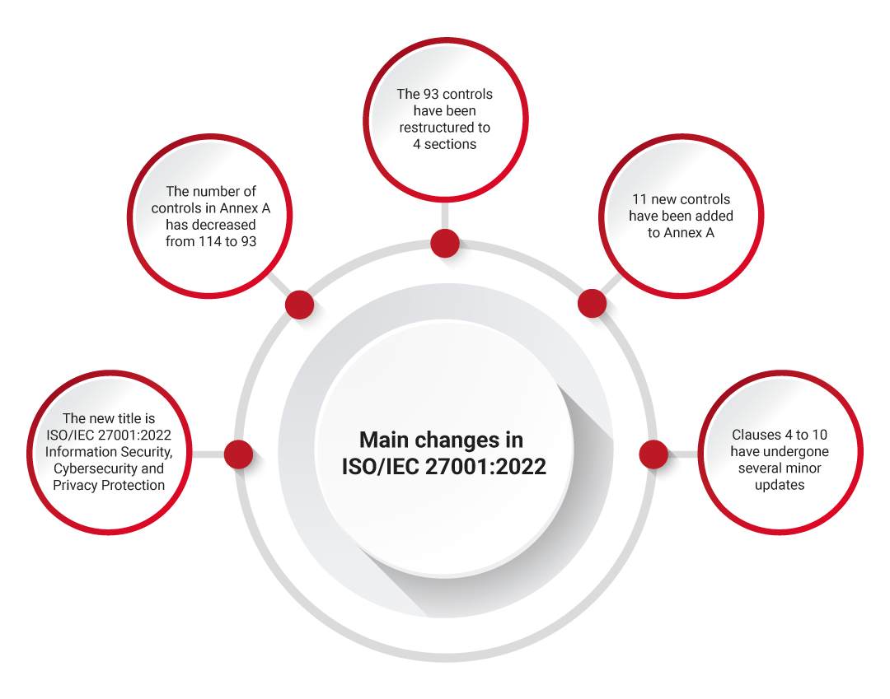
ISO/IEC 27001:2022
Figure 1: Main Changes in ISO/IEC 27001:2022
Source: (PECB, 2025)
In the ISO/IEC 27001:2022 revision, the Annex A is re-structured in 93 controls that are spread across organisational, people, physical, and technological topics, revising the clauses to accommodate cloud use (5.23) and user-endpoint devices (8.1) (IT Governance, 2024) . Empirical evidence indicates that the presence of ISO-certified firms reflects significantly stronger incident-response preparedness and board responsibility (Siponen and Willison, 2009). Nevertheless, critics state that the audit-focused orientation of ISO can solidify controls into compliance checklists unlinked to the current threat intelligence (Culot et al., 2021). To achieve a dynamic BYOD and cloud environment, the ISO 27001 should thus be complemented with dynamic frameworks that operationalise ongoing monitoring.

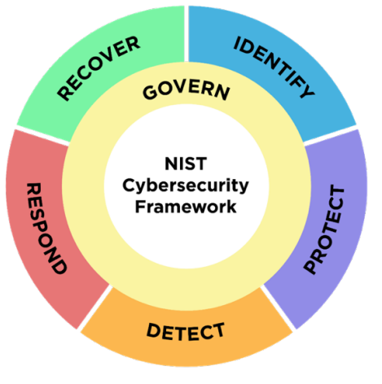
NIST Cybersecurity Framework 2.0
In 2024, NIST published NIST CSF 2.0, which added a sixth function, Govern, to the canonical Identify-Protect-Detect-Respond-Recover (NIST, 2025). This addition institutionalises leadership accountability as it requires specified roles, policies, risk-communication procedures. Scholarly reviews note the practical mapping of CSF to current controls (e.g., SP 800-53, ISO 27001) and its applicability across industries (NIST, 2024; Rose et al., 2020; Shen, 2014). However, its voluntary aspect and non-certification might impede external assurance, which is of specific importance to NG, as its international clients might demand proving its compliance credentials.
Figure 2: Functions of NSF
Source: (NIST, 2025)

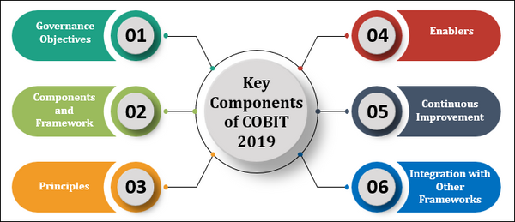
COBIT 2019 and ITIL 4
COBIT 2019 expands the scope of governance past security to comprehensive Information & Technology (I&T) value delivery. Its design considerations and performance-management goals permit quantitative maturity evaluation (Antariksa, Angin and Widodo, 2025). In the case of NG, COBIT offers the strategic management and key-performance-indicator (KPI) framework that technical standards lack (Hurkadli, 2023). ITIL 4, in its turn, integrates information-security management into the Service Value System, providing process discipline of change, incident, and problem management (Informit, 2024; Ishlahuddin et al., 2020). However, both of these frameworks are prescriptive and heavy on process, which can hinder agility unless right-sized.
Figure 3: Key Components of COBIT 2019
Source: (Hurkadli, 2023)

Zero Trust Architecture (ZTA)
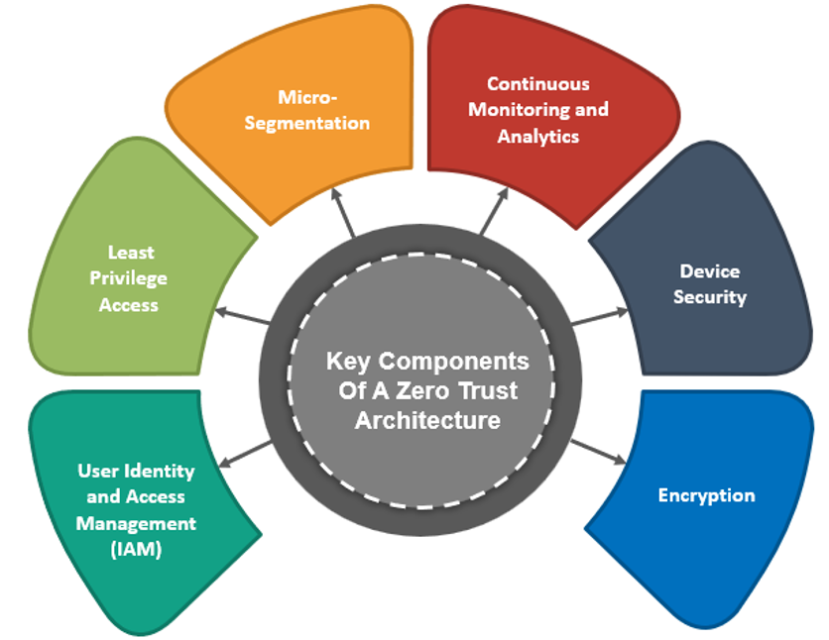
Zero Trust, which is codified in NIST SP 800-207, does not trust implicitly but requires ongoing posture verification of users, devices, and sessions (Rose et al., 2020). Its usefulness is supported by academic evidence of countering lateral-movement and credential-theft attacks that are prevalent in hybrid networks (Gambo and Almulhem, 2025). In the 95% wireless, BYOD ecosystem of NG, endpoint heterogeneity is directly addressed using the micro-segmentation and conditional-access principles of Zero Trust (Rose et al., 2020). However, it cannot be fully implemented without evolved identity administration and telemetry streams, which are not commonly developed in middle-tier corporations.
Figure 4: KEy Components of Zero Trust Architecture
Source: (Kumar, 2024)

ISO/IEC 27701 and ISO 22301
The privacy extension ISO/IEC 27701:2019 operationalises the GDPR principles in an ISMS, establishing the roles of controllers and processors, rights of data-subjects and impacts-assessment of data-protection (Perrin, 2021). Considering NG is exposed to consumer-data, the inclusion of 27701 would guarantee legal processing and auditability. Simultaneously, ISO 22301:2019 introduces a Business Continuity Management System (BCMS) as an important protection against ransomware-caused downtime (ISO, 2019). The literature associates BCMS maturity with better indicators of cyber-resilience and the level of confidence among stakeholders (Herbane, 2022).

Comparative critique of frameworks
Table 1 compares the relative strengths of the frameworks to the context of NG.
Table 1: Comparative Analysis of Major Frameworks
Framework | Core Strengths | Principal Limitations | Relevance to NG
ISO/IEC 27001 (2022) | Certifiable ISMS; structured controls incl. cloud/BYOD | Static, audit-centric; limited real-time adaptability | High—forms compliance backbone
NIST CSF 2.0 | Dynamic, outcome-based; new “Govern” function | Non-certifiable; voluntary uptake | High—operational governance overlay
COBIT 2019 | Board-level metrics, maturity modelling | Abstract; limited security depth | Medium—executive oversight tool
ITIL 4 | Service-management discipline; change control | Process overhead; generic security focus | Supportive—incident/continuity linkage
Zero Trust (SP 800-207) | Device-identity centric; continuous verification | Requires telemetry & identity maturity | Critical—BYOD and wireless risk mitigation
ISO 27701 / 22301 | GDPR compliance & continuity assurance | Additional audit overhead | High—privacy + resilience complement
Importantly, the literature is convergent towards integration and not substitution. According to Wu et al. (2024), hybrid governance architectures, which consider the formalism of ISO and the agility of NIST, are more effective than monolithic adoption regarding compliance and detection-response measures. In the case of NG, the evidence suggests that the triad of the most defensible is ISO 27001 + NIST CSF + Zero Trust. The external assurance and formal risk management in ISO 27001, agile governance in NIST CSF, and the 95% wireless and multi-device perimeter in Zero Trust all are insured (Table 1). COBIT 2019 and ITIL 4 provide additional governance and service-continuity frameworks, and ISO 27701 guarantees GDPR compliance and ISO 22301 grounds resiliency (Kostopoulos, 2017). The following part will then design a hybrid governance-security system, which realises these standards in concrete forms of control and responsibility as well as assurance metrics, which are specific to the hybrid environment of NG.

Design Approach for NatureGreen
The reviewed literature proves that there is no single framework that would provide adequate security to such a hyper-connected enterprise as NG. The proposed design thus adheres to an integrated design architecture that integrates the auditable discipline of ISO 27001, the governance agility of the NIST CSF 2.0 and the Zero Trust paradigm of pervasive verification of devices and identity. This tri-model architecture is supported operationally by the incident- and change-management processes of ITIL 4 and has its basis in the strategic oversight of COBIT 2019.
The proposed model is based on four design principles:
- Risk based Proportionality - there should be a commensurateness between the criticality of data assets and the probability of exploitation (Tuma et al., 2021).
- Zero Trust by default - everything is authenticated, authorised, and constantly verified (Rose et al., 2020).
- Compliance-driven assurance - all policies are in line with ISO 27001 (Clauses 4-10), ISO 27701 (privacy) and ISO 22301 (continuity).
- Continuous improvement and governance accountability - corresponds to the new Govern function of NIST CSF, which entails board-level accountability and quantifiable KPIs (Caldwell et al., 2023).
Zero Trust Enforcement
NIST CSF Core Functions
ISMS Implementation (ISO/IEC 27001 Clauses 4–10)
Board Accountability & Risk Appetite (COBIT / NIST CSF: Govern)

Integrated Security-Governance Model
Figure 5: Layered “Onion” Model of Integrated Data Security, Governance, and Compliance Framework for NatureGreen (NG).
As shown in Figure 5, a layered “onion model should consist of:
- Governance Layer - Board, Chief Information Security Officer (CISO), Data Protection Officer (DPO), Risk Committee.
- Management Layer - ISO 27001 ISMS processes, policy lifecycle, audit and continuous-improvement loop.
- Operational Layer - NIST CSF operates (Identify, Protect, Detect, Respond, Recover) and has metrics positioned to ISO controls.
- Technology Layer - Identity and Access Management (IAM), Mobile Device Management (MDM), Cloud Security Posture Management (CSPM), and Extended Detection and Response (XDR) are implementation points.
This architecture provides traceability between strategic intent to technical control so that board level dashboards demonstrate governance maturity.

Governance and Compliance Structure

Information Security Management System (ISMS)
NG needs to implement an ISMS that is in line with ISO 27001. The ISMS sets up the context (Clause 4), leadership (Clause 5), and risk assessment methodology (Clause 6) (Secureframe, 2025). A Risk Register documents threats, likelihood, impact, controls in place, and residual risk, which are quarterly reviewed by the Risk Committee. Annex A controls are mapped to the environment of NG via the Statement of Applicability (SoA), which includes:
- A 5.23 Cloud Services,
- A 8.1 User Endpoint Devices, and
- A 5.30 ICT Readiness for BC (IT Governance, 2024)
Table 2: Roles and Responsibilities
Role | Core Responsibilities | Accountability
Board of Directors | Approve ISMS, risk appetite, and policies | Overall governance
CISO | Design and maintain ISMS; report metrics | Operational security
DPO | Ensure GDPR and ISO 27701 compliance | Privacy governance
CIO | Integrate security architecture with IT strategy | Technical alignment
Risk Committee | Review risk register; approve mitigation plans | Oversight
All Employees | Comply with policies; complete awareness training | Individual responsibility
Clarity of accountability reduces the type of ownership void prevalent in underdeveloped governance structures (Da Veiga and Eloff, 2010).

Policy Framework and Risk-Management Integration
The policies are the connective tissue between the governance intent and operational performance (Peltier, 2016; Blackley, 2004). The suite of core policies that NG should have are:
- Information - Security Policy - general principles, goals, enforcement authority.
- BYOD and Mobile Device Policy - consistent with NIST SP 800-124 Rev. 2, which establishes enrolment, encryption, remote wipe, and acceptable use.
- Access-Control Policy - least privilege, multi-factor authentication (MFA), periodic access review.
- Data-Classification and Handling Policy - Public, Internal, Confidential, Restricted; all of which are associated with safeguards of storage and transmission.
- Incident-Response Policy - lifecycle based on NIST SP 800-61 Rev. 2 (symbolically recognizing its 2025 withdrawal, though keeping its structured phases).
- Business-Continuity and Disaster-Recovery Plan - in compliance with ISO 22301, with Recovery Time Objective (RTO) and Recovery Point Objective (RPO).
The Risk-Management Process accommodates the cycle of ISO 31000 (Identify, Analyse, Evaluate, Treat, Monitor) in the ISMS continual-improvement loop. The Board establishes its risk appetite, which is operationalised with risk ratings and treatment plans (Muskan, 2025).

Technical Design Elements

Zero Trust Enforcement
Apply Zero Trust Architecture (ZTA) controls to protect the 95% wireless network of NG:
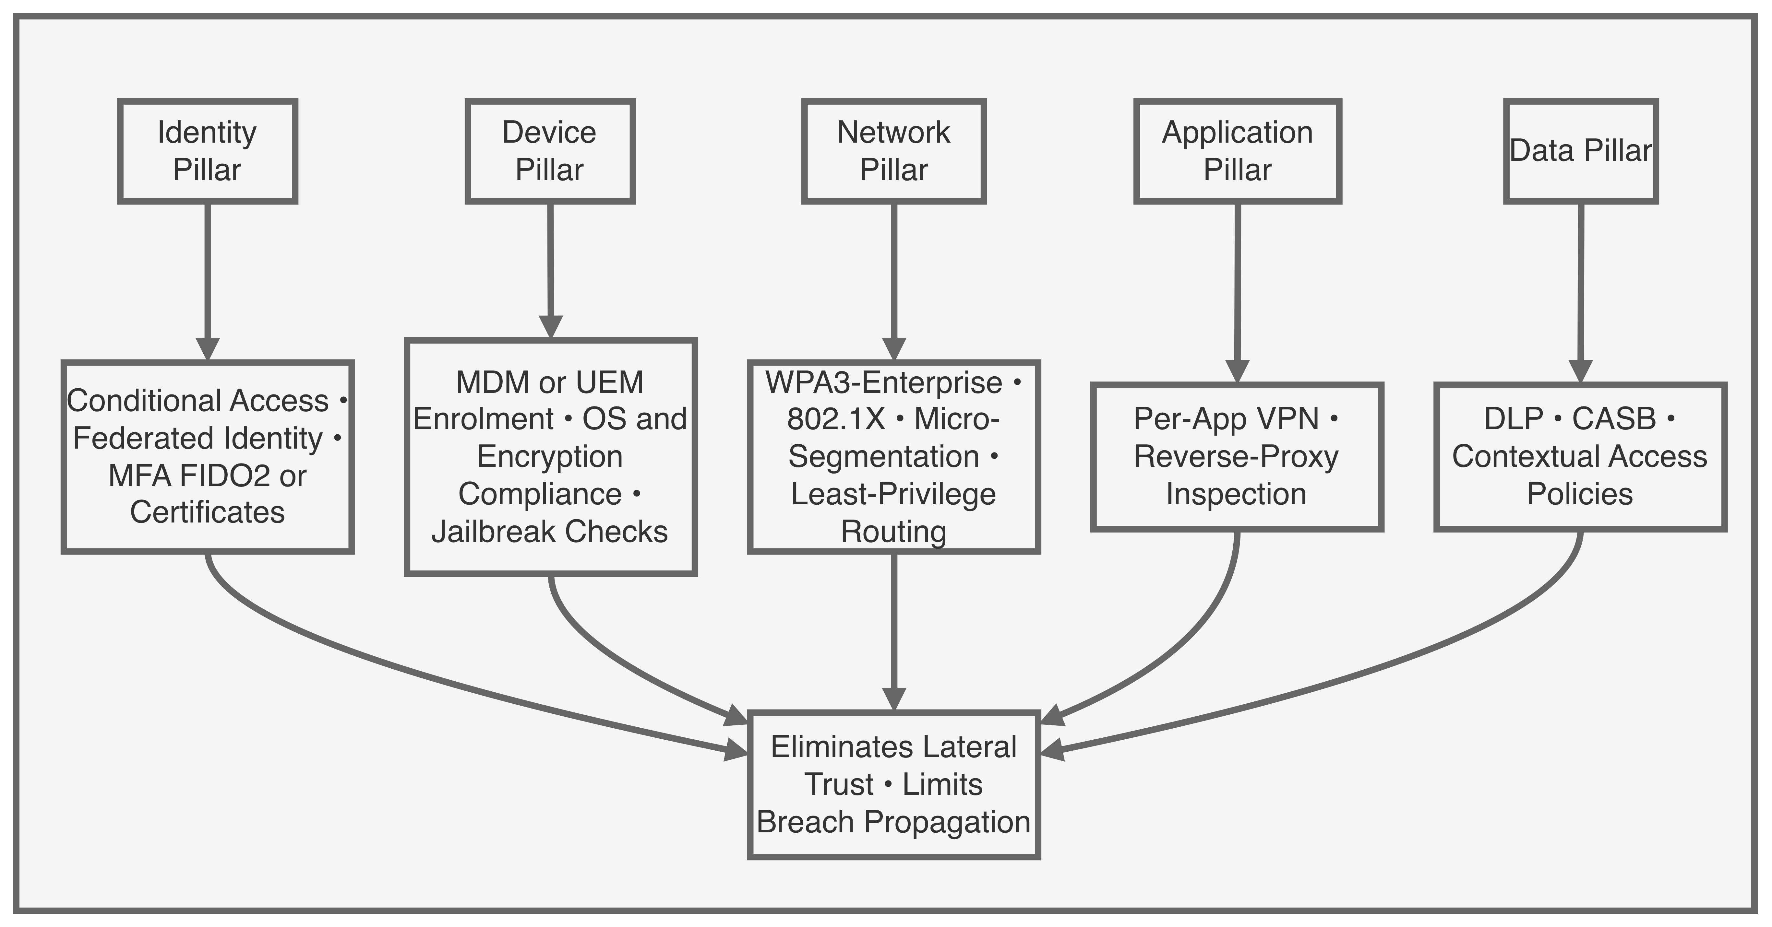
Figure 6: Zero Trust Enforcement Architecture
- Identity pillar: federated identity and conditional access; MFA based on FIDO2 or certificate-based authentication (Figure 6).
- Device pillar: required MDM/UEM enrolment; OS version, encrypted and jailbreak compliance verification (NIST, 2023).
- Network pillar: WPA3-Enterprise 802.1X; micro-segmentation; least-privilege routing.
- Application pillar: reverse-proxy and per-app VPN inspection.
- Data pillar: contextual policy-enforcing Data Loss Prevention (DLP) and cloud-access security broker (CASB).
This model does not support any lateral trust and minimizes the spread of breaches (Figueroa-Lorenzo et al., 2022).

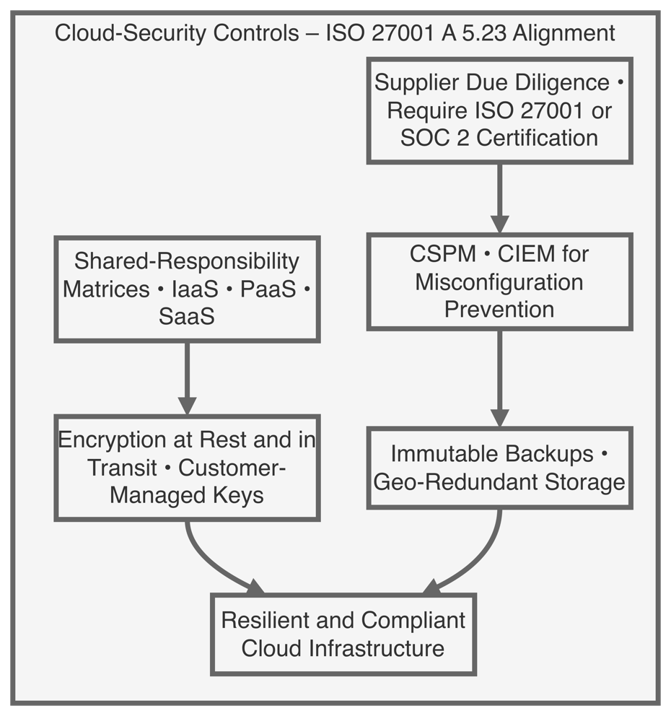
Cloud-Security Controls
Following ISO 27001 A 5.23, NG should (Figure 3):
- Do supplier due diligence; must be certified to ISO 27001 or SOC 2;
- Determine shared-responsibility matrices of IaaS, PaaS, SaaS;
- Implement Cloud Security Posture Management (CSPM) and Cloud Infrastructure Entitlement Management (CIEM) to avoid misconfigurations;
- Implement encryption in rest and transit using customer-managed keys;
- Use immutable backups and geo-redundant storage to achieve resiliency.
Figure 7: Cloud-Security Controls

Privacy and Legal Compliance
The incorporation of ISO 27701 makes it comply with the principles of GDPR, i.e. lawfulness, fairness, transparency, and accountability (Perrin, 2021). The necessary mechanisms comprise (Figure 4):
- Data Protection Impact Assessments (DPIAs) prior to process sensitive data.
- Data Processing Activities (ROPA) stored in central storage.
- Access, rectification, and erasure of data-subject-rights within 30 days.
- Breach-notification process: a notification of breach to the ICO in 72 hours to UK residents (ICO, 2023).
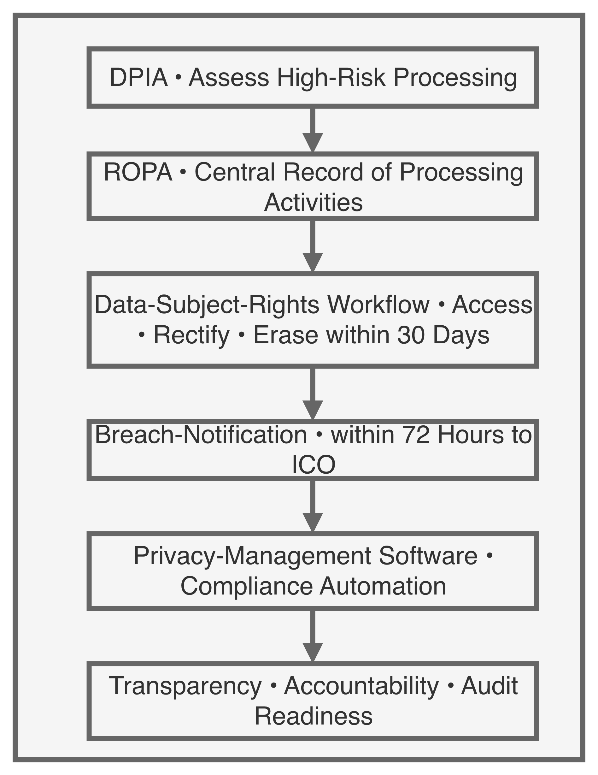
Figure 8: Privacy and Legal-Compliance Architecture
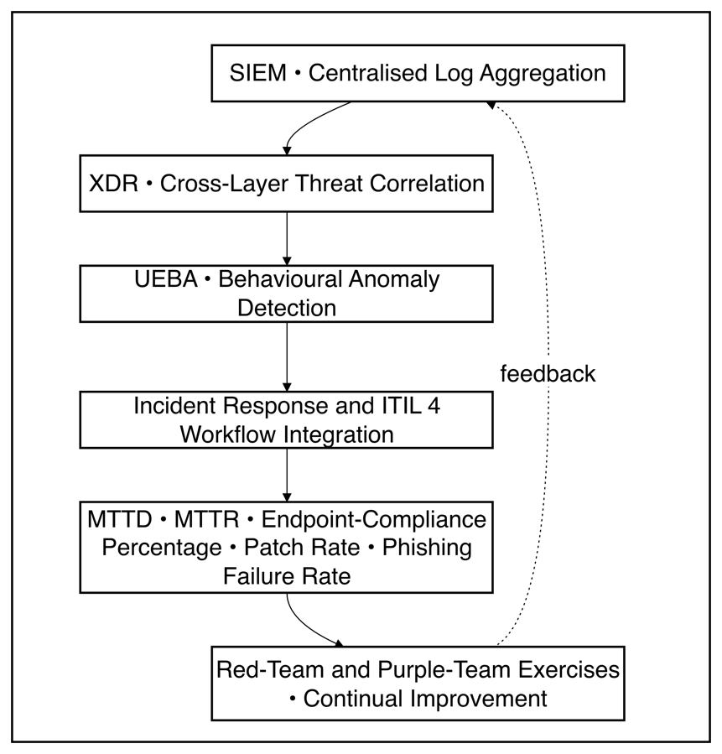
- Audit preparedness and minimized manual overhead are enhanced through compliance automation through privacy-management software.

Monitoring, Detection and Response
Implement a dedicated telemetry platform, combining Security Information and Event Management (SIEM), Extended Detection and Response (XDR), and User and Entity Behaviour Analytics (UEBA). The architecture works with NIST CSF Detect and Respond functions and incident-management processes of ITIL 4. Key metrics include:
- Mean Time to Detect (MTTD) and Mean Time to Respond (MTTR);
Figure 9: Unified Monitoring, Detection, and Response Ecosystem
- Endpoints compliance percentage;
- Patch-compliance rate;
- Failure rate in phishing-simulation.
Control effectiveness is checked by quarterly red-team and purple-team exercises that contribute to a constant improvement process (Caldwell et al., 2023).

Business-Continuity and Resilience Planning
According to ISO 22301, NG is expected to find essential services, have Business Impact Analysis (BIAs), and establish minimum business-continuity requirements (Steen, Haug and Patriarca, 2024). The backups should be separated and verified. Communication and recovery is coordinated by crisis-management teams. It has been demonstrated that organisations with full-scale continuity exercises recover in 30-40% of the time after the incident.

Service-Level Agreements and Third-Party Management
All vendor relationships, especially cloud providers should be covered by security-focused SLAs that address (Smith, 1995):
- Residency and sovereignty of data;
- Breach-notification timeframes;
- Right to audit;
- Sub-processor transparency;
- Punishment on failure to comply;
- Ownership of cryptographic keys;
- Exit and data-deletion processes (isms.online, 2023).
Onboarding is preceded by third-party risk assessment where annual re-certification takes place.

Metrics, Assurance and Continual Improvement
Following the model of performance management suggested by COBIT, NG can have a governance dashboard with the capability level (0-5) of every CSF function. Under ISO 27001 Clause 9.3, management reviews are fed using monthly measures. Checks on conformity are done through independent internal audits; the results initiate corrective measures. The management reviews are done on an annual basis to evaluate residual risk and resource adequacy. The mechanisms of continuous-improvement involve:
- Quarterly policy review in line with the emerging threats;
- Incorporation of the threat intelligence into risk measurements;
- Comparison of industry counterparts based on maturity tiers of the CSFs.
Table 2 Alignment of NG’s risks to frameworks and controls
Key Challenge | Framework Mapped | Control Cluster / Outcome
BYOD & wireless exposure | Zero Trust (SP 800-207), ISO 27001 A 8.1 | Conditional access, MDM/UEM, per-app VPN
Cloud misconfigurations | ISO 27001 A 5.23, NIST CSF Protect | CSPM, CIEM, key management, vendor assurance
Privacy compliance | ISO 27701, GDPR | DPIAs, ROPA, subject-rights workflow
Ransomware / continuity | ISO 22301, NIST CSF Recover | Immutable backups, BIA, tested BC/DR plan
Weak governance | NIST CSF Govern, COBIT 2019 | Board oversight, KPIs, maturity dashboard
This cohesive architecture incorporates governance into the organisational DNA of NG, but it still maintains agility and scalability. It transforms compliance as a cost of reaction to a competitive advantage that is an indication of trust to the regulators, partners and the consumers. The second part will then take a critical look at the justification of the constant development of standards and regulations, and that it is only through adaptive governance that we stand a chance of survival in a threat environment of volatility and speed.

Critical Discussion
Historically, the frameworks of cybersecurity were updated every decadal cycle, yet the threat environment develops much faster, and such a rhythm is no longer feasible. The supply-chain breaches, AI-assisted phishing, and ransomware-as-a-service are the new attack vectors in use, which undermine the set of control (IBM, 2024). The case of the 2024 breach on the UK Electoral Commission due to unpatched software and lack of multi-factor authentication proves that adherence to the legacy standards does not offer any protection when the opponents are more innovative than the rules (The Guardian, 2024). The episode highlights the need to have a living model of governance, the policies and standards adapt together with the adversarial capability.The changes between the ISO/IEC 27001:2013 and 2022 are an illustration of shifting towards agility: control consolidation, introduction of new categories of cloud services (5.23) and endpoint devices (8.1), and linking them in a clear connection with the organisational context (IT Governance, 2024). In the same way, NIST CSF 2.0 (2024) has added a new Govern function, which focuses on board responsibility and results (NIST, 2025). According to academic commentators, the addition will turn the CSF into a strategic governance tool instead of a technical checklist, which is a reflection of the evolving notion of cybersecurity as a corporate-risk discipline, as opposed to an IT silo (Shen, 2014).
These sequential updates represent a form of coevolution: opponents take advantage of the new technology, and regulators take advantage of that and update their expectations and organisational needs to implement the updates. In the absence of vigilance NG would experience standards obsolescence whereby formally compliant controls no longer offset actual risk.Although adaptive regulation improves protection, it also causes what practitioners refer to as compliance fatigue. Organisational incompatibilities and conflicts between UK GDPR and EU GDPR, Digital Information Bill and the variety of data-localisation laws are overlapping mandates that each is accompanied by different reporting metrics (ICO, 2023). Academic studies reveal that companies that only do compliance tick-boxing are losing performance in incident-response, but those increasing compliance with risk management endure resilience (Siponen and Willison, 2009). The point, therefore, is not that the regulation is not needed, but rather the coherence of regulations and ensuring the compliance is part of an adaptive system of governance, which constitutes the continuous-improvement cycle of the NIST CSF.
Conventional models tended to believe in network trust zones, but BYOD and cloud paradigm nullifies perimeter beliefs. As a result, governments are formalizing principles of Zero Trust into official guidance; e.g. the U.S. Federal Zero Trust Strategy (2022) and NIST SP 800-207 require continuous authentication and least-privilege segmentation (Rose et al., 2020). It is widely agreed that academia believes that Zero Trust represents the next logical step in the evolution of compliance: security will be context-adaptive and evidence-driven, and compliance will be assessed through telemetry, as opposed to paperwork (Gambo and Almulhem, 2025). In the case of NG, this change makes audits real-time assurance procedures, and the technical controls to meet the regulation dynamism.
AI poses defensive analytics as well as ethical risk. Future EU AI Act (2025) and the AI Regulation White Paper proposed in the UK highlight the concept of explainability, reduction of bias and accountability in automated decision-making (Wingfield, 2025). It has been cautioned in the literature of security governance that uncontrolled opaque machine-learning models can jeopardize fairness and privacy requirements (de Almeida, dos Santos and Farias, 2021). Thus, the next compliance stance of NG should not only be based on providing confidentiality and integrity in the context of AI-ethics, but also on embedding AI-ethics monitoring in the ISMS line of governance.
Migration between periodic certification and continuous-assurance models has empirical evidence. These use automated control testing and real-time dashboards and self-attesting evidence pipelines. In the case of NG, the implementation of continuous compliance monitoring using security-orchestration and automation tools would initially help reduce the time lag between updates to the framework and live operations. This can reinvent the concept of governance as a feedback loop: threat intelligence can inform risk registers; risk changes can lead to policy changes; policy compliance can inform audit analytics. The need to respond to the increased pace of cyber-regulatory ecosystem is met only by such closed-loop governance that is sustainable.

Conclusion
This report has taken a critical look into how NatureGreen (NG) can come out of its current, ad-hoc, reactive security posture into a structured, standards-based governance architecture. The systemic model, based on ISO/IEC 27001:2022 and operationalised with NIST CSF 2.0, and implemented with Zero Trust Architecture provides the structural and technical platforms of secure cloud and BYOD activities. The privacy compliance would be ensured through the complementary adoption of ISO 27701, with the extension of resilience and executive control provided by ISO 22301 and COBIT 2019. The design fits strategic governance into the operation controls, with the continuous monitoring, incident preparedness and measurable metrics. Importantly, the discussion confirms that the area of cybersecurity and compliance is dynamic rather than confused. Modernisation of regulation, adversarial innovation, and technological changes (like AI) force NG to view governance as a living system, which is being informed iteratively by threat intelligence, audit feedback, and new standards. Overall, sustainable security posture of NG is based on three long-term commitments:
- Making a culture of accountability where security is a priority in boards.
- Integrating continuous assurance systems which transform compliance into real-time trust evidence.
- Adapting dynamically with changing structures and moral standards.
These commitments are not only operationalised by NG to earn intellectual property protection and consumer confidence but serve as a strategic differentiator itself to build resiliency and market believability in the digital-first century.

References
[1] Alder, S. (2025) Cybersecurity Firm Reports 36% YOY Increase in Ransomware Attacks. HIPAA [online]. Available from: https://www.hipaajournal.com/q3-2025-ransomware-report/ [Accessed 6 November 2025].
[2] de Almeida, P.G.R., dos Santos, C.D. and Farias, J.S. (2021) Artificial Intelligence Regulation: a framework for governance. Ethics and Information Technology [online]. 23 (3), pp. 505–525. Available from: https://link.springer.com/article/10.1007/s10676-021-09593-z.
[3] Antariksa, M.D.S., Angin, M.P. and Widodo, A.P. (2025) COBIT 2019 Framework in IT Governance: A Systematic Literature Review of Implementation Challenges and Benefits Across Various Industry Sectors. Journal of Renewable Energy, Electrical, and Computer Engineering [online]. 5 (1), pp. 99–105. Available from: https://www.researchgate.net/publication/391198460_COBIT_2019_Framework_in_IT_Governance_A_Systematic_Literature_Review_of_Implementation_Challenges_and_Benefits_Across_Various_Industry_Sectors [Accessed 6 November 2025].
[4] Blackley, P. (2004) Information Security Fundamentals. Taylor & Francis [online]. Andover, England, UK: Taylor & Francis.
[5] Culot, G., Nassimbeni, G., Podrecca, M. and Sartor, M. (2021) The ISO/IEC 27001 information security management standard: literature review and theory-based research agenda. TQM Journal [online]. 33 (7), pp. 76–105. Available from: https://www.researchgate.net/publication/350433247_The_ISOIEC_27001_information_security_management_standard_literature_review_and_theory-based_research_agenda [Accessed 6 November 2025].
[6] Gambo, M.L. and Almulhem, A. (2025) Zero Trust Architecture: A Systematic Literature Review. [online]. Available from: https://arxiv.org/pdf/2503.11659v1 [Accessed 6 November 2025].
[7] Hurkadli, R. (2023) COBIT 2019 Framework . ITSM [online]. Available from: https://www.itsm-docs.com/blogs/cobit/cobit-2019-framework [Accessed 6 November 2025].
[8] IBM (2024) Cost of a data breach 2024 [online]. Available from: https://www.ibm.com/reports/data-breach [Accessed 29 April 2025].
[9] Informit (2024) MOF, ITIL, and Service Manager | Introduction to MOF and ITIL | InformIT [online]. Available from: https://www.informit.com/articles/article.aspx?p=1743721.
[10] Ishlahuddin, A., Handayani, P.W., Hammi, K. and Azzahro, F. (2020) Analysing IT Governance Maturity Level using COBIT 2019 Framework: A Case Study of Small Size Higher Education Institute (XYZ-edu). 2020 [11]3rd International Conference on Computer and Informatics Engineering, IC2IE 2020 [online]. pp. 236–241. Available from: https://ieeexplore.ieee.org/document/9274599 [Accessed 6 November 2025].
[12] isms.online (2023) ISO 27001 and PCI DSS Integration | ISMS.online. ISMS [online]. Available from: https://www.isms.online/iso-27001/integration-with-pci-dss.
[13] ISO (2022) ISO/IEC 27001:2022 - Information security management systems [online]. Available from: https://www.iso.org/standard/27001 [Accessed 17 September 2025].
[14] IT Governance (2024) ISO 27001:2022 Annex A Controls - A Complete Guide. IT Governance UK [online]. Available from: https://www.itgovernance.co.uk/blog/iso-27001-the-14-control-sets-of-annex-a-explained [Accessed 6 November 2025].
[15] Kostopoulos, G. (2017) Cyberspace and cybersecurity. Auerbach Publications.
[16] Leeson, S. (2024) The Importance of the CIA Triad to Cybersecurity. YourShortlist [online]. Available from: https://yourshortlist.com/the-importance-of-the-cia-triad-to-cybersecurity.
[17] Lim, S. and Oh, J. (2025) Navigating Privacy: A Global Comparative Analysis of Data Protection Laws. IET Information Security [online]. 2025 (1). Available from: https://www.researchgate.net/publication/388401409_Navigating_Privacy_A_Global_Comparative_Analysis_of_Data_Protection_Laws [Accessed 6 November 2025].
[18] Muskan (2025) Post-Pandemic Business Continuity and Strategic Resilience: Innovative Management Practices for a Disrupted World. European Economic Letters (EEL) [online]. 15 (2), pp. 2312–2326. Available from: https://www.eelet.org.uk/index.php/journal/article/view/3065 [Accessed 6 November 2025].
[19] NIST (2024) NIST Cybersecurity Framework. NIST [online]. Available from: https://www.nist.gov/itl/smallbusinesscyber/nist-cybersecurity-framework-0.
[20] NIST, G.M. (2025) The NIST Cybersecurity Framework (CSF) 2.0 (Mandarin Chinese translation). [online]. Available from: https://nvlpubs.nist.gov/nistpubs/CSWP/NIST.CSWP.29.chi.pdf [Accessed 29 April 2025].
[21] Peltier, T.R. (2016) Information Security Policies, Procedures, and Standards [online]. Auerbach Publications.
[22] Rafeq, A., CISA and FCA (2021) Industry News 2021 A Systematic Approach to Implementing a Governance System Using Cobit 2019 [online]. Available from: https://www.isaca.org/resources/news-and-trends/industry-news/2021/a-systematic-approach-to-implementing-a-governance-system-using-cobit-2019 [Accessed 8 May 2025].
[23] Rose, S., Borchert, O., Mitchell, S. and Connelly, S. (2020) Zero Trust Architecture. NIST Special Publication 800-207 [online]. Available from: https://doi.org/10.6028/NIST.SP.800-207 [Accessed 6 November 2025].
[24] Rose, S., Borchert, O., Mitchell, S. and Connelly, S. (2020) Zero trust architecture. NIST SP 800–207. NIST, National Institute of Standards and Technology (NIST), URL: https://nvlpubs. nist. gov/nistpubs/SpecialPublications/NIST. SP. pp. 207–800.
[25] Secureframe (2025) The Core Requirements of ISO 27001 Clauses 4-10 [online]. Available from: https://secureframe.com/hub/iso-27001/clauses [Accessed 6 November 2025].
[26] Shen, L. (2014) The NIST cybersecurity framework: Overview and potential impacts. Scitech Lawyer. 10 (4), p. 16.
[27] Siponen, M. and Willison, R. (2009) Information security management standards: Problems and solutions. Information and Management [online]. 46 (5), pp. 267–270. Available from: https://www.researchgate.net/publication/221998085_Information_security_management_standards_Problems_and_solutions [Accessed 6 November 2025].
[28] Smith, R. (1995) Business continuity planning and service level agreements. Information Management & Computer Security [online]. 3 (3), pp. 17–19.
[29] Von Solms, R. and Van Niekerk, J. (2013) From information security to cyber security. Computers & Security [online]. 38, pp. 97–102. Available from: https://www.sciencedirect.com/science/article/abs/pii/S0167404813000801 [Accessed 6 November 2025].
[30] Soomro, Z.A., Shah, M.H. and Ahmed, J. (2016) Information security management needs more holistic approach: A literature review. International Journal of Information Management [online]. 36 (2), pp. 215–225. Available from: https://www.sciencedirect.com/science/article/pii/S0268401215001103.
[31] Steen, R., Haug, O.J. and Patriarca, R. (2024) Business continuity and resilience management: A conceptual framework. Journal of Contingencies and Crisis Management [online]. 32 (1). [Accessed 6 November 2025].
[32] The Guardian (2024) Online security lapses led to data of 40m UK voters being hacked, says ICO . Electoral Commission [online]. Available from: https://www.theguardian.com/politics/article/2024/jul/30/online-security-lapses-led-to-data-of-40m-uk-voters-being-hacked-says-ico [Accessed 6 November 2025].
[33]UK Legislation (2019) Data Protection Act [online]. Available from: https://www.legislation.gov.uk/ukpga/2018/12/contents/enacted.
[34] Da Veiga, A. and Eloff, J.H.P. (2010) A framework and assessment instrument for information security culture. Computers & Security [online]. 29 (2), pp. 196–207. Available from: https://www.sciencedirect.com/science/article/abs/pii/S0167404809000923 [Accessed 6 November 2025].
[35] Wingfield, R. (2025) The EU AI Act: Where Do We Stand in 2025? . Sustainable Business Network and Advisory Service, BSR [online]. Available from: https://www.bsr.org/en/blog/the-eu-ai-act-where-do-we-stand-in-2025 [Accessed 6 November 2025].
[36] Wu, F.-T., Lee, W.-B., Ku, C.C.-Y., Wu, Y.-S. and Shih, C.-Y. (2024) Integrating ISO 27001, Nist Csf 2.0, and Cyber Defense Matrix for Enhancing Organizational Cybersecurity Governance. [online]. Available from: https://papers.ssrn.com/abstract=4991340 [Accessed 6 November 2025].

