

RESULT

BACHELORS DEGREE ASSIGNMENT SPECIFICATION

Student name: | Anthony Williams-Lloyd | Student P number: | 2014403
Programme: | Built Environment Programmes – Level 6. BSc (Hons) Construction Management; BSc (Hons) Civil Engineering and BSc (Hons) Quantity Surveying pathways.
Module: | Construction Management | Module Level (4, 5, 6): | 6
Module code: | ACBA6000 | Contribution to Overall  Module Assessment (%): | 50%
Lecturer: | Dr Deborah Hughes | Internal Verifier:
Assignment Title: | Programme control | Assignment No (x of x): | 1 of 2
Hand Out Date: | Week Commencing 21/10/22 | Submission deadline: | 20/1/23

Referencing: | In the main body of your submission you must give credit to authors on whose research your work is based. Append to your submission a reference list that indicates the books, articles, etc. that you have read or quoted in order to complete this assignment (e.g. for books: surname of author and initials, year of publication, title of book, edition, publisher: place of publication).
Disclosure: | I declare that this assignment is all my own work and that I have acknowledged all materials used from the published or unpublished works of other people. All references have been duly cited.
Student’s Signature: | Assignments will not be accepted without a signature here | Date:

Turnitin: Lecturer to tick to indicate if an electronic version of the assignment must be submitted to Turnitin. Note: the Turnitin version is the primary submission and acts as a receipt for the student. Both electronic and paper versions MUST be submitted by the same deadline. No marks will be released until both submissions are received. Late submission of either the electronic or paper version will result in a late penalty mark. Penalties for late submission: Up to one week late, maximum mark of 40%. Over one week late, Refer. Only Year Tutors and the Programme Director may grant an extension. | YES | √
 | NO

Learning Outcomes tested  (from module syllabus) | Assessment Criteria. To achieve each outcome a student must demonstrate the ability to:
Determine and assess the principles and application of effective project planning and programming.  Produce method statements and programme of works, analysing time, cost and resources needed for the project construction. | Using appropriate software produce a programme of works. Using this software analyse time cost and resources needed for the construction project.
- Please submit the assignment parts in a suitable report folder– not in poly-pockets.
- This form (ALL PAGES) MUST be at the front of the paper submission. Assignments will not be accepted without this form as it is a requirement that you sign the disclosure regarding referencing convention.
- DO NOT put this form into Turnitin or it will match many similarities with other students’ submissions.

TASK DESCRIPTION

Coursework

Please note this is an academic assessment that relates specifically to the module studied. It is a fictional proposal.

Task A

- You are to assume that UWTSD has received planning consent for a new start up innovation company hub in SA1. [See attached plan and elevation].

The construction is described in the drawings provided on Teams.
Work is proposed to start on 6th March 2023.

- Produce a Gannt chart utilising suitable software showing the critical path. Show a programme from concept design through to handover with detailed programming for the construction phase of a specific element of your choice (25%)
- Develop, evaluate and produce site specific reports for time, cost and resources of the work activities. Costs should be relevant to the element of your choice (25%)
- You need to explain possible ways of addressing performance issues in terms of productivity and incentivisation to the client specific to the scenario (25%).

Task B
You will need to choose ONE of the following scenarios to address.

- There is a strike by the local concrete company which is set to begin on the first day you require concrete. The strike is due to last 5 weeks. Show how this affects the project within the report addressed to the client and how is it generally dealt with from a contractual point of view (Gantt chart). (25%).
or
- The M and E has had to be redesigned just as the work is about to begin due to new information received about Covid transmission. This is predicted to take 4 weeks. Show how this affects the project within the report addressed to the client and how is it generally dealt with from a contractual point of view (Gantt chart). (25%).
or
- There is a delay in the manufacture of the bespoke windows. The delay is due to be 5 weeks. Show how this affects the project within the report addressed to the client and how is it generally dealt with from a contractual point of view (Gantt chart). (25%).
or
- The client changed their mind when they saw the first room and has issued an instruction to change the carpet design. The new carpets have been ordered and will arrive in 4 weeks. Show how this affects the project within the report addressed to the client and how is it generally dealt with from a contractual point of view (Gantt chart). (25%).

The following tasks are allocated a percentage to emphasise the suggested time you should spend on each individual task. Marks will be allocated against the set Marking Criteria indicated on page 6.

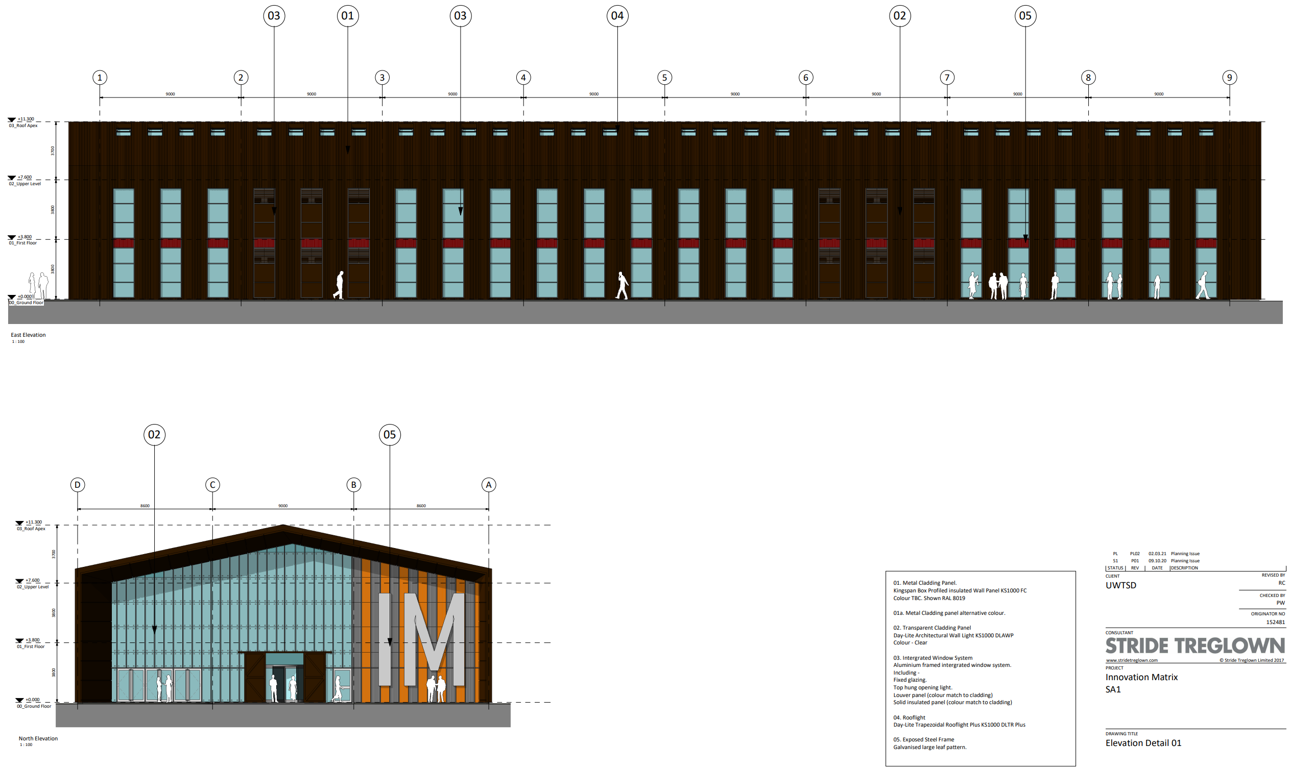
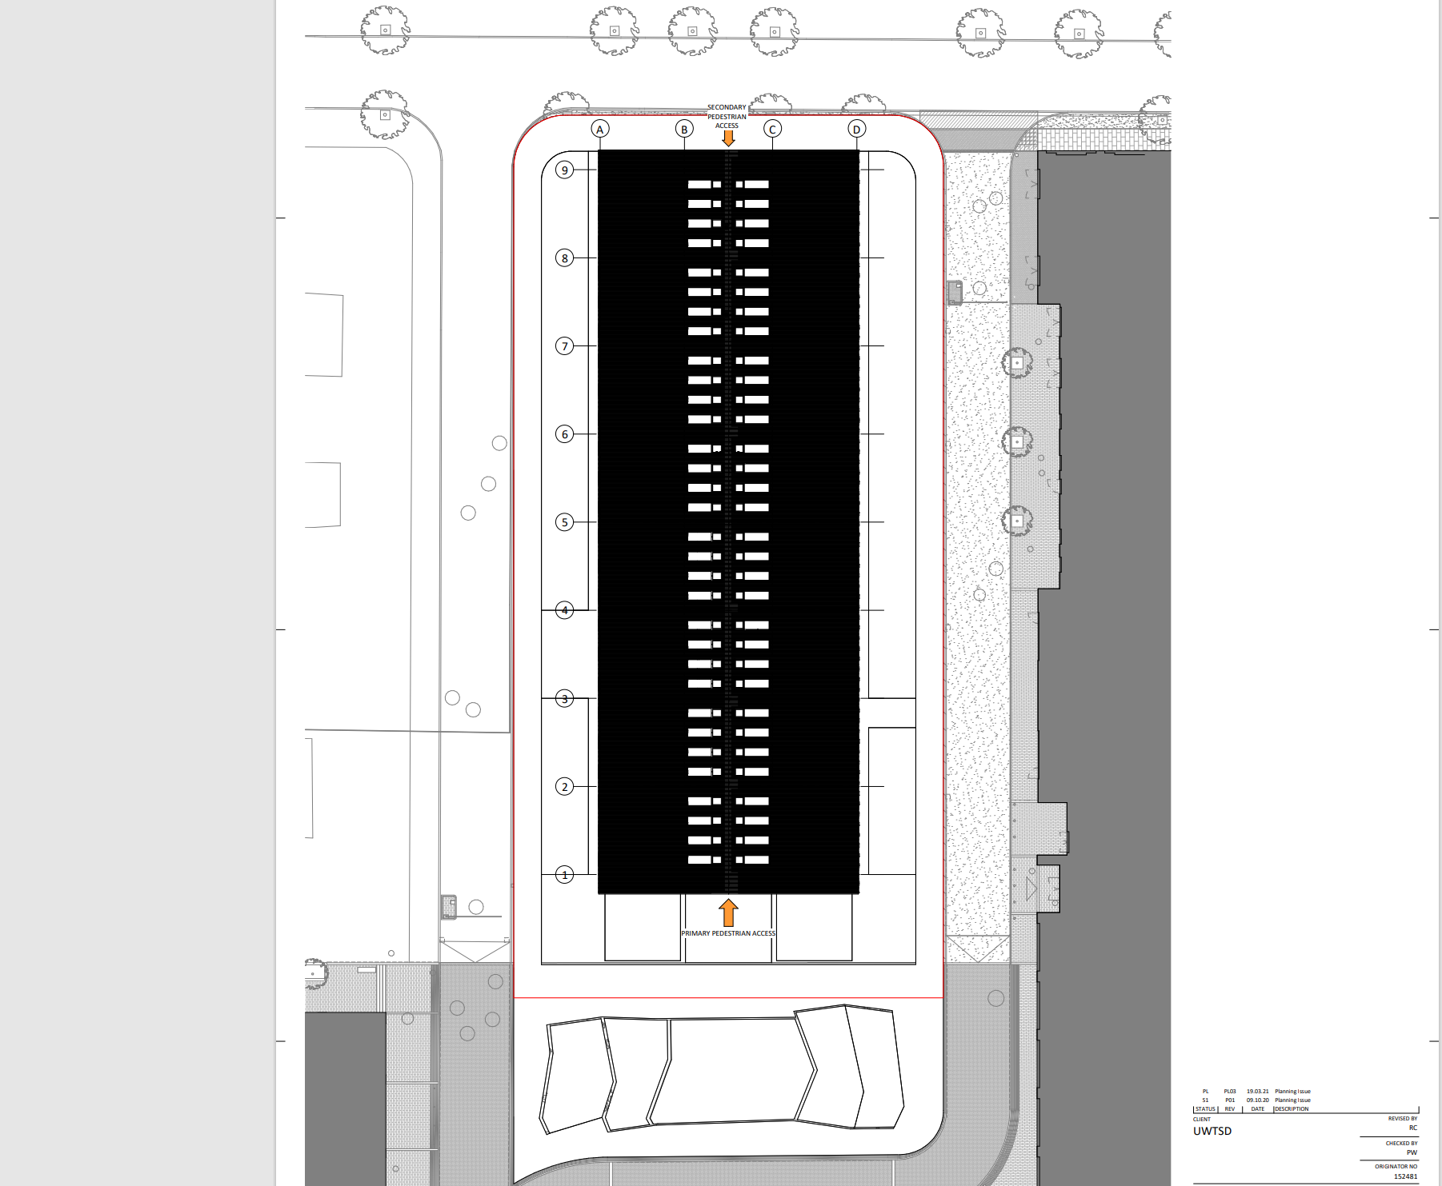

Table Of Contents

Introduction 1

Start up Innovation Company Hub Site Progress Report 2

Executive Summary 3

Resource Level 3

Progress 4

Progress during WC 26.08.2024 4

Planned progress during WC 02.09.2024 4

Health & Safety 5

High Risk Activities 5

Accident/incidents 5

Design 5

Commercial 5

Building Control 8

Mechanical & Electrical 8

Mechanical 8

Electrical 8

Programme 9

Revised Programme 10

Variation following Clients Instruction 11

Incentivisation 11

Conclusion 13

Introduction

Throughout this assignment I am going to be researching and developing my own construction documents, following planning consent for a new start up innovation company hub in SA1 for UWTSD. I have been tasked to produce and evaluate the following documents:
- A Gantt chart/Construction programme showing the critical path from concept design through to handover. The programme will contain a detailed programme of the fit-out stage of the project.
- I will be developing, evaluating and producing site specific reports on time, cost and resources of the fit-out stage.
- I will also be analysing and demonstrating how a delay/change to the agreed SOW affects the programme and how it is dealt with from a contractual point. The scenario for the above is as follows: “The client changed their mind when they saw the first room and has issued an instruction to change the carpet design. The new carpets have been ordered and will arrive in 4 weeks”.

I will also be researching and discussing possible ways of addressing performance issues in terms of productivity and incentivisation to the client specific to the scenario.

Start up Innovation Company Hub Site Progress Report

Site: | SA1
Date: | 2nd September 2024
Client: | UWTSD
Contract Administrator
Architects | Stride Treglown
Principal Contractors | Kier Group

- Executive Summary

  - Resource Level

We have used the allocated resources affectively on this project to get the works completed in conjunction with the programme. As you can see below, we can see how many hours each resource has worked alongside how many we have budgeted for. We can also cross reference this information alongside the costs spent to see if we have budgeted correctly and still on budget/time. The resources we have on site are:

- 1no Contracts Manager
- 1no Quantity Surveyor
- 2no Site Manager
- 1no Assistant Site Manager
- 2no Labourer
- 6no Plumbers
- 4no Vinyl Floor Installers
- 6no Carpenters
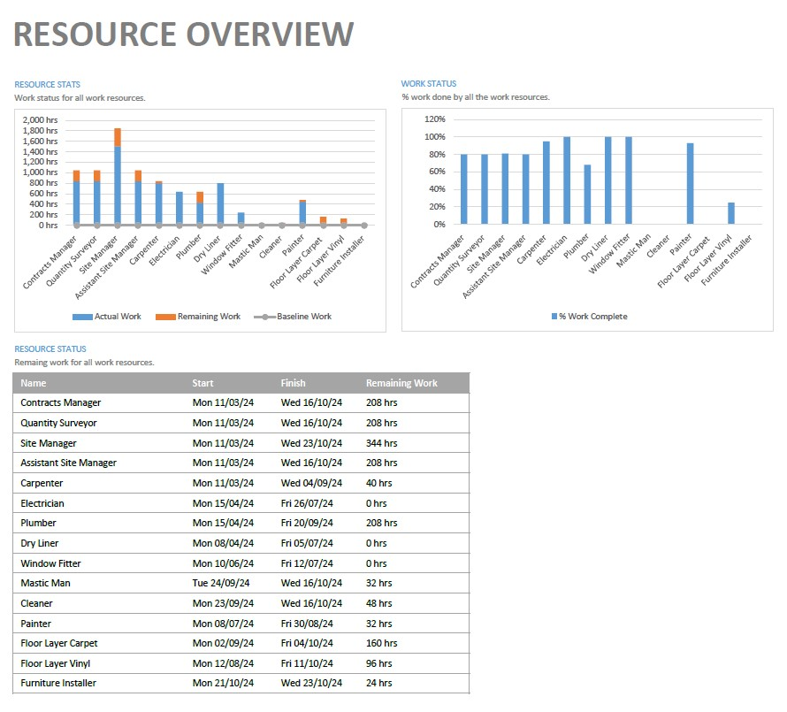
Resource Overview Chart 1

  - Progress

As you can see from the project overview, we are 82% completed on the fir out stage of the project. We are still on programme as works stand and there are no major concerns or issues that will affect handover. All leading items have been pre-ordered and will be delivered to site before needed to make sure we stay on track.

  - Progress During W/C 26th August 2024

- Mechanical Install first & ground Floor
- Painting to ground floor
- Vinyl installed too toilets ground floor

  - Planned Progress During W/C 2nd September 2024

- Complete Mechanical install 1st floor
- Continue Mechanical install ground floor
- Complete toilet cubicle install to ground floor
- Commence carpet install to rooms

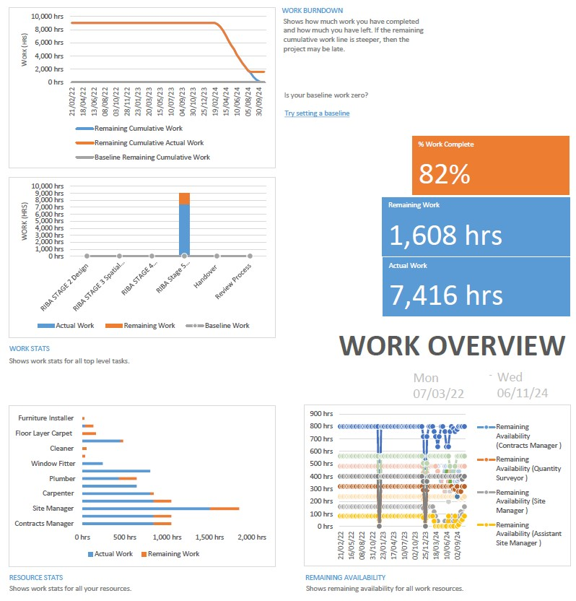

Work Overview Chart 1

- Due to the change in design the floor install date and following activities have been moved 4 weeks to W/C 30.09.2024.

- Health & Safety

- Construction Phase Plan has been issued and approved
- Site Set up and welfare Installed
- Safety Notices signage displayed
- All operatives have received a site induction
- All RAMS in place and signed by operatives
- Signing in procedure in place
- Fire plans are displayed
- F10 received and displayed

  - High Risk Activities

- Working from height
- Mechanical works
- Deliveries/collections (Traffic Management)
- Material distribution
- Dust

  - Accidents/Incidents

- No Accidents or incidents

- Design

- Construction issue drawings received
- Liaising with architect on any details etc

- Commercial

As you can see on the cost overview, we have spent a total of £643,235.44 to complete 82% of the project. This leaves us a remaining to spend £320,846.48 to spend to get this project completed on budget.

- Rolling account updated due to works completed WC 26th August 2024

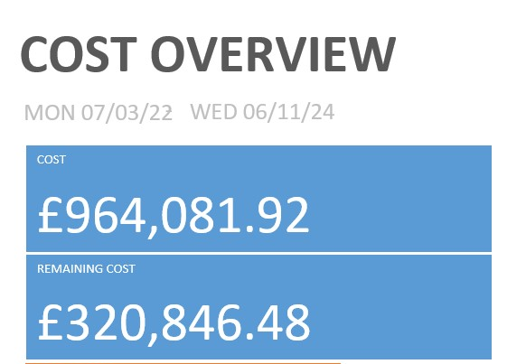

Cost Overview 1
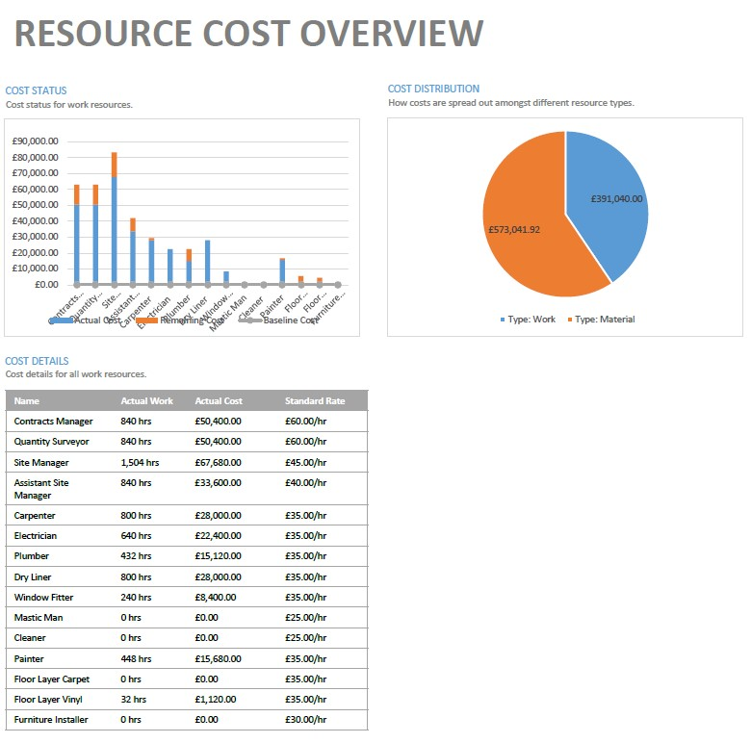

Resource Cost Overview Chart 1

- Client instruction to design change of carpet. New carpet on 4week lead time.
- Variation of £29,640 submitted to clients QS and approved

As you can see from the cost overview below the overall budget of the install phase has increased to £993,721.92 due to the carpet design change. The new labour/material cost distribution are as follows:
- Material - £591,041.92
- Labour - £402,680.00
These costs have increased due to acceleration of labour required to complete the install of the carpets within programme. Due to the increased labour the install will be completed by COP 11.10.2024. the remaining activities can all be completed in time for handover on 01.11.2023
I have attached a revised programme following the new delivery date of the carpets.
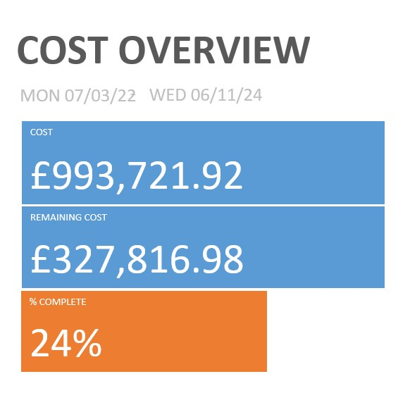
Cost Overview 2

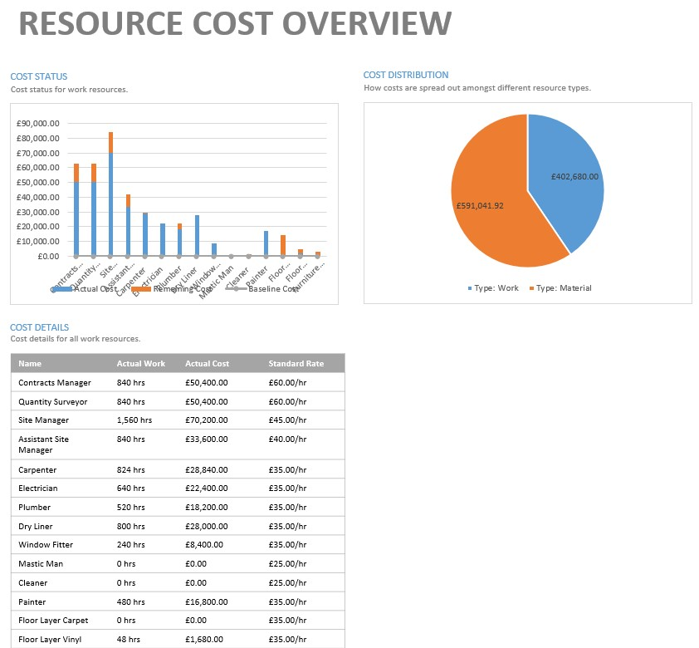

Resource Cost Overview Chart 2

- Building Control

- 8no visits so far
- Foul Connection has been completed and photos issued to Building control
- Drainage survey forwarded to Building Control

- Mechanical & Electrical

  - Mechanical

- Install still ongoing on first & ground floor.
- Install to be completed W/C 16th September 2024
- Testing & Commissioning to start W/C 23rd September 2024
- Mechanical O&M Manual to be issued at Practical Completion

  - Electrical

- Testing & Commissioning complete
- Electrical O&M Manual to be issued at Practical Completion

- Programme

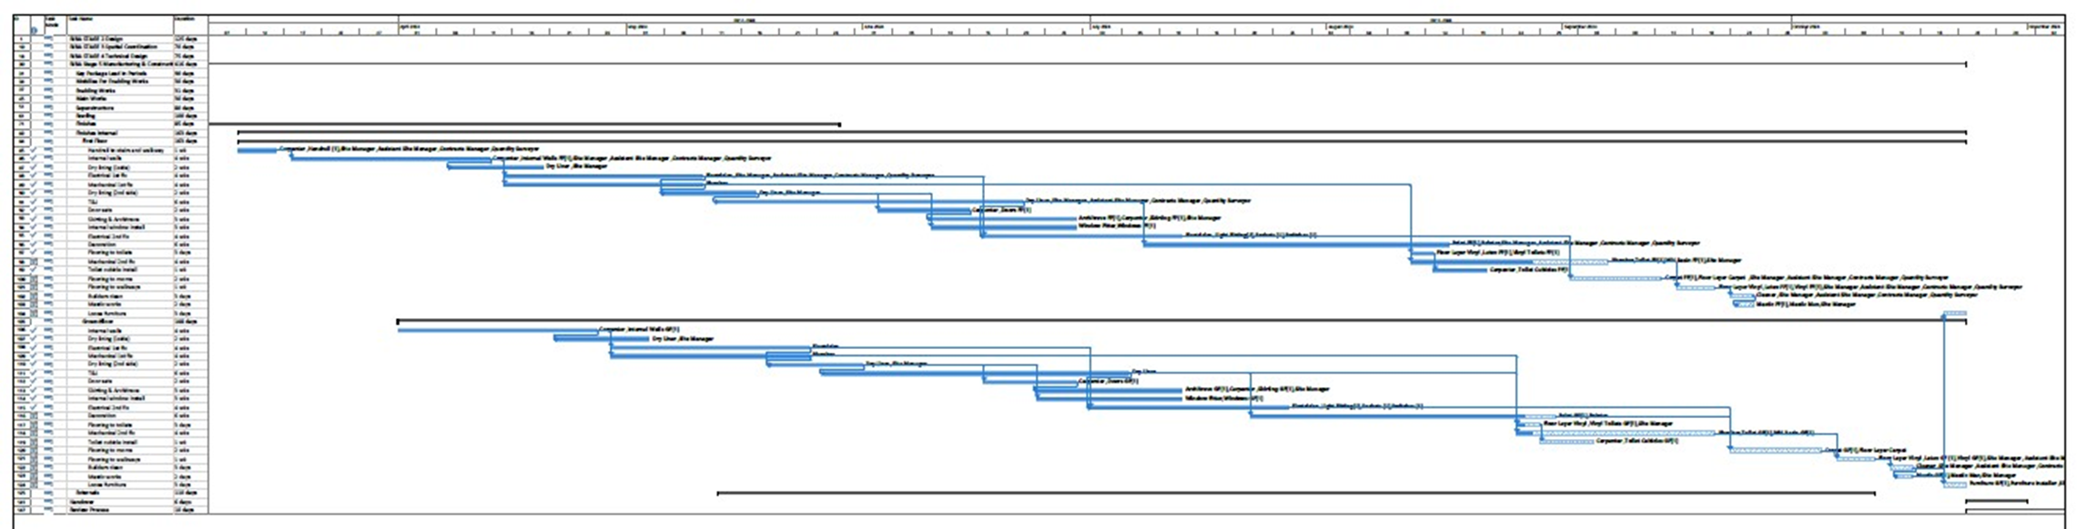

Programme 1

- Revised Programme

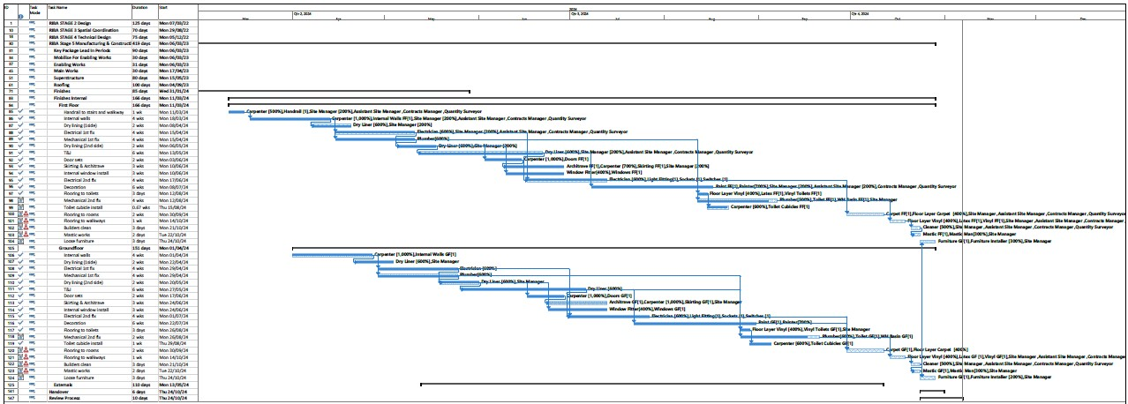

Programme 2
8.1 Variation following Clients Instruction
Under clause 3.5 of an JCT D&B or 3.10 of the Standard Building Contract (“SBC”) contract the client can issue variations at any time. Under this clause the employee (Contractor) must respond within 7 days or the employer has the right to employ someone else to carry out the variation and deduct from the final account. (This is vary unlikely to happen, due to working relationships) A variation cost will be sent over to the client/architect/client QS for approval before the variation works can commence. Contractors should value works in accordance with the Valuation Rules which can be found within Clause 5.4-5.7 Clause D&B and Clause 5.6-5.10 of the SBC.
Depending on the variation or impact to programme a revised programme will be issued with the cost for review before aa decision is made. The employee (contractor) will then receive an Architects instruction or Client’s instruction to proceed with the variation. The variation once approved will be added to the BOQ/account and a new contract sum will be approved on completion.

Incentivisation

Incentives can be defined as a motivational tool used by employers/contractors to encourage and motivate their employees/sub-contractors to increase their productivity. Incentives can be positive or negative depending on the circumstance, but they are simple things to motivate or encourage individuals or companies. Incentives can be either financial or non-financial, but non-finical incentives are designed/aimed more for individual. It is fundamental to fully understand the objective of the project before developing an incentive programme. Once the project objective is understood then an incentive programme can be developed to incentivise the behaviours and performance to achieve the project objectives. (Anon2022)
Companies use different incentive programmes for different employees as one programme is not a one size fits all. Everyone is different on how they are motivated/encouraged to perform and because a financial incentive works for one person it doesn’t mean it will work for the next. Some people will work harder knowing they will receive a monetary incentive if targets are meet, but for others non-monetary incentives are more appealing. (Anon 2022) There a number of different incentives that can be used to motivate individuals/companies but below we are going to discuss 5 that I feel are the most effective:
- Thank You – Receiving acknowledgment from doing a good job by a simple thank you can go a long way. It may sound simple and non-effective but, but this can make an enormous difference in making employees feel appreciated and on board.
- Gifts – Gifs always make good incentives and can come in a variety of different forms. Gifts can be anything from flowers – gift cards – team days out. This type of incentive doesn’t have to be restricted to a specific time of the year, but can be used from meeting a work deadline – an end of year gift.
- Training & Continues Education – Providing a mix of in-house training and support for college or trade programs, or other forms of continuing education can be the perfect incentive to help rebuild/retain employees. Employees like to grow and improve so providing training to employees will motivate them to stay as they feel they are valued. Not only will providing training benefit the employee, it will benefit the employer as the are getting more competent employees who will then in return be more productive.
- Career Growth Opportunities – Every employee works to progress, and no employee would want to remain in the same position for their entire career. Therefore, if they know that they have an opportunity to progress, then they will work hard to improve in their career.
- Monetary – When it comes down to it, monetary compensation is going to be the best incentive for the majority of employees. This can come in many different types of form from cash bonuses, increased wages – paid holiday days. (EL 2022)

Due to the client instructing a change of carpet design, this has had a 4 week delay on install to the first floor meaning the new install will co-inside with the install of the carpets to the ground floor. Due to the new install date this has put huge pressure on the carpet installers. To achieve completion of install by the new install date and stick to the revised programme, they are going to have to work longer hours intended and work weekends.
After reviewing what is needed to achieve the project outcome I believe there is only one incentive programme that will work to motivate the team. Therefore, I have decided to develop a monetary incentive. The monetary incentive I have put in place is a “cash bonus” on completion to all employees involved in the carpet install. We are asking an awful lot of the installers to work the hour required and it will be mentally and physically draining. After week one people will be tired and productivity will start to drop, therefore we need to keep productivity up to achieve the project outcome. I plan on doing this by, at the end of week 1 I will introduce a second incentive of “1 week holiday on completion on full pay”. I personally believe this is the right thing to do as the team will be exhausted. People work to live, not live to work so giving them the time off will help them recharge and also shows they are not just a number and there efforts are truly appreciated.
These two incentives will show the employees that we value their efforts and team work to get the job done. This will build good moral in the team and keeps employee satisfaction up.

Conclusion

In conclusion, I set out to achieve four objectives in this assignment. A Gantt chart/Construction programme showing the critical path from concept design through to handover. The programme will contain a detailed programme of the fit-out stage of the project. – I achieved this by studying the drawings and researching the project before I commenced work on developing the construction programme. Once I fully understood the project, I used my knowledge and skills learnt in lectures and experience to develop the construction programme with all the critical criteria attached.
I will be developing, evaluating and producing site specific reports on time, cost and resources of the fit-out stage. – I developed these reports for the client by inputting all the resource information required into the Gant chart and assigning them to the relevant activity. Once I had done this I could develop the required reports using the Gant chart to pull off any information/data required to develop the report. It is vital that the Gant chart is kept up to date weekly so the information that get dissected from it is accurate. Weekly reports are a great way of keeping the client up to date and capturing any changes or missed items. It will also keep the client up to date on progress and if were on track or if certain elements are falling behind.
I will also be analysing and demonstrating how a delay/change to the agreed SOW affects the programme and how it is dealt with from a contractual point. The scenario for the above is as follows: “The client changed their mind when they saw the first room and has issued an instruction to change the carpet design. The new carpets have been ordered and will arrive in 4 weeks”. – Due to the client change of design, this had a 4week effect on certain elements of the project. Due to the change, I revised the programme with new dates and provided this information in the report to update the client. Due to the change of design, some elements of the critical path were altered to accommodate the change. To keep the project on track we worked longer hours and weekend to achieve the revised install date and keep the programme on track for the original handover date. Contractually, a variation was submitted to the client under clause 3.5 of an JCT D&B or 3.10 of the Standard Building Contract (“SBC”) for approval for the change of design works to commence.
I will also be researching and discussing possible ways of addressing performance issues in terms of productivity and incentivisation to the client specific to the scenario. – Incentives are a great way to motivate individuals and companies to achieve the project goals and keep up productivity. You need to understand the project outcome before you can develop the right incentive scheme, but incentive schemes are not a one size fits all. Incentives can come in the form of monetary or non-monetary form, but research show monetary incentives motivate individuals/companies more effectively.

Table of Images

Resource Overview Chart 1 3

Work Overview Chart 1 4

Cost Overview 1 5

Resource Cost Overview Chart 1 6

Cost Overview 2 7

Resource Cost Overview Chart 2 7

Programme 1 9

Programme 2 10

References

Anon – 2022 - https://www.marketing91.com/types-of-incentives/

Anon – 2022 - https://www.pinsentmasons.com/out-law/analysis/using-incentives-to-drive-contractor-behaviour

Deborah Hughes/Rhodri Thomas – Class material - 2022

Evelyn Long – 2022 - https://capitalforbusiness.net/effective-incentive-programs-for-construction-workers/

Geroge Hedley – 19.12.2018 - https://www.forconstructionpros.com/profit-matters/article/21021074/how-to-choose-the-right-incentive-program-for-your-construction-company

Iyassu Yohannes, Jan-Bertram Hillig, Will Hughes – 2007 - Chrome extension://efaidnbmnnnibpcajpcglclefindmkaj/https://www.irbnet.de/daten/iconda/CIB5038.pdf

JCT Contracts guide - 2016

