Contemporary Themes in the Hotel and
MOHAMMED MIAN 2118790

THE DEEPENING MENTAL HEALTH CRISIS IN THE HOSPITALITY INDUSTRY: CONFERENCE RESEARCH PAPER

Hospitality Sector
BMIH6001

AI Acknowledgment:

I acknowledge the use of CHATGPT, Quill Bot and Grammarly to check my work below for grammatical mistakes and simplify the text. I also used AI to find and research on hotels facing mental health issues within hospitality sector. I confirm that I have not presented any AI generated text as my own work. I confirm I have copies of my drafts, notes, and other resources I used before, and after the use of AI tools which I may be asked to provide in evidence.

Table Of Contents:
- Section: 1 Introduction
- Section: 2 Literature review
- Section 3: Method
- Section 4: Theme impact analysis
- Section 5: Conclusion
- Section 6: Recommendations
- Reference List

1. Introduction

Mental health has become a serious issue in the hospitality industry today, affecting how stable the workforce is, how good the service quality remains, and how long businesses can keep running successfully. The World Health Organization (2022) explains mental health as a state where a person can handle daily stress, work productively, and contribute to society. In hotels and restaurants, this balance is often lost because of long working hours, emotional pressure, and fast digital changes (Karatepe, 2020). The industry depends heavily on people’s energy and emotions, which makes staff more likely to suffer from stress and exhaustion due to irregular shifts and constant customer demands (Robson et al., 2023).

The COVID-19 pandemic made this situation worse. Many workers faced burnout, anxiety, and job insecurity. A study by the International Labour Organization (2023) showed that over 70% of hospitality workers felt more anxious after the pandemic. In the UK, 68% of hospitality staff reported poor mental health caused by overwork and lack of support (The Burnt Chef Project, 2024).

Although technology and AI can make hotel operations faster and easier, they can also cause “technostress,” (Tarafdar et al., 2019) where employees feel pressure from constant use of digital tools (Khatter, 2023). This report uses the DPSIR model and other analytical tools to explore these mental health problems and find ways to improve wellbeing in the industry.

2. Literature Review

2.1 Understanding the Mental Health Crisis in Hospitality

The hospitality industry is one of the most stressful and emotionally demanding sectors. It depends on people’s emotions, communication, and energy, which often causes mental strain. Baum et al. (2020) and Karatepe (2020) explain that long hours, emotional labour, and pressure to please guests often lead to burnout. The World Health Organization (2022) defines burnout as long-term workplace stress that is not well managed, causing tiredness and emotional distance (Maslach & Leiter, 2016).

Mental health problems have risen sharply. The Burnt Chef Project (2024) found that about 70% of UK hospitality workers experience poor mental health due to stress, depression, and lack of support. The International Labour Organization (2023) reported a 32% global increase in these issues since 2020. Baum (2023) adds that low pay, unstable jobs, and weak worker rights make the problem worse. Solnet (2016) note that these inequalities are deeply rooted in the industry’s culture.

Kim, Woo and Uysal (2016) highlight that gender, ethnicity, and job position also affect mental wellbeing. Women and minority staff often face more stress due to discrimination and emotional expectations from guests. This shows that the crisis involves not only work pressure but also fairness and inclusion.

2.2 Theoretical Frameworks on Stress and Organisational Behaviour

The Job Demands-Resources (JD-R) model explains that burnout happens when workers face high demands but have little support or fair pay (Bakker & Demerouti, 2007). In hotels, long hours and lack of care from managers cause exhaustion (Xiong, 2023). When stress continues, workers lose interest and often leave their jobs (Kishore et al., 2023).

The Conservation of Resources (COR) theory says stress increases when people lose time, energy, or social support (Hobfoll et al., 2018). Hospitality workers often feel drained after handling rude guests or pretending to be cheerful (Shahzad et al., 2023). Both theories show that stress is not a personal weakness but a result of poor working conditions.

2.3 The Role of Leadership and Organisational Culture

Leadership and culture strongly affect employee wellbeing. Transformational leaders who motivate and care for staff reduce stress (Bass & Riggio, 2006). Supportive management lowers burnout by 40% in UK hotels (CIPD, 2023) and builds trust (West & Coia, 2021). However, Zada (2025) warn that many companies only promote mental health to look good. Real progress needs open communication, safe spaces, and a culture that treats wellbeing as essential to success.

2.4 Digital Transformation, AI, and the Wellbeing Paradox

Technology and artificial intelligence (AI) have changed hospitality work in major ways. According to Canary Technologies (2025), about 73% of hotels now use AI for guest communication, check-ins, and data forecasting. These tools save time and reduce mistakes but also bring new challenges. Staff must constantly learn new systems and adjust to digital processes, which can lead to “technostress”, a kind of anxiety caused by technology overload (Tarafdar et al., 2019). Suh and Lee (2022) explain that this stress appears when workers feel overwhelmed by digital tasks or fear being replaced by machines.

However, when used properly, AI can help improve wellbeing. Salesforce (2024) found that responsible automation reduces fatigue by managing repetitive work, allowing employees to focus on creative and social tasks. Similarly, Workeen AI (2025) show that intelligent scheduling systems can improve work-life balance by offering more flexible and predictable shifts. Amadeus (2024) predicts that by 2026, personalised digital tools will dominate hospitality, so mental health must be part of how these systems are designed.

Despite these benefits, there are real risks. Jarrahi et al. (2023) warn that constant monitoring through digital systems can make staff feel watched and mistrusted. Khatter (2023) argues that this creates fear instead of productivity. Both Khatter (2023) and Canary Technologies (2025) suggest a “human-first” approach to AI where technology supports people rather than replacing them to build healthier and happier workplaces.

2.5 Economic and Policy Context

The global economy has made stress worse for hospitality workers. Rising living costs, inflation, and stagnant pay have caused financial anxiety (OECD, 2023). In the UK, hospitality employees earn 37% less than the national average (Office for National Statistics, 2023). UKHospitality (2024) adds that poor enforcement of health laws and limited access to mental health services make recovery harder.

The World Travel & Tourism Council (2023) now includes mental health as part of sustainability, alongside environmental and economic goals, supporting the United Nations (2023) Sustainable Development Goal 3: Good Health and Wellbeing. Yet, Salanova et al. (2021) note that small and medium businesses still struggle to apply these standards because of high costs and few resources.

2.6 Gaps and Emerging Debates

Even though awareness has grown, big research gaps remain. Most studies still focus on Western countries, while less is known about developing regions where hospitality work is informal (Baum, 2022). Robson et al. (2023) highlight that few studies directly explore how digital technology impacts worker mental health.

Another issue is the “psychological contract” the unspoken expectations between workers and employers. Cullinane (2006) explains that when promises of fairness or support are broken, employees feel betrayed and emotionally drained. Frey and Osborne (2022) suggest that the industry’s future should move toward “wellbeing capitalism,” where protecting mental health is not just ethical but a key part of business success.

Overall, the literature shows that poor mental health in hospitality results from low pay, long hours, weak leadership, and rapid digital change. The DPSIR, 5 Whys, STAR, and PEAS frameworks together explain the causes and solutions, showing that employee wellbeing is vital not only ethically but also for sustainable business success.

3. Methodology

This research uses a qualitative and exploratory approach to understand the causes of mental health problems in the hospitality industry and how organisations are responding. A qualitative method is most suitable because the topic is complex and involves emotional, social, and technological factors that cannot be measured numerically (Saunders, Lewis & Thornhill, 2019). The study is based only on secondary data, collected from academic journals, global reports, and policy papers published between 2020 and 2025 to include post-pandemic developments and digital transformation in hotels.

All sources were chosen for credibility, relevance, and recent publication, and findings were cross-checked across multiple studies to ensure accuracy (Patton, 2015). No personal interviews or private data were used, so the research fully follows the UWTSD ethical policy for secondary research.

Data collection followed three main steps:
- Data familiarisation: reading and reviewing more than 40 academic and professional sources from 2020-2025.
- Grouping themes: sorting data into categories under the main topic, such as emotional labour, AI adaptation, and leadership empathy.
- Evidence checking: using frameworks like DPSIR and 5 Whys to understand which factors affect mental health most and why.

Four analytical frameworks DPSIR, 5 Whys, PEAS, and STAR were used to connect causes and solutions. DPSIR explains how pressures create burnout, while STAR reviews real cases like Hilton’s wellbeing programme (CAPD). Despite relying on secondary data, reliability was maintained through triangulation and inclusion of multiple global perspectives.

4. Theme Impact Analysis

The mental health crisis in the hospitality industry is a serious and ongoing problem caused by economic pressure, social expectations, and fast technology changes. This section uses the DPSIR framework to explain the main causes and effects of this crisis, the 5 Whys model to find root causes, and the STAR framework to analyse Hilton’s Thrive@Hilton programme. Together, these tools show that poor wellbeing in hospitality is linked to low pay, staff shortages, long hours, and the growing use of automation.

4.1 DPSIR Framework Application
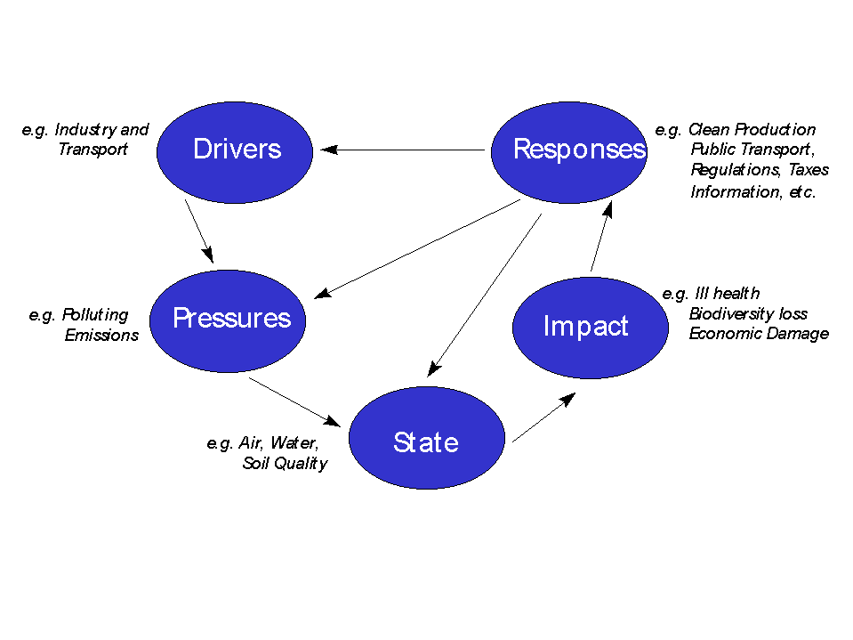
This Photo by Unknown Author is licensed under CC BY
Drivers

Poor mental health in hospitality comes mainly from low pay, fewer workers, and high pressure to perform. After COVID-19, travel demand grew faster than staff numbers. In the UK, more than 140,000 jobs are still vacant (UKHospitality, 2024). The International Labour Organization (2023) said these shortages have made workloads heavier and stress higher.

The Office for National Statistics (2023) found that hospitality workers earn 37% less than the national average, adding financial stress. At the same time, technology has changed daily work. Around 68% of European hotels now use AI for booking and staff planning (Canary Technologies, 2025). This improves speed but also adds stress as staff must learn new systems quickly (Suh & Lee, 2022). Baum (2023) explained that constant pressure for efficiency turns emotional strength into a “job skill,” and Khatter (2023) said wellbeing is now treated like a business goal instead of a basic human need.

Pressures

These causes create heavy stress at work. Employees work long hours, get few breaks, and must always stay positive with guests. The Burnt Chef Project (2024) reported that 78% of UK hospitality workers face stress or burnout. Hochschild (1983) said emotional labour pretending to be happy leads to exhaustion. Karatepe (2020) also found that this behaviour drains motivation and focus.

Technology also increases pressure. Tarafdar et al. (2019) described “technostress,” when staff feel watched by digital tools. Jarrahi et al. (2023) found that algorithmic schedules can reduce control and make employees feel powerless. OECD (2023) reported that many workers are on part-time or short-term contracts, making them feel insecure about money and future jobs.

There is also stigma around mental health. Solnet (2016) found that many staff hide their stress because they fear losing their job or being judged. This silence keeps the burnout cycle going and shows that the pressure is also cultural, not just physical.

State

Because of these pressures, many workers now suffer from poor mental health. The CIPD (2023) said that hospitality staff have the highest level of anxiety-related absences in the UK service sector. Shahzad et al. (2023) noted that fatigue, insomnia, and emotional numbness are common. The International Labour Organization (2023) also found that 57% of hotel staff globally face sleep problems due to overwork.

Technology has made things worse. Frey and Osborne (2022) found that constant ratings and performance scores increase anxiety. Tarafdar et al. (2019) called this “digital alienation,” where workers start feeling like machines instead of people.

Impacts

The results of this crisis hurt both companies and workers. The UKHospitality (2024) report said that over 30% of hotel employees leave their jobs each year due to stress. The CIPD (2023) estimated that replacing a skilled worker costs around £4,000.

The World Travel and Tourism Council (2023) estimated that poor mental health causes $300 billion in global productivity losses every year. Baum et al. (2020) said burnout also reduces guest satisfaction and brand trust.

Socially, women and minority workers suffer more emotional pressure because they are often in lower-paid roles (Kim et al., 2016). This deepens inequality and goes against the United Nations (2023) goal of promoting good health and wellbeing.

Responses

Large hotel brands are starting to act. Hilton, Accor, and Marriott created wellbeing programmes that include counselling, flexible work, and mindfulness tools. For example, Thrive@Hilton offers free therapy, stress training, and AI-based scheduling (Hilton, 2024). Accor (2024) supports workers through its Heartist Fund, giving emotional and financial help.

UKHospitality (2024) suggested making wellbeing part of company KPIs (Key Performance Indicators). Canary Technologies (2025) recommended “human-centred AI” to reduce stress, and Salesforce (2024) said using automation to handle routine jobs gives workers more time for real connection, which supports mental health.

But Zada (2025) warned that many firms only use wellbeing plans for marketing. Baum (2023) said true progress needs fair pay and supportive leadership. Cullinane (2006) added that mental health should be treated as a key business strategy, not just a side issue.

4.2 5 Whys Root Cause Analysis

The 5 Whys model helps find why the mental health crisis continues:
- Why are workers stressed? They are overworked and underpaid (Burnt Chef Project, 2024).
- Why is this happening? Staff shortages and cost-cutting business models (Baum, 2022).
- Why do shortages continue? Hospitality has a poor reputation that discourages new workers (Solnet, 2016).
- Why is the image poor? Companies treat stress as a personal issue, not a management problem (Guest, 2021).
- Why does this mindset persist? The culture still praises endurance instead of wellbeing (Karatepe , 2020).

The root cause is cultural resistance. The industry must redefine “resilience” to mean balance and support, not simply surviving stress.

4.3 STAR Case Study: Hilton’s Thrive@Hilton Programme

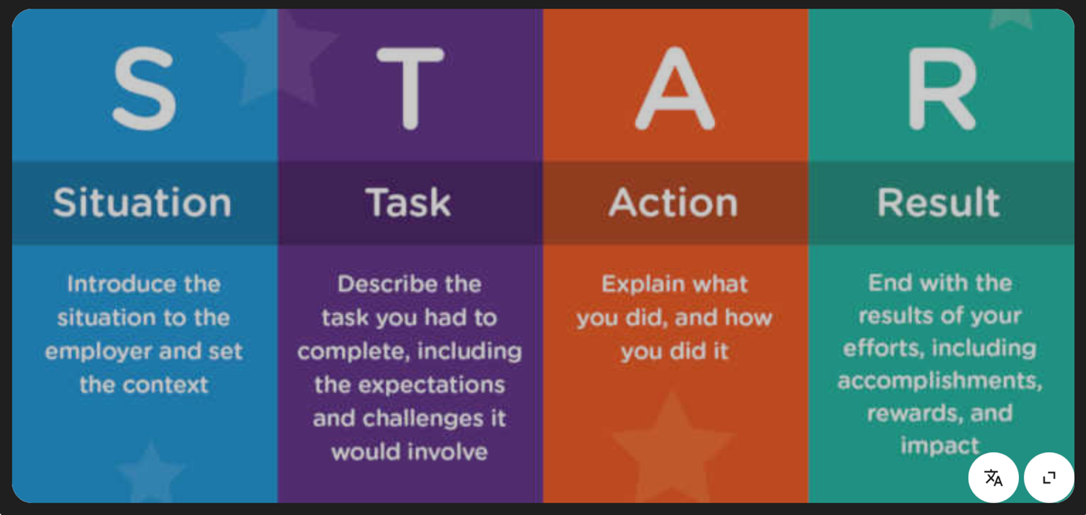
The STAR framework (Situation, Task, Action, Result) shows how Hilton tackled the problem:
- Situation: After the pandemic, Hilton faced high burnout and turnover. About 42% of staff said they felt emotionally drained (Hilton, 2024).
- Task: Improve wellbeing and reduce resignations.
- Action: Hilton created Thrive@Hilton, focusing on Body, Mind, and Spirit. It added 24/7 counselling, mindfulness apps, empathy training for managers, and AI scheduling for fairer shifts.
- Result: In two years, staff satisfaction increased by 21%, and turnover dropped by 14%.

The programme worked because leadership took it seriously. However, Accor (2024) found that some regions had weaker results, proving that consistent management support is key.

5. Conclusion

The hospitality industry is facing a serious and long-lasting mental health problem. Many workers struggle with stress, long hours, low pay, and emotional pressure. The fast growth of technology has also added new stress, such as digital monitoring and fear of losing jobs. These issues cause burnout, low motivation, and poor customer service. The problem is not just about individualsit is part of how the industry works. To fix it, hotels and restaurants must treat mental health as an important part of business success, not just an extra benefit for staff.

6. Recommendations

Using the PEAS framework (Problem, Evidence, Analysis, Solution), the following steps are suggested to help improve mental health in hospitality.

1. Make Mental Health Part of Company Policy

Hotels and restaurants should include mental health in their main business plans and goals, not only in HR work. This means adding wellbeing targets into company reports and measuring staff satisfaction, stress, and turnover rates each year (Baum, 2022). Creating a wellbeing committee at the management level can make sure leaders take real action. Companies should also follow global health guidelines such as the World Health Organization (2022) to ensure fair and safe workplaces for everyone.

2. Train Leaders to Be Supportive and Kind

Good leadership can reduce stress and make employees feel safe. Managers should get regular training in empathy, listening, and communication (Bass & Riggio, 2006). Instead of strict, controlling styles, leaders should follow transformational leadership, which focuses on encouragement and trust (West & Coia, 2021). Mental health should be discussed openly, without shame or fear. When leaders show understanding and care, employees feel valued, which helps reduce burnout and improves teamwork.

3. Use Technology in a Human and Fair Way

As more hotels use artificial intelligence (AI) for scheduling and guest services, it is important that technology helps people, not controls them. AI systems should be clear and fair, and workers should know how their data is used (Canary Technologies, 2025). Staff should get training on how to work with new technologies safely and confidently. Companies should also keep human supervision in decision-making to avoid “technostress” and over-surveillance (Jarrahi et al., 2023). Organisations like UKHospitality should create clear rules for ethical AI use to protect staff wellbeing.

4. Create Flexible and Restorative Work Systems

Work-life balance must be taken seriously. Hotels should plan fair schedules, make sure staff have enough rest days, and offer flexible working where possible (OECD, 2023). Fair pay, paid breaks, and predictable shifts help reduce stress and turnover. Companies can also offer mental health days, mindfulness sessions, and peer support groups. Employees should be invited to share ideas through surveys or wellbeing meetings (CIPD, 2023). This gives them a voice and helps employers make better changes.

In conclusion, the hospitality industry should care for its workers just like it cares for its guests. When mental health becomes part of daily business practice through kind leadership, fair technology, and balanced work, staff feel happier, customers are more satisfied, and the business becomes stronger and more sustainable.

Reference List

Accor (2024) ALL Heartist Fund / Integrated Report 2024. Available at: https://assets.group.accor.com/yrj0orc8tx24/4tViUa177mMSGQxNgi0SWS/37ae4ee9af8341421721b5f8df1cfd4a/ACCOR_RI_2024_MEL_EN.pdf
Amadeus (2024) Travel Dreams Report 2024. Available at: https://www.amadeus-hospitality.com/travel-dreams/
Anderson, L.W. and Krathwohl, D.R. (2001) A taxonomy for learning, teaching, and assessing: A revision of Bloom’s taxonomy of educational objectives. New York: Longman.
Bakker, A.B. and Demerouti, E. (2007) ‘The Job Demands–Resources model: state of the art’, Journal of Managerial Psychology, 22(3), pp. 309–328. DOI: https://doi.org/10.1108/02683940710733115 .
Bass, B.M. and Riggio, R.E. (2006) Transformational Leadership. 2nd edn. Mahwah, NJ: Lawrence Erlbaum Associates.
Baum, T. (2023) ‘Work, Wages and Employment in the UK's Hospitality Sector” https://strathprints.strath.ac.uk/86230/1/Baum_etal_ReWAGE_2023_work_wages_and_employment_in_the_UKs_hospitality_sector.pdf
Baum, T., Mooney, S.K.K., Robinson, R.N.S. and Solnet, D. (2020) ‘COVID-19’s impact on the hospitality workforce new crisis or amplification of the norm?’, International Journal of Contemporary Hospitality Management, 32(9), pp. 2813–2829. DOI: https://www.researchgate.net/publication/343291945_COVID-19's_impact_on_the_hospitality_workforce_-_new_crisis_or_amplification_of_the_norm
Burnt Chef Project (2024) Social Impact Report 2023/24. Available at: https://barmagazine.co.uk/the-burnt-chef-projects-2023-24-social-impact-report-highlights-significant-year-on-year-growth-in-mental-health-support-for-the-hospitality-industry/
Canary Technologies (2025) AI in Hospitality Report 2025. Available at: https://www.canarytechnologies.com/press/ai-hospitality-report (Accessed: 30 October 2025).
CIPD (2023) Health and Wellbeing at Work Report 2023. Available at: https://www.cipd.org/globalassets/media/knowledge/knowledge-hub/reports/2023-pdfs/8436-health-and-wellbeing-employee-views-2023.pdf
Creswell, J.W. and Poth, C.N. (2018) Qualitative inquiry and research design: Choosing among five approaches. 4th edn. Thousand Oaks, CA: SAGE Publications.
Cullinane, N. & Dundon, T. (2006) ‘The psychological contract: a critical review’, International Journal of Management Reviews, 8(2), pp. 113-129. DOI: https://doi.org/10.1111/j.1468-2370.2006.00123.x
Frey, C.B. and Osborne, M.A. (2017) ‘The future of employment: how susceptible are jobs to computerisation?’, Technological Forecasting and Social Change, 114, pp. 254–280. DOI: https://doi.org/10.1016/j.techfore.2016.08.019 .
Hilton (2024) Travel with Purpose / Thrive@Hilton ESG Report 2023. Available at: https://esg.hilton.com/wp-content/uploads/sites/4/2024/05/2023-Travel-with-Purpose-Report-ADA-final.pdf
Hobfoll, S.E. et al. (2018) ‘Conservation of resources in the organisational context’, Annual Review of Organizational Psychology and Organizational Behavior, 5, pp. 103–128. DOI: https://doi.org/10.1146/annurev-orgpsych-032117-104640 .
Hochschild, A.R. (1983) The Managed Heart: Commercialization of Human Feeling. Berkeley: University of California Press.
Jarrahi, M.H., Lutz, C., Boyd, K., Oesterlund, C. & Willis, M. (2023) ‘Artificial intelligence in the work context’, Journal of the Association for Information Science & Technology, 74(3), pp. 303-310. DOI: https://doi.org/10.1002/asi.24730.
Karatepe, O.M. and Kim, W.G. (2020) ‘Does employee engagement mediate the influence of psychological contract breach on pro-environmental behaviours and intent to remain with the organization in the hotel industry’, International Journal of Contemporary Hospitality Management, 32(9), pp. 2813–2829. DOI: https://www.tandfonline.com/doi/full/10.1080/19368623.2020.1812142?utm_source=researchgate
Khatter, A. (2023) ‘Challenges and solutions for environmental sustainability in the hospitality sector’, Sustainability, https://ideas.repec.org/a/gam/jsusta/v15y2023i15p11491-d1201813.html#:~:text=Melbourne%203000%2C%20Australia)-,Abstract,environmental%20degradation%2C%20and%20climate%20change.
Kishore, R., Khadse, K., Gupta, S.K., Karad, V. & Poojara, R. (2023) ‘Impact of employee engagement on turnover intention in the context of hospitality industry’, International Journal of Special Education, 37(3), pp. 16441-16448. https://www.researchgate.net/publication/368756271_Impact_of_Employee_Engagement_on_Turnover_Intention_in_the_Context_of_Hospitality_Industry
MIT Career Advising & Professional Development (CAPD) Using the STAR method for your next behavioural interview (worksheet included). Available at: https://capd.mit.edu/resources/the-star-method-for-behavioral-interviews/
Nowell, L.S. et al. (2017) ‘Thematic analysis: striving to meet the trustworthiness criteria’, International Journal of Qualitative Methods, 16(1). DOI: https://doi.org/10.1177/1609406917733847 .
OECD (2023) Employment Outlook 2023: Rebuilding Labour Markets. Paris: OECD Publishing. Available at: https://www.oecd.org/employment/oecd-employment-outlook/
Office for National Statistics (2024) Annual Survey of Hours and Earnings (ASHE) Bulletin 2024. Available at: https://www.ons.gov.uk/employmentandlabourmarket/peopleinwork/earningsandworkinghours/bulletins/annualsurveyofhoursandearnings/2024
Patton, M.Q. (2015) Qualitative Research and Evaluation Methods. 4th edn. Thousand Oaks, CA: SAGE Publications.
Salesforce (2024) State of the Connected Customer (7th edn). Available at: https://www.salesforce.com/en-us/wp-content/uploads/sites/4/documents/research/State-of-the-Connected-Customer.pdf
Saunders, M., Lewis, P. and Thornhill, A. (2019) Research Methods for Business Students. 8th edn. Harlow: Pearson Education.
Shahzad, F., Ali, S., Hussain, I., Sun, L., Wang, C. and Ahmad, F. (2023) ‘The Impact of Customer Incivility and Its Consequences on Hotel Employees: Mediating Role of Employees’ Emotional Exhaustion’, Sustainability, 15(21), 15211. DOI: https://doi.org/10.3390/su152115211 .
Solnet, D. (2016) ‘What about the workers? Roles and skills for employees in hotels of the future’, Journal of Vacation Marketing, 22(3), pp. 247–262. DOI: https://doi.org/10.1177/1356766715617403.
Suh, A. and Lee, J. (2022) ‘Technostress in hospitality: digital transformation and human sustainability’, Information Technology & Tourism, 24(1), pp. 67–89. DOI: https://www.sciencedirect.com/science/article/abs/pii/S1447677023000591
Tarafdar, M., Cooper, C.L. and Stich, J.F. (2019) ‘The technostress trifecta’, Information Systems Journal, 29(1), pp. 6–42. DOI: https://onlinelibrary.wiley.com/doi/full/10.1111/isj.12169
UKHospitality (2024) Hospitality Workforce Strategy. Available at: https://www.ukhospitality.org.uk/work/hospitality-workforce-strategy/
United Nations (2023) Sustainable Development Goal 3: Ensure healthy lives and promote wellbeing. Available at: https://sdgs.un.org/goals/goal3
Uysal, M., Sirgy, M.J., Woo, E. and Kim, H.L. (2016) ‘Quality of life (QOL) and well-being research in tourism’, Tourism Management, 53, pp. 244-261. Available at: https://www.sciencedirect.com/science/article/abs/pii/S0261517715001661
West, M. and Coia, D. (2021) Improving NHS Staff Wellbeing and Mental Health. London: The King’s Fund. Available at: https://www.kingsfund.org.uk/insight-and-analysis/projects/improving-nhs-culture
Workeen AI (2025) Work-life balance in shift work: how AI can make a difference. Available at: https://workeen.ai/work-life-balance-shift-work-ai-scheduling/
World Health Organization (2022) Mental Health: Strengthening Our Response. Available at: https://www.who.int/news-room/fact-sheets/detail/mental-health-at-work
Xiong, W. (2023) ‘How emotional labor affects hotel employees’ mental health’, International Journal of Hospitality Management, 109, 103184. Available at: https://www.sciencedirect.com/science/article/abs/pii/S0261517722001443
Zada, M. (2025) ‘The role of health-oriented leadership in improving employee well-being in the hospitality industry’, International Journal of Hospitality Management, [online ahead of print]. DOI: https://doi.org/10.1016/j.ijhm.2025.100394 (Available at: https://www.sciencedirect.com/science/article/abs/pii/S0278431925001665 )

