MARKETING FUNDAMENTALS
ANA MARIA CIRSTEA
STUDENT NUMBER 2011016

History of the organisation, Starbucks
Starbucks corporation is known as the coffee house and the international coffee brand that is dependent on the United States, Washington, and Seattle. It opened as a single tiny coffee store that was also opened in 1971 and later became renowned as the coffee giant at the end of the millennium. Starbucks has also led the revolution of coffee in the entire US and beyond. The subsidiary of this coffee brand is known as Seattle Coffee Co where the founders are namely Gordon Bowker and Jerry Baldwin. It was founded in Seattle and the first employee’s name is Howard Schultz (Lancaster & Withey, 2020).


Overview of the organisation
Starbucks corporation comes under the American multinational chain of the roastery reserves and the coffee houses and it headquarter is situated in Seattle. It is considered the largest coffeehouse chain in the whole world and in November 2021, the company expanded its number of stores up to 33,833 in a total of 80 countries. Some of those stores, around 15,444 were located in the entire US.

Key takeaways from Starbucks
The coffee lovers must go to the houses of coffee of Starbucks where various flavours of the coffee-based products are available. Besides, this renowned coffee chain is extensive and comprehensive for the entire and effective marketing approach of Starbucks that seeks lots of inspiration by searching the ways of navigating those marketing approaches. As Starbucks has made the brand unique coffee brand with the help of de-commoditising the nature of the space of the coffee, thus, it has fashioned the unique brew and a unique image of appealing the aficionados of luxury -a craving that is well relished to the prestige, uniqueness and the ritual of the coffee savouring (Stone, 2017).
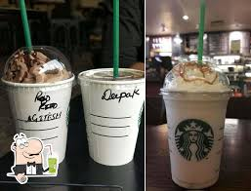

STP analysis of Starbucks
The STP marketing itself is an acronym of segmentation, targeting and positioning, where a three-step model tends to examine the products and services and state the ways for communicating the benefits relating to the specific customer segments.

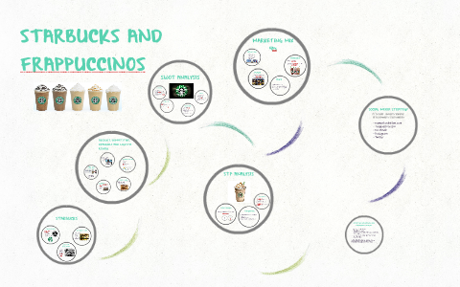
Segmentation
The segmentation, targeting and positioning tend to comprise the overall marketing decisions that are actually directed by making identification of the appropriate group of people where the general public is being treated as the future customers for the entire business in terms of targeting the segment through positing the services and products. Along with that, it also helps in resonating in a good manner where the needs and demands of the people can be referred to through making proper decisions.
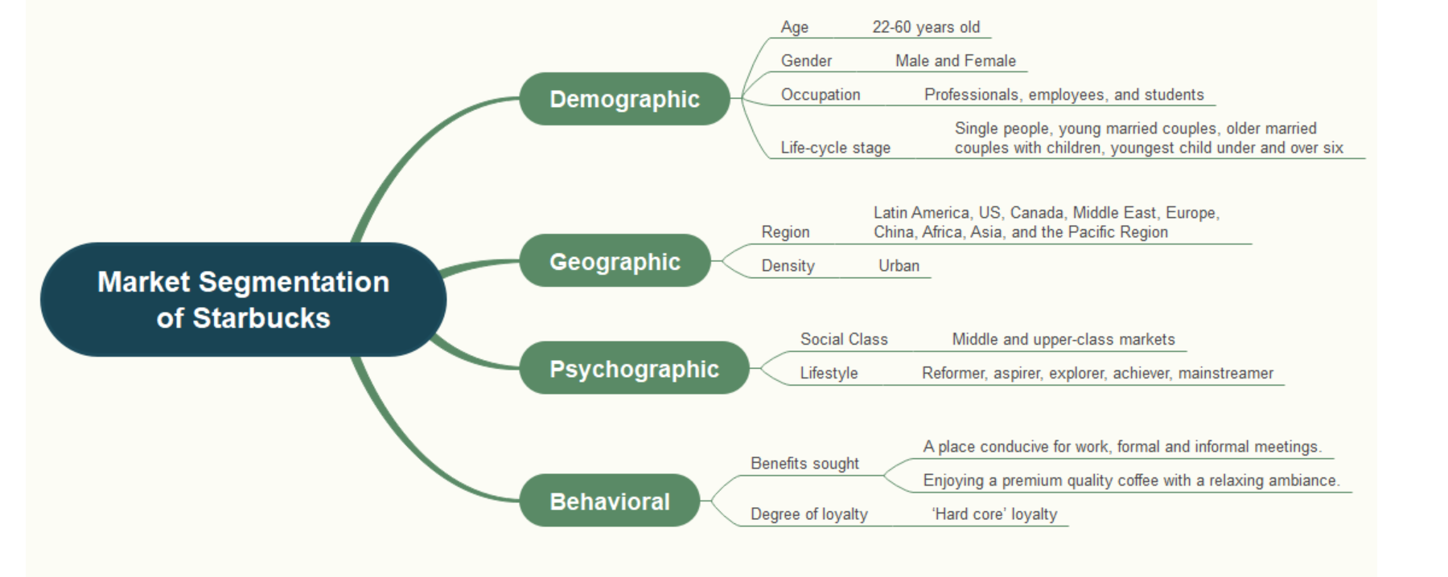
Figure 1: Mind map of the market segmentation of Starbucks
(Source: Starbucks, 2021)

Targeting
Targeting is all about the evaluation of the interests of the market that chooses one or more segments for entering into and focussing on as well. Besides, the company, Starbucks has usually focussed on the elements that create the higher profitability of the generation of the profits that may also be helpful in sustaining the market over time (Russell, 2019). Henceforth, the targeting refers to the segments or groups of the company that tends to decide the selling of the products. Additionally, the target market of Starbucks has focussed on the middle to high-income based office employees who have been looking for premium quality goods. Thus, Starbucks has also associated the international chain of products and services that add the tourists most for helping to travel to the counties where they may visit the supply chain process for adding the local foods of the country to the international domain. Hence, people tend to continue the sustainable food that aims at providing the tables with nutritional food and drinks like calories, sodium, protein, fibre and much more than the actual website. Besides, the customers who are more conscious about their calorie intake can also refer this information to the other interested customers.

Targeting
22-60 years old
Male and female
Employees, students and the professionals
The life-cycle stage of the people includes married couples with children and the young married couples
The region of the organisation in Latin America, Canada, China, Asia, Europe
The sought benefits are a conducive place for working where the formal and the informal meetings are held
It has also enjoyed a lot of the premium quality coffee with a relaxing ambience
The degree of loyalty is the 'hardcore loyalty'
The social class involved in Starbucks are middle and the upper-middle-class markets
The entire lifestyle of people is associated with the mainstreamer, achievers, explorer, and the aspirer
The density of this organisation is situated in the Urban region as a whole.

Table 1: targeting of Starbucks
(Source: Developed by author)

Positioning
Mono segment positioning
The coffee chain of Starbucks has a great target of the premium custom targets only where the individuals who are actually willing to pay extra for getting the improved quality of the products.
Adaptive positioning
The adaptive posting has been added irrespective of Starbucks for addressing the reason for enhancing the awareness relating to the consumer health where this coffee brand has been developed the coffee beverages with including the fewer calories like Caffe Misto (63 calories), Chai Tea Latte (103 calories) and Iced Americano (11 calories).
Standby positioning
The standby position of Starbucks has added beverages like Frappuccino that need to add some effective changes in the market for a certain period of time due to finding out the growing demand of the customers (Kumar, 2020).

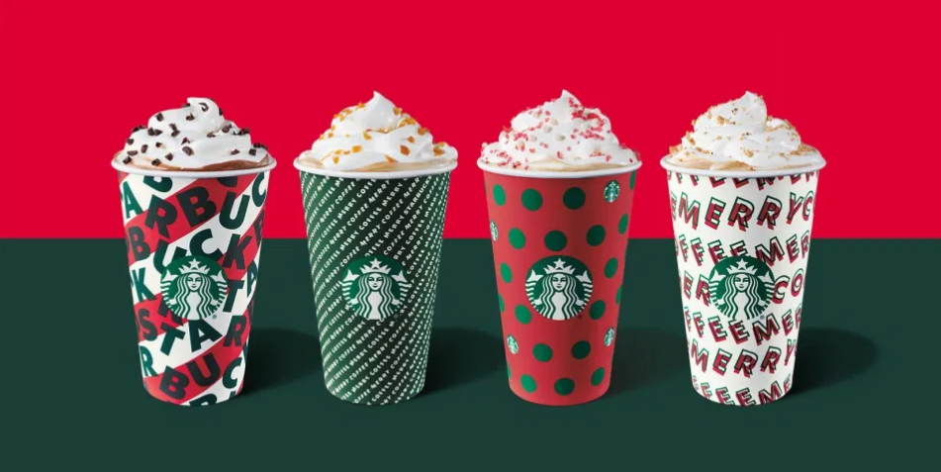
Marketing Mix Strategies of Starbucks
Starbucks is one of the most recognised brands and has a phenomenal marketing strategy. Due to its commitment and marketing power, it has kept the brand consistent, taking its brand awareness to epic heights (Aljarah, 2021). Not all the companies have multi-billion marketing budgets, which has made it difficult for other brands to duplicate the marketing strategy of Starbucks at its pace.
Consistency of experience and branding of Starbucks
Starbucks should be consistent since it is a globally recognised brand. Its consistency spans through each message Starbucks send and every branded collateral it creates including experience and in-store design.
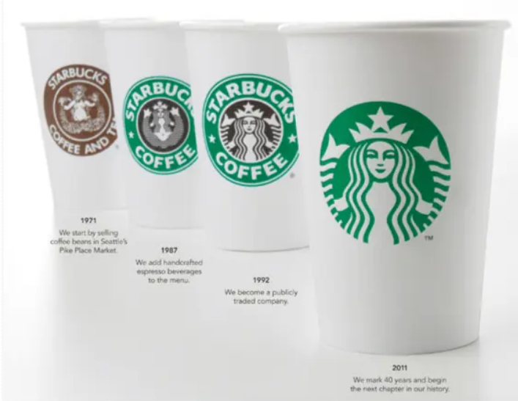
The Classic Siren Logo
Before structuring the marketing mix in this post, it is important to take the audience through Starbucks' logo as well as branding design. Over 47 years, its logo went through design transformation and had transited through 4 varied redesigns to end up being an iconic symbol that graces today's coffee cup (Aljarah, 2021).
While Starbucks wanted to revamp its branding in the year 2011, it faced a particular challenge. Since back then it operated in around 55 varied countries, it needed a branding design that will more likely speak to a wider array of its audiences, thereby the new logo was born (Kim and Park, 2021). With that, the word coffee and Starbucks were removed so that the company can go beyond its usual coffee products.
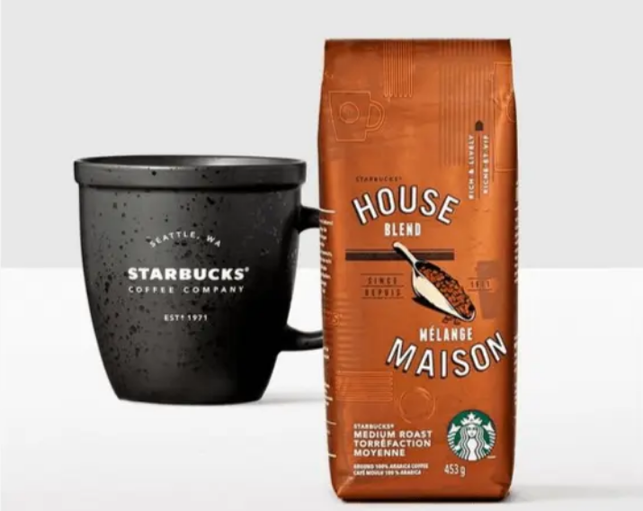
Brand Consistency That Can't Be Beat!
That modern design and clean philosophy could extend to all the things that Starbucks would ever create. Starting from the store ambience to its digital content and store atmosphere, to advertising, sounds, looks, and the feel while one opts for the services of Starbucks. Even the tumblers and cups that one can buy from the store have a modern and clean design on them (Nair et al., 2021). With that, the result came out to be excellent as the customers feel great while they sit at a Starbucks store sipping coffee, they feel consistent even if they are waiting in a queue or reading any social post, watching an ad or TV, or interacting with Starbucks anytime, anywhere. Moreover, the consistency is so aligned that as per the customers the coffee such as Tall, Grande, Venti and so on at one store tastes the same at the other.
Marketing Mix of Starbucks
Starbucks has incorporated the marketing mix of 4Ps appropriately throughout its marketing. Let's get a glance at the marketing 4P of Starbucks that can provide a vivid overview of the products, price, promotion and place of the brand.

Product
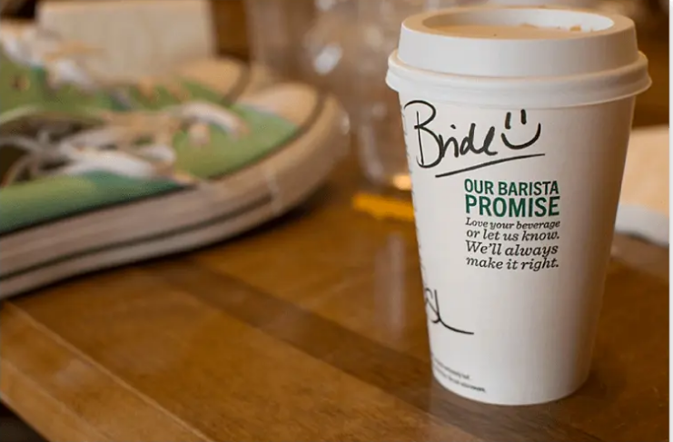
Starbucks' products are always of higher quality and this is how it reaches its target audience and justifies buying the products (Starbucks, 2021). You are a regular customer of Starbucks and paying for your premium coffee cup, which would mean that you would want something justified in return? Also, the taste needs to be better than the same coffee or iced macchiato that you can buy from other stores? You probably would relate to this question and the answer is in the personal experience that you will get by availing the products and services of Starbucks. Yes, Starbucks has crafted higher quality products each time which made the customers stick to it and come back to it. To highlight, Starbucks has its barista promise! "If you do not like the drink, they will fix it for you".
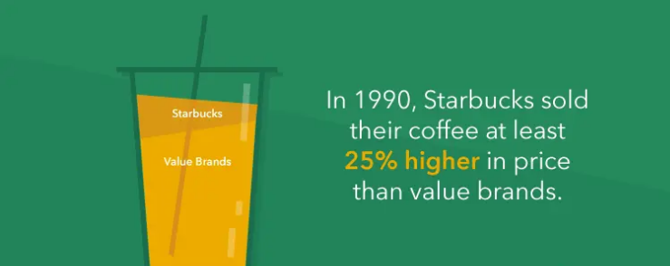
Price
Starbucks sells the products at premium prices, or at 25% higher than that of value brands. In the year 1990, 3% of coffee got sold at premium prices as compared to 2000 onwards, with an increase in the percentage by 40%. Starbucks started coming up with exceptional food and drinks for the people and charged more, why? Because the customers are willing to pay the same!

Promotion
Starbucks over the years has started to use a wider variety of channels to market the coffee from TV ads and spots to social media. It is the marketing media mix that makes the brand well recognisable accompanied by Starbucks' consistent message that one can come across each time, which has made Starbucks stand out from the rest (Starbucks, 2021). The promotions of Starbucks are not cheap, however, if comparisons are drawn from the side of other larger global brands such as Nike, and Apple, it significantly spends less on its marketing but still could make a broader impact.
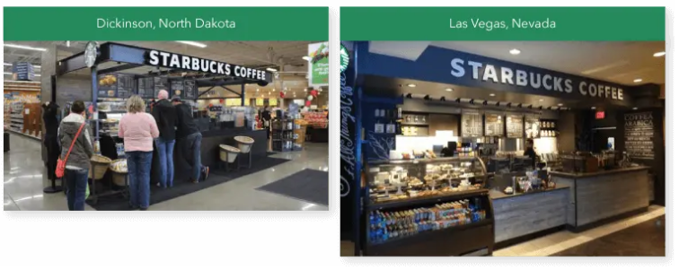
Place

Starbucks has put in a lot of effort to create a comfortable space for the customers where they can come, have the will and want to visit again, relax and hang out. Whenever any person visits any of the stores or outlets of Starbucks, they would probably get the idea of the next place (Starbucks, 2021). Starbucks has done this by maintaining a similar ambience and environment in almost all of its locations.
Ways Starbucks has executed its excellent marketing strategy!
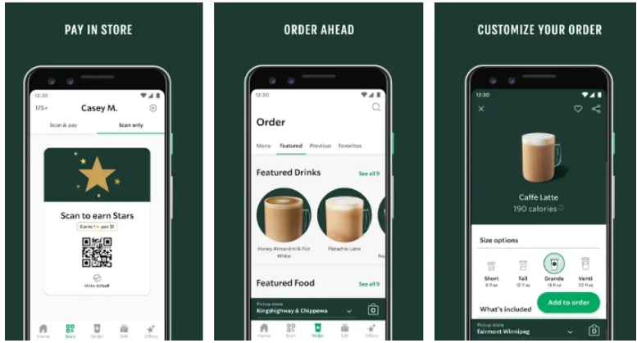
Loyalty Program

Starbucks rewards all its customers who buy the products. The Starbucks reward program provides incentives to purchase the products accompanied by free products by providing a certain amount of money, free in-store refills, extra discounts and offsets (Tsai et al., 2020). The mobile app of the company has made this easier for people to pay in advance and thereby find the location of the nearby store.
Repurposing the current content all across the social media sites
Social media is a powerhouse for the Starbucks marketing team, provided they use it appropriately and Starbucks has two tools at hand, one is repurposing the content and the second one is interacting with potential customers (Tsai et al., 2020). Starbucks creates many contacts and thus it repurposes the contents. The following are some of the posts from Facebook, Twitter and Instagram.
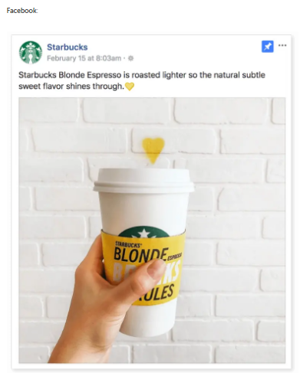
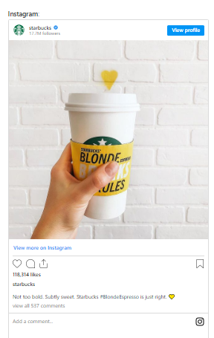
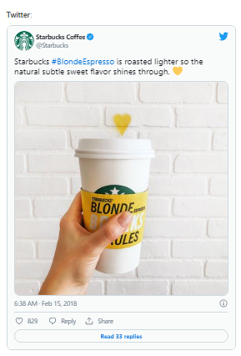

Although each post varies from the other, however, the language and message are the same.

Reference list
Aljarah, A. (2021). Environmental Marketing Strategy and Customer Citizenship Behavior: An Investigation in a Café Setting. International Journal of Hospitality & Tourism Administration, pp.1–25.
Kim, J.-E. & Park, E.-S. (2021). The Spatial Design Marketing Strategy of Global Franchises That Take into Consideration the Characteristics of Modern Consumers—A Study Involving the Global Coffee Companies of Starbucks and Blue Bottle. Land, 10(7), p.716.
Kumar, P. (2020). A Review of Relationship Marketing Fundamentals. Journal of Talent Development and Excellence, 12(2s), 3915-3921. https://www.researchgate.net/profile/Pranav-Kumar-35/publication/343099389_A_Review_of_Relationship_Marketing_Fundamentals/links/607e6d5a907dcf667baf5dee/A-Review-of-Relationship-Marketing-Fundamentals.pdf
Lancaster, G., & Withey, F. (2020). Marketing fundamentals. Routledge. https://books.google.com/books?hl=en&lr=&id=wEplyZBbGT4C&oi=fnd&pg=PR3&dq=Marketing+Fundamentals%E2%80%83&ots=YxdpKsGUdN&sig=0eVSnpqEkQyInbWrmvFrNtmPWLY
Nair, R.K., Sinha, R., Crasto, S.G., Kian, K.W., Kee, D.M.H., Abdullah, S.A.B., Zaidi, S.N.N., En, T.S., Jain, A.K., Valecha, P.M. & Ganatra, V. (2021). The effect of Starbucks Marketing Campaigns on Consumer Buying Behaviour. Asia Pacific Journal of Management and Education(APJME), [online] 4(1), pp.72–81. Available at: http://ejournal.aibpm.org/index.php/APJME/article/view/1052 [Accessed 2 May 2022].
Russell, E. (2019). The fundamentals of marketing. Bloomsbury Publishing. https://books.google.com/books?hl=en&lr=&id=JlU3DQAAQBAJ&oi=fnd&pg=PP1&dq=Marketing+Fundamentals%E2%80%83&ots=5C_dFM3i8W&sig=GoAH4HRmcqUwdj4AXbrkJC-CEwg
Starbucks (2021). Rewards | Starbucks. [online] www.starbucks.co.uk. Available at: https://www.starbucks.co.uk/rewards [Accessed 2 May 2022].
Starbucks (2021). Starbucks Market Segmentation, Targeting, and Positioning. Available at: https://www.edrawmind.com/article/starbucks-market-segmentation-targeting-and-positioning.html. [Accessed on 2 May 2022].
Stone, M. (2017). Fundamentals of marketing. Routledge. https://www.taylorfrancis.com/books/mono/10.4324/9780203030783/fundamentals-marketing-marilyn-stone
Tsai, P.-H., Lin, G.-Y., Zheng, Y.-L., Chen, Y.-C., Chen, P.-Z. & Su, Z.-C. (2020). Exploring the effect of Starbucks’ green marketing on consumers’ purchase decisions from consumers’ perspective. Journal of Retailing and Consumer Services, 56(1), p.102162.

