

Master of Business Administration
LCMB7035 - Dissertation
Title: Evaluating the Impact of Dynamic Capabilities on Competitive Advantage: A Study of Digital Transformation Strategies in UK Mid-Sized Retail Firms (2020–2025)

Student Name: Abhishek Pradeep Joshi
Student ID: 2430962
Supervisor: Andry Rakotovololona Supervisor
Program Manager: Hoang Dang Nguyen
Institute: University of Wales Trinity Saint David (UWTSD) London Campus

Declaration
I hereby declare that the dissertation is my original work and has been carried out by me under the guidance and supervision of my professor. I further declare that this dissertation has not been submitted, either in whole or in part, to any other university, institution, or examining body for the award of any degree, diploma, or other qualification. All sources of information and references used in this study have been duly acknowledged.

Name: Abhishek Pradeep Joshi
Student ID: 2430962
Date: 05/06/2026
Signature: Abhishek Joshi

AI Use Acknowledgements
Artificial intelligence tools were used in this dissertation strictly for copyediting and formatting purposes, including proofreading, improving sentence flow, and ensuring consistent Harvard referencing. All core content—including data analysis, literature evaluation, and theoretical synthesis—is the original work of the author.

Acknowledgements
I wish to extend my heartfelt thanks to my supervisor, Andry Rakotovololona, for their insightful advice, patience, and support throughout the research process. Additionally, I am immensely thankful to my family and friends for their enduring support and encouragement throughout my academic pursuits.

Abstract
This dissertation investigates the impact of dynamic capabilities on competitive advantage through digital transformation strategies in UK mid-sized retail firms between 2020 and 2025. The study focuses on how organisations use sensing, seizing, and reconfiguring capabilities to respond to rapid technological change, evolving customer expectations, and increasing market competition in the post-pandemic retail environment. The research is grounded in Dynamic Capabilities Theory. It examines how digital technologies such as artificial intelligence (AI), big data analytics, cloud computing, and omnichannel retail systems contribute to organisational performance and long-term competitiveness.
A qualitative multi-case study methodology based on secondary data analysis was adopted. Data were collected from academic journals, consultancy reports, company annual reports, and institutional publications,, including Deloitte, McKinsey, and the Office for National Statistics (ONS). The study applied thematic analysis to identify key organisational capabilities and strategic practices associated with successful digital transformation.
The findings reveal that digital transformation alone does not guarantee a competitive advantage. Instead, firms that effectively developed sensing capabilities to identify technological opportunities, seizing capabilities to make strategic investments, and reconfiguring capabilities to adapt organisational structures achieved stronger performance outcomes. The research also identified significant barriers, including financial limitations, resistance to organisational change, lack of digital skills, and weak strategic alignment. Furthermore, firms with higher digital maturity demonstrated improved customer experience, operational efficiency, strategic agility, and stronger market positioning.
The dissertation contributes theoretically by extending Dynamic Capabilities Theory into the context of UK mid-sized retail firms and practically by providing strategic recommendations for managers and policymakers seeking to improve digital transformation outcomes. The study concludes that sustainable competitive advantage in the digital era depends not only on technological investment but also on the continuous development of organisational capabilities and strategic adaptability.
Keywords
dynamic capabilities, sensing capability, seizing capability, reconfiguring capability, digital transformation, competitive advantage, UK retail sector, mid-sized firms, AI adoption, big data analytics, cloud computing, omnichannel retailing, organisational agility, digital maturity.

Table of Contents
Abstract 4
CHAPTER 1: INTRODUCTION and RATIONALE 11
1.1 Research Background 11
1.2 Research Rationale 13
1.2.1 Theoretical Justification 13
1.2.2 Practical Justification 14
1.3 The research contribution and motivation. 15
1.4 Research Aim, Objectives, and Questions. 16
Research Aim 16
Research Objectives 17
Research Questions 17
1.5 Dissertation Structure 17
CHAPTER 2: LITERATURE REVIEW 18
2.1 Introduction 18
2.2 Digital Transformation, Dynamic Capabilities and Competitive Advantage: A Thematic Literature Review 18
2.3 Theoretical Framework and Scholarly Contribution 23
2.4 Conceptual Framework 25
2.5 Theoretical Concept 26
2.6 RESEARCH GAP 27
2.5 Chapter Summary 28
CHAPTER 3: METHODOLOGY 29
Research onion 29
3.1 Introduction 30
3.2 Research Philosophy, Approach, and Design 31
3.3 Justification for Case Study Methodology 34
3.4 Data Sources and Databases 35
3.5 Search Strategy 36
3.6 Inclusion and Exclusion Criteria 37
3.7 Research Quality and Rigour 39
3.8 Ethical Considerations 39
3.9 Chapter Summary 40
CHAPTER 4: DATA ANALYSIS AND FINDINGS 41
4.1 Introduction 41
4.2 Overview of Data Sources and Analytical Framework 41
4.2.1 Overview of Secondary Data Sources 41
4.2.2 Analytical Framework 43
4.3 Theme 1: Sensing Capabilities and Digital Opportunity Recognition 44
4.3.1 Understanding Sensing Capabilities 44
4.3.2 Findings on Consumer Behaviour Recognition 45
4.3.3 Findings on Technology Sensing 46
4.4 Theme 2: Seizing Capabilities and Strategic Digital Investment 47
4.4.1 Understanding Seizing Capabilities 47
4.4.2 Findings on AI and Data Analytics Adoption 48
4.4.3 Findings on Omnichannel Retail Strategies 49
4.4.4 Findings on Strategic Agility 49
4.5 Theme 3: Reconfiguring Capabilities and Organisational Adaptation 51
4.5.1 Understanding Reconfiguring Capability 51
4.5.2 Findings on Organisational Restructuring 51
4.5.3 Findings on Workforce Capability Development 52
4.5.4 Findings on Process Integration 53
4.6 Theme 4: Digital Transformation and Competitive Advantage 54
4.6.1 Relationship Between Digital Transformation and Competitive Advantage 54
4.6.2 Findings on Customer Experience Improvement 55
4.6.3 Findings on Operational Efficiency 56
4.6.4 Findings on Competitive Positioning 57
4.7 Cross-Case Comparative Analysis 57
4.8 Discussion of Findings in Relation to Literature 58
4.9 Chapter Summary 59
CHAPTER 5: CONCLUSION AND RECOMMENDATIONS 60
5.1 Introduction 60
5.2 Summary of Research Findings 60
5.2.1 Summary of Sensing Capability Findings 60
5.2.2 Summary of Seizing Capability Findings 60
5.2.3 Summary of Reconfiguring Capability Findings 60
5.2.4 Overall Research Conclusion 61
5.3 Achievement of Research Aim and Objectives 61
5.4 Theoretical Implications 61
5.5 Practical Implications and Recommendations 61
5.5.1 Recommendations for Retail Managers 62
5.5.2 Recommendations for Policymakers 62
5.6 Research Limitations 62
5.7 Recommendations for Future Research 62
5.8 Final Conclusion 63
References 64

List of Abbreviations

- AI – Artificial Intelligence
- BDA – Big Data Analytics
- CRB – Capability Reconfiguration
- DC – Dynamic Capabilities
- DT – Digital Transformation
- MTD – Market/Technology Development
- MOD – Modification Capability
- ONS – Office for National Statistics
- SOT – Sensing of Technology
- UK – United Kingdom

Glossary

Dynamic Capabilities The firm’s ability to sense opportunities, seize them through strategic action, and reconfigure internal resources to remain competitive in rapidly changing environments.
Sensing Capability The organisational capacity to detect technological trends, shifts in consumer behaviour, and emerging market opportunities through environmental scanning and data-driven insights.
Seizing Capability The ability to mobilise resources, make strategic investments, and implement digital initiatives such as AI, analytics, cloud systems, and omnichannel platforms.
Reconfiguring Capability The capacity to restructure organisational processes, redesign workflows, and realign resources to support digital transformation and long-term competitiveness.
Digital Transformation The integration of digital technologies—including AI, big data analytics, cloud computing, and omnichannel systems—into business operations to improve efficiency, customer experience, and strategic agility.
Omnichannel Retailing A retail strategy that integrates online and offline channels to deliver seamless customer experiences across websites, apps, physical stores, and fulfilment systems.
Organisational Agility The ability of a firm to respond quickly to market changes through flexible structures, rapid decision-making, and adaptive processes.
Digital Maturity The extent to which a firm has developed the technological infrastructure, skills, and organisational capabilities required to effectively implement digital transformation.
Competitive Advantage A sustained performance edge achieved through superior capabilities, customer value creation, operational efficiency, or strategic differentiation.

CHAPTER 1: INTRODUCTION and RATIONALE

1.1 Research Background
The structural shift in the UK retail industry has occurred from 2020 to 2025 in response to a rapid technological change, shifting consumer behaviour, and the disruptive impact of the COVID-19 pandemic (Cai et al., 2023). Industry reports by Deloitte and McKinsey show that the UK e-commerce penetration rose substantially during the pandemic year, and online retailing took up more than 36% of all retail sales during 2021 before settling at around 2628 percent in the following years. This transformation is a lasting alteration in consumer expectations, whereby seamless digital experiences, personalised services, and integration of the omnichannel are no longer a luxury but a requirement to be competitive.
This transformation has been especially experienced by mid-sized retail firms, which are organisations with moderate market share and resource capacity. In contrast to large multinational retailers, these companies usually do not have as many financial, technological, and human resources, but have to compete in an ever-more digital and data-driven market. Simultaneously, they are under the pressure of large digital-native competitors like Amazon and small startups that exploit platform-based business strategies. It poses a strategic conflict between the limited resources and the necessity of constant innovation.
One of the primary strategic responses to these pressures is digital transformation. It involves the incorporation of new technologies like artificial intelligence (AI), big data analytics, cloud computing and omnichannel retail systems in business processes. These technologies help companies to enhance their operational efficiency, customer engagement, and new value propositions.
The latter paradox can be observed more specifically in mid-sized UK retail companies, whose considerable investment in digital technologies has not always led to similar changes in performance or market share. Among the most relevant explanations of this phenomenon is the idea of dynamic capabilities, which was firstly designed by Dynamic capabilities are the capability of a firm to sense the opportunities, to capture them with a strategic move and reorganise the resources to meet the dynamic environment (You, 2023). Such features will be essential in unstable and unpredictable markets, including the post-pandemic retail environment.
Digital transformation in this regard cannot be regarded as an upgrade of the technology but as a strategic process that needs organisational agility, learning and capacity building (Gong and Ribiere, 2025). As an illustration, the deployment of AI-based analytics systems cannot be effective when the companies do not have the management potential to analyse the data and make strategic choices. On the same note, implementing the concepts of omnichannel necessitates integration in supply chains, information systems, and customer experience design, which is determined by how the firm can redesign internal operations.
Thus, the proposed research aims at assessing the role of dynamic capabilities in competitive advantage in the digital transformation strategy in UK mid-sized retail companies in 2020-25. Through this relationship, the study will offer both theoretical and practical considerations to organisations that are facing digital transformation in a very competitive world.
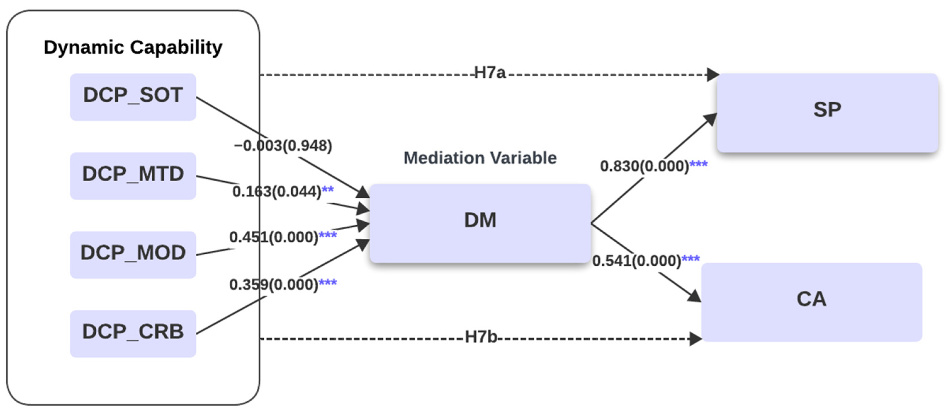
Figure 1: Dynamic Capabilities and Digital Transformation
(Source: Alrub and Sánchez-Cañizares, 2025)

Description of Dynamic Capability Dimensions.
The operationalisation of dynamic capabilities in the study is carried out into four quantifiable elements to enhance empirical articulation:
Sensing of Technology (SOT):
Means the capabilities of the firm to discover new digital technologies and trends in the market. It entails environmental scanning, data-based insights, and identification of opportunities for innovation.
Market/Technology Development (MTD):
Shows the ability of the organisation to create and embrace emerging digital solutions in line with the market demands. These involve AI, analytics, and online infrastructure investment.
Modification (MOD):
Means the capacity of the firm to change internal processes, strategies, and business models due to the digital transformation. It indicates the flexibility and adaptability of the organisation.
Capability Reconfiguration (CRB):
Symbolises the reorganisation and combination of resources, skills, and systems to remain competitive over the long term. It guarantees coordination of digital initiatives and organisational capabilities.
The dimensions offer a more detailed and quantifiable understanding of dynamic capabilities, overcoming the criticism made towards the theory of dynamic capabilities being abstract.

1.2 Research Rationale

1.2.1 Theoretical Justification
The literature on digital transformation and competitive advantage that is currently available is mostly based on the Resource-Based View (RBV) and Dynamic Capabilities Theory (Kero and Bogale, 2023). These models imply that companies attain sustainable competitive advantage not only by owning resources but also by successfully implementing and reorganising them. Sensing, seizing, and reconfiguring have been popularly identified as dynamic capabilities that play a critical role in the process of adapting to the rapidly changing environment.
There is a significant amount of literature that investigates the importance of digital technologies in improving firm performance, i.e. AI, big data analytics, and omnichannel systems. Research has shown that such technologies allow making better decisions, increasing the efficiency of operations, and engaging customers. Also, recent empirical studies indicate the need to match digital strategies with organisational capabilities and business models to attain sustainable competitive advantage.
Nonetheless, even with these developments, there are still some gaps in the literature that are critical. To start with, there is no clarity in the mechanisms by which digital transformation will add to competitive advantage (Reis and Melão, 2023). Most of the studies that have been carried out in relation to dynamic capabilities recognise the significance of dynamic capabilities but they do not explore the development and operationalisation of such capabilities in practice. This gives a gap between theory and application.
Second, the current literature has mixed results on the effect of digital transformation on firm performance. Certain studies have shown good results, whereas others have emphasised poor or even negative influence, especially in organisations that are not highly digital. These contradictions indicate that the correlation between digital transformation and competitive advantage depends on situational conditions, such as organisational competence, leadership, and strategic focus.
Third, the research on mid-sized retail companies, in particular in the UK, is significantly underrepresented (Chowdhury, Limon and Arifur Rahman, 2024). Most of the available literature focuses on large multinational companies or tech companies, which have different resource endowments and competitive pressures. Consequently, existing theoretical frameworks might not adequately reflect the facts of mid-sized organisations, and hence have little generalisability.
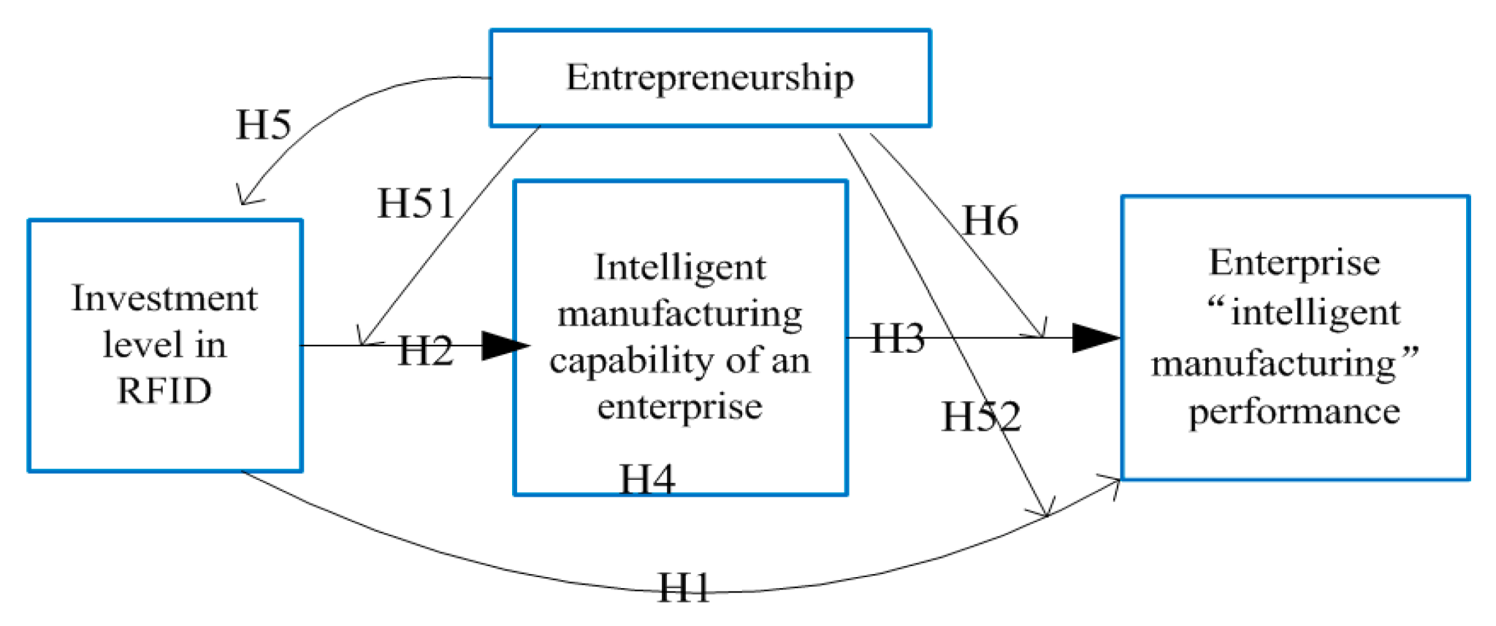
Figure 2: Dynamic Capability Theory-Based Study
(Source: Wang and Liu, 2023)

1.2.2 Practical Justification
In a practical sense, the issues confronting mid-sized retail companies in the UK illustrate the urgency of the research. According to industry reports, a high percentage of digital transformation projects are unable to provide anticipated returns on investment. Indicatively, research by McKinsey may indicate that as many as 70 per cent of digital transformation initiatives fail to deliver their intended results, but not because of technological constraints, but because of organisational and capability-related factors.
Mid-sized retail organisations tend to have several limitations that can be financial, digital, and organisational change resistance (Entekhabi, 2025). These are compounded by the fact that they have to compete with the big retailers that possess peppered technological infrastructure and economies of scale. Consequently, most companies are not able to execute digital strategies well, thus creating inefficiencies and lost opportunities.
Moreover, the high rate of technological transformation leaves questions about what investments will be beneficial in the long term. As an example, companies have to choose between investing in AI-based analytics, cloud-based systems, or omnichannel systems when they lack a clear understanding of the effect on performance. This ambiguity further raises the risk of digital transformation, and it underscores the necessity of a strategic direction.
The next problem is the lack of alignment between the digital strategies and organisational processes. Most companies implement new technologies without incorporating them into their old systems to form disjointed systems, which perform poorly. This underlines the significance of dynamic capabilities, which help firms to coordinate resources, processes and strategies.
The practical importance of this study is that it may offer practical information to managers and policymakers.
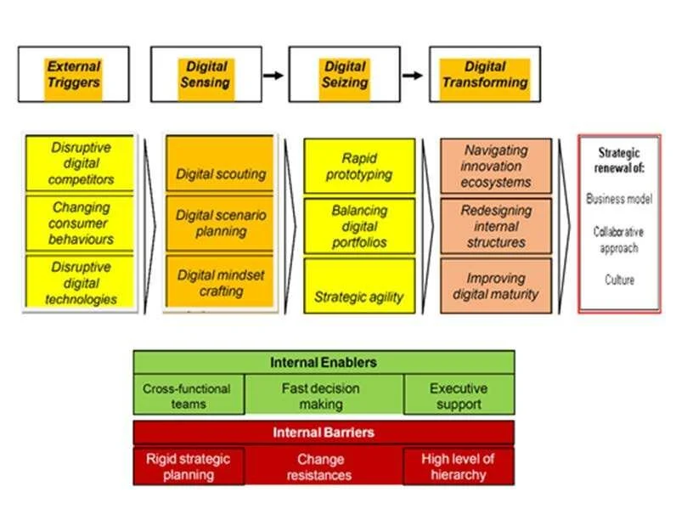
Figure 3: Building Dynamic Capabilities for the Digital Transformation Process
(Source: Warner and Wäger, 2019)

1.3 The research contribution and motivation.
This study has several significant theoretical and practical contributions. Theoretically, it builds on the dynamic capabilities theory by studying how it applies in the digital transformation of mid-sized retail companies (Ahmad and Teo, 2024). It offers a more detailed insight into the development and use of sensing, seizing, and reconfiguring capabilities in the real-world.
The study has an empirical contribution in terms of its concentration on a comparatively understudied aspect of the retailing industry. The study provides an in-depth perspective on the trends of digital transformation and their effects on competitive advantage by reviewing secondary data on the topic between 2020 and 2025 (Elsa, Indrawati and Caska, 2025). This method allows recognising patterns and relationships that might not be so obvious in single-case research.
Practically, the study offers meaningful information to managers who want to cope with digital transformation. It determines the critical issues and success factors of the implementation of digital strategies and provides recommendations on the improvement of organisational capabilities. These lessons would assist the companies to enhance their performance and attain sustainable competitive advantage.
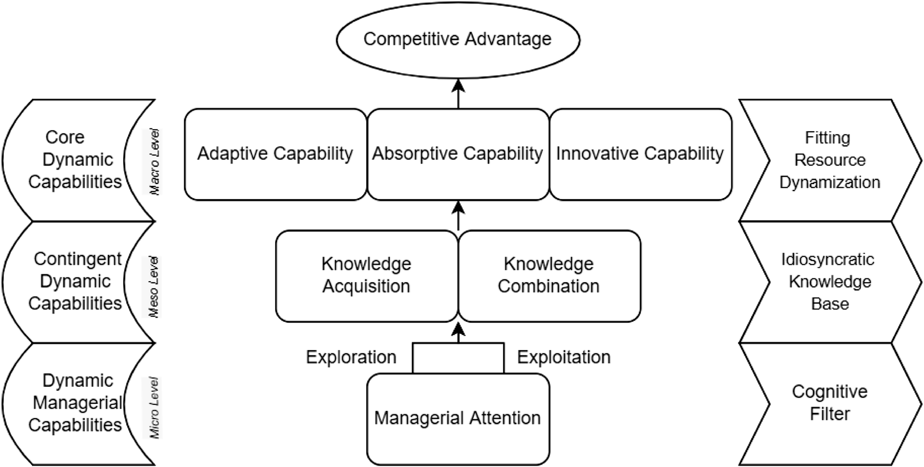
Figure 4: Managerial attention and knowledge-based dynamic capabilities
(Source: Sætra, 2022)

1.4 Research Aim, Objectives, and Questions.

Research Aim
To assess the effectiveness of dynamic capabilities in competitive advantage through digital.
transformation strategies in the UK mid-sized retail firms in the year 2020-2025.

Research Objectives
To determine the important dynamic capabilities of sensing, seizing and reconfiguring in UK mid-sized retail companies.
To explore the role of digital transformation initiatives such as artificial intelligence, data analytics and omni-channel systems in creating competitive advantage.
To examine the constraints encountered by mid-sized retail companies in their effort to pursue digital transformation strategies.
To come up with recommendations on what managers can do to enhance dynamic capabilities and organisational competitiveness.

Research Questions
What are the main dynamic capabilities of UK mid-sized retail companies in gaining a competitive advantage?
What is the role of digital transformation strategies in a competitive advantage?
What are some of the problems that firms have when deploying digital transformation strategies?

1.5 Dissertation Structure
This dissertation is organised into five chapters. The first chapter presents the research background, rationale, aims and research questions, and forms the basis of the research. The second chapter critically examines the literature on dynamic capabilities, digital transformation, and competitive advantage and elaborates on a conceptual framework. Chapter 3 describes the research methodology, which involves research design, data collection and analysis methods. Chapter 4 shows the findings and analysis of the data chosen. Lastly, Chapter 5 presents the discussion of the results, conclusions, implications for the theory and practice, and recommendations for future research.

CHAPTER 2: LITERATURE REVIEW

2.1 Introduction
The chapter is a critical review of the available academic and empirical evidence on the dynamic capabilities. According to Sechele et al.(2024). digital transformation and competitive advantage with reference to UK mid-sized retail firms. This review, based on the research problem revealed in Chapter 1, will fill the gap in understanding the relationship between digital transformation and a sustained competitive advantage and the role of organisational capabilities in this process. Although previous studies recognise the strategic significance of digital technologies, little is known about how firms form and implement capabilities to create value out of such investments.
There are four main areas covered by this chapter. It first discusses the Dynamic Capabilities Theory, which gives the main theoretical perspective on the adaptability of the organisation in the context of a dynamic environment. Second, it examines the issue of digital transformation in the retail sector and discusses the principal technologies of artificial intelligence, big data analytics, and omnichannel systems. Third, it considers competitive advantage frameworks, both the traditional and capability-based approaches. Last but not least, it puts the discussions into perspective of UK mid-sized retail firms, which have their own structural and resource limitations.
The thematic approach is used, which allows carrying out a critical and According to Jiang et al. (2025) integrative analysis of the literature as opposed to a descriptive summary. This will enable a comparative analysis across the studies, finding discrepancies, and the creation of a logical argument that would be consistent with the aims of the research. The chapter is structured and divided into five thematic sections and then the synthesis of theoretical insights and research gaps are identified to inform the conceptual framework and the methodology that follows.

2.2 Digital Transformation, Dynamic Capabilities and Competitive Advantage: A Thematic Literature Review
2.2.1 Theoretical Foundations: Dynamic Capabilities Perspective
Dynamic Capabilities Theory has become a leading theory used in the understanding of the way in which firms respond to rapidly changing circumstances. The theory has its origins in the work of , but builds upon the Resource-Based View (RBV) by stressing the capacity to restructure and mobilise valuable resources in response to the change in the environment, as well as the fact that the resources are possessed. It states that dynamic capabilities are made up of three fundamental processes: sensing opportunities, seizing opportunities, and reconfiguring organisational assets. The processes allow the firms to be competitive in unstable and unpredictable markets.
Sensing capability can be described as the capability of a firm to detect and respond to the changes that occur in the external environment, such as new technologies, changes in consumer preferences, and threats of rivalry. Sensing in the digital transformation context means perceiving the possibilities of technologies like artificial intelligence and data analytics. The capability that is being seized is associated with the capacity of the firm to mobilise resources and undertake strategic investments in order to capture the identified opportunities. This involves embracing online platforms, investing in IT infrastructure and redesigning business models. According to Mueller‐Saegebrecht and Walter (2025), reconfiguring capability, conversely, encompasses the restructuring of organisational processes, routines, and resources in accordance with new strategic directions. Dynamic Capabilities Theory has received a lot of criticism despite its theoretical importance. The conceptual ambiguity of it is one of the key constraints because scholars tend to define and operationalise dynamic capabilities in different ways, which creates discrepancies in empirical studies. Moreover, dynamic capabilities are difficult to measure because they are process-based and are not tangible. Most studies base their proxies on innovation performance or organisational agility, which might not fully reflect the capability underlying these measures. Moreover, the theory can be applied only to a few industries, as empirical operationalisation is missing.
According to Chen et al. (2023). Literary developments in the recent past have tried to overcome these shortcomings by looking at the microfoundation of dynamic capabilities. These are managerial cognition, organisational learning and leadership processes that form the foundation of capability development. As an illustration, a study demonstrates the importance of managerial decision-making and strategic vision in helping companies to feel and capture the digital opportunities. This change towards micro-level analysis makes the theory more explanatory, but adds more complexity.
2.2.2 Digital Transformation in Retail: Concepts and Strategy Importance
Digital transformation is the incorporation of digital technologies in organisational processes that has a fundamental change in the way firms create, deliver and capture value. Over the last several years, digital transformation in the retail industry has been increasing at a greater pace because of technological progress and evolving consumer demands. The strategic significance of digital transformation is evidenced by McKinsey (2023), which states that companies that effectively use digital strategies can attain productivity gains of 20-30 per cent.
Among the main technologies that support the idea of digital transformation, one can distinguish artificial intelligence (AI), big data analytics, cloud computing, and omnichannel retail systems. Retailers can use AI to customise customer experiences by recommending products and predicting customers using recommendation systems and predictive analytics. Big data analytics enable companies to work with high amounts of customer and operational data to make decisions. Cloud computing offers a scalable infrastructure, which offers scalability and cost efficiency. Omnichannel retailing incorporates online and offline platforms to develop smooth customer experiences, which has emerged as a key competitive edge in the UK retail market.
According to Mardosaite, Jasinskas and Romeika (2024), the retail industry has undergone a dramatic change of offline business models to online facilitated business models (Mardosaite, Jasinskas and Romeika, 2024). This shift was catalysed by the COVID-19 pandemic, and UK online retail sales surged significantly at this time. The Office for National Statistics (ONS) has emphasised that e-commerce has contributed more than one-third of total retail sales in 2021, which is a structural change in consumer behaviour. This change has resulted in a greater focus on the personalisation of customer experiences and decisions being data-driven.
Nevertheless, the literature is critical of digital transformation. Most research is technology-focused, meaning that the implementation of digital technologies will inevitably result in performance improvement. This tech-determinism ignores the value of organisational preparedness, culture and abilities. According to McKinsey (2022), empirical sources indicate that as many as 70 per cent of digital transformation initiatives have not reached their goals, mostly because of organisational and strategic issues, and not technological ones.
Furthermore, the results of digital transformation differ considerably among companies, which means that the connection between the use of technology and performance is not direct. Whereas certain companies realise high profitability, other companies realise low or negative returns on investment. This inconsistency shows the necessity to investigate the mechanisms underpinning the creation of value by digital transformation.

2.2.3 Dynamic Capabilities as a Mediator of Digital Transformation
The connection between competitive advantage and digital transformation is becoming more and According to Mele et al. (2024). interpreted through the prism of dynamic capabilities. As much as digital technologies create an opportunity to be innovative and efficient, they do not necessarily create value. Rather, the value is created by the capacity of the firm to effectively deploy and integrate these technologies, which is enabled by dynamic capabilities.
The dynamic capabilities are a mediating factor between the digital transformation and performance outcomes. The sensing ability allows firms to locate the appropriate digital opportunities, including the emerging technologies or alterations in customer behaviour. To give an example, the understanding of the increased significance of e-commerce platforms during the COVID-19 pandemic demanded that firms read the market indicators correctly. The seizing capability entails strategic investment in digital technologies as well as aligning them with business objectives. This involves the use of AI-driven systems, the development of omnichannel strategies and the improvement of digital infrastructure. Reconfiguring capability is to make sure the organisational structures, processes, and resources are reconfigured to facilitate such initiatives.
There are a few studies that affirm the mediating variable of dynamic capabilities. To illustrate, studies on digitally enabled capabilities indicate that digital transformation efforts create organisational capabilities, which subsequently lead to performance improvement. Nonetheless, the literature also shows contradictory results. Research has shown that there is a strong positive correlation between digital transformation and performance, but others have shown limited or inconsistent impacts. These inconsistencies indicate that the success of digital transformation is subject to other things like organisational capabilities, leadership and strategic alignment.
The absence of causal clarity is a serious problem in this field. Although it is believed that dynamic capabilities moderate the connection between digital transformation and competitive advantage, there is still a lack of empirical evidence. Cross-sectional data is used in many studies, limiting the possibility of making causal conclusions. Also, the question of the directionality of this relationship is still under debate. According to some scholars, dynamic capabilities facilitate the process of digital transformation, whereas others opine that digital transformation itself leads to the emergence of new capabilities.
2.2.4 Competitive Advantage in the Digital Era
The cost leadership and differentiation model by Porter (1985) has been used as a conceptual framework to achieve competitive advantage. These models underline the significance of positioning and resource effectiveness in attaining high performance. Nevertheless, in the digital age, agility-related, innovative, and customer-experience capabilities are becoming the competitive advantage.
Digital competitive advantage is defined as the capability to use technology to become more efficient in operations, better in decision making and better in providing personalised customer experiences. Indicatively, companies making use of data analytics will be able to understand customer preferences and behaviour, thus being able to market to them specifically and provide them with better services. On the same note, omnichannel strategies enable retailers to offer a seamless experience on various platforms, which improves customer satisfaction and loyalty.
The empirical data indicate that companies of greater digital maturity are more successful than their competitors. According to Deloitte (2023), digitally mature organisations are said to have higher chances of attaining greater revenue growth and profitability relative to less digitally mature organisations. This explains why it is necessary to combine organisational capabilities with digital technologies to attain a competitive advantage.
Nonetheless, the sustainability of digital competitive advantage is a controversial issue. The high rate of technological change is one of the main challenges because it has allowed competitors to copy innovations at a very fast rate. Consequently, digital technologies can be used to generate a short-lived competitive advantage. This will require constant innovation and capacity building in order to have a competitive advantage.
Relying on organisational capabilities is another important concern. Though digital technologies are opportunities, they are effective in how they are applied and incorporated in the organisation. Companies with inadequate capabilities might also not achieve the full potential of digital as well as perform sub-optimally.
2.2.5 Obstacles and Problems of Digital Transformation
There are a lot of challenges that can impede digital transformation that are linked to it. According to Singun (2025), the most significant are organisational barriers, such as resistance to change, the absence of a vision by the leaders, and inadequate digital skills. The uncertainty and fear of disruption may hinder the transformation process because employees and managers may be hesitant to embrace new technologies.
Technological barriers are also very important. Most of these mid-sized retail companies are based on outdated systems that are hard to align with contemporary digital technologies. It forms inefficiencies and restricts the scalability of digital initiatives. Moreover, the problem of integrating various systems may lead to disjointed operations and customer experiences.
Another significant barrier is financial constraints. Digital transformation demands large amounts of technology, infrastructure and human resources. In the case of mid-sized companies, a low level of financial resources enhances the risk in making such investments. The lack of confidence in the return on investment also makes the process of decision-making a challenge, which contributes to the reluctance or slow-paced implementation of the digital strategies.
Another major problem is strategic misalignment. Most organisations lack alignment of their digital strategies with the general business goals, hence they end up with isolated efforts that do not have any significant impact. This shows the need to incorporate digital transformation into the overall strategic approach of the organisation.

2.3 Theoretical Framework and Scholarly Contribution
Core Theory: Dynamic Capabilities Theory
The main theoretical perspective in this study is Dynamic Capabilities Theory, which offers a sound framework for how firms can attain and remain competitive in evolving environments. The theory was initially presented by and developed further by it, which focuses on the capacity of a firm to integrate, develop, and restructure internal and external capabilities in relation to environmental shifts. According to Other major scholars like Eisenhardt and Martin (2000) also made their contribution in conceptualising dynamic capabilities as something identifiable and replicable. According to Helfat et al. (2007), the theory was further developed by those who added perspectives of the lifecycle to dynamic capabilities. The main aspects of this structure are sensing opportunities, capturing them in a strategic action, and restructuring organisational resources to ensure they remain in line with external demands.
Dynamic Capabilities Theory is especially applicable in industries where there is technological advancement and high competition in the market, like the retail industry. The framework places a heavy focus on the need for organisations to evolve their strategies, processes and resources in order to be responsive to changes in customer expectations and technological disruption. Dynamic capabilities are important for firms to understand and acquire digital opportunities, invest in novel digital technologies, and restructure the way their operations work to stay competitive in the digital age. In addition, the theory emphasises the role of managerial competencies, organisational learning, and strategic agility in maintaining long-term success. Thus, firms with successful creation of dynamic capabilities to create and leverage are more likely to be innovative, resilient, and sustain a competitive advantage in unpredictable business contexts.
Comparison to Other Theories
Although the Resource-Based View (RBV) is based on the ability to have valuable, rare, inimitable, and non-substitutable (VRIN) resources as the foundation of competitive advantage, according to it operates on the assumption of relatively stable market conditions Tuan, Trang and Quan, 2022). On the contrary, Dynamic Capabilities Theory builds on RBV by focusing on how companies redesign and rejuvenate resources within dynamic environments. RBV fails to adequately clarify the response of firms to the fast-changing technology, but dynamic capabilities offer a process-based approach to the capture of innovation and adaptation. That is why the Dynamic Capabilities Theory is more suitable for this research, as it is more dynamic than the digital transformation in the retail sphere.
Apart from RBV, other theories have also been used in the research of organisational change and technology adoption, including Contingency Theory and Technology Acceptance Theory (TAM). Organisational effectiveness is achieved in Contingency Theory by matching the internal structure of the organisation with external environmental parameters, whereas TAM emphasises the influence of the perceived usefulness of and users' acceptance of technology. Still, these theories are weak in explaining how the process by which a firm continuously adapts and renews its resources over time. Dynamic Capabilities is a more holistic theory, as it combines organisational learning, strategic flexibility and resource reconfiguration. Thus, it is more suitable to study the process of digital transformation and the sustained competitive advantage in rapidly changing retail environments.
Theoretical Contribution of the Study
According to this research adds to the development of the Dynamic Capabilities Theory in multiple respects (Mele et al., 2024). To begin with, it applies the theory to a relatively uncharted setting in the case of mid-sized retail companies, which face different resource limitations than large corporations. Second, it incorporates the digital transformation processes into the dynamic capabilities framework, which gives an insight into the interaction of technological adoption with organisational capabilities. Third, the paper examines the capability-performance relationship that bridges the gap in the knowledge of how sensing, seizing and reconfiguring capabilities are converted to competitive advantage. In this way, the study provides a more contextualised and operationalised implementation of the dynamic capabilities theory.
Additionally, the study's findings complement the existing literature by providing actionable recommendations for mid-sized retail businesses on the beneficial use of digital technologies in building their competitiveness on a long-term basis. This research will distinguish itself from the previous studies, which primarily examined large multi-national organisations, as it will identify some unique operating and financial concerns faced by medium-sized retailers in the UK market. The research further contributes to empirical knowledge by aligning theory with practice, including practices in digital investment decisions, process innovation and customer engagement. Furthermore, the study can serve as a model for future academic research and can be modified to be used in other industries that are also undergoing a period of rapid technological change and market uncertainty.

2.4 Conceptual Framework
Digital transformation, dynamic capabilities and competitive advantage have been incorporated into a single analytical framework in the conceptual framework of this study according to Lukito, Suharnomo, and Perdhana (2022). Digital transformation strategies are considered the independent variable, and competitive advantage is the dependent outcome. Dynamic capabilities can be considered a mediating variable, as it clarifies the translation of digital initiatives into organisational performance.
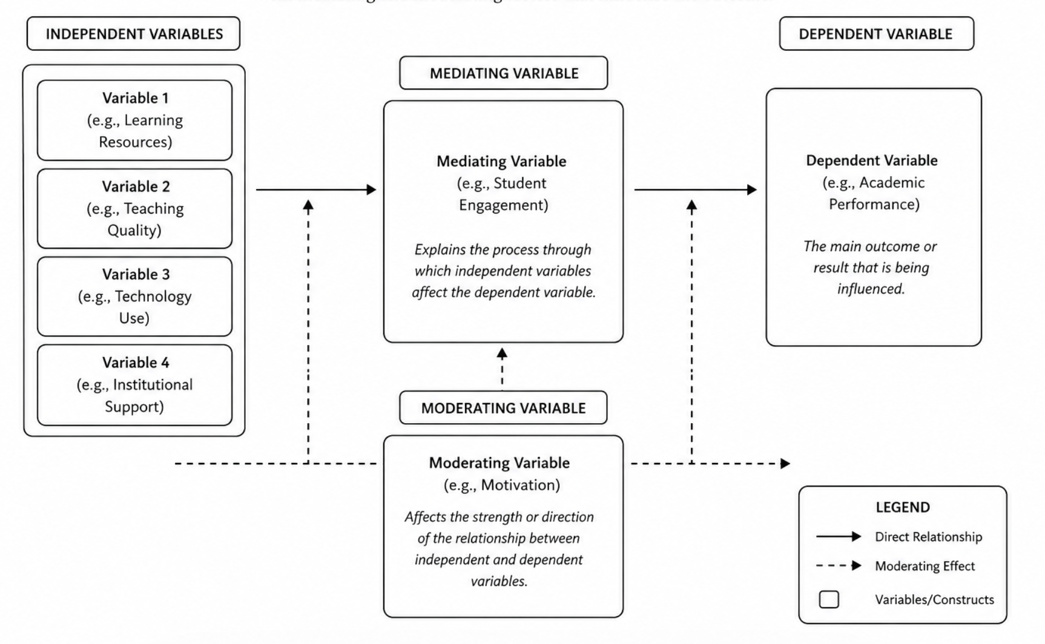
Figure: Conceptual framework
The framework presupposes that digital transformation in itself does not necessarily result in competitive advantage. Rather, it can be effective when the organisation has developed and implemented dynamic capabilities. In particular, sensing capabilities allow firms to recognise technological opportunities, seizing capabilities allow strategic investments and reconfiguring capabilities guarantee that internal processes match external changes.

Moreover, the operational transparency of the model is promoted by the fact that certain dimensions are included in the model, including SOT, MTD, MOD, and CRB. This systematic review enables more effective analysis of how digital transformation helps to create a long-term competitive advantage.

2.5 Theoretical Concept
This study will utilise the dynamic Capabilities Theory as its main theoretical framework, which explains how companies develop and maintain a competitive edge in a fast-evolving environment. The theory, which has its origins in the work by, builds upon the Resource-Based View (RBV), but it focuses not on the firm having valuable resources, but on its capacity to restructure the resource, as well as to renew it, in accordance with changing environmental conditions.
The theory is organised into three fundamental processes, which include sensing, seizing and according to reconfiguring Mueller‐Saegebrecht and Walter (2025). Sensing is the capacity of organisations to recognise opportunities and threats within the external environment, such as technological development and consumer behaviour changes. Seizing entails harnessing resources and taking strategic moves in order to capture the perceived opportunities, commonly by investing in digital technologies and innovation. Reconfiguring has to do with the constant change of the organisational processes, structures and capabilities in order to keep in tune with the evolving market conditions.

2.6 RESEARCH GAP
His research uses the Dynamic Capabilities Theory as a main theoretical framework to demonstrate how organisations develop and maintain a competitive advantage in a fast-changing environment. The theory, which is an extension of the Resource-Based View (RBV), was originally proposed by as they focus on the fact that the organisation is capable of repeatedly reconfiguring, integrating, and renewing the valuable resources in the face of environmental change.
The theory is fundamentally organised on three interconnected processes that include sensing, seizing and reconfiguring (Chavarnakul et al., 2025). Sensing is the ability of a firm to detect new opportunities and threats within the external environment, such as changes in technologies and preferences of consumers. Seizing is a process that entails resource mobilisation and strategic decision-making to capture these opportunities, usually in terms of investments in innovation and digital technologies. Reconfiguring, in its turn, demonstrates how the organisation can modify and reposition its internal operations, structures, and capabilities to be able to compete in the changing market environment.

2.5 Chapter Summary
This chapter has critically reviewed the literature on dynamic capabilities, digital transformation and competitive advantage, thereby providing a broad theoretical base of study. The review demonstrated that digital transformation is being discussed as a strategic imperative, but the effects of the digital transformation on performance are not uniform and depend on the organisational capabilities. Dynamic Capabilities Theory was found to be the most suitable framework that can be used to explain how firms respond to changes in technology and the environment, especially via sensing, seizing, and reconfiguring.
Such gaps indicate the necessity of research that would combine theoretical and empirical approaches to obtain a more profound insight into the connection between digital transformation, dynamic capabilities, and competitive advantage. This need is addressed in the conceptual framework that is developed in this chapter by postulating a mediated relationship between these constructs.

CHAPTER 3: METHODOLOGY

Research onion
This study is based on the research onion model, which offers a systematic approach to the study methodology. On the surface, the study uses an interpretivist philosophy, as competitive advantage and the outcomes of digital transformation are identified as context-specific and socially constructed at the UK mid-sized retail companies. Going in, it takes an abductive strategy, synthesising theoretical knowledge on dynamic capabilities with recent trends of secondary data. The research strategy adopted is a case study approach that is a qualitative mono-method, which is based on secondary data sources. The time horizon is a cross-sectional (2020-2025), and the essential method of analysing the digital transformation and building capability is thematic analysis.

Figure 1:Research onion
(Source:15 Writers, 2024)

3.1 Introduction
This chapter critically describes and rationalizes the methodological framework based on the evaluation of the effects of dynamic capabilities on competitive advantage among UK mid-sized retail companies in the period 2020-25. The paper addresses the research question established in previous chapters, in which extensive investments in digital transformation, including AI, big data analytics, and omnichannel systems, have yielded varied performance results across companies (Reis and Melão, 2023). Indicatively, industry evidence suggests that during COVID-19, although digital adoption was fast, e-commerce has exceeded 30% of the UK retail sales, with many companies unable to convert these investments into long-term competitive advantage. This contradiction emphasises the significance of organisational capabilities but not technology.
To deal with this complexity, the study takes a qualitative multi-case approach, which is based on a secondary dataset and allows critical and data-rich analysis of the role of dynamic capabilities (sensing, seizing, and reconfiguring) in mediating the association between digital transformation and the performance of firms. Furthermore, the study is critical in terms of recognising that in the digital retail environment, competitive advantage is not simply derived from adopting technologies, but from the organisational capacity to strategically and continually adapt these technologies to evolving market conditions. The methodological framework, therefore, has a strong emphasis on understanding the underlying mechanisms of organisations, which enabled some firms to see sustained growth in the post-pandemic era, whilst others saw a limited return on their investments, despite the fact that they have invested the same amount of money in digital. But according to data from industry reports, UK retailers as a whole have been spending more on AI-powered analytics, cloud-based systems, and omnichannel initiatives from 2020 to 2025, and data from McKinsey and Deloitte shows that the majority of AI transformation programmes have stalled due to a lack of strategic agility, leadership alignment, and capability reconfiguration. What this illustrates is that the outcomes of digital transformation are strongly context-specific and do not just relate to technology.
Because of this, the qualitative multi-case design allows for an in-depth analysis of managerial decisions, organisational learning and adaptability processes studied in quantitative methods that might be missed. Secondary qualitative data collected from company reports, consultancy publications and academic literature offers a comparative and longitudinal analysis of the development of dynamic capabilities in the various retail companies. Moreover, the method is suitable for the interpretivist and abductive approach of the research, as it can enable the examination of theory derived from the Dynamic Capabilities Theory in light of the actual organisational experiences in the UK retail sector.

3.2 Research Philosophy, Approach, and Design
Research Philosophy
The research is based on an interpretivist research philosophy, which presupposes that organisational results like the competitive advantage are socially constructed and context-dependent (Mustofa, 2023). The performance of firms in the UK retail industry that have similar technological investments can often be dramatically different and therefore it is argued that performance is contingent on managerial cognition, organisational culture, as well as strategic alignment as opposed to objective technological inputs being the sole determinant. Indicatively, although the use of digital tools is widespread, it has been reported that almost 70 per cent of digital transformation projects fail to deliver desired results, mostly because of the organisational and capability-related factors, and not because of the technological constraints.
Most importantly, the underlying processes are not reflected in positivist approaches that emphasise measurable variables (Imam et al., 2023). Interpretivism can thus allow a more in-depth examination of how companies make sense of digital opportunities and build capabilities in response to environmental uncertainty. Nonetheless, the method is subjective and ungeneralisable too, requiring particular triangulation of data sources.
The study has taken an interpretivist research philosophy as the relationship between digital transformation and competitive advantage is not solely about measurable outcomes of technology, but it is more about how managers interpret and how they make decisions on it. Mustofa (2023) argues that interpretivism is based on the premise that organisational realities are socially constructed and shaped by human actions, organisational culture, and environmental factors. UK mid-sized retail businesses are finding that the results vary greatly between those with comparable spending on artificial intelligence, big data analytics and omnichannel systems. Competitive advantage is not only a result of technological resources but also a result of the capabilities of managers to interpret changes in the market, align strategic course and build dynamic capabilities. The industry data also showed that organisational resistance, lack of leadership and strategic integration, and not technology are the main reasons for the failure of 70 per cent of digital transformation projects to deliver on expectations.
Interpretivism is thus suitable as it allows for a deeper analysis of the understanding and reactions of organisations in the face of digital transformation challenges in an uncertain market environment. Interpretivism can be differentiated from positivist philosophy by studying the subjective experiences of the organisation, learning processes, and capability development (Imam et al., 2023). However, subjectivity and the lack of generalisability are issues that can be raised in interpretivist research. To minimise these constraints, the study utilises triangulation in the use of several secondary data sources such as company reports, consultancy publications and academic literature to strengthen the credibility and depth of analysis.
Research Approach
The study is abductive in nature, and it is based on deductive theoretical foundations with inductive empirical investigation (Yao, 2024). The paper starts with the Dynamic Capabilities Theory, which has sensing, seizing, and reconfiguring as the main processes, yet the current literature has inconsistent results. As examples, digital transformation is reported to have increased productivity by 20-30 per cent in some studies, but showed no increase or decrease in others, especially in mid-sized companies with limited resources.
The abductive method enables the researcher to switch between theory and data with each other, refining explanations by empirical evidence. This is especially significant in the present study since the dynamics between the digital transformation and the competitive advantage would not be linear but rather mediated by situational variables like firm size, digital maturity, and leadership capability.
Research is conducted on an abductive approach, where both deductive and theoretical approaches are supported by an inductive and empirical approach to examine the relationship between dynamic capabilities and competitive advantage. Yao (2024) claims that abductive reasoning is appropriate in the study where theories are already available to explain the phenomena being studied, but the findings are still inconsistent or incomplete. The starting point of this study is the Dynamic Capabilities Theory, which is mainly considered in this study as the three dimensions of the capabilities that are sensed, seized and reconfigured. But the experiences of digital transformation strategies are contradictory, as presented in previous literature. Other research suggests that digital technology can boost productivity and operational performance by 20–30 per cent, but other research suggests a much less positive effect, especially among mid-sized companies with limited financial and technology resources.
The abductive approach is consequently suitable, as it allows a process of continual interaction and feedback between theory and empirical evidence. The study does not test theory in a deductive way, but rather develops theory based on the analysis of secondary qualitative data obtained from UK retail companies from 2020 to 2025. This flexibility is crucial as the link between digital transformation and competitive advantage is not likely to follow a linear path. Rather, it will be determined by contextual factors like leadership capability, organisational culture, digital maturity and resource availability. Moreover, the use of the abductive approach helps in critical analysis by letting the results of the data analysis process emerge in an unexpected way but still be connected to the conceptual framework. Therefore, the study can provide more contextually contextual explanations for the role of dynamic capabilities in digital transformation outcomes in the UK retail industry (Mele et al., 2024).
Research Strategy and Design
It utilises a qualitative multi-case study approach, which enables the in-depth exploration of complex organisational phenomena in real-life contexts (Alshahrani, 2025). Case study research is also most appropriate in answering the questions of how and why, which are at the centre of the study. The study is descriptive in nature, allowing systematic comparison of a variety of firms with contextual richness.
More importantly, quantitative methods may yield more generalisations, but would not be able to capture the finer details of how capabilities are created and put into action. Thus, the design adopted puts more emphasis on analytical depth than statistical generalisability.
A qualitative multi-case study approach is used to delve into the role that dynamic capabilities play in competitive advantage during digital transformation in the context of UK mid-sized retail businesses. Alshahrani (2025) states that the method of case study is well-suited for studying complex phenomena in an organisation in a real environment. This is suitable because digital transformation is a combination of various aspects of technology, strategy and organisation, which can only be partly understood quantitatively. The multi-case design allows the comparison of several cases and the identification of similarities, differences and patterns in the development of sensing, seizing and reconfiguring capabilities across the cases.
The research design is mainly descriptive and exploratory in nature to gain insight into the ways and the reasons why firms produce different transformation results for the same technological investments. The study offers a deeper context around digital transformation practices by exploring organisational strategies, leadership responses, and capability-building processes in detail. The analysis is based on secondary qualitative data that comes from annual reports, consultancy reports, academic studies, and company publications and allows a longitudinal analysis of the developments from 2020 to 2025.
Further, qualitative design emphasises in-depth analysis rather than statistical generalisation. While quantitative methods can offer generalisability, they may not be able to explain the mechanisms of transformation that are at work. This selected design hence enables the deeper understanding of managerial cognition, organisational adaptation and strategic alignment in dynamic market environments (Selivanovskikh et al., 2025). However, the paper recognises that qualitative research using a case study approach could be prone to researcher interpretation and lack external generalisation. To overcome this, systematic cross-case comparison and triangulation of several secondary data sources are used to enhance the rigour and reliability of the research.

3.3 Justification for Case Study Methodology
The choice of a case study methodology is closely related to the goals of the research, i.e. to comprehend the mechanisms by which dynamic capabilities determine the competitive advantage. Digital transformation is a multi-dimensional process that comprises technological, organisational and strategic elements (Reis and Melão, 2023). These interactions can be studied in a holistic way using case studies.
One of the strengths of the case study research is that it offers contextualised and process-based information. To illustrate, though big data can show a relationship between digital investment and performance, it cannot answer questions such as why certain companies are successful and others are not. Case studies enable the discovery of the mechanisms underlying the processes, e.g. how sensing capability helps firms to detect emerging customer trends or how reconfiguring capability assists organisational restructuring.
This approach is further supported by the use of secondary data that offers access to large-scale, longitudinal and real-world evidence.

3.4 Data Sources and Databases
Only secondary qualitative data from academic, institutional and industry sources have been used in the study. Secondary data should be used as it is satisfactory for the research to critically review the existing evidence on digital transformation and the dynamic capabilities of the UK mid-sized retail companies from 2020 to 2025. The secondary sources offer insights into the evolution of the industry over time, the strategies adopted by organisations, and performance comparisons, which are difficult to attain through primary research and would require a significantly longer time frame than was available for this dissertation (Lim, 2025).
Academic databases that are primarily used for sourcing peer-reviewed literature include Scopus, ScienceDirect, Emerald Insight and Google Scholar. High-quality interdisciplinary research articles on the topics of digital transformation, dynamic capabilities, and strategic management were identified using Scopus. ScienceDirect was used to access journals on the subject of retail management, information systems, organisational innovation and business performance. Emerald Insight proved to be especially useful for the depth of business and management literature on topics of competitive advantage, organisational agility and implementation of digital strategy. Google Scholar was also used to access extra academic resources, citations and to find foundational studies that have been cited extensively in the field of Dynamic Capabilities Theory (Kero and Bogale, 2023).
These were complemented by academic databases and the use of institutional and industry sources to give practical and contextual information on the UK retail environment. The sources included reports and publications from the Financial Conduct Authority (FCA), HM Treasury, Deloitte, McKinsey & Company, and the Office for National Statistics (ONS). Reports from the industry were especially helpful in determining the latest trends in e-commerce growth, the use of artificial intelligence, omnichannel retailing and organisational re-structuring in the UK retail market (Deloitte, 2023; McKinsey & Company, 2023).
In addition, the company's annual reports, sustainability reports, and retail industry publications were analysed to explore how organisations have reacted to the digital transformation initiatives in the period of 2020-25. These documents offered strong evidence at the firm level on strategic investments, process change, technology adoption and capability building within medium-sized retail firms.
Data triangulation was used for the academic and industry-based sources to support the study's validity and reliability. The theoretical basis for the study has been drawn from academic literature, while consultancy and institutional reports provide a practical and real-life evidence on the challenges, processes, and results of digital transformation initiatives within the retail industry (Ashour and Flouty, 2023).

3.5 Search Strategy
A systematic and structured search process was undertaken to locate the relevant academic and industry literature for digital transformation, dynamic capabilities and competitive advantage in the context of mid-sized retail businesses in the UK. The search strategy was developed in a way to guarantee uniformity, relevance, and scientific method to the identification of literature in the process. The use of Boolean operators like “AND” and “OR” helped narrow down search results and enhance the selection of articles in the chosen databases (Lim, 2025).
To search the literature, the academic databases Scopus, ScienceDirect, Emerald Insight and Google Scholar were used. These databases have been chosen for their ability to offer high-quality peer-reviewed journals with a strategic management focus, along with their digital innovation and organisational capability and retail transformation content (Kero and Bogale, 2023).
During the search process, the following keyword combinations were used most:

- “digital transformation” AND “UK retail sector”
- To gain a competitive advantage, it is essential to have “dynamic capabilities”.
- “digital transformation” OR “mid-sized retail companies.”
- As you can see, the first two search terms are quite similar.As you can see, the first two terms of the search query are very similar.
- The title is a combination of the two terms, “big data analytics” AND “organisational capability.”
- “omnichannel retailing” AND “customer experience”
- Dynamic capabilities theory” AND “digital innovation”
- The term organisational agility” is often used interchangeably with the term “digital transformation”.
- The term “capability reconfiguration” AND “retail firms”

Peer-reviewed journal articles between 2019 and 2026 were the primary focus of the search as this period aligns with the current developments in digital transformation and retail innovation after COVID-19. Additionally, however, some studies were added where theoretically applicable, especially those focusing on literature on dynamic capabilities theory and the various frameworks of competitive advantage, such as Teece's (2025) or Porter's (1985).
The search process involved several stages and was iterative. First searches were done broadly around digital transformation and competitive advantage in retail. Later searches focused on the capability reconfiguration, organisational agility and digital capability development, specifically on retail organisations (Mele et al., 2024).
The screening process consisted of the titles, abstracts, keywords, and full text of the articles being read to check if they fit the research aims and objectives. Studies that did not have relevance to digital transformation, organisational capabilities or the UK retail context were excluded. To enhance the consistency, reliability and quality of the literature review, duplicate studies and repeated datasets were eliminated in the screening phase (Shaheen et al., 2023).
In addition, industry reports from Deloitte, McKinsey & Company and the Office for National Statistics (ONS) were also incorporated into the search process alongside academic research to provide more up-to-date industry evidence to complement the academic research regarding e-commerce growth, AI adoption, customer behaviour change and omnichannel retail developments in the UK retail market (deloitte, 2023; McKinsey & Company, 2023; Office for National Statistics (ONS), 2023).

3.6 Inclusion and Exclusion Criteria
Inclusion and exclusion criteria were defined and applied consistently to the literature selection process to ensure that the selected literature is relevant, credible and methodologically consistent. In the context of secondary qualitative research, explicit screening criteria are crucial for enhancing transparency, mitigating selection bias, and boosting the general trustworthiness and reliability of the results (Shaheen et al., 2023).

The criteria were designed to reflect the research purposes, which are to understand digital transformation, dynamic capabilities and competitive advantage in the mid-sized retail sector (2020-2025) in the UK. This screening process also meant that only academically demanding studies that were contextually relevant were included in the analysis.

Criteria Type | Inclusion Criteria | Exclusion Criteria
Source Type | Peer-reviewed journal articles, academic books, institutional reports, consultancy publications, and company annual reports | Blogs, opinion articles, unverified websites, and non-academic content
Publication Period | Publications between 2019 and 2026, including seminal theoretical studies where necessary | Outdated studies lacking theoretical or contextual relevance
Topic Relevance | Studies focusing on digital transformation, dynamic capabilities, competitive advantage, AI, analytics, omnichannel systems, and retail strategy | Studies unrelated to digital transformation or organisational capabilities
Geographical Focus | UK-focused studies and relevant international comparative research | Studies with no relevance to the UK retail environment
Industry Focus | Retail organisations, particularly mid-sized firms undergoing digital transformation | Studies focusing exclusively on unrelated industries without transferable findings
Language | English-language publications | Non-English publications
Research Quality | Empirical and theoretical studies with clear methodological contribution and academic rigour | Sources lacking methodological clarity, reliability, or academic credibility

3.7 Research Quality and Rigour
The study takes care of important quality criteria to guarantee methodological rigour. Construct validity is realised with the help of multiple data sources and the established theoretical constructs (Shaheen et al., 2023). The systematic analysis and clear connection of evidence and conclusions assure internal validity. Analytical generalisation creates external validity, and the findings obtained can be used to add to the theory, but not claims at the level of the population. It can be guaranteed by providing clear documentation of research procedures.
Nonetheless, using secondary data might also create certain limitations, such as bias in data and absence of control over the quality of data. Triangulation and source evaluation help to mitigate these problems.
The study adopts several methodological strategies to ensure research quality, credibility, and analytical rigour throughout the investigation of dynamic capabilities and digital transformation in UK mid-sized retail firms. Construct validity is strengthened through the use of multiple secondary data sources, including annual reports, consultancy publications, academic journals, and company websites, which provide triangulated evidence regarding organisational performance, technological investment, and strategic transformation. Industry data indicates that despite substantial investment in AI, data analytics, and omnichannel systems between 2020 and 2025, approximately 70 per cent of digital transformation initiatives failed to achieve intended outcomes because of organisational and capability-related weaknesses. The use of varied data sources, therefore, enables a more balanced interpretation of both successful and unsuccessful transformation cases (Ikegwu et al., 2022).

3.8 Ethical Considerations
The research meets a high level of ethical requirements, although it uses publicly available data (Nii Laryeafio and Ogbewe, 2023). All the sources are referenced to prevent plagiarism, and the information is provided correctly to evade misinterpretation. The study does not involve selective reporting, and it is balanced, so it considers both the positive and negative results of digital transformation.
Also, the research honours organisational integrity by not misrepresenting organisations and following institutional ethical standards.
The researcher seeks to uphold conventional ethical ideals of integrity, transparency and the proper use of data; the study being conducted by referencing secondary qualitative data entered from such sources as companies’ annual reports, consultancy publications, academic papers, and market reports. Involvement of human participants is not involved as all data for the empirical work is interpreted from existing literature, thus,
There are relatively few questions concerning informed consent, physical harm, and the confidentiality of subjects. However, ethical responsibilities of the researcher still cannot be ignored as even organisational information is presented, at some points, to alternative, selectively or otherwise, distorted circumstances.

3.9 Chapter Summary
This chapter has critically defended the methodological framework applied in this study, pointing to the suitability of an interpretivist philosophy, an abductive approach, and a multi-case qualitative design. The secondary data facilitates the context-sensitive analysis of the UK mid-sized retail firms in terms of digital transformation due to the use of secondary data. The methodology is rigorous, transparent, and objective in researching objectives despite the limitations. The following chapter includes the empirical evidence that was obtained in the form of this methodological approach.

CHAPTER 4: DATA ANALYSIS AND FINDINGS

4.1 Introduction
The chapter includes the findings and data analysis, based on the secondary qualitative research conducted on the UK mid-sized retail firms in the year 2020-2025 (Wojtaszek et al., 2025). This chapter aims to examine the importance of dynamic capabilities in creating competitive advantage in digital transformation strategies in the context of rapid technological disruption, changing consumer behaviour, and the restructuring of markets after the pandemic. In many of the previous chapters, we have explored four key areas of digital transformation that pose a great challenge to UK retailers as they strive to compete in increasingly digital markets, namely, artificial intelligence (AI), big data analytics, cloud computing, and omnichannel retail systems. Although there had been a high level of investment in digital technologies, the results of these investments did not show a similar consistency of success across firms, indicating that having a technology wasn't enough to guarantee long-term success in the organisation.

4.2 Overview of Data Sources and Analytical Framework

4.2.1 Overview of Secondary Data Sources
The analysis in this study has been done based on the secondary qualitative data obtained from academic, institutional and industry-based sources of literature published from 2020 to 2025 (Kikasu et al., 2025). Secondary data was deemed appropriate in this study as it was designed to rigorously investigate the industry-wide trend of digital transformation and capability development in UK mid-sized retail companies over a period of time. The secondary data used allowed the researcher to gain access to a large volume of secondary evidence relating to organisational strategy, technology and competitive performance that would not have been possible through primary research within the time constraints of the dissertation.
The primary sources used were reports published by Deloitte, McKinsey & Company and the Office for National Statistics (ONS), as well as peer-reviewed academic journal articles and retail company annual reports. Consultancy reports abounded with evidence from the industry of the rapid growth in e-commerce, artificial intelligence implementation, omnichannel retail and operational restructuring in the wake of the COVID-19 pandemic. For example, Deloitte (2023) observed that retailers with high digital maturity showed higher revenue growth and customer retention than those with lower digital maturity. Likewise, according to McKinsey & Company (2023), companies that successfully use AI and analytics for decision making saw operational productivity gains of around 20-30 per cent.
Main Theme | Sub-Themes Identified | Key Findings
Theme 1: Sensing Capabilities and Digital Opportunity Recognition | Consumer behaviour recognition, technology sensing, market intelligence, and environmental scanning | Firms that effectively identified digital trends and changing customer expectations adapted faster to market disruptions and improved decision-making.
Theme 2: Seizing Capabilities and Strategic Digital Investment | AI adoption, big data analytics, omnichannel retailing, strategic agility, digital infrastructure investment | Strategic investment in AI and analytics improved operational efficiency, customer engagement, and competitive responsiveness.
Theme 3: Reconfiguring Capabilities and Organisational Adaptation | Organisational restructuring, workforce capability development, process integration, digital culture | Successful firms continuously restructured processes and developed employee digital competencies to support transformation.
Theme 4: Digital Transformation and Competitive Advantage | Customer experience improvement, operational efficiency, competitive positioning, innovation capability | Digital maturity strengthened customer satisfaction, productivity, and market competitiveness in the UK retail sector.
Theme 5: Challenges and Barriers to Digital Transformation | Financial constraints, resistance to change, legacy systems, and lack of leadership alignment | Many firms failed to achieve expected digital outcomes due to organisational and capability-related weaknesses rather than technology itself.
Theme 6: Dynamic Capabilities as a Mediating Mechanism | Sensing, seizing, reconfiguring processes, organisational learning, strategic flexibility | Dynamic capabilities acted as the key mechanism linking digital transformation initiatives with sustainable competitive advantage.

4.2.2 Analytical Framework
This chapter adopts the analytical framework from Dynamic Capabilities theory, which provides an explanation on how organisations become more strategic and adaptable in rapidly changing environments. The framework was deemed to be an appropriate one as over the period 2020-2025 there was significant technological and market disruption in the UK retail sector, necessitating companies to embrace digital technologies and to continually adapt their organisational structure, processes and skills to meet the changing consumer expectation.
Four primary analytical dimensions were considered in the analysis: sensing capability, seizing capability, reconfiguring capability and competitive advantage (Pitelis, Teece and Yang, 2024). Sensing capability was defined as a firm's capacity to detect new technological opportunities, watch market developments and understand consumer behaviour changes. This involved leveraging market intelligence, digital analytics, and strategic environmental scanning to uncover opportunities linked to AI, e-commerce, and the omnichannel approach.

4.3 Theme 1: Sensing Capabilities and Digital Opportunity Recognition

4.3.1 Understanding Sensing Capabilities
Sensing capability is the ability of an organisation to sense market opportunities, new technologies and consumer behaviour changes earlier than other competitors. In the context of Dynamic Capabilities Theory, sensing capability is considered a basic process since firms in volatile markets have to constantly monitor external markets and identify new strategic opportunities in order to remain competitive. Opportunity recognition is closely linked to organisational awareness, strategic interpretation and environmental responsiveness, especially in fast-changing sectors like retail (Filser et al., 2023). Sensing capability grew in significance during the period between 2020 and 2025, especially in the case of mid-sized retail businesses, because of the COVID-19 disruption, digital acceleration and changing customer expectations.
The results show that companies with a higher level of sensing used more systematic methods for environmental scanning and market intelligence collection. These companies were more vigilant in tracking customer preferences, competitor activity and technological advances than less digitally advanced companies. During this pandemic period, the recognition of consumer trends took on a new importance: online buying habits in the British retail market jumped significantly. The ONS found that in 2021, online retail sales accounted for more than one-third of overall retail sales for the UK, reflecting a significant shift in the way consumers are buying goods. Retailers that were able to spot this change early were able to react faster, primarily by expanding e-commerce and integrating it into their operations.
In addition, the analysis shows that digital sensing was not limited to customer behaviour, but also contained technology awareness and strategic forecasting. In the era of smart sensing, the acquisition and analysis of data are playing a more critical role in the sensing process, requiring sophisticated data collection and analysis techniques that can enhance the sensing organisation's visibility and responsiveness (Wang et al., 2023).

4.3.2 Findings on Consumer Behaviour Recognition
The results show that there was a clear relationship between one of the retailers' strongest predictors of being able to sense the customer and how much they could sense long-term changes in consumer behaviour. The pandemic has further contributed to the rise in e-commerce, mobile commerce, and contactless payment methods, reshaping shoppers' expectations of convenience, speed, and customisation. According to Alsharif et al. (2022), consumer behaviour in today's world is highly dependent on digital interactions, convenience-based buying habits, and tailored interaction communication. Retailers who understood and were able to adapt to these behavioural trends in time had a better chance of keeping customers loyal during market disruptions.
The analysis shows that those retailers that implemented customer analytics systems had a greater ability to respond to consumer shifts. By leveraging data and analytics, companies could track customer purchasing habits, tailor product suggestions, and fine-tune customer interactions. The benefits of AI-based recommendations for customer interactions and sales conversions were especially significant. According to Khan et al. (2022), AI-powered technologies had a beneficial impact on consumers' purchasing decisions, particularly regarding the personalisation of their buying experiences and the improvement of digital customer experiences.
The results also indicate that the adoption of omnichannel has emerged as a key strategic answer for the evolving consumer expectations. Retailers increasingly brought online and offline together to provide customers with an integrated shopping experience, including click-and-collect orders, mobile apps, and tech payment methods. Yu et al. (2024) state that convenience, trust and usefulness are all essential factors in consumer acceptance of new and innovative digital technologies, and thus, retailers quickly adopted digital payment and mobile commerce services following COVID-19.
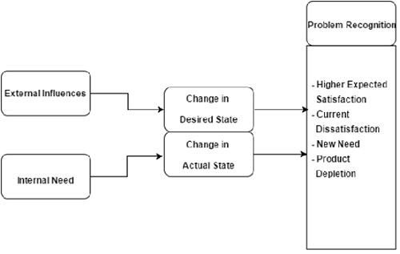
Figure 1: Findings on Consumer Behaviour Recognition
(Source: TutorialsPoint, 2025)

4.3.3 Findings on Technology Sensing
The study reveals that technology sensing has become another key factor of organisational competitiveness in a digital context. Additionally, there was an increasing focus on developments in AI, cloud, big data analytics, and mobile technologies among mid-sized retailers in the UK from 2020 to 2025. Companies that are better at sensing emerging technologies invested more aggressively in digital experimentation and innovation programs and had a better sense of the technologies that were emerging. Wan Mohamad and Rakiman (2024) highlight how digital sensing technologies enhance organisational responsiveness, allowing for quicker data gathering, visibility over operations and strategic forecasting.
The findings indicate that companies that were being more technologically savvy were better equipped to navigate the uncertainty of the post-pandemic retail rebrand. They had already committed to cloud systems, customer analytics solutions, and AI-powered operational systems, which enabled them to be more flexible and responsive in times of uncertainty. Ramdani (2025) also states that in addition to enhancing the ability to interpret their environments, digital sensing mechanisms increase organisational adaptability for making strategic decisions.

4.4 Theme 2: Seizing Capabilities and Strategic Digital Investment

4.4.1 Understanding Seizing Capabilities
Seizing capability is the ability of the organisations to call on resources, execute strategic investments and convert perceived digital opportunities into operational and competitive results. In the Dynamic Capabilities theory, the sensing of opportunities is followed by seizing capability, as firms need to allocate their financial, technological, and managerial resources wisely to take advantage of the new market opportunity. Rizana, Wiratmadja and Akbar (2025) state that to grasp capability, strategic investment decisions, technological implementation, organisational coordination, as well as business model adaptation, must be made to leverage digital transformation into value creation, which can be measured. The COVID-19 disruption was accompanied by highly uncertain market conditions, which made it imperative for mid-sized retailers in the UK to rapidly roll out digital technologies, thus making seizing capability more relevant from 2020 to 2025.
The results point to a link between more aggressive digital investment approaches and more adaptive firms in terms of seizing opportunities. Investments in AI, predictive analytics, cloud infrastructure, and omnichannel retail systems were among the top priorities for these organisations, aimed at enhancing the responsiveness of their operations and customer interactions. While technology plays a critical role, resilient digital transformation also requires organisational capacity to persist and implement digital capabilities long-term, say Chavarnakul et al. (2025).

4.4.2 Findings on AI and Data Analytics Adoption
The analysis highlights that UK mid-sized retailers have made substantial AI and Data Analytics investments over the last five years (2020-2025). The use of predictive analytics, customer segmentation software, and automated inventory management systems to enhance operational efficiency and customer responsiveness continued to grow. Demand forecasting, customer behaviour analysis, supply-chain optimisation, and personalised marketing strategies were some of the areas where AI technologies were significantly applied. AI and big data analytics offer significant benefits for enhancing organisational performance, particularly in environments with high dynamism, by bolstering decision-making quality, providing operational visibility, and enabling predictive capabilities, as noted by Al-Dmour et al. (2025).
But there was also significant variation in the effectiveness of the implementation of AI across firms, the evidence also showed. Better organisations integrated digital analytics efforts with larger organisation plans and goals. Such companies integrated analytics into their decision-making processes, allowing them to adapt and refine their strategies continuously. In contrast, weaker companies were not necessarily prepared to roll out AI technologies, lacked leadership buy-in, or lacked a long-term strategy. Romeo and Lacko (2026) claim that the benefits of AI investments are often underdelivered in many organisations because technology adoption often outpaces the development of organisational capabilities and strategic integration.
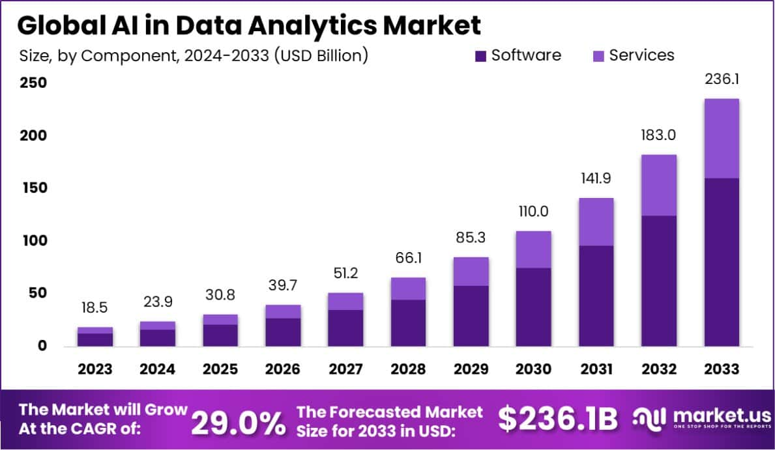
Figure 2: Findings on AI and Data Analytics Adoption
(Source: Market.us, 2025)

4.4.3 Findings on Omnichannel Retail Strategies
The results also suggest that omnichannel retailing gradually became a key part of the seizing capability in mid-sized retail companies in the UK. Retailers are increasingly bringing online and offline channels together, with click & collect, the mobile app, digital payment and combined Customer Engagement Systems. According to Timoumi, Gangwar and Mantrala (2022), omnichannel strategies enhance customer interaction by providing a seamless experience across different purchase channels, thus fostering convenience and customer loyalty.
The analysis shows that successful retailers have made a huge improvement in customer experience by embracing the concept of omnichannel integration. During and after the pandemic, consumers increasingly sought a flexible shopping experience, including online ordering, mobile payment and quick fulfilment options. Companies with click-and-collect and integrated digital payment systems experienced greater customer retention due to the decrease in purchase friction and convenience. Schrotenboer et al. (2022) also highlight that the omnichannel transformation has a positive effect on customer engagement, as it makes the channels more accessible, consistent and interactive in retail.

4.4.4 Findings on Strategic Agility
There was also a heightened sense of strategic agility as another key component of seizing capability in the analysis. Strategic agility is the ability of an organisation to quickly adapt to changes in its environment by making flexible decisions, leaders and resource allocation. Kiilu, Machuki and Aosa (2023) state that strategic agility provides a serious boost to organisational performance as companies dealing with uncertainty need to constantly adjust their business models and strategic priorities to deal with the disruption in the market.
The results show that retailers with good strategic agility responded well to the crisis by adapting their business models. When retail channels were disrupted, these companies quickly redirected investments into e-commerce channels, digital customer interaction, and supply-chain restructuring. The need for leadership responsiveness increased as companies that could make quick strategic decisions were able to adjust more effectively to market changes. Flexibility was also allowed in the deployment of investment funds, which allowed organisations to focus on technologies that had a clear operational and customer impact.
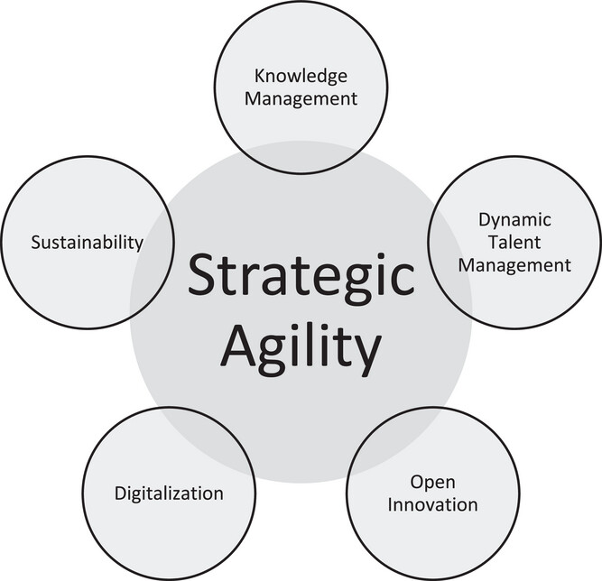
Figure 3: Findings on Strategic Agility
(Source: Christofi, Chourides and Papageorgiou, 2024)
The above-mentioned figure of strategic agility links effectively with the change in market conditions for firms as they need to maintain sustainability, manage knowledge in groups and include talent management.

4.5 Theme 3: Reconfiguring Capabilities and Organisational Adaptation

4.5.1 Understanding Reconfiguring Capability
The reconfiguration of capability can be defined as the ability of an organisation to continuously restructure internal processes, resources and operational systems to meet changing market and technological conditions. Reconfiguration of capability is a key part of Dynamic Capabilities Theory and would suggest that firms need to continually change their organisational structures and incorporate new technologies into their operating systems if they are to remain competitive in the long term. Kulichyova et al. (2025) state that in such a highly uncertain environment, digital transformation must be accompanied by the solution of the dilemma of process redesign, organisational flexibility, and coordinating the use of resources.

4.5.2 Findings on Organisational Restructuring
The study shows that restructuring of the organisation was a critical element in the successful digital transformation of mid-sized retailers in the UK. Organisations became more agile, agencies were more integrated and decision making more decentralised to increase responsiveness and operational coordination. Retailers reassessed their supply chains to accommodate faster fulfilment systems, online ordering and omnichannel supply chains. Additionally, the customer service operations were reengineered using automation, AI-driven communication channels, and customer support platforms.
More importantly, companies that successfully managed digital transformation reported higher levels of change within their internal organisation, compared to those companies that had a rigid organisation system. In the post-pandemic era, Agile structures were found to be effective in introducing technology change and meeting customers' needs quickly. On the other hand, companies with bureaucratic structures and dispersed operational systems tended to have slower innovation processes and lower transformation results. Unwanted aspects of organisational change, such as poor management of change, can hinder the coordination and collaboration among members of a team and result in operational inefficiencies during the process of organisational change, as stated by Jabir, Zahari and Daud (2025).

4.5.3 Findings on Workforce Capability Development
The results also point to the importance of workforce capability development as a key aspect of reconfiguring capability. Employees and managers needed to learn new digital skills and competencies needed to work with AI systems, data analytics platforms, e-commerce processes and data-driven decision making in order to be successful in digital transformation. Retailers that performed better on the organisational adaptation scores invested significantly more in employee reskilling programmes, digital training and leadership development. Organisational learning is a process that reinforces the innovation process and the performance of organisations by allowing the continuous renewal of capabilities and the integration of knowledge, as Pedraja-Rejas, Rodríguez-Ponce and Rojas-Miranda (2025) explain.
The analysis indicated that prosperous companies facilitated organisational cultures based on learning, which encouraged experimentation, collaboration, and digital knowledge development. Leadership adaptation was also important because the managers had to coordinate digital investment strategies while operating at the same time in a state of uncertainty and operational disruption. Bacha and Niesten (2024) propose that, in a turbulent business context, cognitive leadership skills are even more crucial, as leaders need to be able to understand complexity, facilitate learning within the organisation, and lead the strategic adaptation process effectively.
The results have shown, however, that weaker companies had big problems with their workforces when going through the digital transformation. In several mid-sized retailers, employees were less accepting of technology, which meant that the implementation process was delayed and organisational flexibility was reduced. Many companies also struggled with a lack of digital skills, especially in the areas of analytics, cybersecurity and digital systems management. Embattled by challenges of digital operational maturity, the workforce capability limitation is one of the biggest challenges highlighted by Thanvi (2026).
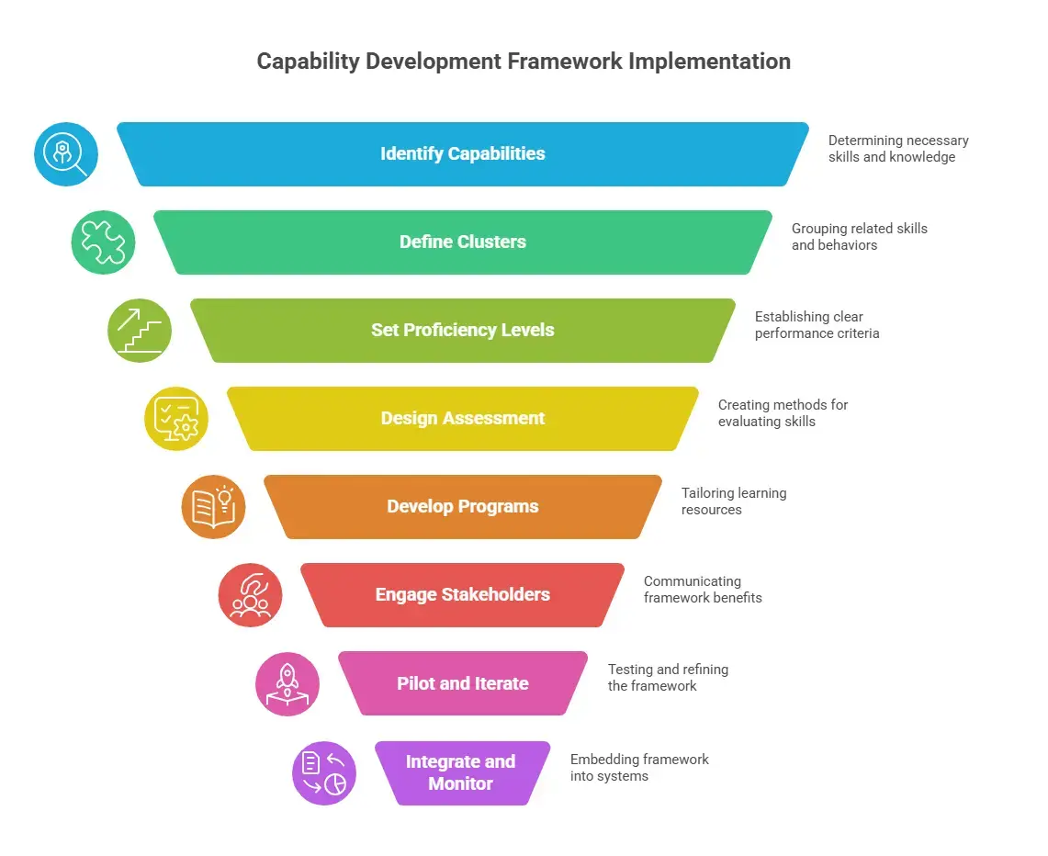
Figure 4: Findings on Workforce Capability Development
(Source: Coursebox, 2025).

4.5.4 Findings on Process Integration
It is also found from the analysis that process integration played a key role in organisational reconfiguration in digital transformation. Mid-sized retailers faced increasing pressure to connect with modern digital systems to better coordinate business operations, respond quickly to customers, and manage data. The importance of data centralisation grew particularly during this recent period, as businesses needed to have integrated information systems that could enable them to make decisions in real-time and to support the omnichannel retail model.
The results show that those companies that integrated systems, customer databases, and digital payment technologies in their supply chains were more efficient and had more uniform customer experiences. Napoleone et al. (2023) state that a digitally-integrated system enhances the reconfigurability of organisations due to its ability to enhance operational flexibility, process visibility and increase the efficiency of coordination. Retailers who had integrated systems performed better in times of consumer demand fluctuations and disruptions in the market during the COVID-19 recovery period.
However, the results also indicate that many companies in the mid-sized segment had great difficulties in the process integration area. Older digital technology was often incompatible with legacy technology, leading to technical complexity and fragmentation of operations. According to Barua (2024), the shift toward AI often brings significant organisational and operational challenges for companies, as they need to revamp their processes while also implementing large-scale data systems.

4.6 Theme 4: Digital Transformation and Competitive Advantage

4.6.1 Relationship Between Digital Transformation and Competitive Advantage
The relationship between Digital Transformation and Competitive Advantage:4.6.1
The results highlight the significant impact digital transformation had on competitive advantage in the UK retail sector from 2020 to 2025 in midsize retail companies. But the link between technology adoption and competitive performance was not linear, straightforward, and automatic. Rather, a company gained a competitive advantage when it managed to successfully embed digital technologies within the organisation's capabilities, operations and goals. Lu and Shaharudin (2024) indicate that digital transformation helps an organisation achieve sustainable competitive advantage via operational efficiency, innovation capability, customer experience and organisational responsiveness to market change.
Post-pandemic, retail transformation was a dominant theme of customer experience as a competitive differentiator. Personalised engagement, smooth omnichannel experiences and faster service delivery were increasingly in focus for digitally mature retailers as they met evolving customer expectations. Additionally, digital transformation enhanced the responsiveness of the market as companies with analytics and digital monitoring systems were able to react more quickly to changes in customer behaviour and demand. According to Stroumpoulis and Kopanaki (2022), digitally integrated organisations are typically more flexible, agile, and resilient because digital systems help to increase the visibility, coordination and responsiveness of organisations in uncertain markets.
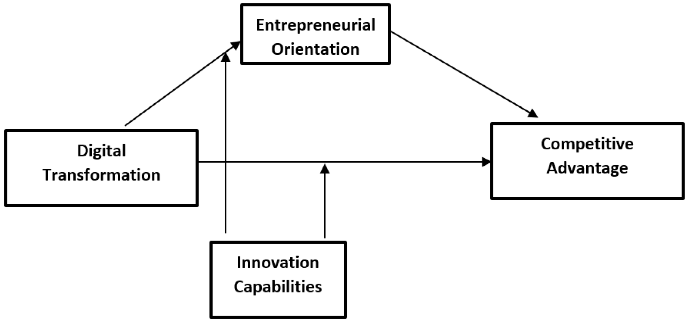
Figure 5: Relationship Between Digital Transformation and Competitive Advantage
(Source: Al-Hakimi et al., 2023)

4.6.2 Findings on Customer Experience Improvement
The results show that customer experience enhancement has now emerged as one of the greatest proof-of-competitive advantage for digitally mature retailers in the UK. These days, companies are more likely to offer individualised services, suggest customer-focused recommendations using AI technology, and incorporate CRM systems to enhance customer engagement and retention. In a study published by Nwabekee et al. (2024), it was concluded that the digital transformation has revolutionised the concept of marketing by providing the tools to integrate data analytics and CRM systems that offer the potential for personalised customer interactions and better relationship management.
The analysis shows that retailers who integrated an omnichannel system and customer analytics platform achieved better service speed, convenience and quality of interactions in several retail channels. The integration of mobile commerce apps, click-and-collect options, and AI-driven suggestion engines allowed companies to offer more personalised shopping experiences and streamline the transactional process. Mobile commerce applications, click-and-collect systems, and AI-backed recommendation engines helped businesses deliver more personalised shopping experiences and minimise transaction friction. As consumers have become more demanding for convenience, personalisation, and response in their digital purchasing journey, Tulcanaza-Prieto, Cortez-Ordoñez and Lee (2023) determined that AI-powered CES can have a positive effect on customer satisfaction.
Companies that are more digitally mature – that is, more integrated into their digital strategy – thus had higher rates of customer loyalty and satisfaction than less digitally integrated companies. Arkadan, Macdonald and Wilson (2024) state that orientation to customer experience is now a strategic concern as customer perceptions are having a growing impact on the organisations' long-term performance and market differentiation.

4.6.3 Findings on Operational Efficiency
The results also show that many UK mid-sized retailers experienced high benefits from digital transformation for improving operational efficiency. Over the years, retailers have turned to various forms of automation, inventory optimisation, and real-time analytics platforms to enhance efficiency and minimise inefficiencies. AI-driven forecasting systems accurately forecast demand, and connected digital supply-chain systems increase transparency and synchronisation of inventories.
According to Khan, Emon and Rahman (2024), Industry 4.0 technologies enhance operational efficiency by providing better visibility, automation, and real-time decision-making in the supply chain. The analysis proves that companies with automated inventory systems and predictive analytics have faster operational processes, better inventory management, and lower operational costs. Data-driven decision-making also helped organisations adapt better to the changes in consumer demand and market volatility in the aftermath of the pandemic.
The advantages of operational digitalisation were cost reduction, quicker transaction processing and better forecasting accuracy. Furthermore, Handoyo et al. (2023) clarify that the operational efficiency will enhance the competitiveness of the organisations, as the efficient use of resources will lead to better productivity and adaptability of the organisations under the unknown conditions of the market. Retailers whose operational systems were integrated in their business, thus, showed higher financial robustness and strategic responsiveness.

4.6.4 Findings on Competitive Positioning
The results highlighted that digital transformation has bolstered the competitive positioning mainly by its market adaptability, responsiveness to innovation and supporting organisational resilience in uncertain times. Companies that were more digitally mature were better equipped to respond to the fast-changing customer behaviour and disruption during the COVID-19 recovery phase. Tojiri (2023) states that today, in addition to pricing, organisational competitiveness is increasingly based on differentiation of products and services based on innovation, responsiveness and customer orientation.

4.7 Cross-Case Comparative Analysis
The comparison identified significant variations across successful and less successful UK medium-sized companies in their sensing, seizing and reconfiguring capabilities over the period 2020-25, during the process of digital transformation (Machucho and Ortiz, 2025). Those firms with more dynamic capabilities had significantly better operational performance, customer responsiveness and competitive advantage as compared to firms with lower D.C. Firms with higher D.C. did not show any significant increase in performance despite heavy investment in digital.
Successful companies showed high levels of sensing by being aware of market trends and continuously observing consumer behaviour, the digital trends, and technological innovation. They saw the potential for e-commerce and omnichannel retailing long before their rivals and acted quickly, investing in AI systems, customer analytics and digital platforms that were integrated into their business. Less successful companies, on the other hand, had less effective strategic responses and less robust environmental scanning processes, leading to a lag in adapting to evolving customer expectations both during and after the disruption caused by COVID-19. A lower level of sensing capability, therefore, lowered the responsiveness of the organisation and its competitiveness (Stadtfeld and Gruchmann, 2024).
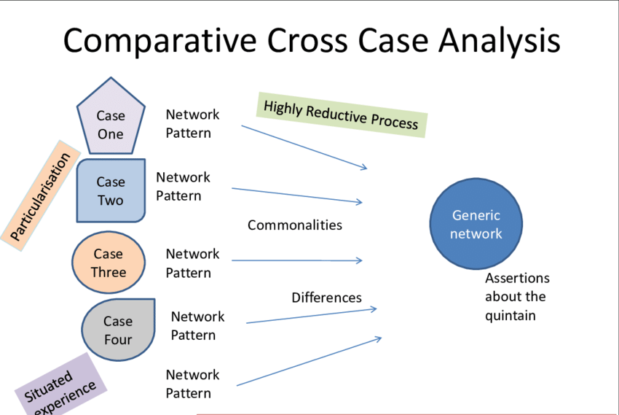
Figure 6: Cross-Case Comparative Analysis
(Source: ResearchGate, 2017)

4.8 Discussion of Findings in Relation to Literature
The results are robust support for the Dynamic Capabilities Theory proposed by Teece, with the three capabilities—sensing, seizing, and reconfiguring—as significant factors to the success of digital transformation within the UK mid-sized retail sector from the years 2020 to 2025. The study validates current digital transformation research that revealed that companies that successfully identified new market opportunities, made strategic investments in technology, and reorganised their internal processes gained greater operational efficiency and competitive advantage for customer engagement (Favoretto et al., 2022). The study also aligns with research on organisational agility, as those organisations that were structured more like an agile team and had more flexible decision-making processes were more successful at adjusting to market disruption and shifting consumer expectations post-pandemic.
We also find, however, that there are paradoxes in existing DTC literature, which suggest that technology investments will automatically lead to better performance. While organisations invested in AI systems, omnichannel platforms and analytics technologies, many businesses did not get the returns they expected due to weak organisational capabilities and strategic alignment. This means that the transformation outcomes were significantly affected by the capability maturity. Firms with greater leadership, organisational learning and flexibility with their operations were more likely to realise a competitive advantage from digital investments when compared to firms with fragmented transformation strategies.

4.9 Chapter Summary
This chapter critically examined the linkages between the concepts of dynamic capabilities, digital transformation, and competitive advantage for UK medium-sized retail companies in the period 2020-2025. The results confirmed that the importance of dynamic capabilities was high to achieve success in organisational change in a context of technological innovation, fast e-commerce evolution, and evolving customer expectations. The analysis also showed that competitive advantage was more related to the adaptability of the organisations and their capability development when compared to technology acquisition.
The chapter concluded that sense-making capability helped companies spot new digital opportunities, track shifts in consumer behaviour, and take proactive measures in the face of technological disruption. The firms that performed better on the sensing processes were quicker to introduce customer analytics, AI systems and omnichannel approaches compared to less adaptive firms.

CHAPTER 5: CONCLUSION AND RECOMMENDATIONS

5.1 Introduction
The chapter is the conclusion of the dissertation, summarising the key findings and critically examining the linkage between the concept of dynamic capabilities and the concepts of digital transformation and competitive advantage in UK mid-size retail organisations from 2020 to 2025. The chapter also ties the results back to the research aims and research questions that were set in previous chapters and the theoretical and practical implications of the research.

5.2 Summary of Research Findings

5.2.1 Summary of Sensing Capability Findings
The results indicated that sensing capability was one of the most significant dynamic capabilities that affect the success of digital transformation among UK mid-sized retailers. Organisations with better sensing skills were able to spot digital opportunities earlier, better recognise shifts in consumer behaviour and were better able to rapidly adapt to the growth in e-commerce and digitally enabled retailing. The research revealed the COVID-19 pandemic drove change in customer buying habits, with online shopping sales accounting for more than one-third of all retail sales in the UK in 2021. Companies that identified these market shifts early and invested in digital customer engagement platforms, AI-powered analytics and omnichannel retail strategies have fared better (Rainy, 2025).

5.2.2 Summary of Seizing Capability Findings
The study revealed that the seizing capability had a significant impact on achieving measurable organisational outcomes from opportunities identified (Finnerty et al., 2026). Likely, the retailers who made the most out of AI technology were those that invested in AI systems, predictive analytics, omnichannel retail infrastructure, mobile commerce, and digital payment technologies, which helped them enhance operational efficiency and customer engagement.

5.2.3 Summary of Reconfiguring Capability Findings
The results also showed that reconfiguration of capability was vital to continue to remain competitive in the digital transformation journey (Mele et al., 2024). Successful retailers continually restructured organisational processes, connected legacy systems to digital technologies and built the competencies of their staff to help them adapt their operations.

5.2.4 Overall Research Conclusion
The findings of the study indicated that digital transformation positively and significantly influenced the competitive advantage of UK mid-sized retail businesses through its relationship with the dynamic capabilities (Shehadeh, 2025). The results showed that, although technological investment is necessary, the effectiveness of the transformation is significantly affected by the maturity of organisational capabilities, so that technological investment is not enough to achieve sustainable competitive advantage.

5.3 Achievement of Research Aim and Objectives
The primary purpose of this research was to evaluate the effectiveness of the digital transformation strategies in achieving competitive advantage by employing dynamic capabilities in mid-sized companies in the retail industries in the UK from 2020 to 2025. The results demonstrate that this was accomplished by using a thematic analysis approach to secondary qualitative evidence garnered from academic literature, consultancy reports, organisational publications and industry data. This study challenged the idea of the capacity of sensing, seizing, and reconfiguring in determining the outcomes of digital transformation and organisational competitiveness amidst technological and market disruptions (Chavarnakul et al., 2025).

5.4 Theoretical Implications
Theoretically, this study is significant in demonstrating the ongoing applicability of Teece's DCT in digitally disrupted retail contexts (McKee et al., 2023). The results showed that the capabilities of sensing, seizing and reconfiguring have a significant impact on the effectiveness of digital transformation in UK mid-sized retail companies between 2020 and 2025.

5.5 Practical Implications and Recommendations

5.5.1 Recommendations for Retail Managers
The results indicate a number of key recommendations for retail management focused on achieving greater digital transformation effectiveness and enduring competitiveness (Sagar, 2024). First, investing in customer analytics systems, market intelligence tools, and AI-powered forecasting technologies should enhance an organisation's sensing capability. It also showed that businesses that identify consumer shifts earlier are more successful at being responsive to customers and adapting to operations in times of market uncertainty.

5.5.2 Recommendations for Policymakers
The results also offer some policy implications for those who want to ensure the digital competitiveness of UK medium-sized retailers (Bargoni et al., 2024). Support schemes for financial investment in AI systems, analytics, technological innovation, and digital infrastructure for medium-sized retailers should be expanded. While many companies were aware of the need to transform, they were constrained by financial means that hindered their ability to do so.

5.6 Research Limitations
The results also offer some policy implications for those who want to ensure the digital competitiveness of UK medium-sized retailers (Bargoni et al., 2024). Support schemes for financial investment in AI systems, analytics, technological innovation, and digital infrastructure for medium-sized retailers should be expanded. While many companies were aware of the need to transform, they were constrained by financial means that hindered their ability to do so.

5.7 Recommendations for Future Research
The study should be expanded in the future by conducting original qualitative research methods like interviews of retail managers, employees and digital transformation specialists (Henderikx and Stoffers, 2022). Organisational evidence would give a better understanding of the behaviour of leaders, the learning processes inside the organisation, and the way in which organisational capability is developed in the context of digital transformation.

5.8 Final Conclusion
The study finds that within the context of mid-sized retail firms in the UK, digital transformation does not provide a sustainable competitive advantage on its own. Rather, the effectiveness of the transformation hinged on the capability building of the organisations, the alignment of transformation with strategic goals, and continuous changes in operations from 2020 to 2025. The results showed that the ability to sense the market, seize and reconfigure was key to increasing the adaptability, responsiveness to customers, operational resilience and competitiveness of the organisation in the longer term.

References
15 Writers (2024) Research Onion: A systematic approach to designing methodology. Available at: https://15writers.com/research-onion/ (Accessed: 17 April 2026).
Ahmad, S.A. and Teo, P.C., 2024. The implementation of enterprise risk management (ERM) frameworks in small and medium enterprises (SMES): A literature review. International Journal of Academic Research in Business and Social Sciences, 14(9), pp.290-307.https://kwpublications.com/papers_submitted/11397/the-implementation-of-enterprise-risk-management-erm-frameworks-in-small-and-medium-enterprises-smes-a-literature-review.pdf
Ahmed, S.K., 2024. How to choose a sampling technique and determine sample size for research: A simplified guide for researchers. Oral Oncology Reports, 12, p.100662. https://www.sciencedirect.com/science/article/pii/S2772906024005089
Al-Dmour, R., Al-Dmour, H., Basheer Amin, E. and Al-Dmour, A., 2025. Impact of AI and big data analytics on healthcare outcomes: an empirical study in Jordanian healthcare institutions. Digital Health, 11, p.20552076241311051. https://journals.sagepub.com/doi/pdf/10.1177/20552076241311051
Alrub, Y.A. and Sánchez-Cañizares, S.M. (2025) Dynamic capabilities and digital transformation: Toward strategic planning in the digital age—Evidence from Palestine. Administrative Sciences, 15(1), p.21. Available at: https://www.mdpi.com/2076-3387/15/1/21
Alshahrani, A., 2025. Adopting emerging technologies in digital government: a multi-case analysis of drivers, enablers, and challenges in Saudi Arabia. Digital Government: Research and Practice, 6(3), pp.1-26. https://dl.acm.org/doi/pdf/10.1145/3719297
Alsharif, A.H., Salleh, N.Z.M., Al-Zahrani, S.A. and Khraiwish, A., 2022. Consumer behaviour to be considered in advertising: A systematic analysis and future agenda. Behavioral Sciences, 12(12), p.472. https://www.mdpi.com/2076-328X/12/12/472
Arkadan, F., Macdonald, E.K. and Wilson, H.N., 2024. Customer experience orientation: Conceptual model, propositions, and research directions. Journal of the Academy of Marketing Science, 52(6), pp.1560-1584. https://link.springer.com/content/pdf/10.1007/s11747-024-01031-y.pdf
Bacha, E. and Niesten, E., 2024. Cognitive capabilities of moral leaders in turbulent environments: a review, theory integration and way forward. Journal of Managerial Psychology, 39(8), pp.1046-1062. https://www.emerald.com/jmp/article-pdf/39/8/1046/9492218/jmp-07-2023-0393.pdf
Bargoni, A., Ferraris, A., Vilamová, Š. and Wan Hussain, W.M.H., 2024. Digitalisation and internationalisation in SMEs: a systematic review and research agenda. Journal of Enterprise Information Management, 37(5), pp.1418-1457. https://www.emerald.com/jeim/article-pdf/37/5/1418/9604561/jeim-12-2022-0473.pdf
Barua, T., 2024. Economic transformation of data analytics through AI: Emerging opportunities and challenges in the workforce. Academic Journal On Science, Technology, Engineering & Mathematics Education, 4(3), pp.10-69593. https://www.researchgate.net/profile/Yogesh-Thanvi/publication/400872908_A_Longitudinal_Review_on_the_State_of_Cybersecurity_2022-2025_Workforce_Governance_Risk_and_Operational_Maturity_and_findings_from_ISACA_Global_Surveys/links/69973b245d60ab48356f02e1/A-Longitudinal-Review-on-the-State-of-Cybersecurity-2022-2025-Workforce-Governance-Risk-and-Operational-Maturity-and-findings-from-ISACA-Global-Surveys.pdf
Braun, V. and Clarke, V., 2024. Supporting best practice in reflexive thematic analysis reporting in Palliative Medicine: A review of published research and introduction to the Reflexive Thematic Analysis Reporting Guidelines (RTARG). Palliative medicine, 38(6), pp.608-616. https://journals.sagepub.com/doi/pdf/10.1177/02692163241234800
Cai, L., Yuen, K.F., Fang, M. and Wang, X., 2023. A literature review on the impact of the COVID-19 pandemic on consumer behaviour: implications for consumer-centric logistics. Asia Pacific Journal of Marketing and Logistics, 35(11), pp.2682-2703.https://www.emerald.com/apjml/article-pdf/35/11/2682/368733/apjml-08-2022-0731.pdf
Chavarnakul, T., Xu, L.D., Bi, Z., Shankar, A., Dhiman, G., Viriyasitavat, W. and Hoonsopon, D., 2025. A Systematic Literature Review on Resilient Digital Transformation, Examining How Organizations Sustain Digital Capabilities. HighTech and Innovation Journal, 6(2).https://digitalcommons.odu.edu/cgi/viewcontent.cgi?article=1119&context=itds_facpubs

Chen, Y., Liu, L., Li, W., Xie, Z. and Wei, C., 2023. Microfoundations of dynamic capabilities: a systematic review and a multilevel framework. Management Decision, 61(6), pp.1717-1753.https://www.emerald.com/md/article-pdf/61/6/1717/1914673/md-05-2022-0615.pdf
Chowdhury, A.R., Limon, G.Q. and Arifur Rahman, M., 2024. Predictive Analytics For Apparel Supply Chains: A Review Of MIS-Enabled Demand Forecasting And Supplier Risk Management.https://papers.ssrn.com/sol3/Delivery.cfm?abstractid=5227219
Cui, J., 2025. Exploring the impact of digital leadership and green digital innovation on corporate digital transformation. Journal of Current Social Issues Studies, 2(4), pp.215-220.https://atripress.org/index.php/JCSIS/article/download/229/172
Deloitte (2023) Digital transformation trends 2023: Leading in a digital-first world. Available at: https://www2.deloitte.com
Digital Adoption (2024) Digital transformation in the retail industry: Benefits, challenges and trends. Available at: https://www.digital-adoption.com/digital-transformation-in-the-retail-industry/
Eisenhardt, K.M. and Martin, J.A. (2000) ‘Dynamic capabilities: What are they?’, Strategic Management Journal, 21(10–11), pp. 1105–1121. Available at: https://doi.org/10.1002/1097-0266(200010/11)21:10/11
Elsa, D., Indrawati, H. and Caska, C., 2025. Digital transformation in SMEs: global maps and trends of research. Strategy & Leadership, 53(2), pp.132-159.https://www.emerald.com/sl/article-pdf/53/2/132/9706609/sl-09-2024-0104.pdf
Entekhabi, M., 2025. Towards the Sustainable Organization: Challenges and Barriers to Sustainability Integration. The Bucharest University of Economic Studies Publishing House, p.77.http://www.etimm.ase.ro/journal/JETIMM_V01_I2_2025.pdf#page=77
Favoretto, C., Mendes, G.H.D.S., Filho, M.G., Gouvea de Oliveira, M. and Ganga, G.M.D., 2022. Digital transformation of business model in manufacturing companies: challenges and research agenda. Journal of Business & Industrial Marketing, 37(4), pp.748-767. https://www.emerald.com/jbim/article-pdf/37/4/748/2457693/jbim-10-2020-0477.pdf
Filser, M., Tiberius, V., Kraus, S., Zeitlhofer, T., Kailer, N. and Müller, A., 2023. Opportunity recognition: Conversational foundations and pathways ahead. Entrepreneurship Research Journal, 13(1), pp.1-30. https://www.degruyterbrill.com/document/doi/10.1515/erj-2020-0124/html
Finnerty, O., Heaslip, G., Stephens, S., Lyons, R. and Onofrei, G., 2026. Entrepreneurial orientation and supply chain sustainability: A Systematic literature review. Business Strategy and the Environment. https://onlinelibrary.wiley.com/doi/pdf/10.1002/bse.70794
Gong, C. and Ribiere, V., 2025. Understanding the role of organizational agility in the context of digital transformation: an integrative literature review. VINE Journal of Information and Knowledge Management Systems, 55(2), pp.351-378.https://www.emerald.com/vjikms/article-pdf/55/2/351/9682999/vjikms-09-2022-0312.pdf
Handoyo, S., Suharman, H., Ghani, E.K. and Soedarsono, S., 2023. A business strategy, operational efficiency, ownership structure, and manufacturing performance: The moderating role of market uncertainty and competition intensity and its implication on open innovation. Journal of Open Innovation: Technology, Market, and Complexity, 9(2), p.100039. https://www.sciencedirect.com/science/article/pii/S2199853123001415
Helfat, C.E., Finkelstein, S., Mitchell, W., Peteraf, M.A., Singh, H., Teece, D.J. and Winter, S.G. (2007) Dynamic capabilities: Understanding strategic change in organizations. Oxford: Blackwell Publishing. Available at: https://global.oup.com/academic/product/dynamic-capabilities-9781405159043
Henderikx, M. and Stoffers, J., 2022. An exploratory literature study into digital transformation and leadership: Toward future-proof middle managers. Sustainability, 14(2), p.687. https://www.mdpi.com/2071-1050/14/2/687
Hokmabadi, H., Rezvani, S.M. and De Matos, C.A., 2024. Business resilience for small and medium enterprises and startups by digital transformation and the role of marketing capabilities—A systematic review. Systems, 12(6), p.220. https://www.mdpi.com/2079-8954/12/6/220
Ikegwu, A.C., Nweke, H.F., Anikwe, C.V., Alo, U.R. and Okonkwo, O.R., 2022. Big data analytics for data-driven industry: a review of data sources, tools, challenges, solutions, and research directions. Cluster Computing, 25(5), pp.3343-3387. https://www.academia.edu/download/115565302/Ikegwu_et_al_2022_Big_data_analytics_for_data_driven_industry_a_review_of.pdf
Imam, M.A., Ahmad, S., Bhatti, M.A.A. and Afzal, M., 2023. Contextualizing research approaches: The role of Western and Islamic philosophies in shaping methodology and knowledge creation. Al-Irfan, 8(16), pp.69-90. https://ojs.mul.edu.pk/index.php/alirfan/article/download/398/253
Jabir, F., Zahari, M.I. and Daud, F., 2025. The Impact of Organisational Changes on Teamwork in Healthcare: A Systematic Review. Malaysian Journal of Medical Sciences, 32(4). https://pmc.ncbi.nlm.nih.gov/articles/PMC13132121/
Jiang, W., Ye, W., Tan, X. and Bao, Y.J., 2025. Network-based multi-omics integrative analysis methods in drug discovery: a systematic review. BioData Mining, 18(1), p.27.https://link.springer.com/content/pdf/10.1186/s13040-025-00442-z.pdf
Kero, C.A. and Bogale, A.T., 2023. A Systematic Review of Resource-Based View and Dynamic Capabilities of Firms and Future Research Avenues. International Journal of Sustainable Development & Planning, 18(10).https://www.academia.edu/download/118338664/110933.pdf
Khan, S., Tomar, S., Fatima, M. and Khan, M.Z., 2022. Impact of artificial intelligent and industry 4.0 based products on consumer behaviour characteristics: A meta-analysis-based review. Sustainable Operations and Computers, 3, pp.218-225. https://www.sciencedirect.com/science/article/pii/S2666412722000095
Khan, T., Emon, M.M.H. and Rahman, M.A., 2024. A systematic review on exploring the influence of Industry 4.0 technologies to enhance supply chain visibility and operational efficiency. Review of Business and Economics Studies, 12(3), pp.6-27. https://cyberleninka.ru/article/n/a-systematic-review-on-exploring-the-influence-of-industry-4-0-technologies-to-enhance-supply-chain-visibility-and-operational
Kiilu, P.M., Machuki, V. and Aosa, E., 2023. Strategic agility and organizational performance: A critical review of literature. DBA Africa Management Review, 13(1), pp.20-44. https://uonjournals.uonbi.ac.ke/index.php/DBAAMR/article/download/1710/1407
Kikasu, E.T., Doba, Y.G., Pillay, S.S. and Kankisingi, G.M., 2025. Higher Education and Its Contribution to Economies of African Countries: Move towards Competence-Based and Skills Demand-Driven Standards in Collaboration with Industry. Journal of Education and Learning, 14(3), pp.21-50. https://files.eric.ed.gov/fulltext/EJ1473972.pdf
Kulichyova, A., Kazantsev, N., White, L. and Islam, N., 2025. Digital transformation in large established organisations: Four restructuring dilemmas based on dynamic capabilities. International Journal of Management Reviews, 27(3), pp.420-450. https://onlinelibrary.wiley.com/doi/pdf/10.1111/ijmr.12395
Leavy, A., Kazak, S., Podworny, S. and Frischemeier, D., 2026. Designing Data Science Learning in Initial Teacher Education: The EDUCATE Conceptual Framework. Education Sciences, 16(2), p.307. https://www.mdpi.com/2227-7102/16/2/307
Lim, W.M., 2025. What is qualitative research? An overview and guidelines. Australasian marketing journal, 33(2), pp.199-229. https://journals.sagepub.com/doi/pdf/10.1177/14413582241264619
Lu, H. and Shaharudin, M.S., 2024. Role of digital transformation for sustainable competitive advantage of SMEs: a systematic literature review. Cogent Business & Management, 11(1), p.2419489.https://www.tandfonline.com/doi/pdf/10.1080/23311975.2024.2419489
Lukito, D., Suharnomo, S. and Perdhana, M.S., 2022. Transformation management capabilities for digital transformation initiatives: a construct conceptualization in alignment with the dynamic capabilities framework. Journal of Organizational Management Studies, 1, pp.1-22. https://www.researchgate.net/profile/Daniel-Lukito/publication/367739196_Transformation_Management_Capabilities_for_Digital_Transformation_Initiatives_A_Construct_Conceptualization_in_Alignment_with_the_Dynamic_Capabilities_Framework/links/687cdb83b3294610e9b8a6a5/Transformation-Management-Capabilities-for-Digital-Transformation-Initiatives-A-Construct-Conceptualization-in-Alignment-with-the-Dynamic-Capabilities-Framework.pdf
Machucho, R. and Ortiz, D., 2025. The impacts of artificial intelligence on business innovation: A comprehensive review of applications, organizational challenges, and ethical considerations. Systems, 13(4), p.264. https://www.mdpi.com/2079-8954/13/4/264
Mardosaite, V., Jasinskas, E. and Romeika, G., 2024. The transformation of digital innovative services in retail trade due to the COVID-19 pandemic: A systematic review. Amfiteatru economic, 26(67), pp.885-902.https://www.econstor.eu/bitstream/10419/306189/1/1906643172.pdf
McKee, S., Sands, S., Pallant, J.I. and Cohen, J., 2023. The evolving direct‐to‐consumer retail model: A review and research agenda. International Journal of Consumer Studies, 47(6), pp.2816-2842. https://onlinelibrary.wiley.com/doi/pdfdirect/10.1111/ijcs.12972
McKinsey & Company (2023) The state of organizations 2023: Ten shifts transforming organizations. Available at: https://www.mckinsey.com/capabilities/people-and-organizational-performance/our-insights/the-state-of-organizations-2023
Mele, G., Capaldo, G., Secundo, G. and Corvello, V., 2024. Revisiting the idea of knowledge-based dynamic capabilities for digital transformation. Journal of Knowledge Management, 28(2), pp.532-563.https://www.emerald.com/jkm/article-pdf/28/2/532/9615577/jkm-02-2023-0121.pdf
Mueller‐Saegebrecht, S. and Walter, A.T., 2025. Strategic agility—an urgent capability for successful business model innovation? A conceptual process model and theoretical framework. Strategic Change, 34(3), pp.407-428.https://onlinelibrary.wiley.com/doi/pdf/10.1002/jsc.2645
Mustofa, M., 2023. Epistemological paradigms in positivism, interpretivism, and action research in educational research: A literature review. Journal of Office Administration: Education and Practice, 3(3), pp.214-224. https://ejournal.unesa.ac.id/index.php/joa/article/download/58634/45715
Napoleone, A., Negri, E., Macchi, M. and Pozzetti, A., 2023. How the technologies underlying cyber-physical systems support the reconfigurability capability in manufacturing: a literature review. International Journal of Production Research, 61(9), pp.3122-3144. https://re.public.polimi.it/bitstream/11311/1215730/4/How%20the%20technologies%20underlying%20cyber-physical%20support%20the%20reconfigurability%20capability%20-%20Postprints.pdf
Nii Laryeafio, M. and Ogbewe, O.C., 2023. Ethical consideration dilemma: systematic review of ethics in qualitative data collection through interviews. Journal of Ethics in Entrepreneurship and Technology, 3(2), pp.94-110. https://www.emerald.com/jeet/article-pdf/3/2/94/1330691/jeet-09-2022-0014.pdf
Nwabekee, U.S., Abdul-Azeez, O.Y., Agu, E.E. and Ijomah, T.I., 2024. Digital transformation in marketing strategies: The role of data analytics and CRM tools. International Journal of Frontline Research in Science and Technology, 3(2), pp.055-072. https://www.researchgate.net/profile/Tochukwu-Ijomah-2/publication/383847607_Digital_transformation_in_marketing_strategies_The_role_of_data_analytics_and_CRM_tools/links/66dc42e464f7bf7b199c79c5/Digital-transformation-in-marketing-strategies-The-role-of-data-analytics-and-CRM-tools.pdf
Parveen, S. (2024) Understanding the dynamic capabilities of an organization. Available at: https://www.linkedin.com/pulse/understanding-dynamic-capabilities-organization-dr-shadma-parveen
Pedraja-Rejas, L., Rodríguez-Ponce, E. and Rojas-Miranda, P., 2025. The impact of organisational learning on innovation and institutional performance in universities: a narrative review. Systems, 13(9), p.743. https://www.mdpi.com/2079-8954/13/9/743
Pitelis, C.N., Teece, D.J. and Yang, H., 2024. Dynamic capabilities and MNE global strategy: A systematic literature review‐based novel conceptual framework. Journal of management studies, 61(7), pp.3295-3326. https://onlinelibrary.wiley.com/doi/pdfdirect/10.1111/joms.13021
Porter, M.E. (1985) Competitive advantage: Creating and sustaining superior performance. New York: Free Press. Available at: View book details
Rainy, T.A., 2025. AI-driven marketing analytics for retail strategy: a systematic review of data-backed campaign optimization. International Journal of Scientific Interdisciplinary Research, 6(1), pp.28-59. http://ijsir.org/index.php/IJSIR/article/download/4/4
Ramdani, F., 2025. An extensive review of SAR remote sensing in mode transportation studies: Major findings and future recommendations. F1000Research, 14, p.322. https://f1000research.com/articles/14-322/pdf
Reis, J. and Melão, N., 2023. Digital transformation: A meta-review and guidelines for future research. Heliyon, 9(1).https://www.cell.com/heliyon/pdf/S2405-8440(23)00041-5.pdf
Rizana, A.F., Wiratmadja, I.I. and Akbar, M., 2025. Exploring capabilities for digital transformation in the business context: Insight from a systematic literature review. Sustainability, 17(9), p.4222. https://www.mdpi.com/2071-1050/17/9/4222
Romeo, E. and Lacko, J., 2026. Adoption and integration of AI in organizations: a systematic review of challenges and drivers towards future directions of research. Kybernetes, 55(3), pp.1286-1307. https://www.emerald.com/k/article-pdf/55/3/1286/11251539/k-07-2024-2002en.pdf
Sætra, H.S. (2022) AI in context and the sustainable development goals: Factoring in the unsustainability of the sociotechnical system. Social Studies of Science. Available at: https://journals.sagepub.com/doi/10.1177/03063070221126275
Sagar, S., 2024. The impact of digital transformation on retail management and consumer behavior. Journal of Business and Management, 26(1), pp.06-14. https://www.academia.edu/download/110983275/B2601010614.pdf
Schlunegger, M.C., Zumstein-Shaha, M. and Palm, R., 2024. Methodologic and data-analysis triangulation in case studies: A scoping review. Western Journal of Nursing Research, 46(8), pp.611-622. https://journals.sagepub.com/doi/pdf/10.1177/01939459241263011
Schrotenboer, D., Constantinides, E., Herrando, C. and de Vries, S., 2022. The effects of omni-channel retailing on promotional strategy. Journal of theoretical and applied electronic commerce research, 17(2), pp.360-374. https://www.emerald.com/ijrdm/article-pdf/51/7/894/1040763/ijrdm-05-2022-0166.pdf
Sechele, G., Rabedzwa, G., Nongayo, S. and Thango, B., 2024. Systematic review on SEO and digital marketing strategies for enhancing retail SMEs' performance.https://www.preprints.org/frontend/manuscript/8d8f48c6aa3c0eb44714157e08c45c3d/download_pub
Selivanovskikh, L., Giardino, P.L., Cristofaro, M., Bao, Y., Yuan, W. and Wang, L., 2025. Strategic ambiguity: a systematic review, a typology and a dynamic capability view. Management Decision, 63(13), pp.123-145. https://www.emerald.com/md/article-pdf/63/13/123/10048350/md-05-2024-1021en.pdf
Shaheen, N., Shaheen, A., Ramadan, A., Hefnawy, M.T., Ramadan, A., Ibrahim, I.A., Hassanein, M.E., Ashour, M.E. and Flouty, O., 2023. Appraising systematic reviews: a comprehensive guide to ensuring validity and reliability. Frontiers in research metrics and analytics, 8, p.1268045. https://www.frontiersin.org/journals/research-metrics-and-analytics/articles/10.3389/frma.2023.1268045/pdf
Shehadeh, M., 2025. Disclosures on digital transformation strategy and financial technology in Jordanian banks: innovations, challenges and opportunities. Journal of Financial Reporting and Accounting. https://www.researchgate.net/profile/Maha-Shehadeh-2/publication/391983003_Disclosures_on_digital_transformation_strategy_and_financial_technology_in_Jordanian_banks_innovations_challenges_and_opportunities/links/69235990e889e65e7968c0dc/Disclosures-on-digital-transformation-strategy-and-financial-technology-in-Jordanian-banks-innovations-challenges-and-opportunities.pdf
Silveira, L.G.D.P. and De Paula, E.V., 2026. Dynamic capabilities erosion: a systematic review, integrative framework, and research agenda. Future Business Journal, 12(1), p.100. https://link.springer.com/content/pdf/10.1186/s43093-026-00800-1.pdf
Singun, A.J., 2025. Unveiling the barriers to digital transformation in higher education institutions: a systematic literature review. Discover Education, 4(1), p.37.https://link.springer.com/content/pdf/10.1007/s44217-025-00430-9.pdf
Stadtfeld, G.M. and Gruchmann, T., 2024. Dynamic capabilities for supply chain resilience: a meta-review. The International Journal of Logistics Management, 35(2), pp.623-648. https://www.emerald.com/ijlm/article-pdf/35/2/623/9467889/ijlm-09-2022-0373.pdf
Stroumpoulis, A. and Kopanaki, E., 2022. Theoretical perspectives on sustainable supply chain management and digital transformation: A literature review and a conceptual framework. Sustainability, 14(8), p.4862. https://www.mdpi.com/2071-1050/14/8/4862
Teece, D.J. (2025) Dynamic capabilities: Foundational concepts. Cambridge: Cambridge University Press (Elements in Business Strategy). Available at: https://www.cambridge.org/core/elements/dynamic-capabilities/90101DC1EA1A6AFF9228C3FA4CD31930
Thanvi, Y.S., 2026. A Longitudinal Review on the State of Cybersecurity 2022-2025: Workforce, Governance, Risk, and Operational Maturity, and findings from ISACA Global Surveys. American Journal of Technology, 5(2), pp.39-51. https://www.researchgate.net/profile/Yogesh-Thanvi/publication/400872908_A_Longitudinal_Review_on_the_State_of_Cybersecurity_2022-2025_Workforce_Governance_Risk_and_Operational_Maturity_and_findings_from_ISACA_Global_Surveys/links/69973b245d60ab48356f02e1/A-Longitudinal-Review-on-the-State-of-Cybersecurity-2022-2025-Workforce-Governance-Risk-and-Operational-Maturity-and-findings-from-ISACA-Global-Surveys.pdf
Timoumi, A., Gangwar, M. and Mantrala, M.K., 2022. Cross-channel effects of omnichannel retail marketing strategies: A review of extant data-driven research. Journal of Retailing, 98(1), pp.133-151. https://magisterenmarketing.cl/wp-content/uploads/2026/01/Cross-channel-effects-of-omnichannel-retail-marketing-strategies.pdf
Tojiri, Y., 2023. Product differentiation strategy for organizational financial profitability: Enchancing market share and profitability-A comprehensive literature review. Atestasi: Jurnal Ilmiah Akuntansi, 6(2), pp.856-876. https://jurnal.feb-umi.id/index.php/ATESTASI/article/download/821/638
Tuan, K.M., Trang, K.H. and Quan, N.H., 2022. Comprehensive review of the sources of competitive advantages. Hue University Journal of Science: Economics and Development, 131(5B), pp.43-62. https://jos.hueuni.edu.vn/index.php/hujos-ed/article/download/6828/1555
Tulcanaza-Prieto, A.B., Cortez-Ordoñez, A. and Lee, C.W., 2023. Influence of customer perception factors on AI-enabled customer experience in the Ecuadorian banking environment. Sustainability, 15(16), p.12441. https://www.mdpi.com/2071-1050/15/16/12441
Umezurike, S.A., Akinrinoye, O.V., Kufile, O.T., Onifade, A.Y., Otokiti, B.O. and Ejike, O.G., 2025. A review of agile marketing in cross-functional teams: Driving product growth through collaboration. Journal of Frontiers in Multidisciplinary Research, 6(2), pp.23-40. https://www.researchgate.net/profile/Omolola-Kufile/publication/393294088_A_Review_of_Agile_Marketing_in_Cross-Functional_Teams_Driving_Product_Growth_through_Collaboration/links/687c3d5fba8eac4f1727ad77/A-Review-of-Agile-Marketing-in-Cross-Functional-Teams-Driving-Product-Growth-through-Collaboration.pdf
Waehrens, B.V., Berger, U., Dueholm, B.C., Lassen, A.H. and Madsen, O., 2026. Operationalizing the Industrial Metaverse: Strategies, Challenges, and Opportunities for the Sustainable Factory of the Future. Sustainability, 18(6), p.2941. https://www.mdpi.com/2071-1050/18/6/2941
Wang, L., Zuo, B., Le, Y., Chen, Y. and Li, J., 2023. Penetrating remote sensing: Next-generation remote sensing for transparent earth. The Innovation, 4(6). https://www.cell.com/the-innovation/pdf/S2666-6758(23)00147-9.pdf
Wang, W. and Liu, C. (2023) Dynamic capability theory based study on performance of intelligent manufacturing enterprise under RFID influence. Electronics, 12(6), p.1374. Available at: https://www.mdpi.com/2079-9292/12/6/1374
Wan Mohamad, W.M. and Rakiman, U.S., 2024. Integrative review of IoT implementation in agri-food supply chain: findings and analysis. In International Conference in Business Management & Innovation (ICBiv) 2023 (pp. 11-17). https://ir.uitm.edu.my/id/eprint/132723/1/132723.pdf
Warner, K.S.R. and Wäger, M. (2019) Building dynamic capabilities for digital transformation: An ongoing process of strategic renewal. Available at: https://www.researchgate.net/figure/Building-Dynamic-Capabilities-for-Digital-Transformation-Process-A-process-model-24_fig2_367792679
Wojtaszek, H., Miciuła, I., Kowalczyk, A. and Stefaniuk, R., 2025. Documenting the Transition: Sustainable Strategic Management and Leadership in European SMEs—A Comparative Analysis of Policy and Industry Reports. Sustainability, 17(21), p.9726. https://www.researchgate.net/profile/Ireneusz-Miciula/publication/397138333.pdf
Yao, Q., 2024. Concepts and reasoning: A conceptual review and analysis of logical issues in empirical Social Science Research. Integrative Psychological and Behavioral Science, 58(2), pp.502-530. https://www.researchgate.net/profile/Q-J-Yao/publication/372570671_Concepts_Reasoningpdf/data/64bec7ef8de7ed28bac00b9d/Concepts-Reasoning.pdf
You, J., 2023. An overview of organizational resilience in research and strategy: implications for the future of work. Insights.https://eprints.whiterose.ac.uk/199852/1/77387_an_overview_of_organizational_resilience_in_research_and_strategy_implications_for_the_future_of_work.pdf
Yu, T., Wang, C., Bian, Q. and Teoh, A.P., 2024. Acceptance of or resistance to facial recognition payment: A systematic review. Journal of Consumer Behaviour, 23(6), pp.2933-2951. https://www.researchgate.net/profile/Chengliang-Wang-5/publication/382799640_Acceptance_of_or_resistance_to_facial_recognition_payment_A_systematic_review/links/66ac83a351aa0775f263d1a6/Acceptance-of-or-resistance-to-facial-recognition-payment-A-systematic-review.pdf
Zeidanloo, H.R. and Špaček, M., 2025. Assessing disruptive potential in the IT sector: a framework for evaluating company-to-company impact. Journal of Innovation and Entrepreneurship, 14(1), p.82. https://link.springer.com/content/pdf/10.1186/s13731-025-00541-5.pdf
Zelenyte, D., 2025. Organizational performance through dynamic capabilities in digital business transformation: A Systematic Literature Review.https://www.theseus.fi/bitstream/handle/10024/882052/Zelenyte_Dominyka.pdf?sequence=2

Appendices

Appendix A: Search Strategy and Inclusion Criteria
Databases and Secondary Sources
Secondary data for the dissertation was collected from academic and professional sources including: Google Scholar, ProQuest, ResearchGate, Deloitte Insights, McKinsey Digital, PwC, KPMG, ONS publications, and annual reports from UK retail firms.
Core Search Strings
- “Dynamic capabilities” AND “digital transformation” AND “UK retail”
- “Sensing seizing reconfiguring” AND “mid-sized firms”
- “AI adoption” AND “retail sector” AND “case study”
- “Omnichannel retailing” AND “UK” AND “digital strategy”
- “Organisational agility” AND “digital maturity”
- “Competitive advantage” AND “digital technologies”
Screening Process
- Initial identification of all potentially relevant sources
- Title and abstract screening to remove irrelevant materials
- Full-text review for conceptual relevance and methodological suitability
- Final selection based on alignment with dynamic capabilities and digital transformation themes
Inclusion Criteria
- Peer-reviewed articles, consultancy reports, institutional publications
- Sources published between 2020–2025
- Studies addressing digital transformation, organisational capabilities, or UK retail
- Qualitative, quantitative, or mixed-method secondary data
Exclusion Criteria
- Studies unrelated to retail or digital transformation
- Purely technical IT papers without organisational relevance
- Sources lacking methodological transparency
- Pre-2010 publications unless theoretically foundational
Ethical Considerations
All secondary data was used in accordance with academic integrity standards, ensuring transparency, proper citation, and respect for intellectual property. No primary data involving human participants was collected.
Appendix B: Data Extraction Framework
Data Extraction Fields
For each selected source, the following information was recorded:
- Author(s) and year
- Type of source (journal article, industry report, institutional publication)
- Sector or organisational focus
- Methodology used in the original study
- Relevant findings or quotations
- Initial descriptive code
- Interpretive category
- Linked dynamic capability (sensing, seizing, reconfiguring)
- Emerging theme
Illustrative Coding Structure
Raw Extract Pattern | Initial Code | Interpretive Category | Linked Theme
Firms adopting AI to track customer behaviour | Technology adoption | Sensing capability | Theme 1: Digital Opportunity Recognition
Investment in cloud systems and analytics | Strategic investment | Seizing capability | Theme 2: Digital Resource Mobilisation
Restructuring teams for digital workflows | Organisational redesign | Reconfiguring capability | Theme 3: Organisational Adaptation
Integration of online/offline channels | Process integration | Digital maturity | Theme 4: Competitive Advantage Outcomes
Analytical Procedure
The thematic analysis followed Braun and Clarke’s six-phase approach: familiarisation, initial coding, theme development, theme review, theme naming, and final reporting. Coding was iterative to ensure consistency across sources.
Theoretical Anchoring
The analysis was guided by:
- Dynamic Capabilities Theory (sensing, seizing, reconfiguring)
- Digital Transformation Frameworks (AI, cloud, omnichannel systems)
- Competitive Advantage Models (capability-based view)
Appendix C: Supporting Tables
Table C1. Summary of Source Contribution by Focus Area
Focus Area | Main Pattern Identified | Illustrative Sources
Sensing Capability | Use of analytics, market scanning, AI-driven insights | Deloitte (2023), McKinsey (2022)
Seizing Capability | Strategic investment in digital tools and omnichannel systems | ONS (2021), Retail Economics (2024)
Reconfiguring Capability | Workforce upskilling, process redesign, structural adaptation | KPMG (2023), PwC (2024)
Competitive Advantage | Customer experience, efficiency, agility | Bain & Co. (2022), Accenture (2025)
Table C2. Mapping of Themes to Research Questions
Research Question | Primary Theme(s) | Analytical Focus
What dynamic capabilities support competitive advantage? | Themes 1, 2, 3 | Sensing, seizing, reconfiguring capabilities
How do digital transformation strategies contribute to competitiveness? | Themes 2 and 4 | AI, analytics, omnichannel, operational efficiency
What challenges do mid-sized firms face? | All themes | Resource constraints, skills gaps, integration issues

