Student name: Emanuela Poclid
Student ID: 2026943
Module code: BMHP4003
Lecturers: Rebecca Kavanagh and Muhammad Hossain

Written assignment
Case study - Mason Kabee

Table of Contents

Introduction 3
Social Identity Theory 4
Theory of Planned Behaviour 5
Frustration Aggression Hypothesis 6
Conclusion 7
References 8

Introduction
The following report is a summary of various social and psychosocial theories and hypothesis. Social Identity Theory will be detailed to identify the opinion individual has towards himself. The Theory of Planned Behaviour is widely applied as a behavioural model (Azjen 1991). It is used to determine different factors, including external opinions which make the individual to engage to the behaviour. The Frustration Aggression Hypothesis has various theories proposed by different people such Dollard et al. (1939) or Berkowitz (1989). Hypothesis that will help in finding the answer to the trigger of behaviour, either being the frustration or other circumstances.

Social Identity Theory

Originally proposed by Henry Tajfel and John Turner in the early 1970s, Social Identity Theory has been described as the way individuals think of themselves when they are part of a group. There are 3 processes; Social Categorisation, Social Identification, Social Comparison, processes that built up the Social Identity Theory.
Social Categorisation is the process where people are put in categories and this is the key where we understand the social environment. Categorizing people will bring information to light about ourselves, in-group and out-group people. Being aware of each person’s category will be useful in case of any situation.
Social Identification is the step where individuals adopt the identity, they categorized their group mentioned in the first process. Through this process, individuals become emotionally invested in their group memberships. With other words, individuals lean to behave in a way they think their group members should behave, and their self-confidence will be impacted by the status of their group.
The third process into Social Identity Theory is Social Comparison. At this point, individuals compare their groups with out-groups in terms of fame and social standing. In order to maintain self-esteem, in-group individuals perceive themselves as having a higher social status than an out-group one. However, the comparison must be relevant to the situation.
Social Identity Theory could be applied to the case study because it is essential in knowing how Mason Kasee think of himself when he is in the group. Behaving in certain ways can not be without any reasons, and before we start to judge/categorize or act, we need to dig all the possible routes into finding the reason or maybe more than one reason. Because Mason Kabee was really positive at the parole board, but later on became verbally aggressive and has been seen with his former associates, we could take in consideration that the group he finds himself in has made him adopt the identity of his group. Therefore, using a Social Identity Theory could be a useful tool in creating a support plan for the young man.

Theory of Planned Behaviour
The Theory of Planned Behaviour is world-wide used as a behavioural model. Ajzen’s (1991) model of theory says that behaviour is planned, although it predicts deliberate behaviour. Ajzen’s theory is a succession of another theory due to the discovery that behaviour can not always be controlled. According to Ajzen’s Theory, any action individuals take, is guided by 3 factors: behavioural, normative and control beliefs. These factors contribute in thinking if our attitudes are reflected in our behaviour. 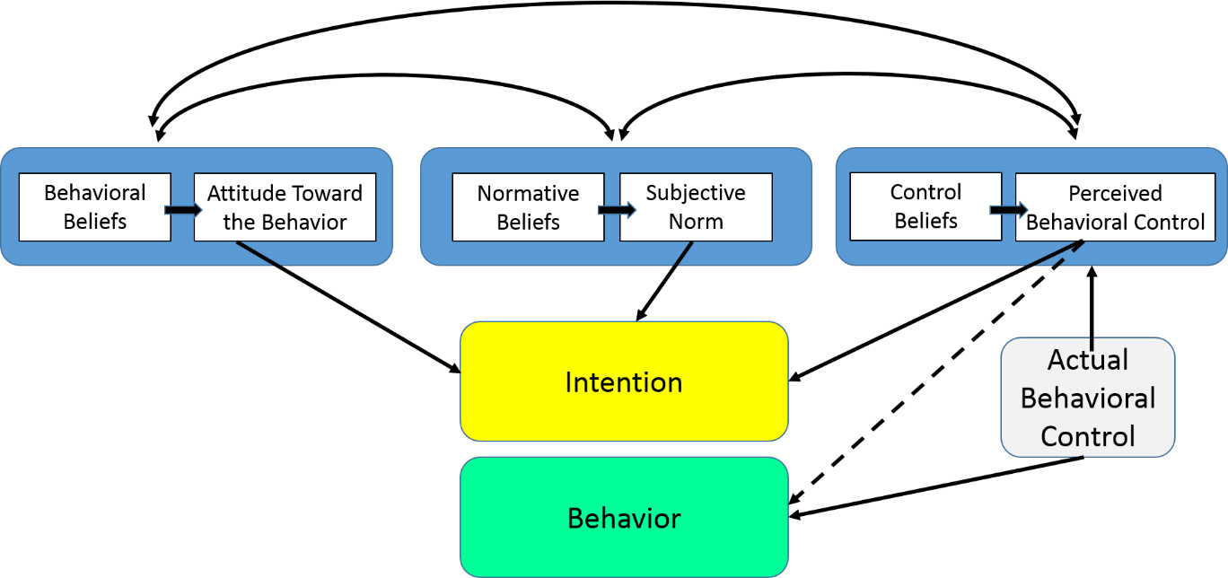
The behavioural beliefs are about the outcome or the consequences of the behaviour put in place.
The normative belief is about the people individuals care about, this may be family and/or friends, and whether they approve or not the behaviour. Or, if they think the individual should or should not engage in the behaviour.
The perceived behavioural control is where the individual think about the difficulty of
performing the behaviour. Whether it is easy or not, or they might think if they are even able to perform the behaviour. It may also be belief about factors that may interfere with their behaviour or they might make it easier to perform it.
Each of these 3 factors play an important role and their role contributes in developing the Intention.
Finally, after completing all the steps, and the intention is well based, the individuals can engage to the behaviour.
The Theory of Planned Behaviour could be another possible tool to be applied in the support plan of Mason Kabee because it offers a large picture of possible reasons for his behaviour. Because behaviour itself it is influenced by variable factors, asking Mason Kabee relevant questions will make the support team know, as many factors as possible.

Frustration Aggression Hypothesis
“The frustration-aggression hypothesis states that aggression is a result of frustration. Frustration is any event or stimulus that prevents an individual from attaining a goal and it’s accompanying reinforcement quality “(Dollard & Miller, 1939).
The Frustration Aggression Hypothesis has been developed by Dollard et al. (1939). He proposed that if we give signs of frustration this will lead to aggression. It is also stated that if the frustration can not be transformed into aggression, the individuals might divert their aggressive spirit towards something else.
But to define aggression it is a complex task to do, as we can say it is the behaviour that causes injuries to other people, or the intention of doing any harm, or the goal to injure other person who does not like or agree with such type of treatment.
However, Berkowitz (1989) did not agree with Dollard about the frustration being the only cause for aggression, and he reformulated the hypothesis, saying that insults, anxiety, unpleasant environmental conditions and various effects and circumstances can cause aggression itself.
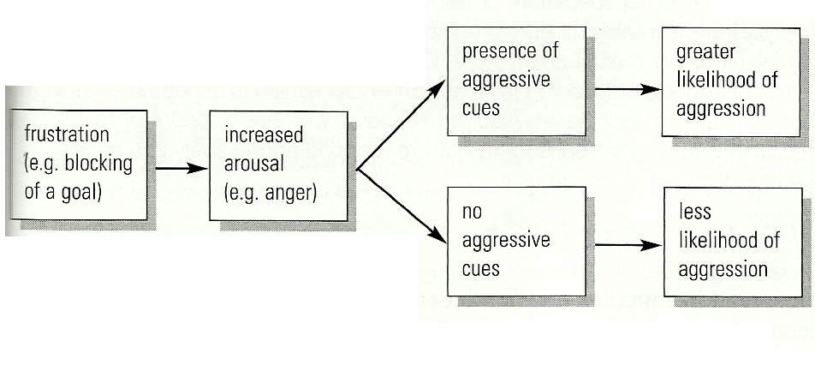
. In sum, Berkowitz’s (1989) reformulation of the theory of Dollard et al. (1939) presents an arguably more sophisticated view of the frustration–aggression link but includes antecedents and consequences that are difficult to observe, making it very challenging to falsify predictions derived from it. For example, if someone is frustrated by cold events but does not behave aggressively, it might not be easy to determine whether this was due to the absence of negative affect or because they did not act upon their aggressive inclinations.
In other words, Frustration Aggression Theory is a method used to find out all the roots that lead toward the aggression. There can be different theories and hypothesis used in order to find out if the frustration was the reason Mason Kabee acted in a certain way, or if there have been other circumstances. A plan including a Frustration Aggression Hypothesis, either from Berkowitz (1989) or Dollard et al. (1939), will reveal many possible causes that have lead the young boy to act aggressively.

Conclusion
Because becoming aggressive, either verbally or physically, can have so many hidden reasons, making a plan based on different social and psychosocial theories and hypothesis, will make it easier to find out the guilty factor that triggered the behaviour. Social Identity Theory is a tool where the individuals are aware of themselves, what perception of themselves they have, which is essential for a start of knowing the person you will work with or be around. The Theory of Planned Behaviour offers a large picture of internal and external triggers towards the behaviour. In the end, Frustration Aggression Hypothesis gives us various theories that can help us find out what has triggered the frustration that made the individual to engage to the behaviour.
References:

Aggression in the Sporting Environment: Cue Arousal and Social Learning Theories. [online]. Available at: https://matthew-belk.blogspot.com/2012/05/cue-arousal-theory-aggression.html [Accessed: 05.04.2022]
Abrams, D.. (2019). Social Identity, Psychology of. Psychology of Sport and Exercise, [online] 40 , pp.127-134. Available at: https://www.sciencedirect.com/science/article/pii/B0080430767017289. [Accessed 05.04.2022]
Dollard, J., Doob, L.W., Miller, N.E., Mowrer, O.H., & Sears, R.R. (1939). Frustration and aggression. New Haven: Yale University Press
Ellemers, N. (2020, Nov 16). Social identity theory. Encyclopaedia Britannica. Available at: https://www.britannica.com/topic/social-identity-theory [Accessed: 05.04.2022]
Milburn, M. A. (1980). ‘Theories of Aggression: A Critique and Possible Reformulation’, Human Relations, 33(6), pp. 353–368.
Norman, P. and Conner, M. (2006). ‘The theory of planned behaviour and binge drinking: Assessing the moderating role of past behaviour within the theory of planned behaviour’, British journal of health psychology. pp. 55–70. Available at: https://web-p-ebscohost-com.ezproxy.uwtsd.ac.uk/ehost/pdfviewer/pdfviewer?vid=0&sid=15167458-fc4e-49d0-9445-7fbd0872d418%40redis [Accessed: 05.04.2022]
Tajfel, H., & Turner, J. C. (2004). The Social Identity Theory of Intergroup Behavior. In J. T. Jost & J. Sidanius (Eds.), Political psychology. (pp. 276–293). Psychology Press. Available at: https://doi.org/10.4324/9780203505984-16 [Accessed 05.04.2022]
The Theory of Planned Behavior. [online]. Available at: https://sphweb.bumc.bu.edu/otlt/MPH-Modules/SB/BehavioralChangeTheories/BehavioralChangeTheories3.html. [Accessed: 05.04.2022]
tutor2u | Aggression: Frustration-Aggression Hypothesis. [online]. Available at: https://www.tutor2u.net/psychology/reference/frustration-aggression-hypothesis [Accessed: 05.04.2022

