MANAGING ENTERPRISE-
BMSW4011- ASSESSMENT WORKBOOK.

BUISNESS NAME:

Atkinsons wellbeing mentorship (we say one & all, one to one mentorship)
The Atkinson Method.

Business Concept
The Atkinsons wellbeing mentorship is a premium personalized coaching service designed to help highly performing individuals and professionals move beyond generic wellness advice. It provides a structured one-on-one partnership that translates holistic wellbeing theory into actionable, sustainable personal strategies.

Core Concept
I will serve as a dedicated mentor and accountability partner, guiding clients through a tailored process that integrates key pillars of wellbeing – emotional. Physical, mental, and often professional purpose driven. The mentorship is grounded in evidence – based practices, but customized to each client with unique lifestyle, challenges and goals, moving them from feeling drained or stuck to thriving with clarity and resilience.

Key Differences
Mentorship over Instructions
- Focus on guided self-discovery, sustainable habit architecture and long
- -term mindset shifts – not just prescriptive plans.
The “Atkinson” method
My proprietary framework (e.g., a blended approach of
Positive psychology, neuroscience-based habit formation and values alignment), Form the structure core of
engagement
3)INTERGRATION FOCUSED.
My solution is designed to fit seamlessly into a client, exiting career and life not to add more to their plate. I will always partner with my clients and set specific, meaningful objectives (e.g., managing energy, reducing anxiety, improving focus, cultivating purpose) and providing the tools and support to achieve them. In short, i offer a bespoke results focused partnership that empowers clients to systematically master their own wellbeing,
leading to improved performance, fulfillment, and sustained personal vitality.

THE STORY BEHIND MY BUSINESS
VENTURE FORGED IN COMPASSION

My venture was not born in a boardroom, but in quite aching spaces between people. It emerged from witnessing friends and family; bright lights dimmed by the struggles of mental health and the grip of addiction. It grew from the understanding that profound struggle often begins with disconnection – with oneself, from purpose, from others. Atkinsons' wellbeing mentorship exits to rebuild those connections. It is a dedicated space for those ready to write a new chapter to move from surviving to thriving. We believe that healing and growth are not solo journeys, but are powerfully accelerated through guided, purposeful partnerships.

My guide method.

My approach moves beyond giving advice. We practice a “Mentorship mindset”, where every interaction is an opportunity for mutual learning and growth. We focus on building” high quality connections – those small uplifting moments that become the foundation for lasting change.
You are an expert in your own life; my role is to be a co-learner and guide. Helping you access your own strengths and wisdom to craft a life of resilience and vitality. This is more than a business; it's a commitment honoring past struggles by fostering present healing and building future wellbeing. This is an invitation to begin your own” positive path “, to discover the clarity and strength that have always been within oneself

Pros + Cons Legal structure
Aspect | Sole Trader | Private limited company (LTD)
Liability | Unlimited (your personal assets are at risk) | Limited (personal assets protected)
Set up | Simple and inexpensive | More complex, costly, and require annul filings
Tax and paperwork | Simple (on personal return) | Complex, but can't be more tax efficient
Profession, A1 Image | Can see informal | Appears more credibility and established

In the very short term, a sole trader is taking a risk personally whereas a limited company offers protection and credibility, but as more rules.

Action to be taken.
1)Uk business consultant
2)Solicitor for personalized set up.

CLIENTS – CENTERED STATEMENT.
MISSION STATEMENT FOR “ATKINSON WELLBEING MENTORSHIP”.

1) Providing a dedicated space and partnership for individuals to reclaim their vitality, clarity and resilience from a place of personal experience.
2) We move beyond advice to offer a structured mentorship – partnership, empowering individuals to systematically rebuild their wellbeing and thrive.

PURPOSE DRIVEN.

1)To guide individuals from struggle to strength through compassionate, one – one mentorship that rebuilds holistic wellbeing.

METHOD FOCUSED.

2)To provide a structured partnership that empowers clients to master their own mental, emotional, and physical vitality.

3) To equip people with resilience and tools to thrive, preventing crisis by fostering sustainable wellbeing.

MARKETING STRATEGY- PRE- LAUNCH MONTH 1-2

. Clarity is what clients understand and appreciate. My unique offer (e.g., 3-month resilience mentorship). My craft stems from turning personal adversity into strength and safe self-awareness. I will also create a one page with my bio services and a clear way for people to contact me. also have one-on-one conversation with a potential referral source (e.g., therapist, life coaches, HR managers to build alliances).

LAUNCH AND INITIAL OUTREACH (MONTH 3).

. I will launch and offer a free high value workshop or webinar on a key wellbeing topic to attract my first leads.
. I will also publish my first 2-3 client testimonials or case studies (even from beta clients). On my website and LinkedIn.
. I will also post consistently on LinkedIn with weekly tips, insights, and pieces of your story.
. Systematize, start a simple email newsletter to nurture contacts and share valuable content regularly.

GROWTH AND AUTHORITY.
(“ON GOING”).

Expand: I will extend reach, pitch to be a guest on a podcast, Local radio, and write articles for wellbeing blogs in your niche.
: REFINE + REPEAT:

I will also double down on the marketing activities (e.g., specific workshop, content type) that generates the most interest and clients.

MARKETING SEGMENTATION FOR “ATKINSON WELLBEING MENTORSHIP”

is my segmentation for” ATKINSON WELLBEING
MENTORSHIP”:
- Motivation – Proactive preventor's vs crisis navigators.
- NEED – need for accountability vs need for confidence.
- Demographics: young professional vs people in major transitions.
I will define my primary segment, Analize the groups from my previous discussions and pick one to start with.
- Choose whose challenges I understand best and whose needs most closely match my core mission. For example, “mid-career professionals experiencing burnout “,
- I will also tailor my offer and messages, Adapt my service and communication for that specific group.
- Service: I will create a program, package name for their goal like the “The Executive resilience reset”.
Use language that speaks directly to their pain points
(e.g., reclaim your energy and focus without
Quitting your job.)
REACH THEM: I will choose marketing activities based on where my segment spends time and seeks
Information

CHANNELS: - LINKEDIN, INDUSTRY SPERCIFIC ONLINE COMMUNITIES,
CONTENT:

. Share articles or host workshop on topics like, “Managing chronic workplace stress “,
Cost/pricing strategy (How you charge) - charge for a complete
Program (e.g., “12-week resilience program). This is often best as it focuses on the outcome, not just on time.

PREMIUM PRICING:

I will set a high price to signal exclusive high value expertise, Hourly/sessions rate: Its simple but can limit perceived value

DIFFERENTATION STRATEGY
WHY CHOOSE ME:

1) My blend of differentiation is a blend of my unique story and personal experience with overcoming adversity is a core authentic strength.
2) Structured method: I will offer a clear step by step process or framework with a specific name (e.g,mentorship for professionals in grief) or the” ATKINSONS METHOD”.

MARKET RESEACH – DATA GATHERING:

1) Client's demand and Problem validation
. Is wellbeing mentorship a “real” problem
. Problem – your audience faces?
I will gather evidence through short interviews,
Ask how they currently manage their wellbeing and what's missing.
. I will search volumes for terms like “wellbeing coach”, “mental health mentor or burnout support to gauge exiting demand.
. My clients are from all walks of life, some wealthy and not so for other clients (so this is why I would introduce unemployment plus, so that this ideal mentorship is for everyone) not just for a few Mid-career professionals.
Highly stressed graduates and roles. Different segments have different needs and budgets.

: COMPETITIVE PRICING
What do other coaches or mentors charge?
Research shows mentors typically charge £50 -£300 range per hour with specific wellbeing or “ad hoc” consulting often in the £100-300 range.
. What do competitors offer? Always make sure to identify what others provide and where the gaps are – perhaps in a more: rational community – focused approach, rather than a purely individual one.
. Service and value proposition testing:
Test interest in different formats (e.g., one on one packages vs group workshop). And my unique story.
. Directly ask about the budget for solving their wellbeing challenges during interviews.

HOW TO USE DATA:
I will support or pivot my niche, as I will use data from interviews and searches to confirm my chosen audience
The right fit, if not, pivoted to a segment with clearer demand and willingness to pay.

REFINING:

I will refine my service and message. Use feedback to shape my core program, “for example”. If clients feel isolated, emphasize the relational and community aspects. My mentorship offers aligning with research on more wholesome well-being approaches.
I will also set strategic prices. Position fees are based on competitiveness or rates. My unique value, and my target client's budget.
.iI will also make it a consistent target to talk with potential clients to validate the problem and their willingness to pay.
1)I will also research competitors to position my unique, rational offering.
2)I will use this data to confidently finalize my target audience,
Service package and price point.

: LOCATION:
. My location will be of 2 choices,
. Cardiff Bay is its modern professional district ideal for targeting corporate clients or professionals. It’s already established for private wellbeing services and host related
Business events which support premium positioning.
Option 2: Would be near Cardiff University (Cathays).
. This area taps into the academic community were formal
Mentoring culture is already gratefully strong. It's ideal for
Serving students, researchers and early career professionals

NEXT STEPS:

- I will use GOOGLE MAPS street view to explore these areas.
- I will also research local property listings for practical costs.
- I will visit my top choices at different times to gauge foot traffic.

HUMAN RESOURSES:

Phase 1 – I will handle everything and consider also a virtual assistant (Admin) and an accountant (Finances)
Phase 2 – Strategic support:
. Marketing specialist (Free lance) to generate clients and run campaigns.
. Associate mentor (contractors) to take on clients under my method once I'm full.

PROFESSIONAL SUPERVISOR:

. (External) For my own guidance and ethical support
Phase 3 - (Establish Practice): Add a program coordinator
And/ or community manager.

ORGANIZATIONAL CHART:

A SIMPLE STRUCTURE ONCE THE BUSINESS STARTS GROWING:

A simple structure once the business

Starts growing:
CHART:

(FOUNDER/ DIRECTOR)

-OPERATIONS

-VIRTUAL ASSISTANCE

-ACCOUNTANT

-GROWTH

-MARKETING SPECIALIST

-DELIVERY

(CONTRACTORS)

-ASSOCIATE MENTOR

-PROFESSIONAL

SUPERVISOR (EXTERNAL)

I will also start by outsourcing key support tasks (Admin marketing) to free my time for clients. My first major hire will be an “Associate mentor” to scale my service delivery once demand is consistent.

START UP FOUNDATIONAL COST:

. My training / Certification: Professional development course's,
Such as specific mentor training programs, this will cost around £1500.

BUSINESS SET UP:
.
. Legal registration, Website domain/hosting basic professional indemnity insurance and initial marketing materiel's, like technology – reliable laptop, video conferencing, scheduling and basic accounting tools.

MONTHLY OPERATIONAL COST:

. Professional supervision: for your own development and ethical practice.
. Budget approximately £80 per hour for a qualified supervisor.
. Associate mentor fees: If i hire help,” BENCHMARK COST”, £8000 -8500 for a graduate student mentor for a summer, and
For my business, this could translate to an hourly contractor rate retainer.
RENT AND WORKPLACE:
. To achieve these dreams, my office will be named “HOME OFFICE” as this reduces the rates by a great deal

SCALE – UP + GROWTH COST:

Boxes that are called priority ticks.
- Formal employment: Hiring my first employee (e.g., an administrator or junior mentor), introduces salaries, payroll, taxes, pensions contributions, and HR management costs.
- ADVANCE TRAINING: Investing in an unspecialized certification
(e.g., Leadership or executive coach training for myself or
My teams).

PRACTICAL STEPS, BUDGET!
. I decide on my target income, then I will work backwards to determine how many clients I will need at my chosen fee.

PRIORTISE ESSENTIALS FIRST.
As previously stated, I will begin with the absolute minimum to operate (a laptop, insurance, and a simple website.)
Also I’ll add rent or associate mentors, only when demand
Request it.

PROACTIVELY: I will offer a 3- month mentorship package
(Which will include me using the “associated mentor cost
Benchmark" to ensure my pricing covers the cost of delivering if I need to delegate work.

The questionnaire was completed by 14 subjects, below are the insights and statistics charts of the outcomes.

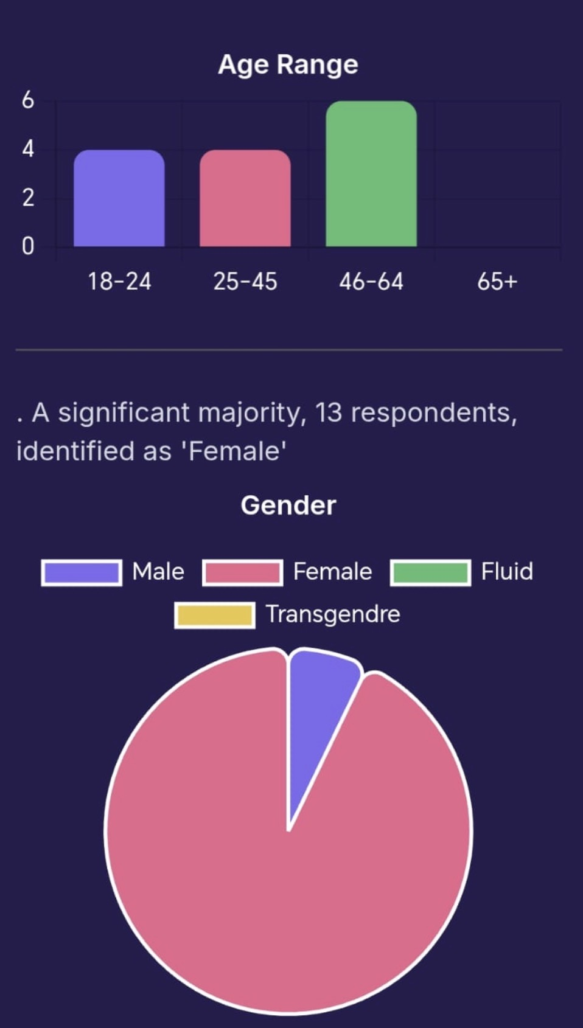

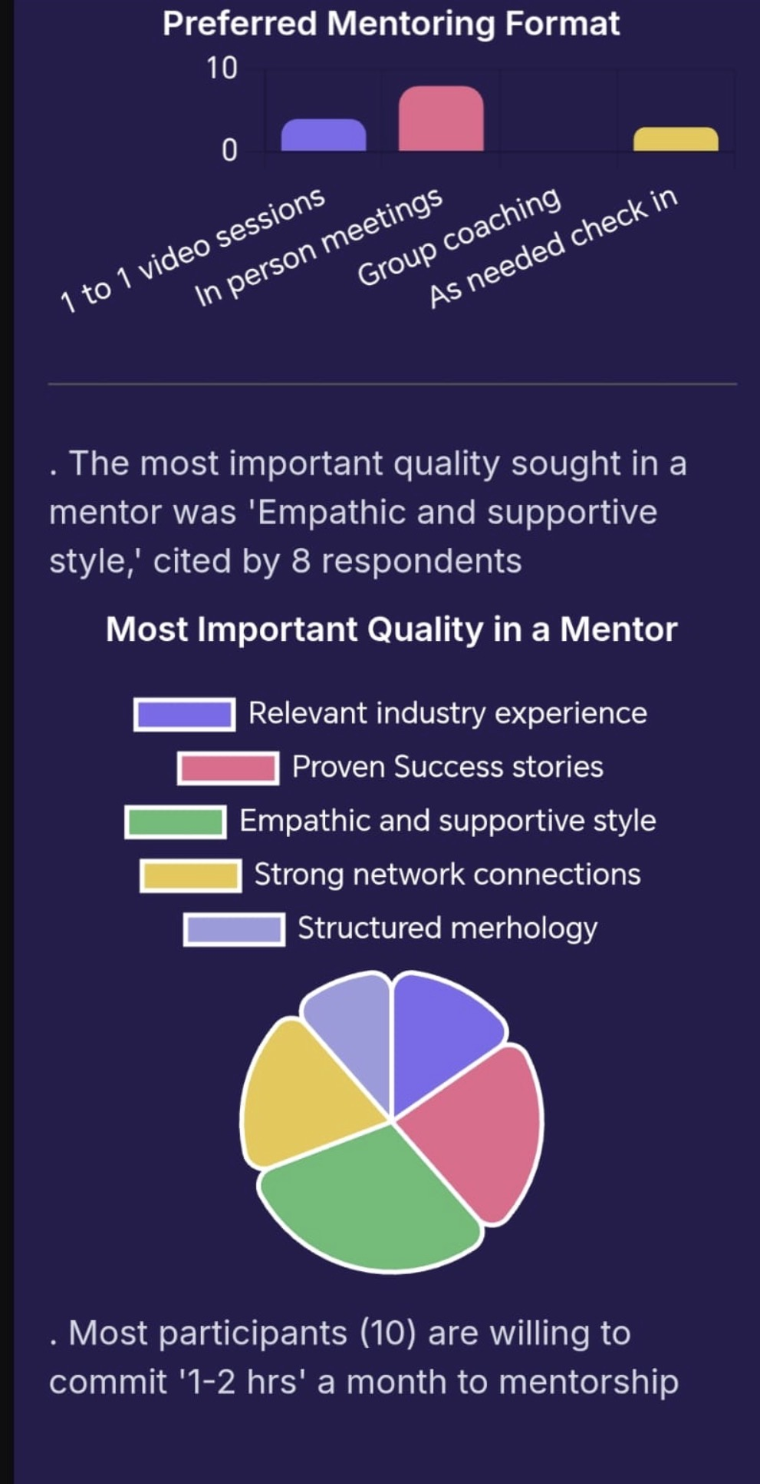
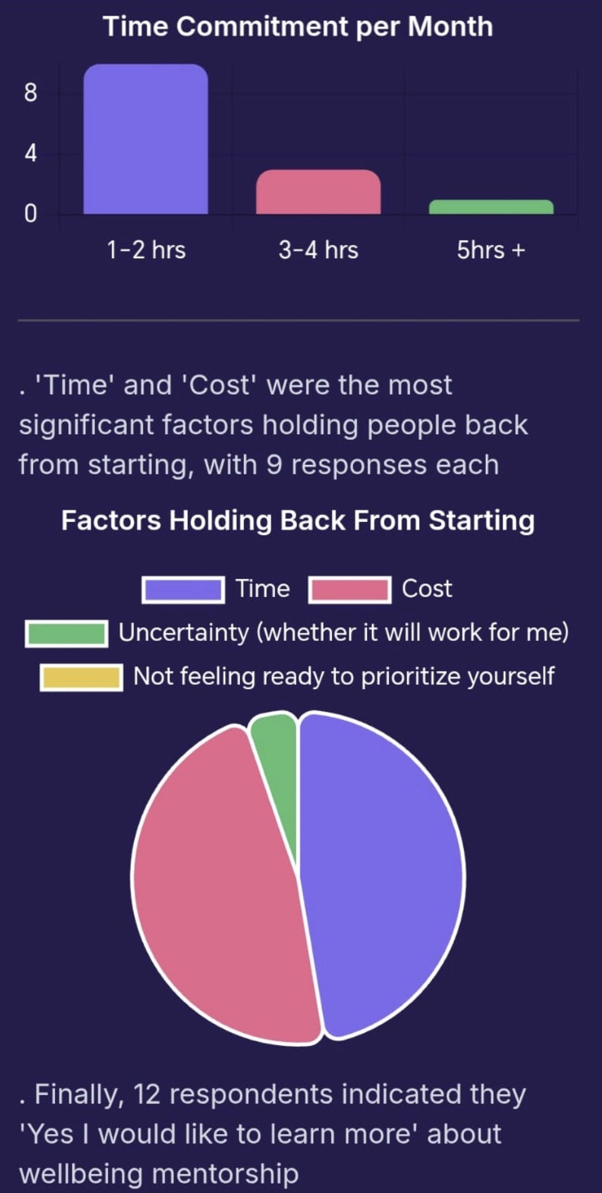
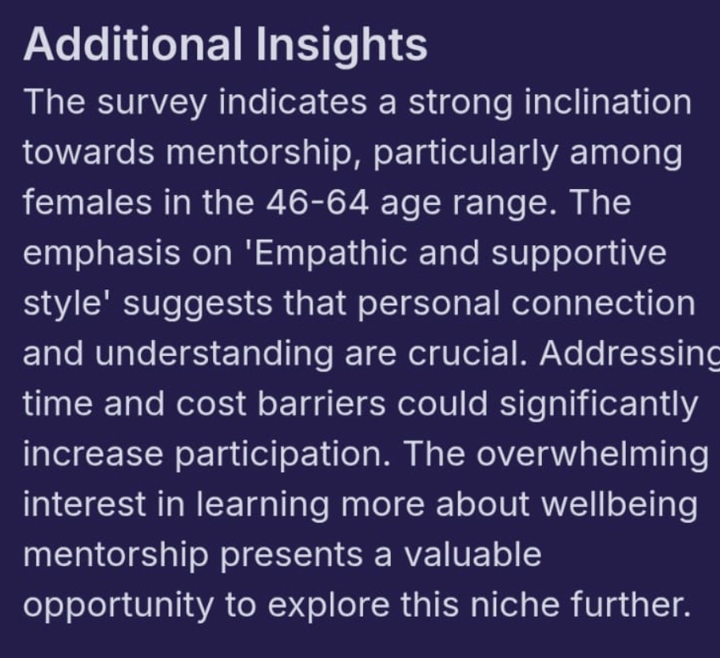
15 HARVARD STYLE MENTORSHIP
REFERENCE:

- Babatope, v.o. (2025). Strategic mentoring in higher education: best practice for Academic success.
1st ends cham springer nature/Palgrave MacMillian.

2)Mullen, C.A. (2024) Equity in school mentoring and induction springer in briefs education)

3)Rhodes, J.C. (2020) older and wiser: new ideas for youth mentoring in the 21st century. Cambridge, M.A. Harvard
University Press.

4)McGhee Peggs, H. (2023), Supervising conflict: A guide
For faculty, Toronto: University of Toronto press.
5) National Academics of Science, Engineering, and
medicine
(2019) The Science of affective mentorship in STEMM. Edited by M.L. Dahlberg and A. Byars – Winston. Washington, DC:
6) Journal Articles (peer – received) Black, V.G. and Taylor,
Z.W.
(2018) nobody's “talking to mentees “, mentoring and tutu
Ring.
Partnership in Learning, 26 (5), pp. 606-626.
7)Santa – Raminez, S. (2022) “Sink or swim: The mentoring experience of Latinx PhD students with faculty of color:
Journal of Diversity in higher education, 15 c), pp.
- Tuma, T.T. et a1. (2021)” The Dark side of Development:
A system characterization of the negative mentoring Experiences of Doctoral students”, CBE – Life Science Education: 20 (2), art16.
9) Curtin, N. Mally, J. and Stewart, A. (2016) Mentoring the
next generation of faculty. Supporting Academic career
aspirations among Doctoral students: Research in higher
Education 57 (6), pp. 714-738.
10)Bettencourt, G., Frieden Sen, R.E. and Bartlett, M.L.
(2021)
Re- Envisioning Doctoral mentorship in the United States:
A power conscious review of literature: International
Journal of Doctoral Studies, 16, pp. 237-252.
11) Allen, T.D. (2023) “Mentoring others:” A Dispositional and
Motivational approach”. Journal of vocational behavior, 62 (1)
c)pp.
12) pfiend, c. Et al. (2022) “Evaluation of a culturally responsive mentorship education program for the advisors of Howard Hughs medical institute Gillian program graduate students: CBE life Science education, 21 (3) ar 50.
13) Sanchez Nieto, F. etal. (2024) “Mentoring up for early career
Investigators: Empowering mentees to proactively engage in their “Mentoring relationships “. Journal of Chemical and Transitional Sciences. 8. C.J est.
14) Higgins, M.C. and Nohria, (1994) “The “SIDE KICK EFFECT”:
Mentoring relationships and development of social capital.
Harvard Business School Working paper, NO. 94-088.
15) Thomas, D.A. and Higgins, M.C. (1996), Mentoring and the
Boundaryless Career: Lessons from Minority Experience: Harvard Business School Working Paper. No. 97-020.

Reflective 3paragrapths brief of Atkinson’s wellbeing mentorship
1. The Spark: Validating the Market Need
The birth of Atkinson’s Wellbeing Mentorship was met with a resounding vote of confidence. The initial market response revealed that 80% of respondents expressed interest, with a remarkable 42% identifying as "very interested." This data was more than just numbers; it was a clear signal that the business idea addressed a genuine and pressing need. It is validated that people weren't just passively curious about wellbeing support, they were actively seeking the structured, personal guidance that the mentorship promised to offer.
2. The Proof: Delivering Tangible Results
The transition from interest to impact was where the concept proved its worth. The pilot program’s post-data tells a powerful story of effectiveness. It wasn't just about high satisfaction scores (4.8/5); it was about measurable improvement in life. Participants saw an average wellbeing increase of 51%, with stress management scores leaping by 56%. Crucially, a 92% completion rate demonstrated that the program was engaging and accessible, successfully converting initial enthusiasm into committed action and real-world results.
The pilot program has provided a solid foundation and a clear roadmap for the future. The 96% recommendation rate and strong referral generation confirm that the mentorship delivers on its promise, creating natural advocates for the brand. Feedback, such as requests for longer 1:1 sessions and digital resources, now offers a strategic direction for refinement. Atkinson’s Wellbeing Mentorship has successfully evolved from a promising business idea into a proven service, ready to scale with confidence. Thank you all for being on this journey with me, without you all I would be still swimming in the sea, thank you all.

