Draft Career developing

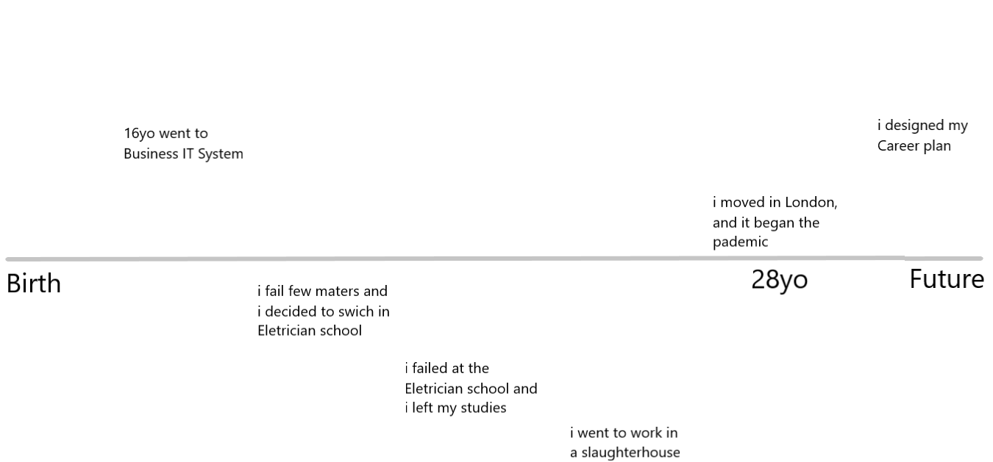

When I was at high school at 16 years old, I had to decide what college I would go and decided to study by university of Parma, SIA course (business, IT, Systems), but after 6 months I decided to swich school because of low grades of 3 subjects. So I went to electrician school, but after the first year I realized than I was not into electrician work at all., so I left my studies and I started to work in a slaughterhouse .with my father. I worked 7 years in a industrial slaughterhouse, and it was the most harmful experience of my life, specially from the mental health point of view. I could learn few thing about the world and my self so every cloud has a silver lining.
At 25 years old I left my full-time job, and I came in London.
I always had a instinct of exploration that push me to know new things, new places, new people, new situations, and for a long time I felt oppressed because I have not seen somebody else feeling what I was feeling, and I supposed to think that something was wrong with me.
I found a job in a italian restaurant and I used to work 9 or 10 hours at day, I have done house-work, work-house with out really enjoy my new experience and neither learn English , basically I was still stuck at the start point. But at least I was in a new country and for a while was enough.
The real game change, it’s happened when it’s started the lock-down be force at stay at home, without nothing to do, and nobody to talk with. That situation put me in a contrition of loneliness, and I started my process of self-analysis.
I tried to understand who I am , and what I really want to do for the rest of my life, I spend more of one year to make my self questions, research and reading books.......... and at the end I came out with a life plan , this plan include a career plan.

Skills Employer wants:

Employers place much importance on finding employees with the necessary skills and abilities for their businesses. There may be extremely specific talents, abilities, and knowledge required to complete the job depending on the career area and profession someone choose to work in. These are supplemented by broad competences and behaviours that are required for successful working. These are the crucial employability skills. the core skills that will make me effective at work
According with NewManu.edu and TargetJobs.co.uk, (links on the button)
Those skills are:

1. Commercial awareness (or business acumen)
This is about knowing how a business or industry works and what makes a company tick. Showing that you have an understanding of what the organisation wants to achieve through its products and services, and how it competes in its marketplace.
2. Communication
This covers verbal and written communication, and listening. It's about being clear, concise and focused; being able to tailor your message for the audience and listening to the views of others.
3. Teamwork
You'll need to prove that you're a team player but also have the ability to manage and delegate to others and take on responsibility. It's about building positive working relationships that help everyone to achieve goals and business objectives.
4. Negotiation and persuasion
This is about being able to set out what you want to achieve and how, but also being able to understand where the other person is coming from so that you can both get what you want or need and feel positive about it.
5. Problem solving
You need to display an ability to take a logical and analytical approach to solving problems and resolving issues. It's also good to show that you can approach problems from different angles.
6. Leadership
You may not be a manager straight away, but graduates need to show potential to motivate teams and other colleagues that may work for them. It's about assigning and delegating tasks well, setting deadlines and leading by good example.
7. Organisation
This is about showing that you can prioritise, work efficiently and productively, and manage your time well. It's also good to be able to show employers how you decide what is important to focus on and get done, and how you go about meeting deadlines.
8. Perseverance and motivation
Employers want people to have a bit of get-up-and-go. Working life presents many challenges and you need to show employers that you're the kind of person who will find a way through, even when the going gets tough... and stay cheerful-ish.
9. Ability to work under pressure
This is about keeping calm in a crisis and not becoming too overwhelmed or stressed.
10. Confidence
In the workplace you need to strike the balance of being confident in yourself but not arrogant, but also have confidence in your colleagues and the company you work for.

In my Self Assessment I am going to compare my natural qualities with the skills than employer wants and how could I get them.

1 Self Assessment
Self-assessment is the first and the most important step in choosing an career. i started to identifying my skills, values, interests, achievements and values to determine what types of positions better fit to me.
I never been sure about my skills and that is why This step was challenging and it i took almost one year during the pandemic to figure out what are really my skills, my learning style, what I need to improve in order to achieve my goals, …..
But eventualy whe I had my list of.... I felt very.....
Below is a brief description of the various components of self assessment.

My skills, what I am good at? (with example) (abstract)
- Eagerness to learn. And Quick learner, during my life I had to adapt different situations. I have studied at school and by my self about different matters (as Computing, coding, design, business and management, digital marketing and accounting). I done many jobs, (as butcher, barman, bartender, waiter, builder), And i think than through all those experiences I got a good basic learning mind set, that allow me to learn quick, and more over, I love learning. it is a big motivation in my life than help me to keep my self active mentally.
- Creativity, I always though in a unconventional way, and this aspect allow me to see things from different point of view from according to what my employers, my teacher, and people that know me well, I always had a creative mind
- Transferable skills. Through all my experiences as student and worker, I understand how connect skills than I got from a job or study to and other new situation. For example from my work in hospitality I learn to organize my work and environment in advance and I cold apply this concept also at my activity as student, or in design that teacher me how structure …. in a way it is enjoyable to see and interact with, I could it apply at other many thing of my life, like software developer and presentations at university.
- Determination, every time I have been in a new job, or a new sport, or I was studying a new topic I had to deal with difficulties, But even when I was very frustrated I have never stop. I may get upset and take a break from my objective, but after a bit I again on it, because I am not able to quit, and this sometimes may be also a problem. My friends say I am stubborn.
- Problem solving, Good analysing and critical observation skills. I always liked observe what is around me and pay attention at the details. During the module of ‘’problem solving and decision making’’ I enjoyed and I preformed good. so I realized that is something that I like and I decided to base my career on it.
- Honest. I always say what I think.
- Ambition
How can I prove it? Give a example?
.
What I need to improve?
Comparing the skills than the employer looks for and what I am good at, we could assume what I should improve in order to fulfil the …. of the work world.

- Communication
- Organisation
- Leadership
- Constancy and Focus
How can I improve them...
- Communication: I will listen more people while they are talking, pay attention at my body language, Check my message before i hit send, Be brief, but specific, and I will apply some communication method.
- Organization: I am already reading some book about time management and I am trying to stay focus on what's important, Make daily, weekly and monthly to-do lists.
- Leadership: having a leadership attitude I think is just something than someone can be cut out for, something which someone has naturally. I would consider my self a leader and I am not really interested to be it. However I still need to improve that skill to be listened to my colleagues and people around me. In order to transmit confidence when I talk about my work or a my idea. I will learn about leadership through direct experiences with people, reading some books about it, and hopefully funding a mentor.
- Constancy and Focus: those are definitely my bigger issues.

Self Motivation
Self-motivation I think is one of my main characteristics. I been several time in hard-times I never let myself overcome from events and That is why I can say for sure to be a determinate, resilient, self-motivated person. for me, Self motivation, it is the ability to push yourself to keep doing, despite from fail and frustration, but also looking beyond the bare minimum of what is required, it is about constantly improving.
.How I keep my self motivated:
1) Maintain a positive outlook.
2) Determine the goal of your work And Breaking Down goals in little tasks
3) Keep an eye on the big picture
4) Acknowledge Achievements and taking breaks time to time
5)Keep my environment positive and stimulating.
6) Find new input to keep my self inspired (as watching video of other software developers on YouTube)

Learning style
‘’A learning style is the way that different people can learn. A style of learning refers to an individual’s preferred way to absorb, process, comprehend and retain information. The four key learning styles are: visual, auditory, tactile and kinaesthetic’’ (Top Hat)
Learning style it is a fundamental point to take in consideration for a career plan. I made more than ones, i made the mistake of not consider my natural learning style, and I just tried to learn thing in the same way of people around me, and I always found great difficulties. Through the class activities and my personal researches, I could discover than I am a Tactile Learner.
tactile learner is who learn by touching and doing, understanding and remember things through physical movement. My approach is "hands-on", and i tend to learn better when some type of physical activity is involved. I also need to be active and take frequent breaks.

Here are some things that tactile learners like you can do to learn better:
- Participate in activities that involve touching, building, moving, or drawing.
- Do lots of hands-on activities like completing art projects, taking walks, or acting out stories.
- Use flashcards and arrange them in groups to show relationships between ideas.
- Take frequent breaks during reading or studying periods (frequent, but not long).
- Use a computer to reinforce learning through the sense of touch.

Other important aspect of my learning preferences are:
- Reflective learning
- Visual learning
- Read/Write learning
- Intrapersonal (Solitary) Learning

My worst way to learn is Linguistic, (combination of auditory and verbal learners). In fact I always found the verbal instructions inefficient, specially for complex matters as math. However, linguistic and audio learning style are the most used in academic system.

This also bring me to choose my favourite reflecting method than is Kolb. Which involve my two favourite learning style ‘’practical experience’’ and ‘’reflective observation’.

Personal SWOT Analysis
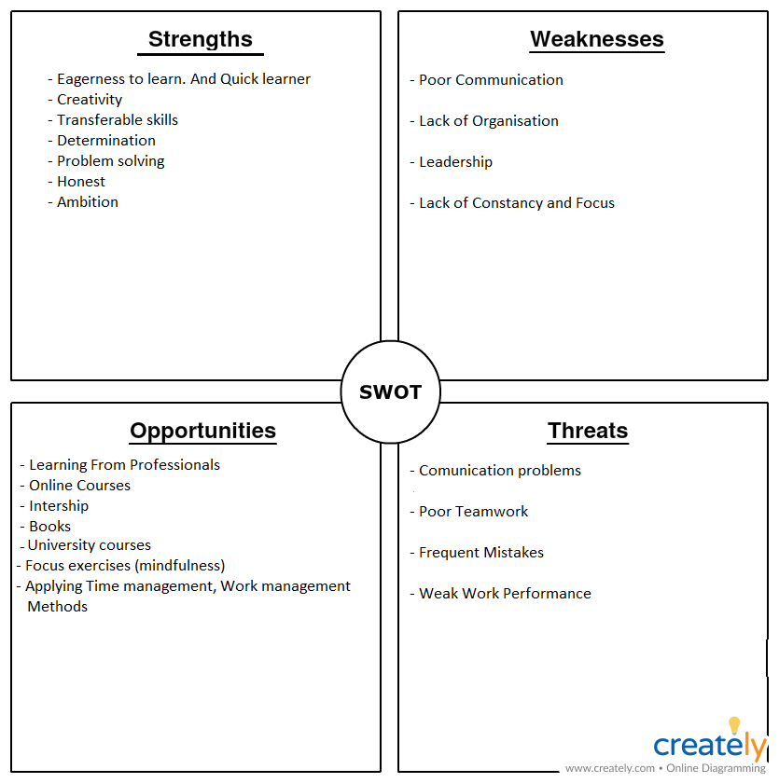

2 Career Explorations
My second step, it was look what the world of job needs at the moment, researching by 4 points:
- most in-demand jobs
- Jobs most paid
- Job with higher growth-rate
- Job with most work-life balance
And I could find out 2 of the 3, career path than I choose.

Most in-demand jobs:
Using The World’s Most In Demand Professions | Michael Page
on top of the list we notice than a big part of the world most in demand professions are in the field of IT, as:
- Information security engineer
- DevOps engineer
- Enterprise architect
- Technical program manager
- Software architect
- Applications architect
- Infrastructure architect
- Software development manager

we can see than the common skill between all top IT professions is programming.

At second place, one of most in-demand jobs According with Indeed.com, CareerFitter.com, and Smallbusinessprices.co.uk are: in the field of Business, as:
- Management Analyst
- Financial Analyst
- Marketing Manager
- Human Resources Manager
- Sales Manager
- Purchasing Manager

Also. according with Indeed.com, Business and IT are one of the most valuable Double-Major combination, like:
- Computer information systems and marketing
- Computer information systems and economics
- Business administration and accounting
- Business administration and computer science

Most paid jobs:
According with Wealthy Gorilla.com and careeraddict.com, )the most paid jobs are:
- Engineering manager:
salary potential $149,000 (US) / £89,000 (UK) / C$109,000 (Canada)
- IT systems manager
salary potential: $127,000 (US) / £55,000 (UK) / C$121,000 (Canada)
- Marketing manager
salary potential: $99,000 (US) / £50,000 (UK) / C$87,000 (Canada)
- Air traffic controller
salary potential: $149,000 (US) / £106,000 (UK) / C$162,000 (Canada)
- Petroleum engineer
salary potential: $171,000 (US) / £91,000 (UK) / C$175,000 (Canada)
- Senior data scientist
salary potential: $160,000 (US) / £81,000 (UK) / C$127,000 (Canada)
- Computer hardware engineer
salary potential: $128,000 (US) / £81,000 (UK) / C$115,000 (Canada)
- Senior software engineer
salary potential $153,000 (US) / £74,000 (UK) / C$121,000 (Canada)

As we can see, even in the most paid job the Engineering, IT, and Business jobs are on the top.
Form that I could also assume that how much a role is able to directly increase the company’s revenue, more your salary will be high. And that gave me a clear idea of what skills I will need to get.

Jobs with higher growth-rate:
According with this interesting and accurate article of GetSmarter Blog

3 Career identification

IKIGARY
I am going to reassume my career identification with a scheme, inspired by Ikigary method.
Ikigai method it is used to find our purpose, or value in life, determing whether or not your work fulfil your....(svuluppa meglio)
Question are...
But I readapt it for make it fit at my case:
What I like to do, (or don’t like)
What the word of work need (what employer want)
What I am good at (my natural skills)
What job it fits my life- style

4 Create Action Plan
Now than I decided my career path I know the skills that are required, I need to plan my career in the details.
Whats is the goal?
- Working as software developer
- Having a basic knowledge of digital marketing and sales
What's skills I need?
- Software developer:
- Coding: Java, Python, PHP
- FrontEnd: HTML, CSS
- BackEnd: JavaScript
- Database: SQL, Tableu
How can I get them?
- Computer Science University
- Self-Learning

What are positive factors? what will help you achieve your goals?
Positive:
- Financial, I can provide for my instruction
- Time, I can organize my time in order to …
- Position, living in London I have a lot of opportunity of study and to work
What are Negative one? What might hinder you?
- I am not an academic person, I hardly fit in a academic system.
- It require time and it is a difficult study
PLANNING
After my career identification, … software developer, with the secondary goal to learn the bases of marketing and sales. Computer Science University definitely could offers all the knowledge than I need to become software developer, But I realized than even I love learning, I am not an academic person and i struggle to fit in a academic system, actually often demotivate my to reach my goals.
Software dev require pretty solid Coding skills, which I used to think only a university could give me, but during my research I have been happy to see than I was wrong.
Online there are plenty of online courses and bootcamp which offers good … for beginners, intermedial, and advanced at a price quiet cheep, compering with a university. there are also challenge website will teach me how to resolve those problems than I really will find at work if I am going to get a software developing job, or in a job interview test. Actually, even online there are plenty free coding courses. According with several professionals of this field, not all employers looks for a degree, considering than for recruit their software devs their uses few ‘’ technical test’’ to understand the skills of candidates. so regardless from degrees a software dev can always show his competence and have a chance to find a job. then I decided that I am going to start at my first steps as software developer by my own, studying as self learner., and on the base of this, I created my action plan.
Of course a university course such Computer science offers a deep knowledge of the machine and its applications consequentially I could have more opportunity. But I an other hand, My program instead aims to gives my the basic knowledge to start to work as software developer as soon as possible the develop my skills strength on the field, which I think is better. by my count, I should learn all I need in 2 years of hard and organized work.

- Set the End Goal
There are any different kind of Software developer and I needed to choose which one is a good fit for my, and I made my decision on the base of what I am natural good at. So I choose FrontEnd Web developer, because it involves more creativity and design. The role consist in design and create websites in order to be enjoyable for the users to interact with, and it works efficiently for the purpose of the site owner.
- Start from Fundamental
According with my research the fundamentals of Software developing involve different subjects as Databases, Operating Systems, Computer Architecture, and most importantly Data structures & Algorithms . buying few book for each argument is the best option. I think it is going to take roughly 6 months for learn them If I will study 2/3 hours at day. I can easily fit it I my day life, considering than I work not more of 6 hours at day, and I start my shift always after 13.30. I could study in the morning and then go to work.
- Learn Program Languages
For working as FrontEnd Web developer is necessary be able to use few programming languages as HTML, CSS, JavaScript which I already have some basic knowledge. According with few professionals it will take 3 / 4 months to learn all them. I could divide my study morning in two sessions: ‘’study of fundamentals’’ and ‘’study of program languages’’ .
- Find Resources
Found resources it could be quite difficult for a self-learner. I someone follow a collage course I would have access at all the information than I need by find my own resources. I can find acces at the information that I need by:
- books
- documentation,
- resources website,
- video courses,
- online bootcamps
- challenge website

- Find a internship and build a CV
At this point I should have the fundamental knowledge to work as FrontEnd software developer, and I should be able to face the basics problem of the role. Internships are the easier way to have a practical experience on the field, and through it it could give a chance to get a job as well. It could be a problem coordinate my current job with a internship but considering than I have 3 days off, I could do it during them.
•In five/ten years time what would you like to be able to say were the achievements of those years
Examining the options ahead

Tasks:
- Summarise and reflect upon your answers to the questions raised
- Follow-up on the life line activity
- Begin to collect the information you require

Personal Develop plan

SWORT
SMART

With my teammate Stefany, we should simulate a job interview in class, where we should to fill in a job application based on our career path, experiences, and academic skills.
Then wrote down five questions each relate at what we wrote on the job application, playing the role of interviewer and applicant (interviewed), and vice-versa. The interview style it should be engaging and friendly, using the body-language, maintain the eye-contact, smile often, and letting the conversation flow. The play role require 10 minutes of talking form both member of the couple.

Concreate experience
After fill in the job application we started to write down the questions trying to make more references at the job application as possible also with concrete examples.
Then we practiced our roles for a couple of days, trying to make it more realistic and fluent as possible
After I fil up our job application, I started from gathering experiences from real managers that used to make those kind of interview and also professional that give advices about how to answers.
After that I tried to found the best way to connect questions and answers at my job application. My teammate had struggled in this part, while I struggled to make seam the interview engaging and fluent, a part that she was confident. But We helped each other, and the result I think was good.
Any interviewer’s questions was related at some point of the job application. getting into previous experiences and what the candidate got from them. we lay out a scenario to see how interviewed manage the situation.
During the practice, I felt a bit weird the matter of playing roles, but thanks to my team mate that she was really enjoy the thing of ‘’acting’’ the role, I had fun eventually; even the part of small-stalks which we used to improvise.

Reflective Observation
I understand that the aim was to understand if the candidate fulfil the requirement of the role and how he/she can bring a positive contribution at the company. And the point as applicant is to show that I could be a positive and enjoyable co-worker, demonstrating how my skills can make the work easier and give a positive contribution at the team, and how can I bring revenue at the company.

Abstract Conceptualization
At the moment of the play role exam in class I was a bit nervous, in fact I think I performed slightly worst comparing when I used to practice, but a part from that, i considered me pretty satisfied.
I made valid question relate at our job application and trying to check all the point of ‘’ PCD ROLE PLAY INTERVIEWS’’, but I apparently messed 2 points.
- Did the interviewer lay out a scenario and ask how the interviewee would react
- Did the interviewer map out the interview

Active Experimentation
this task a could learn effectively how it works a job interview, and through it, what the employer looks in a candidate, and how a candidate can show his skills in order to fulfil that expectations.
- From interviewer point of view:
- From interviewed point of view:
The thing that I like more about this task was the fact that it was not just a ‘’study’’. We have not just a theorical approach but we lately practiced that role and got into the situation, than it match with my learning style beside and a practical learner.
I also understand what I need to improve. As how map out the interview, and laying out a scenario and ask how the interviewee would react. Even if with the question ’’.................’’ as interview I got the information that I needed, so for me it is fine, I just need to understand how formulate questions better.
But more important, I had the chance to see how software developer interview are made. I understand than the 75% of the interview it is practical test, to see how resolve problem, and what are my IT skills. So first of all I going to focus on coding and getting more IT skills as possible.

NOTE:
Engagement with Literature Skills:
- Lavori piu pagati, miglior work-free time
- Come diventare software developer, passi necessari e skills da avere secondo, (chi)
- Come ottenere
- Come pianificare la cariera, Professional Development Plan?
- Come matenere self motvation : keep ur focus di mattia

Skills employer looks for:
What are the top 10 skills that'll get you a job when you graduate? (targetjobs.co.uk)
Top 5 Skills Employers Look For | Nth Degree (newmanu.edu)
Jobs most required:
Top 10 Most Popular Jobs In the World By Country (smallbusinessprices.co.uk)
The World’s Most In Demand Professions | Michael Page
2021's 100 Best Jobs in America | Best Jobs Rankings | US News Careers
Double-major
18 Top Business Double Majors | Indeed.com
Most paid jobs:
Top 6 Highest Paying Jobs in the World [A Complete Guide] | upGrad blog
The 20 Highest Paying Careers in the World (2021) - Wealthy Gorilla
The 20 Highest-Paying Jobs in the World (careeraddict.com)
Job with higher growth-rate
Which Jobs Will Be In Demand In The Next 10 Years? - GetSmarter Blog

I choose to study in this university for have a point of start in my academic preparation. getting the basics of English, and (prendere considenza con il sistema didattico in uk). Initially I was a bit disapoint because my fisrt idea was to study business and management but the course was already full and I had to enrol at this one, but now I am pretty glad about that because I learn very usefull tools that I am sure that they (riveleranno) useful during my study, my future job, but also in daily life and my personal development. Example.....

