Travel Mission

When I had the idea to create the app, the first thought i had was making a traveling app. Personally, I find it can be quite difficult to go on holiday and find some activities to do, so I thought that this app could help people. I also wanted to make sure I’d be able to take care of the people using it as well, so that when people use the app, they could get discounts on travelling, medicine and hotels.
I also had the idea that it would have a point system, so when you would complete challenges on the app, you would get points and level up, which would give you better discounts.
You would get different ‘Challenges’ depending on which county you are in. ‘Challenges’ are essentially activities, you start off with three and once you complete one, another one will replace it.
I also wanted the audience to get recommended countries and reasons why they should visit there, as the main purpose of the app is to get people to explore the world more and experience new things.

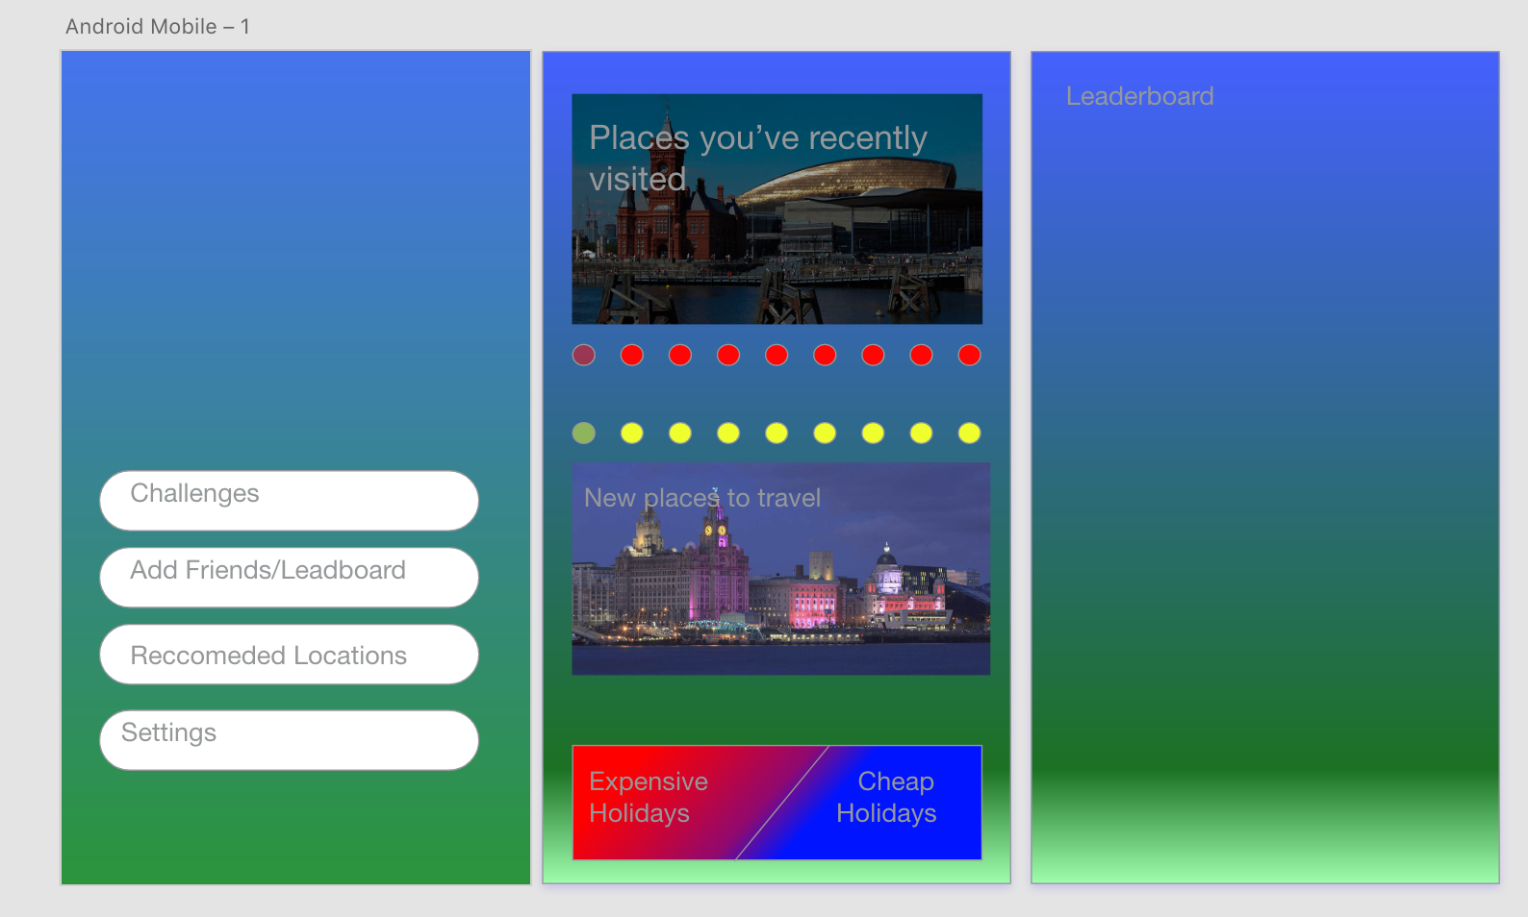
First Design/Wireframe

This was my first design, for the background, I decided to go for a blue with the gradient of green, I thought that these colours would make sense because, as my app is essentially a travelling the world app, i thought the blue would represent the sky/sea and that the green would represent the land, but I thought this design looked to amatuer, so I decided to change it later on.
For the home page (Left page), I decided to add 4 rectangle shapes, which are w-292 by h-47, and have them one under another aligned. The font I used inside was ‘Helvetica Neue’, which is the default ‘Adobe Xd’ font.
For the ‘Recommended Locations’ (Middle page), I used an image of Cardiff Bay, which had the text “Places you’ve recently visited” on it, if you would click this button, it would send you to another page, which has the places you’ve recently visited, but by this time, I didn’t create that page yet.
Underneath that, I had a line of red dots, to make this, I created a ‘Ellipse’, I changed the colour to red and then used the ‘Repeat Grid’ and dragged it to the right, which then created 9 dots. I changed the opacity on the first ‘Ellipse’, as I wanted the user to be able to swipe through the images above and by doing so, the ‘Ellipse’ would get darker on the one next to it when the image got swiped, so the audience would know which slide they are on but I couldn’t manage to do this in the end, so i deleted it from my final design. I did a similar thing with the “New places to travel”, but the line of dots were yellow and above the image.

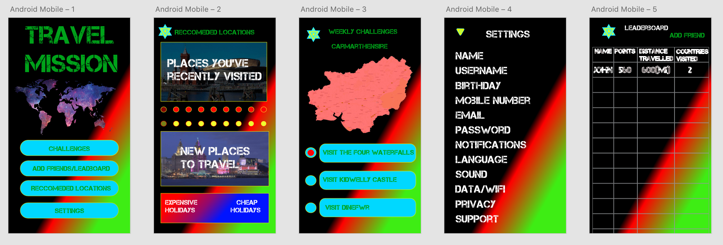
Second Design
For my second design, I decided to use the font ‘Capture it’ because i thought it gave the app a rough look to it, or a military look, which I was hoping it would make people feel confident enough to try exploring the world. I made the text colour green and blue, as I thought the white stood out well with the black, and the green looks like land.
I decided to change the background colours, to Black, with the gradient of red and green. I was hoping the black would give the app a ‘Out of this world’ type of feeling to the audience, with green signifying the earth and the red to show danger and excitement, as I think this is what the audience would think of the idea.
In this design, I added the ‘Weekly Challenges’, the idea of this idea was to try challenges in the county that you’re in, so each county would have different challenges. Recently ‘TrawsCymru’ made buses free on weekends, so this allows people to travel to different locations without having to pay for them, so this doesn’t give them the excuse of not being able to travel there. One of the issues I had with the ‘Pokemon GO’ app was, I couldn’t really use it as where I lived, affected the ‘Pokemon’ I could get, so this became pointless for me, so I thought, if I could make every location, have a purpose/challenge, people will download this.
For the ‘Settings’ page, I only labeled the type of settings I would have. I would use the alignment line, as this would help make the page look tidy and not have the words all over the place looking messy and unprofessional.
I also added the ‘Leaderboards’, I found this quite difficult to make on ‘Adobe Xd’, as they didn’t have a table maker. So what I did was, write, all the titles, and the make a rectangle over it, and then ‘Repeat Grid’ all the way down.
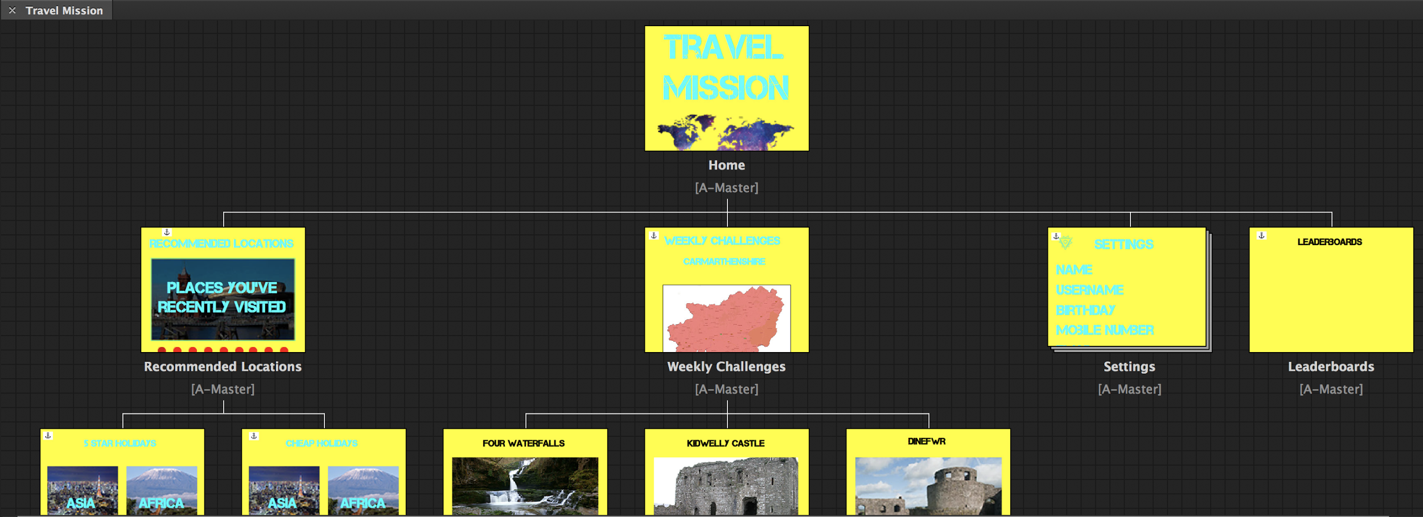
Third Design

I then tried moving to ‘Adobe Muse’ as I thought I had more opportunities to try different things, but I had an issue every time I tried ‘Preview Site in Browser’ and the pictures looked really pixelated for some reason. So I decided to move back to ‘Adobe Xd’ because I prefered how I could test the app on my phone and how the pictures didn’t look pixelated.

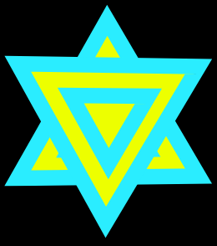
Logo

This was my first logo design, I was going to stick with this but when i presented my app at the presentation, my tutor told me how it looked similar to the ‘Star of David’ so i decided to change it.
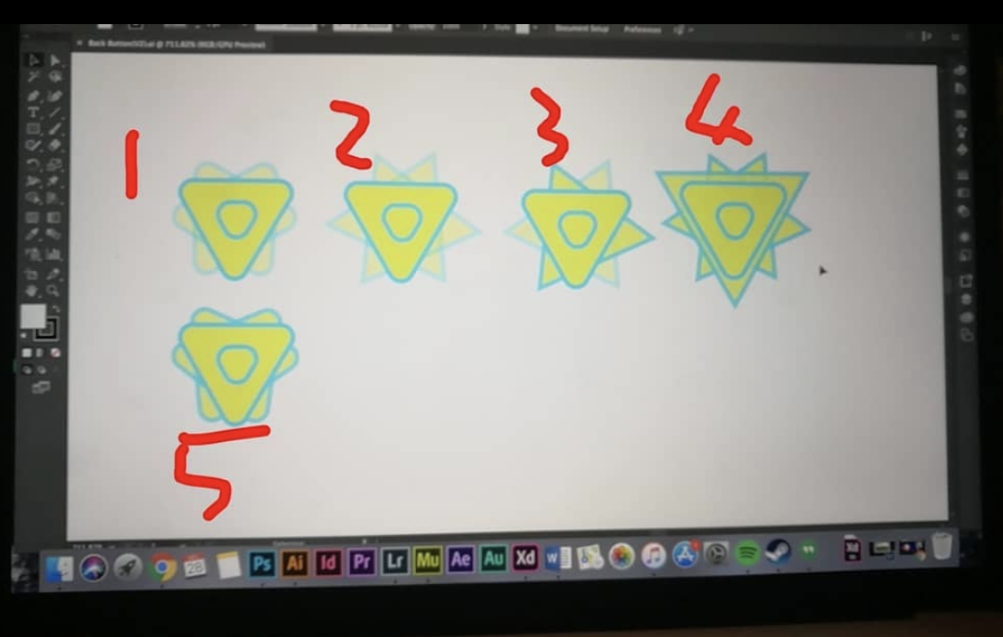
I made 5 different logos and posted on ‘Instagram’, which logo I should go for, most of them said 5, so I decided to go with that one.
One fault I made with the logo, one of the commenters asked “How does the logo represent the app?”, which I think was a good point, as the logo doesn’t really stand for anything.

Fourth/Final Design
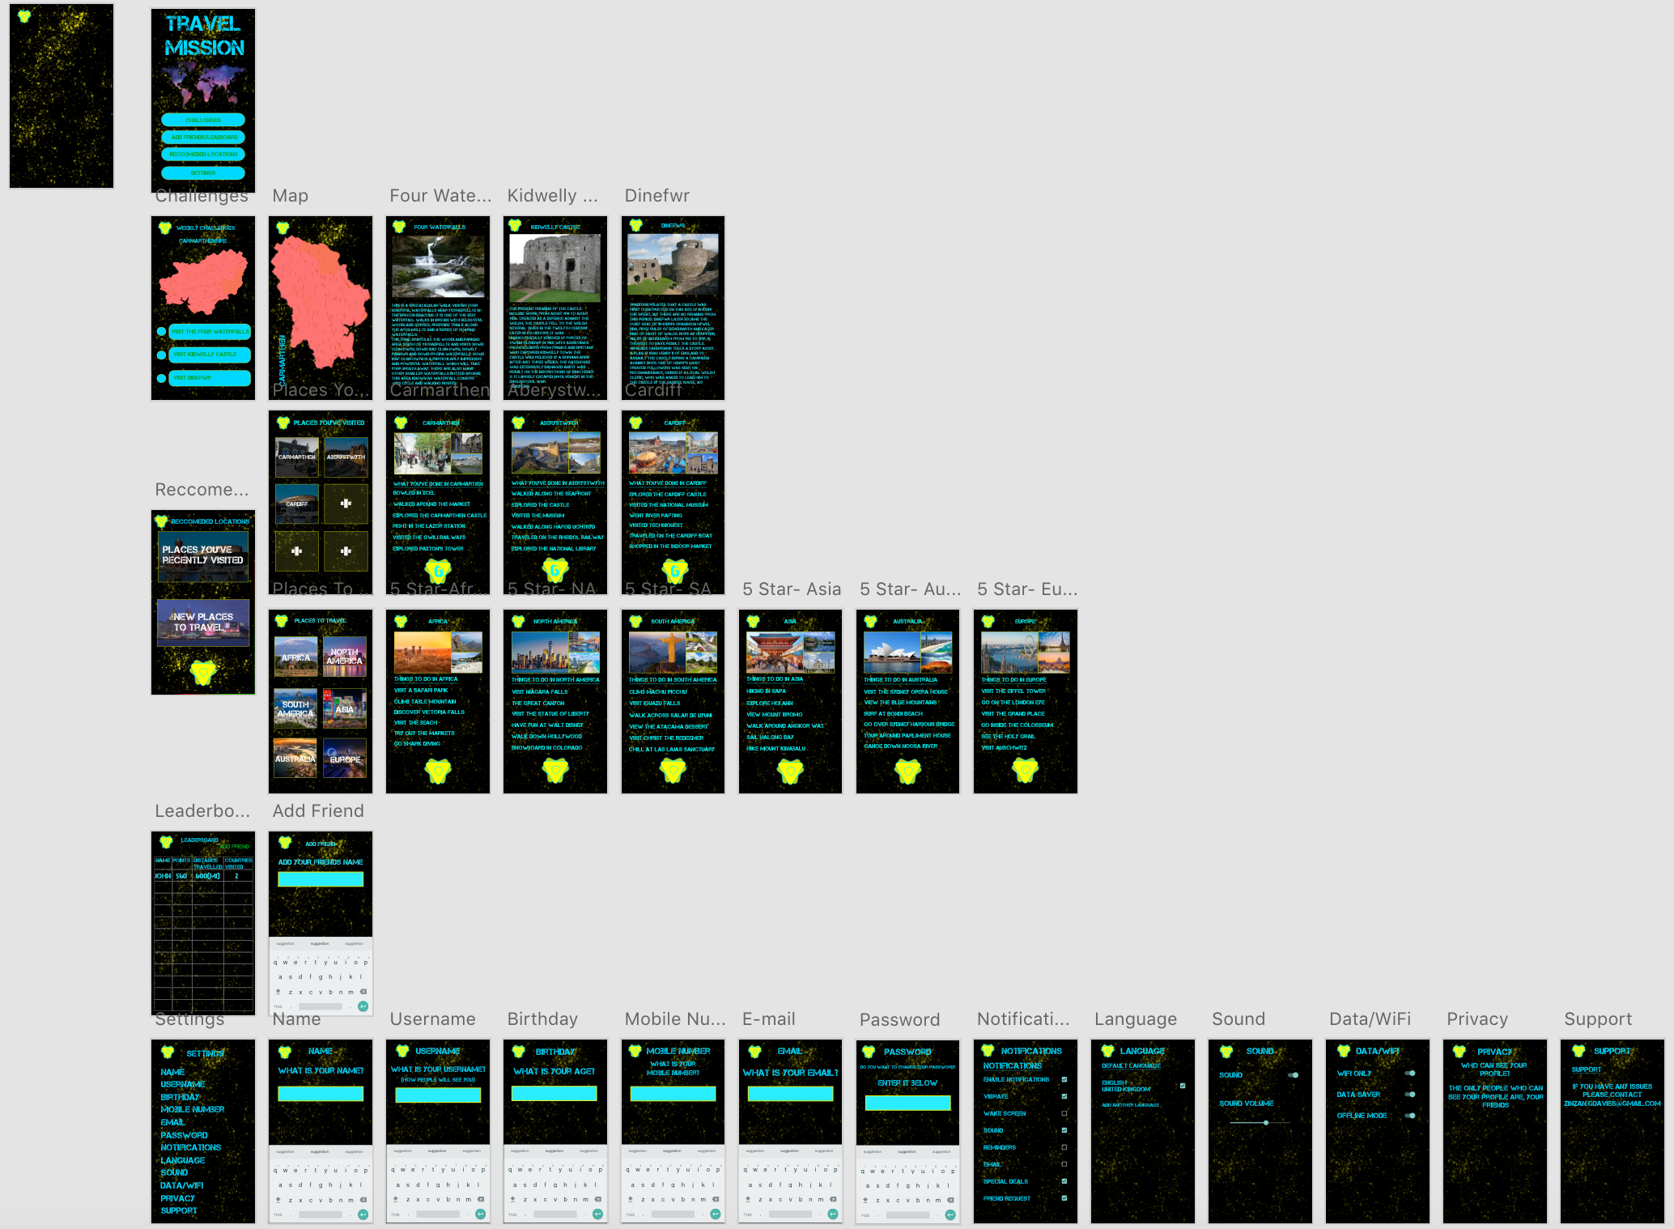
I changed the background again, as I still wasn’t comfortable with the others, so I made this background in photoshop and just added ‘Kylie’s Spatter Brushes’ which was in yellow, this was meant to represent the stars in space.
For the ‘Weekly Challenges’ I added a button, so if you’d click on the county, it would enlarge onto another page. The one problem I had with this was, the text was still a bit pixelated. You could also click on the challenges, so they’d know more about it. One of the problems with this is, the font is difficult to read, so I would change this in the future
In places you’ve visited, there are six boxes at the moment, but the more locations you visit, the more you will unlock.
If you click on a location, It will show you three pictures of the locations and the things that you did there. At the bottom, it will show how many challenges you have done.
For the ‘Settings’, I added a lot of tools from the ‘Google Material’ ‘UI Kits’, so this would help with the user interface.

Pseudocode

INPUT ‘Challenges’
OUTPUT ‘Weekly Challenges’
INPUT ‘Visit Dinefwr’
OUTPUT ‘Dinefwr’
UNTIL ‘Dinefwr’
Conclusion
I the app did most of what I wanted to create, one of the things I didn’t manage to add what the discounts and leveling up your account, It was unfortunate I couldn’t add this, but maybe If I had more time, I would be able to.
I decided not to add transitions because, I didn’t think they were needed, maybe if each background was different from each page, it would work.
I think I could’ve shown more people my work, because I think it did help when I’d show my app to some people and they’d give me their opinion on something and it would always be useful.
Another thing I could’ve done was, have a mood board and have a colour palette, as I never really stuck to one.

