Emma Jenkinson ……………………P143027………….………Textiles for Interiors

Fatal Flora

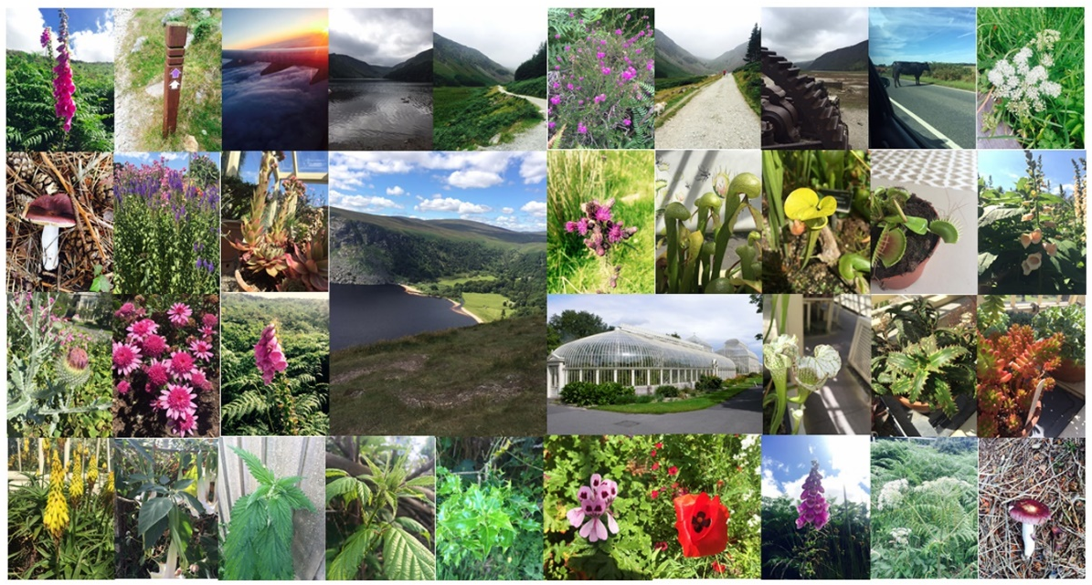

The Brief
From my time in Ireland during the summer break I have built up a bank of research including photographs and drawings of poisonous, carnivorous and herbal plants. The idea to study ‘dangerous’ plants originated from my final project in the second year, which consisted of tropical plants with snippets of Venus fly traps. Whilst creating drawing studies of Venus fly traps, I was enthralled with the concept of danger among the delicate.
For my final major project, I would like to go into more depth with this concept by combining poisonous and carnivorous plants with herbal and delicate plants, Creating a contrast between the ‘good’ and the ‘evil’. I think this concept is quite challenging and risky as using poisonous plants rather than a simple ‘pretty’ motif is quite uncommon. I must be careful not to make it look too menacing, maybe experimenting with processes to make the dangerous look beautiful.
Inspired by the concept danger among the delicate I aim to create a collection of wallpapers with three stories based on an overarching theme of nature, the collection will be called Fatal Flora. Each story will feature poisonous plants, contact poisonous plants (irritates the skin) and carnivorous plants, each will be intertwined with delicate florals. The stories will be called:
Lilium’s wrath / Pandemonium: poisonous plants
Venus’s Darlings / Enrapture: carnivorous plants
Ivy’s Scorn / Inferno: contact poisonous plants

Methods, Aims and Goals.
I intend on expanding my research by considering wallpaper companies, designers, artists and illustrators to enhance my drawing techniques and skills. Also, I intend to undertake shop reports in London, to give me a better understanding on how to create a design collection
I aim to produce a collection of high-end, luxury wallpapers, akin to Sanderson, Harlequin and Zoffany. Creating my own collection will be quite challenging as I have limited experience in this area. However, in doing so, I think this will benefit me significantly as this will broaden my skills and versatility in my portfolio. Also, I will have gained knowledge and experience for future projects and commissions.
The processes I intend to use for my wallpaper collection are traditional and digital. I will start off by creating detailed drawings using fine liners which can be either translated onto a traditional screen, or scanned digitally onto photoshop. Also, I intend to use techniques I found successful during the Advanced Creative Enquiry brief, such as pencil drawings, gouache, water colours and collage.
Traditional processes- screen printing with the use of puff binder, opaque binder, pearl binder, flock and foil, will give a raised appearance.
Digital processes- Photoshop with the use of repeat patterns, filters, colour tints, and digital drawing, will give a flat matt appearance.
I also intend to combine both digital and traditional processes to create more of a dynamic collection. Using both processes will complement the concept of contrasting elements within my designs. For example, the use of screen printed puff binder over a digital print will give two very different effects. Creating a contrast between loud and delicate processes. The use of traditional processes will also broaden my skills and versatility in my portfolio as I normally tend to stick with the comfortability of digital design.

Inspiration
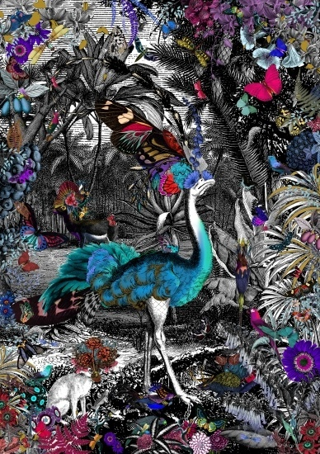
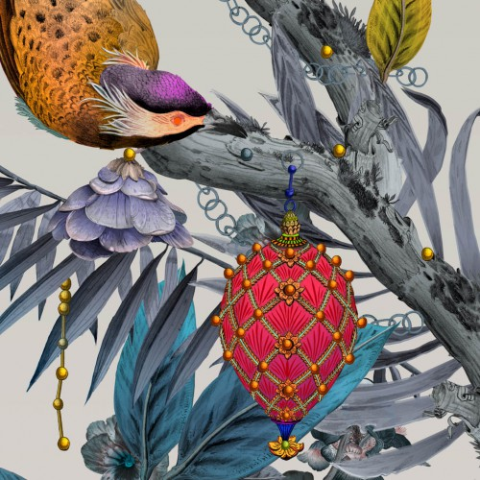
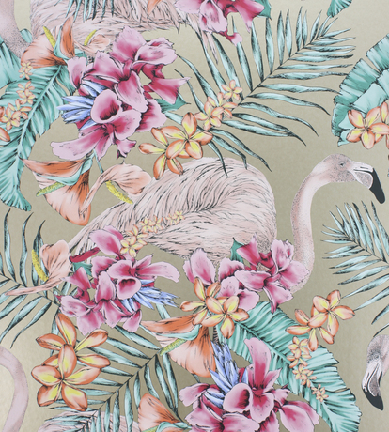

Left: Kristjana S Williams, Middle: Matthew Williamson, Right: Kit Miles

Above are three examples of artists and designers that most inspire my work. Both Kristjana S Williams and Kit Miles have influenced my work through out second year. I would like to continue to follow these artisits through out my major project as I feel they are still relevent to my work. I have recenly come across Matthew Williamson’s work through researching Osbourne & Little. All three artisits feature birds and other wildlife among dramatic florals. Although I am not incorparating wildlife into my designs, I still would like to feature another element into my drawings rather than only having nature as the focal point. To find a solution for this, I intend to carry out study trips to build up a bank of primary images and drawings.
Having taken part in a project for BBC, briefed by Camira Fabrics. I have learned how to simplify my drawings and to abstract my designs. I intend to bring these new skills forward into my major project as I feel my collection will significantly benefit from this. For example, I will still create elaborate and highly detailed wallpapers, but I will also create simplified coordinating wallpapers to balance out the collection.

