A critical evaluation of the impact a ‘Sustainable Customer Relationship’ has on an organisation and its customers

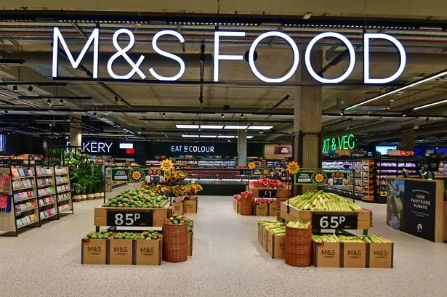


Student name: Cristina Limbau
Student number: 2410885
Lecturer name: Gwyneth Jones
Module name: Building a Sustainable Marketing Relationship (BMSW5007)
Date: 24th November 2025
University of Wales Trinity Saint David

Table of content

Contents
A critical evaluation of the impact a ‘Sustainable Customer Relationship’ has on an organisation and its customers 1
Table of content 2
Executive Summary 3
Introduction 4
Main Findings 5
1. M&S Food – Organisational Overview 5
1.1 Historical Development and Current Market Position 5
1.2 Mission, Values and Strategic Alignment 5
2. Data and Customer Relationships 7
2.1 Sustainable Customer Marketing Relationships 7
2.2 CRM and CRM Software System 7
2.3 M&S Food: Data Collection, Analysis, Evaluation 8
3. CRM Strategy Analysis 9
3.1 Segmentation, Targeting and Positioning 9
3.2 7P’s of Marketing 10
3.3 The 4Cs of Customer Needs 10
3.4 Ethics and Sustainability 11
4. Conclusion and Recommendations 13
4.1 Conclusion 13
4.2 Recommendations 13
5. Reference List 15

Executive Summary

This report examines how Customer Relationship Management (CRM) strategies influence organisational performance at M&S Food, with a focus on building sustainable customer relationships that support retention and loyalty. Operating in a highly competitive UK grocery sector, M&S Food strengthens its position through premium quality, innovation and responsible sourcing, although its market share remains modest compared with major competitors. Recent transformation efforts have improved financial performance, yet high operational costs and strong competition create ongoing pressures.
The analysis shows that data-driven personalisation through the Sparks loyalty programme plays a central role in segmentation, targeting and customer engagement. While these practices enhance loyalty, they also risk encouraging discount-driven behaviour and raise privacy considerations. M&S’s differentiation strategy and use of the marketing mix further support its premium positioning, though higher prices limit accessibility for some customers. Ethical and sustainability initiatives reinforce trust and emotional loyalty but also contribute to higher costs.
The report concludes that M&S has strong CRM foundations but would benefit from greater affordability, deeper loyalty experiences and clearer sustainability communication to strengthen long-term customer centrality and loyalty.

Introduction

Customer Relationship Management has become a central pillar of modern marketing, showing how organisations build long-term, profitable relationships with customers. Armstrong and Kotler (2020) emphasise that effective CRM begins with understanding customer needs and aligning marketing decisions around delivering long-term value. CRM provides a structured approach for understanding customer needs, creating personalised experiences and developing strategies that support retention and loyalty (Buttle, 2019). Its importance is evident within the UK grocery sector, where retailers face intense competition, shifting consumer expectations and rising demands for ethical, sustainable and digitally enabled services (Williams and May, 2022).
Within this context, customer centrality has emerged as a critical determinant of business success. By leveraging customer data, segmentation insights and targeted value propositions, companies are better equipped to strengthen trust and sustain loyalty (Kotler, Kartajaya and Setiawan, 2021). For M&S Food, a brand strongly associated with quality and innovation, effective CRM strategies support both competitive advantage and sustainable customer relationships in a market where switching behaviour is increasingly common (Li, Wang and Zhang, 2023; Marks & Spencer Group plc, 2025a).
This report evaluates how CRM strategies, policies and practices influence organisational performance at M&S Food, with a specific focus on building sustainable customer relationships that enhance retention and loyalty. It provides critical insights supported by academic theory and real-world examples, offering evidence-based recommendations for strengthening the organisation’s long-term marketing performance.

Main Findings

M&S Food – Organisational Overview

1.1 Historical Development and Current Market Position
M&S Food has developed from a traditional premium retailer into a modern food division centred on quality, innovation and responsibly sourced products. Its long-standing emphasis on premium own-brand ranges has strengthened brand trust but has also limited its ability to compete directly with value-led supermarkets, making market agility essential (Marks & Spencer Group plc, 2025a).
Recent financial results indicate improved performance. M&S Food increased its market share to 3.9% and delivered strong sale growth during the latest financial year (Marks & Spencer Group plc, 2025a). According to Statista (2025), Mark&Spencer continues to hold a modest share of the UK grocery market compared to larger competitors. Despite this growth, its share remains relatively small within a consolidated UK grocery sector dominated by larger retailers, reinforcing its position as a niche, quality-focused player. The competitive pressure within the UK food retail sector has intensified, with recent reporting suggesting that M&S Food’s revamp has contributed to increased rivalry with key competitors such as Waitrose (Daily Mail, 2023) Profitability has recovered, yet it remains sensitive to inflationary pressures and the higher costs associated with premium sourcing and production (BBC News, 2023; CommonShare News, 2025). This highlights a strategic tension between maintaining high-quality standards and ensuring long-term financial resilience in a competitive environment.

1.2 Mission, Values and Strategic Alignment
Marks & Spencer’s organisational mission is: “to bring the magic of M&S through exceptional quality, value, service and innovation to every customer, whenever, wherever and however they want to shop with us” (Marks & Spencer Group plc, 2025b). This purpose aligns closely with M&S Food’s reputation for premium quality, responsible sourcing and customer-oriented innovation (Marks & Spencer Group plc, 2025c).
Critically, however, the mission places limited focus on customer relationships, loyalty-building or personalised engagement despite these being central to sustainable CRM outcomes. Effective CRM requires explicit commitment to customer centrality and long-term relationship value (Ferrer-Estévez and Chalmeta, 2023). Without direct reference to relationship management within its purpose, the organisation risks leaving CRM objectives implicit rather than strategically integrated. Strengthening the mission to reflect customer insight, loyalty and engagement would better support M&S Food’s ambitions for sustainable customer relationships and retention.

2. Data and Customer Relationships

2.1 Sustainable Customer Marketing Relationships
Sustainable customer marketing relationships refer to long-term, trust-based interactions where organisations aim to continuously meet customer needs and create mutual value over time. According to Ferrer-Estévez and Chalmeta (2023), sustainable customer relationships depend on ongoing engagement, ethical practices and customer-centric value that supports loyalty. These relationships are critical for business success because long-term customers generate lifetime value, require fewer marketing resources and are more resilient to competitor promotions (Buttle, 2019). In the UK grocery sector, developing sustainable relationships is essential for protecting market share. Houlton (2023) notes that recent improvements to the M&S Food range have helped the brand reconnect with customers and increase shopper engagement.

2.2 CRM and CRM Software System
CRM is defined by Buttle (2019) as a strategic process that integrates people, processes and technology to understand customers and manage interactions throughout the customer lifecycle. CRM systems collect and store customer data, enabling businesses to analyse behaviour, segment customers and deliver personalised experiences that strengthen loyalty. Kotler, Kartajaya and Setiawan (2021) highlight that CRM technologies play a crucial role in supporting customer-centric strategies by enabling targeted communication and enhancing customer satisfaction.
However, CRM systems also present challenges. Gupta (2020) notes that poor data quality, technological complexity and weak organisational integration can reduce the effectiveness of CRM initiatives. Additionally, over-personalisation may raise privacy concerns if customers feel their data is being used excessively. These limitations demonstrate that CRM success depends not only on software, but also on responsible data maintenance.

2.3 M&S Food: Data Collection, Analysis, Evaluation

Data Collection
M&S Food collects customer data primarily through the Sparks loyalty programme, online shopping accounts, the M&S mobile app and in-store digital interactions (Marks & Spencer Group plc, 2025a). Sparks captures detailed behavioural information such as purchasing patterns, product preferences and response to promotional offers. This provides M&S Food with a strong basis for understanding customer needs and tailoring marketing efforts.

Data Analysis and Evaluation
Data collected through Sparks is analysed to segment customers, personalise offers and predict future purchasing behaviour. According to Marks & Spencer Group plc (2025a), Sparks insights enable targeted promotions and product recommendations, improving the relevance of communications. M&S also analyses sustainability-related preferences, ensuring alignment with its responsible sourcing commitments (Marks & Spencer Group plc, 2025c). These analytics support strategic decision-making, from store layout adjustments to digital marketing optimisation. Personalisation has become a key driver of retail differentiation, helping companies strengthen customer engagement and loyalty (Lindecrantz, Tjon Pian Gi and Zerbi, 2020).
The Sparks programme plays a key role in building long-term customer relationships by providing personalised rewards and offers based on shopping behaviour. This tailored approach strengthens customer recognition and encourages repeat purchases (BBC News, 2023). However, Sparks also has limitations. Its focus on discounts may create transactional loyalty, where customers engage for financial benefits rather than emotional connection. Additionally, data privacy concerns may reduce customer willingness to share information if transparency is not maintained (Gupta, 2020). Despite these challenges, M&S Food’s data-driven CRM practices significantly enhance the organisation’s ability to deliver personalised, value-driven interactions that support sustainable customer relationships.

3. CRM Strategy Analysis

3.1 Segmentation, Targeting and Positioning
The STP model is a marketing approach used to divide a market into meaningful groups, select the most attractive segments and position the brand to appeal to those customers (Kotler, Kartajaya and Setiawan, 2021). STP is important for CRM, because targeted communication and relevant offers make customers feel understood, which supports long-term loyalty (Buttle, 2019).
M&S Food relies on behavioural and psychographic segmentation, driven by data from the Sparks loyalty programme. Sparks collects information on product preferences, purchasing habits, dietary needs (Marks & Spencer Group plc, 2025a). M&S uses this data to target customers with personalised offers, weekly tailored discounts and exclusive experiences.
For example, Sparks rewards loyal customers with personalised vouchers and birthday treats, which helps strengthen engagement (BBC News, 2023). However, there is a risk that frequent promotions lead to customers return for discounts rather than brand attachment.
M&S Food positions itself as a premium, quality-led and ethically responsible food retailer (CommonShare News, 2025). The brand differentiates on quality, taste, packaging, sustainability and innovation.
A critical point is that this premium positioning limits the organisation’s ability to compete on price. Competitors like Aldi and Lidl offer strong quality at lower prices, challenging M&S Food’s ability to attract value-conscious shoppers.

3.2 7P’s of Marketing
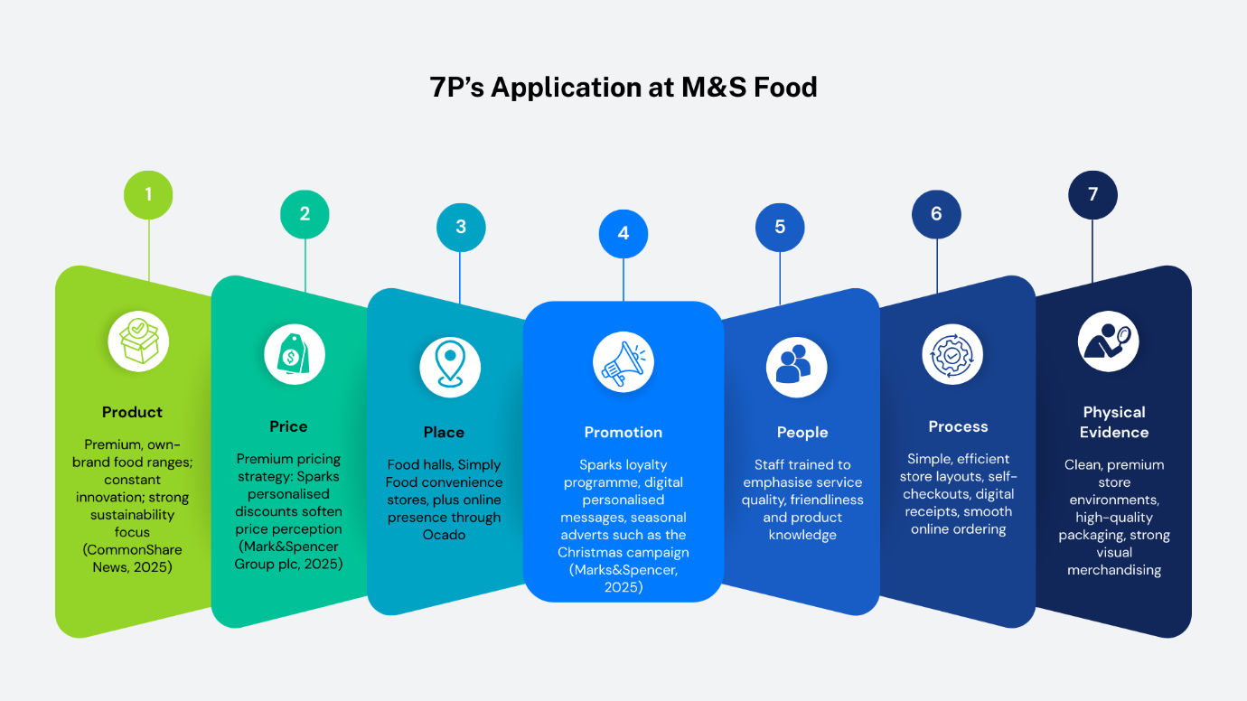
Porter (1980) identifies three generic strategies: cost leadership, differentiation and focus. M&S Food clearly follows a differentiation strategy, using superior quality, innovation and ethical sourcing to stand out in the crowded UK grocery market.

The 7Ps help M&S Food strengthen relationships by creating a consistent, high-quality experience. The premium product offering builds emotional loyalty, while promotions via Sparks provide personalised incentives for repeat purchases (BBC News, 2023).
However, price remains a barrier. Although the quality justifies the premium positioning, this excludes budget customers and limits loyalty among wider demographics. Gupta (2020) notes that customer trust and value perception are essential for long-term loyalty.

3.3 The 4Cs of Customer Needs
The 4Cs model, customer wants and needs, cost to satisfy, convenience and communication, places the customer at the centre of marketing strategy, promoting stronger alignment with customer expectations (Kotler, Kartajaya and Setiawan, 2021).

4C | Evaluation of M&S Food
Customer Wants & Needs | M&S Food responds to customer needs for high quality, freshness and ethically sourced products (Marks & Spencer Group plc, 2025c). However, customers seeking value-for-money may feel underserved.
Cost to Satisfy | M&S prices remain higher than competitors. Sparks rewards help reduce cost perception, but economic pressure makes premium pricing less attractive (BBC News, 2023).
Convenience | Strong convenience through small stores, ready meals and Ocado online delivery. Yet, M&S has fewer locations than Tesco or Sainsbury’s, reducing accessibility for some customers.
Communication | M&S uses personalised Sparks messages, email campaigns and seasonal adverts such as Christmas Advert (Marks & Spencer, 2025). A limitation is that heavy digital communication excludes less tech-aware customers.
While M&S meets many emotional needs (quality, ethics, branding), competitors may outperform them on functional needs such as price and store accessibility. This imbalance influences the depth of customer loyalty and proves that M&S must rely on differentiation to remain competitive.

3.4 Ethics and Sustainability

Ethics and sustainability involve responsible business practices that balance environmental, social and financial performance. This aligns with the Triple Bottom Line (people, planet, profit), which encourages organisations to create value beyond financial gain (Buttle, 2019). Ethical behaviour enhances brand trust and supports customer loyalty (CommonShare News, 2025). Lee and Charles (2021) highlight that customers are more likely to repurchase from retailers they perceive as ethical and transparent in their promotions. Tan (2024) notes that M&S’s Corporate Social Responsibility initiatives have become increasingly important for strengthening customer trust and long-term brand reputation.”
M&S Food promotes strong ethical standards, such as responsible sourcing, carbon reduction and waste minimisation (Marks & Spencer Group plc, 2025c). These align closely with consumer expectations for sustainable food systems. Seasonal messaging and media communications reinforce these values.
Ethical commitments come with higher operational costs, which contribute to premium pricing. Some researchers argue that when companies make environmental or sustainability claims that are not applied consistently across all products, consumers may perceive this as misleading, which can undermine trust (de Freitas Netto et al., 2020).
Ethical practices strengthen emotional loyalty by reassuring customers that their purchases support responsible values. If ethical initiatives raise prices, they may discourage lower-income consumers. Achieving the right balance between sustainability and affordability remains a challenge for M&S Food.

4. Conclusion and Recommendations

4.1 Conclusion

This report found that M&S Food applies several CRM practices that contribute positively to its performance and customer relationships. Personalisation through the Sparks loyalty programme strengthens engagement by tailoring offers to customers’ shopping habits (Marks & Spencer Group plc, 2025a). M&S Food’s commitment to quality, innovation and responsible sourcing also supports emotional loyalty, as customers increasingly value ethical and sustainability-driven brands (Marks & Spencer Group plc, 2025c; Ferrer-Estévez and Chalmeta, 2023). Its differentiation strategy enables M&S to stand out from price-led competitors and maintain a strong premium identity.
However, challenges remain. Premium pricing reduces accessibility for many customers, especially during economic pressure, which may limit long-term loyalty. Sparks creates engagement but can still encourage “promotion-driven” behaviour, meaning loyalty may be more transactional than emotional (BBC News, 2023). Furthermore, if sustainability messages appear inconsistent or overly promotional, customers may view them as misleading or exaggerated claims, which can weaken trust (de Freitas Netto et al., 2020).

4.2 Recommendations

To strengthen long-term loyalty and support sustainable customer relationships, M&S Food should:
- Enhance affordability, offering more value-focused choices without compromising quality.
- Develop deeper loyalty experiences within Sparks, such as exclusive events, personalised recipes or early product access.
- Ensure full transparency in sustainability communication to avoid mixed messages
- Invest further in customer-centric digital tools, improving convenience and personalisation for all customer groups.
These improvements would help M&S Food achieve stronger customer centrality and long-term loyalty.

5. Reference List

- Armstrong, G. and Kotler, P. (2020) Marketing: An Introduction, Global Edition. 14th edn. Pearson.
- BBC News (2023) ‘M&S revamp pays off with profit boost from food sales’, BBC News, 3 October. Available at: https://www.bbc.co.uk/news/business-67353897 (Accessed: 19 November 2025).
- Buttle, F. (2019) Customer Relationship Management: Concepts and Technologies. 4th edn. Routledge. Available at: https://doi.org/10.4324/9781351016551
- CommonShare News (2025) ‘Marks & Spencer’s Global Food Strategy: Unlocking New Market Opportunities’, CommonShare News, 27 February. Available at: https://news.commonshare.com/blog/marks-spencer-s-global-food-strategy-unlocking-new-market-opportunities (Accessed: 18 November 2025).
- Daily Mail (2023) ‘Marks & Spencer revamp sparks supermarket war with Waitrose overhaul’, Daily Mail, 3 January. Available at: https://www.dailymail.co.uk/news/article-13438395/Marks-Spencer-revamp-Waitrose-overhaul-food-supermarket-war.html (Accessed: 17 November 2025).
- de Freitas Netto, S.V., Sobral, M.F.F., Ribeiro, A.R.B. and da Luz Soares, G.R. (2020) ‘Concepts and forms of greenwashing: a systematic review’, Environmental Sciences Europe, 32, 19. doi: 10.1186/s12302-020-0300-3
- Ferrer-Estévez, M. and Chalmeta, R. (2023) ‘Sustainable customer relationship management’, Marketing Intelligence & Planning, 41(2), pp. 244–263. doi: 10.1108/MIP-06-2022-0266
- Gupta, K. (2020) ‘Role of 4C’s of marketing mix in building trust to achieve brand loyalty in case of fastener’s industry: a PLS SEM approach’, International Journal of Public Sector Performance Management, 6(5), pp. 587–604. doi: 10.1504/IJPSPM.2020.110131.
- Houlton, C. (2023) ‘The M&S Food revamp: How it’s winning over shoppers’, Grocery Gazette, 3 January. Available at: The M&S Food revamp: How its winning over shoppers (Accessed: 18 November 2025).
- Kotler, P., Kartajaya, H. and Setiawan, I. (2021) Marketing 5.0: Technology for Humanity. Chichester: John Wiley & Sons.
- Lee, L. and Charles, V. (2021) ‘The impact of consumers’ perceptions regarding the ethics of online retailers and promotional strategy on their repurchase intention’, International Journal of Information Management, 57, 102264. Available at: https://www.sciencedirect.com (Accessed: 17 November 2025).
- Li, L., Wang, Y. and Zhang, Y.Y. (2023) ‘A critical examination of M&S’s current strategic and marketing position, as well as potential sustainable competitive marketing strategies’, International Journal of Science and Business, 18(1), pp. 108–117. doi: 10.5281/zenodo.7572224.
- Lindecrantz, E., Tjon Pian Gi, M. and Zerbi, S. (2020) ‘Personalizing the customer experience: Driving differentiation in retail’, McKinsey & Company, 28 April. Available at: https://www.mckinsey.com (Accessed: 18 November 2025).
- Marks & Spencer (2025) The M&S Food Christmas advert. Available at: https://www.marksandspencer.com/food/content/christmas-food-tv-advert (Accessed: 18 November 2025).
- Marks & Spencer Group plc (2025a) Annual Report and Financial Statements 2025. London: Marks & Spencer Group plc. Available at: https://corporate.marksandspencer.com (Accessed: 19 November 2025).
- Marks & Spencer Group plc (2025b) Responsible Marketing. Available at: https://corporate.marksandspencer.com/sustainability/our-products/responsible-marketing (Accessed: 18 November 2025).
- Marks & Spencer Group plc (2025c) Sustainability. Available at: https://corporate.marksandspencer.com/sustainability (Accessed: 19 November 2025).
- Porter, M.E. (1980) Competitive Strategy: Techniques for Analyzing Industries and Competitors. New York: Free Press.
- Statista (2025) Marks & Spencer – Statistics & Facts. 5 August. Available at: https://www.statista.com/topics/3707/marks-and-spencer/ (Accessed: 17 November 2025).
- Tan, K.H. (2024) Strategic Analysis and Enhancement of Corporate Social Responsibility Practices at Marks & Spencer (M&S). Graham International University.
- Williams, A. and May, J. (2022) ‘A genealogy of the food bank: Historicising the rise of food charity in the UK’, Transactions of the Institute of British Geographers, 47(3), pp. 618–634.

