Student Name: | Stacy-Ann Watson
Student Number: | 2238279
Module Code: | LCHS7003
Module Title: | Community Care and Management of Longer-term Conditions
Lecturer’s Name: | Dr Aishat Bakre
Assignment Title: | Component 1: Information Booklet of Long- term Condition Management

Table of Contents

- Introduction ………………………………………………………………………………….. page 3

- Explanation and Evaluation of Asthma as a Long-Term Condition…………………… Page 4

- A Critical Evaluation of Impacts…………………………………………………………… page6

- Identifying and investigating current theoretical perspectives, including models and care agendas local………………………………………………………………………………… page7

- Critically examining the implementation of local and national political health and social care agendas local……………………………………………………………………………….. Page11

- Recommendations for improvement……………………………………………………... Page14

- Conclusion……………………………………………………………………………….…. Page 14

- Reference list………………………………………………………………………..…….. page 16

Information Booklet: Long-Term
Condition Management-ASTHMA

1. Introduction
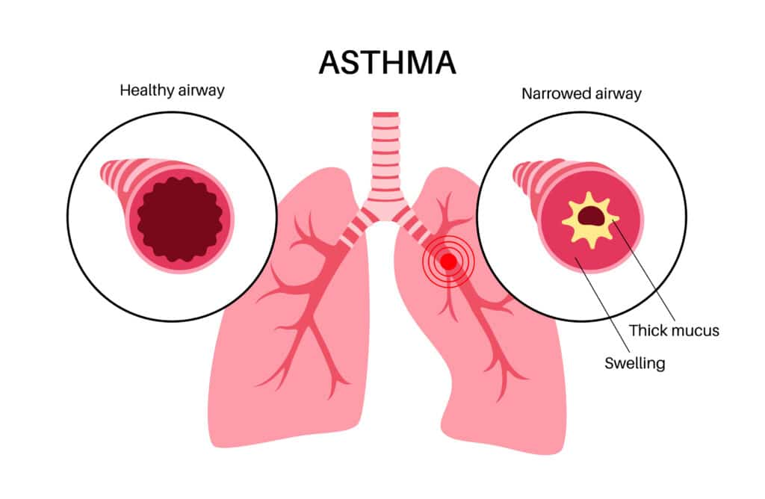
Asthma is a chronic respiratory condition characterised by persist airway inflammation, variable airflow limitation, and a recurring pattern of respiratory symptoms including wheezing, dyspnoea, chest tightness, and coughing.
(source: carespace.health)

It represents one of the most common long-term conditions globally and within the United Kingdom, affecting people across all age groups and social backgrounds.

While asthmas cannot yet be cured, it is a highly manageable condition, and with appropriate support, medication, and self-management education, most people living with asthmas can achieve good symptom control and lead full, active lives.

However, significant disparities persist in outcomes, and asthmas continues to be associate with avoidable hospitalisation, reduced quality of life, and premature death.

This booklet examines asthma through a public health and community care lens. With person-centred principles at its core.

It explains the nature of asthmas as a long-term condition, analysing its physical, psychological and social impacts and explores the theoretical frameworks-including person-centred care that underpin modern asthma care.

National guidelines and local delivery in West Midlands are reviewed, alongside the challenges that prevent consistently.

Finally, evidence-based recommendations are proposed to improve care delivery, reduce inequalities, and strengthen support for individuals, families, and communities affected by asthmas.

2. Explanation and Evaluation of Asthmas as a Long-Term Condition

Definition and Nature of Asthma:
A long-term or chronic condition is defined as a health problem that persists six months or longer, requiring ongoing management, and may not have a definitive cure.

People living with such conditions typically need regular medication, monitoring, and lifestyle adjustments to maintain health and wellbeing.

Asthma fits this definition precisely: it is a heterogeneous condition involving chronic inflammation of the bronchial airways, which become hyper-responsive to various triggers, leading to reversible narrowing and obstruction of airflow (Papi et al., 2022).
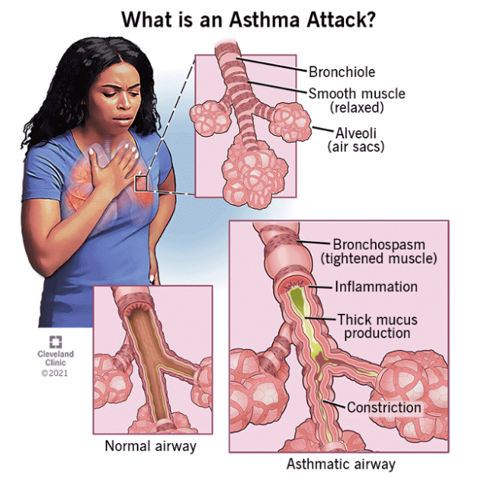
(Source: touchofgod.org)
Symptoms vary widely between individuals and over time, ranging from mild occasional wheezing to severe, life-threatening attacks. Although symptoms may disappear for periods, the underlying inflammation and airway hyper-responsiveness remain, meaning asthma requires lifelong monitoring and management (Kapri et al., 2023).
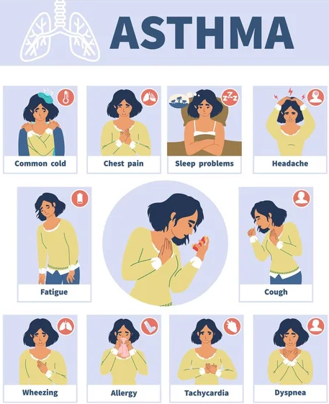

(Source: VectorStock)

Asthma is increasingly recognised not as a single disease, but as a collection of different phenotypes and endotypes distinct subtypes defined by underlying biological mechanisms, patterns of symptoms, age of onset, and response to treatment. This heterogeneity explains why people experience asthma so differently and why some respond better to certain therapies than others (Cazzola et al., 2022).

Common subtypes include allergic asthma, which typically begins in childhood and is linked to hay fever and eczema; non-allergic asthma, which develops later in life and is triggered by factors such as stress, cold air, or respiratory infections; and severe asthma, which remains poorly controlled despite maximum standard treatment and requires specialist referral and targeted therapy.

Global and UK Prevalence and Burden:
The World Health Organisation estimates that approximately 363 million people worldwide live with asthmas, resulting in around 442,000 deaths annually, the majority occurring in low-and middle-income countries where access to basic medication and care is limited (World Health Organisation, 2024). Global prevalence continues to rise, particularly in urbanising regions, driven by changes in environment, lifestyle, and air quality.

In the United Kingdom, asthma is one of the most significant public health challenges. It affects approximately 5.4 million people equivalent to nearly 8% of population including 1.1 million children and 4.3 million adults (Asthma and Lung UK, 2025). Around 160.000 new diagnoses are recorded each year.

Every day in the UK, approximately 200 people are admitted to hospital with asthma, and around three people die from an asthma attack most of which are considered preventable (Asthma and Lung UK, 2025).

There are also marked regional and socioeconomic variations, prevalence and hospital admission rates are significantly higher in urban areas and in communities experiencing greater deprivation. Birmingham, as a large industrial city with areas of high deprivation and poorer air quality, experiences some of the highest asthma prevalence and admission rates in the country (Birmingham City Council, 2025).

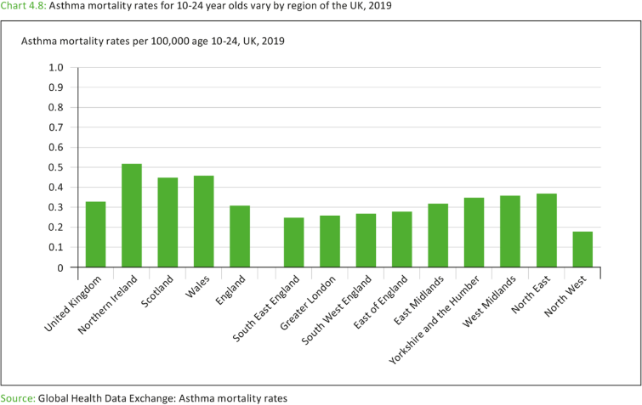
(source: AYPH-Youth Health Data)

3. A Critical Evaluation of Impact:

Physical Impact:
Risk factors | Details
Genetic predisposition | A family history of asthma, eczema, or hay fever significantly increases individual risk, indicating a strong heritable component to the condition (Department of Health and Social Care, 2025). However, genetic alone do not determine whether someone will develop asthma environmental interactions are critical. disorder in the family and possibility of allergic conditions increase the risk of asthma among adults (GOV, 2025).
Air pollution | Different types of indoor and outdoor pollution create irritation in the airway and that contributes to the risk.
Tobacco smoke exposure | Maternal smoking during pregnancy and passive exposure in childhood are strongly linked to asthma development in children. Active smoking in adulthood worsens symptoms, reduces medication effectiveness, and accelerates lung function decline  (Soremekun et al., 2023).
Lifestyle | Excess body weight is an independent risk factor for asthma, particularly in woman, obesity related asthma is often more difficult to control and less responsive to standard inhaled steroids. (Cazzola et al., 2022).
Respiratory infection | Viral infections such as rhinovirus and influenza are the most common triggers for acute exacerbations and may contribute to the initial onset of asthma in genetically predisposed individuals (Papi et al., 2022).
Environment allergy | Prevalence of different allergic conditions like eczema and rhinitis often lead to the increasing risk.
The overall evaluation of this long-term disorder figures out it as a chronic respiratory condition that can be effective throughout the life of a patient. The critical study shows that the implication is not only physical but influence the overall psychological well-being and social inclusion of an individual. Different types of monitoring and support are required in this regard, and it can affect the life of the family members as well due to the severity (World Health Organization, 2024).

Physical Implications:
Different types of physical implications like coughing, wheezing, and shortness of breathing are the chronic consequences of asthma. Intermittent or persistent symptom Canvas in the condition and poor control eventually restrict the everyday activities. The severe consequence of acute asthma attack main required emergency treatment and it is found from the study of the NHS that severity can be controlled through the inhalation of proper medicine GOV, (2025).

Psychological implications:
Where can be significant psychological consequences like anxiety, fear and stress among individual who have experienced severe level of asthma, and this type of psychological implications eventually creates another cycle of breathing difficulty that leads to acute level of
asthma (Philip et al., 2022).

It is necessary to treat psychological effect as primary and significant to control the fear and avoid the possibility of having asthma attack. Proper education, action management and opportunities are required with the concerns of the professionals in this regard.

Social implications:
Due to the issues of environmental pollution, there are range of restrictions for the individuals who are diagonals with asthma. Social relationships are affected due to these and different type of limitations lead to the issues of social exclusion and withdrawn. The critical study shows that social consequences are not inevitable. According to the study of the NHS, effective treatment and appropriate education with reasonable adjustment will be effective for the management of social implications (Poamaneagra et al., 2024).

Wider context:
Apart from the patients, Asthma has wider level of impact on families and carers as well. There are issues of emotional anxiety, tension, financial and practical burden for the monitoring and maintenance of the patient in the long run. Critical study shows that the environment of family and friends can be positive to motivate the patients and educate them to avoid the possibility of exacerbation (NHS England, 2026).

4. Identifying and investigating current theoretical perspectives, including models and frameworks:
Treatment | Purpose and evaluation
Anti-inflammatory reliever inhaler (AIR) | Simplify the process of treatment with relaxation
Maintenance and reliever therapy (MART) | Important for prevention of symptom and an important approach to start the treatment
Biological therapy | An important option to manage severity (NHS England, 2026).
Oral corticosteroid | Highly impactful for acute derivation
Nebulizer and oxygen | Important emergency intervention (NHS England, 2024).
Current Theoretical Perspectives in Long-Term Condition Management:
The management of LTC from the theoretical perspective defines asthma as a disease whose management requires continuity and should ideally be done in a collaborative manner since it cannot be addressed on its own (Papiet al., 2022). Airway inflammation has been associated with the biopsychosocial theory, anxiety, restriction of activities, and disruption of socialisation, while the self-management theory emphasises knowledge and skills. Evaluation needs to incorporate and relate theory with outcomes like symptom control, exacerbations and quality of life.

According to the World Health Organisation (2024), there are 262 million people affected by asthma in the world, and it is responsible for more than 450,000 deaths every year, showing the benefits of frameworks, but individual responses and the capacity to implement them differ and are still a limit identified throughout diverse patients and families.

UK Model: NHS House of Care Model for Person-Centred Asthma Management:
According to NHS England (2024), the NHS “House of Care” represents an example of person-centred management in the United Kingdom, as there is an association between people based on their need to be involved and informed; care is also associated with proactive preparation.

When used in asthma, it can be used to help deliver personalised care planning, joint decision-making, review and coordinated care. It strengthens consultation that moves from the clinicians to the partnership and self-management.

For example, an asthma nurse may be able to agree an asthma plan with an individual and the technique of inhalers. There are benefits to prevention and continuity of services, but the capacity of the workforce is a limitation, as is the digital access to and the inconsistent use of prevention across NHS settings and care.
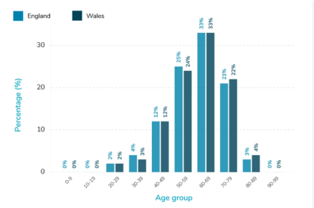
Source: (NHS, 2023)

International Model: Chronic Care Model and Its Application to Asthma:
According to Goh et al. (2022), the Chronic Care Model (CCM) has been developed to make health services take a proactive approach to managing chronic conditions and consists of six elements. Health system organisation, community resources, self-management support, delivery system design, decision support and clinical information systems.
For asthma, these components work to facilitate recalls, action plans, guideline-led prescribing and monitoring. For instance, there are patterns that can be seen, and then the review for those patients who experience recurring attacks of exacerbation can be done (Skolnik et al., 2024).

There are about 262 million people suffering from asthma worldwide. This process is scalable; however, the need for high-quality data is essential.

Comparative Evaluation of UK and International Models:
Comparative Evaluation addresses the person-centred approach to care in the NHS model of House of Care as well as personalised and supported self-management, whereas the CCM international model addresses the design of organisations for proactive chronic disease management.

NHS House of Care model is the most relevant one for NHS integrated pathways, and CCM brings in flexible components for systems (Eustace-Bowman, 2026).

Asthma has a connection with population registers with recall systems and an action plan. Shortcomings: duplication, resource consequences, variations in different populations; Strengths: continuity and prevention of diseases.

Evidence-Based Frameworks for Asthma Self-Management and Patient Activation:
According to NHS (2025), evidence-based self-management frameworks enable patients to identify symptoms, take medications properly, detect worsening and implement agreed plans. Patient activation is the process of knowledge, skills and confidence that empower them to make decisions.
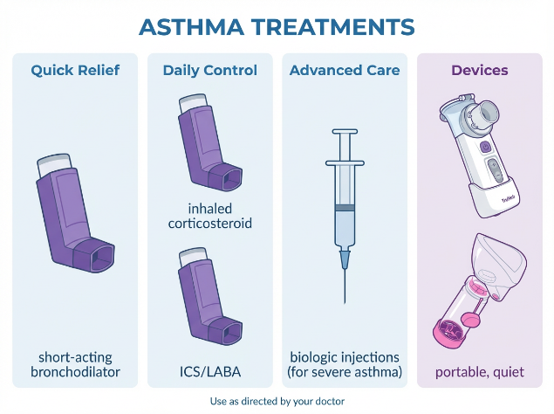
(Source: blog.truneb.com)

Teaching to use the inhaler properly, to identify when it may be worsening and have them to have a written plan. Benefits include autonomy, earlier intervention and adherence.

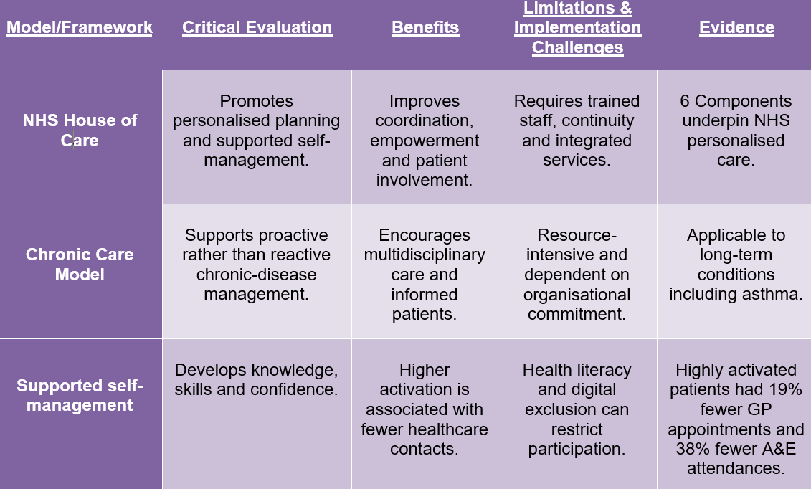
Challenges are health-literacy gaps, lack of engagement, anxiety, language issues and behavioural maintenance. An organised education program thus can minimise unnecessary worsening and use of emergency health care services in the long term.

Applying Theoretical Models to Improve Asthma Outcomes and Quality of Life:
Implementation of theoretical approaches in the case of asthma requires making them practical for the patients. The House of Care plan can be linked with the CCM register, review, checking inhalation technique, and development of a personalised plan during practice (Pinnock et al., 2023).

If someone suffers from three exacerbations within a year, the chances are they may not need to have more emergency medication. For three exacerbations within a year, a patient may receive education and coordinated follow-up, and a medication review.

The advantages encompassed improved symptom control, a sense of confidence and continuity, and early intervention. These include severity, triggers, co-morbidities, and issues with adherence, unequal access to respiratory services, and limitations of routine NHS practice.

Critical Evaluation of Models and Frameworks: Strengths, Limitations and Implementation Challenges:
Figure: Critical Evaluation of Models and Frameworks
(Source: Author)

According to NHS England (2023), it is very important to concentrate on the strengths of the models and frameworks using critical analysis.

The framework can help in decision-making based on the person-centred approach, promoting patient self-management and care coordination, as well as the reduction in the number of avoidable exacerbations.

The House of Care model promotes personalisation of the NHS services, while CCM helps to enhance the technology infrastructure and information technology. Some of the limitations include the lack of staff, conflicting goals, lack of data, digital divide, health literacy, as well as uneven local capability and resources (Moyo, 2025).

The pandemic of asthma affects 262 million people worldwide; therefore, scalability is required but must be context-based.

5. Critically examining the implementation of local and national political health and social care agendas Local
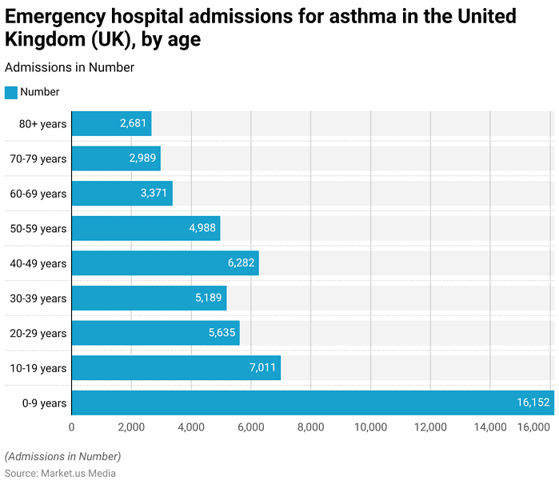
(source: Market.us Media)

Health and Social Care Agendas for Asthma Management:
The focus on Integrated Care Systems (ICSs), primary care networks and councils in coordinating asthma prevention, diagnosis and ongoing care is set out in local health and social care agendas. Their implementation should enable national standards to be translated to a local targeted service such as Action Plans, inhaler checks and asthma reviews.

There are local deprivation, housing, air quality and access to services that will need attention for evaluation. There continued to be a demand for emergency asthma admissions at 39,384 in England in 2024/25 (Poamaneagra et al., 2024).

Advantages: Intervention at an early stage and teamwork; Disadvantages: The availability of the labour force.

National Political Health and Social Care Agendas for Asthma Care in England:
According to Santoni et al. (2025), there are national political health and social care strategies which form the basis of the priorities that are involved in the prevention of asthma, early diagnosis, personalisation and the reduction of admissions to hospitals where it is not necessary.
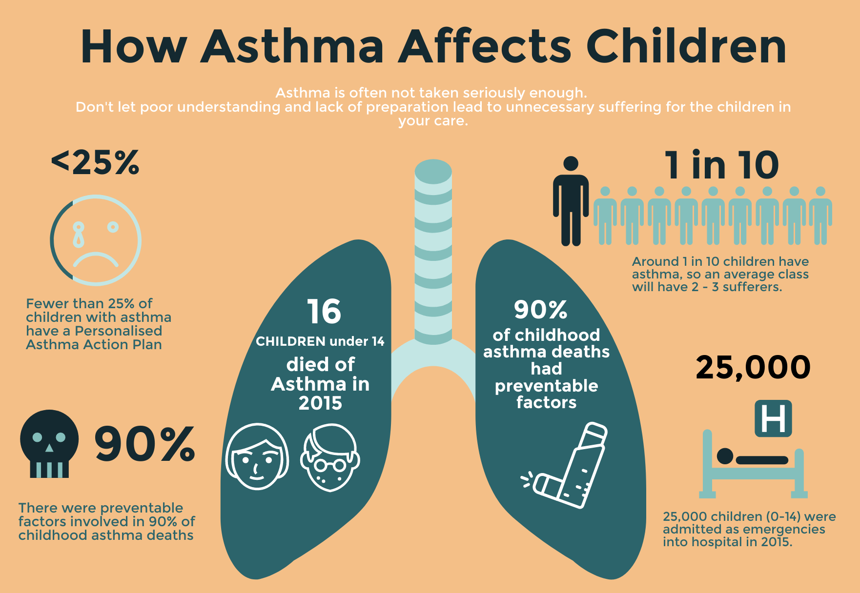
(source: HTSTraining)

The asthma program of NHS England and the programs for children’s asthma align with the priorities of the government by making the priorities measurable service objectives. Large numbers of adults admitted to hospital with emergency asthma in England (39,384) in 2024/25 (Choi et al., 2025).

Advantage: Is the “accountability” and “standardisation”; Drawback: Other priorities, budget and different local capacity implementation.

NHS Long-Term Condition Policy and Its Relevance to Asthma Management:
Asthma is a long-term condition where treatment for acute attacks is considered episodic and is not the goal of NHS long-term condition policy. Its significance is in the aspect of provision of care and support in accordance with individuals' wishes and preferences, accommodating support for individuals and families, collaboration and working with a range of professionals and prevention of avoidable deterioration.

Strategies for the approach include annual asthma reviews, optimisation of medications and structured asthma education. Sustained workload in primary care with approximately 80,000 new asthma diagnoses per year (NHS England, 2026).

The advantages are continuity, empowering the patient and earlier intervention; the disadvantages are inequalities of access, fragmented records, time pressures and barriers in maintaining self-management support between contacts with clinicians.
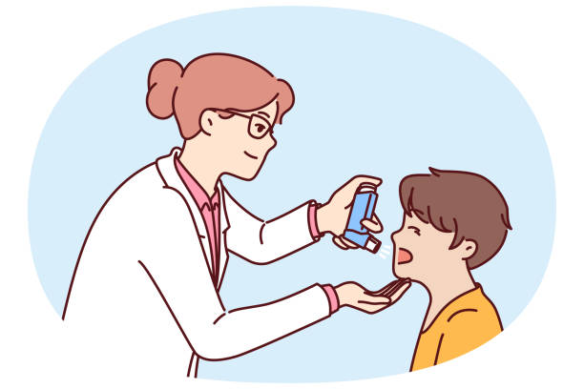
(source: istockphoto.com)

Implementation of National Asthma Guidelines and Evidence-Based Standards:
The guidelines for evidence-based medicine serve as a source of national principles guiding the decision-making process regarding proper diagnosis and management of asthma in a systematic way.

According to Ziad and Green (2026), the guidelines for BTS/NICE/SIGN 2024 state that objective testing, personalised medicine and correct inhalation therapy should be utilised without the use of SABA monotherapy in the specified patient population. An example of this is the introduction of indicators for the objective testing and annual asthma reviews in the current (2025/26) GP contract.

The pros and cons are measurable improvement in quality; cons are access to equipment; training staff; complexity of diagnosis; and variations and discrepancies in adherence to guidelines.

Local–National Integration: Reducing Health Inequalities in Asthma Outcomes:
Local National integration involves expressing national asthma priorities in a locally focused asthma service that would reach broader stakeholder needs, such as social and environmental factors. Asthma is not one of the other ten conditions prioritised by the five other conditions in Core20PLUS5, highlighting lower reliever overuse and fewer attacks (Hooper, 2024).

Evaluation needs the combination of national indicators and local deprivation, housing and access data for ICSs. But not in all areas of England were the rates of admission of adults to hospital emergencies due to asthma during 2024/25 always at 79.5 per 100,000 (Hui, 2025).

The strength of the project is its preventive and equality aspect, while its weakness lies in the aspect of non-participation and socio-economic hindrances to participation and success.

Developmental Initiatives for Improving Asthma Prevention, Diagnosis and Management:
Developmental programs seek to improve the prevention, detection and treatment of asthma by allowing accurate assessment, optimisation of inhalers, asthma action plans and follow-ups after attacks.

Spirometry, optimisation of medicines and personalised asthma action plans are regarded as high-impact interventions on the NHS England’s intervention hierarchy. Evaluation will allow the transformation of health care from reactive health care to preventive health care through such practices as evaluating children who have returned to the local facility after being seen in emergency services on the effectiveness of their inhalers (McCrossanet al., 2024).
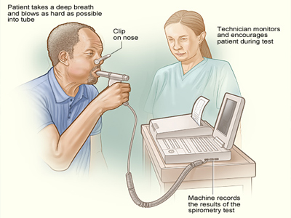
(Source: asthmaallergynetwork.org)

Pros include early intervention, safe medication and self-management, while cons include staff training and appointment capacity
.

6 Recommendations for improvement:
- Personalise care plans: agree goals, triggers, medications, inhaler techniques, actions, and reviews on an individual basis with the patient and their family members.

- Enhance self-management: educate patients, action plan, teach back, symptoms identification, and ensure fast access pathways following exacerbation/deterioration.
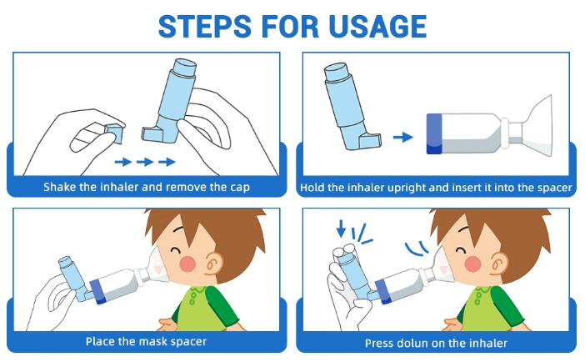

- Enhance coordination: coordinate GP care, respiratory nurse specialist, pharmacist, schools and other local services via record sharing, specialist referral, and discharge planning.

- Tackle inequalities: target vulnerable population groups via registries, prioritise deprived areas tackle housing and pollution, and ensure cultural and communication accessibility.

- Plan future care: for people with severe, life-limiting asthma, conduct early advance care planning, symptom management, family support, and end-of-life planning.

7. Conclusion:
Asthma is a common, lifelong, and complex condition that touches every part of a person’s life their physical health, emotional, wellbeing, social relationships, education, employment, and future opportunities. It is also a condition of stark contrasts, for some, it is a mild inconvenient easily managed; for others, it is a daily struggle shaped by poverty, poor housing, pollution, and fragmented services.

Asthma’s outcomes are ultimately a measure of social justice how well a society protects its most vulnerable members.

Modern frameworks such as the House of Care and Chronic Care Model provide the foundations for excellent care, and national guidance sets clear standards for what should be delivered.

Birmingham has made meaningful progress, establishing specialist hubs, expanding pharmacy roles, and linking with the housing and environmental partners. Yet ambition outstrips delivery. Progress is slowed by workforce shortages, fragmented systems, and deep-rooted inequalities that medication along cannot resolve.

Improving asthma outcomes will require more than better clinical guidelines. It will require a commitment to person-centred care-ensuring every person with asthma understands their condition, feels confident managing it, and has the support they need from informed professionals.

It will require a commitment to equity-directing resources to the communities where the burden is heaviest rather than where delivery is easiest. And it will require a commitment to partnership bringing together health services, local government, communities, and individuals to address not just the symptoms of asthmas, but the environments and inequalities that cause it. When people breathe well, they live well and that is the goal.

Reference List
Asthma and lung, (2025) Air pollution and asthma. Available at: https://www.asthmaandlung.org.uk/conditions/asthma/asthma-triggers/pollution. (Accessed: 25 September 2026).
Cazzola, M., Rogliani, P., Ora, J., Calzetta, L. and Matera, M. (2022) ‘Asthma and, 20266rbidities: recent advances.’ Polish archives of internal medicine. Available at: 10.20452/pamw.16250. (Accessed: 25 September 2026).
Choi, E.-Y., Bea, S., Lee, H., Choi, A., Han, J.Y., Kang, E.H. and Shin, J.-Y. (2025) “Exposure to antibiotics during pregnancy or early infancy and the risk of autoimmune disease in children: A nationwide cohort study in Korea,” PLOS Medicine. Edited by L.Å. Persson, 22(8), op. 10-77. Available at: https://doi.org/10.1371/journal.pmed.1004677. (Accessed: 25 September 2026).
Eustace-Bowman, I. (2026) Integrated care for patients following acute stroke: Evidence synthesis and development of a novel holistic approach to stroke care, Ljmu.ac.uk. Edited by K. Higginbotham, I. Jones, B. Buckley, and G. Lip. Available at: https://researchonline.ljmu.ac.uk/id/eprint/28579/. (Accessed: 30 September 2026).
Goh, L.H., Siah, C.J.R., Tam, W.W.S., Tai, E.S. and Young, D.Y.L. (2022) “Effectiveness of the chronic care model for adults with type 2 diabetes in primary care: A systematic review and meta-analysis,” Systematic Reviews, 11(1), p. 2-73. Available at: https://doi.org/10.1186/s13643-022-02117-w. (Accessed: 30 September 2026).
GOV, (2025) Asthma and airborne allergens. Available at: https://www.gov.uk/guidance/asthma-and-airborne-allergens (Accessed: 30 September 2026).
GOV, (2025) Respiratory disease profile: statistical commentary, June 2025 Available at: https://www.gov.uk/government/statistics/update-of-indicators-in-the-respiratory-disease-profile-june-2025/respiratory-disease-profile-statistical-commentary-june-2025 (Accessed: 7 October 2026).
Hooper, L. (2024) Sussex women’s health: Part 1 – exploring population health. Available at: https://www.sussex.ics.nhs.uk/wp-content/uploads/sites/9/2025/04/Sussex-Womens-Health_Part-1-Report_Final-25032024.pdf. (Accessed: 7 October 2026).
Hui, M.T. (2025) Health care delivery of asthma in health care systems across the world: A comparison of three health systems, MavMatrix. Available at: https://mavmatrix.uta.edu/honors_spring2025/9 (Accessed: 7 October 2026).
IQAIR, (2025) Air quality in United Kingdom Available at: https://www.iqair.com/in-en/air-quality/uk (Accessed: October 9, 2026).
Jsnaoldham.co.UK (2019) Joint strategic needs assessment | health conditions, Jsnaoldham.co.uk. Available at: https://www.jsnaoldham.co.uk/health-conditions/health-asthma/. (Accessed: 9 October 2026).
Kapri, A., Pant, S., Gupta, N., Paliwal, S. and Nain, S. (2023) ‘Asthma history, current situation, an overview of its control history, challenges, and ongoing management programs: an updated review.’ Proceedings of the National Academy of Sciences, India Section B: Biological Sciences, 93(3), pp.539-551. Available at: https://link.springer.com/article/10.1007/s40011-022-01428-1 (Accessed: 9 October 2026).
McCrossan, P., Shields, M. and McElnay, J. (2024) “Medication adherence in children with asthma,” Patient Preference and Adherence, Volume 18, pp. 555–564. Available at: https://doi.org/10.2147/ppa.s445534. (Accessed: 9 October 2026).
Moyo, G. (2025) “Bridging the Digital Health divide: AI-Powered telemedicine, policy barriers, and equity solutions for underserved communities,” Intech Open eBooks [Preprint]. Available at: https://doi.org/10.5772/intechopen.1010970. (Accessed; 12 October 2026).
NHS (2025) NHS England » supported self-management education guide, www.england.nhs.uk. Available at: https://www.england.nhs.uk/publication/supported-self-management-education-guide/. (Accessed: 12 October 2026).
NHS England (2023) The change model guide, NHS England. Available at: https://www.england.nhs.uk/wp-content/uploads/2018/04/change-model-guide-v5.pdf. (Accessed: 12 October 2026).
NHS England (2024) Person-centred care, NHS England. Available at: https://www.hee.nhs.uk/our-work/person-centred-care. (Accessed: 13 October 2026).
NHS England (2026) NHS England » annex: Operational performance update, www.england.nhs.uk. Available at: https://www.england.nhs.uk/long-read/annex-operational-performance-update-1-feb-24/. (Accessed: 13October 2026).
NHS, (2024) Symptoms of asthma. Available at: https://www.nhs.uk/conditions/asthma/. (Accessed: 13 October 2026).
Papi, A., Blasi, F., Canonica, G.W., Morandi, L., Richeldi, L. and Rossi, A. (2022) “Treatment strategies for asthma: Reshaping the concept of asthma management,” Allergy, Asthma & Clinical Immunology, 16(1), pp. 5-7. Available at: https://doi.org/10.1186/s13223-020-00472-8. (Accessed: 14 October 2028).
Philip, K.E.J., Buttery, S., Williams, P., Vijayakumar, B., Tonkin, J., Cumella, A., Renwick, L., Ogden, L., Quint, J.K., Johnston, S.L. and Polkey, M.I. (2022) ‘Impact of COVID-19 on people with asthma: a mixed methods analysis from a UK wide survey.’ BMJ open respiratory research, 9(1), p.e001056. Available at: https://bmjopenrespres.bmj.com/content/9/1/e001056 (Accessed: 14 October 2026).
Pinnock, H., Noble, M.J., Lo, D., McClatchey, K., Marsh, V. and Chi Yan Hui (2023) “Personalised management and supporting individuals to live with their asthma in a primary care setting,” Expert Review of Respiratory Medicine, 17(7), pp. 577–596. Available at: https://doi.org/10.1080/17476348.2023.2241357. (Accessed: 14 October 2026).
Poamaneagra, S.C., Tataranu, E., Stefanescu, G., Andronic, C.M., Balan, G.G., Gilca-Blanariu, G.E., Ioniuc, I., Mihai, C., Anchidin-Norocel, L. and Diaconescu, S. (2024) “Behind the scenes: A pilot study on the evaluation of healthcare professionals’ approaches to transitional care in adolescents with chronic gastrointestinal disorders,” Cureus [Preprint]. Available at: https://doi.org/10.7759/cureus.68092. 9’Accessed: 18 October 2026).
Reed, J. (2023) “lung disease: ‘For asthma to take her life was just unbelievable,’” BBC News, 21 March. Available at: https://www.bbc.com/news/health-64988494. (Accessed: 18 October 2026).
Santoni, A., Wait, S., van Boven, J.F.M., Desson, Z., Jenkins, C., Khoo, E.M., Winders, T., Yang, D. and Yorgancioglu, A. (2025) “Improving care for people with chronic respiratory diseases: Taking a policy lens,” Advances in Therapy, 42(6), pp. 2569–2586. Available at: https://doi.org/10.1007/s12325-025-03191-x. (Accessed: 18 October 2026).
Skolnik, N., Yawn, B.P., Correia de Sousa, J., Vázquez, M.M.M., Barnard, A., Wright, W.L., Ulrich, A., Winders, T. and Brunton, S. (2024) “Best practice advice for asthma exacerbation prevention and management in primary care: An international expert consensus,” npj Primary Care Respiratory Medicine, 34(1). Available at: https://doi.org/10.1038/s41533-024-00399-2. (Accessed: 18 October 2026).
Soremekun, S., Heaney, L.G., Skinner, D., Bulathsinhala, L., Carter, V., Chaudhry, I., Hosseini, N., Eleangovan, N., Murray, R., Tran, T.N. and Emmanuel, B. (2023) ‘Asthma exacerbations are associated with a decline in lung function: a longitudinal population-based study.’ Thorax, 78(7), pp.643-652. Available at: https://doi.org/10.1136/thorax-2021-217032
WHO, (2026) Asthma Available at: https://www.who.int/news-room/fact-sheets/detail/asthma (Accessed: 20 October 2026).
World Health Organization (2024) Asthma, World Health Organization. Available at: https://www.who.int/news-room/fact-sheets/detail/asthma. (Accessed: 20 October 2026).
Ziad, A. and Green, R.H. (2026) “Update in asthma management: A narrative review of recent advances, challenges, and future directions,” Clinical Medicine, 26(5), pp. 100-623. Available at: https://doi.org/10.1016/j.clinme.2026.100623. (Accessed: 20 October 2026).

