

NAME: Sion Griffiths
Student Number: 2007491
Contents
1.0 Introduction 3
2.0 General overview of levelling surveying 3
2.1 Definition of a levelling survey 3
2.2 The reason for the survey 3
2.3 How the survey was conducted 3
3.0 Equipment used in a level survey 4
3.1 Tripod 4
4
4
4
4
4
3.2 The ‘Dumpy’ 4
3.3 Staff 5
5
5
5
3.4 Survey Book 5
4.0 Levelling procedure 6
4.1Setting up procedure 6
4.2 survey procedure 6
5.0 Computation and plotting of levels 8
6.1 booking sheet 8
6.2 Graph and table 9
6.3 Table Cut and Fill 9
conclusion 9
7.0 references 10

Introduction

This report will give a general overview of what a level survey is, why a level survey is carried out and explain what equipment is used and the reasons for choosing that equipment. This report will also go through what procedures we took to carry out the survey, the reason we carried this out and what the results were, showing these from the survey sheet which is the height and collimation method and plotting these results in a graph to show the amount of earthwork that will need to be ‘cut’ or ‘filled’.

General overview of levelling surveying

2.1 Definition of a levelling survey

The most common method of obtaining the elevations of ground points relative to a datum is levelling. Levelling is defined as the measurement of vertical distance in relation to a horizontal line of sight. As a result, a graduated staff for vertical measurements and an instrument with a horizontal line of sight are required, such as a dumpy level, tripod and staff. (Jamal, 2017)

2.2 The reason for the survey

This survey was conducted because the university would like to reconstruct the roadworks that currently surround the campus therefore, it was our duty to survey the level of the existing ground and discover what the difference in levels were in the proposed area.

2.3 How the survey was conducted

This survey was carried out by firstly finding the Temporary Benchmark (TBM) which is a recognised elevation point used in construction and surveying works. After finding the TBM we then took a reading from the temporary benchmark and calculated the height of collimation, after we calculated the height of collimation, we then carried on with the survey by taking a spot level at every 20 metres. We used a 30-metre tape to ensure that we were taking the spot level at the correct distances. After taking a reading form the spot levels, we then booked them in accordingly. The proposed area was a long stretch and had some corners where we couldn’t see the staff, so we had to take a foresight to allow us to be able to traverse meaning that we could move the equipment and set up in an area where we could back sight our last point and also see the next intended point. There were some areas that were a lot lower than others and some that were a lot higher, in the areas where the ground was lower, we had to increase the height of the staff so that we could take the reading. After we finished the survey, we then headed back and calculated the points that we had taken and found the results. (civilguruji.com, 2021)

Equipment used in a level survey

A level survey uses 3 pieces of equipment, and these are:

3.1 Tripod

The tripod is made of aluminium and plastic, with three extendable/lockable legs, these allow the surveyor to set the dumpy to a comfortable height and also allows for the dumpy to be set level when on uneven ground. At the foot of each leg there is spikes which help aid in the stability of the tripod by being planted into the ground while keeping the dumpy level. There is also a base plate with a screw fitting for installing the level dumpy. There is also a shoulder strap that secures the legs together to help in the ease of carrying the tripod. (Step-by-Step Guide to Dumpy Level Survey, n.d.)
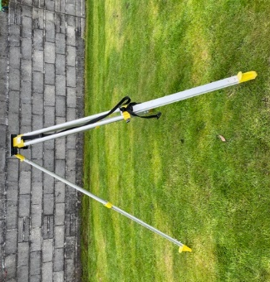
Tripod.
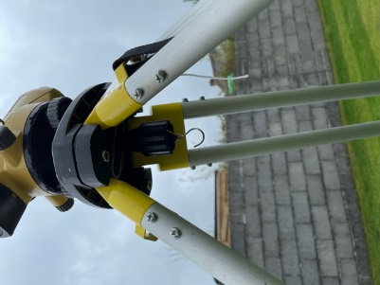
Screw fitting.
Shoulder strap and adjustable screws.

Spikes.

3.2 The ‘Dumpy’

The Dumpy level has an eyepiece that the surveyor looks through to take an accurate reading from the staff, it also has a bullseye spirit level which helps the surveyor see if the dumpy is level and if the ‘bubble’ is in the centre of the circle or bullseye. The three levelling screws are used to level the dumpy by rotating them. There is a focus screw for the telescopic lens which allows the surveyor to see clearly and can change focus to see more clearly at different distances, while the base has a 360-degree compass that allows the user to rotate and take a reading from around it’s the circumference. (Step-by-Step Guide to Dumpy Level Survey, n.d.)

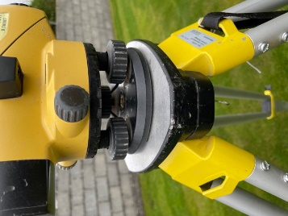
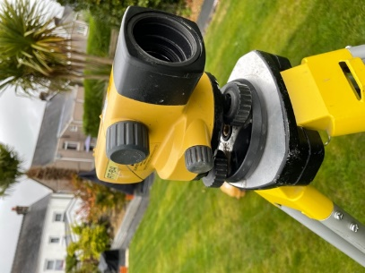
Dumpy.
Levelling screws.
Focus screw.

3.3 Staff
The 5m staff is divided into 5 sections each section being 1 metre. Each 'block' is 10 millimetres, whereas each 'E' is fifty millimetres. The colour rotates between black and red for each metre. The staff can also give a reading from the opposite side but instead of being in blocks it is in millimetres. The staff is used to take ‘spot’ levels which means the surveyor takes a reading in an area where they need to find out the level or if they are doing a land survey, they could use the grid method which is taking a reading of the staff every 5, 10, 15 metres or any number of meters that would be suitable in a grid. The surveyor doesn’t have to use the grid method they could also use chainage where the surveyor would read the staff at a certain number of meters. (Step-by-Step Guide to Dumpy Level Survey, n.d.)

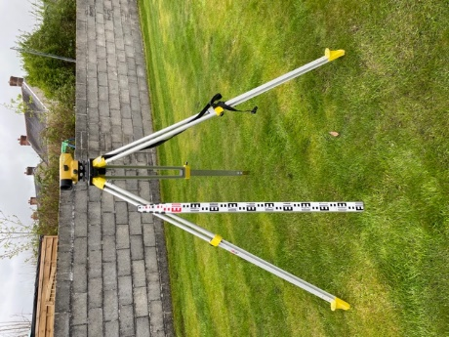

5M staff.

3.4 Survey Book

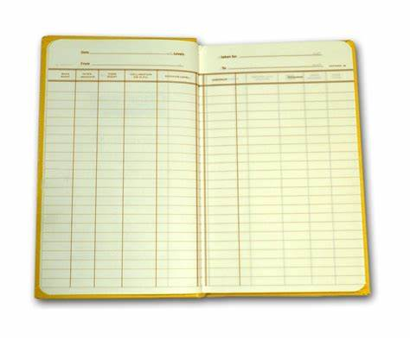
The survey book was used in the level survey to record the readings that we took at each spot. There are two types of booking methods which are the height of collimation method or the rise and fall method. For our survey we used the height of collimation method, this method is booked in by using 5 columns the first being the back sight, the second being the intermediate sight column, the third being the fore sight, Fourth the height of collimation, fifth being the reduced level and then there are two sections on the other side for remarks and notes. The first reading taken is the backsight which is taken off a known point or a datum then you add the back sight that you took to the datum (Reduced level) to get your height of collimation. And any reading taken afterwards would be an intermediate or foresight unless you move the setup to a new location. (LSSLTD.NET, 2018)

(GEO Survey Instruments Ltd, n.d.)

4.0 Levelling procedure

4.1Setting up procedure
- Firstly, before any spot levels could be taken, we had to set the equipment up. The first thing we did was undo the legs from the strap and loosen the screws to extend the legs. Once the legs were extended to a comfortable height for us, we then tightened screws and stood on the feet to ensure the stability of the tripod.

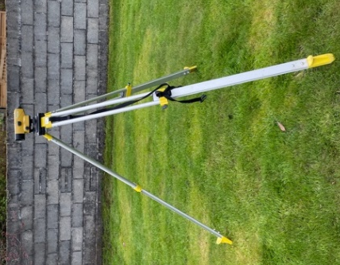
- After setting the tripod up we then pulled the dumpy level from its case and placed it on top of the tripod, once the dumpy was safely on the tripod and in the correct place we then secured it by tightening the screw from the tripod into the bottom of the dumpy.

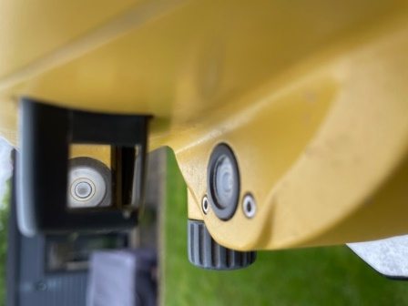
- After the dumpy and the tripod were secure, we then used the levelling screws to make the dumpy level.

4.2 survey procedure

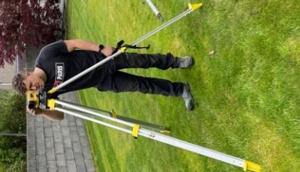
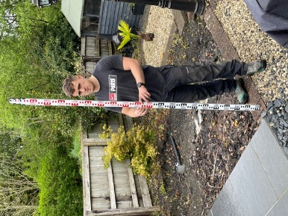
- Firstly, after setting up we took a back sight from on top of the datum, we did this by having one of the group members hold the staff and rock it back and forth slowly to get an accurate measurement. When taking our back sight, we made sure that when we needed to move the equipment the distance for our foresight would be at approximately the same distance as our backsight so that it would avoid any errors due to collimation, refraction or the earths curvature. (shanmukha, 2017)

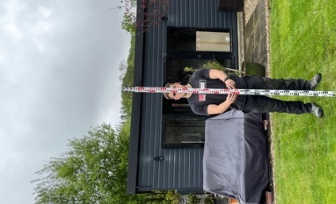
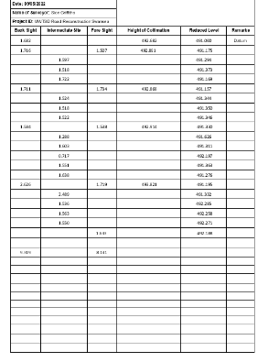
- After taking our back sight we then recorded it into our booking sheet, this is where we then recorded all our data including our intermediate sights, foresights, reduced levels and our height of collimation. When a foresight has been recorded in the book or sheet make a remark identifying it as the change point. (shanmukha, 2017)

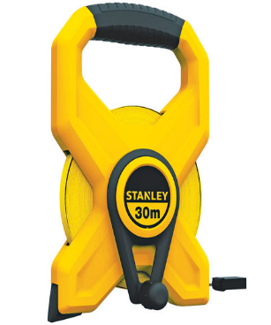
- Once we had taken our back sight, we then continued with the survey taking our spot levels at every 20m and again having one of the group member rock the staff back and forth slowly. These were our intermediate sights and foresights.

- After taking every spot level we measured 20m using a 30-meter tape from each last point to the next until we reached our final foresight. We had the member that held the staff hold the tape on the exact point we took the level from as one of the other members taped the 20m to the next point.

(www.machinemart.co.uk, n.d.)

Computation and plotting of levels

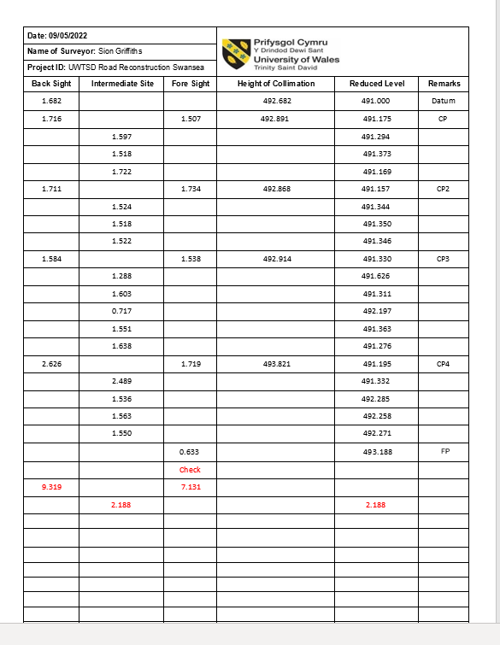
6.1 booking sheet

Please see the find the results from our survey within in this survey sheet.
Within this survey sheet the CP stands for change point and the FP stands for final point.
At the end of this survey sheet we have made checks to ensure that our booking in was done correctly so there is less room for error within our survey.

6.2 Graph and table
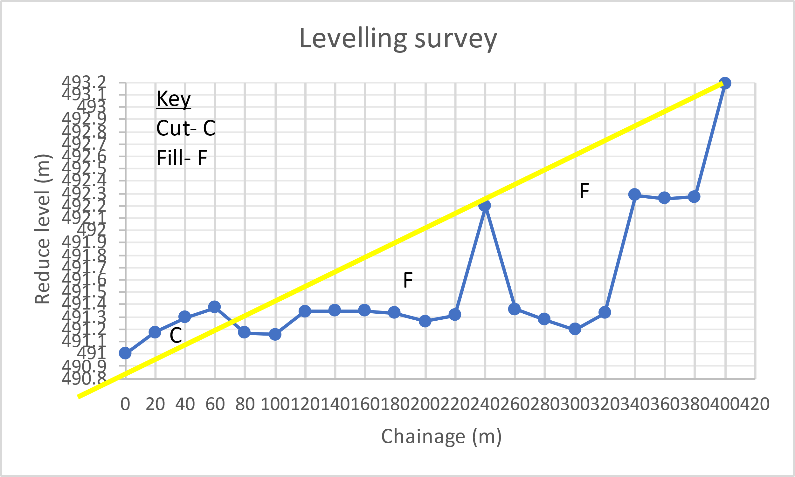

Key: C= Cut
F= Fill

This graph shows the area of land that need to be filled and cut to meet the current start and end point of the new proposed road to be built on the UWTSD Swansea campus.

6.3 Table Cut and Fill

 | Cut | Units. Volume | Number | Total Vol
 |  | 2 | 4 | 8
 | Fill | Units. Volume | Number | Total Vol
 |  | 2 | 86 | 173

These tables show the total amount in meters of the soil that needs be cut and filled for the proposed road.

conclusion

To conclude this report shows the findings from the survey that we carried out on the UWTSD Swansea campus for the new proposed road. The data from the graph shows that there is a lot of ground that needs to be backfilled to suit the levels that are required to meet the existing datum and final point from our survey as shown in both the booking sheet and the graph. In total a volume of 173 meters will need to be back filled to complete this new proposed road to the level that the university require. Of the surveyed land there is only a small amount of ground that will need to be cut. The data from the graph and table show that the amount of land that will need to be cut only amounts to a small figure of 8 meters which in comparison to the amount that will need to be filled is very little meaning that the new road construction will have a very high cost. Possibly the university could look at an alternative road that could be more cost effective.

7.0 references

civilguruji.com. (2021). What is mean by a Site Benchmark & Temporary benchmark (TBM). [online] Available at: https://civilguruji.com/blog/Site-Benchmark-and-temporary-benchmark#:~:text=A%20temporary%20benchmark%20%28TBM%29%20is%20a%20point%20with [Accessed 6 May 2022].
GEO Survey Instruments Ltd. (n.d.). Chartwell 2426 Collimation Book. [online] Available at: https://geosurvey.co.uk/product/chartwell-2426-collimation-book/ [Accessed 9 May 2022].
Jamal, H. (2017). Levelling in Engineering Survey - Types, Methods, Procedures. [online] www.aboutcivil.org. Available at: https://www.aboutcivil.org/levelling-in-engineering-surveying.html.
LSSLTD.NET. (2018). Methods for Booking a Levelling Run. The Height of Collimation Method - LSSLTD.NET. [online] Available at: https://www.lssltd.net/methods-for-booking-a-levelling-run-the-height-of-collimation-method/.
shanmukha (2017). LEVELLING PROCEDURE. [online] CIVIL ENGINEERING. Available at: https://knowledge4civil.wordpress.com/2017/07/23/levelling-procedure/?msclkid=00d6d0d5cfa911ecbf3ae7964d2746ce.
Step-by-Step Guide to Dumpy Level Survey. (n.d.). [online] Available at: https://jigsawcambs.org/images/step%20by%20step%20guide%20to%20dumpy%20level%20survey.pdf.
www.machinemart.co.uk. (n.d.). Stanley 30m Long Tape Measure - Machine Mart - Machine Mart. [online] Available at: https://www.machinemart.co.uk/p/30m-long-tape-measure/?awc=3131_1652110474_55085adc7b3173ed159293bfe141da37 [Accessed 9 May 2022].

