Matthew Daniell (2200129)
| 2200129@uwtsd.student.ac.uk
Learning in the Digital Era
BMPS4009 and BMPL4007

Contents
Summary 3
Mind Map 4
Video Presentation 5
Reflection 6
References 7 and 8

Summary
When you first start learning and preparing for higher education it is good to understand all of the necessary steps and challenges that it will face. According to (UCAS, 2022) University allows for a perfect opportunity to expand your knowledge and discover new people and have new challenges. This suggests that University and higher education gives student of all ages an opportunity to explore topics in a greater amount of detail which gives them a better understanding of how to apply this degree and topic in the real life. “Employers are not only looking for graduates to be equipped with the knowledge in their specialised fields but also to possess fundamental transferrable skills to enable them to operate effectively within an organisation” (Watson, A. 2018). This shows that people who study within higher education are more likely to get job. This is because the university would get you ready and teach the fundamentals of higher education learning so that they can apply this in their everyday job in the future.

Preparing for higher education also requires student to understand how to properly reference and to avoid an academic misconduct. According to Santini (2018) Plagiarism is the most prominent issue that student face during higher education. Referencing is a really important skills that anybody within higher education need to know. Without knowing how to properly reference you can be done for academic misconduct and your reputation would be a negative one. Academic writing is crucial as student need to understand the level that academic writing needs to be. This is because academic writing uses different techniques and changes what you should not do in your writing. According to (The University of Sheffield, 2022) “Academic writing tends to avoid the types of contractions and abbreviated language that you might use in other forms of communication”. This means that you will need to try to avoid using abbreviations and contractions within your academic writing. This is because it would be deemed a more professional way writing academically.

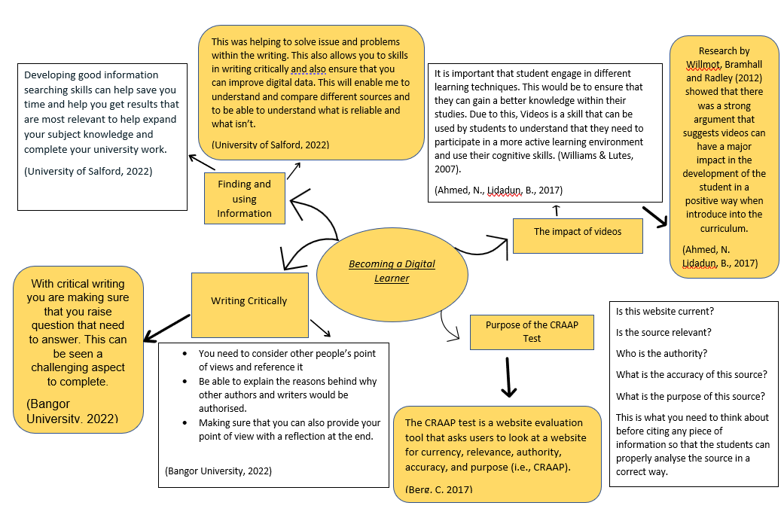
Mind Map

Video Presentation

Click Here to View my PowerPoint Presentation on Becoming a team player: https://youtu.be/GdyK10o1b9M
In this video, I talked 3 important element that are involved in becoming a team player. These include:
- Personal Identity and sense of place
- Working in a team
- Effective Communication

Reflection

When I first started university, I had a number of fears that I had to overcome. The major issue I had to understand is to gain the ability to write concisely. This is because in university there is a requirement to stick to certain word counts. Due to this write concisely is a huge importance. During my short time in university, I have already learned how to write concisely. According to Jane Rosenzweig (2022) The best way to write concisely is to delete any words not relating to your sentence, make sure that not repeat yourself and make sure you do not tell the reader what you will include within the sentence and just do it. I will now be able to implement this into my written work within my years of university. Another element I struggled massively with was my confidence. This is because I personally did not believe that I would be able to process the level that university requires. I had a lot of self-doubt within the first 2 weeks of starting university. In order to get rid of self- doubt I will notice all of the negative aspects I have about the topic and challenge every aspect of that (NHS, 2020). This fundamentally work for every situation as if you challenge everything to do with university then it would become a lot easier, and you will become successful. Finally, the last area which I struggled to grasp was Harvard Referencing. This is because I have not had to properly reference previously in education, so initially it was a challenge. According to Ahmed, S, Roche, T (2021) Academic referencing is the main areas that makes you a student and academic referencing also allows university to decide who is ready for it and how is not. This meant that I had to learn how to academic reference in order to be able to progress through university and become a student.

References
Adams, J, Greenwood, D, Thomashow, M, Russ, A, (2016) 'Sense of Place', North American Association for Environmental Education, May 9th. Available at: Sense of place | eePRO @ NAAEE (Accessed: 28 October 2022).
Ahmad, N., Lidadun, B. (2017) 'Enhancing Oral Presentation Skills Through Video Presentation.', PEOPLE: International Journal of Social Sciences, Vol. 3(2), pg. 386. Available at: https://doi.org/10.20319/pijss.2017.32.385397. (Accessed 22 October 2022)
Ahmed, S, Roche, T (2021) ' The role of academic referencing within students' identity development' Journal of Further and Higher Education, Issue 3, P.P. 377-388. Available at: https://doi.org/10.1080/0309877X.2020.1766665 (Accessed on: 30 October 2022)
Berg, C. (2017) Teaching Website Evaluation. Place of publication: New Jersey. Volume 24. Available at: TEACHING WEBSITE EVALUTION.: EBSCOhost (uwtsd.ac.uk) (Accessed on 23 October 2022)
NHS (2020) Raising Low Self-Esteem. Available at: Raising low self-esteem - NHS (www.nhs.uk) (Accessed: 30 October 2022).
North-eastern University Graduate Programs (2019) 12 Communication Skills That Will Advance Your Career. Available at: 12 Communication Skills That Will Advance Your Career (northeastern.edu) (Accessed: 28 October 2022).

Rosenzweig, J. (2022) How to Write Concisely. Available at (How to Write Concisely (hbr.org) Accessed: 30 October 2022).

Santini A. (2018) The Importance of Referencing. The Journal of Critical Care Medicine, Vol.4 (Issue 1), pp. 3-4. Available at: https://doi.org/10.2478/jccm-2018-0002 (Accessed:17 October 2022)
Tannenbaum, S, Salas, E. (2020) Teams That Work: The Seven Drivers of Team Effectiveness. Oxford: Oxford University Press. Available at: https://doi.org/10.1093/oso/9780190056964.001.0001 (Accessed on 28 October 2022)
The University of Sheffield (2022) Academic Writing. Available at: Academic writing | 301 | The University of Sheffield (Accessed: 20 October 2022).
UCAS (2022) Why Choose Higher Education? Available at: Why choose higher education? | Undergraduate | UCAS (Accessed: 16 October 2022).
University of Bangor (2022) What is Critical Thinking. Available at: What is critical writing? | Study Skills | Bangor University (Accessed: 21 October 2022).
University of Salford (2022) Finding Information. Available at: Finding information | University of Salford (Accessed: 21 October 2022).
Watson, A. (2018) 'Higher Education: Preparing Students to be work-ready', Open Access Government, (51903) 10th September. Available at: Higher education: Preparing students to be work-ready (openaccessgovernment.org) (Accessed:16 October 2022).

