

Student Name: Hardik Bharatbhai Patel

Student ID: 2504926

PROPOSAL

Topic: Role of Generative AI (ChatGPT-like Tools) in Enhancing Customer Engagement in Digital Marketing Campaigns. A case example of H&M

Table of Contents
1. Introduction 5
1.1 Background 5
1.2 Problem statement 5
1.3 Aim and objectives 5
1.4 Research Questions 6
1.5 Structure of thesis 6
2. Literature Review 6
2.1 Use of Generative AI (ChatGPT-like Tools) in Digital Marketing Campaigns 6
2.2 Role of Generative AI in Enhancing Customer Engagement 7
2.3 Benefits and Challenges of Using Generative AI in Digital Marketing 7
2.4 Literature gap 8
2.5 Theoretical Framework 8
3. Research Methodology 8
3.1 Research Philosophy 8
3.2 Research Approach 8
3.3 Research Design 8
3.4 Research Type 9
3.5 Data Collection Method 9
3.6 Data Analysis 9
3.7 Ethical Considerations 9
3.8 Advantages of Secondary Data 9
3.9 Disadvantages of Secondary Data 9
3.10 Types of Secondary Data and Their Uses in Research 10
3.11 Searching for Sources of Secondary Data 10
3.12 Evaluating and Selecting Secondary Data 10
4. Expected findings 11
5. Limitations 12
6. Timeframe 13
7. Conclusion 13
8. References 14

List of Figures
Figure 1 Saunders Research Onion 11
Figure 2 Gantt Chart 13

1. Introduction

1.1 Background
The pace of development of digital technologies has altered the way business firms relate to their customers. Generative AI applications, such as ChatGPT, have constituted an important aspect of digital marketing in the recent past, offering one-to-one communication, real-time customer care, and content creation. The technologies help brands to improve customer interaction and customer relationships within competitive markets. The tools are also beneficial to customer communication, personalised marketing, and tailored customer experiences and allow businesses to enhance engagement and provide more relevant online interactions across various online platforms (digitalagencynetwork, 2026).

1.2 Problem statement
Digital marketing is shifting towards generative AI usage, and the effects of generative AI on customer engagement within the fashion retail sector are not well-known. Though digital technologies, including ChatGPT-like tools, are actively used by H&M in their communications with customers, the specific application of these tools in marketing campaigns is not actively discussed (Patil et.al. 2024). This leaves a research gap on their effectiveness, their benefits and challenges. Thus, this paper will examine how Generative AI can be used to improve customer interactions at H&M. Limited knowledge is also known regarding the support of these technologies in communicating with customers, offering them a personalised customer experience, and the efficiency of digital marketing practices in H&M.

1.3 Aim and objectives
Aim of the Research:
The aim of this research is to examine the role of Generative AI (ChatGPT-like tools) in enhancing customer engagement in digital marketing campaigns, with a case example of H&M.
Research Objectives
- To examine how Generative AI (ChatGPT-like tools) are used in H&M's digital marketing campaigns to support customer communication and marketing activities.
- To analyse the role of Generative AI (ChatGPT-like tools) in enhancing customer engagement through personalised interactions and customer experiences at H&M.
- To identify and evaluate the benefits, challenges, and financial impact of using Generative AI (ChatGPT-like tools) in H&M's digital marketing campaigns, particularly in terms of marketing cost efficiency and return on investment (ROI).

1.4 Research Questions
- How are Generative AI (ChatGPT-like tools) used in H&M's digital marketing campaigns to support customer communication and marketing activities?
- How does Generative AI (ChatGPT-like tools) enhance customer engagement through personalised interactions and customer experiences at H&M?
- How does the use of Generative AI (ChatGPT-like tools) affect H&M's digital marketing in terms of benefits, challenges, marketing cost efficiency, and ROI ?

1.5 Structure of thesis
There are five chapters in this thesis. Chapter 1 introduces the topic of research, its aim, objectives, research questions, and statement of the problem. In Chapter 2, the literature is reviewed. The methods of the study are outlined in Chapter 3. Chapter 4 reports findings and contains a discussion of the findings in the context of research objectives. Finally, Chapter 5 provides a conclusion, recommendations, limitations, and suggestions on future research.

2. Literature Review
The following section will emphasise the current literature concerning the role of Generative AI (ChatGPT-like systems) in digital marketing, customer interaction, advantages of AI implementation, and issues of AI variability by using H&M as the example.

2.1 Use of Generative AI (ChatGPT-like Tools) in Digital Marketing Campaigns
Generative AI has revolutionised digital marketing so that businesses can engage in more personalised marketing, automate customer communications and enhance the efficiency of communication, as cited by Garrido-Merchán et.al. (2024). The marketing efforts can be supported by ChatGPT-based tools to create relevant materials and answer real-time conversations, which will enable the brand to keep communication with its customers ongoing. The technologies also assist in communication with the customers, as they offer personalised product suggestions, marketing content development, and enhance customer interaction via various digital media related to the marketing process. Nevertheless, Generative AI improves marketing performance, but it depends on the quality of the information and careful human oversight to avoid miscommunication and inaccurate information, as well as to deliver truthful messages and information, as per Kshetri et.al. (2024).

2.2 Role of Generative AI in Enhancing Customer Engagement
Grewal et.al. (2025) note that Generative AI improves interaction with customers through personalised suggestions and interactive dialogue that enable customers to be more satisfied. However, AI-driven chatbots advance customer relationships by answering instantly and being available everywhere through online channels. Individualised customer experience, achieved with the help of AI-generated suggestions and personalised communication can enhance customer satisfaction, persuade repeat interactions and enhance long-term customer relationships with the brand. On the other hand, Soni (2023) argues that overdependence on AI can take away the human aspect of dealing with customers, which can have an impact on trust and emotional attachment. According to the Relationship Marketing Theory, meaningful and consistent interaction is employed to build long-term customer relationships, indicating that Generative AI has the potential to be used to facilitate a conversation, in combination with customer-focused marketing principles as per Büyüksomer and Tekeoğlu (2024).

2.3 Benefits and Challenges of Using Generative AI in Digital Marketing
According to the view of Alkhalfan and Al Mubarak (2025), Generative AI has the following advantages: increased efficiency, lower marketing expenses, and better customer experiences, which are realised by automating tasks. However, Gujar and Panyam (2024) note that AI can also help businesses analyse their customer data and provide more efficient marketing messages. It is significant to assess the strengths and weaknesses of Generative AI to comprehend overall success in customer communication and enhancing the effectiveness of digital marketing. Nonetheless, the issues associated with the privacy of personal information, bias in the algorithm, and ethical considerations can decline the level of trust and acceptance of technologies among customers, as per Kshetri et.al. (2024).

2.4 Literature gap
The current literature has discussed Generative AI in digital marketing; there has not been much research discussing the use of Generative AI in customer engagement at H&M. This paper fills this gap by exploring its utilisation, advantages and limitations. This paper fills in this gap by focusing on the support provided by Generative AI in relation to communication with customers, personalised customer experience, and advantages and limitations of using AI in the H&M digital marketing campaigns.

2.5 Theoretical Framework
This research will be informed by the Technology Acceptance Model (TAM), the Relationship Marketing Theory, and the Diffusion of Innovation Theory. Those theories offer an adequate pattern of perception in adopting Generative AI and the impact of AI on administratively interacting with customers and the advantages and issues of adopting AI in digital marketing campaigns of H&M (Rahman et.al. 2024).

3. Research Methodology

3.1 Research Philosophy
The philosophy embraced in this work will be interpretivism to derive the contribution of Generative AI in customers' engagement with H&M based on current interpretations (Pop et.al. 2025). The use of positivism was not pre-determined by the fact that the study does not test quantifiable relationships.

3.2 Research Approach
The inductive approach will be adopted to develop understanding from existing literature on Generative AI and H&M. The deductive approach was not chosen as the test does not involve testing of predetermined hypotheses.

3.3 Research Design
The research design chosen will be exploratory research to investigate the new role of Generative AI in digital marketing campaigns of H&M (Titus et.al. 2026). The descriptive and explanatory designs were not selected since exploration is the major consideration.

3.4 Research Type
A qualitative type of research will be employed in the study in order to acquire detailed information about the applications of Generative AI and customer engagement based on secondary literature. Quantitative research was not used since there is no need for numerical analysis.

3.5 Data Collection Method
The digital marketing approach of H&M is analysed with the help of secondary data (academic journals, books, company reports, and reputable websites). Primary data was not chosen as there is adequate information published.

3.6 Data Analysis
Thematic analysis will be used, and recurring themes are identified based on the secondary data on Generative AI and customer engagement. This is the reason why statistical analysis was not chosen, as the data being analysed are not numeric.

3.7 Ethical Considerations
To maintain ethical considerations, the paper correctly references all the sources, avoids plagiarism and no information is lost. No informed consent is needed due to the utilisation only of publicly available secondary data, which is gathered and analysed.

3.8 Advantages of Secondary Data
Secondary data offers access to a variety of credible academic journals, company reports and industry publications. It is economically efficient, time saving and allows the researcher to examine available knowledge, contrast the various viewpoints and come up with a holistic perception of the subject of research.

3.9 Disadvantages of Secondary Data
Secondary data can then be old, incomplete, or it may have been compiled to serve some other purpose other than what the present study is aiming at. Researcher do not have much control over the quality and accuracy of data, missing first-hand information can lack depth to the analysis and understanding of the research problem (Rahman et.al. 2024).

3.10 Types of Secondary Data and Their Uses in Research
The secondary data will contain academic journals, books, company reports, industry publications, and the credible websites. These are reference materials that offer information, theoretical perspectives and facts on the ground giving researchers the opportunity to interpret trends, draw comparisons, make arguments and solutions to research questions without having to go out there and collect primary data.

3.11 Searching for Sources of Secondary Data
Academic databases, peer-reviewed journals, books, company annual reports, government publications, industry reports and reliable websites are among some of the sources of secondary data. Such sources serve as credible and pertinent resources to underpin literature reviews, data analysis, evidence-based findings in research (Wessel et.al. 2025).

3.12 Evaluating and Selecting Secondary Data
The consideration of secondary data ought to be founded on its credibility, relevance, accuracy, reliability and the time of publication. The information used by researchers should be chosen in peer-reviewed journals, credible organisations and official company reports to make sure the data is reliable, recent, and can be used to answer the research questions.
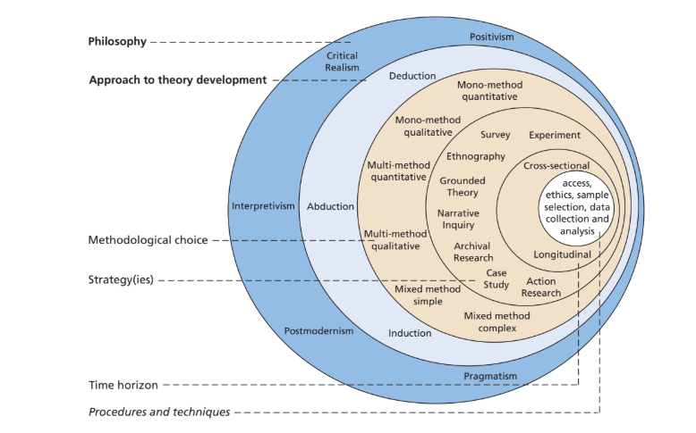
Figure 1 Saunders Research Onion
(Source: Mark N. K. Saunders, Philip Lewis, and Adrian Thornhill (Pearson Education, 2019)

4. Expected findings
This study aims to examine the role of Generative AI (ChatGPT-like tools) in enhancing customer engagement in digital marketing campaigns, using H&M as the case example. According to the available literature and the chosen theoretical framework, it can be predicted that the results will reflect that Generative AI has become a significant platform and enhances interactions with customers by using personalised communication and automated responses; it can also be expected that the marketing material should be tailored accordingly (Wessel et.al. 2025). These results should also indicate that Generative AI can facilitate the communication and marketing processes of the customers by providing them with personalised information, appropriate responses, and other useful digital experiences on the internet.
Evidence in the industry also indicates that personalisation based on AI can enhance customer value and price satisfaction. As an illustration, three-quarters of the businesses cited more customer spending through AI-enabled personalisation, and 88% of customers were more inclined to buy when their experience was tailored in real time. Such results can also manifest in the digital marketing of H&M (Twilio, 2026). Nevertheless, the study can also emphasise the problems, like data privacy and ethical aspects and the necessity of human control to make the process of communication accurate and reliable. All these anticipated results will help to understand how Generative AI can be applied to facilitate digital marketing strategies in the fashion outlet market (Lanfranchi et.al. 2026).

5. Limitations
There are a few limitations to this study. First, the study utilises only secondary sources gathered in the form of academic journals, books, company reports and valid online sources. Because of this, the research will lack firsthand information on H&M customers or employees, potentially restricting the level of comprehension. The lack of primary data might also restrain an in-depth analysis of how customers attain AI-assisted communication, personalised experience, and online marketing operations at H&M. Second, the study includes only H&M as the case study, which implies that the results of this study cannot be directly generalised to other fashion retailers and industries (Kshetri et.al. 2024). Third, these could be the availability and quality of published information, which might affect the extent of the analysis because some current practices of the company might not be published. Also restricted by time are the possibilities to study a broader sample of organisations or perform longitudinal research. To reduce all these shortcomings, the study will tap into current and valid scholarly materials, critically compare various perspectives, and undertake a methodical thematic review.

6. Timeframe
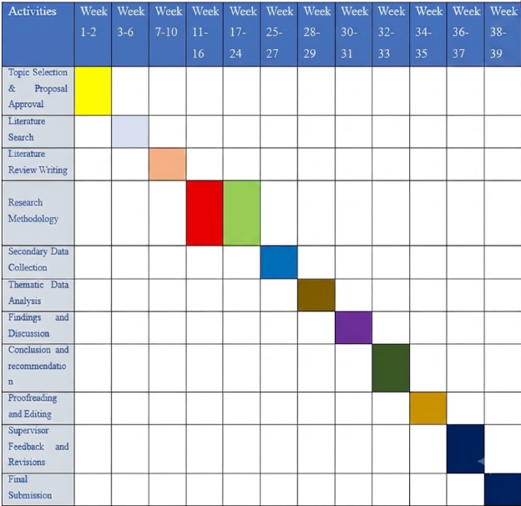
Figure 2 Gantt Chart
(Source: Self-generated)

7. Conclusion
This proposal has presented the purpose, goals, research questions, literature review, and research strategy to analyse the role of Generative AI (ChatGPT-like tools) in improving customer interaction in the digital marketing campaigns of H&M. The research is timely in that Generative AI is gradually gaining prominence in contemporary marketing activities. The chosen qualitative research methodology and secondary data type are sufficient to achieve the goals of the research.

8. References
Alkhalfan, R.F. and Al Mubarak, M. (2025) Effectiveness of Digital Marketing Activities: A Review of Key Challenges, Benefits and Opportunities. Innovative and Intelligent Digital Technologies; Towards an Increased Efficiency: Volume 2, pp.903-923. https://doi.org/10.1007/978-3-031-71649-2_75
Arbale, H. and Mutisya, D.N. (2024) Book Review:" Research Methods for Business Students" by Mark NK Saunders, Philip Lewis, and Adrian Thornhill (Pearson Education, 2019). African Quarterly Social Science Review, 1(2), pp.8-21. https://doi.org/10.51867/AQSSR.1.2.2
Büyüksomer, A.E. and Tekeoğlu, A.N.T. (2024) Enhancing marketing communications with generative AI: A systematic literature review. Journal of Industrial Policy and Technology Management, 7(2), pp.109-122. https://www.researchgate.net/profile/Akif-Buyuksomer-2/publication/387952367_Enhancing_Marketing_Communications_with_Generative_AI_A_Systematic_Literature_Review/links/67843ab38210a977a184c953/Enhancing-Marketing-Communications-with-Generative-AI-A-Systematic-Literature-Review.pdf
digitalagencynetwork, (2026), H&M, (Online). Accessed from< https://digitalagencynetwork.com/hm-marketing-strategy/> accessed on 8 July 2026.
Garrido-Merchán, E.C., Arroyo-Barrigüete, J.L., Borrás-Pala, F., Escobar-Torres, L., de Ibarreta, C.M., Ortíz-Lozano, J.M. and Rua-Vieites, A. (2024) Real customisation or just marketing: are customised versions of generative AI useful?. F1000Research, 13, p.791. 10.12688/f1000research.153129.3
Grewal, D., Satornino, C.B., Davenport, T. and Guha, A. (2025) How generative AI is shaping the future of marketing. Journal of the Academy of Marketing Science, 53(3), pp.702-722. https://doi.org/10.1007/s11747-024-01064-3
Gujar, P. and Panyam, S. (2024) Generative AI in digital advertising campaigns. International Journal of Computer Trends and Technology, 72(5), pp.51-55. https://doi.org/10.14445/22312803/IJCTT-V72I5P106
Kshetri, N., Dwivedi, Y.K., Davenport, T.H. and Panteli, N. (2024) Generative artificial intelligence in marketing: Applications, opportunities, challenges, and research agenda. International journal of information management, 75, p.102716. https://www.sciencedirect.com/science/article/abs/pii/S026840122300097X
Lanfranchi, G., Cioli, A., Amanti, A. and Marinelli, L. (2026) Reconfiguring competitive advantage: a resource dynamic framework for generative AI adoption in digital content marketing. European Journal of Innovation Management, 29(3), pp.770-798. https://doi.org/10.1108/EJIM-03-2024-0317
Patil, D., Rane, N.L. and Rane, J. (2024) The future impact of ChatGPT on several business sectors. Deep Science Publishing. https://books.google.co.in/books?hl=en&lr=&id=KuYyEQAAQBAJ&oi=fnd&pg=PP1&dq=Though+the+digital+technologies
Pop, A.M., Sim, M.A. and Horea, I.C. (2025) THE ROLE OF CHATBOTS IN BUSINESS COMMUNICATION. CUSTOMER INQUIRIES. CASE STUDY: H&M. Annals of the University of Oradea, Economic Science Series, 34(1). 10.47535/1991auoes34(1)036
Rahman, J., Raihan, A., Tanchangya, T. and Ridwan, M. (2024) Optimising the digital marketing landscape: A comprehensive exploration of artificial intelligence (AI) technologies, applications, advantages, and challenges. Frontiers of finance, 2(2), p.6549. 10.59429/ff.v2i2.6549
Soni, V. (2023) Adopting generative ai in digital marketing campaigns: An empirical study of drivers and barriers. Sage Science Review of Applied Machine Learning, 6(8), pp.1-15. https://www.researchgate.net/profile/Vishvesh-Soni/publication/376612647_Adopting_Generative_AI_in_Digital_Marketing_Campaigns_An_Empirical_Study_of_Drivers_and_Barriers/
Titus, S.A., Agarwal, V. and Mahajan, D. (2026) A Systematic Literature Review on AI-Driven Sustainable Marketing Optimization. Canadian Journal of Marketing Research, 16(2), pp.443-452. https://doi.org/10.5281/zenodo.20150956
Twilio, (2026), Customer Loyalty, (Online). Accessed from<https://www.twilio.com/en-us/press/releases/socer-2025 > accessed on 16 July 2026.
Wessel, M., Adam, M., Benlian, A., Majchrzak, A. and Thies, F. (2025) Generative AI and its transformative value for digital platforms. Journal of Management Information Systems, 42(2), pp.346-369. https://doi.org/10.1080/07421222.2025.2487315

