Name: Lindsay Davies
Student number: 2414210
University of Wales Trinity Saint David
Module/code: Nutrition in Sport and Exercise/(BMSS5002)
Tutor name: Geraint Forster
Word count: 2182
Title: Acute Effects of Nitrate-Rich Beetroot Juice on 20-Minute Cycling Time-Trial Performance in Recreationally Active Adults

Co-pilot was used in this assessment only for permitted purposes, including supporting background research, helping to organise and structure the assignment, and proofreading my own writing for clarity and grammar. No AI-generated text has been submitted as my own work, and all written content in this assessment is my original creation.
I also used Co-pilot to help identify appropriate statistical tests, understand SPSS and Excel procedures, structure my tables and figures, and clarify the meaning of my outputs. All statistical decisions, interpretations, and written descriptions of the Results section are entirely my own.
In addition, Co-pilot supported the research process by helping me locate relevant academic sources, understand methodological considerations, and check the rationale behind my design choices. These interactions were used only to guide my thinking, not to generate any written content for submission.

AI tool | Purpose | Example prompt(s)
Co-pilot | Learning | Using all this data here=excel spreadsheet with the results of testing=what are the logical tests I would run on SPSS, to find if beetroot improved sports performance
Co-pilot | Learning | Give me a step by step guide on how I will clean this data here to go into SPSS EASY=EXCEL SPREADSHEET.
Co-pilot | Learning | Give me a step by step guide on how I run descriptive stats on SPSS.
Co-pilot | Learning | Tell me step by step guide on how to create the difference variables
Co-pilot | Learning | How do I run normality checks on my data on SPSS
Co-pilot | Learning | Using these results here for normality checks=results=tell me the vital details that I need to include in a table to present this information cleanly and easy read
Co-pilot | Learning | Now using all this =results output from SPSS= how can I put all the information that is required into a table to make it easy to see for people
Co-pilot | Learning | Can you tell me how I will create charts on excel using the mean heart rate here=data already on excel=and tell me which chart would be best for me to use
Co-pilot | Learning | Can you tell me how I will create charts on excel using the mean power output here=data already on excel=and tell me which chart would be best for me to use.
Co-pilot | Learning | Give me a step by step guide on how to do t-Tests and how many do you think I should perform.
Co-pilot | Learning | Using this=RESULTS FROM THE PAIRED T-TEST=show me how to present these nicely in a table.
Co-pilot | Learning | Which of these do you think I should present in a chart? Give me the step by step guide on how to do it in excel and which chart is most appropriate.
Co-pilot | Learning | How do I perform a repeated Anova in SPSS, step by step please.
Co-pilot | Learning | Using this=RESULTS OF THE REPEATED ANOVA=tell me how to display this in a table
Co-pilot | Learning | Now tell me again how to do the chart in excel and which one to use please
Co-pilot | Learning | Tell me how to run the order of effects on my data in SPSS.
Co-pilot | Learning | I now need a table to easily show this=Order of effects results
Co-pilot | Learning | Give me a step by step guide again on how to make the charts for these in excel.
Co-pilot | Learning | Looking at all the results from my tests, explain what each test means and what the output is telling me so I can understand it clearly.
Co-pilot | Learning | Tell me the logical order in which I should display these results=TABLES, CHARTS, AND WRITING OF THE RESULTS FOR ALL MY RESULTS
Co-pilot | Research | Looking at my data here=RAW DATA OFF EXCEL=is there any reason that my data is skewed, for example is one participant accountable?  What is the reasons that this might be happening?
Co-pilot | Research | Find me the original paper for the Borg RPE scale
Co-pilot | Research | Show me a recent academic journal that speaks of the importance of testing supplement/placebo at the same time of day.
Co-pilot | Research | Show me an academic journal that looks at how motivation can impact exercise testing.
Co-pilot | Research | Show me an academic paper that looks at the strengths of using a cross-over design in exercise testing.
Co-pilot | Research | Find me a paper that looks at the G power for exercise testing.
Co-pilot | Research | Show me a recent academic journal that examines sample size effects on analysing your data.
Co-pilot | Research | Show me a recent academic journal looking at convenience sampling in exercise testing
Co-pilot | Research | Show me the original paper for the PARQ+
Co-pilot | Research | Show me that speaks about the duration you should fast before testing effects of beetroot juice.
Co-pilot | Research | Show me a journal that looks at the risks of beetroot juice
Co-pilot | Research | Show me the prohibited list on the world-anti-doping-agency
Co-pilot | Research | Find me recent academic journals on beetroot being used as an ergogenic aid.
Co-pilot | Research | Find me academic sources that look at how beetroot juice (NO) interacts with someone on a cellular level.
Co-pilot | Research | Find me studies similar to mine=PROTOCOL FOR BEETROOT TRIAL.
Co-pilot | Research | Show me a study that has looked at how beetroot enhances cycling performance.
Co-pilot | Research | Find me a paper that looks at the differences of how trained and untrained athletes differ in their response to beetroot
Co-pilot | Research | Find me software that is used to fully randomise the order in which the participants receive the beetroot juice/placebo.
Co-pilot | Research | Show me the software that I can use to calculate the G*Power for my trial
Co-pilot | Research | Show me a paper that supports altering the resistance on a watt bike for males and females when exercise testing.
Co-pilot | Structure | Put my work into logical subheadings here=MY METHODOLOGY SECTION
Co-pilot | Structure | Put my discussion into subheadings here=MY DISCUSSION SECTION

Acute Effects of Nitrate-Rich Beetroot Juice on 20-Minute Cycling Time-Trial Performance in Recreationally Active Adults

Beetroot juice is widely used as a nutritional ergogenic aid due to its high nitrate content (Glowacz et al., 2025). Through the enterosalivary pathway, nitrate is reduced to nitric oxide (NO), a key regulator of vascular and metabolic function (Pappas, Wilkinson and Gow, 2023; Mueller et al., 2025). NO enhances vasodilation, oxygen delivery, and mitochondrial efficiency, providing a mechanistic basis for potential improvements in endurance performance (Zoughaib et al., 2024; Tian et al., 2025). Beetroot juice also contains polyphenols and betalains, which provide antioxidant and anti-inflammatory effects that may reduce exercise-induced stress and support endurance performance (Zoughaib et al., 2024; Lee et al., 2026).
Recent systematic reviews report small but meaningful improvements in endurance performance with nitrate supplementation, particularly in 5–20-minute high-intensity time trials (Tian et al., 2025; Poon et al., 2025). Mechanistic studies support these findings, showing reduced oxygen cost during submaximal cycling and enhanced muscle contractile efficiency (Tan et al., 2022; Esen et al., 2023). However, responses vary widely and are influenced by training status, sex, baseline nitrate intake, and exercise intensity (Silva et al., 2022). Recreational individuals may respond differently from trained athletes, and few studies have examined acute nitrate effects in this population.

With beetroot juice increasingly used and evidence mixed, further research on its acute effects is warranted. A 20-minute cycling time trial sits within the severe-intensity domain where nitrate-related efficiency gains may influence performance (Tian et al., 2025). This mini-trial examined whether a single dose of nitrate-rich beetroot juice improves 20-minute cycling time-trial performance.

Methodology
Study Design
A randomised, double-blind, placebo-controlled crossover design was employed. Blinding was maintained using commercially prepared Beet It Sport shots supplied in identical packaging, with only the manufacturer aware of the nitrate content (Beet It Sport, 2026). The order in which participants received the nitrate and placebo supplements was randomised using a true randomisation tool (Random.org, 2026). All testing was completed on calibrated Wattbike ergometers (Wattbike, 2026). The resistance standardised by sex (level 4 for women and level 7 for men) to ensure a consistent workload across participants (Hedman et al., 2021).

Participants
Six healthy, recreationally active university students were recruited through convenience sampling. The sample consisted of one female and five males. Participants had a mean age of 27 years, mean height of 176.3 cm, and mean body mass of 80.1 kg. All participants completed both conditions: (1) nitrate-rich beetroot juice and (2) a nitrate-depleted placebo. Eligibility criteria excluded cardiovascular disease, musculoskeletal injury affecting cycling, and nitrate allergy. All participants completed a PAR-Q+ screening questionnaire to confirm suitability for high-intensity exercise (Warburton et al., 2011). Participants were informed of potential discomforts, including increased heart rate, muscular fatigue, and mild gastrointestinal symptoms. Height was measured using a standard stadiometer, and body mass was assessed using an InBody bioelectrical impedance analyser (Seca, 2026; InBody, 2026).

Supplement Administration
Participants fasted for at least three hours before testing and consumed the assigned supplement 2–3 hours prior to exercise (Zamani et al., 2021). To standardise conditions, they avoided caffeine, alcohol, strenuous exercise, cruciferous vegetables, and antibacterial mouthwash for 24 hours before each session (Zamani et al., 2021). A one-week washout period separated the two trials to ensure complete clearance of the supplement (Zamani et al., 2021).

Testing Procedures
Each session followed a standardised protocol. This included a resting blood pressure measurement and a 5-minute warm-up. Participants then completed a 20-minute cycling time trial on a calibrated Wattbike with identical settings across visits (Wattbike, 2026). Heart rate was continuously recorded using a Polar monitor, and blood pressure was measured pre‑ and post‑exercise with a digital device (Polar Electro 2026; OMRON Healthcare, 2026). Performance outcomes included average power, average heart rate, and ratings of perceived exertion recorded every five minutes using the Borg scale (Borg, 1973). Post-exercise blood pressure was measured 2–3 minutes after completion. All trials were conducted at the same time of day under controlled laboratory conditions. Participants received standardised instructions before each trial.

Ethical Considerations
All procedures adhered to established ethical guidelines for human exercise testing (World Medical Association, 2013). Participants were screened for contraindications and informed of their right to withdraw. Written informed consent was obtained from all participants prior to testing. All data were anonymised to ensure confidentiality.

Results

Descriptive Statistics

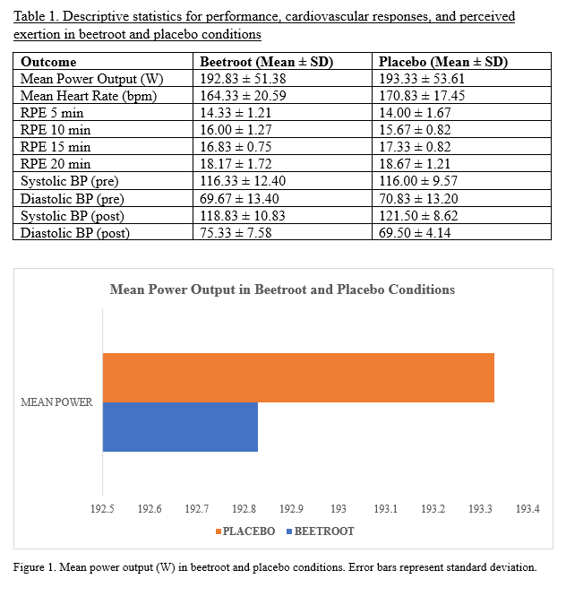

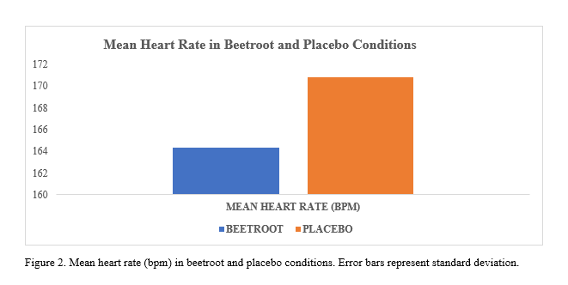

Descriptive statistics for all outcomes are shown in Table 1. Overall, values were similar between beetroot and placebo across performance, cardiovascular responses, and perceived exertion. RPE increased over time in both conditions, and blood pressure values showed only small, inconsistent differences. Figures 1 and 2 illustrate the patterns for mean power output and heart rate.

Normality Testing

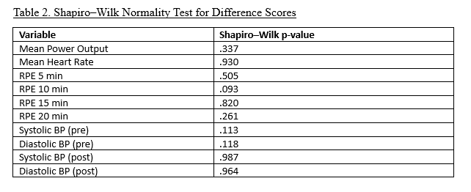
Shapiro–Wilk tests showed all difference scores met normality assumptions (p > .05), supporting the use of parametric analyses. Full results are presented in Table 2.

Paired Samples t-Tests

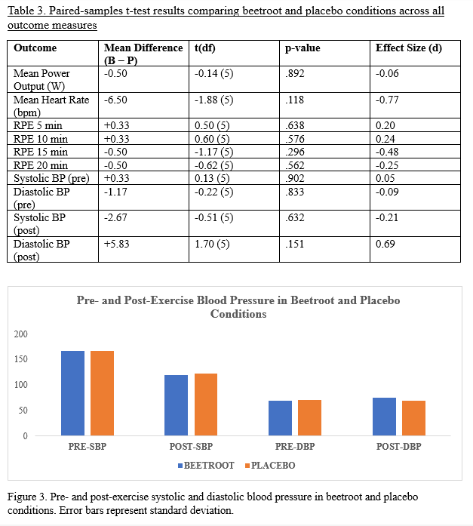Paired-samples t-tests showed no significant differences between beetroot and placebo for any outcome (all p > .05; Table 3). Mean power and heart rate were statistically similar between conditions, and RPE and blood pressure values showed no meaningful differences. Effect sizes were small across all variables. Figure 3 displays pre- and post-exercise blood pressure for both conditions.

Repeated Measures ANOVA

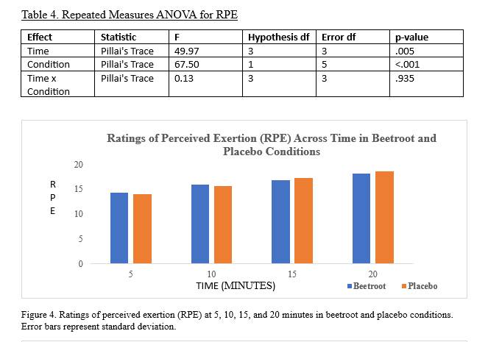

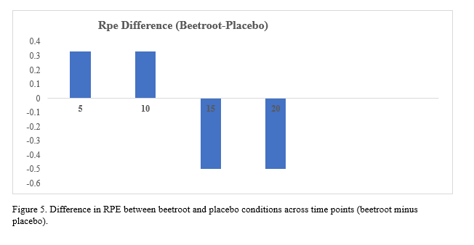
The repeated measures ANOVA showed significant effects of Time and Condition, but no Time × Condition interaction (Table 4). RPE increased across the trial, and overall values differed between beetroot and placebo, but the pattern of change over time was similar in both conditions. Figures 4 and 5 illustrate RPE values and difference scores across time.
ORDER EFFECTS

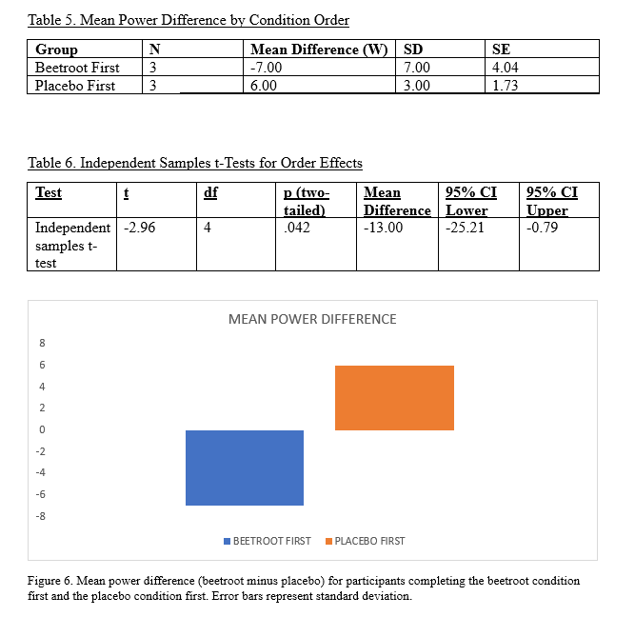
An independent-samples t-test showed a significant order effect, with mean power differences differing between participants who completed beetroot first and those who completed placebo first, t(4) = −2.96, p = .042. Descriptive statistics are shown in Table 5, and t‑test results in Table 6. Figure 6 illustrates the mean power differences for each condition order.

Discussion

Overall Performance Outcomes
Acute beetroot juice ingestion did not meaningfully improve 20-minute cycling time-trial performance in this sample of recreationally active individuals. Beetroot juice produced only small, non-significant differences in power, heart rate, and perceived exertion relative to the placebo condition. These findings suggest limited ergogenic benefit under the specific conditions of this study, although individual responses varied. A closer examination of the data highlights substantial variability between participants, which shaped the overall pattern of results.

Inter-Individual Variability
A key feature of the results was the large variability in individual performance responses.
The small sample size magnified the effect of single participants on group averages (Faber and Fonseca, 2014). One participant performed better on placebo, which distorted the overall pattern. Given this variability, it was important to examine whether trial sequence contributed to performance differences

Order Effects
A significant order effect was found, indicating that trial sequence influenced performance outcomes. Participants completing beetroot first showed different power changes than those completing placebo first. This suggests familiarisation or pacing differences contributed to the variability in results.

Possible Explanations for the Placebo-Better Participant
This outcome may reflect natural nitrate non-responsiveness reported in previous research (Silva et al., 2022). Such non-responsiveness is more common in fitter individuals with optimised nitric oxide pathways (Silva et al., 2022). Daily variation in motivation or fatigue may also have influenced this participant’s pacing (Andrade, 2021). Differences in baseline dietary nitrate intake could have favoured the placebo condition (Tian et al., 2025). Lower nitrate conversion on the beetroot day may reflect minor changes in oral bacteria (Zamani et al., 2021). A familiarisation effect may also have improved performance in the second trial, regardless of supplement (Wong et al., 2025).

Physiological Responses
Heart rate was lower with beetroot, suggesting reduced cardiovascular strain without performance change. RPE values were similar across conditions, indicating no perceived benefit. Blood pressure responses showed no clear pattern, which is expected in small acute trials (Faber and Fonseca, 2014).

Methodological Controls
Several methodological features aimed to reduce variability and strengthen internal validity. The randomised crossover design reduced between-participant differences, a key strength of this approach (Lim and In, 2021). Supplements were taken 2–3 hours before exercise, aligning with typical recommendations for peak nitrate and nitrite availability (Zamani et al., 2021). Dietary and behavioural controls reduced variability in nitrate absorption and conversion (Zamani et al., 2021). Avoiding antibacterial mouthwash protected oral nitrate-reducing bacteria essential for nitric oxide production (Zamani et al., 2021). The one-week washout period prevented carry-over effects, as nitrate returns to baseline within 48 hours (Zamani et al., 2021). Testing occurred at the same time of day to limit circadian variation (Bommasamudram et al., 2022). Standardised instructions reduced motivational and pacing differences between trials (Nikolaidis, 2023). Despite these controls, individual variability remained high, highlighting the complexity of nitrate responses.

Comparison with Previous Research
The closest comparator is the crossover trial by Wong, Lau, and Burns (2025). Their study reported improved muscle oxygenation and faster cycling performance after beetroot ingestion. Their protocol closely matched the present study in participants, exercise mode, and timing. Differences in findings may reflect stricter dietary control and standardised nitrate dosing in their trial (Wong, Lau, and Burns, 2025). The longer 20-minute trial here may also reduce the influence of nitric-oxide-related efficiency gains (Wong, Lau, and Burns, 2025). Importantly, their study included 24 participants, giving greater statistical power to detect small performance effects.

Evidence from Systematic Reviews
Broader evidence from recent reviews supports these observations. Tian et al. (2025) reported large variability in nitrate responses across different populations. Poon et al. (2025) found small effects that depend on dose, timing, and training status. Zamani et al. (2021) noted that inconsistent protocols across studies often contribute to mixed or null findings. The present findings align with this wider pattern of variable and context-dependent outcomes.

Mechanistic Considerations
Mechanistic evidence also helps explain the limited performance changes. Nitrate can reduce oxygen cost during submaximal cycling (Tan et al., 2022). It may also enhance calcium handling and contractile efficiency (Esen et al., 2023). These effects are subtle and may not appear in small, varied samples. Moderators such as sex, fitness, and habitual nitrate intake influence responsiveness (Silva et al., 2022). The mixed recreational sample here may have masked small benefits (Silva et al., 2022).

Practical Implications
Practical implications remain modest. Acute beetroot juice may offer limited benefit for short continuous efforts in recreationally active individuals. However, the supplement is low-risk and inexpensive. Some individuals may still benefit under optimised dosing and dietary control (Tian et al., 2025). Beetroot may be most useful for repeated high-intensity efforts or severe-intensity time trials (Wong et al., 2025).

Limitations
Several limitations must be acknowledged. The small sample reduced statistical power and increased the likelihood of missing real effects (Faber and Fonseca, 2014). The study was underpowered, G*Power indicated 27 participants were needed for medium effects (Faul et al., 2009). Dietary intake was not fully controlled, increasing variability in baseline nitrate levels. A single acute dose limits generalisability to multi-day protocols (Zamani et al., 2021). Recreational participants may respond differently from trained athletes (Silva et al., 2022).

Context for Ethical and Safety Issues
Although these findings clarify the performance effects of acute beetroot juice, they also highlight the need for responsible supplement use. Any practical application of nitrate supplementation must consider potential risks, individual variability, and compliance challenges (Zamani et al., 2021). It is also important to recognise the wider ethical and safety issues surrounding supplement use in sport (WADA, 2026). These considerations ensure that supplementation remains safe, legal, and informed in real-world practice.

Ethical and Safety Considerations

Safe, ethical supplement use is essential for nitrate strategies (World Medical Association, 2013). Beetroot juice is usually well tolerated, though mild gastrointestinal discomfort may occur (Zamani et al., 2021). Beetroot can also cause harmless red urine or stool, which may concern uninformed users (Sauder and Rout, 2023). Compliance issues may arise because beetroot products have a strong taste and colour, which can reduce acceptability (Zamani et al., 2021). Consistent dosing is also important, as nitrate content varies across commercial products (Zoughaib et al., 2024).

Supplement legality must also be considered. Dietary nitrate is permitted under the World Anti-Doping Agency Prohibited List, as it is a natural food-derived compound (WADA, 2026). However, users should remain cautious with commercial supplements, as some may be contaminated if manufactured in facilities that also handle banned substances (Zamani et al., 2021). Choosing third-party tested products reduces this risk and supports safe practice (Zamani et al., 2021).

Responsible use also requires clear guidance on dosing, timing, and individual suitability. Users should be informed about potential side effects and realistic performance expectations (Zamani et al., 2021). Screening tools such as the PAR-Q+ can help identify individuals who may require medical advice before supplementation (Warburton et al., 2011). Practitioners should also consider individual variability, as responsiveness differs across sex, fitness, and habitual nitrate intake (Silva et al., 2022).

Ethical practice involves promoting informed decision making rather than encouraging unnecessary supplement use (World Medical Association, 2013). Beetroot juice should complement, not replace, evidence-based training and nutrition strategies (Lee et al., 2026). When used responsibly, nitrate supplementation can be integrated safely into practice while respecting legal, health, and ethical standards (Zamani et al., 2021).

References

Andrade, C. (2021) ‘The inconvenient truth about convenience and purposive samples’, Indian Journal of Psychological Medicine, 43(1), pp. 86–88. Available at: https://doi.org/10.1177/0253717620977000 (Accessed: 14 March 2026).

Beet It Sport (2025) Nitrate evidence stacks high: landmark review of 180 studies confirms proven athletic performance benefits. Available at: https://www.beet-it.com/blogs/news/nitrate-evidence-stacks-high-landmark-review-of-180-studies-confirms-proven-athletic-performance-benefits (Accessed: 26 March 2026).

Beet It Sport (2026) Research grade nitrate and placebo shots. Available at: https://www.beet-it.com (Accessed: 14 March 2026).

Bommasamudram, T., Ravindrakumar, A., Varamenti, E., Tod, D., Edwards, B.J., Peter, I.G. and Pullinger, S.A. (2022) ‘Daily variation in time-trial sporting performance: a systematic review’, Chronobiology International, 39(9), pp. 1167–1182. Available at: https://doi.org/10.1080/07420528.2022.2090373 (Accessed: 4 April 2026).

Borg, G. (1973) ‘Perceived exertion: a note on “history” and methods’, Medicine & Science in Sports, 5(2), pp. 90–93.

Esen, O., Dobbin, N. and Callaghan, M.J. (2023) ‘The effect of dietary nitrate on the contractile properties of human skeletal muscle: a systematic review and meta-analysis’, Journal of the American Nutrition Association, 42(4), pp. 327–338. Available at: https://doi.org/10.1080/07315724.2022.2037475 (Accessed: 14 March 2026).

Faber, J. and Fonseca, L.M. (2014) ‘How sample size influences research outcomes’, Dental Press Journal of Orthodontics, 19(4), pp. 27–29. Available at: https://www.scielo.br/j/dpjo/a/kJsVCrLstNgsvxkmxh9nGQF/?lang=en (Accessed: 4 April 2026).

Faul, F., Erdfelder, E., Buchner, A. and Lang, A-G. (2009) ‘Statistical power analyses using G*Power 3.1: tests for correlation and regression analyses’, Behavior Research Methods, 41(4), pp. 1149–1160. Available at: https://link.springer.com/article/10.3758/BRM.41.4.1149 (Accessed: 4 April 2026).

Głowacz, J., Popiel, M., Dziekoński, K., Rybowski, J., Krzyśkowska, S., Redner, A., Kwiecień, I., Zwierzchlewska, P., Rusin, B., Stanibuła, D. and Buczek, K. (2025) ‘Beetroot juice as a natural ergogenic supplement: a literature review of its effects on physical performance and training adaptation’, Quality in Sport, 39, 59096. Available at: https://doi.org/10.12775/QS.2025.39.59096 (Accessed: 14 March 2026).

Hedman, K., Lindow, T., Elmberg, V., Brudin, L. and Ekström, M. (2021) ‘Age and gender specific upper limits and reference equations for workload indexed systolic blood pressure response during bicycle ergometry’, European Journal of Preventive Cardiology, 28(12), pp. 1360–1369. Available at: https://doi.org/10.1177/2047487320909667 (Accessed: 14 March 2026).

InBody (2026) Electrical Impedance Analysis. Available at: https://www.inbody.in/technology.php (Accessed: 2 April 2026).

Lee, E., Park, H-Y., Sun, Y., Choi, J-H., Woo, S., Cho, S., Kim, S., Zheng, Y., Kim, S-W. and Lim, K. (2026) ‘Beetroot juice and exercise for clinical health and athletic performance: a narrative review’, Nutrients, 18(1), 151. Available at: https://www.mdpi.com/2072-6643/18/1/151 (Accessed: 13 March 2026).

Lim, C-Y. and In, J. (2021) ‘Considerations for crossover design in clinical study’, Korean Journal of Anesthesiology, 74(4), pp. 293–299. Available at: https://ekja.org/journal/view.php?doi=10.4097/kja.21165 (Accessed: 4 April 2026).

Milton Laskibar, I., Martínez, J.A. and Portillo, M.P. (2021) ‘Current knowledge on beetroot bioactive compounds: role of nitrate and betalains in health and disease’, Foods, 10(6), 1314. Available at: https://doi.org/10.3390/foods10061314 (Accessed: 14 March 2026).

Mueller, B.J., Roberts, M.D., Mobley, C.B., Judd, R.L. and Kavazis, A.N. (2025) ‘Nitric oxide in exercise physiology: past and present perspectives’, Frontiers in Physiology, 15, 1504978. Available at: https://www.frontiersin.org/articles/10.3389/fphys.2024.1504978/full (Accessed: 14 March 2026).

Nikolaidis, P.T. (2023) ‘Exercise testing and motivation’, Sci, 5(1), 12. Available at: https://www.mdpi.com/2413-4155/5/1/12 (Accessed: 4 April 2026).

OMRON Healthcare (2026) Medical devices and healthcare solutions. Available at: https://www.omron-healthcare.co.uk/ (Accessed: 2 April 2026).

Pappas, G., Wilkinson, M.L. and Gow, A.J. (2023) ‘Nitric oxide regulation of cellular metabolism: adaptive tuning of cellular energy’, Nitric Oxide, 131, pp. 8–17. Available at: https://doi.org/10.1016/j.niox.2022.11.006 (Accessed: 14 March 2026).

Polar Electro (2026) Compare Polar sensors. Available at: https://www.polar.com/uk-en/comparison/sensors (Accessed: 2 April 2026).

Poon, E.T-C., Iu, J.C-K., Sum, W.M-K., Wong, P-S., Lo, K.K-H., Ali, A., Burns, S.F. and Trexler, E.T. (2025) ‘Dietary nitrate supplementation and exercise performance: an umbrella review of 20 published systematic reviews with meta-analyses’, Sports Medicine, 55, pp. 1213–1231. Available at: https://link.springer.com/article/10.1007/s40279-025-02194-6 (Accessed: 14 March 2026).

RANDOM.ORG (2026) List randomizer. Available at: https://www.random.org/lists (Accessed: 2 April 2026).

Sauder, H.M. and Rout, P. (2023) Beeturia. In: StatPearls [Internet]. Treasure Island (FL): StatPearls Publishing. Available at: https://www.ncbi.nlm.nih.gov/books/NBK557608/ (Accessed: 4 April 2026).

Seca (2026) Seca 213 portable stadiometer. Hamburg: Seca GmbH & Co. KG.

Silva, K.V.C., Costa, B.D., Gomes, A.C., Saunders, B. and Mota, J.F. (2022) ‘Factors that moderate the effect of nitrate ingestion on exercise performance in adults: a systematic review with meta-analyses and meta-regressions’, Advances in Nutrition, 13(5), pp. 1866–1881. Available at: https://doi.org/10.1093/advances/nmac054 (Accessed: 14 March 2026).

Tan, R., Wylie, L.J., Wilkerson, D.P., Vanhatalo, A. and Jones, A.M. (2022) ‘Effects of dietary nitrate on the O₂ cost of submaximal exercise: accounting for “noise” in pulmonary gas exchange measurements’, Journal of Sports Sciences, 40(10), pp. 1149–1157. Available at: https://doi.org/10.1080/02640414.2022.2052471 (Accessed: 14 March 2026).

Tian, C., Jiang, Q., Han, M., Guo, L., Huang, R., Zhao, L. and Mao, S. (2025) ‘Effects of beetroot juice on physical performance in professional athletes and healthy individuals: an umbrella review’, Nutrients, 17(12), 1958. Available at: https://doi.org/10.3390/nu17121958 (Accessed: 14 March 2026).

Warburton, D.E.R., Jamnik, V.K., Bredin, S.S.D. and Gledhill, N. (2011) ‘The Physical Activity Readiness Questionnaire for Everyone (PAR-Q+) and Electronic Physical Activity Readiness Medical Examination (ePARmed-X+)’, The Health & Fitness Journal of Canada, 4(2), pp. 3–17. Available at: https://doi.org/10.14288/hfjc.v4i2.103 (Accessed: 14 March 2026).

Wattbike (2026) Wattbike Air Pro. Available at: https://commercial.wattbike.com/products/wattbike-airpro (Accessed: 2 April 2026).

Wong, T.H., Lau, I.G.L. and Burns, S.F. (2025) ‘An isotonic beetroot drink improves muscle oxygenation and cycling time trial performance in physically active individuals: a randomised crossover trial’, International Journal of Food Science and Technology, 60(2), vvaf136. Available at: https://doi.org/10.1093/ijfood/vvaf136 (Accessed: 14 March 2026).

World Anti-Doping Agency (WADA) (2026) The World Anti-Doping Code: The 2026 Prohibited List. Montreal: WADA. Available at: https://www.wada-ama.org/sites/default/files/2025-09/2026list_en_final_clean_september_2025.pdf (Accessed: 26 March 2026).

World Medical Association (2013) Declaration of Helsinki – Ethical Principles for Medical Research Involving Human Participants. Available at: https://www.wma.net/policies-post/wma-declaration-of-helsinki-ethical-principles-for-medical-research-involving-human-subjects (Accessed: 01 April 2026).

Zamani, H., de Joode, M.E.J.R., Hossein, I.J., Henckens, N.F.T., Guggeis, M.A., Berends, J.E., de Kok, T.M.C.M. and van Breda, S.G.J. (2021) ‘The benefits and risks of beetroot juice consumption: a systematic review’, Critical Reviews in Food Science and Nutrition, 61(5), pp. 788–804. Available at: https://doi.org/10.1080/10408398.2020.1746629 (Accessed: 14 March 2026).

Zoughaib, W.S., Fry, M.J., Singhal, A. and Coggan, A.R. (2024) ‘Beetroot juice supplementation and exercise performance: is there more to the story than just nitrate?’, Frontiers in Nutrition, 11, 1347242. Available at: https://doi.org/10.3389/fnut.2024.1347242 (Accessed: 14 March 2026).

