
Student: Marie Jandova
Student number: 2020984

Programme: BA (Hons) Leadership and Management Skills for the Workplace
Module: Managing Projects in the Organisation.
Module code: BMSW 5104
Module Leader: Dr Rexon Nting
Assignment Title: Managing Projects in the Organisation.
- Individual Presentation on proposed project management plan.
- Evaluation of project management plan – 2500 words.

Introduction
This report evaluating a Project Management Plan. Focusing on building a Pond Park in University area. This report shows the importance of project management tools in a real life and comprising the usefulness of project management tool before, during and after Covid-19 pandemic. In order successfully complete this project this report contain tools as a Quad Cart, Stakeholder analysis, WBS, Gantt Chart, CBS, Risk assessment. Function of those tools is described in each section for better understanding of those results stated in the report.
Table of Contents
Introduction 1
Task 2. Body 2
The project management process 2
Project Scope: 2
1.Project Initiation 2
2.Project Planning 5
3.Project Execution 7
4.Project Monitoring and Controlling 9
5.Project Closing 12
Conclusion 13
References 13
Task 2 15

Task 2. Body
The project management process –
Has five different stages and those stages are supported with tools, drawings, and analyses.
- Project Initiation (Project Description, Business Case, Quad Chart)
- Project Planning (Stakeholders Analysis, Stakeholder Communication Map)
- Project Execution (Work Breakdown Structure “WBS”, Recourses – Organisational Chart)
- Project Monitoring and Controlling (Gantt Chart, Cost Breakdown Structure, Risk Assessment)
- Project Closing (Documentation – Project result approval)

Any business plan or project requires communication, those tools are designed to communicate the project between stakeholders, allowing to clearly see the project idea simply written in templets.
Those tools were designed and used a long time before the Covid-19 pandemic, but after the Covid-19 restriction when people were forced to stay in their homes, those tools become a necessity. People began to work from home on a daily basics and communicating only online using teams, zoom calls etc. and sharing information thought communication tools like the ones described above in the brackets.
Remote project management also gives the opportunity to work overseas or on few different project across when not physically being present. People can use PM tools to connect and work as a team, seeing updates in the project life - online.
Even though the Pandemic is pretty much over, PM Managers and other stakeholders rely on the PM tool daily, it helps them efficiently manage budgets, timelines, productivity, improves relationships with stakeholders, assesses project risks, and customer satisfaction.

Project Scope:

1.Project Initiation

Project Description
Building a Park with a pond and seating area in the University
Replacing sixteen car-parking spots with 48-88 m Park with ponds, benches, tables and bins with easy access to all University members and the public.
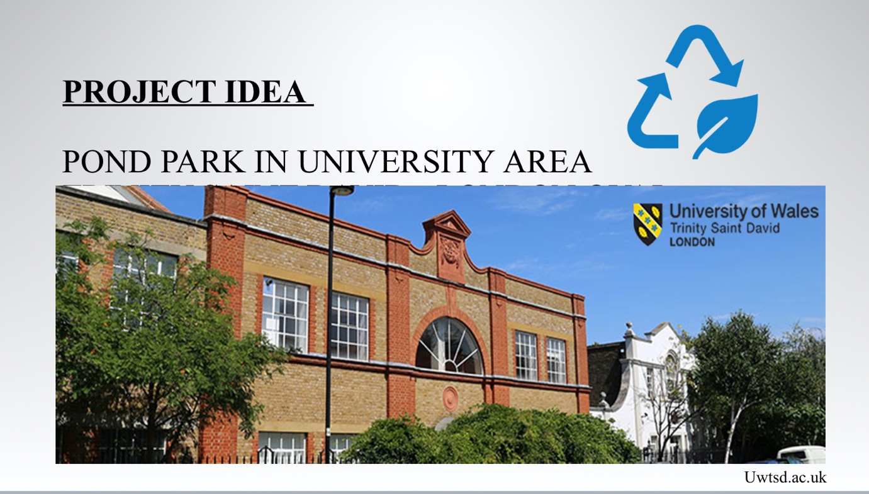
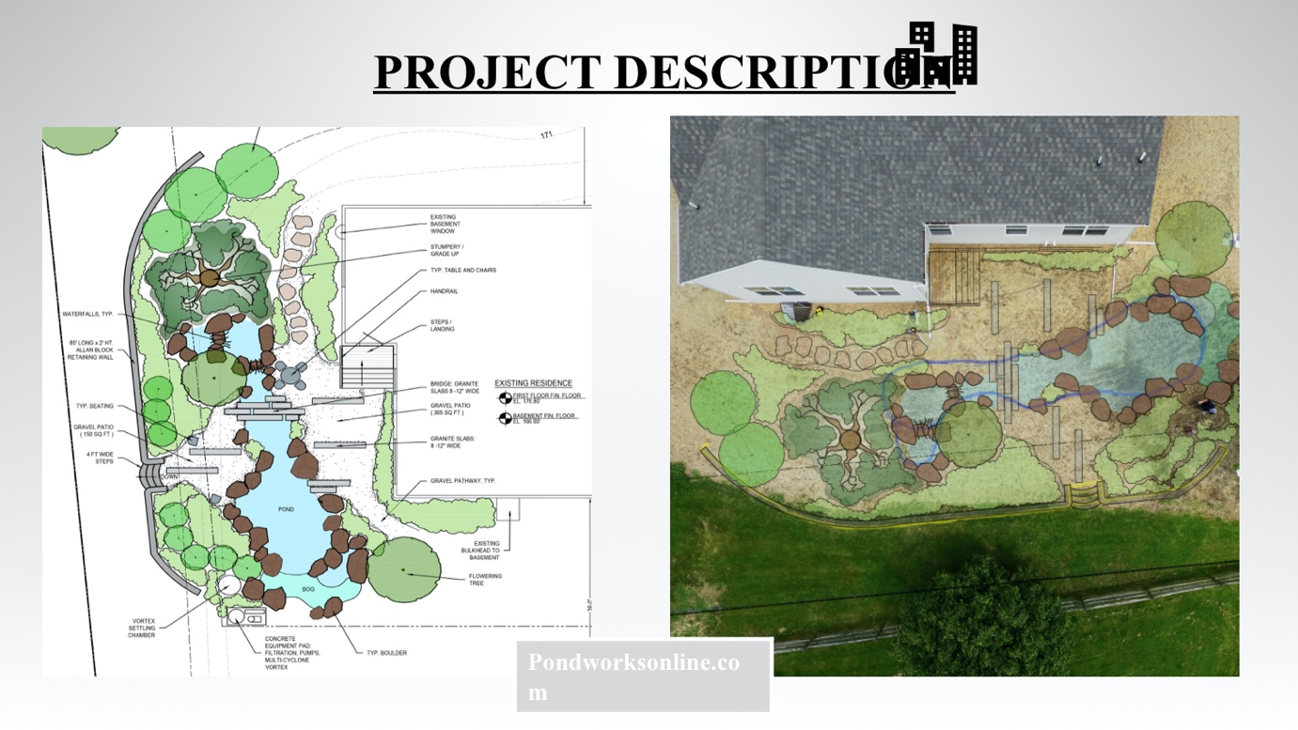

Business Case
- Business Case templet is let’s say basic justification of a project that is undertaking the purpose and benefits of a project. Business template has commercial benefits.
- Business Case templet can be shown in the presentation of a project, on a build boards, news, TV, in the local information, in the investor presentation.
- Business Case templet should convince stakeholders to take action and be positive to the project.
Building Park in the University area will benefit not only School staff and students but also other stakeholders and the community. This project aims to build a green area with a little water pond and outdoor seating with easy access to all. Several studies show that students can benefit from outdoor breaks. Parks improve physical and mental health in all age groups. Parks have not only recreational benefits but also environmental and aesthetic benefits. Especially after the Covid-19 pandemic, people still recommend co keep their distance, meeting outside etc. park is designed to meet all those recommendations and accomplish the purpose.
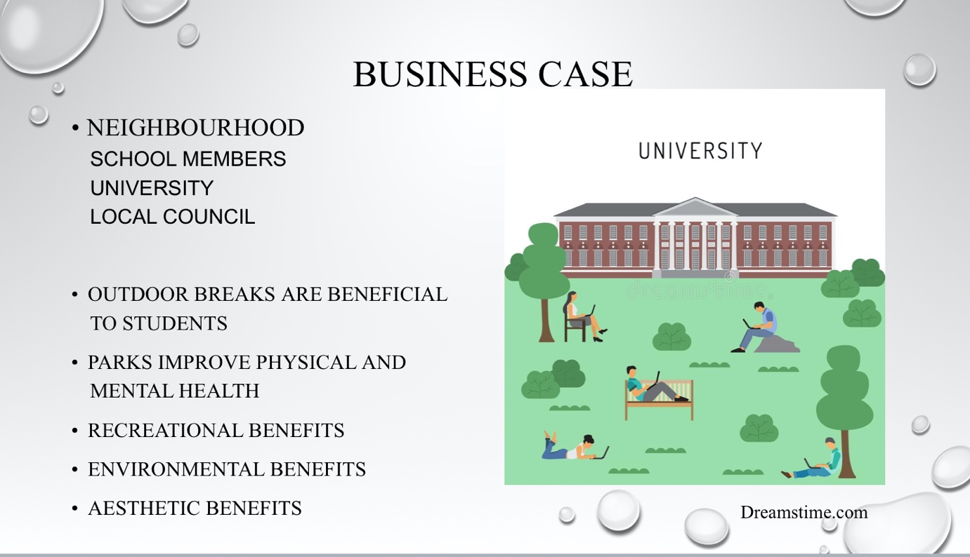

Quad Chart
- Technical Information can be very simply and briefly described in Quad Chart which is a communication tool, a drawing of a few tables to clearly separate the most important planning information about:
- What is the purpose of this project?
- What is the desired result of this project?
- Who are the customers of this project?
- What is the measure of success in this project?
University on its own has a big parking area which is not being fully used. Many people are often seen having their lunch outside sitting on the pavements of the car park. Park will be the perfect solution to this current problem and will also attract external users and new potential students.
According to the current plans made, this project should only take one month and cost approximately £35,000.
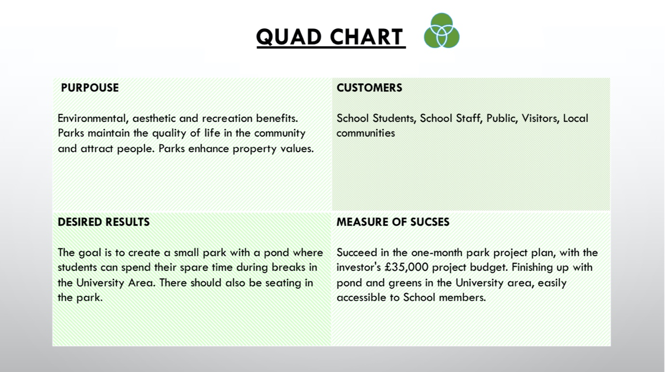

2.Project Planning

Stakeholders Analysis
- Stakeholder is anyone who is involved in any kind of way in my project or has any interest in the project. In this case, the University Park area we have many stakeholders because the park will be located in the University area but accessible to the public also.
This project stakeholders are:
- Development team – Helping to develop with low impact and low power
- University, students, sponsors, school staff, and council – the customers the project should satisfy. Their power is pretty high as they need to be happy and satisfied with the results, they need to approve. But their impact is low.
- External users, the public, neighbourhood and media – can not dictate how they would like the project/work to be done as they are not the customers but they can have a big impact on the project. For example, the local community might not agree with the project or won’t agree with the idea, in this case, they can protest against it, sign petitions or even try to destroy or stop the project on their own. The project needs their support to succeed. That’s why is very important to keep them informed. Those people usually live in the area or people that have different beliefs or visions.
- Project managers, Financial officers, Project Colleagues – those stakeholders we need to manage closely as they directly working on the project and they have a big over the project and a big impact the project. They are managing costs, work breakdown, resources, organising and leading other people. Those are very important people in the project.
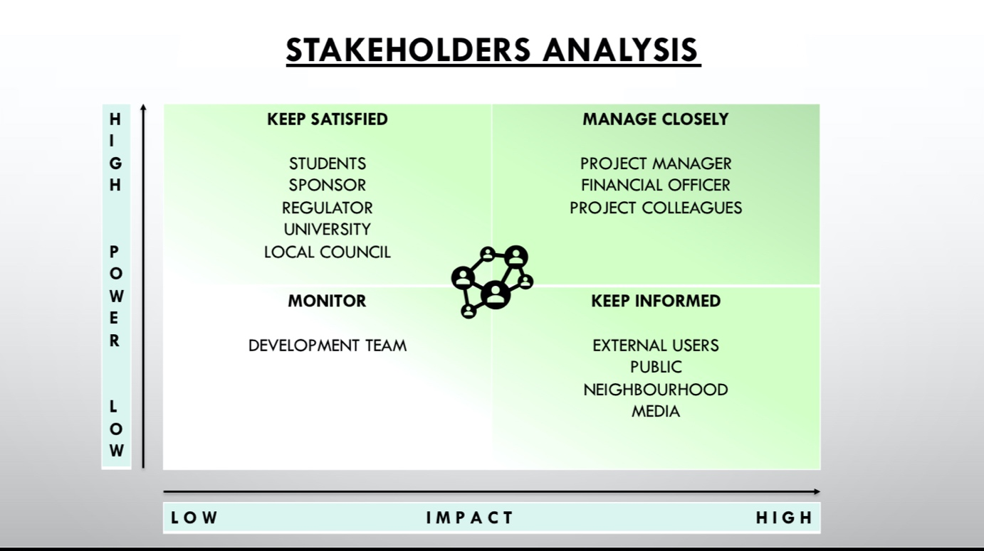

Stakeholders analysis – Communication Map
- When managing a project, the Project Manager needs to communicate with the stakeholders. Present the project and information on the project's progress. To communicate this there is a simple table in which we can clearly see whom we have to contact and keep updated during the project.
For example:
a) The investors for this Park project will want to see the financial report, to compare if the project in different times of period spending the money as planned, if it's less or more than planned than there is a problem. “ what’s the reason for the project to be cheaper?” “Are they using the correct material?” or “ Why the project cost more than planned?” “Is there everything being done as planned” “what happened?” etc... This report needs to be submitted as agreed before, Weekly.
b) The Project Manager will want to see daily updates from the Project Team to compare how is the work being done, in what speed, if there are any issues, if there are enough people to complete the work, if the right money is being used. This way the project manager has better control over the project when physically not present. The report can be sent via E-mail. This was a very big advantage when Covid-19 restrictions would recommend working remotely.
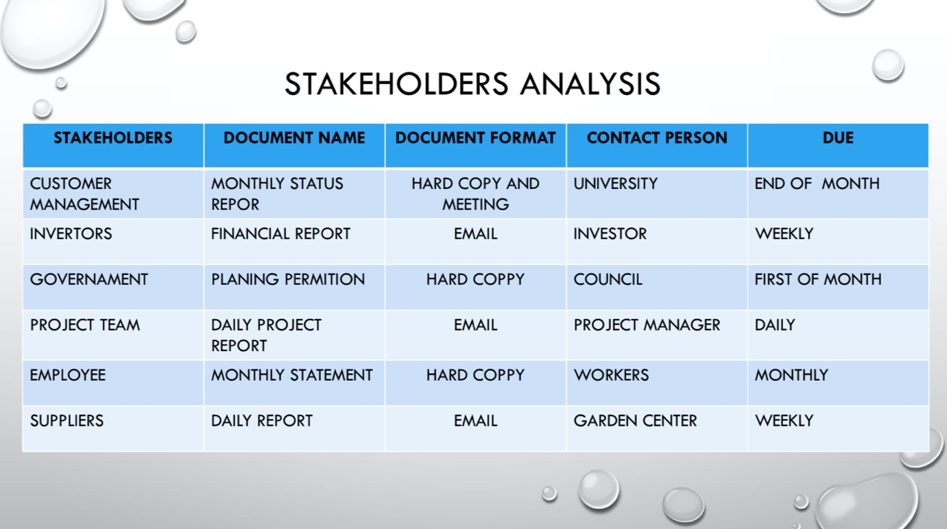

3.Project Execution

Work Breakdown Structure (WBS)
- WBS is a PM planning tool that breaks larger work into smaller tasks. It allows them to track the project step by step. WBS breaks tasks into under tasks and under tasks called – Activity, Sub Activity and Sub sub Activity.
- When Project is broken down into smaller tasks is much easier to keep track and it becomes more manageable which is the goal.
With the final design and approval of the project within seven days, it should only take twenty days to deliver, as this WBS explains step by step in each activity.
As Park is being done on the previous parking place, there are hard landscaping works needed right from the beginning to prepare suitable land. The land has to be completely clear of any trees and previous foundations. Digging of the hole and preparation for the pond begins. This should take eleven days. Pond installation and electrician work another two. Soft landscaping will take about nine days, Landscapers need to plant and clean and finish the final project.
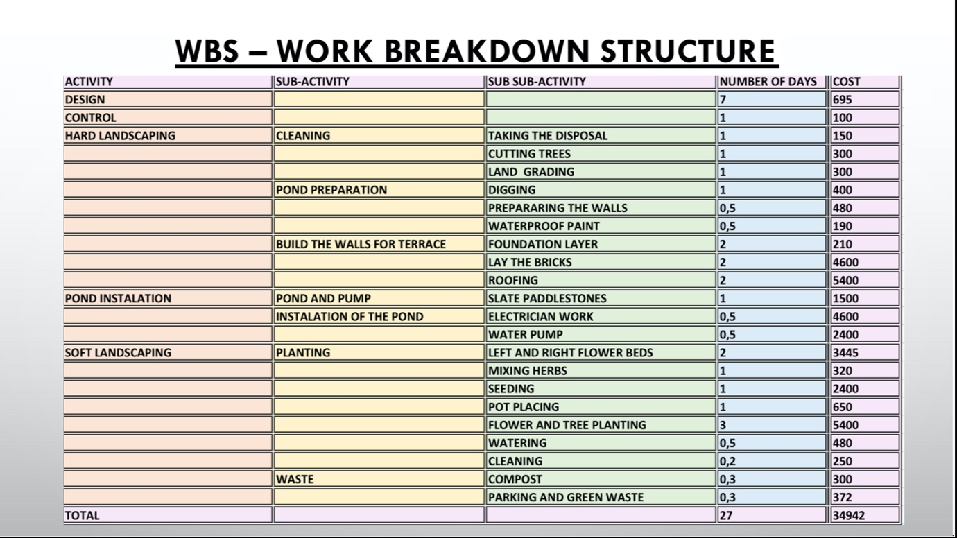

Recourses – Organisational Chart)
Organisational chart is a diagram that visualise and detailing who in the project is responsible for what
- Resource can be a team, person, another company, tools, time, finance
- Project usually need multiple Resources in order to be doable and completed.
- Resource Chart (Organisational Chart) is necessary to define whose responsibility will be to carry out different tasks in the project
- With Organisational structure is much easier to allocate labour resources

First very important person is the Project Manager. In this case it is me. the University student. I have developed this Project idea. I created this team of people involved in this project, monitor the progress of a project, solve any upcoming issues, manage the money, satisfy the stakeholders, and evaluate the project performance.
My effort, input and time is one of the resources.
Another very important resource for this project is a person - the contractor.
This project is closely connected and collaborating with the Garden Centre. This organisation is one of the most important resources in this project as the Garden Centre has also it is own resources. They for example have their Designer, Architects, Landscapers, Tools, Tool rental connection, Vans, Waste, Suppliers, Plants.
This project still need someone responsible for Labour part, even though there is a contractor, there are some works that require specialists or someone who is not employed under Garden Centre. Labour cost is the cost of person per hour.
Project managers also need responsible suppliers that will collaborate and try to bring creative solution to the project. Is very important to insure reasonable cost and in the budget, good quality and time of a delivery as this project is planned on thirty days exactly.
And on the end, in any project, there is a finishing supervisor. Finishing Supervisor has to make sure that the project is safe, in the required quality, on time, and if finished to University and Sponsor satisfaction.

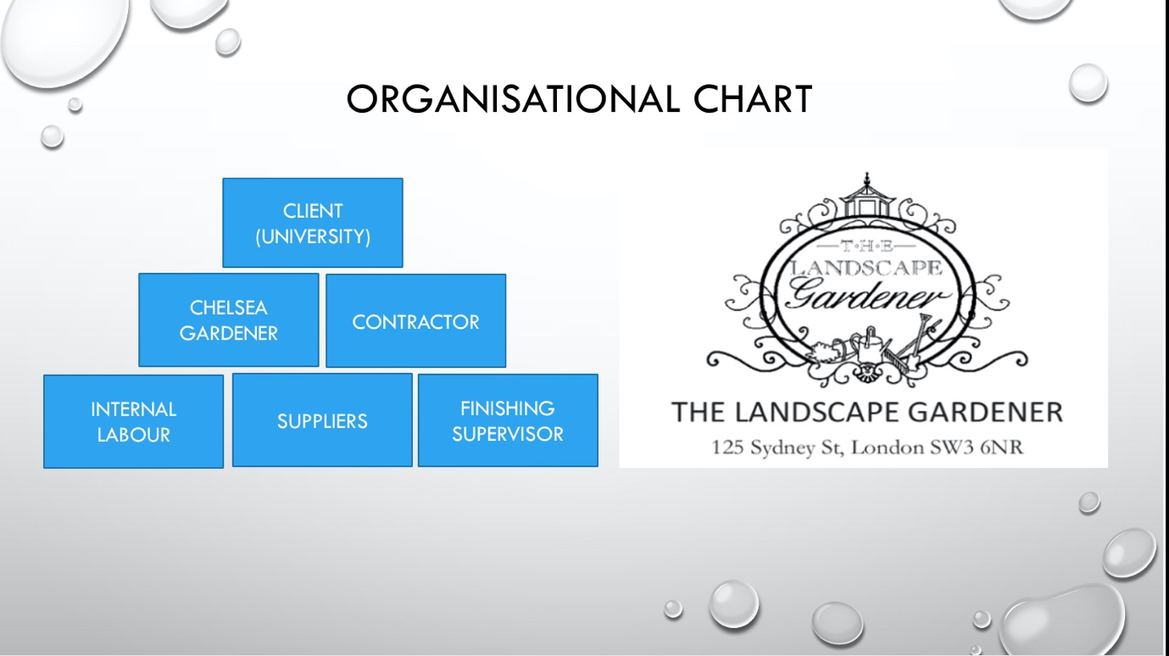

4.Project Monitoring and Controlling

Gantt Chart
Amazing tool used for better visualisation that can help to schedule, manage and also monitor different tasks and resources in the project. This took is the most popular tool in PM. Gantt Chart is a horizontal timetable with all the tasks and subtasks planned, it usually has the start and finish date of each task completed. That way is very easy to monitor progress in a real time. This tool is used both physically and remote and therefore Covid-19 did not affect it is usefulness.

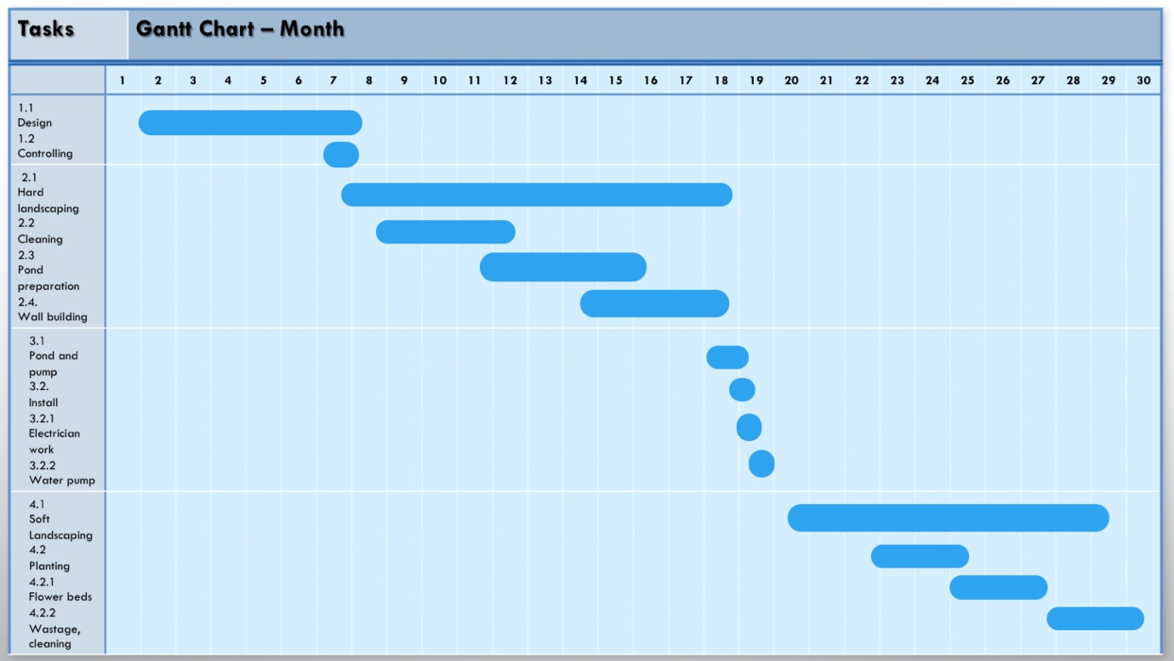

Cost Breakdown Structure (CBS)
The Cost breakdown structure represents the costs of each work needed or done in the WBS in order to complete the project.
- CBS allows better control over the budget
- It is very important to have a good CBS so underspending or overspending is clearly noticeable from the beginning.
- When noticing deviation in the early stage is easier to identify the problem and solve it.
- CBS helps the customer to understand what exactly they are paying for
CBS to the Park Project includes materials, labour, and consumption tax assessed on the value added in each production stage of a good or service (VAT)

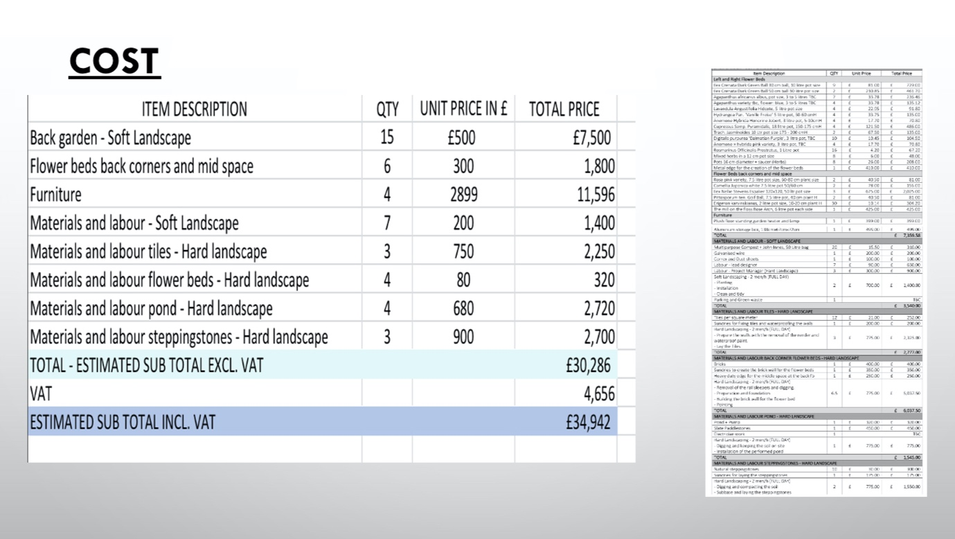

Risk Assessment
Risk assessment is measuring the possibility of a risk to become reality.
Identifying the possible risk and analyse what could happen if the risk actually occurs.
- Risk needs to be identified first
- Potential risks need to be controlled
- Findings needs to be recorded and reviewed
- Each project has its own risks and it is very helpful to analyse them before starting the project that way the risks can be limited, avoided or a strategy plan can be made.

The risks for the Park Project are:
Materials – it can happen that there won't be enough material in the stock, or especially after covid-19 lots of companies are bankrupted. Is also hard to deliver to the UK due to Brexit restrictions. The importance is medium, and the likelihood is also medium. To prevent from this happening, the project should have more sources of material to back up just in case.
Budget – very important for this project as there are investors and the project has been planned to be done for some amount of money. The likelihood is very high as prices of materials can raise very quickly over time. To prevent this from happening, project managers need to follow current market prices and future analyses.
Design Changes – The importance is pretty low, as long as customer is happy and the project can meet their requires. Likelihood is also low because project has been previously approved. It can happen that the soil will not be good enough to dig a hole for the pond in the first meter, but it can be moved and redesigned.
Employees – Due to Covid-19, many people could easily get ill or had to self-isolate. When managing a project, is very important to consider employees first and then decide how to continue with the project. It can happen that Employees call sick or will not turn to work, this could slow down the work and give several delays. The importance is very high but the likelihood is medium since post covid situation getting better.
Weather condition – As this is an outdoor project, work can not be carried in storms or heavy rain and unfortunately, London is famous for it is changing weather. This could potentially slow down the work. Importance is medium and likelihood also medium. To prevent this from happening, PM can try to plan out the works more accordingly to the weather forecast or build a temporary roof.
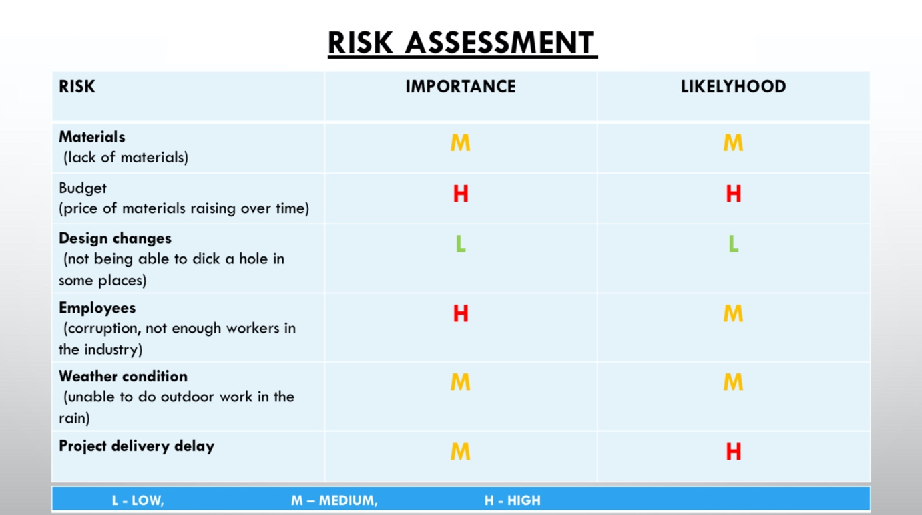

5.Project Closing

Documentation – Project result approval
Project closure documentation is to formally and legally close the project. Make sure that all the contractual works have been completed. It is also the final information about the project delivery, budget, and workers. Kind of measure of success. The project closure document should also contain lessons learned.
Closing project steps:
- Formally transfer all deliverables (Delivering the project to the customer – University – making sure everything has been fully completed and handed off from all parties)
- Complete paperwork (All the documentation has to be signed from stakeholders as a proof that all the work has been completed)
- Release sources (Let all the workers free and available for another project)
- Archive documents (This is Information management and knowledge storage, it can be always useful to look back at old records when needed)
- Celebrate success (celebrate a good job being done with the team, important part how to keep people motivated and appreciated)

Conclusion
This report proves that the use of PM tools keeps the work organised and everyone informed. PM tools are used as a communication tool. This report proves and shows the use of each tool and the clear benefits or each tool. The biggest advantage for this case is the ability to use all those tools remotely which can save time to stakeholders and the Project Manager is able to keep an eye on the project while not being physically present.
Several studies have shown that Covid-19 had positive impact on Project management, as more people started educating them self and using communication tools – online more often.
Business transformation projects contribute significantly to create opportunities, and the projects’ performance has been positively impacted during this crisis period (Project Management Institute – PMI).

References
- Berkun, S., ed. (2008). Making things happen: mastering project management. Sebastopol, California: O’Reilly

- Buffrick, R., ed. (2009). The project workout: the ultimate handbook of project and programme management. Harlow England: FT Prentice Hall

- Costtracker.com (2021). What is a CBS and why is it important? [online] Available at: https://www.costtracker.com/what-is-a-cost-breakdown-structure/ Accessed: 30.08.2022

- PMI.org. (2020). Positive Impact of the COVID-19 Crisis on Project Management. [online] Available at: https://www.pmi.org/chapters/luxembourg/stay-current/newsletter/positive-impact-of-the-covid-19-crisis--on-project-management# Accessed: 30.08.2022

- Roberts, P., ed. (2011). Effective project management [electronic resource]. Philadelphia:; London ;: Kogan Page.

Task 2



