
OPEN FROM 12PM TILL LATE
FOR DELIVERIES & COLLECTION
PLEASE DIAL
02920 414567
FOR RESERVATIONS, PLEASE DIAL
02920 511511
CONTACT US & ORDER ONLINE AT
WWW.HOTELTRINITY.CO.UK
HOTEL TRINITY SWANSEA,99 SWANSEA RD SW1 6HY
FOR GUIDENCE WITH ANY FOOD ALLERGIES PLEASE CONTACT US BEFORE PLACING AN ORDER …………..

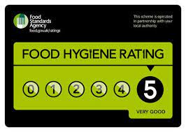
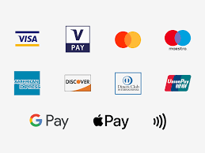



Hotel Trinity Swansea
RESTAURANT & TAKEAWAY
MENU

MAINS

DELHI KORMA
(GF) (V)Succulent free-rage charred spring Irish chicken or Country Mix Veg simmered in a Mughlai-style korma sauce. Butter nan & Pilau Rice, Serve and Pair with a Large glass of Rose Rosato 16

JANE RUSSELS MEATBALLS

Jane Russell’s award-winning nduja meatballs. Buttered tagliatelle, aged parmesan shavings and basil. Serve and pair with a glass of Red Chianti 18

SEITIAN HALF POUNDER
(VGN)Vegan Seitan 1/2 pounder - Juicy seitan patties dipped in-house made Korean BBQ sauce served with onions, red cabbage, roasted potatoes 14

BLACK ANGUS FILLET mignon 10OZ
Two 5oz cuts of fillet, beautifully delicate and tender. Recommended rare, Served with Chunky chips, bacon, and honey mustard dressing and Bearnaise Sauce 24

CHEFS SPECIAL FISH AND CHIPS
Beer Battered Fish & Chips, served with rustic potatoes & tarte Sauce 18

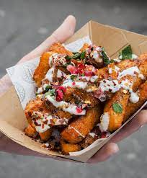

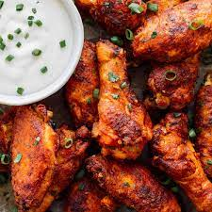

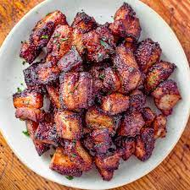



STARTERS
(GF) Chefs Soup & Bread 6

(VGN) Gyoza - Vegetable filled Steamed Dumplings. Served with Sea Salted Edamame Beans & Soy Dipping Sauce 7

Honey Glazed Spiced Pork Bites 7 (GF)
Breaded Whitebait with Tartar Dipping Sauce 6.5

Chicken Wings – Choose from Smokey BBQ or Spicy Buffalo sauce. Served with
Blue Cheese Dip & Celery Sticks 6

(V) Halloumi Fries with Sweet Chilli Dipping Sauce 6

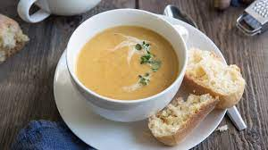

WINE AND DRINKS
ROSE ARGALI 2021 BTL 19/ GLS 4.5
COLLEZIONE DI PAOLO CHIANTI 2020 BTL 22/GLS 4.5
CLOUDY BAY CHARDONNAY BTL 20/GLS 4.8
LEFFE PINT 5.2 HALF 3.7
COBRA PINT 5.2 HALF 3.5
SPIRITS, GIN, VODKA, RUM, WHISKEY 4
COKE 3
DCOKE 3
ORANGE JUICE AND LEMONADE 3.5
LEMONADE
(ALCOHOLIC DRINKS NOT SERVED ON DELIVERY)

MENU
DESSERTS
(V) CLASSIC CRÈME BRULEE
Madagascan vanilla-glazed brulee, served with house-baked vanilla biscuit & fresh berries 8

(V) BELGIAN CHOCO BROWNIE
Warm brownie with vanilla bean ice cream 7

(V) LEMON AND RASBERRY CHEESECAKE
Light lemon, mascarpone & cream cheese mouse, served on cheesecake 6

If you have any questions, allergies, or intolerances, or you require allergen information please let us know before ordering. GF/GLUTEN FREE, V/SUITABLE FOR VEGETARIAN, VGN/VEGAN
Reference list.
Drink and pair, (2022). Drink and pair. Available at: https://drinkandpair.com/ (accessed: 11th June 2022).
Karmana, (2016). Discover our story. Available at: https://karmana.co.uk/ (accessed:12th June 2022).
Laithwaites, (2022). Laithwaites. Available at: https://www.laithwaites.co.uk/ (accessed: 11th June 2022).
Maldron hotel, (2022). City centre hotels. Available at: https://www.maldronhotelnewcastle.com/ (accessed: 10th June 2022).
Millar and Carte, (2022). The masters of steak. Available at: https://www.millerandcarter.co.uk/restaurants/east-and-west-midlands/millerandcarternorthampton#/ (accessed: 11th June 2022).
Vinatis, (2022). Great wines and great prices. Available at: https://www.vinatis.co.uk/ (Accessed: 13th June 2022).

