Research Project Proposal – Analyse the impacts of socio-economic force on employees’ performance management and monitoring in different work modes: Hospitality HR’s perspective

Personnel Resourcing & Development

(BMIH5005)

Lecturer’s name: Dr. Helen Lee
Student name: Loredana Leonte
Student ID 2234509

Information and background
With a worldwide presence, luxurious accommodations and exceptional service, Hilton Hotels is one of the best-known hospitality brands. Founded in 1919 by Conrad Hilton, the company now manages 22 brands over 7,500 properties across 126 countries and territories (Hilton.com), with new properties being yearly added (BusinessWire).
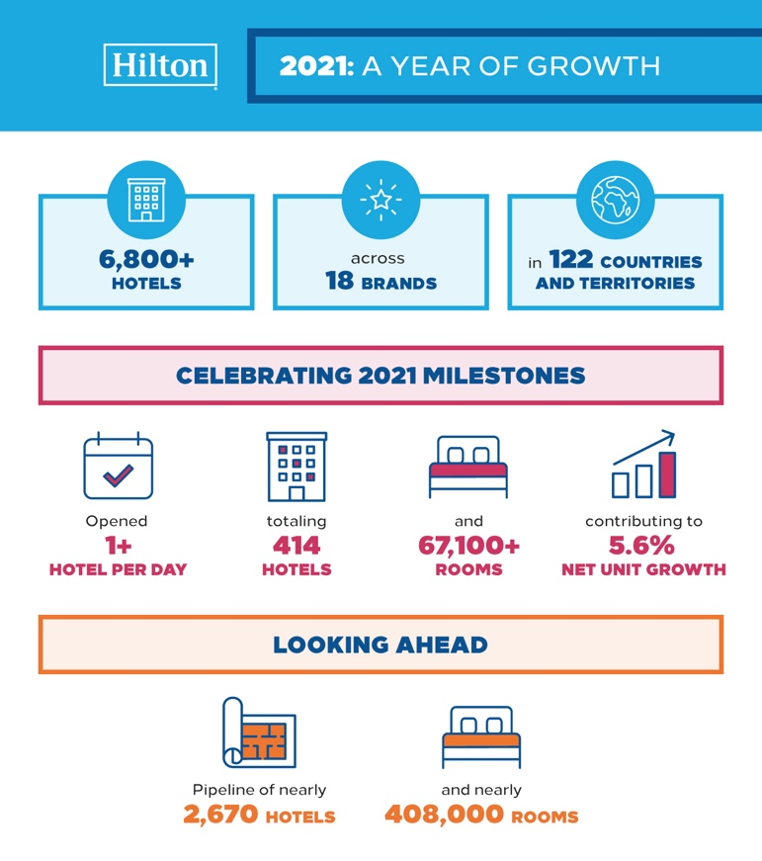
Hilton properties in 2021

The brand’s values revolve around hospitality and guest satisfaction, teamwork and leadership, integrity and ownership, and from 2010, “diversity and inclusion under Culture, Talent & Marketplace”, after the company initiated the Executive Committee Networking Program. The main focus though, falls on the effort to create memorable experiences for guests while promoting a positive and inclusive work environment for their employees.
Since its founding, the company initiated various programs aimed at supporting its employees, from continuous development training programs to competitive compensation and benefits packages, all the way to opportunities for career advancements (Dudovskiy, 2016). Hilton has been long recognised for its commitment to diversity and inclusion, as well as sustainability efforts.
As the industry trends changed, along with employee expectations, Hilton explored new work models. Flexible work arrangements, in the shape of flexible schedule, and remote work options to accommodate the changing needs and preferences of its employees are examples of these models, with “SuperFlex, workforce model, that allows call centre staff to choose their schedule and number of working hours” leading the way. Furthermore, with the rise of digital technology and its huge effects on economy, Hilton, like other global companies, is exploring innovative approaches to manage its talent and plan its workforce to be able to stay competitive in the ever-evolving hospitality landscape. Overall, Hilton continues to adapt its work models to ensure employee satisfaction and retention while staying ahead of industry trends.

PESTLE Analysis
Using the PESTLE framework, an analysis of the socio-economic factors impacting the hospitality industry would be:
Political:
Changes in government policies regarding immigration, visas, and travel restrictions can affect the availability of talent in the hospitality industry (CIPD, 2019). In UK, Brexit is one of the biggest issues, restricting EU citizens to bring in their expertise, especially as the legislation related to minimum wage isn’t in concordance with The UK Government white paper for controlling the flow of EU workers (HM Government, 2018), especially in hospitality. Laws can also affect hospitality industry as working hours, and employee benefits can impact labour costs and workforce management strategies, but tourism authorities can also “influence laws, regulations, systems, incentives, and processes they develop”.
Economic:
Inflation can increase operating costs for hotels, forcing them to increase costs for guests and freeze, or even lower wages and benefits to employees (Torrington et al. 2020). The increase of minimum wage rates impact, at the same time, labour costs, particularly in regions where wages are a significant portion of operating expenses.
Social:
Globalisation and economic hardship and instability bring about demographic shifts, such as immigration, or shifts in consumer preferences among younger generations. An ageing population have serious consequences on the workforce, among them being: “stereotyping and discrimination, longevity and on-site expert knowledge, variances in workplace behaviour, a multigenerational employee pool, chronic disease management, occupational safety, and the application of adaptive strategies to reduce injury occurrences”. Work-life balance expectations are changing globally, as employees increasingly value quality off-work time, prompting hotels to offer flexible work arrangements and other benefits to attract and retain talent. The platform economy (like agency staff) has brought challenges (platforms like Airbnb disrupt traditional models of accommodation), but also opportunities for the hospitality industry, (agency staff can be hired for only the time needed).
Technological:
Adoption of technology and AI is increasingly transforming hospitality, companies adopting technology for various purposes, including performance management, guest services, and workforce management. “Hotels can provide round-the-clock assistance to guests, addressing their queries, handling reservations and even suggesting personalised recommendations”.
Legal:
Labour laws and regulations governing different work models, such as remote work arrangements, impact Hospitality companies as they must comply with them, to ensure employee rights and data privacy are protected (thestrategystory.com, 2022).
Environmental:
Environmental factors such as climate change, public health crises, or natural disasters may disrupt traditional work modes. Contingency plans for maintaining performance management processes, sustainability initiatives within the hospitality industry, and realistic forecasts of business opportunities can influence employee performance management (Pestleanalysis.com).

Industry Trends & Challenges:
Over the past five years, the emergence and evolution of different work modes in response to various socio-economic factors and changing workforce preferences has changed the hospitality industry. Work modes that have gained prominence in the hospitality industry include:
Remote Work: Digital technology easily facilitates the adoption of remote work arrangements in the hospitality sector. Administrative, marketing, and customer service roles can now be performed remotely, allowing employees to work from home or other locations outside of traditional office settings, especially after the COVID-19 global experience (Gandini & Garavaglia, 2023).
Flexible Scheduling: With the increasing importance of flexible scheduling options to address employees' personal preferences and lifestyle needs (Ozduran et al, 2023), hospitality companies help improve employee satisfaction and retention while ensuring adequate staffing levels during busy times, and cost efficiency during low-business periods.
Hybrid Work Models: Hybrid work models combine elements of remote and onsite work, allowing employees to split their time between working from home and working in a hotel property. This approach provides the benefits of in-person collaboration, also catering to diverse employee preferences of working from home, while optimizing productivity.
Platform Economy: The platform economy reached hospitality industry through platforms that connect agencies or independent contractors with short-term job opportunities. Hospitality industry profits from platform economy by using services such as food delivery, housekeeping, event staffing, and transportation services (Denis-Smith, 2020). Offering flexibility and enabling on-demand access to additional labour resources during peak periods or special events, these platforms are a great solution for cost efficiency.

Research on Socio-economic Forces and Work Modes:
In the hospitality industry, socio-economic factors play a significant role in influencing employee performance and shaping work models. Economic trends, such as minimum wage changes and inflation, can impact employee morale and productivity (Krekel, 2019). Furthermore, demographic shifts and changing work-life balance preferences affect employee choice for flexible work arrangements. The rise of the platform economy has also introduced new challenges and opportunities for workforce management in the hospitality sector.
Employee Performance Management
Research done on employee performance management in the hospitality industry shows the importance of adapting HRM practices to different work models, including hybrid, flexible, and remote arrangements. Monitoring employee performance raises challenges like ensuring accountability, maintaining communication, and providing adequate support for remote workers. Potential solutions involve implementing AI-powered performance management systems, setting clear performance metrics, and creating a culture of trust and accountability.
Monitoring Employees in Different Work Modes
Current practices for monitoring employee performance in different work models often involve the use of technology tools, such as performance tracking software and communication platforms. However, ethical considerations and privacy concerns must be addressed to respect the rights of employees. Solutions include implementing transparent monitoring policies, providing training on data privacy, and soliciting feedback from employees to ensure their voices are heard.

International Hotel Brand Examples
Industry examples can help to shine a light on the challenges faced by the emergence of new work models, and the solutions adopted by different companies. Leading competitors like Marriott and IHG (InterContinental Hotels Group) have implemented different work models.
Marriott:
The work models implemented by Marriott to adapt to changes of employee preferences and industry trends offer flexible work arrangements, including remote work options, flexible scheduling, and part-time opportunities, to accommodate diverse employee and company needs (Gibbons, 2020).
Marriott implemented technology-driven performance management systems that offer remote feedback and performance evaluation, prioritising CPD programs to ensure employees have the skills and resources needed for their roles.
Marriott's flexible work models have helped improve employee satisfaction, retention, and productivity. By embracing remote work options and flexible scheduling, Marriott has been able to attract top talent and foster a more inclusive work environment.
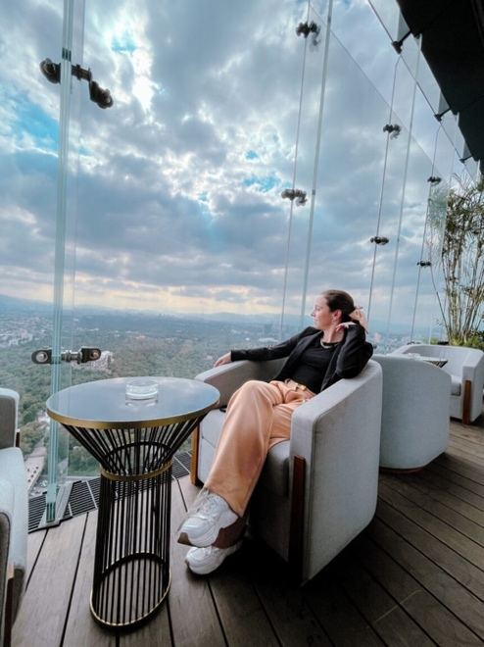
This is What Working Remote at Marriott Looks Like (Marriott Careers)

Among the challenges Marriott faces, there is the maintaining communication and collaboration among remote teams. Effective communication channels and adequate support for remote employees is essential to overcome this challenge. The importance of balancing flexibility with accountability for employee satisfaction is emphasised from the investments made by the company in performance metrics platforms that are necessary to ensure employees remain productive and aligned with organizational goals.
IHG (InterContinental Hotels Group):
Crowne Plaza Hotels & Resorts - part of IHG Hotels & Resorts, has implemented hybrid work models that combine remote work options with in-person collaboration opportunities. “Crowne Plaza has already laid the groundwork by creating spaces and a service style that are specifically catering to these desires.” IHG provides employees with the flexibility to work from home or from a designated office location, depending on their role and preferences.
To manage employee performance, IHG implemented regular check-ins and performance feedback sessions. Performance management software and tools to track progress help to identify areas for improvement and recognise achievements. The company's hybrid work models allow employees to enjoy the benefits of remote work while maintaining a sense of connection and belonging to the organization. This flexibility contributes to higher employee morale and job satisfaction. Providing equal support and recognition for all employees regardless of their work location is critical for maintaining engagement and motivation, hence the challenge to offer these to both remote and in-office employees.
Leading competitors like Marriott and IHG have implemented various work models to adapt to the continuous changing preferences of the workforce and to the industry trends.

Potential Solutions for Hilton
Based on research findings and industry examples, potential solutions for Hilton to effectively manage employee performance in different work models include:
1. Implementing technology-driven performance management systems to track progress and provide feedback to employees.
2. Offering flexible work arrangements, such as remote work options and flexible scheduling, to accommodate diverse employee needs.
3. Providing training and support for managers to effectively manage remote teams and maintain communication and collaboration.
4. Fostering a culture of trust, accountability, and transparency to ensure employees feel valued and supported regardless of their work location.
5. Addressing privacy concerns and ethical considerations by implementing transparent monitoring policies and providing training on data privacy.
By implementing these solutions, Hilton can adapt to changing socio-economic factors and effectively manage employee performance in different work models, ultimately enhancing employee satisfaction, productivity, and retention in the hospitality industry.

Conclusion
Socio-economic forces, industry trends, and work models impact employee performance management in the hospitality industry. Economic factors, globalisation, demographic shifts, and the rise of the platform economy impact employee preferences and necessitate flexible work arrangements. Effective performance management practices must adapt to different work models, addressing challenges such as accountability, communication, and privacy.
Adopting different work models and implementing effective performance management practices can benefit Hilton in several ways. Offering flexible work arrangements can improve employee retention by accommodating diverse needs and preferences. Enhanced communication and collaboration tools can boost productivity and implement a positive work environment. Prioritising employee satisfaction and well-being can enhance Hilton's brand reputation as an employer of choice in the competitive hospitality industry.
For Hilton to effectively manage employee performance in different work models, the General Manager should consider recommendations such as adapting to the changing work landscape, as it is crucial to prioritise employee well-being and productivity; offering flexible work arrangements, such as remote work and adjustable schedules, which can help employees achieve a better work-life balance and ultimately improve their happiness and productivity; investing in technology, providing training and support, and addressing privacy concerns are also essential steps in adapting to these changes; ensuring clear communication, providing regular feedback, and maintaining transparency in monitoring practices, as these can mitigate challenges that arise from remote work, such as communication barriers and privacy concerns.
By taking these steps, businesses can create a supportive and productive work environment that benefits both employees and the company. Adapting to the changing work landscape may require some adjustments, but the result will be a more engaged and satisfied workforce.

Future Research
Areas for further research in the impact of socio-economic forces and work models on employee performance in the hospitality industry include:
1. Long-term effects of remote work on employee engagement and job satisfaction.
2. Strategies for effectively managing diverse teams in hybrid work environments.
3. Impact of technological advancements on performance management practices and employee outcomes.
4. Comparison of performance management practices across different segments of the hospitality industry, such as hotels, restaurants, and tourism agencies.
Further research in these areas can provide valuable insights for hospitality industry stakeholders looking to optimise employee performance in evolving work environments.

Bibliography:

Books, articles and publications
- Denis-Smith, D., 2020, “Legal Talent Platform Economy – The Beginning of the End?”, Chapter in: The Legal Tech Book: The Legal Technology Handbook for Investors, Entrepreneurs and FinTech Visionaries, Chichester, FINTECH Circle Ltd
- Gandini, A., Garavaglia, E., “Another work routine is possible’: everyday experiences of (unexpected) remote work in Italy”, 2023, Culture and Organization, 29:5, 397-415, https://doi.org/10.1080/14759551.2023.2201003
- Koc, E., Cross-Cultural Aspects of Tourism and Hospitality: A Services Marketing and Management Perspective, 2021, Routledge
- Krekel, C., “Employee Well-being, Productivity, and Firm Performance: Evidence and Case Studies”, 2019, Chapter 5 in: Global Happiness and Wellbeing Policy Report 2019 by Global Council for Happiness and Wellbeing, World Government Summit
- Ozduran, A. et al, “Work-family conflict, subjective well-being, burnout, and their effects on presenteeism”, 2023, The Service Industries Journal, https://doi.org/10.1080/02642069.2023.2209507
- Secretary of State for the Home Department, The UK’s future skills based immigration system, 2018
- Torrington, D., Hall, L., Taylor, S., Atkinson, C., 2020, Human resource management, 11th ed, Harlow, Pearson Education Limited

Blogs and business websites
- Dudovskiy, J., “Hilton Hotels CSR Programs and Initiatives”, 2016, https://research-methodology.net/hilton-hotels-csr-programs-and-initiatives/, accessed on 23rd of February 2024
- Business Wire, “Hilton Celebrates Growth and Development Milestones as Company Prepares for a New, Reinvigorated Era of Travel”, 2022, https://www.businesswire.com/news/home/20220121005394/en/Hilton-Celebrates-Growth-and-Development-Milestones-as-Company-Prepares-for-a-New-Reinvigorated-Era-of-Travel, accessed on 22nd of February 2024
- Creating a practical immigration system for post-Brexit Britain, 2019, https://www.cipd.org/uk/about/news/post-brexit-immigration/, accessed on 21st of February 2024
- Frue, K., Pestle Analysis, " Pestle Analysis for Hotel Industry", 2019
- Gibbons, S., “3 Things You Can Learn From Marriott About Taking Care Of Employees”, https://www.forbes.com/sites/serenitygibbons/2020/04/30/3-things-you-can-learn-from-marriott-about-taking-care-of-employees/, accessed on 23rd of February 2024
- Great Place to Work “5 Things Successful Hybrid Work Models Have in Common”, 2022, https://www.greatplacetowork.co.uk/resources/successful-hybrid-work-models, accessed on 21st of February 2024
- IHG, “Pressure is on employers to adopt flexible working conditions and blended travel to attract and retain talent”, 2022, https://www.ihgplc.com/en/news-and-media/news-releases/2022/pressure-is-on-employers-to-adopt-flexible-working-conditions, accessed on 21st of February 2024
- San Segundo, I., “This is What Working Remote at Marriott Looks Like”, 2023, https://careers.marriott.com/en-GB/blog/remote-jobs/, accessed on 23rd of February 2024
- The Strategy Story, “Hilton Hotels PESTEL Analysis”, 2022, https://thestrategystory.com/blog/hilton-hotels-pestel-analysis/# , accessed on 20th of February 2024
- White, M.S., Burns, C., Conlon, H.A., “The Impact of an Aging Population in the Workplace”, Workplace Health & Safety. 2018;66(10):493-498, https://doi.org/10.1177/2165079917752191, accessed on 23rd of February 2024
- Diversity & Inclusion at Hilton, 2020, https://www.hilton.com/en/corporate/wp-content/uploads/2019/11/20190225_External-Diversity-Brochure.pdf, accessed on 22nd of February 2024
- Revolutionizing The Hospitality Industry With Artificial Intelligence, 2023, https://www.forbes.com/sites/forbesbusinesscouncil/2023/09/11/revolutionizing-the-hospitality-industry-with-artificial-intelligence/, accessed on 23rd of February 2024

Web pages
- “About us” page, https://www.hilton.com/en/corporate/, accessed on 23rd of February 2024

https://www.businesswire.com, Hilton 2021 infografic
“Diversity & Inclusion at Hilton”, 2019, p.3
“5 Things Successful Hybrid Work Models Have in Common”, 2022, https://www.greatplacetowork.co.uk/resources/successful-hybrid-work-models
Koc, E., Cross-Cultural Aspects of Tourism and Hospitality: A Services Marketing and Management Perspective, 2021, Routledge, p. 24
White, M.S., Burns, C., Conlon, H.A., “The Impact of an Aging Population in the Workplace”, Workplace Health & Safety. 2018;66(10):493-498.
Berman, D., “Revolutionizing The Hospitality Industry With Artificial Intelligence”, 2023
San Segundo, I., “This is What Working Remote at Marriott Looks Like”, 2023
Ginger Taggart, Vice President, Brand Management, Global Crowne Plaza Hotels & Resorts, in IHG Website

