A Report on Site Specificity

What issues can arise from site specific art?
Abigail Ashman
2204992

Table of Figures
Figure 1 – Face 2 Face by JR and Marco 2007
Figure 2 – Remembering By Ai Weiwei 2009

Intro…
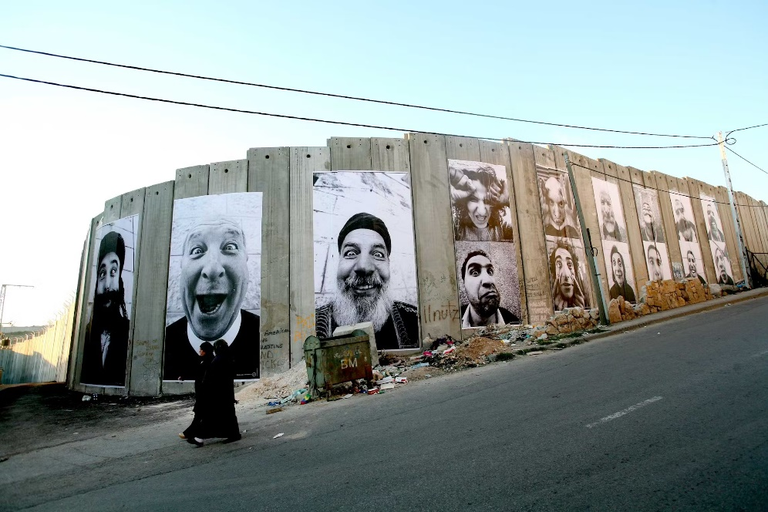
Artwork 1

Figure 1

Face 2 Face is a site specific artwork by JR and Marco that was displayed in 2007 on the separation wall in Bethlehem between the Palestinians and the Israelis. It showed portraits of people from both sides of the wall that shared the same jobs such as Farmers, Taxi drivers and teachers. JR and Marcos aim of the project was to make the opposing cities realise how similar the people occupying them really are, ‘these people… [are] like twin brothers raised in different families’ (JR - Artist, 2019), along with bringing joy to those involved in such a terrible war, ‘We want, at last, everyone to laugh and to think by seeing the portrait of the other and his own portrait’ (JR - Artist, 2019).

Artwork 2
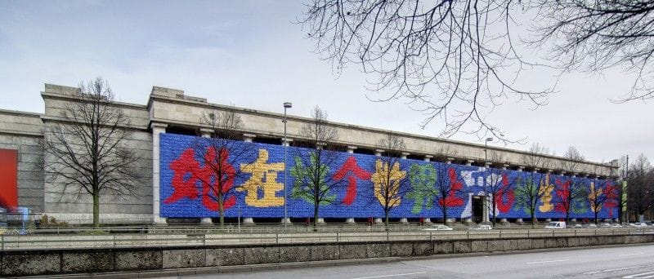
Figure 2
Remembering by Ai Weiwei is an artwork displayed in Germany made to commemorate the Sichuan earthquake in China that took 5,219 lives. This work consists of 9,000 backpacks that spell out a sentence from a victims mother “All I want is to let the world remember she had been living happily for seven years.” (Weiwei, 2018) It was displayed on the historic building Haus der Kunst which in itself causes the artwork to become a political act due to the building being made specifically for Adolf Hitler who was never accepted as an artist. The curation of this work landed multiple people time in jail due to the Chinese government wanting to withhold information to coverup mistakes that cost many people their lives.
Both of the artworks described above pose ethical and political issues which landed the artists in legal trouble. Ai Weiwei has been exiled from China and imprisoned due to his highly politically charged work and criticism of the Chinese Government. Face 2 Face was described as the ‘largest illegal photography exhibition ever’ (JR - Artist, 2019)
…

List of References
JR - Artist. (2019). JR - Artist. [online] Available at: https://www.jr-art.net/projects/israel-palestine [Accessed 21 Oct. 2024].

Weiwei, A. (2018). Ai Weiwei: The artwork that made me the most dangerous person in China. [online] the Guardian. Available at: https://www.theguardian.com/artanddesign/2018/feb/15/ai-weiwei-remembering-sichuan-earthquake [Accessed 21 Oct. 2024].
‌

‌

