

LOCATION: Swansea | LLEOLIAD: abertawe
LEVEL 6 | LEFEL 6
EXAMINATION PERIOD | CYFNOD ARHOLIADAU
may 2025 | mai 2025
MODULE CODE: ACDA 6008
SCIENTIFIC PRINCIPLES OF OME DESIGN
TIME: 2 HOURS

answer all of section A

answer 2 out of 3 QUESTIONS in section B

Equipment or materials required. Please select from the following:
Adnoddau neu ddefnyddiau sydd eu hangen.

Cyfrifiannell/Calculator
Llyfr Agored/Open Book.
Arall/Other Nodwch/Please Note ……………………….

BEGIN EXAM QUESTIONS HERE!

SECTION A

ANSWER ALL 6 QUESTIONS IN THIS SECTION

- In terms of heat of explosion and impulse, describe the difference between an ideal and non-ideal detonation. Would such an explosive have better utility in driving metal or generating blast?

[5 marks]

- a) Using the diagram below, explain the significance of the point highlighted on the lethality curve for a 70 kg male in the free field

[3 marks]

b) If the individual were standing next to a reflecting surface, would you expect survivability to be better or worse, and why?

[2 marks]

- a) On the diagram below, the x-axis shows the diameter of aluminium particles that may be added to a secondary explosive to enhance blast. The y-axis denotes the time at temperatures of 2500, 3000 and 4500 K a particle takes to reach its ignition temperature of 2050 K. What does this graph tell you in terms of the most appropriate conditions to establish for the addition of aluminium to an explosive?

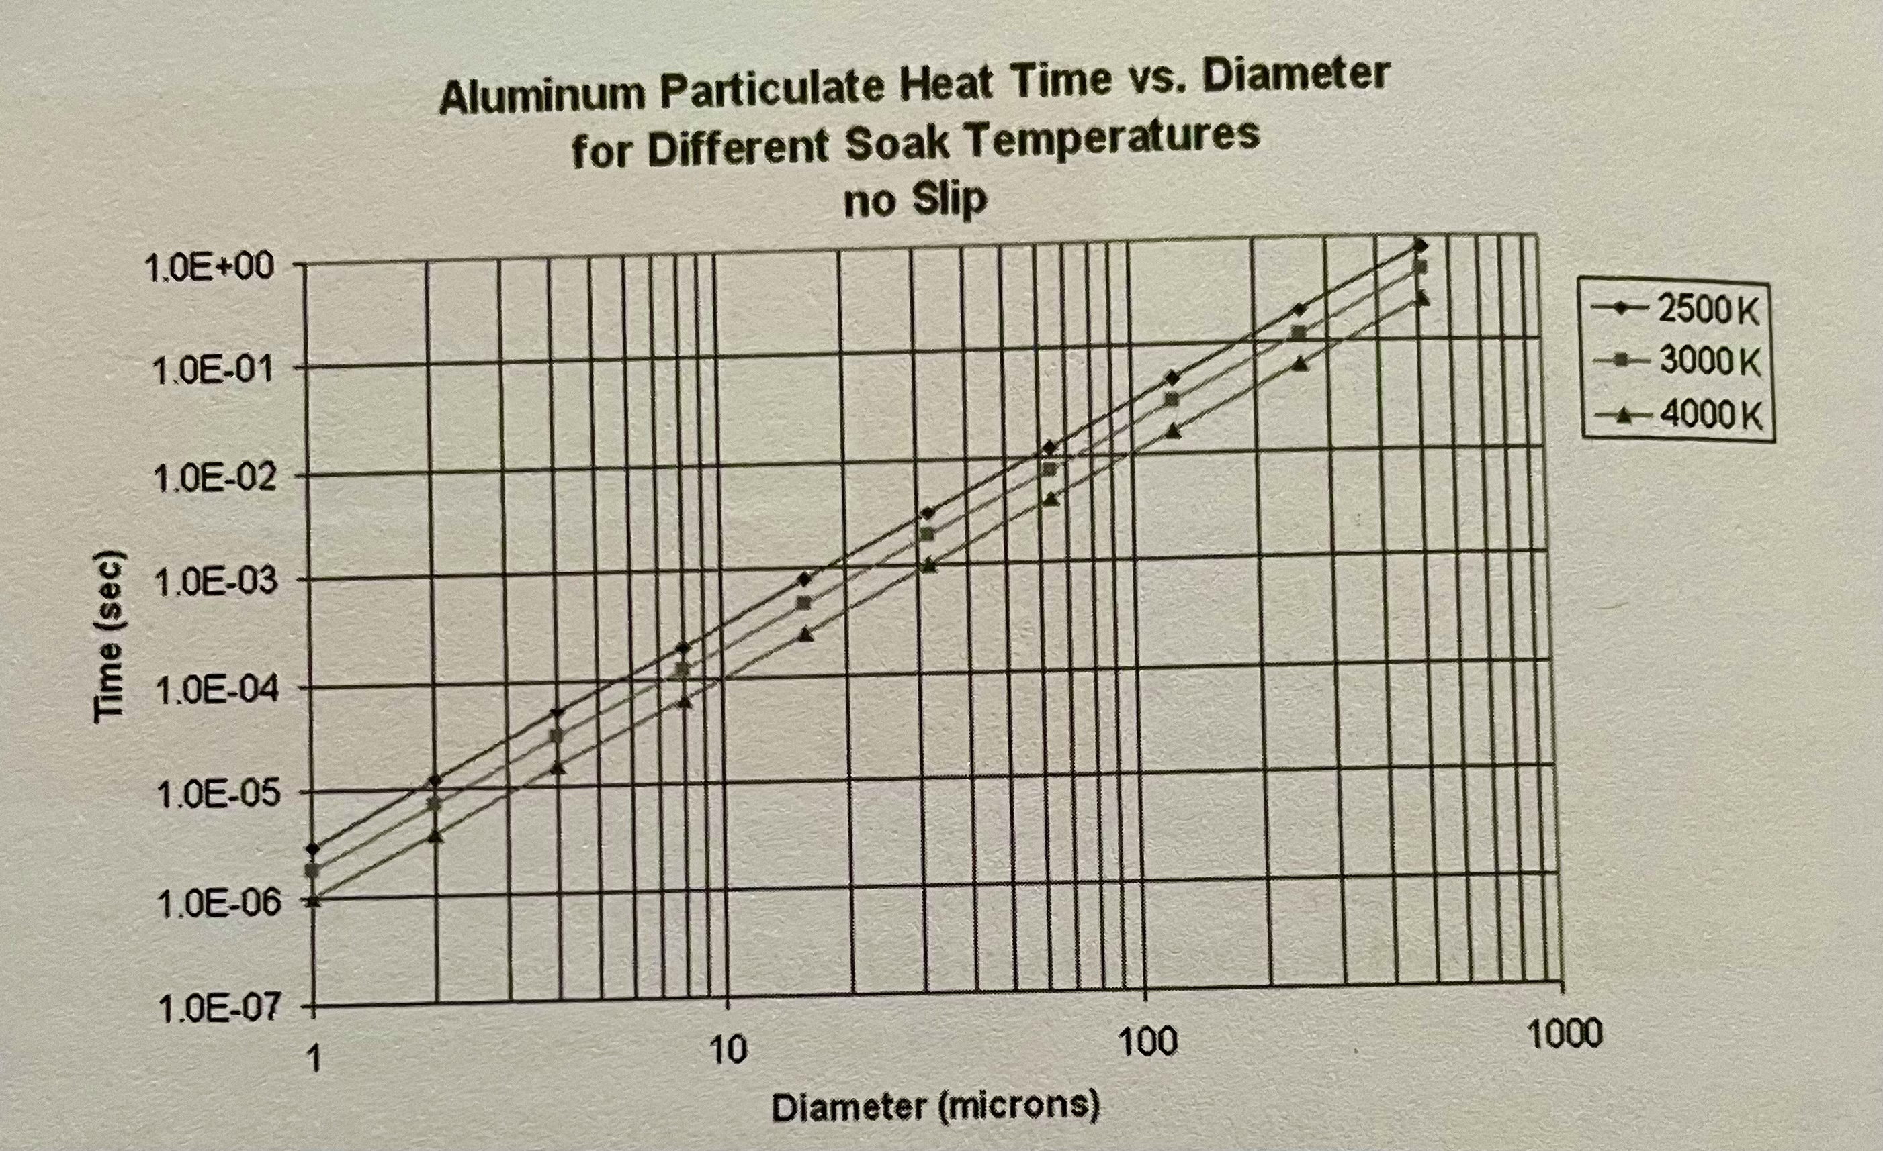

[3 marks]

b) Why is the time at which it takes aluminium particles to react in an explosion important to the designer?

[2 marks]

- a) An explosive comprises 30% TNT, 30% RDX, 20% TATB and 20% aluminium. Given the parameters described in the table below, and the equation provided, what is the theoretical detonation velocity of the mixture in km s⁻¹?

D_{i} TNT | 6.97 km s⁻¹
D_{i} RDX | 8.80 km s⁻¹
D_{i} TATB | 8.00 km s⁻¹
Di Al | 6.850 km s⁻¹
V_{i} | The volume fraction of component

$$D_{mix}=\sum{D_{i}V_{i}}$$
[3 marks]

b) If the theoretical density (ρ) of the composition is 1.85 g cm⁻¹, calculate the detonation pressure (P_{cj}) in GPa

$P_{cj}≅$ $\frac{ρD_{mix}^{2}}{4}$
[2 marks]

- A 1 kg blast warhead at sea level (1.013 bar) produces and overpressure of 9.83 bar at 1m, which is capable of irreparably deforming the fuselage of a particular air platform. If this blast warhead were to be incorporated into a MANPADS, required to operate at engagements up to 5000 m (atmospheric pressure 0.54 bar), will the damage criteria remain the same? If not, why not, and what would the designer need to take into consideration for missile? What would the impact be on the user?

[5 marks]

- a) Describe the mechanical properties required of a cased munition and its explosive to produce large natural fragmentation.

[2 marks]

b) What would be an appropriate mathematical relationship to demonstrate the relationship between charge mass (C) and case mass (M) for a light cased munition?

[2 marks]

c) Does a case mass of 30 kg and an explosive mass of 100 kg fit into your criteria for a light cased munition?

[1 mark]

SECTION B
ANSWER 2 OUT OF 3 QUESTONS IN THIS SECTION

- a) From the diagram and data below, calculate the initial fragmentation velocity (V_{o}) and beam angle for a static cylindrical warhead detonated from the rear. Assume M/C = 1.05. Use S.I. units for the equations.

$ρ=\frac{m}{v}$ Relationship between density, mass and volume

$π\frac{d^{2}}{4}l$ Equation to describe the volume of a cylinder, where l is the length of the cylinder and d the diameter of the cylinder
$V_{o}=\sqrt{2E}{\left(\frac{M}{C}+0.5\right)}^{-0.5}$Gurney Equation for a Cylinder, where $\sqrt{2E}$ is the Gurney constant, M the mass of the case material and C the mass of the charge

$θ=\sin^{-1}\left\{\left(V_{o}\cos{∝}\right)/2D\right\}$ Equation to determine Taylor Angle, where V_{o} is the initial fragment velocity and D the velocity of detonation of the explosive. See diagram below for position of angles, where theta refers to the fragmentation angle at positions A and B respectively.

Case material density | 7840 kg m⁻³
Gurney Constant $\sqrt{2E}$ | 2460 ms⁻¹
Velocity of detonation of explosive D | 7840 ms⁻¹

Tip:

You will need to work out the Taylor angles at Point A (the point of initiation) and Point B to determine the beam angle (θ_{A} + θ_{B}).

[25 marks]

b) Whilst Gurney is a good predictor for initial fragment velocity, what assumptions must the designer be aware of?

[10 marks]

- a) Describe the baseline requirements for a munition to be classed as ‘insensitive’ under STANAG 4439? For each requirement you describe, please indicate the type of insult that the munition is experiencing and the chemical process by which detonation could progress.

[25 marks]

b) A wooden box comprising 5 anti-tank mines is afforded Hazard Classification Code 1.1D for storage, transportation and use. The box is packed in the configuration shown below, with the fuzes stored in the same box, but not fitted to the mines. The total NEQ of the box is 13.5 kg

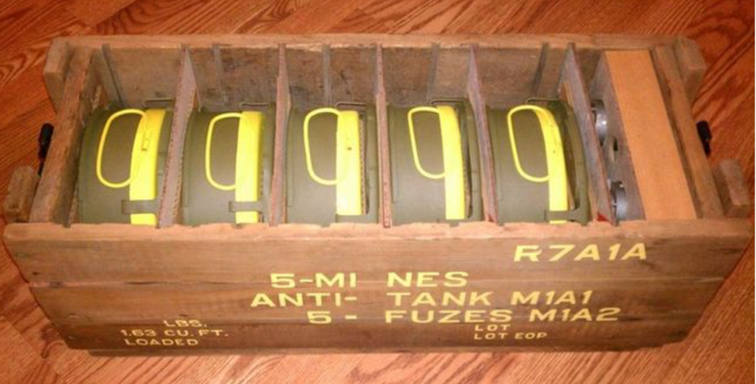

Given the explosive filling (TNT) and the nature of packaging, these mines are not considered to be IM compliant. What could be done to the packaging and explosive filling to make this system less vulnerable to external insult? Will the effort of compliance outweigh the cost for a ‘dumb’ system such as this?

[10 marks]

- a) What is the advantage of case bonding a solid propellant into a rocket motor? Discuss the engineering/material science considerations that limit where case bonding can be used.
[8 marks]

(b) What is a hypergolic liquid bipropellant and what are the advantage/disadvantages compared to a non-hypergolic propellant? Give an example of both a hypergolic and a non-hypergolic liquid bipropellant.
[7 marks]

(c) Using the failure mode and effects analysis (FMEA) method discuss 2 different failures, failure modes, failure mechanisms; and tests used to monitor the life of a rocket motor. Give examples of how these failure modes are influenced by the charge/motor design, environmental conditions and propellant type.
[20 marks]

Diwedd/End

