ORGANISATIONAL CONSULTANCY: LEVEL 6
Student Name: Abdul Quiyum
Student ID: 2229328
Lecturer: Jaliya De Silva
Name of the Company: Aldar Hotel, UAE

I confirm that I have not used any AI tools in the research and creation of this assignment. I confirm that I have not presented any AI generated materials as my own work. I confirm that I have copies of my drafts, notes, and other resources I used, which I may be asked to provide in evidence.

Executive Summary
Key Problem or Issue
The consultancy report has been conducted to highlight the major issue that is being faced by Aldar Hotel, UAE in recent years. The company is facing issues with their inefficient employee base and lack of talent pool in their workplaces to manage the business effectively in the national and international markets. The report has been structured by the Boston Consulting Group which is a consultancy company due to the purpose of giving probable recommendations and change management strategies in their organisations for improving their talent management. The lack of employee efficiency can be an effective reason behind the poor customer satisfaction and engagement of the investors as well in the business practices. The report has minutely analysed the statistical figures and has included multiple reliable theories and models for assessing the market trends, industry of the UK and to identify the strengths and weaknesses of Aldar Hotel in the market.
Findings
The respective report sheds light on the STEEPLED, SOARS, and TOWS analysis that assists in the identification of the external and internal factors followed by future directions to enhance the strategies of Aldar Hotel for improving internal operations of business. The overall expenditure for Research and Development (R&D) was AED 22,790,139,757.00 that can help Aldar Hotel to foster innovation in organisation. The inflation rate of the UK in 2023 was 1.62% whereas in 2024 the report revealed 2.3% inflation rate. The statistical data helps in reflecting that the inflation rate in the UK has increased that can reflect negatively increasing the prices of the products. The major trading partners including imports and exports are the United States, China, Iraq, Japan, and others that can enhance the opportunity for the internationalisation of business. Apart from this, the presence of labour rights can aid the employees of Aldar Hotel to grasp rights regarding working hours. The labour rights incorporate working hours of “eight hours per day” along with “forty-eight hours per week”.
Analysis of the Findings
Aldar Hotel operations in the different segments including marinas, beach clubs and golf courses assists in increasing the profits and catering the demands of the customers. The improvement in the reputation of Aldar Hotel can be helpful in attracting customers and tailoring the services by the employees can help in increasing sales followed by the profitability segment. Improving reputation can help Aldar Hotel in attracting investors along with elevating funds to improvise business operations. On the other hand, lack of efficiency among the employees of Aldar Hotel can reflect negatively in providing better services to the customers. The usage of “Monthly Recurring Revenue (MRR)” can be helpful for Aldar Hotel to measure the consistent revenue generated. Apart from this, the usage of “Customer Acquisition Cost (CAC)” assists in evaluating average cost to “acquire a new customer” in Aldar Hotel.
The aspirations reflected in the report are to increase profits by 75% in the coming 2 years. The improvement in the training of employees in Aldar Hotel can aid in enhancing efficiency of staff. Lack of efficiency among the employees can hinder productivity along with the service quality in the competitive market. The increase in the revenue along with great brand value in the present market of UAE can help in the adoration of technologies and attracting customers and investors. Considering the aforementioned attributes, it can be stated that hiring skilled employees along with increasing investment for enhancing employee skills in Aldar Hotel can reflect a positive impact in enhancing the efficiency of employees and providing better services to customers.
Recommendations to the Client
The organisational managers of the company have significantly been recommended for adapting the diversity and inclusion practices in their workplaces for increasing the creativity and innovation in their thinking patterns. Additionally the Boston Consulting Group has suggested the change management processes to the Aldar Hotel for adapting new technologies and digitalisation in the human resource management department. The group has also suggested that the organisational managers should be aware of recruiting potential employee bases from the local and global markets. Recruiting new and talented employee bases from the different countries by maintaining the diversity and inclusion practices can facilitate the organisational managers to increase the creativity and innovative problem solving approaches in their employee base. On the other hand the recruitment of the diversified employees is not the only solution that has been suggested by the Boston Consulting Group, rather the organisational leaders of Aldar Hotel need to be focused on arranging customized training for their employees to increase their efficiency in their job roles. However, communication can also play a significant role in increasing the collaboration and creativity in the employees by sharing the thoughts and expertise of each other.
Conclusion
The consultancy report has suggested that the Aldar Hotel and the organisational manager of the company has faced a major issue in their organisation for their lack in efficient employee base and lack of customer satisfaction and decreased productivity rates as well. The UAE market has a positive impact on the business development of the company and the Boston Consulting Group has suggested some core change management processes which can be followed by the company to increase the efficiency of their employees to generate better business success. However, the report has involved multiple theories and models to provide an in-depth understanding of the issues and suggestions for Aldar Hotel regarding their employee proficiency.
Table of Contents
Executive Summary 1
Introduction 5
Analysis 7
Describing the issue in Aldar Hotel 7
Implication of STEEPLED analysis to identify external factors 8
Application of SOAR analysis to analyse the positive factors of Aldar Hotel 11
Implying TOWS Analysis to Highlight Possible Future Directions for Aldar Hotel 13
Recommendations and Change Management 14
Action Plan 19
Conclusion 20
Reference List 22

Introduction
Aldar Hotel operates in the hospitality industry and it’s headquarter is in the United Arab Emirates (UAE). The location in which Aldar Hotel operates includes Abu Dhabi and Ras Al Khaimah in UAE (aldar.com, 2025). In this context, it can be stated that expansion of the business in the different markets is beneficial for the organization as it helps in increasing the customer base along with the profitability segment. In accordance with the reports “Aldar Hospitality and Leisure” looks after Aldar’s portfolio of leisure assets along with hotels that are anchored around Saadiyat and Yas Island (aldar.com, 2025). In addition to this the respective organisation has 13 hotels including 2,900 hotel keys as well as managing business operations across golf courses, marinas followed by beach clubs (aldar.com, 2025). Operation management in Aldar Hotel is beneficial as it helps in increasing efficiency along with enhancing the quality control.
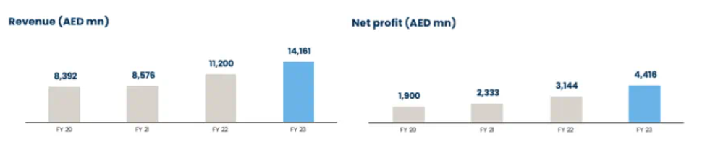 Figure 1: Revenue and Net Profit of Aldar Hotel
(Source: aldar.com, 2024)
Based on the aforementioned context, the improvisation in the operations management can be helpful for Aldar Hotel in providing better services to the customers. The perspectives by Rane et al. (2023), has mentioned that enhancing the customers services can reflect a positive impact in retaining target customers and increasing profits. Streamlining the business processes of Aldar Hotel can aid in enhancing productivity and enhancing the internal attributes of business that might help in the expansion of the business internationally. On the other hand, in the financial year 2023, the revenue of Aldar Hotel increased by 26%, AED 14.2 billion and the net profit was AED 4.4 billion reflected in figure 1 compared to the financial year 2022 (aldar.com, 2024). Enhancing the financial aspects can be helpful for Aldar Hotel to enhance the operations of the business and gaining advantage in the competitive business landscape.
The room capacity of Aldar Hotel is high and can be helpful in providing accommodation to an increasing number of customers. For instance, “Aldar Hotel in Sharjah City Centre” is one of the convenient location for the travellers in order to access the accommodation and has a total of “85 well-appointed rooms” including Family Suite, Deluxe King Room with 48 m²/517 ft², 24 m²/258 ft² room size and other options (agoda.com, 2025). Aldar Hotel has 4,239 Rooms and Suites as well as Meetings and Events Space (aldar.com, 2025). The presence of such services can be helpful for the respective organization to attract business leaders for meetings, official purposes along with tourists and travellers.
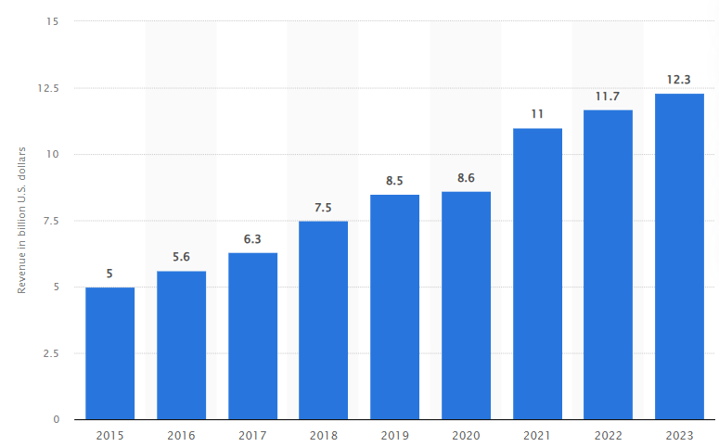
Figure 2: Boston Consulting Group Revenue Globally
(Source: statista.com, 2024)
Boston Consulting Group (BCG) is a multinational company that operates in more than 50 countries including Japan, UAE, Spain and other locations under consultancy industry (bcg.com, 2025). Beside this the revenue of BCG was $12 billion globally that is increased compared to previous year mirrored in figure 2 (statista.com, 2024). The increasing revenue helps in reflecting that the demand of BCG consultancy services in the global market is increasing extensively and providing consultancy services to Aldar Hotel can aid in attracting customers and elevating profits. The purpose of this report is to evaluate the issue faced by Aldar Hotel, regarding lack of efficiency among staff that can be problematic in providing services to the customers and might result in a decreased customer base and revenue in a competitive market. The inclusion of STEEPLED analysis can aid in analysing the external factors that are negatively affecting the organisation operating in the market. The SOAR analysis can aid in analysing positive attributes of Aldar Hotel that strengthens business establishment and TOWS analysis to reflect possible future directions for Aldar Hotel.

Analysis

Describing the issue in Aldar Hotel
The focus on the issues faced by the organizations is beneficial as it helps in the development of effective strategy in order to combat the issue effectively along with grasping competitive positioning in the market. One of the major issues faced in the hospitality industry is lack of skills among the employees that reflects hurdles in providing better services to the customers from different backgrounds. For instance, the reports revealed that 22% of the employers in the UK are experiencing a skills gap in the hotel and restaurant sector (statista.com, 2023). This reflects that skill gap in the hospitality industry is one of the major issues that creates challenges in providing better services to customers. Considering this lack of efficiency among staff in Aldar Hotel can be one of the noteworthy issues that mirror a negative impact in providing services to customers and enhancing the internal business operations.
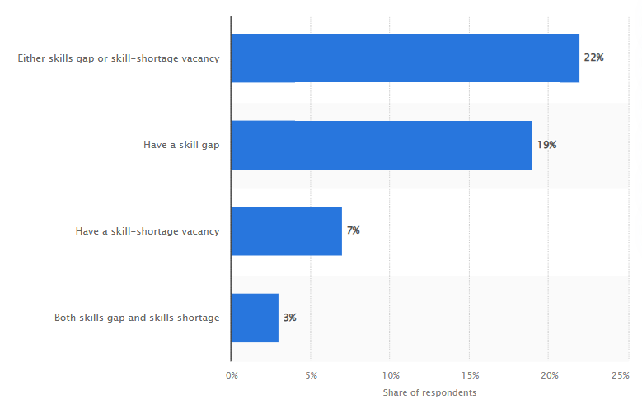
Figure 3: Employers Experiencing Skills Shortage and Skills Gap in Hotel and Restaurant Sector
(Source: statista.com, 2023)
Lack of efficiency among the employees in Aldar Hotel can reflect multiple issues such as poor customer services, keeping data of customers due to insufficient skills to use technologies, decreasing customer base, reputation and profits. In accordance with the viewpoint of Galanakis et al. (2021), has mentioned that after the pandemic the demand for the usage of advanced technologies has increased drastically. In this regard, in the hospitality industry lack of knowledge regarding the usage of technologies can hinder in providing appropriate services to customers for online bookings, transactions, keeping records and others. The causes for the lack of sufficient skills among the employees in Aldar Hotel might be lack of training and development programs, engagement of employees, feedback from employees regarding lacking areas, communication gap and others. The perspectives by Mehale et al. (2021), has mentioned lack of training and development due to insufficient communication can reflect negatively in enhancing the skills of employees. Issues in enhancing the skills of employees in Aldar Hotel can create hurdles in improving the efficiency of staff in order to use advanced technologies for better market research. Enhancing market research can help in the identification of the customer’s preferences, providing online services such as booking facilities, transaction and others to increase customer base along with revenue in the competitive business landscape.

Implication of STEEPLED analysis to identify external factors
Factors | Description | Impact
Social | - The population of United Arab Emirates is estimated to be 11,346,000 till mid 2025 (worldometers.info, 2025)  - The population of United Arab Emirates is “equivalent to 0.14%” in the total world population (worldometers.info, 2025) | Positive
Technological | - The total expenditure for Research and Development (R&D) was AED Dirham 22,790,139,757.00 (fcsc.gov.ae, 2025)  - Adoption of advanced technologies such as data infrastructure, cloud services and artificial intelligence (iiss.org, 2024) | Positive
Economic | - Gross domestic product (GDP) of UAE in 2024 was approximately $545 billion and expected to increase by $167.6 billion between 2024 and 2029 and forecasted to reach $712.69 billion (statista.com, 2024)  - Inflation rate in 2023 was 1.62% and in 2024 was 2.3% this reflects that the inflation rate has increased (statista.com, 2024)  - Unemployment rate was 2.71% in 2023 declined by 0.17% from 2022 (macrotrends.net, 2025) | Positive and Negative
Environmental | - UAE pledged to reach “net zero carbon emissions by 2050” (trade.gov, 2023)  - Focussing on to invest $163 billion for key technologies and clean and renewable energy (trade.gov, 2023) | Positive
Political | - Trading partners of UAE includes China, United States, Japan, Iraq and others (worldbank.org, 2025)  - UAE scores 68 and ranks 26th in the Corruption Perceptions Index (transparency.org, 2025)  - Decrease in corruption rate reflects political stability in the nation | Positive
Legal | - Presence of “Regulation of Employment Labour Relations” also reflected as “UAE Labour law” for the private sector that prohibits “forced labour and discrimination” on the basis of race, religion, sex, national, gender and social origin or disability (u.ae, 2025) | Positive
Ethical | - Concerns for labour rights that includes working hours of “eight hours per day” and “forty-eight hours per week” (gov.ae, 2025) | Positive
Demographic | - 81.1% that is 9,207,088 people living in urban area (worldometers.info, 2025)  - Literacy rate in 2022 was 98.29% increased by 0.16% from 2021 (macrotrends.net, 2025) | Positive
Table 1: STEEPLED Analysis of UAE
(Source: Self-Created)
Analysis
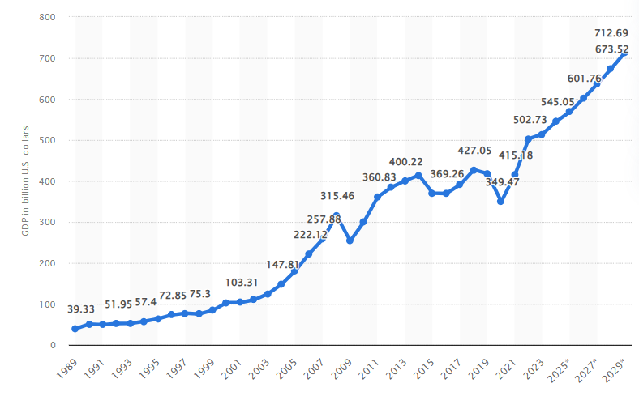
Figure 4: Gross Domestic Product (GDP) of UAE
(Source: statista.com, 2024)
The usage of the STEEPLED analysis is significant for the different organizations as it helps in evaluating the external factors that sheds a positive impact in the establishment of the business. The population of UAE is estimated to be 11,346,000 till mid 2025 (worldometers.info, 2025). The increasing population in UAE can reflect positively in increasing demand for Aldar Hotel services. Contrastingly, the adaptation of advanced technologies such as data infrastructure, cloud services and artificial intelligence in UAE has increased (iiss.org, 2024). The adoption of advanced technologies can positively impact Aldar Hotel in enhancing the online services for customers that can attract potential customers. The GDP of UAE is forecasted to increase by $167.6 billion by 2029 to reach $712.69 billion (statista.com, 2024). However, the inflation rate is high and can negatively reflect Aldar Hotel as the prices of the products will be high and that can impact the profitability segment.
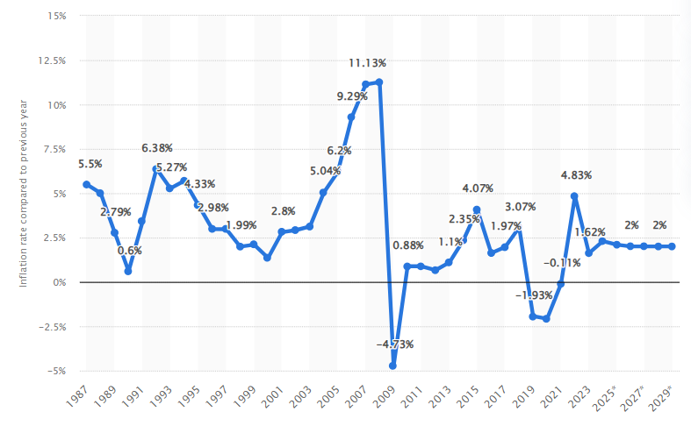
Figure 5: Inflation Rate of UAE
(Source: statista.com, 2024)

Application of SOAR analysis to analyse the positive factors of Aldar Hotel
Strengths | Opportunities | Aspirations | Results
- Location of hotels around Yas Island and Saadiyat (aldar.com, 2025)  - Increasing number of hotels with 2,900 hotel keys (aldar.com, 2025)  - Operations of business across marinas, golf courses and beach clubs (aldar.com, 2025)  - Revenue of Aldar Hotel was AED 14.2 billion and net profit was AED 4.4 billion in 2023 that is increased (aldar.com, 2024)  - Increasing number of rooms that is 4,239 Rooms and Suites along with Meetings and Events Space (aldar.com, 2025) | - Expansion of the business in international market to increase customer base and profits  - Adaptation advanced technologies can aid in providing better services to customers  - Enhanced reputation can help in attracting investors and increasing funds to enhance business operations  - Better training to employees can enhance efficiency of staff | - Increasing customers base by 60% in next 1.5 years  - To maximise profits by 75% in next 2 years  - Passionate about providing better services to customers by providing more online facilities and enhancing services  - Enhancing employee efficiency by hiring experts to carter the demands of customers from different cultural backgrounds | - Implication of “Customer Acquisition Cost (CAC)” to analyse average cost to “acquire a new customer”  - Using “Monthly Recurring Revenue (MRR)” to evaluate consistent revenue generated  - Increased demand of Aldar Hotel services
Table 2: SOAR Analysis Aldar Hotel
(Source: Self-Created)
The above analysis has suggested that the hospitality company Aldar Hotel has several kinds of strengths and opportunities for itself to run the business in the UAE country. On the other hand, the company has several aspirations and goals for itself that can be reached by the organisational members of the Aldar Company to expand the business in the international countries. However, the company needs to focus on the hiring and training of employees to develop a strong potential employee base in their organizations to fulfil the customer demands. Additionally, the company has different kinds of opportunities in the UAE market to mitigate their organisational issue inefficiency among organisational employees.

Implying TOWS Analysis to Highlight Possible Future Directions for Aldar Hotel
 | INTERNAL
E  X  T  E  R  N  A  L |  | Strengths | Weaknesses
E  X  T  E  R  N  A  L | Opportunity | S/O: The company has a higher revenue rate and great brand value in the local market of UAE. However, the greater revenue rate and market value can increase the opportunity of attracting and retaining the investors in the business practices for the long run. | W/O: A greater revenue and brand value in the market can generate higher expectations from the customer base and the supplier base as well (Fan et al., 2021). On the other hand, the increased brand value can generate higher annual expenditure rate for business due to tax purposes.
E  X  T  E  R  N  A  L | Threats | S/T: The insufficient employee efficiency can cause for arrangement of employee training and the opportunity for the youths for recruitment. Therefore the inefficiencies among the employee base in the organisations can generate the opportunity for recruitment and training and development programs for addressing the issue (Tien et al., 2021). | W/T: A decreased or insufficient efficiency among the employee base can cause decreased productivity and service quality in the market. However, due to this factor, the brand reputation and competitive advantage of the organisations can also be hampered in both the national and international markets (Hart and Rodgers, 2024).
Table 3: TOWS Analysis for Aldar Hotel
(Source: Self-Created)
As per the above table it has been stated that the company has a major strength which is its brand value and revenue rate. On the other hand the major disadvantage of the company is its lack of talent based in the workplaces. Based on this view, the study by Rane et al. (2023) has demonstrated that the increased brand value and revenue rate can generate a highly active customer base in the market with increased customer preferences and brand loyalty. On the other hand, it can also cause higher annual expenditure and increased cost of business due to tax and higher demands from suppliers.
The major disadvantage of lack of efficiency among the organisational employees in their job roles can generate both the threats and opportunities for the company. As per the study by Tien et al. (2021) it has been stated that the shortcomings of insufficient efficiency among the employees can generate the opportunity for an advanced hiring process and arranging the training and development programs for the employees to retain them efficiently in the markets. Additionally the study has defined that the customised training and development programs can enhance the efficiency of the employees and it can decrease the probability of poor service quality and decreased productivity rate. On the other hand, it has been suggested by the study of Kang and Lee, (2021) that the inefficient employee base in the organisations can result in poor competitive advantage and brand reputation in the markets. In this regard, it can be determined that the strategy of increasing the efficiency among the potential employee base in the markets can be facilitating for the company to enhance their competitive advantage and brand reputation in the local and global markets.

Recommendations and Change Management
Arranging training and development programs
The organisational managers or human resource managers in the company can go through the change management processes of arranging training and development programs for their employees. As per the study by Kraiger and Ford, (2021) it has been stated that the strategy to arrange for advanced training and development programs in the workplaces can address the issue of an inefficient employee base. Additionally the study has also stated that the organisational managers need to take care of several change management processes such as addressing the needs and weaknesses of the employees based on their job roles. On the other hand, it has also been suggested by the study of Shet and Pereira, (2021) that the strategy for identifying the demands and requirements of the employees in their job roles can require advanced skills of leadership and management.
The organisational leaders need to flexibly treat the employees and make a transparent relationship with each other to get the awareness regarding the strengths and weaknesses. According to the study by Riyanto et al. (2021) it has been stated that the consideration of the training and development programs can highly increase the motivation and employee efficiency as per their job roles. Additionally the study has also reported that increased job efficiency can highlight the advantage of increased quality in service and enhanced customer satisfaction rates towards the business practices.
Hiring potential employees
The lack of employee efficiency in the organisational workplace can be a result of poor recruitment and inefficiencies of the human resource managers as well. In this regard, the study by Tien et al. (2021) has demonstrated that the emerging issue of poor talent base in multinational companies can be resolved with a hiring process only. Additionally the former study has also stated that the strategy to implicate new and advanced hiring processes can require severe changes in the management teams of Aldar Hotel. For instance, the study by Tong et al. (2021) has demonstrated that the process of maintaining objectivity in opinions is greatly needed for making effective hiring processes in the organisations. In this regard, it can be determined that the flexibility and objectivity both are needed in the organisational human resource management teams for recruiting talented employees by fulfilling their economic and social needs.
Hiring employee base for making a talent pool in the organisations can be facilitating for the company to develop their competitive advantage and brand reputation in the markets both in the national and international markets. According to the study by Munawar et al. (2021) it has been demonstrated that the recruitment process can also decrease the unemployment rate of the countries which can attract the governmental figures as well for increasing the investment in the businesses. In addition the strategy of hiring new employees can also require a high budget for the organisations to offer them a good and satisfactory salary scale as per their experience and potentiality in their job roles (Van der Heijde et al., 2022). In this regard, it can be summarised that the company Aldar Hotel and its human resource managers can potentially hire new and potential employees in their workplaces and reduce the unemployment rate of the country as well as retain the governmental bodies for increasing the budget and funds in business practices.
Implicating advanced technologies
The role of advanced technologies in this recent decade is irreplaceable and it can help the business organisations in multiple ways. As per the study by Gilch and Sieweke, (2021) it has been highlighted that the process of considering digital transformation in the organisations can be determined as one of the best processes for reducing human errors in hiring and training employees based on their potentiality and talent. In this regard, it has also been observed that almost every multinational hospitality sector has gone through the change management processes of digital transformation in this era (Alrawadieh et al., 2021). However, the organisational managers and the human resource managers especially need to take care of multiple change management methods for upgrading the business processes from traditional to digital.
The strategy of change management can require a flexible and upgraded form of leadership for increasing the employee motivation and employee coping abilities as well. As per the study by Oruh et al. (2021) it has been stated that the situational leadership style can be an effective way to increase the employee motivation as well as to increase the coping abilities of the employees under any kind of circumstances. On the other hand, the study has also highlighted that the digital transformation can also cause increased employee turnover and decreased employee engagement due to poor understanding of new business management methods. In this regard, the study by Morandini et al. (2023) has suggested that the strategy for addressing training and development programs for the employees can decrease their issue of poor understanding of the function of the technologies. However, the consideration of technical training and development programs in the organisations can increase the technical skills of the employees which can allow the firms to follow the modern and digitized business management methods instead of the traditional ones.
Enhancing digital or virtual communication
Communication is the key for increasing the collaboration and teamwork in the organisational employee base. As per the study by Stofberg et al. (2021) it has been reported that the strategy of implicating digital technologies in the human resource management departments of the organisations can result in increased collaboration and teamwork in the employees. However, the studies have also demonstrated that the process of increasing communication and collaboration within the employee base can increase their efficiency by sharing the thoughts and expertise of each other (Lee et al., 2021). Based on this view the study by Neill and Bowen, (2021) has demonstrated that active listening is one of the most important parts of the communication system in the individuals and due to this the employees are needed to be potential in listening to each other and solving the organisational issues together.
Considering the diversity and inclusion practices in Aldar Hotel
The strategy of diversity and inclusion can increase the collaboration and creativity of the organisations which can enhance the problem solving approaches of the organisations. According to the study by Mangaliso et al. (2022) it has been stated that the diversity and inclusion practices in the organisational contexts can require multiple change management methods in the organisations such as the language translation and sharing the thoughts of each other regarding the job roles. On the other hand, the emerging situations like communication gap, language barriers, dissimilarities in opinions and many more can also somehow be helpful for the company to increase the coping abilities of the employees to avoid uncertain situations and circumstances.
Measures or KPIs for Assessing the Success Factors of the Aldar Hotel
The success factor of the hospitality industry is used to be measured by so many key performance indicators such as the factors and advantages that can be developed by implementing the change management methods and strategies. As per the study by Burhan Ismael et al. (2021) it has been stated that the strategy to implicate training and development programs for the employees in the organisations can be a process to increase the efficiency and coping abilities in them to increase their production capability. In this regard, it can be determined that the major key performance indicator for measuring the training and development program success rate can be the level of efficiency of the employees in their respective job roles (Tambare et al., 2021). On the other hand, the study by Adaobi and Snr, (2022) has demonstrated that the attendance rate of the employees in the training sessions and the before and after productivity rate can also be measured by the organisational managers for defining the success rate of the training and development programs in the organisations.
Diversity and inclusion has been chosen as one of the major strategies for increasing the employee efficiency in the organisation through increasing the creativity rate and innovation in thinking. According to the study by Idogawa et al. (2023) it has been highlighted that the change management of communication, language translation and coping with others are significantly needed for implicating diversity and inclusion practices. In this regard, it can be determined that the key performance indicators or measures such as creativity level and coping abilities within the employees can be utilised by the employees for assessing the effectiveness of diversity and inclusion (Prayag and Dassanayake, 2023). On the other hand, the uncertainty avoidance rate of the companies as well as the employees with better problem solving approach and decision making capabilities (Fietz et al., 2021). However, it can be analysed that the recommendations like implicating diversity and inclusion as well as the training and development practices can effectively change the organisational culture of Aldar Hotel by manifesting the collaboration and uniformity in the employee base.
However, the recommendation and change management section has also suggested new and advanced technologies in the organisation for adapting the modern era business management and employee management in the human resource management department of Aldar Hotel. As per the study by Diawati et al. (2023) it has been suggested that the process of technology implication can require the availability of highly skilled employees in the technical teams of the workplaces. In this regard, it can be determined that the measures like availability of skilled employees in the organisations and the frequency of cybersecurity threats can be utilised as key performance indicators in the organisations for assessing the success factors of implicating advanced technologies (Kafi and Adnan, 2022). On the other hand, the study by Vrontis et al. (2023) has stated that the implication of the advanced technologies in the organisations can be effective for managing the employees based on their strengths and interest areas or their job roles. Therefore, it can be summarised that the measures like frequency of cybercrime activities and delays in detecting the fraud cases can be utilised as the key performance indicators in this regard.
Aldar Hotel can significantly use the recommendations like fostering advanced hiring processes in their organisations to increase the talent pool in their workplaces. As per the study by Marion and Fixson, (2021) it has been stated that the consideration of the digital and virtual communication in the organisations can be an effective idea to increase the creativity and problem solving approaches of the organisations. In this regard, it can be determined that the increased collaboration and teamwork can be the appropriate measuring assessment to justify the definition and effectiveness of the communication processes in the organisations (Thornhill-Miller et al., 2023). On the other hand, the strategy of hiring new and potential employees in the organisations and its effectiveness can be measured by assessing the talent pool and competitive advantage of the companies (Jibril and Yeşiltaş, 2022). However, the satisfaction rate of the customers can also be measured by the organisational managers to evaluate the effectiveness of hiring new employees and recruitment processes.
The concept of diversity and inclusion as well as the new technological implications in the organisational contexts can highlight the requirements for effective change management in the management as well as in the employee base. As per the study by Skýpalová et al. (2023) it has been stated that the process of implicating new technologies in the human resource management can help the employee base to communicate effectively to each other belonging from different cultures and backgrounds. On the other hand, it has been stated that the employees needed to be trained properly and in customised ways for being efficient in their job roles (Malik et al., 2023). In this regard, it can be determined that the effective change management processes for implicating the recommendations in the Aldar Hotel can highly facilitate the organisational managers to increase their employee efficiency and customer satisfaction as well.

Action Plan
The main issue prevailing in Aldar Hotel is lack of efficiency among the staff that can lead to multiple challenges such as poor customer services, issues in keeping data of customers and decreasing reputation and profits. Malik et al. (2023) mentioned that focussing on the lacking points of the employees is beneficial for the development of solutions for training and development.
No | Problem | Solution | Desired outcome | Time  Scale | Completion Date | Planned  Budget (Approximately)
1 | Poor customer services leads to reduce customer base | Focussing more on diversity along with the inclusion practices for the attracting employees from different cultural backgrounds to analyse the preferences of the customers from different locations and tailoring services accordingly | The improvement in the customer services by tailoring the facilities based on the preference such as food choices and others can increase the retention of customers along with increasing customers base | 4 to 5 months (Approximately) | 15/05/2025  (Approximately) | AED 30000 (Approximately)
2 | Issues in keeping data of customers | Providing appropriate training to the employees of Aldar Hotel for the usage of advanced technologies such as AI, IoT and others to enhance the market research to apprehend the preferences of the customers and providing better online services | Improvement in the market research can assist employees in customizing the services of Aldar Hotel for customers and improvement in the technical skills can aid in keeping data of customers secure and enhancing online services such as online transaction, booking, solving queries and others | 11 to 12 months (Approximately) | 20/ 12/2025  (Approximately) | AED 55000 (Approximately)
3 | Decreasing reputation and profits | Enhancing marketing skills of the employees can be helpful in increasing awareness of Aldar Hotel and reflecting positive attributes can enhance the reputation of organization and profits. | Improving the reputation of Aldar Hotel can help in attracting investors extensively that might increase funds and better services to the customers increases the profitability segment | 7 to 8 months  (Approximately) | 25/08/2025 (Approximately) | AED 45000 (Approximately)
Table 4: Action Plan for Aldar Hotel
(Source: Self-Created)

Conclusion
Based on the above factors it can be concluded that concentrating on the lacking points can help Aldar Hotel to enhance the business strategy. It is observed that enhancing the business strategy in the organization can shed a positive impact in enhancing the competitive positioning in the market. The improvement in the business strategy with enhancing customer service can help in increasing demand in the international markets. Increasing demands in the international markets can be helpful for Aldar Hotel for the business expansion and increasing customer’s base. The increasing number of hotels and business operations in beach clubs, marinas along with golf courses of Aldar Hotel reflects positively in increasing profits. One of the noteworthy issues in Aldar Hotel is lack of efficiency among the employees that sheds a negative impact in providing appropriate services to the customers. It can also be noted that after the pandemic the demand for online services in the hospitality industry is increasing extensively.
Lack of knowledge among the employees of Aldar Hotel can reflect negatively in providing online customer services such as facilitating in room bookings, hotel specific features, transactions and others. Beside this, from STEEPLED analysis it can be noted that the increasing GDP of the UK can reflect negatively due to the increasing prices of Aldar Hotel rooms and services. In addition to this, due to the rising costs of raw materials that can make the additional facilities costly. Apart from this, it is to be noted that UAE focuses on “net zero carbon emissions by 2050” and this strategy in Aldar Hotel can reflect a positive impact in the development of sustainability related measures. In this context, providing appropriate knowledge to the employees in Aldar Hotel regarding sustainability aspects and policies can aid in enhancing efficiency to implement and enhancing the image of the organization.
Besides this, SOAR analysis helps in reflecting that the financial factors of Aldar Hotel have improved compared to previous years and can aid in the adaptation of advanced technologies to provide better services to customers. The TOWS analysis aids in reflecting the opportunity for recruitment of employees from different cultural backgrounds. The hiring of employees for diversified cultures can help Aldar Hotel in tailoring the services for customers based on needs. Change management focusing on training and development programmes in Aldar Hotel can help in providing appropriate training to employees for the better operation management and better services to customers to increase customer base followed by profits. Apart from this increasing Return on Investment (RoI) can aid in attracting investors to elevate funds that might help Aldar Hotel to invest in technologies and providing better customer service and increasing demand of services can increase profits.

Reference List
Adaobi, C.C. and Snr, C.O.K., 2022. Employees training and development on organizational performance. Convergence Chronicles, 3(4), pp.749-764.
agoda.com (2025). “Aldar Hotel”. Available at: https://www.agoda.com/en-in/aldar-hotel/hotel/sharjah-ae.html?cid=1844104&ds=iot3WdNy1tOb4pTa [Accessed on: 1st February 2025]
aldar.com (2024). “FY 2023 Group Highlights”. Available at: https://www.aldar.com/en/news-and-media/aldar-fy-2023-financial-results [Accessed on: 1st February 2025]
aldar.com (2025). “Aldar Hospitality”. Available at: https://www.aldar.com/en/explore-aldar/businesses/hospitality/hotels#hotel%20location=Abu%20Dhabi&o=rating_hotel_numberValue,Descending&e=0 [Accessed on: 1st February 2025]
aldar.com (2025). “Aldar Hospitality”. Available at: https://www.aldar.com/en/explore-aldar/businesses/hospitality [Accessed on: 1st February 2025]
aldar.com (2025). “Our Journey”. Available at: https://www.aldar.com/en/explore-aldar/about-aldar/story [Accessed on: 1st February 2025]
Alrawadieh, Z., Alrawadieh, Z. and Cetin, G., 2021. Digital transformation and revenue management: Evidence from the hotel industry. Tourism Economics, 27(2), pp.328-345.
bcg.com (2025). “BCG Locations​​​”. Available at: https://careers.bcg.com/global/en/location [Accessed on: 1st February 2025]
Burhan Ismael, N., Jabbar Othman, B., Gardi, B., Abdalla Hamza, P., Sorguli, S., Mahmood Aziz, H., Ali Ahmed, S., Sabir, B.Y., Ali, B.J. and Anwar, G., 2021. The role of training and development on organizational effectiveness. Ismael, NB, Othman, BJ, Gardi, B., Hamza, PA, Sorguli, S., Aziz, HM, Ahmed, SA, Sabir, BY, Ali, BJ, Anwar, G.(2021). The Role of Training and Development on Organizational effectiveness. International Journal of Engineering, Business and Management, 5(3), pp.15-24.
Diawati, P., Gadzali, S.S., Abd Aziz, M.K.N., Ausat, A.M.A. and Suherlan, S., 2023. The role of information technology in improving the efficiency and productivity of human resources in the workplace. Jurnal Teknologi Dan Sistem Informasi Bisnis, 5(3), pp.296-302.
Fan, D., Xiao, C., Zhang, X. and Guo, Y., 2021. Gaining customer satisfaction through sustainable supplier development: The role of firm reputation and marketing communication. Transportation Research Part E: Logistics and Transportation Review, 154, p.102453.
fcsc.gov.ae (2025). “Total Research and Development (R&D) Expenditure as percentage of GDP per sector”. Available at: https://uaestat.fcsc.gov.ae/vis?lc=en&fs[0]=datasourceId%2CFCSC-RDS&fs[1]=FCSC%20-%20Statistical%20Hierarchy%2C0%7CResearch%20and%20Development%23BUS_RD%23&pg=0&fc=FCSC%20-%20Statistical%20Hierarchy&snb=2&df[ds]=FCSC-RDS&df[id]=DF_RD_EXPEN&df[ag]=FCSA&df[vs]=1.4.0&pd=2015%2C2021&dq=A..TEXP.AED..&ly[cl]=TIME_PERIOD&to[TIME_PERIOD]=false [Accessed on: 1st February 2025]
Fietz, B., Hillmann, J. and Guenther, E., 2021. Cultural effects on organizational resilience: Evidence from the NAFTA Region. Schmalenbach Journal of Business Research, 73(1), pp.5-46.
Galanakis, C.M., Rizou, M., Aldawoud, T.M., Ucak, I. and Rowan, N.J., 2021. Innovations and technology disruptions in the food sector within the COVID-19 pandemic and post-lockdown era. Trends in Food Science & Technology, 110, pp.193-200.
Gilch, P.M. and Sieweke, J., 2021. Recruiting digital talent: The strategic role of recruitment in organisations’ digital transformation. German Journal of Human Resource Management, 35(1), pp.53-82.
gov.ae (2025). “Awareness and Guidance”. Available at: https://www.mohre.gov.ae/en/media-center/awareness-and-guidance/workers-rights.aspx [Accessed on: 1st February 2025]
Hart, P.F. and Rodgers, W., 2024. Competition, competitiveness, and competitive advantage in higher education institutions: a systematic literature review. Studies in Higher Education, 49(11), pp.2153-2177.
Idogawa, J., Bizarrias, F.S. and Câmara, R., 2023. Critical success factors for change management in business process management. Business Process Management Journal, 29(7), pp.2009-2033.
iiss.org (2024). “The UAE’s technology ambitions”. Available at: https://www.iiss.org/publications/strategic-comments/2024/10/the-uaes-technology-ambitions/ [Accessed on: 1st February 2025]
Jibril, I.A. and Yeşiltaş, M., 2022. Employee satisfaction, talent management practices and sustainable competitive advantage in the Northern Cyprus hotel industry. Sustainability, 14(12), p.7082.
Kafi, M.A. and Adnan, T., 2022. Empowering organizations through IT and IoT in the pursuit of business process reengineering: the scenario from the USA and Bangladesh. Asian Business Review, 12(3), pp.67-80.
Kang, E. and Lee, H., 2021. Employee compensation strategy as sustainable competitive advantage for HR education practitioners. Sustainability, 13(3), p.1049.
Kraiger, K. and Ford, J.K., 2021. The science of workplace instruction: Learning and development applied to work. Annual Review of Organizational Psychology and Organizational Behavior, 8(1), pp.45-72.
Lee, Y., Tao, W., Li, J.Y.Q. and Sun, R., 2021. Enhancing employees’ knowledge sharing through diversity-oriented leadership and strategic internal communication during the COVID-19 outbreak. Journal of knowledge management, 25(6), pp.1526-1549.
macrotrends.net (2025). “UAE Literacy Rate 1975-2025”. Available at: https://www.macrotrends.net/global-metrics/countries/are/uae/literacy-rate#:~:text=Adult%20literacy%20rate%20is%20the,a%200.34%25%20increase%20from%202019. [Accessed on: 1st February 2025]
macrotrends.net (2025). “UAE Unemployment Rate 1991-2025”. Available at: https://www.macrotrends.net/global-metrics/countries/are/uae/unemployment-rate [Accessed on: 1st February 2025]
Malik, A., Budhwar, P., Patel, C. and Srikanth, N.R., 2023. May the bots be with you! Delivering HR cost-effectiveness and individualised employee experiences in an MNE. In Artificial Intelligence and International HRM (pp. 83-113). Routledge.
Malik, A., Budhwar, P., Patel, C. and Srikanth, N.R., 2023. May the bots be with you! Delivering HR cost-effectiveness and individualised employee experiences in an MNE. In Artificial Intelligence and International HRM (pp. 83-113). Routledge.
Mangaliso, M.P., Mangaliso, N.A., Ndanga, L.Z. and Jean-Denis, H., 2022. Contextualizing organizational change management in Africa: Incorporating the core values of Ubuntu. Journal of African Business, 23(4), pp.1029-1048.
Marion, T.J. and Fixson, S.K., 2021. The transformation of the innovation process: How digital tools are changing work, collaboration, and organizations in new product development. Journal of Product Innovation Management, 38(1), pp.192-215.
Mehale, K.D., Govender, C.M. and Mabaso, C.M., 2021. Maximising training evaluation for employee performance improvement. SA Journal of Human Resource Management, 19, p.11.
Morandini, S., Fraboni, F., De Angelis, M., Puzzo, G., Giusino, D. and Pietrantoni, L., 2023. The impact of artificial intelligence on workers’ skills: Upskilling and reskilling in organisations. Informing Science, 26, pp.39-68.
Munawar, H.S., Khan, S.I., Ullah, F., Kouzani, A.Z. and Mahmud, M.P., 2021. Effects of COVID-19 on the Australian economy: Insights into the mobility and unemployment rates in education and tourism sectors. Sustainability, 13(20), p.11300.
Neill, M.S. and Bowen, S.A., 2021. Ethical listening to employees during a pandemic: New approaches, barriers and lessons. Journal of Communication Management, 25(3), pp.276-297.
Oruh, E.S., Mordi, C., Dibia, C.H. and Ajonbadi, H.A., 2021. Exploring compassionate managerial leadership style in reducing employee stress level during COVID-19 crisis: the case of Nigeria. Employee Relations: The International Journal, 43(6), pp.1362-1381.
Prayag, G. and Dassanayake, D.C., 2023. Tourism employee resilience, organizational resilience and financial performance: the role of creative self-efficacy. Journal of Sustainable Tourism, 31(10), pp.2312-2336.
Rane, N.L., Achari, A. and Choudhary, S.P., 2023. Enhancing customer loyalty through quality of service: Effective strategies to improve customer satisfaction, experience, relationship, and engagement. International Research Journal of Modernization in Engineering Technology and Science, 5(5), pp.427-452.
Rane, N.L., Achari, A. and Choudhary, S.P., 2023. Enhancing customer loyalty through quality of service: Effective strategies to improve customer satisfaction, experience, relationship, and engagement. International Research Journal of Modernization in Engineering Technology and Science, 5(5), pp.427-452.
Riyanto, S., Endri, E. and Herlisha, N., 2021. Effect of work motivation and job satisfaction on employee performance: Mediating role of employee engagement. Problems and Perspectives in Management, 19(3), p.162.
Shet, S.V. and Pereira, V., 2021. Proposed managerial competencies for Industry 4.0–Implications for social sustainability. Technological Forecasting and Social Change, 173, p.121080.
Skýpalová, R., Stojanová, H., Troger, H. and Caha, Z., 2023. Human resource management across generations within the context of world of work 4.0. Emerging Science Journal, 7(3), pp.843-853.
statista.com (2023). “Proportion of employers experiencing a skills gap or skills shortage in the hotel and restaurant sector in the United Kingdom (UK) in 2017”. Available at: https://www.statista.com/statistics/899004/hospitality-sector-skill-shortage-and-skills-gap-united-kingdom-uk/ [Accessed on: 1st February 2025]
statista.com (2024). “Global revenue of Boston Consulting Group from 2015 to 2023”. Available at: https://www.statista.com/statistics/999444/boston-consulting-group-global-sales/ [Accessed on: 1st February 2025]
statista.com (2024). “United Arab Emirates: Gross domestic product (GDP) from 1989 to 2029”. Available at: https://www.statista.com/statistics/297605/uae-gross-domestic-product/ [Accessed on: 1st February 2025]
statista.com (2024). “United Arab Emirates: Inflation rate from 1987 to 2029”. Available at: https://www.statista.com/statistics/297779/uae-inflation-rate/ [Accessed on: 1st February 2025]
statista.com (2024). “United Arab Emirates: Inflation rate from 1987 to 2029”. Available at: https://www.statista.com/statistics/297779/uae-inflation-rate/ [Accessed on: 1st February 2025]
Stofberg, L., Strasheim, A. and Koekemoer, E., 2021. Digitalisation in the workplace: the role of technology on employee engagement and creativity teams. In Agile coping in the digital workplace: Emerging issues for research and practice (pp. 231-257). Cham: Springer International Publishing.
Tambare, P., Meshram, C., Lee, C.C., Ramteke, R.J. and Imoize, A.L., 2021. Performance measurement system and quality management in data-driven Industry 4.0: A review. Sensors, 22(1), p.224.
Thornhill-Miller, B., Camarda, A., Mercier, M., Burkhardt, J.M., Morisseau, T., Bourgeois-Bougrine, S., Vinchon, F., El Hayek, S., Augereau-Landais, M., Mourey, F. and Feybesse, C., 2023. Creativity, critical thinking, communication, and collaboration: assessment, certification, and promotion of 21st century skills for the future of work and education. Journal of Intelligence, 11(3), p.54.
Tien, N.H., Ngoc, N.M. and Anh, D.B.H., 2021. Current situation of high-quality human resources in FDI enterprises in Vietnam-solutions to attract and maintain. International Journal of Multidisciplinary Research and Growth Evaluation, 2(1), pp.31-38.
Tien, N.H., Ngoc, N.M. and Anh, D.B.H., 2021. The situation of high quality human resource in FDI enterprises in Vietnam: Exploitation and development solutions. International Journal of Multidisciplinary Research and Growth Evaluation, 2(1), pp.46-52.
Tien, N.H., Ngoc, N.M. and Anh, D.B.H., 2021. The situation of high quality human resource in FDI enterprises in Vietnam: Exploitation and development solutions. International Journal of Multidisciplinary Research and Growth Evaluation, 2(1), pp.46-52.
Tong, S., Jia, N., Luo, X. and Fang, Z., 2021. The Janus face of artificial intelligence feedback: Deployment versus disclosure effects on employee performance. Strategic Management Journal, 42(9), pp.1600-1631.
trade.gov (2023). “United Arab Emirates - Country Commercial Guide”. Available at: https://www.trade.gov/country-commercial-guides/united-arab-emirates-clean-tech-and-environmental-technologies [Accessed on: 1st February 2025]
transparency.org (2025). “Our Work In United Arab Emirates”. Available at: https://www.transparency.org/en/countries/united-arab-emirates [Accessed on: 1st February 2025]
u.ae (2025). “Protection of workers’ rights”. Available at: https://u.ae/en/information-and-services/jobs/employment-in-the-private-sector/labour-rights#:~:text=The%20law%20prohibits%20forced%20labour,below%20the%20age%20of%2015. [Accessed on: 1st February 2025]
Van der Heijden, B.I., Davies, E.M., Van der Linden, D., Bozionelos, N. and De Vos, A., 2022. The relationship between career commitment and career success among university staff: The mediating role of employability. European Management Review, 19(4), pp.564-580.
Vrontis, D., Christofi, M., Pereira, V., Tarba, S., Makrides, A. and Trichina, E., 2023. Artificial intelligence, robotics, advanced technologies and human resource management: a systematic review. Artificial intelligence and international HRM, pp.172-201.
worldbank.org (2025). “United Arab Emirates Trade”. Available at: https://wits.worldbank.org/CountrySnapshot/en/ARE [Accessed on: 1st February 2025]
worldometers.info (2025). “United Arab Emirates Population”. Available at: https://www.worldometers.info/world-population/united-arab-emirates-population/ [Accessed on: 1st February 2025]

