Executive Summary
This report is produced to understand the extent of COVID-19 impact on the Nursery Worlds Magazine (NWM) to design an appropriate Change Management (CM) plan. NWWM current activities are examined against the external environment with extensive PESTLE analysis. The solution to people' resistance to change identified with Lewin's CM model. The report concludes with recommendations to strengthen the existing organisational culture and to modify leadership approaches.

Table of Contents
Introduction 1
NWM's Business Profile 1
Analysing the COVID impact on the NWM 1
Determining the Forces of the Changes 2
PESTAL Analysis 3
PESTLE Findings 5
Lewin's CM Model 7
How Lewin Model can be Implemented 8
Change Management Programme 11
Systemic CM in the NWM 11
Process 12
Defining the Organisational Functional Changes 12
CM Scope 13
Changes in power distribution 14
Evaluating the Organisational Culture 14
Recommendation 16
Conclusion 19
References 19
Appendix 25

Introduction
The purpose of the report is to analyse the unprecedented changes accelerated from the COVID-19 pandemic to the world of work and its possible impact on the Nursery World Magazine (NWM) magazine and subscription website. Founded in 1995 in the United Kingdom (UK), NWM has been providing a vital role as one of the leading resources and equipment facilitators to the decision-makers across the early years' education and childcare industry (NWM,2020). Organisations in the COVID pandemic are living in a dynamic changing environment. The severity of the COVID required organisations' leaders to think and make rapid decision to change. It has changed people' ways of living and working. According to Stastica (2020), while many businesses have managed to strive through this pandemic with simultaneous change initiatives, many companies failed, including retail, health, education, both online and instore oriented. Therefore, the report heavily emphasised holistic Change Management (CM) approaches that include analysing the extent of COVID-19 impact and NW's internal capabilities to rethink its business functionality. The report also looks at the senior management's critical role in preparing the organisational culture (Stonehouse, 2013). According to his suggestion, the manager should act as the catalyst to lead the changes initiatives. The report concludes with a CM plan to assist the NW e-commerce in establishing a successful changes initiative.

NWM's Business Profile
NWM sells a subscription to early years professional, parent and guardian with news magazine and website subscription. The company offers its customers a vast number of choices, from sending paper magazine and access to the highly informative website. NWM differentiate its business model through a well-selection of product and services that fulfilled customer demand. The website is designed to be easy and interactive, emphasising customer needs and demand to create a wealth of advice and information. NWM's services involve a combination of e-services, including early years management guidelines; in-depth industry news coverage to inform readers of any form of changes; facilitate updated training programmes to respond to those changes; employment and recruiting services (NWM, 2021).

Analysing the COVID impact on the NWM
NWM is a big part of the UK's early years education industry. From local authorities to teachers, private nursery owners, childminders, and individual professionally involves in the sectors are the main subscribers to this multidimensional e-services (NWM,2020). In the UK, the outbreak of Covid-19 unfolded with Prime Ministers (PM) Boris Johnson's announcement of a national lockdown on March 25 with various degree of restrictions such as social distancing and self-quarantine. This radicality placed organisations in every industry into a state of sudden changes, even caused many well-established businesses to collapse (Mustoe, 2020). However, many companies managed to remain active and successfully thrived even new business ideas emerged from this pandemic. These organisations have proactively responded to these changes with effective CM that allowed them to adapt well and pull together business operation (Austin, 2020). The impact of COVID remained both beneficial and detrimental as access to the e-services has surged with the lockdown. However, it also placed the childcare industry into significant losses due to a loss in demand (Adam, 2020).

These are the main challenges
- Working with uncertainty. Not knowing government next movement makes it harder to make the next move.
- Many nursery businesses are shutting down due to the loss in demand. This will take away the motive for these subscribers to use the services.
- To combat this outbreak, leaders had to make short term how and where they operate to follow the prevention control measures. These changes have a negative affect on employee's health and wellbeing, therefore, affecting employees' performances (Segal, 2020)
- The employment law has changed; therefore, HR professionals must ensure compliance with the latest employment laws (Legislation.gov.uk, 2021).
- Due to the rapid expansion in the online newspaper, independent blogging websites with extensive content sharing features have higher competition levels.

Determining the Forces of the Changes
Because organisation function within many interdependent factors which influence its day-to-day activities. Cummings and Worley (2005) note the crucial fact of understanding the differences in the type of changes as every change is the result of its diverse environment. For example, Covid- 19 as the global pandemic have brought simultaneous uncertainty and has had a large impact on UK businesses. This caused the leading decision-maker, the leaders, politician and business owners, to take radical measurements (Bank of England, 2020). This clarifies the main forces that are responsible for all the changes. Therefore, it is essential to examine the external environment to determine the degree to which organisational change is needed (Senlior, 2002).
PESTE is one such tool that examines the most important aspects of the external environment: political, Economic, Social, technological, and Environmental. Therefore, to better deal with the changes, this report conducts a detailed PESTLE analysis to examine the different reactions and potential resistance stemming from the external environment.

PESTAL Analysis
Political- The crisis-imposed country leaders to apply high-stake decisions. This includes applying a various degree of national policies in response to the prevention control acts. The recent changes in government include policies around social distancing, self-quarantine. These policies remained compulsory to the organisation that operates in the physical premises. Although the NWM operates in the online platform, it is still highly impacted as a big segment of subscribers are among the early year's education sectors that operate in the physical world. For example, while the full country went to the full lockdown, schools and childcare provider remained opened for the key worker children in response to the government rule (McKinsey and Company, 2020).

Economic: While the government strived to protect public health, the pandemic's strain has leverage the cost, demand, and prices across industries, organisation and people lifestyle (Bloom et al. 2020). For example, since 2020, many nursery owners and professionals have forced to close their business and change their career route. This could create a loss in demand to a big segment of subscribers as the current circumstance takes away the customer's purpose and motivation to access the services. At the same time, there is a big rise in online companies who are providing similar services, which increase the competition (Sharme, 2020). Therefore, NWM must consider that these factors could directly affect the finance and instability among the services users.
Social: To combat the COVID threats and challenges, people had to adapt to a different lifestyle within the professional and personal lives. This introduced a variety of social changes and trends. For example, remote working becomes more preferable and, for many, the only way to maintain the business survival. However, there is increased anxiety around home working integration as people are faced with personal responsibilities such as home-schooling, looking after family members, grief due to COVID etc. These factors represent the need for ongoing support for individual and organisation to cope whit these changes (CIPD, 2020).
Technological: As the government, organisations and businesses respond to this pandemic, it's clearer that technology remained the main tool to everyone. The UK Health Secretary, Matt Hancock, expresses this outbreak as one of the most uniquely challenging experience but thanks to the technology that allowed the nation to be better equipped to deal with the outbreak. NWM as an e-commerce company and its leading position in the UK market evident its compatibilities in utilising the technological advantages. However, the recent technological advantages have transformed peoples' way of learning due to accessibility to many learning platforms and information sources (Jarratt, Spiro, and Darrall, 2020).
Legal: The pandemic has doubled people's use of the internet and NWM remained one of the main information sources to its subscribers. Customer's access to the website doubled in 2020. It has sadly become apparent that it has also increased the risk of online fraud, scam and cybercrime. According to the General Data Protection Regulation (GDPR), organisations has full responsibility to protect its customer and employee's information and privacy. Therefore, the company needs to increase its web maintenance activity to safeguard its customer's information and privacy (Jarratt, Spiro, and Darrall, 2020).
Environmental: The fast-spreading coronavirus has made the world upside down and disrupted peoples life routine. It has also introduced a new way of living that will bring long-term benefit to everyone. People are adopting a healthier lifestyle, including healthy food choice, good hygiene practice, physical exercise. Support is available from the government to social and independent enterprise, helping people cope with the pressures (Davis, 2020).The table below is used to understand the severity of negative and positive aspects of these factors to the NWM:

PESTLE Findings

PESTLE | Factors | Potential Impact | Type | Importance
Political | Social Distancing  Self-Isolation | High  Medium  Low  Unknown | Positive  Negative  Moderate  Unknown | Critical  Important  Unimportant  Unknown
Economic | Nursery closing down | High  Medium  Low  Unknown | Positive  Negative  Moderate  Unknown | Critical  Important  Unimportant  Unknown
Social | Homeworking  Home- schooling | High  Medium  Low  Unknown | Positive  Negative  Moderate  Unknown | Critical  Important  Unimportant  Unknown
Technology | Transformed customer expectation | High  Medium  Low  Unknown | Positive  Negative  Moderate  Unknown | Critical  Important  Unimportant  Unknown
Legal | Safeguarding company's and customer privacy | High  Medium  Low  Unknown | Positive  Negative  Moderate  Unknown | Critical  Important  Unimportant  Unknown
Environmental | A better way of lining | High  Medium  Low  Unknown | Positive  Negative  Moderate  Unknown | Critical  Important  Unimportant  Unknown
Although navigating the implication of the COVID-19 includes a lot of unprecedented uncertainties. However, with the PESTE analysis, it is more apparent that the recent changes in the external factors have brought both threats and opportunities for the NWM. This clarifies the main areas of the business that require attention (Forsyth, 2012).
Challenges of the CM
Every change encompasses three essential aspects that overlapped: people, processes and culture. For example, change in any part of an organisation, big or small, will impact its people's work (Carnal and Rune, 2014). According to Creasy (2007), organisations' changes require technical approaches through project management and the human approach by focusing on its people. There needs to be an alignment among these three essentials, as shown in figure 1:

Source: (Creasy, 2007).
Unsuccessful change management occurred to implement crucial change in the organisation due to insufficient focus on people, unfitting organisational culture, inadequate management support and poor leadership. Thus, NMW must consider these organisational aspects before implementing change (Mosadeghard and Ansari, 2014). Prosci, (2020) argues that CM must lead and manage any project to enable people to accept new processes, new system, structure, and values. Over the several years, models are used to provide a holistic plan for well-designed, wisely adapted, and well-implemented change programme. There are many CM models to facilitate successful changes in execution.

This part of the report introduces Lewin's CM model that can guide the company to maintain a well-proportion alignment to the organisational aspects to respond to the changing environment.

Lewin's CM Model
One of the dominant perspectives within "planned approaches" to change is a (Lewin, 1951) cited in (Cumming et al. 2016) model of change, which argues that change involves a three-stage
process:
- unfreezing current behaviours
- moving to the new behaviours
- refreezing the new behaviours.

According to Burnes (2004), an organisation must adapt through a strategic process for effective change initiation. The unknown and increasing complexity of the pandemic and the rapid development of innovative ideas into the online platform made it necessary to use a disciplined but proactive systematic approach. Burnes (1996) identifies the direct influences of strategic management on CM strategies. And Lewin's model of change is one of the dominant perspectives that support strategic approaches to changes to ensure a planned application of resources/capacities to achieve objectives. He argues that every change involves a distinct three stages: − unfreezing current practice, implement the change and refreezing the new way. This model aims to prepare the people within the changing environment by understanding the change process. Hughes (2006) explain organisational change is a movement from the known state to the unknown state change. This uncertainty may concern people's worth, abilities, and coping competency. This influences people behaviour for not supporting the changes unless they are convinced and reassured.
Lewin model simplifies the organisational change using the metaphor of changing ice block shape. To turn a large cube into a cone shape, the cube needs to be melted, leaving its existing formation. This creates the space for moulding the ice water into the desired shape. Finally, a new shape needs to be solidified with refreezing (Hussain et al. 2018).

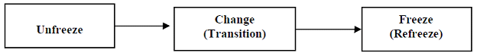
Source: (Cumming et al. 2016).

How Lewin Model can be Implemented

Unfreezing stage – The first stage of change involves preparing the organisation to learn about the changes and gradually move towards accepting the changes. It involves dismantling the existing ideas and practices to create a place for new ideas. This stage plays a crucial role for the employees to clear their mind of the old way of doing and coming out of the comfort zone to embrace the new ideas (Lewin, 2011). Pierce, Gardner, and Dunham (2002) identify two types of change in an organisation, proactive and reactive changes as the influence of the internal and external environment.
Currently, the NWM faces reactive type changes that pressure the company to take specific measures to make certain changes. Therefore, NWM's every changes effort needs to start with the vision. Knowing the vision will clarify the primary purpose of new ways of working, thus promote employee involvement which the most used and effective solution for overcoming resistance in organisational Change (Vroom & Yetton, 1973). The main focus is to ensure the company's survival while prioritising the workforce and customer's health and wellbeing. Once the people at the company understand the company's effort and the main reason for the changes, it becomes easier for them to support the new ideas (Bugubayeva, Sansyzbayevna and Teczke, 2017).
Communication plays a vital role throughout the organisational change. However, at this stage a clear and consistent communication strategy is necessary for developing a compelling message. Most importantly, it is also important to clarify the possible negative impact of the changes and their support during the change process. For example, the new homeworking initiative has challenged many employees across industries in developing a work-life balance (Seikh, 2013). According to CIMA (2020), employees have been struggling to bring their work life into their home life as covid also imposed many personal responsibilities such as home-schooling, bereavement, supporting family members etc. This led to poor mental health due to a lack of support from employers.
Change- Once employees are empowered with solid knowledge of the upcoming events, it will eventually shift to the actual changing stage. This is where the transition will take place through action-taking. It is important to realise that task assignment and delegation are critical at this stage because it is the people who will make the change happen (Lewin, 2011). Therefore, the employees at the NWM must develop a sense of urgency to take authorities and share responsibilities. However, it is important to understand its take time to embrace the new direction and participation. It will be useful for NWM to invest and discover the factors responsible for employees' resistance and difficulties to make the change transition. NWM must equip its workforce with the appropriate employee development tool (education, training, mentoring, coaching) to give them the proper skillset and expertise. It will boost their confidence to initiate the changing operation (Cummings et al. 2016). The challenges posed by the COVID forced cultural shit into the company, and technology remained the main dominator. According to Burnes (2019), a knowledge-sharing environment can help an organisation initiate a smooth, complex cultural shift. It allows information to flow from the organisation's multiple levels involving knowledgeable individuals sharing their beliefs, experiences, skills, competencies, and abilities. It is important to note here that as the current workplace becomes increasingly relying on the digitalised communication platform, NWM must ensure an organised process for explaining the assignment's expected quality, the performance outcomes, and the consequences.
Freezing Stage – In the final stage of Lewin's model comes to the refreezing step. In this stage, change takes shape because people within the company are in a more stable state and understand the changes' practical values. This state of mind influences people to accept the change better and even comprehend new working ways. It became easy for the organisation to transform the organisational culture where people's new belief system remains the main dominator. This stage is critical for people to continue with the new ways of doing things and not getting back to their old habits. It is also essential to monitor people activities to sustain the new habits and practice.
To sustain this mentality, Lewin (2011) believe that all the new behaviours and expected principles discussed in the previous stage need to be reinforced. Therefore, to lock in all the desired activities and attitudes, NWM must appreciate the engagement and progress of employee's input as the influencer to the change progression. Reward and acknowledgement are recognised as effective reinforcement for strengthening employees' new behaviours and activities (Burnes, 2016). According to Ajmal et al. (2015), an effective reward system involves establishing intrinsic and extrinsic rewards systems. NWM, with its existing digitalised culture, should aim to update its current culture because the pandemic has created new criteria to define a positive work culture. The current work environment needs to comply with newly lockdown policies, flexible working conditions, and the necessary professional growth while securing financial sustainability (CIPD, 2020). Through these incentives, NWM can reinforce the future way of working with increased interaction on the digitalised platform with better efficiency (Naghibi and Baban, 2011)
The possible upcoming issues
For the NWM, it is for sure that the service demands have grown as customers are relying on the company for up-to-date news and information. To capitalise on this opportunity, productivity needs to be increased. However, talking about change and managing change, the issues most organisation are facing at the moment are mainly related to the uncertainty around the pandemic, including anxiety, work-life balance, feeling loos of control in life and financial insecurity. The CIMA (2020) reports that most leaders and managers are facing difficulty in supporting employee's wellbeing and mental health while managing the business expectation. Therefore, to continue NWM business functionality, the leadership needs to be able to balance both the business demand while prioritising the wellbeing of the workforce.
To help employees cope with this turmoil, the Lewin model appears as an effective solution because of its people centre approach for successfully establishing the new work environment. However, the effectiveness of this model relies on the skills and attributes of the leaders. Cummings and Worley (2003) identify five key leadership that are necessary throughout the change process. They are creating the vision, providing political support, facilitate a smooth transition, motivating change and sustaining momentum. The table describes how these characteristics can be utilised in each step to overcoming the issues:
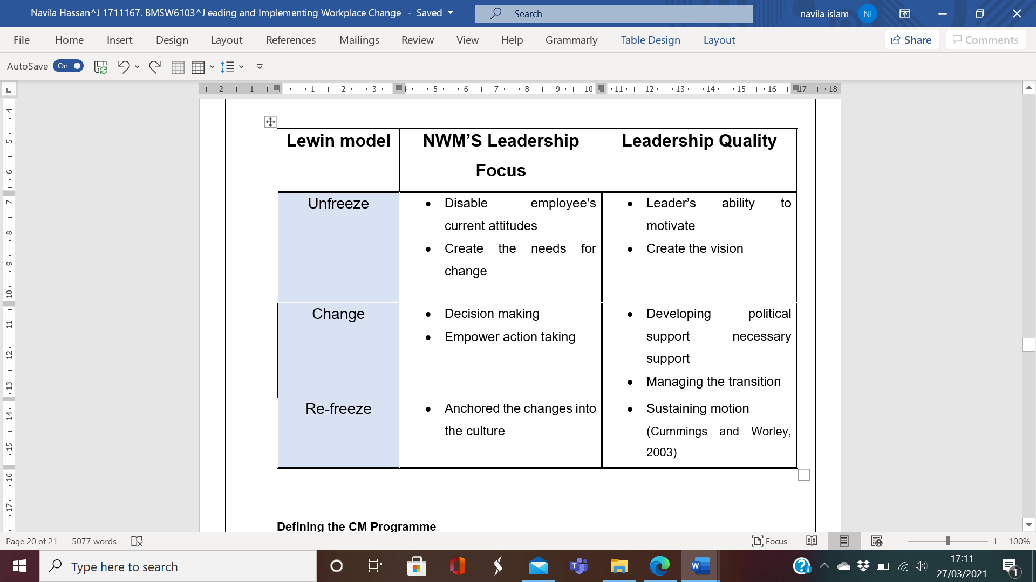

Change Management Programme

Change and Change Management (CM)
Change in an organisation is the movement from one state to another and consider as the only serving tool for organisation to respond to any forces of changes. CM is the formal process for initiating the changes successfully. According to Aswale (2015), in the 21st century, organisations are in constant state of changes driven by both internal and external forces. This highlights that change has become the norm for many organisations but not managing effectively could also lead to significant frailer even company collapsed (Forsyth, 2012). However, unlike other forces, including technology, market, customers etc. Covid-19 as the global pandemic is far more complex and sensitive as it is fundamentally related to the public health emergency. This has resulted in excessive competitors, shift customer behaviour and work schedule that is not expected. Looking at its complexity, the company is faced with unplanned changes (Rosenthal and Pijnenburg, 1991). The purpose of CM is then, despite the nature of the crisis, organisations need to respond in a planned and scheduled manner to act fast (Shaw, 2018). There are many approaches to plan and implement effective CM; however, because of the severity of the COVID crisis NWM need to consider a systematic approach (Senior, 2002).

Systemic CM in the NWM
CM is an essential part of every development. An effective CM needs to prioritise both the product itself and the process of happening throughout the end. Cao et al. (1999) argue that organisational changes can be categorised into four types. It is significant to remember that these four different types of change are interconnected and interacting. Through a systematic CM, organisation associate all the important elements steam through these four characteristics (Cao, Clarke, and Lehaney, 2004).
The diagram illustrates the flows of individual changes characteristics:

Process
Firstly, the changes in the organisational process begin by transforming certain inputs into output. For NWM, this may involve modifying the working condition, quality of the services and product development. The company's process initiation phase needs to rely on collecting new data around the new employment legislation; employees survey to learn the effective way to maintain workforce during and after the lockdown. The early years professional and carer development industry's market research identifies the need for online learning facilities for the early years professional and parents. The social trend has transformed people learning preference (The Local Government Association, 2021)). This also requires better coordination of resources that may include acquiring activities outside the functional departments' boundaries. For example, during the pandemic, virtual learning has become more norm and most common way to communicate. According to Jarratt, Spiro, and Darrall, (2020), many organisations increase their investment in their learning technologies, modernised tools and software. Therefore, to address this part of the change, NWM need to approach its subscribers with technologically advanced programmes, offer relevant features and remotely accessible (Kshirsagar et al. 2020)

Defining the Organisational Functional Changes
Secondly, changes in an organisation can impact its certain functional areas or the whole organisation. This can be their operational system, design, product, knowledge, technologies, marketing, promotion, etc. In any business, these areas are all coordinated and controlled by its organisational structure. The decision-making system around resource allocation, product development, recruitment criteria, employee performance, and career development is all designed through the structural layout. Structure as the dominion of the changes' decision making the suitability of the NMW's organisational structure should be examined. It is about responding to the crisis logically and flexibly with well informative decision system (Armstrong, 2009). For example, many businesses are thriving well during this lockdown regardless of their industry, platform, and size. It is reported, these businesses have managed to adapt well in modifying the right changes areas. Therefore, it is significant to identify the areas that are likely to be interrupted by the changes to avoid falling behind or even being collapsed (Odor, 2018).

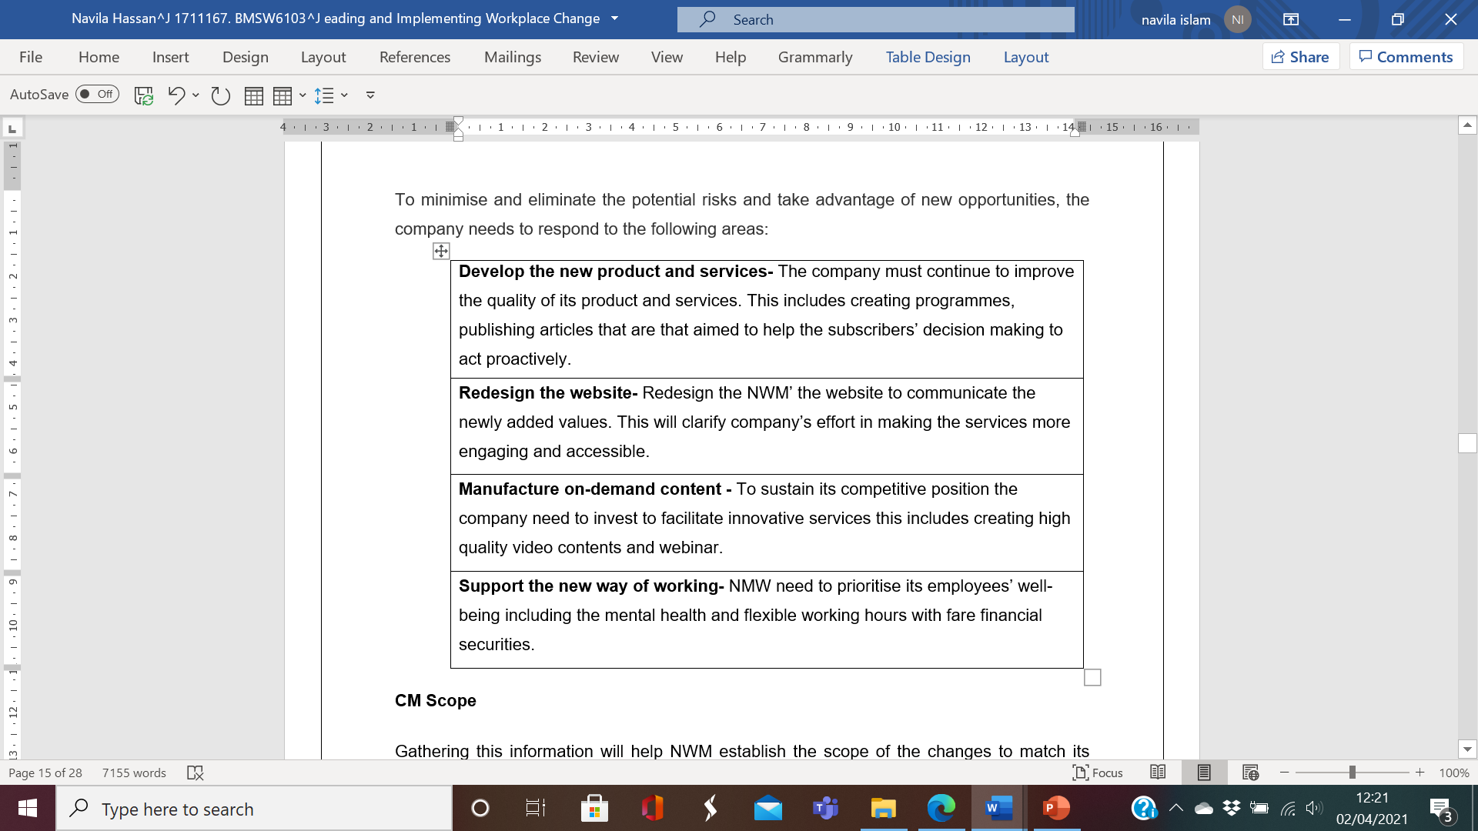
To minimise and eliminate the potential risks and take advantage of new opportunities, the company needs to respond to the following areas:

CM Scope
Gathering this information will help NWM establish the scope of the changes to match its internal capabilities. A clear scope of changes brings discipline into the CM process because it helps divide the work by setting the right objectives and goal. Knowing the scope is also necessary for resources management to clarify the budget to avoid surprise cost. For example, with Covid, NWM is faced with different forms of changes such as modifying the working facilities, updating product and services to meet the customer changing demand and managing the supply chain relationship. Each change involves financial budgeting and the staff with the right competencies to carried out the changes.
The following question will be considered before establishing a clear scope:
- Why is this change happening
- What is the aim goal of these changes?
- Are these changes feasible?
- Who are the right people for the changes' activities?
- Who are the possible stakeholders?
- What are the project restrictions? (PMI, 2008)

Changes in power distribution
It is essential to identify relevant people who are directly involved in the change effort. There are four key roles the Sponsor (Senior Leaders), Champion (Leader), Change Agent (employee) and Stakeholder (customer and supply chain), who have a vital role to play throughout the entire change execution. Understanding where each characteristic influences and contribution is important as they are the people who clarify the change outcomes, define the scope, arranges resources, and their contribution. One right way to organise this group of people is to examine the organisation's management structure because it explains their position, role, and responsibilities in the organisation and recognises the right stakeholders who represent a particular part of the business (Cao, Clarke, and Lehaney, 2004).
The below table describes the role and responsibilities of each position of the NWM:
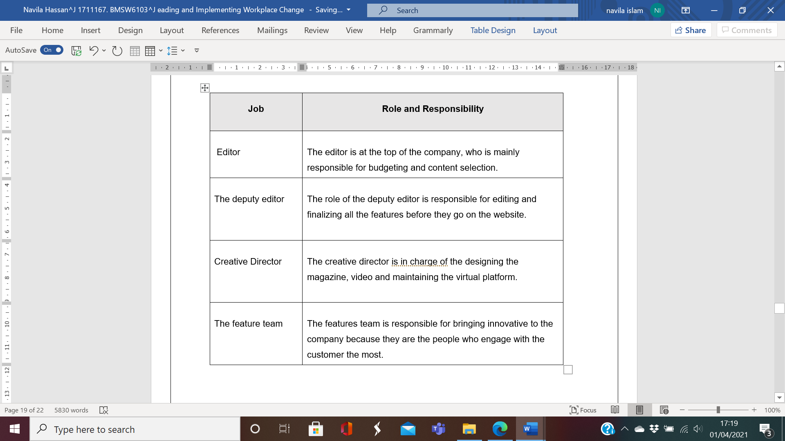

Evaluating the Organisational Culture
Culture is the shared mindsets that distinguish individual, group or community from one another. It is defined by a set of values, attitudes and behaviour that may represent certain belief, histories and customs (Hofstede, 1980). Organisational culture is the shared system originated from the founders and sustained through the people who lead and work for it (Schein,1996). NWM' organisational culture present as the adhocracy culture because of its flexible organisational structure that encourages its employee to act independently. NWM has revolutionised the early years' industry with its dynamic entrepreneurial and creative business model through its subscription website. Innovation and experimentation are its business core, where the industry professional pays to access resources and publication. Google is a famous example of an adhocracy culture where employees are in charge of their creativity to find innovative product and solution. Similarly, at NWM, the organisational activities are structured with an opposite to bureaucracy ranking its employee based on their performances rather than the job role (NWM, 2021).Below diagram demonstrate the foundation of NWM's current organisational culture:
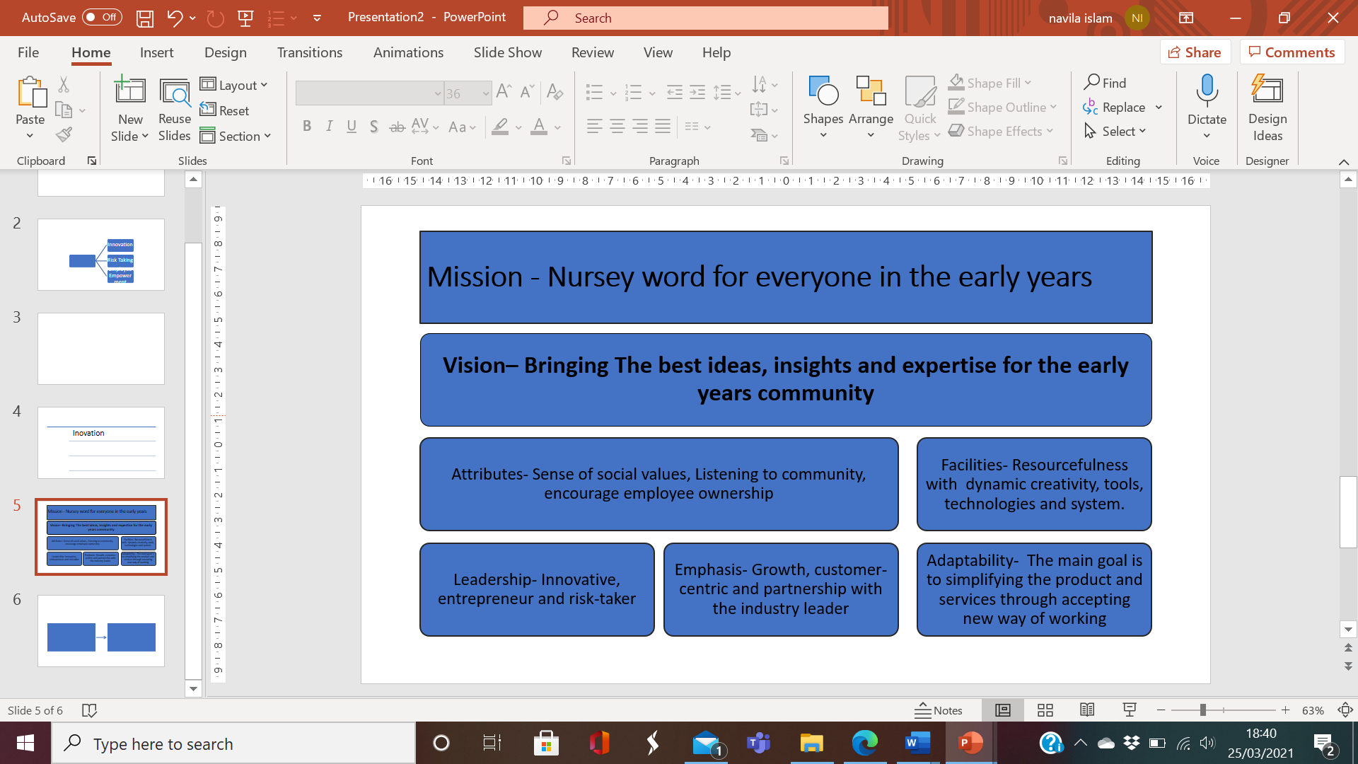
O'Reilly, Chatman and Caldwell (1991) identify seven primary characteristics to describe organisational culture, and these characteristics play a vital role to create an open and collaborative organisational culture. Some of these characteristics are presented in the NWM work culture. They are described below:
- Innovative and risk-taking- The company has been leading the way since 1925, providing unrivalled analysis, expert guidance, and professional development programmes both in print and online. The company has continued to thrive associating technologies, digitalisation, and online platforms that are easy to use, interactive, and accessible through any devices. The business focuses on promoting diversity covering topics from all around the world, national political agendas, expert opinion, and business insight related to early years (NWM, 2021).
- Attention to detail- The company places high values on the attention to detail as an underlying value in presenting the information. As the magazine business, information is the company's main sources, and NWM aims to produce its information with high accuracy. These beliefs are shared among the employees to articulate the degree to which employee is expected to produce their works (report, analysis, articles) that are accurate and time relevant. This expectation has influences employee' behaviour and performance, which exhibit through the company's consistent growth.
- People orientation- CIPD (2020) recognises that business in the 21st century requires running with people orientation. This involves implementing a series of values that is focused on its staff. NWM's operation model appeared as HR-focused to initiate customer-centric facility and services. As the world of work growing with globalisation, technology, changing workforce and demographics, and skills shortages add to organisations' challenges. The company has been transforming its workforces with soft and hard skills development programme that empowered employee to work efficiently in the 21st century (Robins, 2001).

Recommendation
With Covid, the company is faced with different forms of changes, and these changes are interrelated. If the interaction of different kinds of change is to be successfully executed, the report suggests the following recommendation:
Strengthens the new digitalised way of working – As a website-oriented business, virtual working, interaction, and collaboration are norms for the company. However, for the new homeworking initiative and interactive online learning facilities for the customers, a better way to manage the digital platform needs to be encouraged. This may involve the following:
- Arrange for a combination of technologies and software to support remote work
- Access control facilities and data security must be made available to both employee and customer.
- GDPR Policies and procedures need to be in place.
- Access to training to promote and enhance digital learning (Seagal, 2020).
Support Stakeholder- The CM plan must consider the people, directly and indirectly, involved in NWM's specifically people who are vulnerable and influences most by the upcoming changes. In the past, individuals with financial interest were given exclusive prioritisation; however, in today's world, business reputation relies on business ethical and sustainable behaviour that includes prioritising each stakeholder group (CIMA, 2014). Therefore, for developing a successful CM plan, all stakeholders' interest should be considered through the Stakeholder Analysis (SA) (Krishna, Jainabe and Dangayach, 2011).
The below table highlight the stakeholder influences:

Integrate Project Management (PM) in the CM- Every CM have a defined goal, and PM is defined as the vehicles for delivering changes. PM is a great management tool to identify the right tasks that are necessary for the change process. According to Roberts (2012), every project starts with defining its deliverable that includes the following
- Setting the start and end date
- A defined budget.
- Defined resources include human resources, materials, IT equipment etc.
With PM, the big vision of the NWM's change achievement can be braked into smaller tasks. Each of these tasks would have its own set of objectives with a defined end date. Therefore, the CM can be progressed cost-effectively as the budgeting can be monitor with the PM and managing the time efficiently (Prosci, 2020).
Lead CM with empathy - If the company aim to undertake a successful organisational change, they must ensure the team is on board and motivated to make the changes happen. First and foremost, they must confirm employees' safety at the workplace, both in the physical world and the home working environment. According to Segal (2020), organisations that failed to reach their business continuity's long-term purpose lacked empathy in their CM plan. This even limited the potential of its people to get their intended outcomes. It for sure that the demand for the services is rapidly growing and to capitalise on this opportunity employee's productivity need to be increased. Since the Pandemic workforces across organisations are attempting to work through this change while also maintaining the change in their personal lives. In doing so, most are undergoing a range of reactions as portrayed by the COVID-19 Kubler-Ross change curve:
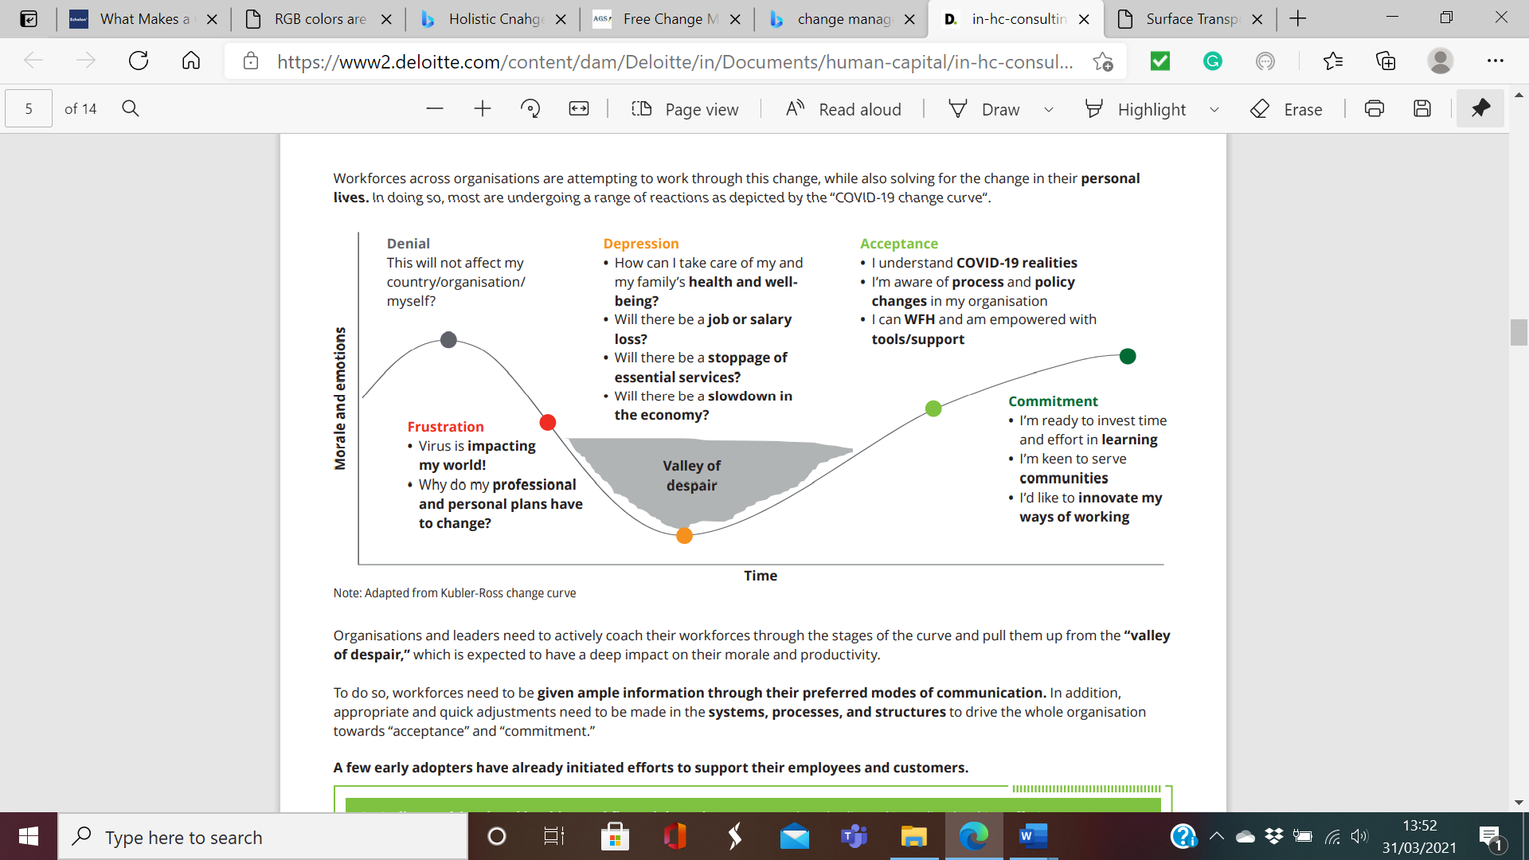
Source of Fig: (Diloitte, 2020)
The leader needs to develop the following abilities:
- Emotional Intelligence (EI)- Leader with high EI are self-aware; they are able to control their emotion, consider other people emotion too, therefore, can maintain a healthy relationship. Having these abilities is significant at the time of the CM because it allows them to put their self into employees' situation which helps them to create a system to create a smooth change transition (Raithatha, 2015).
- Trustworthy- The power of the internet and social media have made all kinds of information accessible. Therefore, people in the organisation are mostly exposed to information that can be both credible and non-credible. Therefore, honesty and integrity need as the based for the motive behind every action and decision in the CM process (Segel, 2020).
Coaching and Mentoring- Coaching and mentoring are the most influential employee development tools that involve actively listen to the employees and help them to overcome their obstacle. With these tools, organisation and leader managed to keep their people resilient, motivated through this most challenging time (Jarosz, 2020). Therefore, implementing coaching and mentorship in the NWM's leadership will influence the leader's decision-making to make appropriate and quick adjustments towards employees' acceptance and commitment in the process.

Conclusion
The impact of COVID have created pressure from the multidimensional site and have shifted the CM criteria. Now organisations are not only looking at innovation, the creativity of the product and service they also need to maintain the unprecedented but necessary adaptation to the new way of working. NWM's organisational culture represents an employee empowered environment. The company's emphasis on their future goal, which is to provide excellent services to their customer consistently, is clearly defined. Employees' talent and passion are being looked after because they are encouraged to bring different perspectives and take their initiative. Therefore, it can be said that the culture of the NWM's remained as the power tool for the long-run success of the NWM's leading position. However, Spicer (2020) explains that organisations' underlying values and norms need to be re-adjusted towards employees' safety and resilience to continue performance efficiency. As the magazine website and educational partner, the company needs to prioritise the employees and clients to alleviate the uncertainty around the workplace and services.

References
- Austine, K. (2020). 'Lockdown lessons: The firms adapting and thriving', BBC News, January 8. (Online) Available at: Lockdown lessons: The firms adapting and thriving - BBC News (Accessed: 27/03/2021).
- Ajmal, A., Bashir, M., Abrar, M., Khan, M.M. and Saqib, S. (2015) The Effects of Intrinsic and Extrinsic Rewards on Employee Attitudes; Mediating Role of Perceived Organizational Support. Journal of Service Science and Management, 8, 461-470. http://dx.doi.org/10.4236/jssm.2015.84047 (Accessed: 21/03/2021).
- Bank of England (2020). Impact of Covid-19 on UK businesses – evidence from the Decision Maker Panel in 2020 Q4 (Online) Available at: Impact of Covid-19 on UK businesses – evidence from the Decision Maker Panel in 2020 Q4 | Bank of England (Accessed: 27/03/2021).
- Bloom, A. et al. (2020). The impact of Covid-19 on businesses' expectations: evidence from the Decision Maker Panel [online] Available at: The impact of Covid-19 on businesses' expectations: evidence from the Decision Maker Panel | Bank of England ( Accessed: 01/04/2020).
- Burnes, B. (1996) 'No such thing as a "one best way" to manage organisational change', Management Decision, 34(10), pp. 11–18. [Online] Available at: https://search-proquest-com.ezproxy.uwtsd.ac.uk/docview/1416108024?pq-origsite=primo&accountid=130472 (Accessed: 01/04/2021).
- Burnes, B. (2004) Managing Change: A Strategic Approach to Organisational Dynamics, 4th Edn (Harlow: Prentice Hall)
- Burnes B. (2019). 'The Origins of Lewin's Three Step Model of Change', Journal of Applied Behavioural Science, 56 (1), pp. 32-59. [Online] Available at: A-Lewin 3-Step ModelV1 Accepted Version.pdf (stir.ac.uk) (Accessed: 01/04/2021).
- Bugubayeva, R.O., Sansyzbayevna, R.B. and Teczke, M. (2017). 'Approaches and models for change management', Jagiellonian Journal of Management vol. 3 (3), pp. 195–208 ResearchGate [Online] Available at: https://www.researchgate.net/publication/330928021_Approaches_and_models_for_change_management (Accessed: 25/04/2021).
- Cummings, S. et al. (2016). 'Unfreezing change as three steps: Rethinking Kurt Lewin's legacy for change management', Human Relations 69(1) [Online] available at: Unfreezing change as three steps: Rethinking Kurt Lewin's legacy for change management (sagepub.com) (Accessed: 21/03/2021).
- Cummings, T. G., & Worley, C. G. (2003). Organisation Development and Change (Online) Available at: Organization Development and Change, 9th ed. (mcs.gov.kh) (Accessed: 23/03/2021).
- CIPD. (2020). Coronavirus (COVID-19): Flexible working during the pandemic and beyond Available at: Coronavirus (COVID-19): Flexible working during the pandemic and beyond | Guides | CIPD (Accessed: 21/03/2021).
- CIMA. (2020). The Better Manager Manual Available at: https://www.managers.org.uk/wp-content/uploads/2020/08/better-managers-manual-2020-covid19.pdf (Accessed: 23/03/2021)
- CIMA. (2014). Stakeholders Analysis and Management. (Online) Available at: https://www.managers.org.uk/wp-content/uploads/2020/03/CHK-234-Stakeholder-analysis-and-management-1.pdf (Accessed: 31/03/2021).
- Carnall, C. and Rune, TB (2014). Managing change in organisations Sixth ed,). Harlow: Financial Times Prentice Hall. [Online] Available at: https://r1.vlereader.com/Reader?ean=9780273736431 (Accessed: 01/04/2021).
- Cao, G., Clarke, S. and Lehaney, B. (2004). 'The Need for a Systemic Approach to Change Management—A Case Study', Systemic Practice and Action Research, 17(2) PP. 103-126 (Online) available at: *The Need for a Systemic Approach to Change Management&#x2014;A Case Study (springer.com) (Accessed: 29/03/2021).
- Davis, R (2020). 'Coronavirus and the social impacts on Great Britain: April 23 2020', Office for National Statistics [Online] Available at: Coronavirus and the social impacts on Great Britain - Office for National Statistics (ons.gov.uk) (Accessed: 01/04/2020).

- Deloitte. (2020). Combating COVID-19 with an agile change management approach (Online) Available at: in-hc-consulting-deloitte-change-management-pov-on-covid-noexp.pdf (Accessed: 05/04/2021).
- Forsyth, P. (2012). Managing Change, London; Philadelphia: Kogan Page. (Online) Available at: https://r1.vlereader.com/Reader?ean=9780749463908 (Accessed: 27/03/2021).
- Hughes, M. (2006). Change Management: A Critical Perspective. London: Chartered Institute of Personnel and Development.
- Hussain, A.T. et al. (2018). 'Kurt Lewin's change model: A critical review of the role of leadership and employee involvement in organisational change', Journal of Innovation & Knowledge.3 (3), PP. 123-127. ScienceDirect (Online) available at: Kurt Lewin's change model: A critical review of the role of leadership and employee involvement in organisational Change - ScienceDirect (Accessed: 29/04/2021)
- Jarratt, E., Spiro, H. and Darrall, S. (2020). 'Reflecting on the use of AI and data-driven technology in the pandemic' GOV.UK [Blog]. 8March. Available at: https://cdei.blog.gov.uk/2021/03/08/reflecting-on-the-use-of-ai-and-data-driven-technology-in-the-pandemic/ (Accessed: 27/04/2021).

- Jarosz, J. (2021) 'The impact of coaching on wellbeing and performance of managers and their teams during pandemic', International Journal of Evidence Based Coaching and Mentoring, 19 (1), pp.4-27. DOI: 10.24384/n5ht-2722 (Accessed: April 1 2021).
- Local Government Association. (2021). Wellbeing of children under five and supporting the early years sector affected by the COVID-19 pandemic, House of Commons January 20 2021 (Online) Available at: Wellbeing of children under five and supporting the early years sector affected by the COVID-19 pandemic, House of Commons January 20 2021 | Local Government Association (Accessed: 29/03/2021).
- Kshirsagar,A. et.al. (2020). Adapting workplace learning in the time of coronavirus, McKinsey Accelerate Report (Online) Available at: https://www.mckinsey.com/business-functions/mckinsey-accelerate/our-insights/adapting-workplace-learning-in-the-time-of-coronavirus (Accessed: 29/03/2021).
- Krishna, A., Jainabe, R., Dangayach, G.S. (2011). 'Business Ethics: A sustainability Approach'. Procedia - Social and Behavioural Sciences,25 (2011) pp.281 – 286 [Online] Available at: Business Ethics: A Sustainability Approach | Elsevier Enhanced Reader (Accessed 31 /03/20201).
- Lewis, L. K. (2011) Organizational Change: Creating change through strategic communication. 1 st edition. United Kingdom: Wiley- Blackwell.
- Legislation.gov.uk. (2021). Coronavirus Act 2020, (Online) Available at: Coronavirus Act 2020 (legislation.gov.uk) (Accessed: 26/03/2021).

- Mosadeghard, A.M. and Ansarian, M. (2014). ‘Why do organisational change programmes fail?’, International Journal of Strategic Change Management 5(3) PP.189-218 ResearchGate [Online] Available at: (PDF) Why do organisational change programmes fail? (researchgate.net) (Accessed: 02/04/2021).

- McKinsey and Company. (2020). COVID-19: Implications for business [Online] Available at: Coronavirus' business impact: Evolving perspective | McKinsey (Accessed: 01/04/2021)

- Mustoe, H (2020). 'Covid: One in three UK hospitality firms fear collapse', BBC NEWS, November 19. Available at: Covid: One in three UK hospitality firms fear collapse - BBC News (Accessed: 30/01/2021).

- NWM. (2020). ABOUT NURSERY WORLD (Online) Available at: About Nursery World | Nursery World (Accessed: 17/02/2021).

- NMW. (2021). Viewpoint (Online) Available at: Opinion | Nursery World (Accessed:17/03/2021).

- NWM. (2021). Contact Us (Online). Available at: https://www.nurseryworld.co.uk/advanced-page/contact-us (Accessed: 04/04/2021).
- Naghibi, M. H. and Baban, H. (2011). 'Strategic change management: The challenges faced by organisations', International Conference on Economics and Finance Research IPEDR vol.4 PP.542-544. [Online] Available at: *108-F00035.pdf (ipedr.com) (Accessed: 23/03/04).

- Odor, H. (2018). 'Organisational Change and Development', Organisation Culture and Dynamics: A literature Review (Online) ResearchGate Available at: (PDF) Organisational Change and Development (researchgate.net) (Accessed: 28/03/2021).

- O'Reilly, C. A., Chatman, J., and Caldwell, D. F. (1991). 'People and organisational culture: A profile comparison approach to assessing person-organisation fit'. Academy of Management Journal, 34(3), 487–516. https://doi.org/10.2307/256404 (Accessed: 30/03/2021).

- PMI. (2008). A Guide to the Project Management Body of Knowledge. 4th Edn. [Online] Available at: PMBOKGuideFourthEdition_protected.pdf (works.gov.bh) (Accessed: 30/03/2021).

- Prosci. (2020). Best Practices in Change Management [Online] Available: https://www.prosci.com/hubfs/2.downloads/research-executive-summaries/11th%20Edition-Best-Practices-Executive-Summary-11-2020.pdf?hsLang=en-ca (Accessed: 01/04/2021)

- Roberts, P. (2011). Effective Project Management. Dawsonera [Online] Available at: https://www-dawsonera-com.ezproxy.uwtsd.ac.uk/abstract/9780749461584 (Accessed: 27/03/2021)

- Raithatha, M.S. (2015). 'The Role of Emotional Intelligence in Change Management, INDIAN JOURNAL OF RESEARCH, 4(2) PP-43-44 [Online] Available at: https://www.worldwidejournals.com/paripex/recent_issues_pdf/2015/February/February_2015_1424254178__91.pdf (Accessed: 31/03/2021.

- Sharma, S. (2020). Industries Thriving During The Pandemic, Available at: Industries Thriving During The Pandemic (forbes.com) (Accessed: 02/04/2021).

- Seikh, M. (2013). The Role of Communication in Change Management. PhD Thesis. University of Gothenburg. [Online] Available at: gupea_2077_33908_1.pdf (Accessed: 02/04/2021).

- Senlior, B. (2002). Organisational change, 2nd ed. Pearsion Education: England.

- Spicer, A. (2020). 'Organisational Culture and COVID-19', Journal of Management Studies [Online] Available at: Organizational Culture and COVID‐19 (wiley.com) (Accessed: 30/03/2021).

- Segal, L.H. (2020). 'Positive leadership in uncertain times', McKinsey and Company. [Online] Available at: https://www.mckinsey.com/business-functions/organization/our-insights/positive-leadership-in-uncertain-times (Accessed: 31/03/2021).

- Stonehouse, D. (2013). 'The Change Agent: The Manager's Role In Change', British Journal of Health Care Management 19(9) PP.443-445. (Online) ResearchGate, Available at: (PDF) The Change Agent: The Manager's Role In Change. (researchgate.net) (Accessed: 16/02/2021).

- Shaw M. (2018) Unplanned Change and Crisis Management. In: Farazmand A. (eds) Global Encyclopedia of Public Administration, Public Policy, and Governance. Springer, Cham. Available at: https://doi.org/10.1007/978-3-319-20928-9_748 (Accessed: 26/03/11).

- Stastica. (2020). Share of businesses that have closed or temporarily paused trading in the United Kingdom due to Coronavirus (COVID-19) as of April 2020. (Online) available at: https://www.statista.com/statistics/1114406/coronavirus-businesses-closing-in-the-uk/#statisticContainer (Accessed: 26/03/11).

Appendix

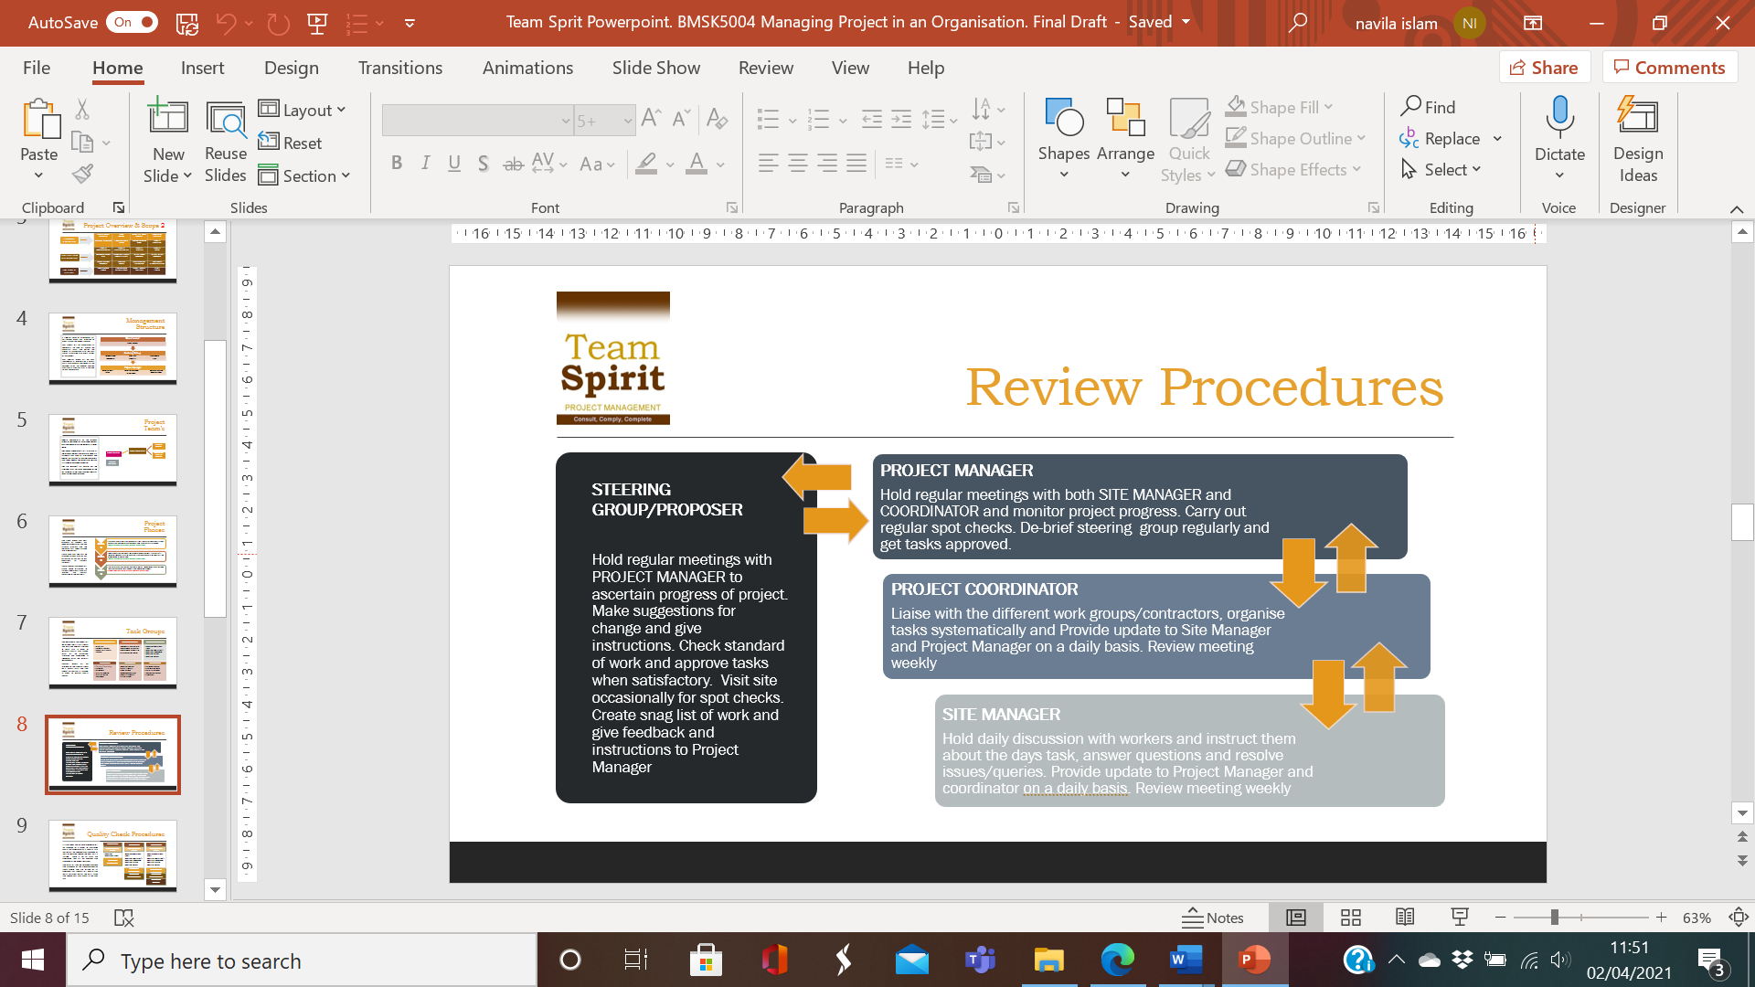
• Allow enough time to fix the problem before the completion date.

