Module code:LCHS4003
Introduction to health and social care
Tutor : Mumtaz Goolam
Student name: Zoya Muzaffar
Student number: 2435513
Poster & Task 2
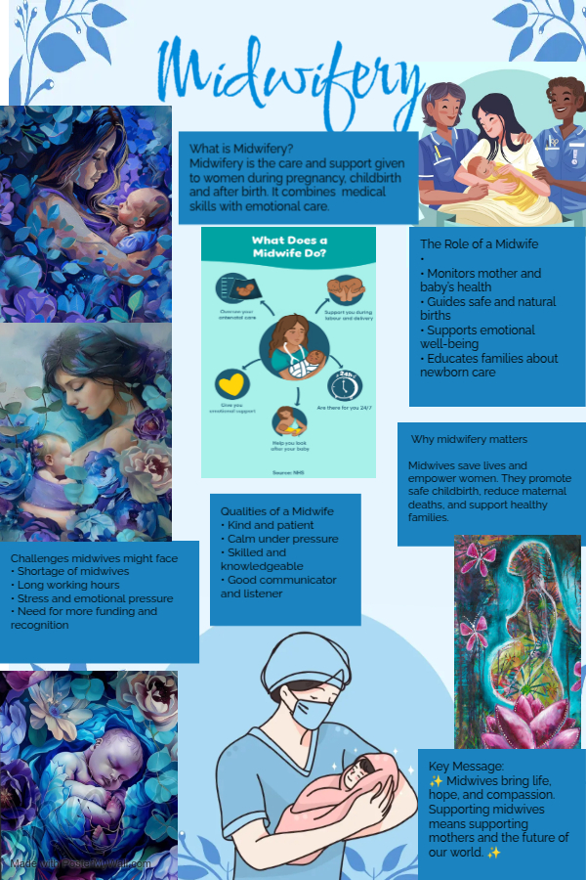
Task 2 essay overview
Introduction
The National Health Service (NHS) is one of the most significant social achievements in British history. Established in 1948, it was created to provide free and universal healthcare for all citizens, regardless of wealth or social class. The foundation of the NHS was not just a medical reform but a social revolution that reflected changing attitudes toward equality, welfare, and state responsibility. Its creation was influenced by decades of political struggle, wartime experiences, and the growing belief that health should be a right, not a privilege.

Historical Context Before 1948
Before the NHS, healthcare in the UK was deeply unequal. Access to medical care depended largely on a person’s income. The wealthy could afford private doctors, while poorer citizens relied on charity hospitals, local authorities, or voluntary organisations. Working-class families often avoided seeking treatment because of cost, leading to high rates of disease and preventable deaths.

During the 19th and early 20th centuries, some social reforms tried to address this imbalance. The National Insurance Act of 1911, introduced by David Lloyd George, provided limited medical coverage for certain workers, but it did not include dependents or the unemployed. This patchwork system meant that many people still had no access to consistent healthcare (Webster, 2002).

The outbreak of World War II (1939–1945) changed everything. The war effort highlighted the need for a healthy population and a coordinated health system. The Emergency Medical Service (EMS), set up during the war, brought hospitals and doctors together under state control for the first time. This temporary system showed that a national approach to healthcare could work effectively, inspiring post-war reform.

The Beveridge Report and the Birth of the NHS
A major turning point came with the Beveridge Report of 1942, written by Sir William Beveridge. The report proposed a comprehensive welfare system to tackle the “five giants” of want, disease, ignorance, squalor, and idleness. Beveridge argued that healthcare should be free at the point of use and available to everyone. His ideas gained massive public support during the war, as people dreamed of building a fairer society once peace returned (Beveridge, 1942).

After the war, the Labour Government, elected in 1945 under Prime Minister Clement Attlee, turned these ideas into action. Aneurin Bevan, the Minister of Health, led the creation of the NHS. Despite strong opposition from doctors’ organisations and the Conservative Party—who feared loss of independence and bureaucracy—Bevan pushed the reform through Parliament. On 5 July 1948, the NHS officially came into operation.

Key Principles of the NHS
The NHS was founded on three core principles that still define it today:
- It meets the needs of everyone.
Healthcare would be comprehensive, covering physical and mental health services for all citizens.
- It is free at the point of delivery.
No one would pay when receiving care. Services would be funded through taxation, ensuring equality of access.
- It is based on clinical need, not the ability to pay.
Treatment would depend on medical necessity rather than personal wealth or status (NHS England, 2023).

These principles reflected a belief in social justice and collective responsibility. The idea was that every citizen contributes to the system through taxes and, in return, receives care when needed—a model of mutual support that redefined the relationship between government and society.

Impact and Legacy
The NHS transformed British life almost overnight. Millions of people gained access to doctors, hospitals, and treatments that were previously unaffordable. Infant mortality rates fell, life expectancy improved, and public trust in government increased. Over time, the NHS became a symbol of national identity and pride, embodying the principle that compassion and fairness should guide public policy.

Although it faces modern challenges such as funding pressures, staff shortages, and rising demand, the founding vision of the NHS remains strong. Its creation marked a turning point in global healthcare, influencing welfare systems around the world.

Conclusion
The origins of the NHS lie in a period of hardship and hope. Born from the shared experience of war and the desire for equality, it stood as a promise that no one should suffer for lack of medical care. Guided by the ideals of universality, equality, and compassion, the NHS continues to represent one of Britain’s proudest achievements—a lasting legacy of the belief that good health is a human right, not a privilege.

References
- Beveridge, W. (1942). Social Insurance and Allied Services (The Beveridge Report). London: HMSO.
- NHS England. (2023). The NHS Constitution for England. Retrieved from https://www.england.nhs.uk/
- Webster, C. (2002). The National Health Service: A Political History. Oxford University Press.
- The King’s Fund. (2023). The NHS at 75: How It All Began. Retrieved from https://www.kingsfund.org.uk/

