2018-2020 Forecast Outlook of Welsh Housing Market
The Briefing Paper

Produced for
Celtic Building Contractor’s Limited

Produced By
Gavin Perry
Senior Quantity Surveyor

15th December 2017

Executive Summary

The aim of the following report was to establish the current performance of the Welsh Housing Market and forecast the future outlook over the next two years. Data was gathered and analysed from economical statistical organisations, trends and drivers behind the statistics identified. Data shows that the Welsh housing market is currently preforming well with house prices steadily increasing. The report concludes that this trend is set to continue over the next two years due to demand, and in order to maximise opportunities over this period recommendations have been formulated.

Table of Contents Page No

Executive Summary………………………………………………………………………2

Glossary…………………………………………………………………………………...4

List of Figures…………………………………………………………………………….5

Appendices………………………………………………………………………………..6

1. Introduction……………………………………………………………………………7

2. The Economy - Here and Now
2.1. Housing Market………………………………………………………………………………………..8
2.2. Construction and Infrastructure Outputs……………………………………………………………9

3. Housing and Construction – Looking Forward…………………………………….10

4. Challenges/Opportunities
4.1. Challenges………………………………………………………………………………………………11
4.2. Opportunities…………………………………………………………………….……………………..13

5. Recommendations/Actions……………………………………………………………14

6. Conclusions…………………………………………………………………………….15

References………………………………………………………………………………...16

Glossary

- Brexit – The term used to describe Britain’s exit from the European Union

- CAD – Computer Aided Design

- Consumer – Purchasers of goods and services for personal consumption

- CPA – The Construction Products Association

- Economy - The state of a country or region in terms of the production and consumption of goods and services and the supply of money.

- HRA caps – Housing revenue account requires all authorities to keep accounts of all expenditure relating to council properties

- ICT – Information Communication Technology

- Infrastructure – Refers to buildings, roads and power supply to maintain society

- Macroeconomics – The part of economics that deals with cumulative decisions and factor such
as interest rates and government policies

- Microeconomics – The part of economics that deals with individual factors and decisions

- ONS – The office for National Statistics

- PESTLE Analysis – A framework tool used by analysts to monitor macro environments

- RICS – The Royal Institute of Chartered Surveyors

- SME’s – The term given to ‘small to medium enterprises’

- Stamp Duty – A tax placed on legal documents at time of transfer

- Trends – Refers to a general direction that something appears to be going

List of Figures Page No

Figure 1, Affordable Housing……………………………………………………….7

Figure 2, Commercial Occupiers Demand…………………………………………8

Figure 3, Residential Regional Prices………………………………………………8

Figure 4, ONS New Orders………………………………………………………….9

Figure 5, Forecast Number of Recruits Required Annually……………………...12

Appendices Page No

Appendix 1, PESTLE Analysis…………………………………………………………19

1. Introduction

The following report has been prepared at the request of ‘Celtic Construction Contractors Limited’. The aim of the report will be to brief the management on the likely outlook of the Welsh housing market over the next two years, enabling the business to initiate preparations from recommendations, to maximise future opportunities.
To forecast the likely outlook of the Welsh housing market, the report will assess the current state of the Welsh economy and that of the UK economy respectively, primarily focusing on housing and construction/infrastructure sectors.
Property prices have a significant affect on the housing market, and this is no more evident from the recessions of 1980, 1990/91 and 2008, where falling property prices was ultimately the largest factor to influence the failing economy. (www.economicshelp.org 2017)
The objectives of the report will be to highlight the current performance of the Welsh housing market by reviewing up to date statistics. A future outlook will be developed incorporating forecast models, and PEST analysis. Drivers and trends will be identified along with relative government legislation and future policies.

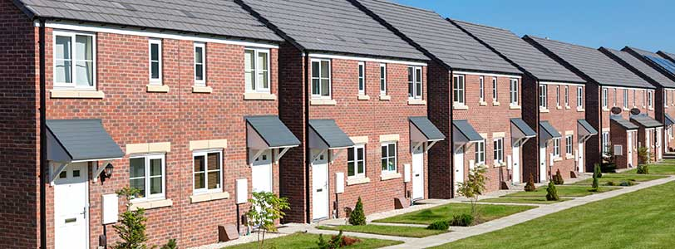
Figure 1, Affordable housing (www.theplanner.co.uk , 2017)

2. The Economy – Here and Now

2.1 Housing Market
The (ONS) Office for National Statistics (2017) reported in its statistical bulletin in September that nominal total value of residential transactions in England and Wales for year ending March 2017 concluded at £239 billion. By way of contrast this was down from £273 billion in the year ending March 2016, the decrease witnessed in property transaction value is the first time since post financial crash 2009. Despite the decrease in value, 21% of neighbourhoods in England and Wales saw an increase in transactions by March 2017 from the previous year, believed to be down to the changes to stamp duty which took effect on April 1st 2016. (www.ons.gov.uk, 2017)
In the RICS October 2017 UK residential market survey, indicators showed a softening to both demand and sales with a national price net balance of just +1% which proceed two consecutive months of +6%, displaying a flat trend on a UK basis. The market survey results display wide price variation across UK regions, with Wales returning further house price gains.
In addition to house price gains, Wales was only one of three locations to have experienced a rise in new buyer enquiries in October, with the majority of the UK remaining flat or negative. Rental growth projections remain relatively positive across the board where it is anticipated the next three months will see a net balance of +11%. The Q3 2017 RICS UK Commercial property market survey show positive results in terms of the industrial sector with a modest increase in investor and occupier demand, tenant demand for industrial space returned a net balance +28%. That said the retail sector saw a fall in demand of -16% for the second consecutive quarter. (www.rics.org/economics, 2017)

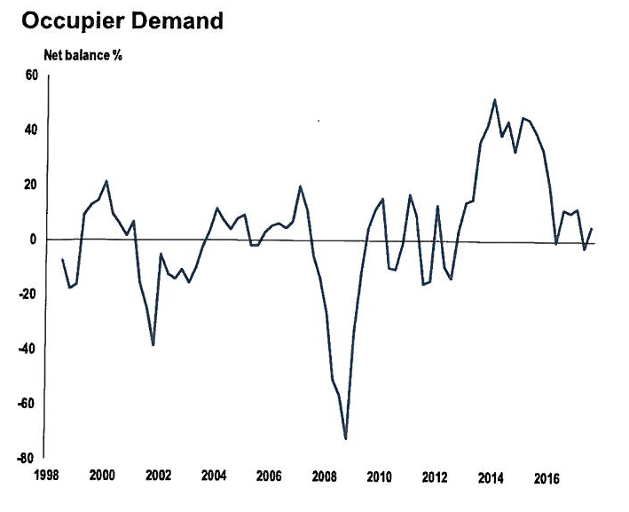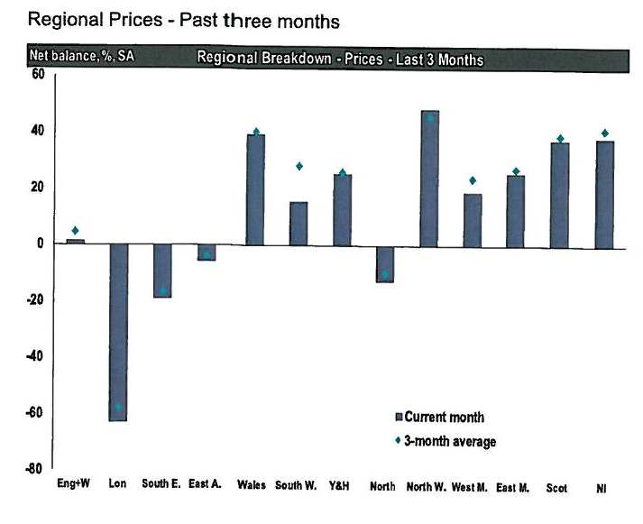
Figure 2, Commercial occupier demand Figure 3, Residential regional prices
(www.rics.org/economics, 2017)

2.2 Construction and Infrastructure Outputs

Construction outputs in Wales over the four quarters ending 2017 Q2 increased by 4% on the previous 4 quarters. Construction output in Wales for Q2 2017 increased by 1.1% on the previous quarter, but the UK index fell by 0.5% over the same period. (www.gov.wales/statistics, 2017)
Data published by the (ONS) on the 8th December, construction output fell for the sixth consecutive period. Falling by 1.4% in October alone on a quarterly assessment. The fall in construction output stems from a decline in both repair and maintenance work and all other new work. On a month by month assessment, output fell by 1.7% in October. In contrast to these figures, new orders across the board seen a positive increase in Q3 (July to September) 2017. Total new orders seen a percentage increase of 37.4% when compared with the previous quarter. This increase has been driven mainly by a growing infrastructure sector. (www.ons.gov.uk, 2017) In addition to infrastructure, new housing orders increased by 9.5%.
The figures from the (ONS) are backed up by those of the RICS UK Construction and Infrastructure Survey produced in the third quarter of 2017. Of its contributors, 21% more reported a rise in overall workloads in the infrastructure sector. Surveyors responded similarly to housing, reporting a rise in activity for public and private housebuilding 12% and 33% respectively. (www.rics.org/economics, 2017)
The graph below (Figure 4) from the (ONS) demonstrates the trends of new orders in the third quarter 2017.

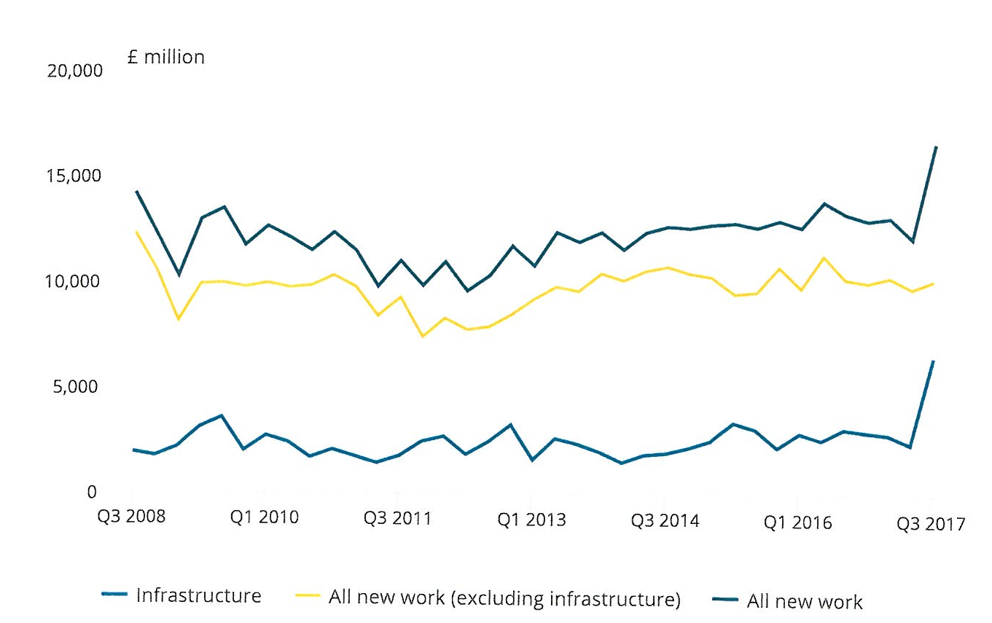
Figure 4, ONS New orders (www.ons.gov.uk, 2017)

3. Housing and Construction – Looking Forward

According to Savills Residential Market Survey Autumn 2017, data indicates a slowdown in property price growth in 2018 mostly in part to the severe uncertainty surrounding the Brexit outcome. This trend is already evident when comparing the ONS and RICS Q3 data. As more certainty is offered over the Brexit final deal, it is expected that growth will return late 2018/2019 as employment, wage and GDP growth swing back towards trend levels. (www.savills.co.uk, 2017) Looking ahead to 2019-20 rising interest rates are expected to impact price growth rates with the cost of borrowing, and those with variable rate mortgages being affected, intern house price growth will be dependent on national wage increases. According to Welsh Government statistics 2017, full time Welsh employees have average gross weekly earnings of £498.40 and the UK £550.40. In the year between April 2016 and April 2017 Welsh full time earnings decreased from being 91.7 of the UK average to 90.6 displaying an uneven trend in wage growth. (www.gov.wales/statistics, 2017)
Surveyors to the RICS UK Construction and Infrastructure Survey produced in the third quarter of 2017 expressed similar concerns regarding the Brexit outcome. Post EU referendum 62% of contributors expected construction activity to rise rather than fall, in Q3 this number had fallen to 45% which indicates a less optimistic outlook ahead. Despite this 30% more contributors expect employment to rise over the next twelve months. (www.rics.org/economics, 2017)
The Construction Products Association (CPA) industry forecast 2017-19 expects that total construction output will increase by 1.2% in 2018 and 2.3% in 2019. Once again stating that major infrastructure projects will be the key drivers. Regarding private housing the CPA appear optimistic, and forecast that private housing new starts will grow by 3.0% this current year which takes into account a fall in starts in central London due to oversupply, this demonstrates what effect the London property market has on that of Wales. Growth in 2018-19 is expected to be 2.0%. (www.constructionproducts.org.uk)

4. Challenges/Opportunities

4.1 Challenges

The Welsh housing market is directly affected by issues facing that of the UK housing market and as a consequence a broader picture must be drawn to display the effects of these challenges within micro and macroeconomics. The challenges likely to be experienced are summarised below;
- Brexit – On the 23rd June 2016 the UK public voted 51.9% in favour to leave the European Union. The uncertainty surrounding the outcome of what Brexit will mean is mainly the issue. The Brexit decision is causing uncertainty throughout all sectors and affecting consumer confidence. (Davidson, S, thismoney.co.uk, 2017)

- Inflation – The current UK inflation rate is 3%, 1% over the bank of England’s target of 2%. The current effects of this inflation rise means that the cost of living far exceeds that of peoples wage growth. With the cost of living rising, consumers will be less inclined to spend. (www.bankofEngland.co.uk, 2017)

- Rising Interest Rates – Interest rates coincide with inflation, and in respect of the high inflation rate mentioned previously, the bank of England have risen interest rates to kerb consumer demand. Rising interest rates encourage consumers to save rather than spend. And in addition to this, increase costs for people on variable rate mortgages. (www.bankofEngland.co.uk, 2017)

- Material Costs – The depreciation in the value of Sterling has led to the rises in import costs of materials. These rises in costs will be transferred to construction companies and developers, who will either be required to pass it on to the end user, or absorb the impact and accept smaller profit margins. (www.constructionproducts.org.uk)

- Skills Shortages – The construction industry could see a 20-25% decline in available labour force in the next ten years due to an ageing work force and lack of uptake in the industry. (Farmer, M, p8, 2016) The declining skilled work force could result in not being able to meet the housing shortage demand and intern fail to achieve maximum potential Gross Domestic Product (GDP). (www.citb.co.uk, 2017)

- Domestic Sprinkler systems – As of January 1st 2016 amendments made to document B of the building regulations now makes it compulsory to install automatic fire suppression systems to new and converted residential houses and flats. The expense associated with this legislation will increase financial pressures on landlords and house builders. (www.gov.wales, 2017)

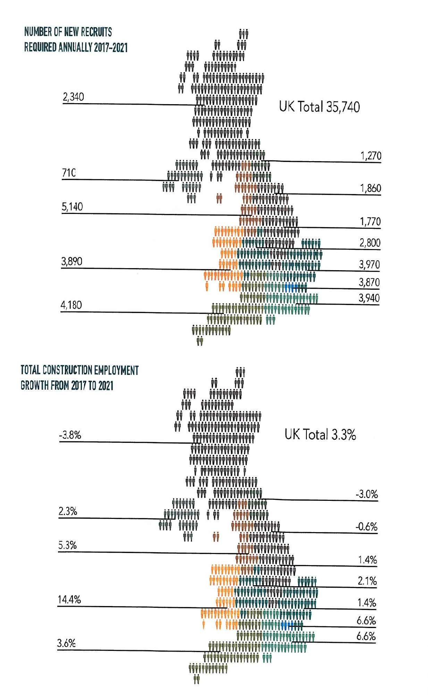
Figure 5, Forecast number of recruits required annually (www.citb.co.uk, 2017

4.2 Opportunities

Much has been presented in the form of challenges facing the market, but what about the positive opportunities which may present themselves over the next two years. Below are a series of opportunities surrounding the Welsh/UK housing market;

- Taking Wales Forward – The Welsh Government strategy paper ‘Prosperity for All’ sets out Welsh Government commitments to be delivered between now and 2021. key points to take from this paper is the government’s commitment to;
  - Deliver 20,000 new affordable homes by 2021
  - Unlock the potential of SMEs to build new homes
  - Encourage council house building at a greater pace
  - Continue the Right to Buy scheme (www.gov.wales, 2017)

- Current housing Shortfall – Welsh Government estimates that 14,000 new homes per year need to be built for the next 15 years to keep up with current demand, this does not account for the current shortfall. The demand for new homes is there, this could provide a healthy housing market for the foreseeable future. (www.assembly.wales, 2017)

- UK Autumn Budget – Following the release of the Autumn Budget, Mr Phillip Hammond made key announcements on the housing and construction markets. Although these might offer opportunities going forward, most are likely to have little if no effect over the next two years, but may increase confidence within the sector. The most relevant announcements include;

  - Home Building Fund: SMEs will get a further £1.5bn
  - Housing guarantees worth up to £8bn to support house building, to include SMEs
  - The budget for affordable housing increased from £7.1bn to £9.1bn
  - £34m to enhance innovative training programmes and boost skills recruitment
  - Stamp duty for all first time buyers homes up to £300,000 scraped
  - The lifting of HRA caps for authorities in high demand areas (www.rics.org/economics, 2017)

5. Recommendations/Actions

Having assessed the current economic status of the Welsh/UK housing market, and that of the construction sector. Recommendations have been formulated in preparation for the next two years. Wales and the UK is currently experiencing a period of high uncertainty, but never the less there are actions which can be taken now to ensure future development.
The headline recommendations of this report are as follows;
- Review current company training policies, establish what resources will be required to meet future demand, and devise a modern skills and training model that will provide the skills required to meet a modernised industry.

- There are strong indications that the infrastructure sector is to see significant growth over the next two years and foreseeable future. Investing in a civil engineering arm to the business to maximise opportunities to be considered.

- Modernise or Die, the management should investigate modern construction methods in the form of pre-manufacturing solutions and off site construction. This would have the potential to significantly reduce waste, and labour costs in a competitive market. (Farmer, M, p11, 2016)

- Investment in (ICT) Information Communication Technology – The investment and adoption of (ICT) technologies in the form of software development, cloud computing and data centres incorporated with (CAD) Computer Aided Design will aid in streamlining the companies processes. (www.designingbuildingswiki, 2017)

- Rental Properties – With the rental sector expected to grow by 3.5% per annum over the next five years (www.rics.org/economics, 2017) and an estimated 25,000 empty private sector homes in Wales alone (Baxter, J, www.assembly.wales, 2017). There is potential to invest and convert these empty dwellings into flats and rental accommodation should be considered.

6. Conclusions

Data suggests the performance of the current Welsh Housing Market remains strong, and that it is likely to continue for the foreseeable future due to high consumer demand. The Welsh and UK construction sectors appear to be healthy despite a slight dip in the third quarter of 2017. New orders suggest that the industry will recover somewhat in 2018. 2018 is likely to be a year of uncertainty, and until the final deal on Brexit is established, consumer confidence is likely to decrease and corporate investors less likely to invest. Forecast models have suggested that as we near the finish line of the Brexit negotiations and outcomes of the deal are made clear, consumer confidence will increase and investors who have held back will be more inclined to invest. Interest rates and inflation remain a concern for the bank of England, and it is anticipated interest rates will continue to rise over the next two years form the current rate of 0.5% to 1% in 2020 depending on inflation levels. (Lambert, S, thismoney.co.uk, 2017)
Economics aside, in order to secure the future of ‘Celtic Construction Contractors Limited’ the company must acquire new recruits to undertake apprenticeship and other skills training programmes to combat the severe skills shortage within the industry. Failure to act now may result in a lagging workforce to keep up with future demand.

References

Baxter, J. (2017). Is Wales facing a housing crisis. Available: http://www.assembly.wales/NAfW%20Documents/ki-021.pdf%20-%2003112011/ki-021-English.pdf. Last accessed 9th Dec 2017.
CITB. (2017). Construction 2030 and Beyond: The Future of Jobs and Skills in the UK Construction Sector. Available: https://www.citb.co.uk/research/research-reports/. Last accessed 9th Dec 2017.
CITB. (2017). Construction Skills Network Forecasts 2017-2021. Available: https://www.citb.co.uk/research/construction-skills-network/. Last accessed 9th Dec 2017.
CPA. (2017). Construction Industry Forecasts 2017-2019. Available: https://www.constructionproducts.org.uk/publications/economics/construction-industry-forecasts-quarterly-update-available-spring-autumn-winter/construction-industry-forecasts-spring-2017/. Last accessed 9th Dec 2017.
Davidson, S. (2017). How will Brexit really affect Britain's property market? SARAH DAVIDSON crunches the numbers behind house prices and forecasts. Available: http://www.thisismoney.co.uk/money/mortgageshome/article-4360258/How-Brexit-really-affect-Britain-s-housing-market.html. Last accessed 9th Dec 2017.
Designing Buildings Wiki. (2017). Information Communications Technology in Construction. Available: https://www.designingbuildings.co.uk/wiki/Information_and_communications_technology_in_construction. Last accessed 10th Dec 2017.
Edgar, L. (2017). UK Councils 'Increasingly Unable' to meet affordable housing demands. Available: https://www.theplanner.co.uk/news/uk-councils-increasingly-unable-to-meet-affordable-housing-demands. Last accessed 8th Dec 2017.
Farmer, M. (2016). Modernise or Die. The Farmer review of the UK construction labour model. 1 (1), p8-11.
Lambert, S. (2017). What next for interest rates? Bank of England raises base rate back to 0.5%. Available: http://www.thisismoney.co.uk/money/news/article-1607881/When-UK-rates-rise.html. Last accessed 10th Dec 2017
Pettinger, T. (2017). How the housing market affects the economy. Available: https://www.economicshelp.org/blog/21636/housing/how-the-housing-market-affects-the-economy/. Last accessed 8th Dec 2017.
RICS. (2017). Autumn Budget 2017 RICS Full Response. Available: http://www.rics.org/Global/Autumn_Budget_2017_FULLRESPONSE_RICS_221117_jf.pdf. Last accessed 9th Dec 2017.
RICS. (2017). Demand backdrop continues to deteriorate. Available: https://www.rics.org/uk/knowledge/market-analysis/rics-residential-market-survey/. Last accessed 9th Dec 2017.
RICS. (2017). Industrial sector remains strong while retail struggles. Available: https://www.rics.org/uk/knowledge/market-analysis/rics-uk-commercial-market-survey/. Last accessed 9th Dec 2017.
RICS. (2017). RICS UK and Infrastructure Market Survey. Available: https://www.rics.org/uk/knowledge/market-analysis/rics-uk-construction-market-survey/. Last accessed 9th Dec 2017.
Savills. (2017). Residential Property Forecasts - Spotlight, Autumn 2017. Available: http://pdf.euro.savills.co.uk/uk/spotlight-on/spotlight-residential-property-forecasts---autumn-2017.pdf. Last accessed 9th Dec 2017.
The Bank of England. (2017). Inflation. Available: https://www.bankofengland.co.uk/monetary-policy/inflation. Last accessed 9th Dec 2017.
The Office for National Statistics. (2017). Construction output in Great Britain: October 2017 and new orders July to September 2017. Available: https://www.ons.gov.uk/businessindustryandtrade/constructionindustry/bulletins/constructionoutputingreatbritain/october2017andnewordersjulytoseptember2017. Last accessed 9th Dec 2017.
The Office for National Statistics. (2017). Construction output in Great Britain: September 2017. Available: https://www.ons.gov.uk/businessindustryandtrade/constructionindustry/bulletins/constructionoutputingreatbritain/september2017. Last accessed 9th Dec 2017.
The Office for National Statistics. (2017). House price statistics for small areas in England and Wales; year ending December 1995 to year ending March 2017. Available: https://www.ons.gov.uk/peoplepopulationandcommunity/housing/bulletins/housepricestatisticsforsmallareas/yearendingdecember1995toyearendingmarch2017. Last accessed 9th Dec 2017.
Welsh Government. (2016). Part B, Fire Safety. Available: http://gov.wales/topics/planning/buildingregs/approved-documents/part-b-fire/?lang=en. Last accessed 10th Dec 2017.
Welsh Government. (2017). Key Economic Statistics - November 2017. Available: http://gov.wales/statistics-and-research/key-economic-statistics/?lang=en. Last accessed 9th Dec 2017.
Welsh Government. (2017). Prosperity for All: The National Strategy. Available: http://gov.wales/docs/strategies/170919-prosperity-for-all-en.pdf. Last accessed 9th Dec 2017.

Appendix A

Pestle Analysis
Item Under Investigation: | Welsh Housing Market | Date: | 10th December 2017
Company: | Celtic Construction Contractors Ltd | Analyst: | Gavin Perry

Element | Factor | Business Impact
Political | - Conservative Government (Without Majority)  - Autumn Budget  - EU Referendum (Brexit)  - Welsh Government strategy (Prosperity for all) | - Current unstable conservative government in power without majority causing uncertainty to the financial markets.  - Key announcements made in regards to housing and construction sectors for the future.  - The unknown outcome of Brexit is causing uncertainty with consumers.  - Outlines a positive strategy for public housing and construction over the next two years.
Economic | - Inflation at 3%  - Interest Rate rise to 0.5%  - Labour Skills Shortage  - Fall in Sterling (£) | - Current high inflation rates are increasing peoples living costs with stagnant wages.  - Rise in interest rates affecting people with variable rate mortgages, putting more strain on household finances. Less inclined to spend.  - Severe shortage of skilled trades and professional staff. Struggle to meet work demands in future.  - The fall in the pound is causing higher import cost of material, fuel and groceries.
Sociological | - Expanding Population  - Ageing Population  - Income Distribution  - Career attitudes  - Rent not Buy | - An ever increasing population is placing immense strain on current housing market.  - The requirement to construct more suitable homes for an ageing demographic  - Welsh incomes on average less than rest of UK. Wages not increasing in line with inflation.  - Less people leaving lower education taking up a career in the building trade. Needs to be made more appealing.  - More and more people having to rent rather than buy due to low wages and size of first time buyer deposits.
Technological | - (ICT)  - Offsite manufacturing | - The requirement to invest in (ICT) technologies to enhance and streamline company in competitive market.  - The adoption of such methods could reduce construction costs and speed up delivery, safer.
Legal | - Document B – Fire Regulations  - Health & Safety  - Construction Contract  - Pensions and Statutory holidays for employees | - New legislation requiring all new and converted dwellings to incorporate automatic fire suppression systems will increase construction costs and require skilled professionals for installation.  - Added pressures to comply with modern day H&S regulations.  - A trend is emerging with construction contracts that places more financial risk on the contractor.  - Employment law now places further requirements on employers to contribute to worker’s pensions. These costs must be realised.
Environmental | - Global Warming  - Sustainability  - Pollution  - Waste/Recycling | - More frequent weather systems leading to fewer workable days for external works.  - The requirement to construct more sustainable homes that meet current standards.  - As a company, its overall emissions should be reviewed in order to reduce and improve.  - Reducing construction waste and increasing recycling efforts might increase profit margins. As well as ethical reasons

