
Breaking Barriers: Women in Motorsport Industry
Implementation Plan

12/01/2024
UNIVERSITY OF WALES TRINITY SAINT DAVID

Summary

This report outlines a comprehensive implementation plan to increase women's participation in motorsport, addressing historical challenges and fostering inclusivity. Despite notable achievements by women in motorsport, persistent stereotypes affect their self-assessment and performance.
Effective leadership, particularly transformational leadership, is crucial for creating an inclusive environment. The action plan focuses on development programs, financial support, equal technical assistance, and role model promotion. Notable initiatives like Dare to be Different, F1 Academy, FIA Girls on Track, Formula Female, and Iron Dames aim to break barriers and elevate women's status. Financial challenges are acknowledged, emphasising the need for government support and increased private sponsorship.
The plan also underscores the importance of equality in technical support, introducing advancements like the female crash test dummy for enhanced safety. The lack of female role models is addressed, suggesting increased representation through media initiatives. The time plan acknowledges the gradual nature of change, highlighting the varied timeframes for different tasks. Risk management strategies focus on inclusivity, financial opportunities, technical support, and role model promotion.
Recommendations stress the significance of transformational leadership and the promotion of female role models to accelerate positive changes. Promoting female leadership in motorsport is not just a matter of fairness but a strategic move for the sport's growth, ensuring equal opportunities and inspiring future generations.
Table of Contents
Summary 1
1. Implementation Plan 3
1.1 Introduction 3
1.2 Rationale 3
2. Aims and Objectives 4
2.1 Action Plan 5
2.2.1 Time Plan 7
2.2.2 Risk Management and Strategies 8
3. Recommendations 10
4. Conclusion 10
Bibliography 12

Implementation Plan

1.1 Introduction

In the early days of motorsport, pioneering women such as Camille du Gast and Dorothy Levitt made significant steps. The post-1950 era brought standout figures like Pat Moss and Maria Teresa de Filippis, who became the first woman to compete in a Formula One World Championship event in 1958. The second woman in Formula One, Lella Lombardi, scored points in 1975. Noteworthy rally drivers included Michèle Mouton and Louise Aitken-Walker. In the 1980s, Desiré Wilson entered Formula One, and Jutta Kleinschmidt became the first woman to win the Dakar Rally in 2001 (FIA, 2023).
Despite the achievements of women in motorsports, the belief that women are less skilled drivers due to stereotypes affects their self-assessment and driving performance. Research indicates that women tend to be more careful and compliant drivers, involved in fewer accidents than men. However, stereotypes lead to negative perceptions of their abilities (Moe, 2023).
Effective leadership in motorsport is essential for creating an inclusive and supportive system where women can be recognised, celebrated, and empowered to contribute significantly to the sport. Transformational leadership, characterised by inspiring and charismatic leaders, can be crucial in promoting diversity, including encouraging women's participation in motorsport (Feyes, 2018).

1.2 Rationale

The rationale for this paper centres around the involvement of women in motorsport and their future. While historically male-dominated, recent years have seen a positive shift with increased female participation. Achieving true gender equality is an ongoing goal (Bird, 2023).
Promoting gender diversity in motorsports has many benefits, proving that women have the skills needed. Contrary to stereotypes, women excel in motorsport's physical and psychological aspects (Holding, 2023).
Additionally, a diverse industry attracts a broader fanbase, leading to higher profits and financial success (Dennis, 2022).
Women's contributions in leadership roles are linked to significant financial gains (PFC, 2023) and foster innovation in engineering (Technojobs, 2023). Beyond financial and competitive advantages, promoting gender diversity reflects environmental responsibility (CS, 2023). Addressing the gender pay gap in motorsport is essential for fairness and a sustainable future (Nelson, 2018).
Embracing gender equality in motorsport is an ethical and strategic move for the sport's future, enhancing competition, attracting diverse fans, ensuring financial success, fostering innovation, reflecting environmental responsibility, and addressing salary disparities.

Aims and Objectives

The implementation plan aims to increase women's participation in motorsports and create equal opportunities for their involvement and development. The plan includes the following steps.

- Development Programs: Introduction of development programs for female racing talents, covering various skill levels from karting to higher racing series.
- Financial Support: Establishment of funds or grants to financially support promising female drivers in their racing careers.
- Equality in Technical Support: Ensuring women have equal access to high-quality technical support and engineering teams to make their vehicles competitive.
- Role Model Promotion: Activelypromoteg and reward the successes of female drivers to build a positive image, inspire future generations, and break stereotypes.

Implementing these steps will create a fairer environment for women in motorsports, paving the way for increased participation and development.

2.1 Action Plan

Development Programs

To address challenges for women in motorsport, dedicated programs have emerged. Dare to be Different, a non-profit founded in 2016, promotes women's involvement in motor racing through events across the UK (ISSU, 2016).
The F1 Academy, launched in 2022 by Formula One, supports young female drivers in advancing from karting to higher levels of racing (Kew, 2023). The FIA Women In Motorsport Commission, established in 2009, actively recognises and promotes women across various motorsport roles (FIA, 2023).
FIA Girls on Track focuses on girls aged 8 to 14, fostering positive motorsport experiences to increase female participation (Wolff, 2023).
Formula Female employs fun programs and STEM workshops to encourage women's involvement on and off the track (FormulaFemale, 2023).
The Iron Dames, initiated in 2018, support women in diverse motorsport roles and continually achieve historic victories (IronLynx, 2023). These initiatives collectively aim to break barriers, create opportunities, and elevate women's status in motorsports, but in the realm of competitive driving, women make up only 10% across all categories (Autosport, 2023).
An observation is that there needs to be more participation by women and girls in motorsports. To provide female drivers with better opportunities to grow, there should be increased efforts and more chances offered to them by opening new ventures where women can train and compete. Women enter competitions with significantly less training and testing time than men, placing them at a disadvantage right from the start (MSE, 2023).

Financial Support

Motorsport is one of the most expensive sports in the world w,ith Formula 1 at the top of it. The costs associated with technology, development and maintenance of racing cars, driver salaries, and logistics make it the most expensive sport globally (Lorna, 2023).
To enter the most prestigious form of racing, drivers must compete in equally costly series. The entry barrier is difficult for many drivers; without proper funding, it can be nearly impossible (Rencken, 2021).
The expenses associated with progressing through the steps to reach Formula 1, including starting from karting and advancing through junior formulas, are estimated to be around €8 million (Mcleod, 2023).
In 2022, the government affirmed its dedication to supporting women's motorsports. They acknowledged the financial hurdles affecting women's sports. Despite being unable to intervene directly, the government is collaborating with the support sector to improve the visibility and sustainability of women's sports (Goulding, 2022).
Several platforms offer funding for female racing drivers such as Girls on Track UK, More Than Equal, FIA Women in Motorsport or F1 Academy. Still, in the majority of cases, funding for motorsports comes from private sponsorship. While almost half of U.S. athletes are women, sponsorships for women's sports comprised less than 1% of all sports sponsorships in 2020 (Almeyda, 2023).
This highlights how challenging it is for women to secure proper funding, especially in motorsports, where financing plays a crucial role. To support women's development in motorsport, it would be beneficial if the government to allocate more funds towards their growth and attract more sponsors through media.

Equality in Technical Support

There are many barriers to women entering motorsports. Evidence has highlighted issues like the absence of dedicated facilities for girls, such as toilets or cloakrooms, inadequate clothing, and a lack of suitable-sized shoes. These challenges emphasise the concrete barriers often hindering women's access to motorsport activities. Addressing these issues is crucial for enabling women to participate more widely in the sport (FIA, 2019).
Over the last five decades, crash test dummies have been based on the average dimensions of an average man. In 2023, Swedish engineers introduced the world's inaugural female crash test dummy to enhance road safety for all drivers. The SET 50F is the first model based completely on a female body. This will enable tests that ensure car safety and increase women's protection. Based on a study from the University of Virginia in 2019, road accidents affect individuals differently in terms of injury risks, with women being 73% more prone to injuries than men (Chulain, 2023).
Introducing the SET 50F model in racing crash tests may make women feel safer. Given the nature of the sport, high-speed collisions can lead to severe injuries and fatalities. Making advancements in crash test technology is particularly significant for enhancing safety measures for women.

Role Model Promotion

The lack of role models in female motorsports does not help increase women's participation. The Netflix series "Drive To Survive" has made Formula 1 more popular than ever among female fans. It appeals to women as it provides a look behind the scenes and showcases drivers' everyday lives (Bird, 2023).
While millions shape their perception of Formula 1 through this series, it's worth noting that women account for less than 3% of speaking time across Drive to Survive episodes (Roper, 2022).
The absence of a prominent leader to inspire women towards motorsport contributes to girls' resistance to motorsports and succumbing to stereotypes. Introducing a leader and increasing the production of documents, films, and other social media initiatives with a female leader at the forefront of this effort will bring benefits in the future.

2.2.1 Time Plan

Introducing more women in motorsport is a gradual process involving various challenges. Achieving equal opportunities requires time, especially in opening new ventures, obtaining government grants, or achieving equal sponsorship. Creating women-centric facilities involves government intervention, but advancements in clothing can happen swiftly. Ensuring practical crash tests are done takes time. Promoting female role models takes time, but social media facilitates a quicker impact. Despite the time-consuming nature of these efforts, these tasks contribute to fostering a more inclusive environment for women in motorsports.

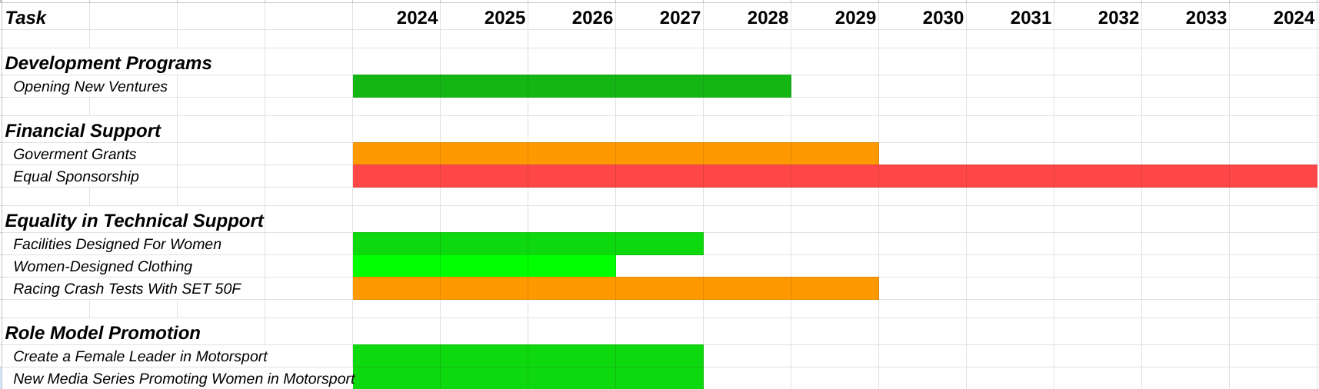
Source: Own elaboration based on approximate time of implementing tasks

2.2.2 Risk Management and Strategies

The risk management plan for women in motorsport focuses on mitigating challenges in development programs, financial support, technical aspects, and role model promotion. By supporting inclusivity, equal financial opportunities, tailored technical support, and active promotion of female role models, the plan aims to foster a more supportive and diverse environment within the motorsport community. Embracing contemporary leadership principles, such as transformational leadership, will drive these initiatives and ensure sustained progress.
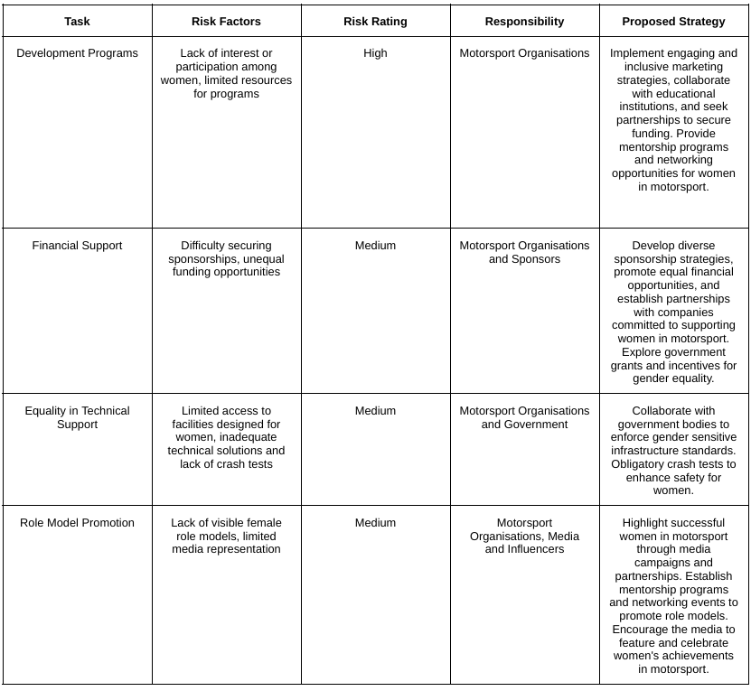
Source: Own elaboration based on previous findings

Recommendations

Transformational leadership involves a style of leadership that aims to make positive changes in individuals and social systems. In its best form, it brings about valuable changes in followers to turn them into leaders. When practised genuinely, it boosts followers' motivation, morale, and performance through various methods. These include connecting the follower's personal identity to the mission and collective identity of the organisation, serving as a role model that inspires them, encouraging followers to take more responsibility for their work, and understanding their strengths and weaknesses to align them with tasks that bring out their best performance (MindTools, 2023).
Role models guide success, offering a blueprint for achieving ambitious goals. They exemplify the behaviours necessary to reach those goals, acting as an inspiration even when working in entirely different domains (AccessPsych, 2022).
According to the dictionary, a role model is “a person whose behaviour, example, or success is or can be emulated by others, especially by younger people” (Dictionary).
That is why supporting and promoting female leadership in the motorsport industry is crucial to accelerate positive changes, ensuring women have equal opportunities to compete with men.

Conclusion

The journey of women in motorsport reflects a history with many obstacles and achievements. Despite successes, persistent stereotypes impact women's self-assessment and performance. Effective leadership, particularly transformational leadership, stands out as a crucial catalyst for creating an inclusive and supportive environment. Embracing gender diversity in motorsport breaks barriers and brings financial success, innovation in engineering, and environmental responsibility. The action plan outlines key steps, including development programs, financial support, equality in technical assistance, and role model promotion, to enhance women's participation. However, the existing challenges, from financial barriers to the absence of role models, require a comprehensive and time-bound approach. The risk management plan underscores the importance of inclusivity, equal financial opportunities, tailored technical support, and active role model promotion. Promoting female leadership in motorsport is not just a matter of fairness; it's a strategic move for the sport's growth, ensuring equal opportunities and inspiring future generations.

Bibliography

AccessPsych. (2022) ‘The importance of role models’ [Online] Available: https://www.accesspsych.com.au/the-importance-of-role-models/ , Accessed 2023, December, 27th

Almeyda, D. (2023) ‘Why We Should be Funding Women: Catching up with Tatiana Calderón’ [Online] Available: https://parcfermeco.com/journal/why-we-should-be-funding-women-catching-up-with-tatiana-caldern , Accessed 2023, December, 27th

Autosport. (2023) ‘More than Equal publishes findings from female motorsport study’ [Online] Available: https://www.autosport.com/general/news/more-than-equal-publishes-findings-from-female-motorsport-study-/10492156/ , Accessed 2023, December, 27th

Bird, N. (2023) ‘Women In Motorsport: The Revolution’ [Online] Available: https://www.elle.com/uk/life-and-culture/a44747611/women-in-motorsport/ , Accessed 2023, December, 27th

CS. (2023) ‘Are companies with female CEOs more likely to be environmentally friendly?’ [Online] Available: https://certified-sustainable.co.uk/are-female-ceos-more-environmentally-friendly/ , Accessed 2023, December, 27th

Chulain, A. (2023) ‘This is the first crash test dummy modelled on the female body. Will it make cars safer for women? [Online] Available: https://www.euronews.com/next/2023/09/21/this-is-the-first-crash-test-dummy-modelled-on-the-female-body-will-it-make-cars-safer-for , Accessed 2023, December, 27th

Dennis, S. (2023) ‘The gender shopping gap’ [Online] Available: https://www.performancemarketingworld.com/article/1751425/gender-shopping-gap-men-spend-75-goods-bought-in-store , Accessed 2023, December, 27th

Dictionary ‘Role Model’ [Online] Available: https://www.dictionary.com/browse/role-model , Accessed 2023, December, 27th

Feyes, E. (2018) ‘Leadership and the Promotion of Diversity in the Work Force and Beyond’ [Online] Available: ‘https://ohiostate.pressbooks.pub/pubhhmp6615/chapter/leadership-and-the-promotion-of-diversity-in-the-work-force-and-beyond/ , Accessed 2023, December, 27th

FIA. (2019) ‘SOCIOLOGICAL SURVEY’ [Online] Available: https://www.fia.com/sites/default/files/cdes_sociological_survey_v3.pdf , Accessed 2023, December, 27th

FIA. (2023) ‘Women in Motorsport’ [Online] Available: https://purposedriven.fia.com/page/women-motorsport , Accessed 2023, December, 27th

FIA. (2023) ‘WOMEN THROUGH THE DECADES’ [Online] Available: https://www.fia.com/women-through-decades%20 , Accessed 2023, December, 27th

FormulaFemale. (2023) ‘About us’ [Online] Available: https://www.formulafemale.org/ , Accessed 2023, December, 27th

Goulding, G. (2022) ‘W Series: UK Government committed to supporting future of women’s motorsport’ [Online] Available: https://www.givemesport.com/88076520-w-series-uk-government-committed-to-supporting-future-of-womens-motorsport/ , Accessed 2023, December, 27th

Holding, J. (2023) ‘“No reason” why women can’t compete in F1, says major study’ [Online] Available: https://www.topgear.com/car-news/motorsport/no-reason-why-women-cant-compete-f1-says-major-study , Accessed 2023, December, 27th

IronLynx. (2023) ‘WOMEN DRIVEN BY DREAMS’ [Online] Available: https://www.ironlynx.it/iron-dames/ , Accessed 2023, December, 27th

ISSU. (2016) ‘AUTO+ WOMEN IN MOTORSPORT #10’ [Online] Available: https://issuu.com/issufia/docs/auto__women_in_motor_sport_10 , Accessed 2023, December, 27th

Kew, M. (2023) ‘Susie Wolff appointed managing director of F1 Academy’ [Online] Available: https://www.autosport.com/f1/news/susie-wolff-appointed-managing-director-of-f1-academy/10437872/ , Accessed 2023, December, 27th

Lorna, P. (2023) ‘Ranked: 10 Most Expensive Sports Worldwide’ [Online] Available: https://utopia.org/guide/ranked-10-most-expensive-sports-worldwide/ , Accessed 2023, December, 27th

Mcleod, K. (2023) ‘Why Haven't There Been Many Female Drivers in Formula 1’ [Online] Available: https://grandprixadventures.com/news/women-in-f1.php , Accessed 2023, December, 27th

MindTools. (2023) ‘Transformational Leadership’ [Online] Available: https://www.mindtools.com/alj9lad/transformational-leadership , Accessed 2023, December, 27th

Moe, A. (2023) ‘Women drive better if not stereotyped’ [Online] Available: https://www.sciencedirect.com/science/article/abs/pii/S0001457515300786 , Accessed 2023, December, 27th

MSE. (2023). ‘The F1 Academy is set to make its debut in 2023: Will Susie Wolff be able to steer women into the F1 fast lane?’ [Online] Available: https://mse.dlapiper.com/post/102ic5c/the-f1-academy-is-set-to-make-its-debut-in-2023-will-susie-wolff-be-able-to-stee , Accessed 2023, December, 27th

Nelson, D. ‘Revealed: Formula 1’s gender pay gap’ [Online] Available: https://motorsportbroadcasting.com/2018/04/04/revealed-formula-1s-gender-pay-gap/ , Accessed 2023, December, 27th

PFC. (2023) ‘Are female CEOs better than male CEOs?’ [Online] Available: https://www.personalfinanceclub.com/are-female-ceos-better-than-male-ceos/ , Accessed 2023, December, 27th

Rencken, D. (2021) ‘Is F2’s $3 million admission price good value for aspiring F1 drivers?’ [Online] Available: https://www.racefans.net/2021/07/28/is-formula-2s-3-million-admission-price-good-value-for-aspiring-f1-drivers/ , Accessed 2023, December, 27th

Roper, G. (2022) ‘The Shocking Truth about Women in Drive to Survive’ [Online] Available: https://www.femalesinmotorsport.com/post/the-shocking-truth-about-women-in-drive-to-survive , Accessed 2023, December, 27th

Technojobs. (2023) ‘The future of women in engineering’ [Online] Available: https://www.technojobs.co.uk/info/tech-news/20230621-the-future-of-women-in-engineering.phtml , Accessed 2023, December, 27th

Wolff, S. (2023) ‘FIA GIRLS ON TRACK’ [Online] Available: https://www.susiewolff.com/fia-girls-on-track , Accessed 2023, December, 27th

