Jordan Brown
2319771
3,914 Words

Voice Acoustics and Physiology in Cross-Training the Tenor Voice

This study aims to investigate the relationship between voice acoustic properties and the anatomical structure and function of the tenor voice. I will be examining the ways in which the tenor’s choice of vocal tract and vowel shapes assist in the stylistic changes between classical and music theater genres. It is known that the relationship between voice physiology and vocal acoustics make a significant impact on the training of a singer (Miller, 1996). However, I am seeking to look further into this relationship to develop my private practice as a voice teacher. I have recently experienced a shift in my own voice training. As a younger singer in undergraduate school, I trained as a lyric baritone. Through aging and the continued training of my voice I have come to believe I am a tenor. To understand more thoroughly how the training of the tenor voice works across different genres, I will be investigating three areas of voice pedagogy and how they relate to one another in cross training the tenor voice.

- Voice Physiology and Anatomy
- Vocal Acoustic functions
- Voice Registration

Cross training is a systematic methodology based in exercise science and has been recently applied by a number of voice pedagogues in their practice (Ragan, 2020). A voice teacher’s work in cross training a singer views the student as a vocal athlete (Leborgne, Rosenberg 2021). I have discussed in previous research the need to carefully consider the health of the vocal athlete when working with students. However, this paper will specifically focus on cross training the tenor voice and will discuss different strategies that lie within the cross training methodology.

An understanding of vocal anatomy and function is essential when teaching singers (Rollings Bigler, Osborne, 2021). Due to the high vocal impact of both operatic and musical theater genres, the singer must be equipped with the proper technique to provide efficiency and safety while performing. An instructor that is well-equipped with this knowledge can understand the needs of each individual voice and provide a comprehensive, systematic approach to cross-training their singers (Sandage, 2018).

Laryngeal Cartilages
The mechanism of the human voice is made up of a cartilaginous structure called the Larynx. It sits above the trachea and consists of nine total cartilages: The thyroid, cricoid, and the epiglottis as single, unpaired cartilages, and the arytenoid, cuneiform, and corniculate cartilages as paired cartilages (Suárez-Quintanilla et. al, 2020). The arytenoid cartilages are said to be the most important of the three paired cartilages due to their flexibility and strong pyramidal shape (Miller, 1996 p.245). These paired cartilages are described as “attachments for muscles whose functions are to open and close the glottis” (Ware, 1998 p. 98). The cuneiform cartilages serve as support for the aryepiglottic folds above the vocal folds, (Suárez-Quintanilla et. al) and the corniculate cartilages are very small, elastic cone-shaped cartilages that articulate in tandem with the movement of the arytenoids.

The thyroid cartilage is the largest of the unpaired cartilages of the larynx. It wraps around the center of the larynx and is connected to the hyoid bone by the superior cornu with its main function being to protect and support the vocal folds (Suárez-Quintanilla et al, 2020). The cricoid cartilage is located at the top of the trachea and completes the lowest portion of the larynx (Figure I). The main function of the cricoid cartilage is to serve as an attachment for key muscles that aid in the adduction of the vocal folds as well as maintain an open airway for clear and efficient breathing (Lubker, 1975).

Extrinsic Muscles
There are multiple different musculature functions of the larynx that all assist in the movement of the vocal anatomy. The first of these extrinsic muscles are the laryngeal elevators, also known as the Suprahyoid Muscles (Ware, 1998). These four suprahyoid muscles are the digastric, stylohyoid, mylohyoid, and geniohyoid muscles. The digastric muscle aids in raising the base of the tongue and the hyoid bone (Christy, 1975). The stylohyoid muscle elevates both the base of the tongue and the hyoid bone. The mylohyoid muscle assists in depressing the jaw, raising the hyoid bone and the base of the tongue and raises the floor of the mouth. Like the stylohyoid muscle, the geniohyoid muscle elevates the hyoid bone and the tongue. The hyoglossus muscle works alongside the styloglossus muscle to compress the sides and depress the bass of the tongue (Slome, 1971).
The second set of extrinsic muscles serve as laryngeal depressors called the Infrahyoid Muscles (Lubker, 1975). The sternohyoid muscle aids in depressing the larynx and the hyoid bone. The sternothyroid muscle activates to tilt the thyroid cartilage to increase pharyngeal space. This typically happens around E4 in an adult male tenor voice (Bozeman, 2013). This pharyngeal space allows for more accurate tuning of the first formant which gives the tenor their “lofty” and “hooded” sound characteristic of most operatic tenors (Perna, 2014). Strategies around acoustic and pre-phonatory tuning will be discussed further on in this paper.

With this knowledge a teacher can utilize different approaches to accompany the cross-training of a tenor’s voice. Perna (2014) employs numerous strategies that embody this physiological-acoustic relationship of the voice. One strategy to use during the transition into the upper register, which generally starts between D4-F4, is a rounding of the lips and a lowering of the larynx. The protruding of the lips provides a “covered” sound without the voice sounding to nasal or spread, and the lowering of the larynx is provided by the articulation of the sternothyroid muscle. A simple exercise to use for this is an arpeggiated scale passing through the passaggio. For example, singing [a] on a Bb major arpeggio, ensuring the tenor finds that “covered” feeling as they approach the second passaggio (Figure II). One exercise that can be applied to the musical theater style is singing [vae] on a 1-3-5-3-1 scale (Figure III). This engages both the stylohyoid and digastric muscle as they assist in heightening the base of the tongue and hyoid bone. This causes a more narrow, nasal sound for a brighter timbre, and assists in finding a mixed voice for the upper tenor range above D4 (Ragan, 2020).

Intrinsic Muscles
The intrinsic laryngeal muscles possess different functions such as abductors (openers), adductors(closers), tensors and relaxers of the vocal folds (Vennard, Hirano, 1971). The thyroarytenoid is the one of the main internal muscles of the vocal mechanism. It has a significant impact on the movement of the vocal folds. It relaxes and shortens the vocal ligaments, pulls the arytenoids down and inward to bring the vocal folds together, and pulls the vocal folds apart. The muscles of adduction bring the vocal folds together by tensing. These muscles are called the transverse arytenoid, oblique arytenoid, lateral cricoarytenoid and the posterior cricoarytenoid (Appleman, 1975). These muscles mainly serve as a function to bring the vocal folds together to vibrate and create sound. The main muscle of vocal fold elongation is called the cricothyroid muscle. As this muscle contracts, the thyroid cartilage tips forward and stretches the vocal ligament which then increases the perceived pitch from the vocal folds much like a stringed instrument’s pitch increases as the string is tightened (Miller p. 253-255).

Using this knowledge of the main intrinsic laryngeal muscles, a teacher can properly assist a tenor in training their vocal mechanism while maintaining balance and coordination. A strategy that targets muscle coordination focuses on a smoother onset of the vocal folds by utilizing a staccato to legato scale on an [a] vowel (Figure IV). This exercise can be beneficial for both operatic and music theater training because no matter what style the tenor is singing in, a clear and smooth onset is imperative (Björkner, 2008).

Voice Acoustics and Resonance
The voice acoustic system occurs naturally through speech and singing and can be a daunting subject for many to investigate (Mayr, 2016). There are two primary theories that attempt to describe the intricacies of voice acoustics. One theory is the Myoelastic-Aerodynamic theory which presents a physics-centered approach to the control of the voice, and the second being the Source-Filter theory which describes what is happening inside the vocal tract during vocalization using acoustics (Herbst et. al, 2022). My primary focus for this research will be in the basic function of voice acoustics and resonance and how it can be manipulated to assist in cross training the tenor voice. This is why I have chosen to focus only on Source-Filter theory since this theory mainly relies on acoustics to understand the events that happen inside the vocal tract during vocalization (Figure V). The two primary areas of focus I will be investigating are the subglottic system and activity below the glottis, and the supraglottic system and how the vocal tract filters sound.

Before any sound is made, the vocal mechanism must create a sound known as the sound source (Bozeman, 2019). The sound source happens at the inner level of the vocal mechanism. Through coordination of the intrinsic laryngeal muscles and the corresponding air flow, the sound source is created. Air passing through the vocal folds creates a buzzing noise by the vocal folds chopping the air in a steady rhythmic pattern (Björkner, 2006). If the vocal folds create a steady periodic articulation, the result is a series of harmonics. After the source sound is created by the vocal folds, the system then receives these vibrations and turns them into frequencies called harmonics (Miller 1996 p. 282). Ken Bozeman has led the way in the realm of voice acoustics and states that these harmonics are “determined by four factors: The mode of phonation, laryngeal register, intensity, and fundamental frequency” (Bozeman, 2022). The question then is how does a teacher use this information to train their student’s voice to achieve the desired sound? This question brought me to investigate acoustics further and look into formants and how they can be manipulated.

The resonances inside the vocal tract are referred to as formants (Bozeman, 2022). Formants are labels used to describe the frequencies that occur naturally inside the vocal tract after the sound source has been filtered. (Herbst et. al, 2022). The vocal tract plays a key role in the formation of these formants since it is a flexible tube (Björkner, 2006). Herbst et. al provide a simple definition of the vocal tract and describes it as a “quarter-wave resonator with uniform geometry, with the first resonance frequency around 500 Hz and the higher resonances about 1000 Hz apart.” (Herbst et. al, 2022). This information is important to understand when it comes to combining the knowledge previously discussed around physiology and anatomy with the understanding of how the tuning of the vocal tract affects the singers’ formants.

It is important to note that although the terms resonances and formants are used interchangeably in much of the literature, they are not the same when taken at face value (Bozeman, 2019). Bozeman goes on to define resonances as a potential response by the vocal tract after being excited by the source sound. Formants are the frequency peaks in the sound that is being radiated by the vocal tract, and this is the sound that is eventually perceived by the listener. The research thus far has brought me to believe the other area of importance that cannot be ignored revolves around registration.

Registration
In operatic high male voices, there comes a point in which a voice teacher must observe the mechanics in singing above the passaggio (Ravens, 2014). It is widely accepted that the stage voice above the passaggio (SVaP) cannot be fully modal (Perna, 2014). This means that there must be a physical adjustment at the vocal fold level when singing above the passaggio. It is not a matter of the singer’s ability. It is the voice’s anatomical makeup that prevents the vocalist from using full chest voice, a thyroarytenoid-dominant system, throughout the extreme highs of their range (Echternach et al, 2013). At some point there must be a shift in registration to avoid overuse of the intrinsic muscles and to avoid strain on the vocal folds. This is further reasoning for why it is important for an instructor to be aware of how they can mechanically adjust their student’s voice to achieve the desired sound no matter what style they are singing in.

Richard Miller states that “vocal registers appear to be determined by actions of the intrinsic muscles of the larynx” (Miller, 1996 p. 292). This means that the vocal folds take on different shapes when maneuvering through registers by the actions of the CT and TA muscles, and differing amounts of air flow and subglottic pressure (Finks, 1992). The edges of the vocal folds are called vocal ligaments (Ware, 1998). These are fibrous ligaments and are elastic in character. The cricothyroid muscle stretches these vocal ligaments until they can no longer stretch any further. Once the maximum length of the ligaments has been obtained, the thyroarytenoids contract and allow the vocalis muscles to relax, giving way to a thinner vocal fold closure (Titze, 1990). This thinner vocal fold posture gives way for a headier, lighter, more airy sound quality that is referred to as head voice or falsetto. This is due to the reduced resistance to the airstream because of a reduced action by the cricothyroid muscles (Vennard, 1967).

The sound quality of a male’s falsetto voice is not usually the desired outcome when singing in the high vocal impact styles like opera and music theater. This is why resonance strategies must be adopted in order to achieve the desired brilliance in timbre (Mayr, 2016). This brilliance in timbre that is perceived in many tenors comes from a “middle register” or voix mixte (Lamperti, 1902). The quality of sound is not affected like the sudden shift into falsetto. This mixed voice register balances between the robust chest voice sound quality, and the light and airy falsetto quality to achieve this intermediate register described as warm, beautiful, and having characteristics of chest register while employing a low-impact vocal fold pressure as if in falsetto mode (Herbert-Caesari, 1950).

The matter in which I approach most registration issues with my students is rooted in two main pedagogical areas: Muscle engagement and acoustics. In order to properly coordinate the muscles of adduction with the engagement of the thyroarytenoid and cricothyroid muscles, a vocal exercise that targets muscle engagement and aligns the vocal tract for efficient acoustic properties is necessary (Miller, 1996). Ragan (2020) advocates for a skillful resonance strategy in combination with a breath management strategy to ensure proper coordination of registrations in the male voice (p. 136). This coordination strategy ensures that the thyroarytenoid muscle is taking on a passive role in the head register while the cricothyroid muscle is dominant. During the transition to the chest register, the thyroarytenoid muscle is activated. This exercise ensures a more efficient negotiation between muscles which works with the tuning of the vocal tract to stabilize the singer’s voice during head-chest registrations (Titze 1990).

Pre-phonatory tuning, or the alignment of the vocal tract, is crucial for efficient vocalization (Bozeman, 2019). The relationship between the shape of the vocal tract and the sound source provides the voice instructor with numerous ways in which they can assist a singer in optimizing their instrument for stability. Fant (1960) describes the vocal tract as a resonator tube of the larynx that can be enlarged naturally in three ways. One is by chewing as if slowly eating a meal which helps relax the extrinsic muscles of the larynx. The second is by feeling the relaxation of the muscles after swallowing. The third method is to inhale through the mouth as if one is surprised, or to sigh with the feeling of a yawn. These methods aid in relaxing the extrinsic muscles of the larynx and position the cartilage in a low position for optimal phonation.

The application of pedagogical knowledge in the voice studio must be applied in in a manner that observes aspects such as the student’s learning style, the instructor’s style of teaching, student-teacher relationships, and pedagogical methodologies (Bennett, 1986). My approach to this research has led me to ask questions regarding my own practice as a voice teacher, and how my methodologies can be improved.

Part II: Critical Reflection
During this research process I found myself drawn to Kolb’s Cycle of Reflective Practice and Experiential Learning or ELT (Kolb, 1968). This cyclical model of learning and reflection utilizes four steps that are designed to support the learning process by ways of reflection on past experiences and actions (Akella, 2010). To apply this theory to my own practice and my first-hand experience during this research process, I am going to follow the four cyclical steps and analyze them on a deeper level to understand exactly how my process of research works for me and how I can improve it for future projects during my time in the MA program.

The first step in Kolb’s Cycle of Reflective practice is the concrete experience (Zuber-Skerritt, 1992). Although I feel I could write an entire paper just on my concrete experiences during this process, I will only focus on one specific instance. One concrete experience I had during this module was my difficulty with time management. After observing the concrete experience, the second step in this cycle is a reflective observation which articulates why and how the concrete experience happened (Akella, 2010). In January, after the holidays, I felt ready to tackle the next module, however I quickly realized that I may have overloaded my schedule a bit with performances, recitals, competition adjudication jobs and traveling for work. I found it difficult to find time to sit down and research my topic. My hope in reflecting upon this difficulty is that I can be more organized from the beginning of the next project so that I can feel more confident in my own research and what I know about my choice of topic. One way that I would like to become more organized is by adapting a continuous improvement (CI) technique as described by Khan, et al (2019). This continuous improvement technique supports the researcher by employing a systematic five-step process to continuously adapt. These five steps, also known as 5S, are sort, set in order, shine, standardize and sustain. My hope is that by implementing these steps at the beginning of my research, I will be able to make quick adjustments if need be. That way I can continue with the process instead of feeling discouraged and lose time because of the discouragement.

The third step in Kolb’s theory is abstract conceptualization (Akella, 2010). This step, in a way, is an extension of the reflective observation step, only it relies on critical analysis, logic and reasoning instead of feelings to observe what went well and what can be improved. I believe this step is the most significant of the four steps due to the number of possible theories, concepts and solutions that can come from it. Although my experience of inorganization led to not having managed my time well, I know one thing worked in my favor. I started using specific folders on my desktop to save each of my articles that I found and labeled the folders based on the subject of those articles. If the item I referenced was a physical book, I put a note tab on the page and labeled it with the in-text citation I used in the paper so that I could go back to that reference if I needed to.

To understand how I can further improve this process I am going to use the abstract conceptualization step and attempt to think logically about what could be improved. Since time management was an issue before, I think setting up a routine for myself would be beneficial. Previously, because my schedule was so full, I found it difficult to carve out time to research. Setting up myself for success in the next module, I am going to set aside office hours for myself every morning, Monday through Friday, for two hours a day. This way I have a specific time laid out for work on my research. This will hopefully provide more structure without distraction, and therefore lay the foundation of my research so the writing process becomes much easier.

The fourth and final step to Kolb’s theory is active experimentation (Akella, 2010). This step requires the reflector to test their theories they submitted to in step three and use those theories to apply their learning into practice. Since I have not started the next module, I will be choosing to apply this cycle of learning to my own practice as a voice teacher. Kolb’s cycle is very similar to what I already practice with my students in their lessons, however my teaching style tends to reflect more on the positive side of what my students are achieving. This idea of positive feedback brought me to discover Ghaye’s model of Teaching and Learning through Reflective Practice (Ghaye, 2010). The reason I utilize a positive outlook on the feedback I give to my students is simple. It is better received (De Rivera, 1977). If I provide my students with positive feedback, the information I am providing them will more likely be received. The relationship between student and teacher is my main concern during lessons as well. This method of positive critiques builds a better foundation of trust between myself and my students.

Not only do I have a goal to improve my own organizational skills in my studies, I also have a goal to establish a better understanding of trust with my students. Using Ghaye’s model of reflective practice as mentioned previously, I feel as though I can take my teaching strategies to an even higher level. I do feel as though the relationship I have with my students is very relaxed and enjoyable. However, sometimes that can lead to my students feeling disengaged with the work we are attempting to do inside each voice lesson. The balance between efficient lesson management, positive relationship status between student and teacher, and actual technical progression can be challenging. So, I would like to devise a strategy for myself to improve my methods in my daily studio work.

Overall, the process of reflection has been beneficial to me for two reasons. I have noticed my excitement and interests have been reignited after a busy performance schedule. Through this investigation and research, I have been able to refocus my energy towards my students and focus on their development. As a student who strives to continually improve just as Kolb and Ghaye encourage us to do, I have three items I would like to focus on during the next module.

- Utilize Kolb and Ghaye’s models of reflective practice and continuous improvement inside the voice studio.
- Form a strategy to organize myself from the beginning of the next module to ensure maximum time management.
- Create a check-in time with each of my students at the beginning of their lesson to continuously foster an encouraging environment.

I have appreciated the opportunity to reflect on my own practice as well as observe the research around voice acoustics, physiology and registrations. I have more questions to investigate in the future, but I believe that is what this process is for. I will continuously remind myself of my goals and strive to advocate for my students and myself throughout the coming months.

Appendix A
Personal Development Plan



Appendix B

Figure I: Laryngeal Cartilages

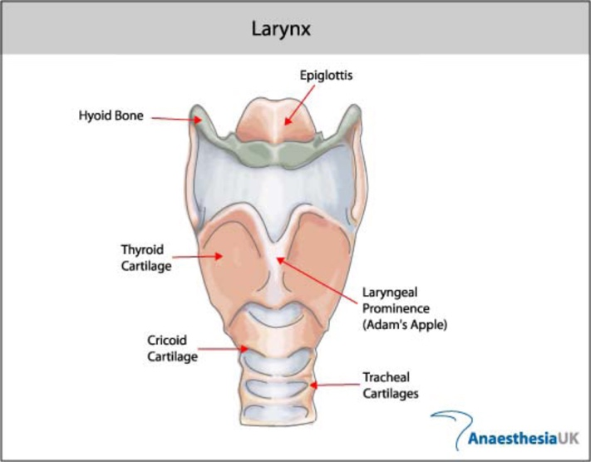 (UK, 2024)

Figure II: Bb Major Arpeggio.
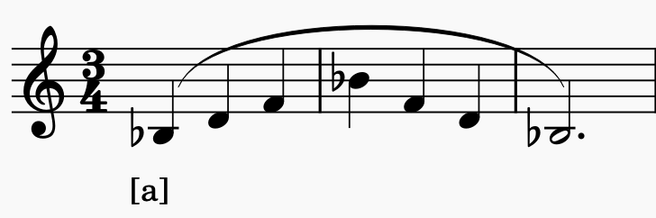(Ware, 1998)

Figure III: Bright timbre, MT style exercise.
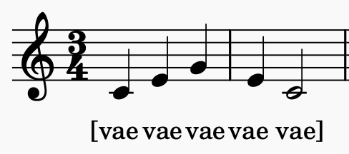 (Ragan, 2020)

Figure IV: Staccato-Legato Onset Exercise.
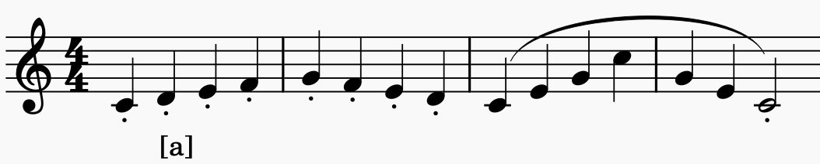 (Ragan, 2020)

Figure V: The Vocal Tract and Source Filter
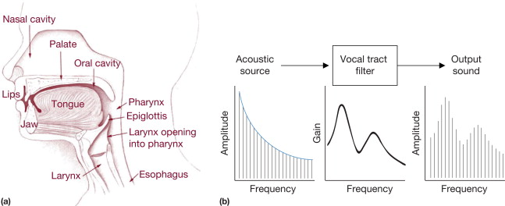(Pasley, 2015)

Citations

Akella, Devi. “Learning Together: Kolb’s Experiential Theory and Its Application.” Journal of Management and Organization, vol. 16, no. 1, Mar. 2010, https://doi.org/10.5172.

Appelman, D.R. (1975). The Science of Vocal Pedagogy. University of Indiana Press.

Benett, P. (1986). A Responsibility to Young Voices. Music Educators Journal, 73(1), 33–38. https://doi.org/10.2307/3400391

Björkner, E. (2008). Musical Theater and Opera Singing—Why So Different? A Study of Subglottal Pressure, Voice Source, and Formant Frequency Characteristics. Journal of Voice, 22(5), pp.533–540. doi:https://doi.org/10.1016/j.jvoice.2006.12.007.

Bozeman, Kenneth W. Practical Vocal Acoustics. Rowman & Littlefield, 18 Aug. 2022, books.google.com/books?id=5NCAEAAAQBAJ&pg=PA11&source=gbs_toc_r&cad=1#v=onepage&q&f=false. Accessed 1 Apr. 2024.

Bozeman, K.W. (2010). The Role of the First Formant in Training the Male Singing Voice. Journal of Singing, 66(3), pp.291–297.
Christy, V, Patton, J. (1974) Foundations in Singing. New York; London: Mcgraw-Hill.

Echternach, Matthias, et al. “The Effect of Nasalance on Vocal Fold Oscillation Patterns during the Male Passaggio.” Journal of Voice, vol. 35, no. 4, 23 Sept. 2019.

Finks, P.L. (1992). Vocal Registration: History, Analysis and Modern Pedagocial Application. The Keep. [online] Available at: https://thekeep.eiu.edu/cgi/viewcontent.cgi?article=3193&context=theses [Accessed 12 Feb. 2024].
Ghaye, T. (2007). Is reflective practice ethical? (The case of the reflective portfolio). Reflective Practice, 8(2), 151–162. https://doi.org/10.1080/14623940701288859

Ghaye, T., Dixon, M. and Lee, S. (2016). Strengths-Based Reflective Practices for the Management of Change: Applications of Sport and Positive Psychology. Journal of Change Management, 16(2), pp.142–157.
Herbert-Caesari, Edgar F, and Beniamino Gigli. The Voice of the Mind. London, Alma Caesari-Gramatke And Rolf Gramatke, 2002.

Khan, A.S., Kaviani, A.M. and Galli, B.J. (2019). Application of continuous improvement techniques to improve organization performance: A case study. Bingley, 10(2). doi:https:// doi.org/10.1108/IJLSS-05-2017-0048.

Kleinheksel, A.J., Weichao, C., Rudd, M.J. and Minor, S. (2023). Putting refection back into practice: Kolb’s theory of experiential learning. SN Social Sciences Journal, 3(59).
Leborgne, W and Daniels Rosenberg, M. (2021). The Vocal Athlete: Application and Technique for the Hybrid Singer. San Diego, Ca: Plural Publishing.
Lubker, J. (1975). Transglottal Airflow During Stop Consonant Production. Journal of the Acoustical Society of America, 53(212), pp.48–50.
Mayr, A. (2016). Investigating the Voce Faringea: Physiological and Acoustic Characteristics of the Bel Canto Tenor’s Forgotten Singing Practice. Journal of Voice, 31(2), pp.255–259.
Miller, Richard. The Structure of Singing: System and Art in Vocal Technique. Boston, Schirmer Cengage Learning, 1996.

Pasley, B.N. (2015). Vocal Tract - an overview | ScienceDirect Topics. [online] www.sciencedirect.com. Available at: https://www.sciencedirect.com/topics/medicine-and-dentistry/vocal-tract [Accessed 19 Apr. 2024].
Perna, N. (2014). Nasalance and the Tenor Passaggio. Journal of Voice, 70(4), pp.403–410.
Ravens, S. (2014). The supernatural voice : a history of high male singing. Woodbridge, Suffolk ; Rochester, Ny: Boydell Press.

Ragan, K. A Systematic Approach to Voice. Plural Publishing, 20 Apr. 2020.

Sandage, M.J., Hoch, M. (2018). Exercise physiology: Perspective for Vocal Training. Journal of Singing, 74(4), 419-425.

Slome, D. (1971). “Physiology of the mouth, pharynx and oesophagus” Scott Brown’s Diseases of the Ear, Nose and Throat. 1(3d), pp. 235-302.

Suárez-Quintanilla, Juan, et al. “Anatomy, Head and Neck, Larynx.” Nih.gov, StatPearls Publishing, 2020, www.ncbi.nlm.nih.gov/books/NBK538202/. Accessed 7 Mar. 2024.

Titze, I. (1990). A Brief Introduction to Muscles. The NATS Journal, 46(4), pp.16–17.
UK, A. (n.d.). Airway masterclass 3: The larynx (Image). [online] WFSA Resource Library. Available at: https://resources.wfsahq.org/atotw/airway-masterclass-3-the-larynx-tutorial-of-the-week-number-114/. [Accessed 19 Apr. 2024]

Ware, C. Basics of Vocal Pedagogy. McGraw-Hill Companies, 1998.
Vennard, William, Hirano, M. (1971). Varieties of Voice Production. The NATS Bulletin, 27(1), pp.30–37.

Vennard, William, Von Leden, Hans. The Importance of Intensity Modulation in the Perception of a Trill.” Nih.gov, Folia Phoniatrica, 1967, https://pubmed.ncbi.nlm.nih.gov/5584818/. Accessed Mar. 2024.

