Pollution Management of Coal mining and processing operation


Harry W. Foxton

University of Wales Trinity Saint David
School of Engineering
BEng Energy and Environmental Engineering

Abstract
With restrictions to the use of coal mining in Wales being tightened to the point of almost zero new mines, it is vital that the mines that are still being operated are done with the upmost control over particulate and gas emissions during the mining and processing steps. This report has identified the most notable sources of possible air pollution and targeted each based on a conceptual model. Not only will pollution control reduce emissions to the atmosphere but, in some cases will provide an additional source of income to the mining facility. For instance, the use of pre-mine gas extraction from the gas seams can be used to gain a reasonable source of almost completely pure natural gas (methane), or the collection of chemically removed sulfur from the coal to prevent the possibility of acid rain, which can also be used to produce pure sulfur and sold as a sought after bi-product. There is a vast array of physical and operational changes outlines in this report that will tackle the reduction of particulate and gaseous emissions.

Contents
Initial research 2
Abstract 3
Contents 4
Pollution Management of Coal mining and processing operation 5
Conceptual system Model 6
Emissions Reduction Analysis 7
Strategy and Site Recommendations 8
References 9

Pollution Management of Coal mining and processing operation
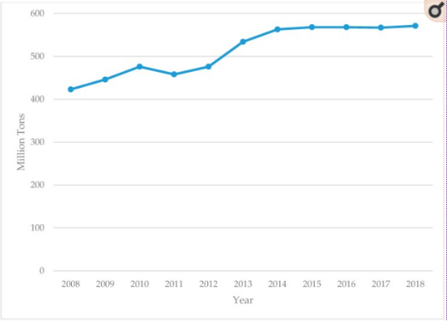
For decades it has been known that the health risks associated with air pollution are a global health problem, with an estimated 3.2 million deaths a year as a result of outdoor air pollution (Kurt, et al., 2017). A study undertaken in Australia based on their National Pollutant Inventory showed that Coal mines represented 42.1% of air particulate pollution of ≥10 micrometres (PM10) (Herndryx, et al., 2020) making this a significant risk factor when designing a new mining and processing facility. With the proposed site in Llanbacol, Wales, an open cast mine is to be put in place combined with a chemical treatment facility for the main purpose of Sulphur removal; an important step to mitigating the environmental impacts of burning coal. Sulphur occurs in coal in 3 major forms: Pyrite, Organic and Sulphate and once processed will release in Sulphide form, which once in the atmosphere will produce Vitriol or Sulphuric acid with the possibility of acid rain (Liu, et al., 2001). The proportion of energy generated by coal is dropping due to the renewable shift with a decrease in coal mining from 125,000 metric tons in 1970-75 down to 42,718 metric tons mined between 2013-18 (Statistica, 2019), however the same cannot be said on a global scale, with a rise in the amount of coal being mined with Figure 1 showing the quantity of coal mined in Australia over 10 years. With strong opposition from the local community and environmental groups, it is imperative that the facility design goes beyond the minimum requirements laid out by the NRW (National Resources Wales) to create a low-risk facility to both the local community and ecology. This report will investigate a conceptual model of the mining and processing procedures at the site and break down what can be done at each of those stages to mitigate the release of both particulate emissions between ≤1 and 50 micrometres and acidic gas release.
Figure 1 – The quantity of mined Coal in Australia over a 10 year period

Conceptual system Model
To ensure the delivered Strategy made for the reduction of air pollution is most efficient, understanding each step of the process and how that step can lead to possible air pollution is vital. A conceptual has model has been laid out to break down the required steps in the brief as shown in Figure 1.
Mining
Crushing
Screening
Processing
Particulate emission and natural trapped gas contaminant
Particulate emission
Small particulate emission through dust release
Small particulate emission through dust release

Acidic Gas emission
Movement and Storage
Figure 2 – Overview conceptual model showing the pollution from each area of the process from mining to processing
This breakdown of the process and how emissions are distributed at each point allows for a more directed strategy to mitigating pollution. The clear main areas of concern are going to be filtering and capturing particulate matter and the capture and deacidification of the Sulphuric gas emissions from the processing stage. The nature of an open cast means that containment of contaminants is more difficult. Once past the mining process, there is room for all stages of possible contamination to be fully contained.

Emissions Reduction Analysis
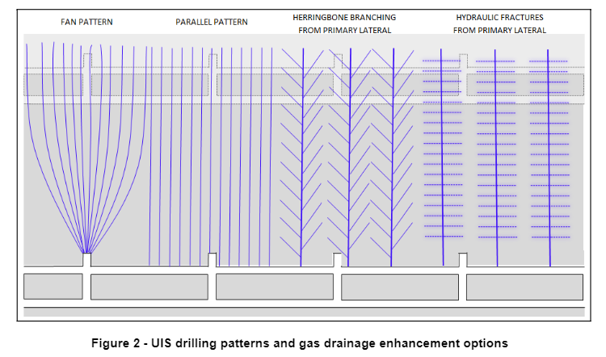
As organic matter is compressed over thousands of years to form peat and eventually coal, pockets of methane will form in between the layers of coal known as coal seam gas, which is a type of fugitive gas (trapped gas). Due to coal seams gas’ underground formation it is almost completely pure methane at 97% purity (AVR UK, 2018). If left unharvested, the methane will be released into the atmosphere during the mining process and with methane being potentially 21 times more potent as a greenhouse gas than carbon dioxide (Environmental defence fund, 2020), it mustn't have a chance to be released, the nature of open cast mining means that while the extraction of coal has higher efficacy, the risk of seam gas leakage into the atmosphere is high; One possible solution could be the use of coal seam gas survey and extraction prior to the start of mining at the Llanbacol site. Not only will this reduce the risk of natural gas emissions to contribute to possible site air pollution but will also provide an additional source of revenue for the site as the natural gas can be used as localized electrical power generation to provide power for some of the more domestic applications on site. Many pre-mine gas extraction methods have been developed depending on the site’s geology and gas release potential as shown in Figure 3 presented in Underground Coal Operators Conference, 2009.
Figure 3 – Potential methods of pre-mining gas drainage (Black & Aziz, 2009)
The Same conference findings presented that almost 50% of pre-mine extraction methods proved to be unbeneficial, however after further investigation, there were proved to be a series of issues left unconsidered when mining using the above borehole methods, most notably, the blocking of boreholes due to water and coal fines and the poor monitoring flow from the boreholes. Fugitive gas management is a key step to reducing possible natural gas emissions during the mining process.
The destructive process of open-pit mining and the movement of mined goods means that reasonably large quantities of dust/particulate emissions are released as a result. Some of the key factors in determining the scale to which this emission occurs are as follows (NSW EPA, 2019):
- Weather – High wind can move dust particles outside of the mine premises and into surrounding landscapes, combined with dry weather, wind can present a serious threat to the quantity of airborne particulate emissions.
- Location – Movement of coal via haulage roads should be planned based on the surrounding residential areas and are not raised to reduce the likelihood of movement of dust particles.
- Duration – The length of time an action is taking will have a large impact on the dust quantity and ability to become airborne
Employing a RAG (red, amber, green) strategy into each of the main process actions (mining loading, transporting) means that there are discrete decision criteria to inform the actions for that day. Another very common method to pair with this RAG criteria is the use of water before the loading and transportation stage; while the use of water does come with its occupational hazards, if well managed will significantly reduce dust release. Another potential method of dust control is the use of an aqueous foam which will capture coal dust-laden air for a controlled duration and durability which then turns into a liquid form to be drained away. This patent outlines the chemical compositions required of the foam for the most effective capture of particulates based on particle size and geological composition of the area of concern (Netting, 1983).
While dust control in the outdoor environment requires attentive observation and manual labor for ground wetting, the storage, transportation and processing stages can all be done in far more controlled environments. The first stage is to load the coal from stockpiles into the hoppers, there are a few methods that can be used to prevent dust release when dumping into this, now controlled environment; the coal can be loaded via a fully enclosed loading bay with ‘staging curtains’ used to prevent billows of dust coming back out of the hopper system, as it enters the hopper it can then be sprayed again, also to reduce the change of any airborne dust release.
After being loaded into the bunkers based on the operation described above, the coal will most likely be transported via a conveyor system. Similarly to outdoor operation, the use of water can be used to reduce dust emissions, however in the case of a conveyor system, the wetting can be automated and controlled for optimal flow; both the transported goods and the belt can be wetted to reduce dust emissions combined with an automatic belt cleaning system and regular maintenance routine to ensure equipment is not damaged which could increase vibrations leading to increased dust emission (Colinet, et al., 2010).
The crushing stage also has the potential to cause large quantities of small PM10 dust release; one very key piece of technology is known as water-air scrubbing which combines highly pressurized water with an air vacuum, while the water will remove up to 90% of dust, the vacuum will provide a negative pressure coefficient in the crushing stage to prevent any possible dust leakage (Optromix, 2020). Some shearing technology can integrate dust extraction into the crushing implement to prevent any kind of release in the first place (Colinet, et al., 2010).
The final major area of a source of pollution is acidic gas release from the chemical processing stage of coal desulphurization process. There are two possible options for acid treatment that could have been used on the Llanbacol site; Acid leaching can use a variety of acid-based elements depending on the geological composition of the area. But commonly; nitric acid is used for the purpose of oxidizing the combustible Sulphur so that when burned it does not form a gaseous Sulphur dioxide, which indeed has the potential to form acid rain (Xia & Xie, 2017). Acid leaching also reduces the quantity of minerals in the coal, such as Boron and Lead which can also be released into the atmosphere with harmful effects. The chemical leaching process leads to the early formation of Sulphur dioxide which can then be extracted via a negative air pressure and enclosed environment, after passing through a series of grate filters to capture particulate matter. After capture the acidic gas can be refined into solid sulfur which has applications in paper bleaching and food preservatives.

Strategy and Site Recommendations
The pollution control strategy will be divided into long-term and short-term recommendations that will affect both the physical systems in place and the operating procedure of mining staff and usage of machinery.
Beginning the mining operation with a gas survey will determine whether the use of gas drainage is economically feasibly for the specific site. If determined as economically viable; then by default fan-pattern gas extraction should begin. Once the gas extraction is complete the short-term recommendations for the site are to ensure the loading area of the hoppers and storage bunkers are fully enclosed and equipped with water spraying on entry and curtains to prevent blowbacks of particulate matter. The next step is to ensure the belt is equipped with spraying and self-cleaning systems which will help reduce the ability for dust to move around the facility. It must now be ensured that the crushing stage has a water-air based scrubbing system for the best efficacy of particulate removal during the destructive process. The final step in the short term is to ensure there is sufficient extraction systems in the chemical processing stage that will allow for possible acidic gasses to be captured, the implementation of an on site sulfuric gas processing facility will also ensure maximum capital return on any sulfur sold out from the site.
In the long term, the strategies put in place are only as effective as the staff using them, so ensuring company policy reflects the company’s commitment to minimal pollution is vital: The first step is to implement a RAG system of operation, to determine the quantity and duration of mining, loading and transport related operations based on wind, weather, safety and proximity to residential areas allowing for clear guidelines to staff to prevent any miscommunications once mining commences. Next there must be a regimented maintenance routine of all moving in-facility equipment to minimize dust release.

References
AVR UK, 2018. Coal Seam, Shale Gas and Abandoned Mine Gases. [Online]
Available at: https://www.avkuk.co.uk/en-gb/gas-supply/coal-seam-shale-and-abandoned-mine
[Accessed 19th May 2020].
Black, D. & Aziz, N., 2009. Reducing Coal Mine CHG Emissions Through Effective Gas Drainage and Utilisation. Wollongong, Research Online.
Colinet, J. F. et al., 2010. Best Practices For Dust Control in Coal Mining, s.l.: Centers for Disease Control and Prevention.
Environmental defence fund, 2020. Methane: The other important greenhouse gas. [Online]
Available at: https://www.edf.org/climate/methane-other-important-greenhouse-gas
[Accessed 19th May 2020].
Herndryx, M., Islam, M. S., Dong, G.-H. & Paul, G., 2020. Air Pollution Emissions 2008-2018 from Australian Coal Mining: Implications for Public and Occupational Health. International Journal of Environmental Research and Public Health, 17(5).
Kurt, O. K., Zhang, J. & Pinkerton, K. E., 2017. Pulmonary Health Effects of Air Pollution. Curr Opin Pulm Med., Volume 2, pp. 138-143.
Liu, G., Peng, Z., Yang, P. & Wang, G., 2001. Sulfur in coal and its environmental impact from Yanzhou mining district, China. Chinese Journal of Geochemistry, 20(273).
Netting, D. I., 1983. Method for reducing the amount of coaldust in the environment surrounding coal mining. Springfield Pa., Patent No. 4,380,459.
NSW EPA, 2019. Dust Assessment Handbook. [Online]
Available at: https://www.epa.nsw.gov.au/-/media/epa/corporate-site/resources/air/19p1502-dust-assessment-handbook.pdf?la=en&hash=52A628671A9BE9980990B75BDDE3A751C1A4D0ED
[Accessed 20th May 2020].
Optromix, 2020. Coal Dust Scrubbing. [Online]
Available at: https://wetairscrubber.com/coal-dust-scrubbing/
[Accessed 20th May 2020].
Statistica, 2019. Deep and surface mining coal production in the United Kingdom (UK) 1970-2019. [Online]
Available at: https://www.statista.com/statistics/370721/deep-and-surface-mining-coal-production-in-the-united-kingdom/
[Accessed 17th May 2020].
Xia, W. & Xie, G., 2017. A technological review of developments in chemical-related desulfurization of coal in the past decade. International Journal of Mineral Processing, Volume 161, pp. 65-71.

