
Applied Leadership and Management in the Workplace
Module Assignment Submission
Student Name: | Whitney Davies
Student Number: | 2329046
Module No: | BMSK4016
Module Title: | Developing Professional Practice
Statement of Confirmation of Authenticity
By the act of making this submission, the student declares that this is the work of the student named above. The work has not, in whole or in part, been knowingly presented elsewhere for assessment, or where assessment has been built on a previous assessment, this has been identified. Where materials have been used from other sources it has been properly acknowledged. If this statement is untrue, the student acknowledges that an assessment offence has been committed.
Attention is drawn to the plagiarism and unfair practice policies of both the University and of ILM.

Table of Contents
Introduction 3
Self-Management 3
Bias 4
Accountability and Authentic Behaviour 4
Accountability 4
Authentic Behaviour 6
Interpersonal Relationships 6
Communication Plan 7
Professional Integrity 7
Development of own Professional Practice 8
References 10
Appendix A – Personal Development Plan 11

Introduction
This report will provide an analysis of the provided case study, focusing on several key themes. This will look at self-management, personal and cognitive biases, accountability, and authentic behaviour, emphasising the importance of responsibility and genuineness in interactions. Interpersonal relationships will be explored to highlight effective communication and collaboration. The last topic will be personal integrity and present strategies for developing one’s professional practice, continuous growth, and improvement. Appendix 1 will be an example of a PDP and Appendix 2 will be a Me Manual.

Self-Management
According to (Raeburn, 2023) Self-management is an important part of anyone's life, it is what allows individuals to control their emotions, thoughts, and behaviours. It helps the following areas:
- Time management – focuses on how to use time wisely and efficiently.
- Self-motivation – motivation plays a crucial role in creating goals and seeing them through.
- Stress management – Stress is a regular part of human life and therefore managing stress is important, good stress management can increase productivity and can assist in improving focus.
- Adaptability – this is learning to be flexible and to be resilient when changes or blockers occur.
- Decision making – problems will often occur when working on a project and decision making is a key component of problem solving.
- Goal alignment – when creating goals, it is important to set out tasks that can help achieve the end goal. These goals need to be SMART.
- Personal development – personal development is particularly important to keep on top of, being able to learn new things and adapt when necessary. Creating goals, and tracking progress.
In this case study Dr Alice Parker shows some good self-management traits, Alice can keep her emotions under control when faced with tricky situations with team conflicts and what she believes is gossip at her expense.
Alice tries to be adaptable, despite the tricky team dynamic and delays from senior management. However, while this shows the senior management were not being dependable, it raises a few questions:
- Did Alice as the project lead, take charge and request status updates?
- Did she raise the importance of what was needed and when?
- Did Alice set clear goals and delegate tasks?
- How were each task being monitored?
- Did she try to solve the problem? It is not evident that Alice made any decisions to solve this issue.
Looking at the how the team has acted, they have not been able to manage their emotions or put their opinions aside. They allow their emotions to drive them which has affected their work and the working relationship. They blame Alice for the missed deadline, rather than holding themselves accountable for the parts they have played in it.
One thing that could have improved this situation is creating interim goals and tasks, as the end goal was the same for each team member, however they should have all had their own tasks that they should have overseen, and they should have taken account of the importance of making sure these tasks were completed on time and with the end goal in mind. Giving employees their own responsibility can often be a way of making them feel valued and important. These tasks, however, should have had regular status update meetings. To keep progress going and addressing any issues that would cause delays.

Bias
The case study shows a few biases that could a factor in this situation. A few examples of types of biases are as follows:
- Personal bias: Personal Bias is the biases that we learn from what we are taught through life, such as our opinions or our life experiences, from what we are taught from those who raised us.
- Cognitive bias: Murphy (2021), stated that cognitive bias is the most common type of bias. Research shows there are more than 175 types of cognitive bias. These biases can lead to poor judgments, which can lead to unreasonable conclusions or assessments. These perceptions can affect a person's behaviour and attitude, positively or negatively.
- Unconscious Bias: Unconscious bias is the biases that people have beyond their own consciousness.
Gender Bias is a common bias in the workplace. According to Diehl et al. (2022), gender bias is still quite common, even in female-lead industries because companies believed that just adding more females to the company was bridging the gap. Through their research, they discovered one example of the bias persisting is constrained communication, in which women must be mindful when expressing authority and disregarding their accomplishments. They reported a lack of acknowledgement for their contributions and being interrupted by men when they were speaking. This is what is reported in the case study.
In this case study, the female team members are being overlooked on regular basis and their work is not being rightfully credited or acknowledged. The example of this is when Alice mentions that a fellow male colleague asked her for an update because he wanted to deliver it for the upcoming meeting. The male team members are sticking together which is the gender bias and an affinity bias as they are favouring those more like themselves.
The other bias here could be a sexual orientation bias because Alice and her wife are on the team and they are gay, it appears they are being talked about negatively. However, there does not seem to be concrete evidence of this but that is how it has been perceived.

Accountability and Authentic Behaviour

Accountability
Timms (2021), defines accountability as taking ownership of results and working to improve future results. it is important here to know the difference between responsibility and accountability. responsibility is taking ownership of tasks only and not focusing on the end results. Becoming accountable means that you focus on what you can do to achieve better results in future and not what you cannot do. He believes the word accountability has been weaponised in popular culture and because of this it has become synonymous with blame and punishment. Blame is what people will do when they do not want to be accountable themselves. Blame can cause a lot of distrust and fear into a team.
Because of the delay and the blame that the team is putting on Alice then it looks like no one is taking accountability for themselves. In an article written by Caprino (2019), They suggest a few tips on how to be accountable, one of these tips is taking a step back from your situation and having a real think about how you are contributing the problem. Rather than assuming your current challenges stem entirely from others or factors beyond your control, recognise that you are 50% of the equation. What are you doing, thinking, and saying that is perpetuating this issue? How can you alter your behaviour (and do something quite different from your usual approach) to intervene in this ongoing pattern and they wisely say if you are unhappy with a situation, you have two choices: either change the situation or adjust your feelings and thoughts about it.
Anna could have learned what motivates everyone within the team and offered to help them achieve this, for example, if money motivates them then see if they could arrange any bonuses or compensation, if it is status or titles that motivates them then perhaps mention how this project success will affect their promotions etc.
As mentioned above it is good to find about what motivates an employee and giving employees important tasks can also improve productivity in work, if done correctly. In his book Covey (1989) suggests that a Win/Win Performance Agreement. This is based on the results rather than the methods to get there. He states that with a Win/Win accountability, people will evaluate themselves by using a criteria they created at the beginning of the task. In a Win/Win performance agreement, consequences are natural or a logical outcome of the performance rather than a reward or punishment given by the boss.
The 4 usual types of consequences (rewards and penalties).
- Financial: income, allowances, penalties
- Psychological: recognition, respect, credibility
- Opportunity: training, development, benefits
- Responsibility: growth or loss of authority
However, Covey asserts that the Win/Win must have the right support for it to work. It is essential to have trust and personal integrity for those using the technique.
Timms (2021) reminds us that if we just blame others for what has gone wrong, and expect them to solve the problem, we are not protected from the long-term repercussions of those problems.
There is an image created by Low, D (1932), regarding a war, this has been adapted over the years, but the true message remains the same. The image is below.
It shows people in the same boat and the boat is sinking but those on the right are taking a ‘not my problem’ approach, this will clearly result in the ship sinking. This ship can act as a metaphor for any project. A successful team would realise their goals align and work together to achieve that success.
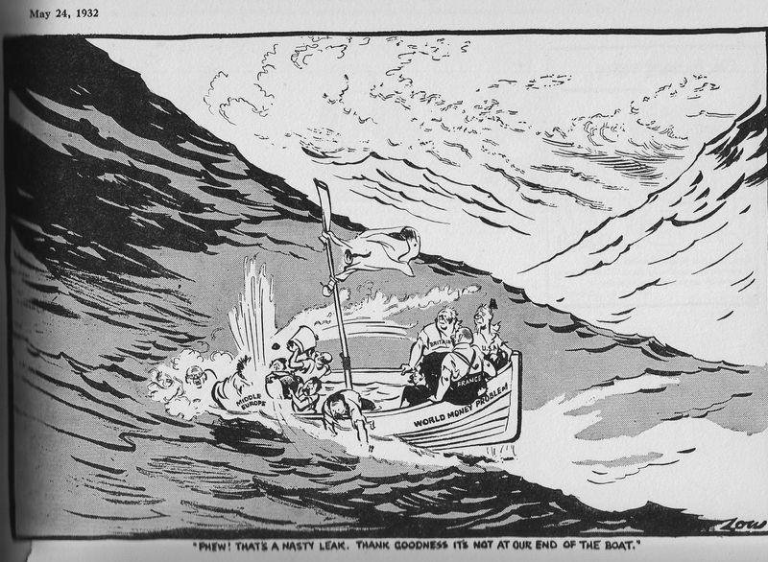
(source: David Low 1932)

Authentic Behaviour
According to the publication by Joseph (2018), wisely says there are 3 key things that those who are authentic do well; They know themselves, they own themselves and there are prepared to always be themselves.
Regarding those who are gossiping and excluding the female team members, in particular Alice and her wife, while to me this is morally wrong. They may be acting how they always would and being their authentic self. While being authentic means something specific thing i.e. staying true to yourself, it is different for everyone. For example, as mentioned above, those gossiping in the case study, may not like Alice, perhaps her gender or her sexuality and they are owning that they do not like it and that is them staying true to themselves. However, the team member that Alice thinks may have felt some remorse for what was happening, was not being authentic, they knew they did not like the way Alice and her wife were being treated but he allowed it to continue.
Without knowing the team, it is difficult to know whether they are being their authentic selves.

Interpersonal Relationships
There are 5 types of interpersonal relationships according to Franz (2021), This is 1) Family relationships, 2) Friendships, 3) Romantic relationships, 4) Platonic relationships and 5) Professional relationships.
In a project like this, team relationships are important. Alice could have made the decision to do a team building exercise when the team first got together. (Nottrodt, J, 2023) states that team building is essential for numerous essential aspects of a team, such as communication, collaboration, morale, and productivity. It creates trust within the team, which is linked to innovation, effective decision-making, and employee retention.
Having a healthy line of communication is essential to any team. The team should have felt comfortable enough to raise their concerns throughout the project and all inputs should be encouraged, especially as the team is diverse and with different backgrounds and experiences.
This also works both ways as Alice did not seem comfortable enough to ask the team if they had concerns or if there was an issue they wanted to raise. This shows there is a severe lack of trust and communication.
Harris (2021) tells us that there are few steps to successful communication in the workplace. You must first remember what your communication goal is. The best communication is engaging, customer-focused, easy-to-use, enough but not too much and effective.
- You must ensure your message or information is thorough. It implies that when you are communicating something, whether it is an idea, instruction, or feedback, you should cover all necessary details and be ready to answer any questions or clarify points.
- You must communicate the When, What, Why, Who and How.
- You also need to ensure you know who your audience is. The audience will the determine what information you share.
- You need to understand what establish how the information you provide will be used once you have shared it.
- You need to know the best way to communicate your message, how your audience prefer to be communicated with for example, face to face, calls and emails. Pay attention to their ways of working.
- Create a communication plan an example is below.
- Check your message has been sent/received correctly, keep in mind that one-time contact is often not enough.
- Reflect on the communication processes on what has been successful and what failed to learn from mistakes and repeat success.

Communication Plan

Professional Integrity
Cloud (2006) summarises that integrity means being honest, having strong morals and principles being morally upright. Integrity is also defined as the state of being whole and undivided, the condition of being unified, unimpaired, and a lack of corruption. Cloud stresses that integrity is vital because it brings many benefits. Being genuine builds trust, while seeking the truth helps us see things clearly. Working hard leads to reaching our goals and making money. Facing challenges lets us spot and fix problems. Focusing on growth helps us improve, good practice for this would be to create a personal development plan (PDP). Finally, thinking beyond ourselves helps us see the bigger picture and grow as individuals.
In this case study shows a great lack of professional integrity. There is the gender affinity bias where Alice and other female co-workers are being overlooked and excluded from the team. This leads to the point of lack of inclusivity within the company. There is poor communication between all members of the team. There is hurtful gossip/workplace bullying. There is a lack of collaboration within the team, team members trying to take credit for others work. The biggest failure for the company is that due to all of this, Alice and her wife are leaving the company.
If this is a common theme throughout the whole company then this will show a high employee turnover which will be public knowledge and this will hurt a company’s reputation, this could result in less clients, less business, less money and then the company will struggle to survive.

Development of own Professional Practice
I have encountered numerous instances in a workplace that have tested my own self-management, regular bad manager meetings, unkind comments regarding my personal appearance from the manager, colleagues assuming if I did not have a degree that I was not capable of handling more challenging work. I felt as if I had to prove myself on a regular basis. The manager worked unethically and encouraged others to do so.
I believe that a great company should focus on investing in their employees and fostering an inclusive workplace. It is important to create a company where employees really look out for each other. Serving with integrity to earn the trust of employees and clients and upholding that trust. Another key focus area would be collaboration to achieve success.
To get to know team members it would be good for everyone to fill out a little page about themselves. A Me Manual or My Manual (appendix B). Some light-hearted things, some fun facts about themselves but also importantly adding how they like to work, what areas they feel they excel in, what could be areas for improvement and then also what they would like achieve (this will help find out what motivates them) but if employees could fill this out when they start and then they can share this with the teams they work with and everyone can become a little more understanding of each other and feel more comfortable and familiar.
It is also good to be clear on the skills/experience that is needed for promotions, creating a skills/talent matrix that employees can use to guide them throughout their careers would be helpful. There are companies out there that do not have a clear promotion process and this can cause employees to feel unmotivated.
Having regular check ups with team members to check how work is going, if they need any support, how their workload is and how their wellbeing is and allowing them to voice any concerns and questions they may have. This will hopefully let the employee feel respected and valued.
At the beginning of the year, sending out a PDP company wide and allowing the employees to be in charge of their own PDP but having reviews a couple of times a year to ensure that all is on track and progressing well and addressing any areas where they’ve hit a block and how the company can support them to be back on track. Usually when a company invests in their employee’s future or shows they really care about the employee’s future, the employee feels empowered and motivated.
Another area I would like to look at the “probation period” it is common for companies to have a probation period for new employees, I think the word probation gives off a negative connotation. I think I would adopt the milestone period. The probation period is usually based on whether the employee manages to make it to the end of the period. Whereas in the milestone period, I would give them goals or KPI’s to achieve within a certain timeframe, for example taking on a certain number of new tasks or getting feedback for the tasks they’re completing to show they’re doing things right or how to improve for the future or ensuring they are promoting the right company values (being inclusive, having integrity).

References
Caprino, K. (2019, August 18). 4 Ways To Take Accountability For Your Actions (And Why So Many Don’t). Forbes. [online] available at: https://www.forbes.com/sites/kathycaprino/2019/08/18/4-ways-to-take-accountability-for-your-actions-and-why-so-many-dont/ (accessed on 01/10/2024)
Cloud, H. (2006). Integrity : the courage to meet the demands of reality. Harper.
Covey, S. R. (1989). 7 Habits of Highly Effective People. Simon & Schuster Ltd.
Diehl, A., Stephenson, A. L., & Dzubinski, L. M. (2022, March 2). Research: How Bias Against Women Persists in Female-Dominated Workplaces. Harvard Business Review. [online] available at: https://hbr.org/2022/03/research-how-bias-against-women-persists-in-female-dominated-workplaces (accessed 03/10/2024)
Harris, L. (2021). Effective Communication at Work. Independently Published.
Franz, M. (2021). What are the types, examples, and challenges of interpersonal relationships? Study.com. [online] available at: https://study.com/learn/lesson/interpersonal-relationships.html (accessed 04/10/2024)
Joseph, S. (2018). Authentic : how to be yourself & why it matters. Piatkus.
Low, D. (1932). [online] available at: https://alt.usage.english.narkive.com/CItHH5tU/origin-of-saying:i.5.1.full. (accessed 01/10/2024)
Murphy, N. (2021, November 10). Types of bias. CPD Online College. [online] available at: https://cpdonline.co.uk/knowledge-base/safeguarding/types-of-bias/ (accessed on 30/09/2024)
Nottrodt, J. (2023, March 16). 13 reasons why team building is important. HR Morning. [online] available at: https://www.hrmorning.com/articles/why-is-team-building-important/#:~:text=Team%20building%20is%20essential%20to (accessed on 21/09/2024)
Raeburn, A. (2023, July 21). Self-Management: 7 Skills to Become a Better Leader • Asana. Asana. [online] available at: https://asana.com/resources/self-management (accessed on 20/09/2024)
Timms, M. (2021). How Leaders Can Inspire Accountability.

Appendix A – Personal Development Plan
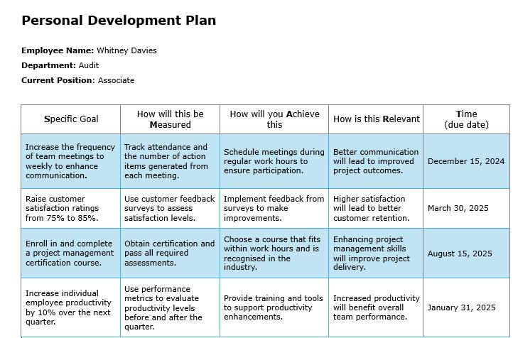

Appendix B – Me Manual



