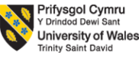

Programmes: BA International Hotel Management
Module: Managing Guest Service Operations
Module code: BMIH6002
Student Name: Flavia Nanu
Student Number: 2239004
Lecturer Name: Jessica Newport

I confirm that I have not presented any AI generated text as my own work. I confirm I have copies of my drafts, notes, and other resources I used before, and after the use of AI tools which I may be asked to provide in evidence.

Introduction
The reflective learning log evaluates the experience of Sarah Dunn, Yvette, Toni, Debbie, and Thomas. We have been appointed for a placement term in “Crown Bawtry Collection.” This assessment presents our experiences as team members while attending a placement opportunity regarding sustainability management, marketing, based on theoretical knowledge gained while working in this placement. “Crown Bawtry Collection” is an entrepreneur collection hall that operates in three prestigious venues named as “The Crown Hotel Bawtry,” “Bawtry Hall”, and “Rossington Hall” (Rossington Hall, n.d.a). Services provided in this property are staying, weddings, events, unforgettable hospitality, fine dining in contemporary elegance, to historic charms. The “Crown Hotel Bawtry” consists of “Robata Grill Restaurant,” “Terrace,” “Crown Bar,” offering breakfast, lunch, dinner, desserts, drinks, are beverages (Crown Hotel Bawtry, n.d.a). Fully furnished hotels with contemporary and rustic feelings are a unique feature of Crown Hotel (Crown Hotel Bawtry, n.d.b). In this assessment, we have explained the experiences and research of employees regarding the servicing strategy of Crown Hotel Bawtry.
Main Body
Sustainability and Marketing Execution Strategy
We have noticed the sustainability initiative of “Crown Bawtry Collection” focuses on taking climate-resilient actions, using natural resources, and fostering circularity. The climate action objective of “Crown Bawtry Collection” emphasises CHG emission, renewable electricity generation and “Volatile Organic Compound (VOC) emissions” (Crown Cork, n.d.). We were instructed to reduce water usage, and sanitation, hygiene, and replenishment are followed to use natural resources effectively. This hospitality brand focuses on zero landfill waste, recycling, and refurbishing recycled materials for further usage. While investigating this company, I have found that this hospitality brand emphasises safety precautions, employee job satisfaction and diversity, and inclusion of hospitality staff.
The 7Ps of marketing model, taught in a lecture seminar, has been applied to analyse the marketing execution strategy of “Crown Bawtry Collection”. We have learned about the marketing mix model with the 3rd week of marketing essential lectures of 4 steps for products. Since hospitality is a service-based business, the 7Ps of the marketing mix model have been applied.
Product
“Crown Bawtry Collection” offers luxury hospitality services with meals, food, and beverages as per our observation. The beverage section of this hotel is named “Crown Bar,” which offers premium beers named “Beer Moretti” and “Guinness,” fine wines, champagnes, cocktails including “Espresso” and “Porn Star martinis” (Crown Hotel Bawtry, n.d.c).
Price
A premium pricing strategy is followed by “Crown Hotel Bawtry” to address affluent customers for hospitality services. The weekly wedding packages, including 660-day and 90 evening guests, are available at £9999.00 (Crown Hotel Bawtry, n.d.d).
Place
“Crown Hotel Bawtry” has its physical properties in the UK, although services can be booked online personalised website of the company.
Promotion
Social media platforms such as Facebook and Instagram are used by “Crown Hotel Bawtry” to promote its services. The official Instagram page is followed by 5,510 followers, and 44K people follow the official Facebook page of “Crown Hotel Bawtry” (Instagram, n.d.; Facebook, n.d.).
People
We experienced that inclusivity, diversity, and worker safety precautions are followed in “Crown Hotel Bawtry” to evaluate employee engagement and job satisfaction. A total of 10 filter officers, including Jason Peter, Craig James, are in charge of making decisions, regulating employee policy, and maintaining corporate activities (GOV UK, n.d.a).
Process
We have worked in a hybrid process that is followed for booking services from an online website and adding other changes to services.
Physical Evidence
Physical evidence of the company is the registered office address at “High Street, Bawtry, Doncaster, South Yorkshire, United Kingdom” (GOV UK, n.d.b). The company was previously known as “Broomco (3190) Limited” from 18th May to 12th June 2003 and “Blue Wood Hotels Limited” from 12th June 2003 to 3rd February 2004.
Implication of DRIP theory
The DRIP theory has guided us to attain success by small and consistent measures, which I have learned in business strategy management module. According to Rutherford and O’Fallon (2007), technology endorsement in terms of advanced communication, computers, personal devices, and mechanical equipment has not only saved physical effort but also improved servicing efficiency in real-time. Regarding the Level 4 Hospitality and Guest Service module, I have realised that I must be emotionally knowledgeable and concerned about the emotions of a customer when addressing recovery. “Crown Hotel Bawtry” has applied DRIP theory to differentiate hospitality services, reinforcing trendy hospitality service trends based on customer expectations. Guests have the flexibility to choose hospitality service on their own.
Reflective comparison
What
We have participated in the placement opportunity at the “Crown Hotel Bawtry.” Our five team members have had the opportunity to gain experience as a hotel manager, HK (House Keeping) manager, event manager, function coordinator, and receptionist at Rossington Hall. Debbie, the function coordinator and function coordinator has helped me to meet stakeholder expectations, arranging resources for the hospitality function.
How
In comparison to that, the job role of a receptionist is considered to be less hectic as it requires Thomas to execute effective communication skills to entertain customers, and he has helped me to improve the customer communication strategy. Haag (2013) explained ethical rights and expectations of staff that should be known while working in a hospitality management company. Wilson (2009) clearly differentiates the objectives of employees and students in work-based learning. Learners' goal is to earn value along with money, whereas employees might solitarily focus on financial gain.
Why
I have had the opportunity to work as a hotel manager; therefore, keeping track of financial details, housekeeping activities, events, functions, and reception activities was my responsibility, which have learned in the customer loyalty module using the service recovery paradox.
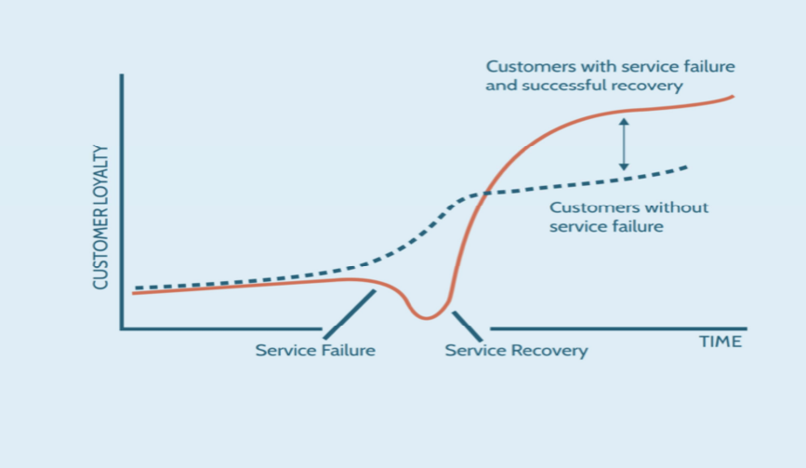
Figure 1: Service Recovery Paradox
(Source: Lecture Slide)
We were taught about the service recovery paradox model that customer satisfaction also remains high in case of service failure in the hospitality industry. I have witnessed a practical demonstration of such a situation when Yvette, the HK manager, mistakenly delivered service to the wrong service.
When
As a hotel manager, Yvette and I have sincerely apologised for such a non-international mistake. We were shocked when guests kindly accepted our apology despite getting angry. According to Hu and Min (2025), emphasising transparency, data privacy increases customer satisfaction and generates awareness. Thus, a placement opportunity in “Crown Hotel Bawtry” and communication with existing staff have taught us about the importance of being transparent and soft skills such as humbleness, effective communication, to excel in the career of hospitality management.
Suggestion improvements
Exploring the WOW factor to enhance guest engagement
The weekly lecture on customer loyalty has taught us to explore WOW factors, that is service features which are preferred by most of the customers. Hiezl and Gyurácz-Németh (2021) found that hospitality customers from Gen Z value personalised service as per their preferences. The exploration of WOW factors excavates the opportunity to diversify guest experience by including customisation.
Introducing differentiated experience to gain a competitive advantage
The second suggestion for “Crown Hotel” could be adding variation from the rest of the hospitality brands in the UK. The service differentiation strategy could be initiating cultural events on classical instruments bearing the significance of folk music, cultural treasures of the UK.
Conclusion
The working experience in “Crown Hotel” has taught us about the integrity of privacy values and transparency to evaluate customer satisfaction. We had the opportunity to execute our hospitality management skills is the hotel. We have identified areas of weakness and points that need to be emphasised for increasing customer loyalty. The 7Ps of marketing mix model applied in assessment evaluates the premium business model of “Crown Hotel” mainly targets financially affluent citizens and corporate offices. Based on placement experience and theories taught during class lectures, suggestions were made to increase customer loyalty of “Crown Hotel.” Personalisation of hospitality services based on individual customer demand and bringing differentiation in services such as cultural event arrangement has been recommended to increase customer loyalty. In conclusion, our cognitive thinking, decision-making in practical situations have been evaluated by participating in a placement opportunity at “Crown Hotel”.
References
Crown Cork (n.d.) Sustainability. Available at: https://www.crowncork.com/sustainability (Accessed: 17 October 2025).
Crown Hotel Bawtry (n.d.a) BAR, GRILL & TERRACE. Available at: https://www.crownhotel-bawtry.com/restaurant/ (Accessed: 17 October 2025).
Crown Hotel Bawtry (n.d.b) History. Available at: https://www.crownhotel-bawtry.com/about/#:~:text=The%204%20star%20Crown%20hotel,boutique%20shops%2C%20bars%20and%20restaurants. (Accessed: 18 October 2025).
Crown Hotel Bawtry (n.d.c) CROWN BAR. Available at: https://www.crownhotel-bawtry.com/crown-bar/ (Accessed: 18 October 2025).
Crown Hotel Bawtry (n.d.d) ULTIMATE CROWN WEDDING PACKAGE. Available at: https://www.crownhotel-bawtry.com/wedding-venue-doncaster/ultimate-crown-wedding-package/ (Accessed: 17 October 2025).
Facebook (n.d.) Crown Hotel Bawtry. Available at: https://www.facebook.com/crownhotelbawtry/ (Accessed: 17 October 2025).
GOV UK (n.d.a) THE CROWN HOTEL (BAWTRY) LIMITED. Available at: https://find-and-update.company-information.service.gov.uk/company/04768891/officers (Accessed: 18 October 2025).
GOV UK (n.d.b) THE CROWN HOTEL (BAWTRY) LIMITED. Available at: https://find-and-update.company-information.service.gov.uk/company/04768891 (Accessed: 17 October 2025).
Haag, E. (2013) Internship guide: Work placements step by step. Eleven International Publishing.
Hiezl, K. and Gyurácz-Németh, P. (2021) ‘Hotel service personalisation and the willingness of information sharing: The case of generation Z’, Tourism Today, 175.
Hu, Y. and Min, H.K. (2025) ‘Information transparency, privacy concerns, and customers' behavioural intentions regarding AI-powered hospitality robots: A situational awareness perspective’, Journal of Hospitality and Tourism Management, 63, pp. 177-184.
Instagram (n.d.) crown_hotel_bawtry. Available at: https://www.instagram.com/crown_hotel_bawtry/?hl=en (Accessed: 18 October 2025).
Rossington Hall (n.d.) Crown Bawtry Collection. Available at: https://rossingtonhall.co.uk/crown-bawtry-collection/ (Accessed: 18 October 2025).
Rutherford, D.G. and O’Fallon, M.J. (2007) Hotel Management and Operations. Hoboken: John Wiley & Sons, Inc.
Wilson, J. ed. (2009) A Good Practice Guide for Placement and Other Work-based Learning Opportunities in Higher Education: Good Practice for Placements Guides: Vol 2 (Vol. 2). ASET.
Appendix: Three learning objectives
Objectives | Significance
To evaluate emotional intelligence to deal with staffs and customers | Job satisfaction and staff retention are likely to increase.
To strengthen critical thinking skills | Finding a different approach for resolving an issue.
To improve mental resilience for dealing with adverse situations | Stabilising mental peace and work-life balance.

